**Supplementary material for:**

Mass balance and ablation processes of a perennial polar ice patch on the northern coast of Ellesmere

GAUTIER DAVESNE 1,2, DANIEL FORTIER 1,2, FLORENT DOMINE 2,3, Christophe Kinnard 2, 4

*1 Cold Regions Geomorphology and Geotechnical Laboratory, Département de géographie, Université de Montréal, Montréal, Canada.*

*2 Centre for Northern Studies, Université Laval, Québec, Canada.*

*3 Takuvik Joint International Laboratory, Laval University (Canada) and CNRS (France), Département de chimie , Université Laval, Québec, Québec G1V 0A6, Canada.*

*4 Glaciolab, Département des sciences de l’environnement, Université du Québec à Trois-Rivières, Trois-Rivières, Canada.*

*Correspondence to:* [*gautier.davesne@umontreal.ca*](mailto:gautier.davesne@umontreal.ca)

Table S1. Details of monitoring instruments

|  |  |  |  |  |  |  |  |  |
| --- | --- | --- | --- | --- | --- | --- | --- | --- |
| Variable | Site | Symbol (unit) | Instrument | Height (m) | Instrument source | Stated accuracy | Range | Record period |
| Snow height | SILA-AWS | SH (m) | Sonic distance sensor | 1.5 | SR50, Campbell Sci. | ±0.01 m | 0.5 to 10 m | 2005-2019 |
| Wind speed | SILA-AWS | V (m s−1) | Anemometer | 10 | 05103-10 R.M Young | ±0.3 m s−1 | 0 to 100 m s−1 | 2005-2019 |
| Wind direction | SILA-AWS | DIR (°) | Anemometer | 10 | 05103-10 R.M Young | ±3° | 0 to 360° | 2005-2019 |
| Air temperature | SILA-AWS | Ta (°C) | Thermohydrometer | 1.5 | HMP35CF | ±0.2°C | -53-48°C | 2005-2019 |
| Relative humidity | SILA-AWS | RH (%) | Thermohydrometer | 1.5 | HMP35CF | ±2% (0-90%) | 0-100% | 2005-2019 |
| Air temperature | IP1-AWS | Ta (°C) | Temperature logger | 1.5 | Hobo U22-001 Onset | ±0.21°C | -40° to 70°C | 10 June -10 July 2017 |
| Air temperature | IP1-AWS | Ta (°C) | Thermohydrometer | 0.5 / 2 | S-THB-M002 Onset® | ±0.21°C | -40 to 75°C | 10 June -19 July 2019 |
| Relative humidity | IP1-AWS | RH (%) | Thermohydrometer | 0.5/ 2 | S-THB-M003 Onset® | ±2.5% | 0-100% | 10 June -19 July 2019 |
| Wind speed | IP1-AWS | V (m s−1) | Ultrasonic anemometer | 2.5 | WindSonic 4 Gill instr. | ±2% at 12 m s−1 | 0-60 m s−1 | 10 June -19 July 2019 |
| Wind direction | IP1-AWS | DIR (°) | Ultrasonic anemometer | 2.5 | WindSonic 4 Gill instr. | ±2º at 12 m s−2 | 0-360° | 10 June -19 July 2019 |
| Shortwave rad. (incoming) | IP1-AWS | ↓SW (W m-2) | Pyranometer | 1 | Kipp & Zonen SP-Lite | <10% | 0.4 to 110 mm | 10 June -19 July 2019 |
| Net radiation | IP1-AWS | Q* (W m-2) | Net radiometer | 1 | Kipp & Zonen NR-Lite | ±5-10 W m−2 | 0.2 to 100 mm | 10 June -19 July 2019 |
| Atmos. pressure | IP1-AWS | AP (mbar) | Pressure sensor | 2 | Hobo U20L-04 Onset® | ±6,2 mbar | 0 to 1450 mbar | 10 June -19 July 2019 |
| Snow temperature | IP1-AWS | Tsnow (°C) | Thermistors | 0; ‒0.4; ‒0.7; ‒1; ‒1.3;  ‒1.6; ‒1.95;  ‒2.2 | Geocryolab | ±0.1°C | -40° to 70°C | 10 June -19 July 2019 |
| Discharge | Flume | Qf (cm3 s-1) | Water level sensor |  | Hobo U20L-04 Onset® | ±6,2 mbar | 0 to 1450 mbar | 10 June -19 July 2019 |

Table S2. Summary of the micrometeorological variables; i.e. mean daily atmospheric pressure (*PA* in hPa), mean daily, maximum and minimum air temperature (*Ta-daily*; *Ta-max*; *Ta-min*, in °C), mean daily relative humidity (*RHdaily*, in %), maximum 15-min average wind speed (*WSmax* in m s‒1), mean daily maximum wind speed (*WSdaily* in m s‒1) and mean daily incoming solar radiation (*SW↓* in W m‒2) recorded by the AWS and the resulting terms of the surface energy balance; i.e. net radiations (*Q\** in MJ m−2 d−1), sensible heat fluxes (*Qh* in MJ m−2 d−1), latent heat fluxes (*Qe* in MJ m−2 d−1), the melt fluxes (*Qm* in MJ m−2 d−1) and the melt rate (in mm d‒1 w.e.) on the ice patch IP1 for the three different cases that reflected the dominant conditions encountered in summer along the northern coast of Ellesmere Island. Case 1 (28 June 2019) was characterized by sunny and calm conditions; Case 2 (5 July 2019) was a foggy day; Case 3 (9 July 2019) was marked by the influence of a low-pressure system and overcast conditions.

|  |  |  |  |
| --- | --- | --- | --- |
|  | Case 1 (28 June) | Case 2 (5 July) | Case 3 (9 July) |
| PA (hPa) | 1029 | 1016 | 1010 |
| Ta-daily 0.5 m (°C) | 2.2 | -0.4 | 4.3 |
| Ta-max 0.5 m (°C) | 4.6 | 2.1 | 8.2 |
| Ta-min 0.5 m (°C) | 0.9 | -1.2 | 0.8 |
| RH 0.5 m (%) | 81.9 | 99.1 | 82.9 |
| Ta-daily 2 m (°C) | 3.1 | 0.3 | 4.6 |
| Ta-max 2 m (°C) | 5.8 | 2.3 | 8.1 |
| Ta-min 2 m (°C) | 1.9 | -0.7 | 2.1 |
| RH 2 m (%) | 80.2 | 97.9 | 82.4 |
| WSdaily  (m s−1) | 1.5 | 2.1 | 3.9 |
| WSmax (m s−1) | 3.1 | 3.8 | 7.86 |
| SW↓mean (W m‒2) | 347.5 | 228.8 | 239.8 |
| Q* (MJ m−2 d‒1) | 3.32 | 2.43 | 3.40 |
| Qh (MJ m−2 d‒1) | 1.20 | 0.06 | 6.51 |
| Qe (MJ m−2 d‒1) | 0.01 | 0.28 | 2.00 |
| Qm (MJ m−2 d‒1) | 4.54 | 2.76 | 11.9 |
| M (mm d‒1 w.e.) | 12.5 | 8.2 | 37.2 |

Table S3. Synoptic-type classification for the Canadian High Arctic and the resulting dominant weather along the northern coast of Ellesmere Island (after Alt, 1987 and Pope and others, 2017).

|  |  |  |  |
| --- | --- | --- | --- |
| Type | Name | Synoptic | Weather along the coast of Ellesmere Island |
| I | Polar Ocean circulation | Anticyclone in the Arctic Ocean /low-pressure over Baffin Bay | High pressure, clear-sky or low-stratus, fog |
| IIs | Cyclonic system with rain | Low 500-hPa geopotential heights in Beaufort Sea | Rainfall with high wind, cold temperature |
| IIr | Cyclonic system with snow | Low 500-hPa geopotential heights moving across islands from central Polar Ocean | Snowfall with high wind, cool temperature |
| III | Island circulation | Ridge development in eastern North America due to low 500-hPa geopotential heights in the Asian side of the Arctic Ocean | Wind, warm air advection, overcast, slight rain |

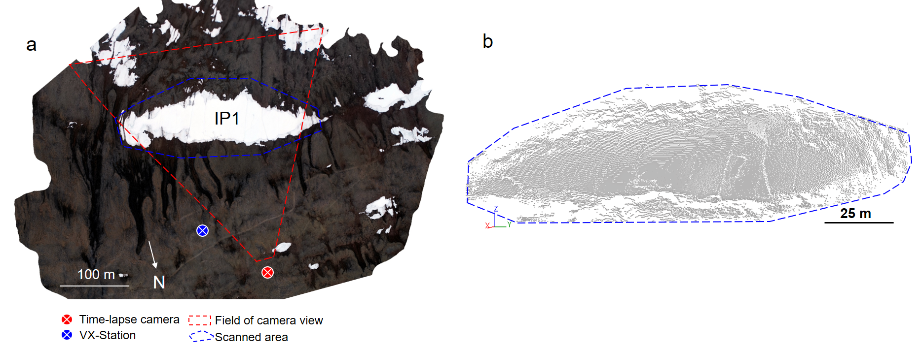

Fig. S1. a) Overview of the study area overflown by an uncrewed aerial vehicle (UAV) on 19 July 2019 showing the location of the time-lapse camera and its field of view, and of the laser scan VX-station and the polygon used to delineate the scans; b) example of a scan of the ice patch (frontal view) taken on 19 July 2019.

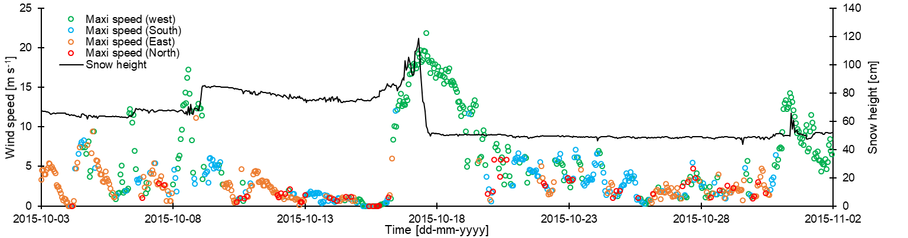

Fig. S2. Hourly evolution of the wind speeds (filtered by orientations) and snow height (*SH*, cm) throughout October 2015 showing an extreme erosion event on October 17 during which ~ 70 cm of snow was removed in a few hours from the snow patch of the SILA site at Ward Hunt Island.

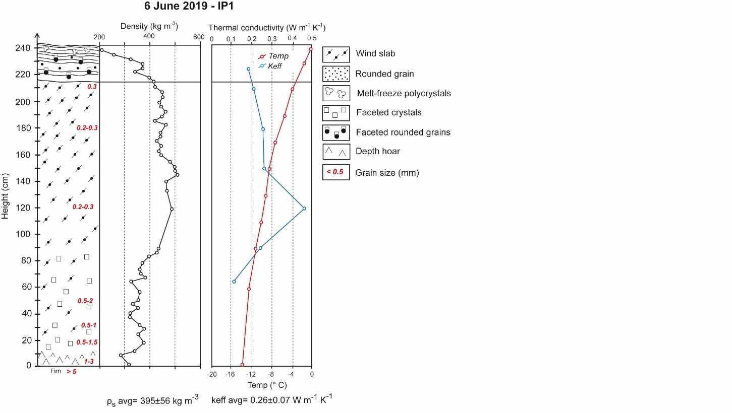

Fig. S3. Snow stratigraphy of a snowpit dug in the seasonal snow accumulation of the ice patch IP1 showing the snow grain type and size, the snow density (*ρs*, kg m-3), the snow temperature and thermal conductivity (*keff*, W m-1 K-1).

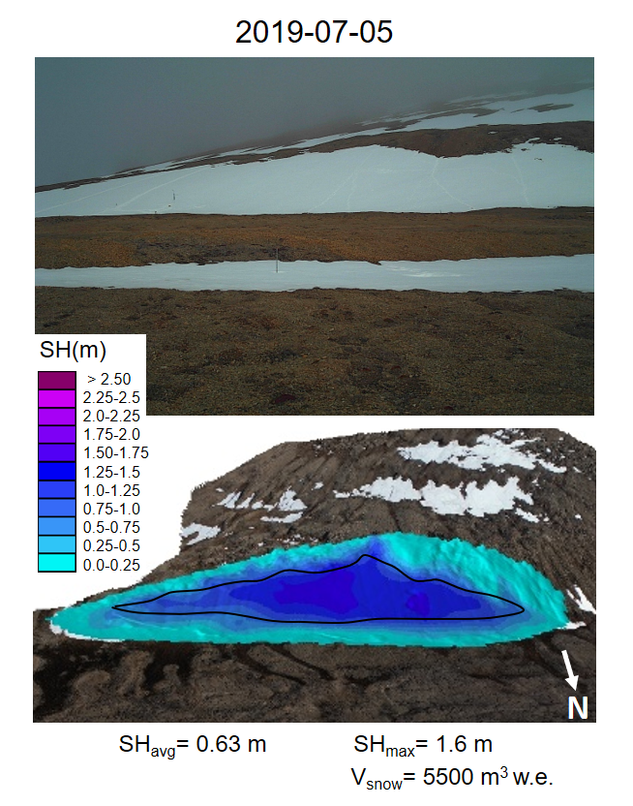

**Fig. S4.** Time-lapse photographs of the ice patch system and its surrounding terrain and map of the end-of-summer snow height (*SHmax* in m) on 5 July 2019. The black line delimits the contour of the ice body as it was at the end of summer 2016. The average and maximum snow height (*SH* in m) and the total volume of snow (*Vsnow* in m3 w.e.) are shown at the bottom of the figure.

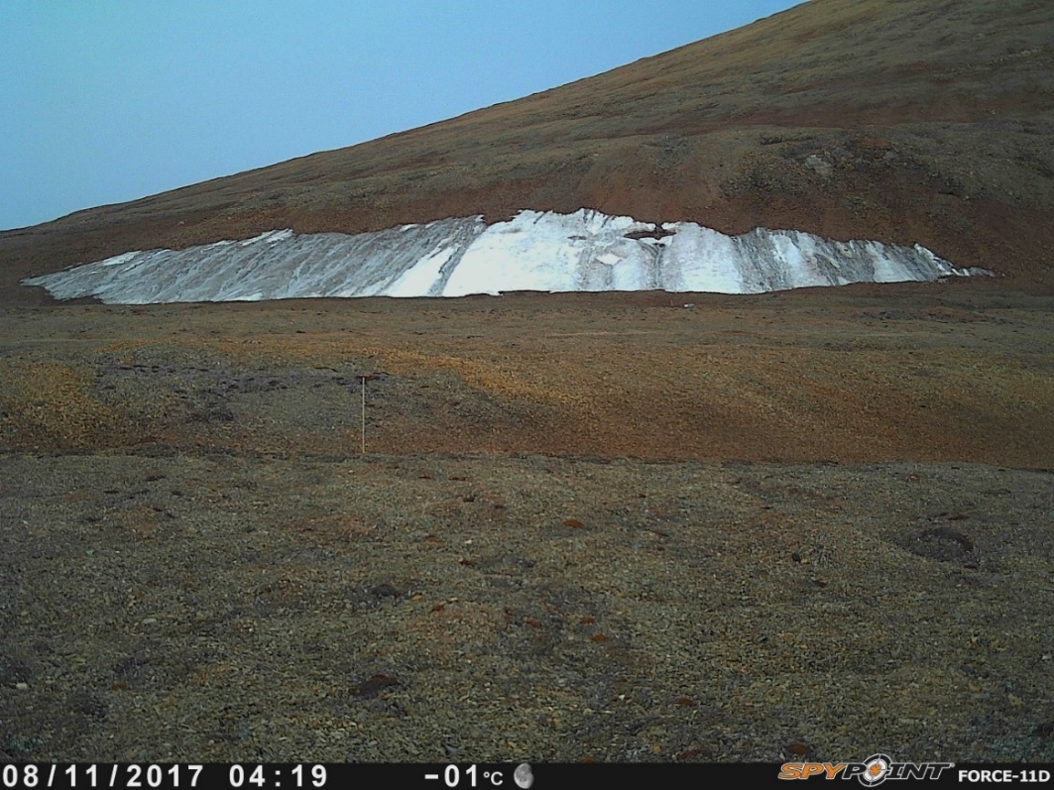

Fig. S5. Photograph of the ice patch IP1 at its minimum extent on 11 August 2017.

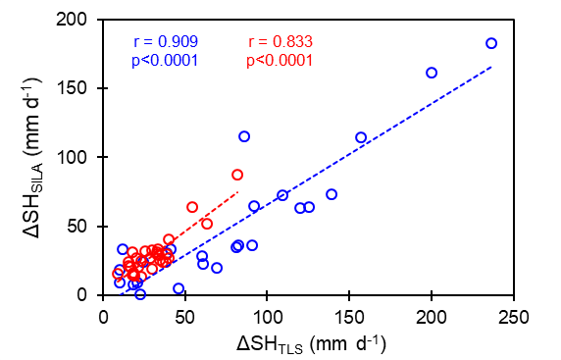

Fig. S6. Comparison (Pearson’s correlation test) between the daily snow height change recorded at SILA station (*ΔSHSILA* in mm d‒1) and measured by TLS (*ΔSHTLS* in mm d‒1) on the ice patch IP1. The red colour is for 2017 and the blue for 2019.

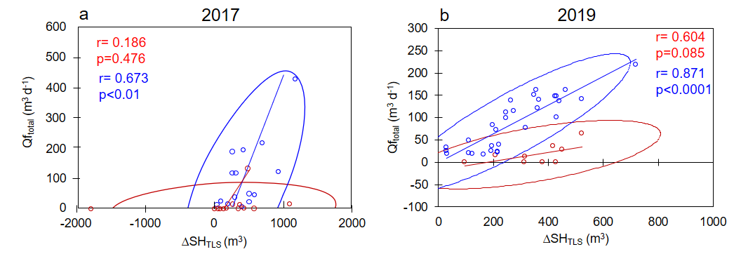

Fig. S7. Comparison (Pearson’s correlation test) between the daily ablation rate *(∆SHTLS* in m3 d‒1) measured by TLS and the daily meltwater discharge (*Qftotal* in m3 d‒1) measured at flumes for 2017 (a) and 2019 (b). The red color represents the data collected at the beginning of the melt seasons and includes the snowstorm of 28 June for the 2017 data while the blue color represents data collected outside these periods.

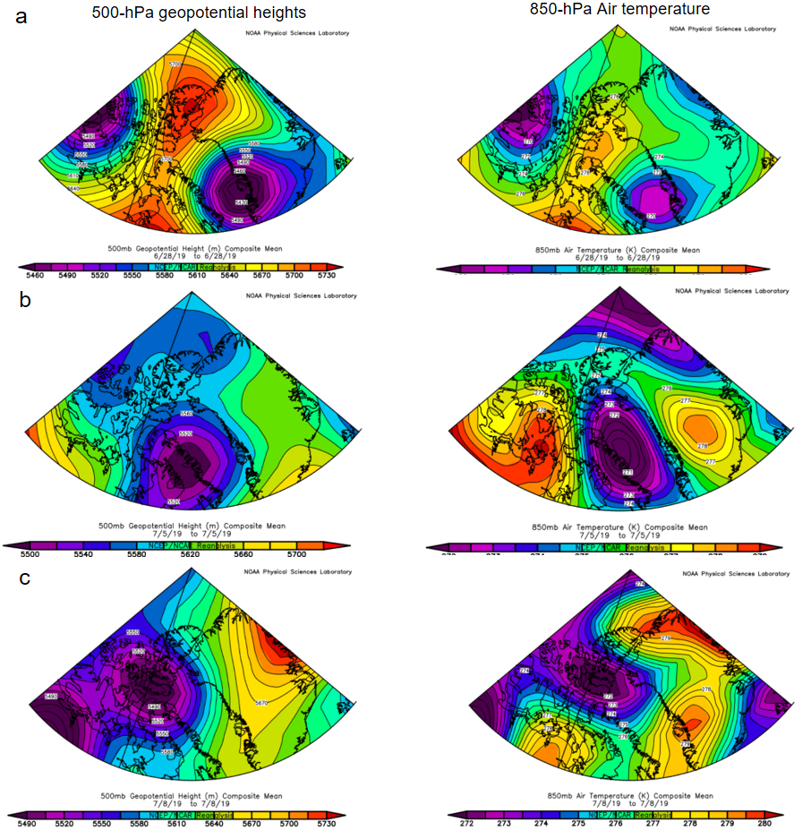

Fig. S8. Contour map of the 500-hPa geopotential heights (left) and 850-hPa air temperature (right) during the three days considered to be representative of dominant summer weather conditions on the north coast of Ellesmere Island: a) Case 1 (28 June 2019); b) Case 2 (5 July 2019) and c) Case 3 (9 July 2019). The geopotential at 500 hPa is the altitude at which 500 hPa is reached. What appears in orange/red here corresponds to high geopotentials, i.e. anticyclones, and what appears in pink/purple corresponds to low geopotential, i.e. depressions. Data were obtained from NCEP/NCAR reanalysis available at : [www.psl.noaa.gov/data/composites/day/](http://www.psl.noaa.gov/data/composites/day/).

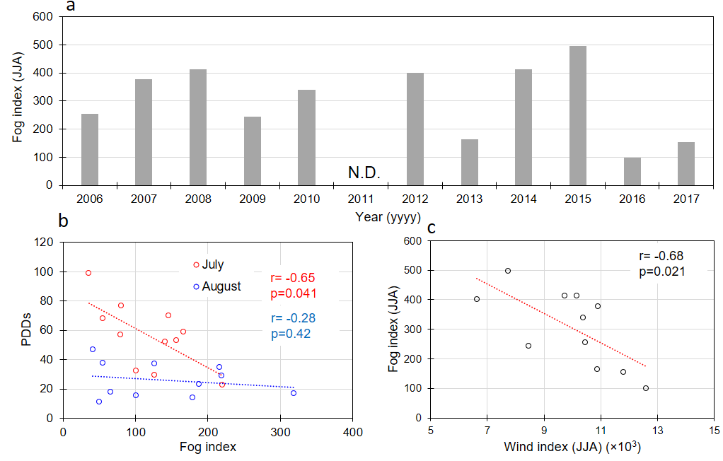

Fig. S9. a) Evolution of the summer (JJA) fog index, consisting of the sum of hours with relative air humidity above 95% at SILA station for the period 2006-17; b) Relationship between fog index of July and August and the positive degree-day (PDDs) for the period 2006-17; c) Relationship between summer wind index and fog index for the period 2006-17.

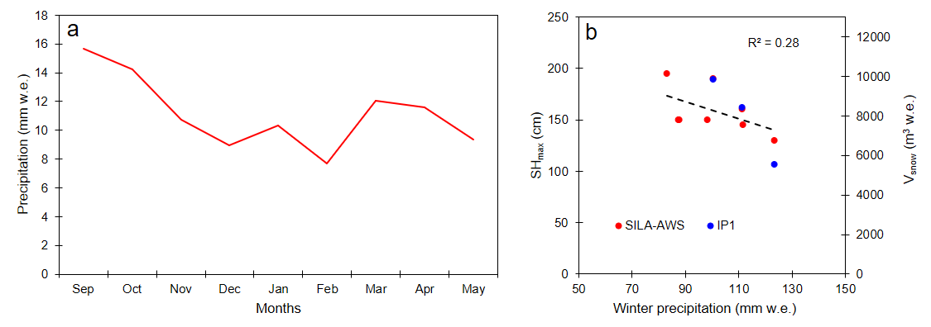

**Fig. S10.** a) Mean monthly precipitation (in mm w.e.) recorded at Alert (Nu) from 2006 to 2019 for the cold season (Sep-May) (Environment Canada, 2021); b) Relationship between the end-of-winter snow accumulation at WHI, measured at SILA (*SHmax* in cm) and on the ice patch IP1 (*Vsnow* in m3 w.e.), and winter precipitation recorded at Alert, Ellesmere Island (Nu).

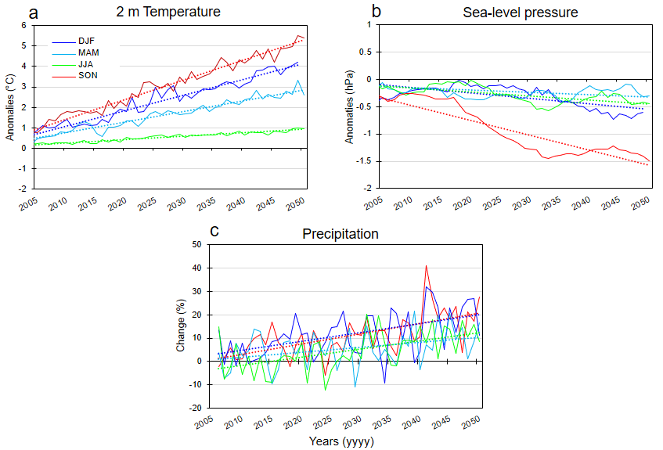

**Fig. S11**. Projection of climate conditions at Ward Hunt Island to 2050 for the winter (DJF), spring (MAM), summer (JJA) and fall (SON) based on the Coupled Model Intercomparison Project phase 5 (CMIP5) for the scenario RCP4.5 ensemble average. a) and b) evolution of the seasonal anomalies in 2 m temperature (°C) and sea-level pressure (hPa), respectively; c) Evolution of the seasonal change (%) in precipitation. Data from Climate Change Institute (2021). The dashed lines represent the linear trend for each season (DJF, MAM, JJA, SON).