**Taylor dispersion for coupled electroosmotic and pressure-driven flows in all time regimes**

**Supplementary Material**

**Caleb J. Samuel1, Ray Chang1, Kunlin Ma1 and Juan G. Santiago1**†

1Department of Mechanical Engineering, Stanford University, Stanford, CA 94305, USA

**CONTENTS**

|  |  |
| --- | --- |
| 1. Analytical reduction of our quasi-steady solution to Griffiths & Nilson's (1999) solution for electroosmotic flow only | 2 |
| 1. Benchmark comparisons of quasi-steady solution and Brownian dynamics simulations for  and | 3 |
| 1. Nomenclature | 6 |
| References | 10 |

1. **Analytical reduction of our quasi-steady solution to Griffiths & Nilson's (1999) solution for electroosmotic flow only**

We here demonstrate how our solution for the quasi-steady dispersion coefficient reduces to that of Griffiths & Nilson (1999) for the case of pure electroosmotic flow (EOF; ). We begin with our expression for the dimensionless dispersion coefficient, (3.20) from the main paper:

.

Substituting  and re-arranging, we can rewrite as follows:

,

where the value of  is given by (3.15) of the main paper. First, we consider the term We may express the latter as



Substituting into ,

.

Next, expanding the term ,



Lastly, substituting into and multiplying by ,

.

The latter simplified equation is equivalent to equation (38) of Griffiths & Nilson (1999). Thus, in the restrictive case of EOF only, our solution for the coefficient of effective dispersion in the long-time regime reduces to Griffiths & Nilson’s solution of the coefficient of effective dispersion

1. **Benchmark comparisons of quasi-steady solution and Brownian dynamics simulations for**  **and** 

We here present additional comparisons between our analytical solution for the two-dimensional concentration field and Brownian dynamics simulations for the cases of and 1000. Figure 4 presents a similar comparison for . Figure 5 presents a similar comparison forand . The figures provided here are therefore complementary to figures 4 and 5 of the main paper. As in the main paper, figures S1 and S2 each show solute distributions for three dimensionless times (in blue, orange and green). The top half of each channel is an example Brownian dynamics simulation, while the bottom half shows the analytical solution (from (3.40) of the main paper). Figure S1 and S2 respectively show cases with  of 20 and 1000. The values of  and  are indicated along the right of the figures.

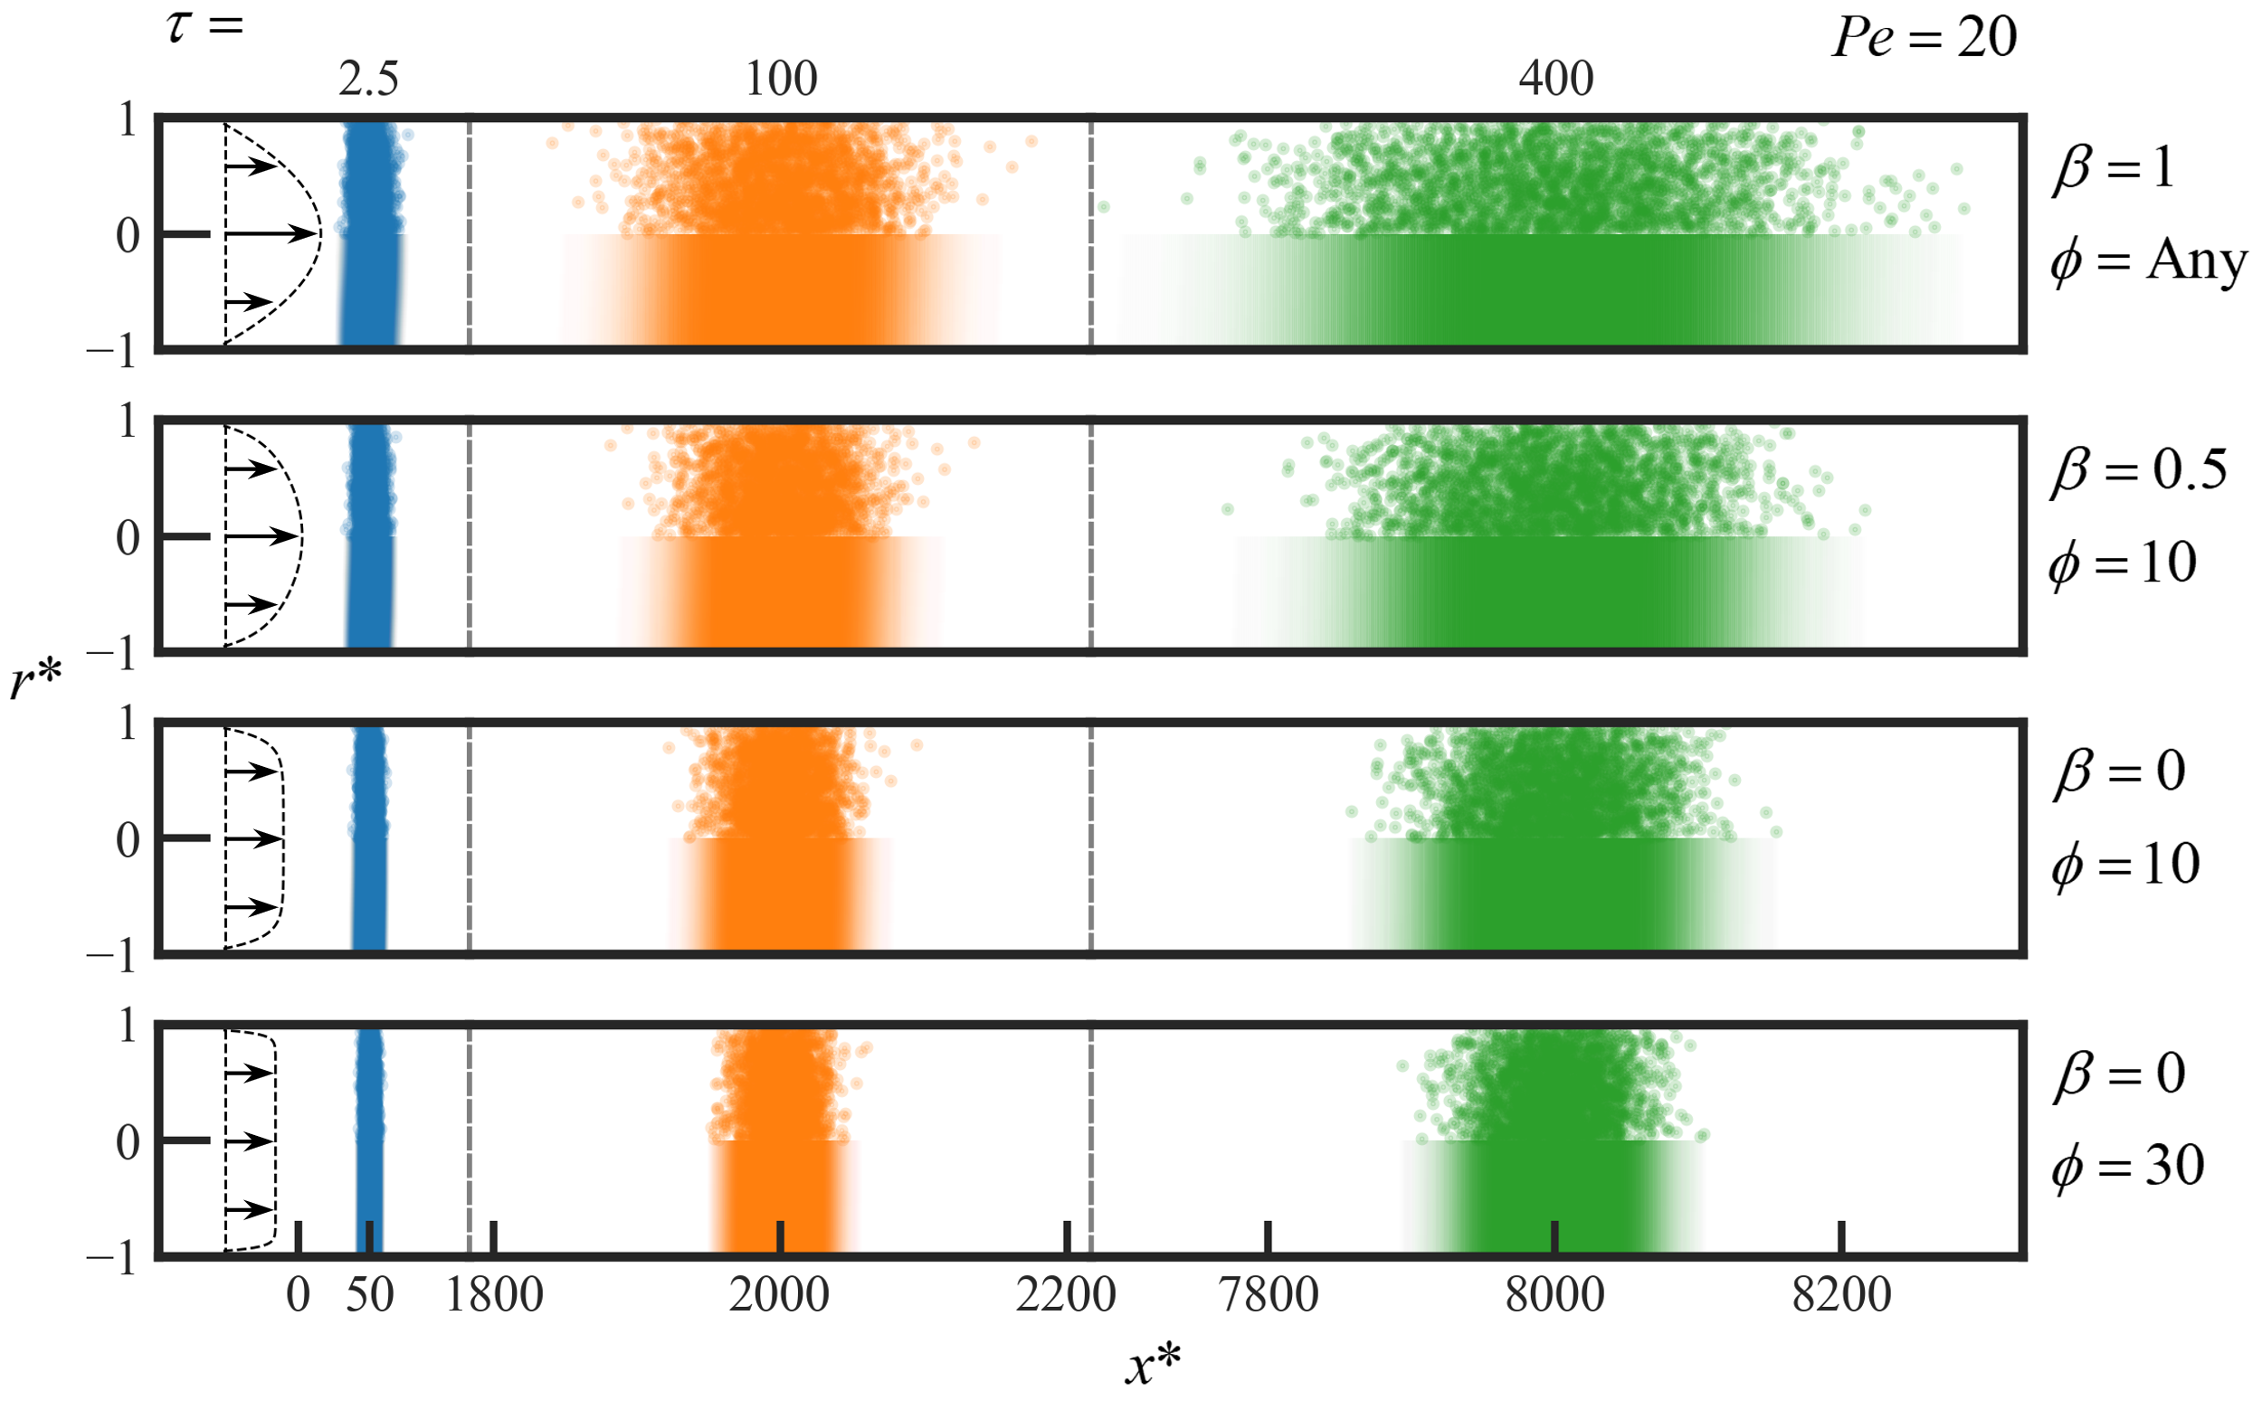

Figure S1. Benchmark comparisons between Brownian dynamics simulations and the analytical solution of the quasi-steady solute concentration field at three values of dimensionless time,. This is the equivalent of figures 4 and S2 but created for . The plot shows dimensionless radius, , on the ordinate and dimensionless axial position, , on the abscissa. The top half of each subplot shows individual particles from the Brownian dynamics simulations and the bottom half of each subplot shows the concentration field predicted by the analytical solution in (3.40). Subplots show four combinations of the fraction of bulk velocity caused by pressure, , and the tube radius scaled by Debye length, . The far left of the subplots shows the flow profile used to generate the data for each row.

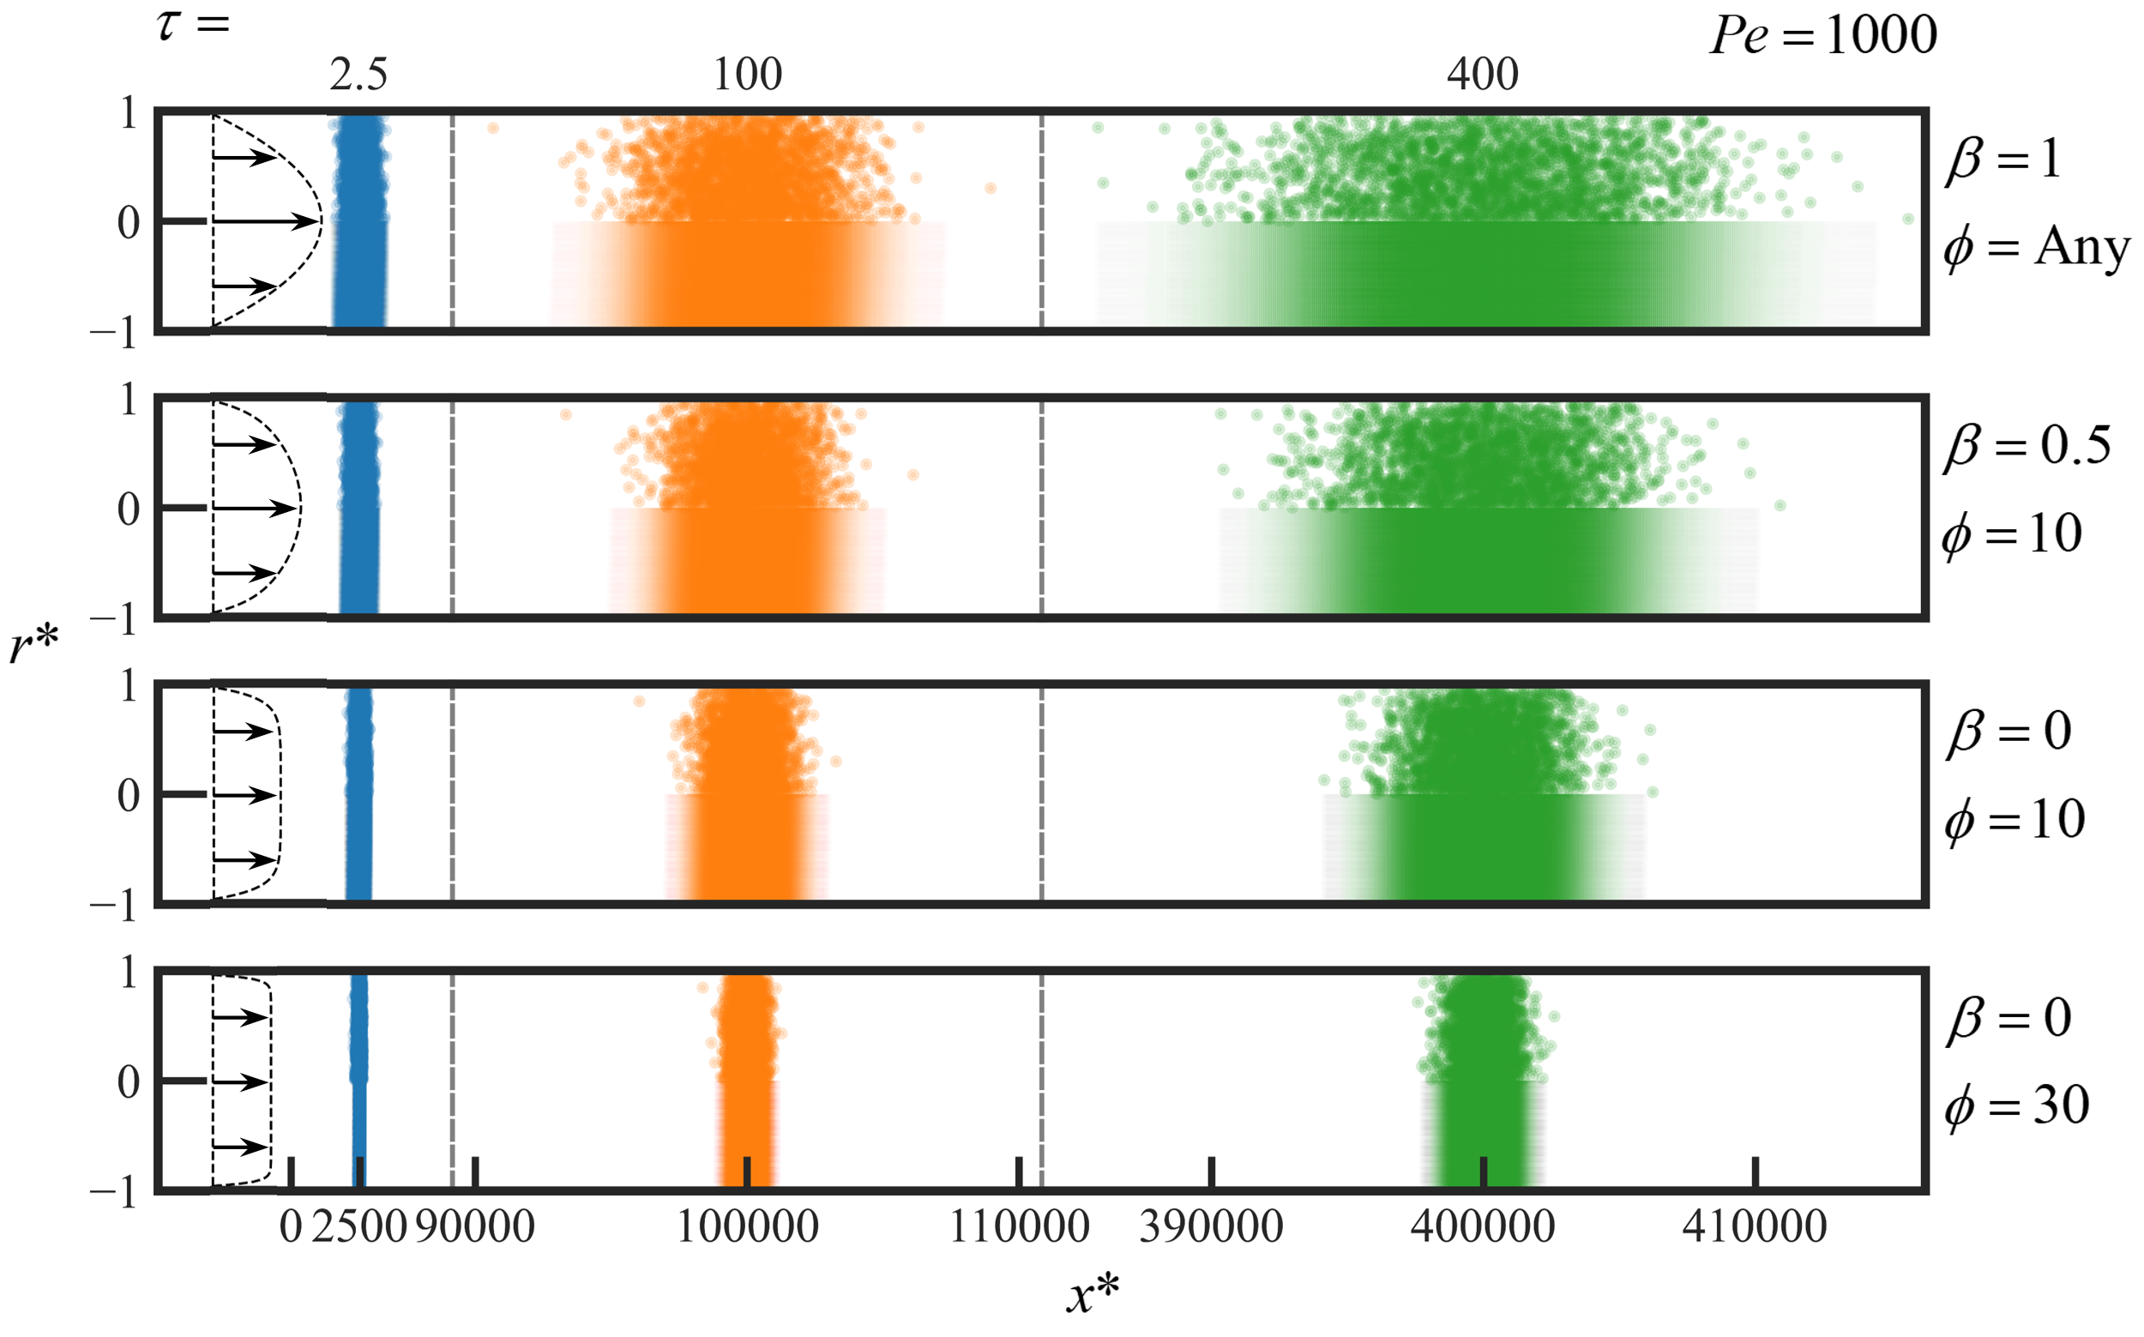

Figure S2. Benchmark comparisons between Brownian dynamics simulations and the analytical solution of the quasi-steady solute concentration field at three values of dimensionless time,. This is the equivalent of figures 4 and S1 but created for . The plot shows dimensionless radius, , on the ordinate and dimensionless axial position, , on the abscissa. The top half of each subplot shows individual particles from the Brownian dynamics simulations and the bottom half of each subplot shows the concentration field predicted by the analytical solution in (3.40). Subplots show four combinations of the fraction of bulk velocity caused by pressure, , and the tube radius scaled by Debye length, . The far left of the subplots shows the flow profile used to generate the data for each row.

As in figures 4 and 5 of the main paper, the analytical solution and Brownian dynamics simulations show excellent agreement for all combinations of parameters.

1. **Nomenclature**

We here provide a comprehensive list of the nomenclature used in the main paper.

**Operators**

cross-sectional area average

deviation from cross-sectional area average

dimensionless variable

variable associated with transient solution (from method of moments)

evaluated at the axial centreline of the channel

evaluated in an electroneutral reservoir

normalization by bulk velocity

**Dimensional**

 inner radius of tube

positional vector at the slipping plane

cross-sectional area of tube

concentration of solute

scaling parameter for cross-sectionally averaged concentration field

scaling parameter for deviation from cross-sectionally averaged concentration field

positional vector at the axial centreline of the channel

molecular diffusivity

coefficient of effective dispersion

 coefficient of effective dispersion associated with transient solution

elementary charge

electric field

Boltzmann constant

 a specific axial distance of interest

 initial width of a “top hat” solute zone

ionic density function of the *ith* species

moles of solute in tube

three-dimensional position vector

absolute temperature

 flow profile of the electroosmotic flow component

flow profile of the pressure-driven flow component

 flow profile

bulk velocity from electroosmotic flow

bulk velocity from pressure-driven flow

net bulk velocity

Helmholtz-Smoluchowski velocity scale

positional vector within an electroneutral reservoir

axial position in a moving frame at the net bulk velocity

path between channel centreline and an electroneutral reservoir at constant electrochemical potential

valence number of the *ith* species

permittivity of fluid

zeta potential

Debye length

dynamic viscosity of fluid

electrochemical potential of the *ith* species

= electric charge density function

characteristic width of solute zone

electric potential

**Dimensionless**

dimensionless concentration of solute

 *nth* moment of the concentration field integrated along the-axis

dimensionless coefficient of effective dispersion

 dimensionless coefficient of effective dispersion associated with transient solution

eigenfunction associated with transient solution

Green’s function

dimensionless distance of tube for optimization of 

 *nth* moment of the concentration field

Péclet number based on net bulk velocity

Péclet number based on electroosmotic flow bulk velocity

Péclet number based on pressure-driven flow bulk velocity

dimensionless radial coordinate

 *nth* moment about the axial mean of the concentration field

Green’s function variable for axial dimension

dimensionless -position (for method of moments solution)

-position scaled by solute zone width (for quasi-steady state solution)

 *ith* root of 

ratio of pressure-driven flow bulk velocity to net bulk flow velocity

 coefficient that quantifies the contribution of electroosmotic flow to the dispersion

coefficient that quantifies the contribution of pressure-driven flow to the dispersion

 coefficient that quantifies the contribution to dispersion associated with the coupling of pressure-driven flow and electroosmotic flow

function relating Helmholtz-Smoluchowski velocity to electroosmotic bulk velocity

eigenvalue associated with transient solution

smallness parameter defined as the ratio between tube inner radius and solute zone width (used in quasi-steady state solution)

dimensionless time

characteristic dimensionless time of interest

tube radius scaled by Debye length

 Péclet number in terms of the (radially varying) velocity profile

**Optima**

optimum value of  to minimize variance for transporting solute (over an arbitrary axial distance)

 optimum value of  to minimize variance for transporting solute (over a fixed axial distance)

optimum value of to minimize rate of increase of variance (for quasi-steady state solution)

 optimum value of to minimize variance obtained from transient solution

specific flow profile associated with 

REFERENCES

Griffiths, S. K. & Nilson, R. H. 1999. Hydrodynamic dispersion of a neutral nonreacting solute in electroosmotic flow. *Analytical Chemistry*, **71** (24).