Journal of Fluid Mechanics
Supplementary material for
Turbulence in a channel with a patchy submerged canopy: the impact of spatial configuration
Hyoungchul Park^{1*} and Heidi Nepf¹
¹Department of Civil and Environmental Engineering, Massachusetts Institute of Technology, Cambridge, MA, United States

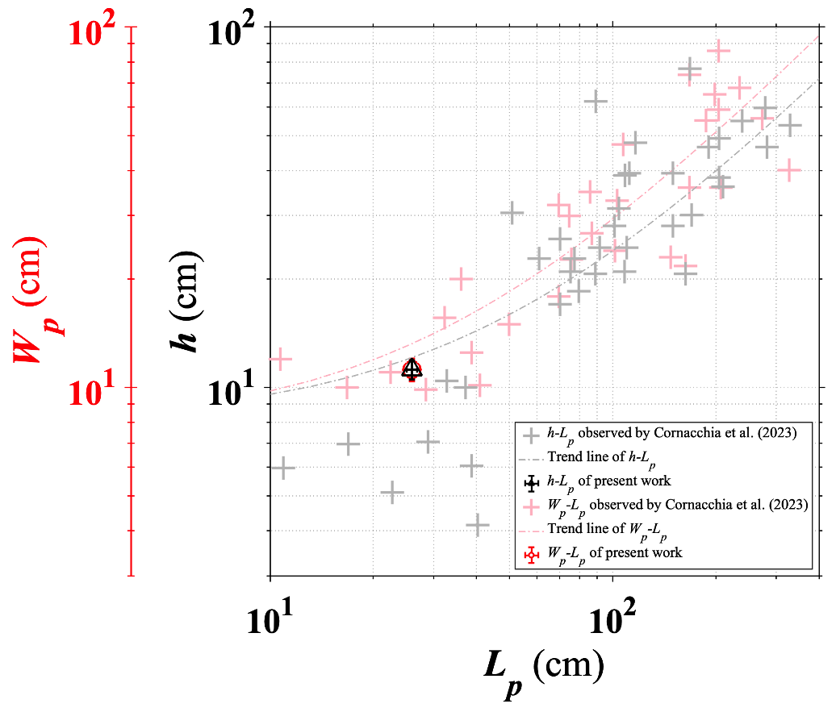
Figure A1. Geometry of natural vegetation patches observed in a river channel by Cornacchia et al. (2023), and the geometry of the artificial patches used in this study; Black colored marker: deflected height – patch length, red colored marker: patch width – patch length.

FigureA2. Vertical profiles of $∂^{2}u/∂z^{2}$ for four different configurations in Figure 5 of manuscript.

