Supplementary Figures for

Suppression of the Segré-Silberberg effect by polymer additives

Daekwon Jin¹, Jee In Park¹, Jae Bem You², Younghun Kim³ Hyomin Lee⁴ and Ju Min Kim^{1,5*}

¹Department of Energy Systems Research, Ajou University, Suwon 16499, Republic of Korea
²Department of Chemical Engineering, Kyungpook National University, Daegu 41566, Republic of Korea
³Department of Chemical Engineering, Kwangwoon University, Seoul 01897, Republic of Korea
⁴Department of Chemical & Biological Engineering, Jeju National University, Jeju 63243, Republic of Korea
⁵Department of Chemical Engineering, Ajou University, Suwon 16499, Republic of Korea

*To whom correspondence should be addressed:

E-mail: jumin@ajou.ac.kr; Fax: +82-31-219-1612; Tel: +82-31-219-2475 (J.M.K.)

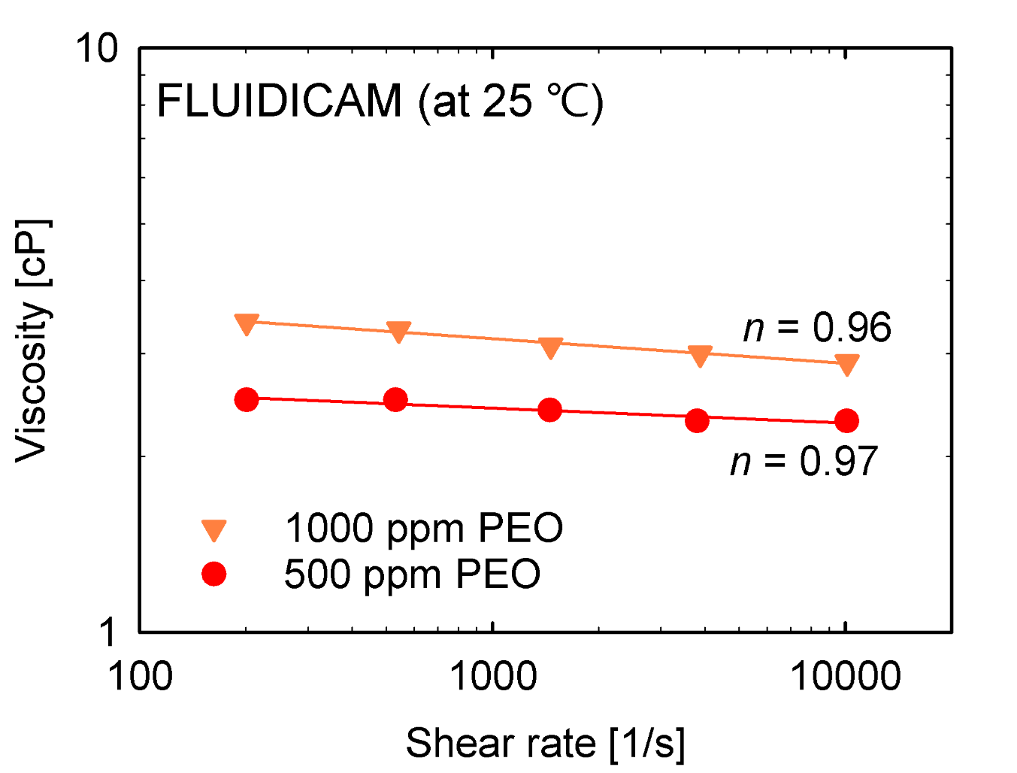
Figure S1. The viscosity data at high shear rates obtained with a microfluidic viscometer (FLUIDICAM Rheo, Microtrac Formulaction) at 25 ℃. Solid lines indicate the power-law model fitting, and $n$ values denote the power-law indices.

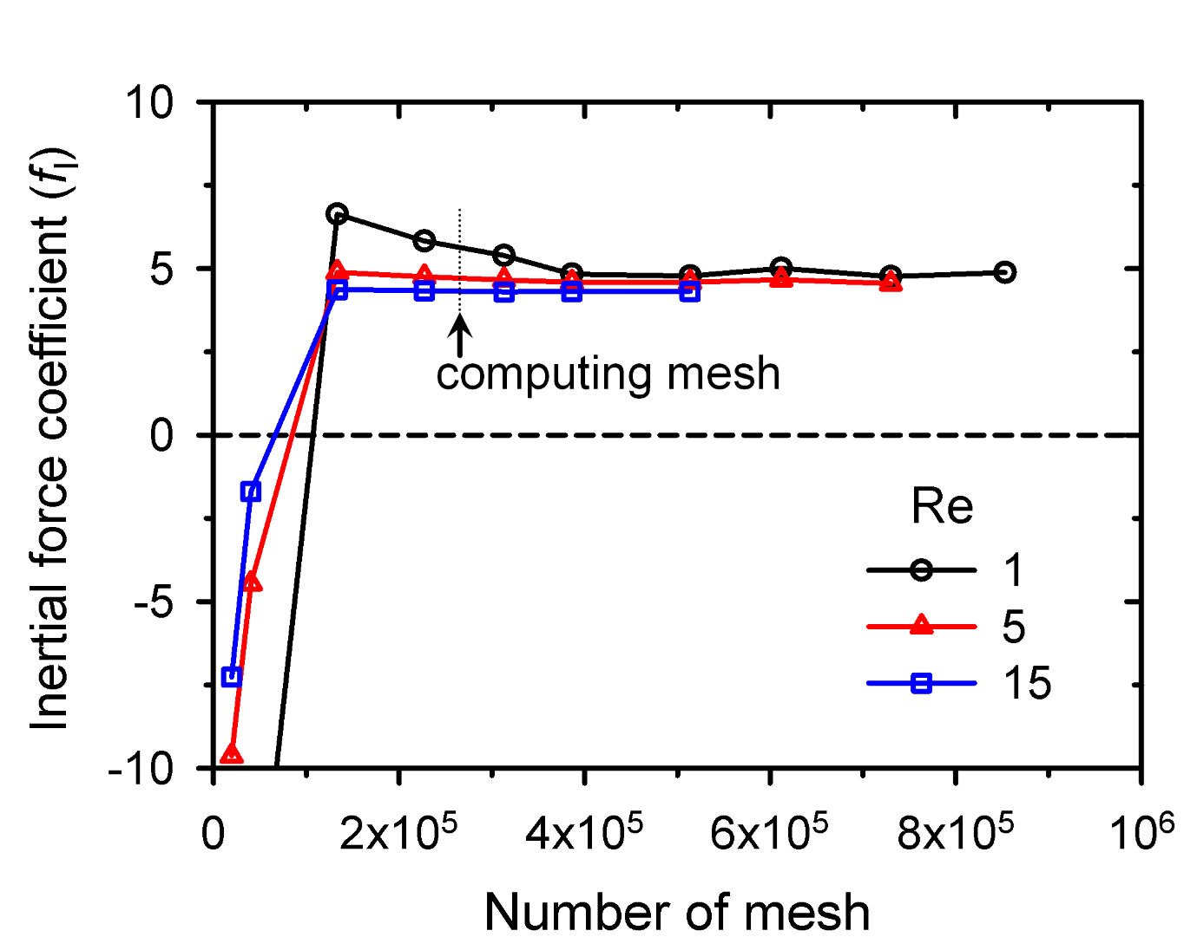
Figure S2. The mesh refinement test results for calculating inertial lift force. The inertial lift force was independent with the amount of mesh. In order to reduce the computation time, computations were carried out at set points shown by dotted lines in the plot.

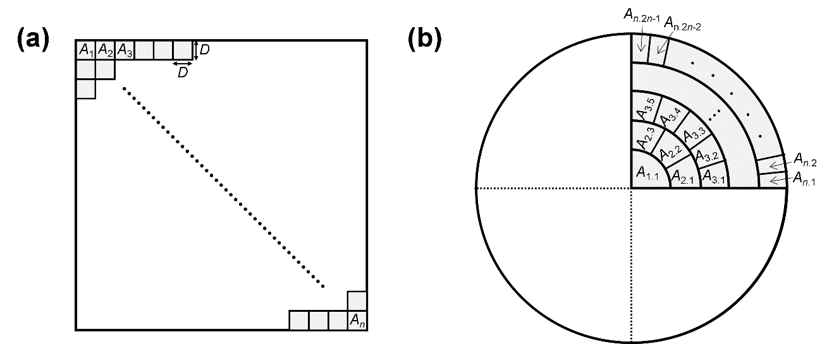
Figure S3. The methods for dividing the channel cross-section to calculate the global Shannon entropy (GSE). This method involved the exclusion of 3 µm (d/2; d: particle diameter) of the channel edge as the particle center points were not present. We divided the cross-section in each case to obtain the same bin area. (a) The square channel was partitioned into n square bins (D×D). Both the number and size of the bins were selected to satisfy the constraints: the number of bins < number of particles and D < d. (b) The circular channel cross-section was partitioned into bins by modifying the Luc Masset's method (Masset et al. 2011). As the circular tube satisfies axi-symmetry, all particles moved parallel to one quadrant when the circle was divided into four quadrants, and the GSE value was then obtained. The quadrant was evenly divided in the radial direction. Each bin had the same area, and its number was 100.

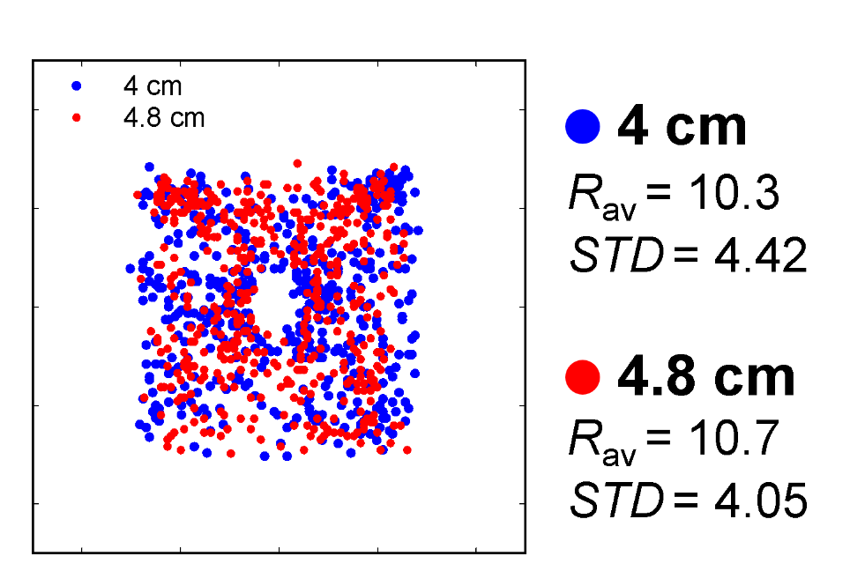
Figure S4. Particle distributions observed in the channel cross-section at two different downstream location from the channel inlet (4 and 4.8 cm) in 500 ppm PEO solution. The flow rate was 6 ml/hr. $R_{av}$ and STD indicate the average distance of the particles from the channel center and its standard deviation, respectively (particle number = 500 for both cases).

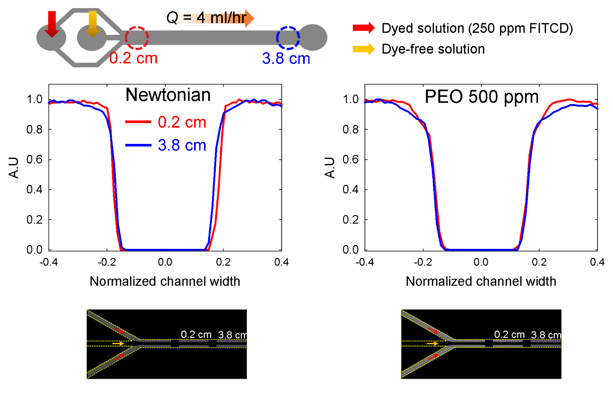
Figure S5. Experimental results for observing the existence of secondary flow using fluorescence dye. The presence of secondary flow was investigated by monitoring whether the dyed and dye-free streams mix. The dyed solution flowed into the side inlets (red arrow) and the dye-free solution flowed into the middle inlet (yellow arrow). At the 0.2-cm (red lines in the graphs) and 3.8-cm downstream locations (blue lines in the graphs) after the two streams merged, the fluorescence intensity was measured across the channel. The intensity distributions were obtained except near each wall owing to the optical interference between the fluid and wall (Hong et al. 2021). From these tests, we can confirm the absence of secondary flow in the Boger fluid at a high flow rate of 4 ml/h.

References
Hong, S.O., Park, K., Kim, D., Lee, S.S., Lee, C. & Kim, J.M. 2021 Gear-shaped micromixer for synthesis of silica particles utilizing inertio-elastic flow instability. Lab Chip 21(3), 513–520.
Masset, L., Bruls, O. & Kerschen, G. 2011. Partition of the circle in cells of equal area and shape. Master thesis. University of Liege.

