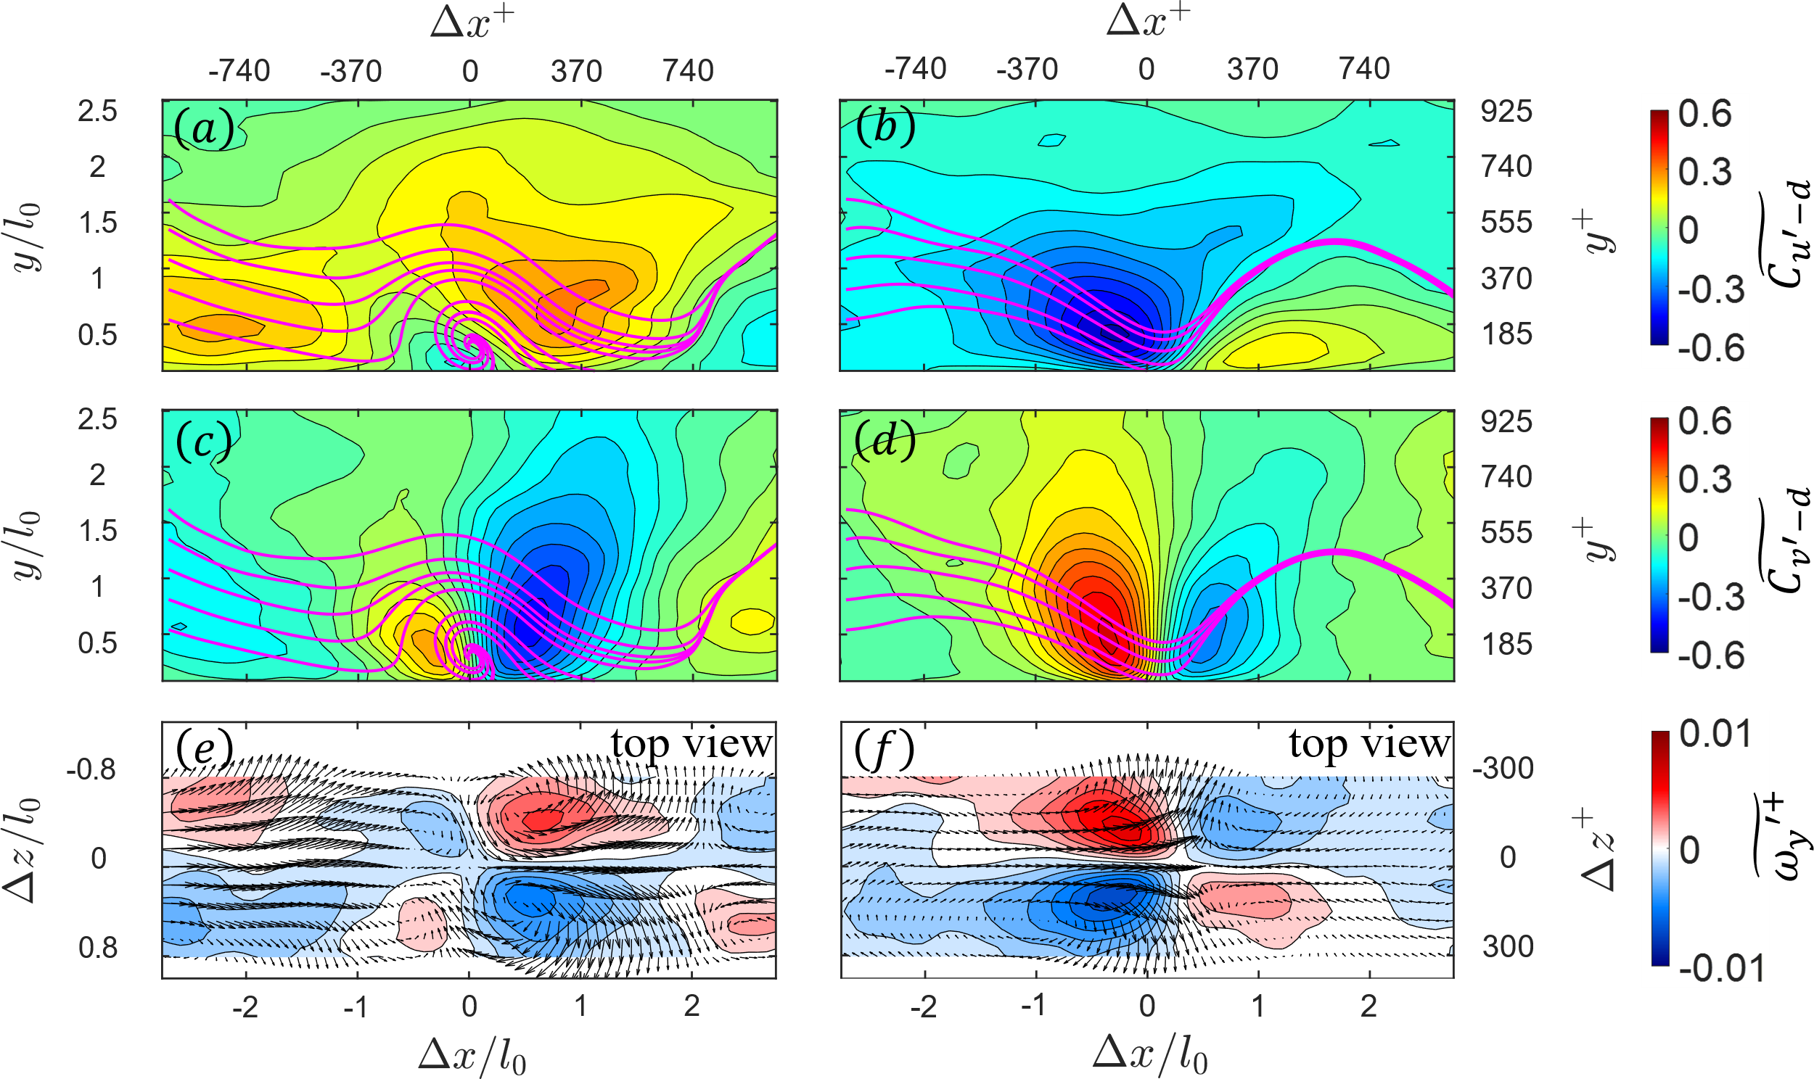
FIGURE S1. Conditional statistics and correlations for a surface bump (left column) and a dimple (right column) at ${Re}_{τ}=3300$: $(a,b)$ $u'-d$ correlation, $\left(c,d\right)$ $v'-d$ correlation, and $(e,f)$ top view of the conditionally averaged ${ω_{y}}^{+}$ and vectors of in-plane velocity components at $y^{+}=120$.

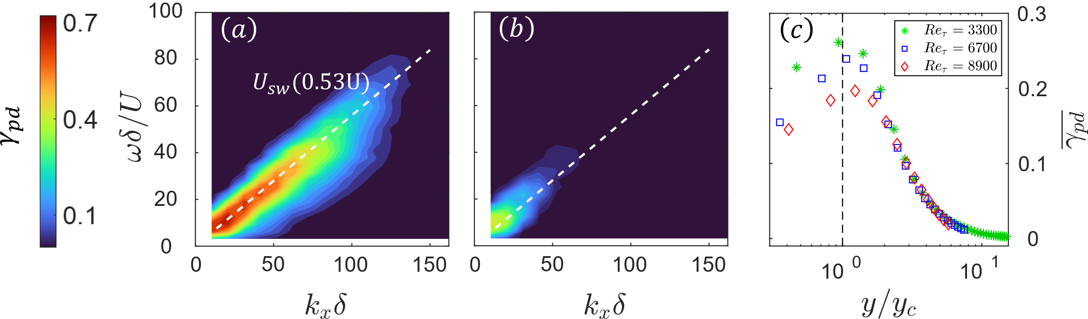
FIGURE S2. Pressure-deformation coherence spectra $γ_{pd}={(E_{pd})}^{2}/(E_{pp}E_{dd})$, where $E_{pd}$, $E_{pp}$ and $E_{dd}$ are the cross and auto spectra of pressure and deformation, respectively. Results are shown for ${Re}_{τ}=3300$ at: $(a)$ $y/δ=0.009$, i.e. $y<y_{c}$, and $\left(b\right) y/δ=0.09$, i.e. $y>y_{c}$. Dashed lines show $U_{sw}$. $(c)$ Wall-normal profiles of average coherence, conditioned on $γ_{pd}≥0.1$.

