Supplementary material: Binary collision dynamics of equal-sized nanodroplets

Yi-Feng Wang^{1,2}, Yi-Bo Wang^{1,2}, Zhi-Hui Cai^{1,2}, Qiang Ma^{1,2}, Yan-Ru Yang^{1,2}, Shao-Fei Zheng^{1,2*}, Duu-Jong Lee^{3,4}, Xiao-Dong Wang^{1,2*}
1. State Key Laboratory of Alternate Electrical Power System with Renewable Energy Sources, North China Electric Power University, Beijing 102206, PR China;
2. Research Center of Engineering Thermophysics, North China Electric Power University, Beijing 102206, PR China;
3. Department of Mechanical Engineering, City University of Hong Kong, Kowloon Tong 999077, Hong Kong;
4. Department of Chemical Engineering & Materials Science, Yuan Ze University, Chung-Li 32003, Taiwan.

Content:
This supplementary material includes (1) the statement proving that the investigation of the collision dynamics is independent of the choice of potentials in MD simulations when using the dimensionless number group, (2) a supplementary table and supplementary figures, i.e., Table S1 and Figs. S1-S8, and (3) a reference list for this supplementary material.

The statement proving that the investigation of the collision dynamics is independent of the choice of potentials in MD simulations when using the dimensionless number group
Here, the problem of the choice of potential models is discussed in detail. To save computational cost, a relatively simple coarse-grained mW water model is chosen in this study. The viscosity predicted by the mW water model is only one-third of the viscosity of real water, so mW water can be considered “pseudo” water or an artificial liquid. However, the choice of this potential does not affect the revelation of collision dynamics. This is because, for the binary collision dynamics of equal-sized droplets at the nanoscale, when the values of the dimensionless parameter group (We, Oh, and B) remain constant, the collision dynamics is uniquely determined, regardless of the choice of liquids. Since nanoscale experiments are currently very difficult to conduct, MD simulations have become a primary research tool. In principle, in MD simulations, by using any liquid and changing the droplet diameter and impact velocity to cover a broad range of We, Oh, and B, the collision dynamics of nanodroplets can be completely revealed. That is, provided that the chosen intermolecular potential considers the most fundamental repulsive and attractive interactions in MD simulations, the general result of collision dynamics can be obtained, while other complex interactions do not affect it (here, it should be noted that this conclusion only applies to normal conditions. In some special conditions, the collision dynamics will depend on other complex interactions. For example, when an external electric field exists, polar liquids will be polarised, so molecules experience additional electric field forces, leading to different collision dynamics compared to non-polar liquids). This conclusion has been confirmed by our MD simulations as follows. In addition to the mW water model, we have also supplemented simulations of a LJ liquid (argon, a non-polar liquid whose potential only contains the fundamental intermolecular repulsive and attractive interactions), the TIP3P water (its viscosity is also one-third of real water, so it can also be regarded as “pseudo” water), and the SPCE water (its density ρ=999 kg m⁻³, surface tension γ=61.3 mN m⁻¹, and viscosity μ=0.722 mPa s at 300 K are close to real water with ρ=996 kg m⁻³, γ=72 mN m⁻¹, and μ=0.851 mPa s, so it can be considered as “real” water), where the physical properties of argon refer to Wang et al. (2022b) and the ones of water models are from Song & Dai (2010) and Pascal & Goddard III (2014). We compared the maximum spreading factors of these four different liquids for head-on collisions and found that no matter it is the simplest LJ liquid, or relatively complex “pseudo” water and “real” water, the results are identical when the dimensionless parameter group takes the same values, as shown in Fig. S1(a-b). This clearly demonstrates that the collision dynamics of nanodroplets does not depend on the choice of liquids or the choice of potential models in MD simulations when using the dimensionless number group. Therefore, although using an artificial liquid, the mW water, the MD results are still physically realistic.
Table S1. Tests of the statistical feature of MD simulations for binary nanodroplet collisions by the maximum spreading factor (β_{max}).
We | β_{max} |  |  |  |  | β_{max,ave} | Relative deviation (%)
 | 1 | 2 | 3 | 4 | 5 |  | 1 | 2 | 3 | 4 | 5
6 | 1.522 | 1.518 | 1.489 | 1.500 | 1.504 | 1.507 | 1.0 | 0.7 | -1.2 | -0.5 | -0.2
24 | 1.928 | 1.919 | 1.938 | 1.945 | 1.930 | 1.932 | -0.2 | -0.7 | -0.3 | -0.7 | -0.1
74 | 3.009 | 3.062 | 3.07 | 3.007 | 3.006 | 3.033 | -0.1 | 0.1 | 1 | 0.1 | 0.1

Figure S1. (a) The comparison of the maximum spreading factor among mW water, TIP3P water, and argon at Oh=0.49 and B=0; (b) the comparison of the maximum spreading factor between TIP3P water and SPCE water at Oh=0.69 and B=0. The physical properties relating to collision dynamics are ρ=996 kg m⁻³, γ=66 mN m⁻¹, and μ=0.2837 mPa s for the mW water, ρ=997 kg m⁻³, γ=52 mN m⁻¹, and μ=0.316 mPa s for TIP3P water, and ρ=999 kg m⁻³, γ=61.3 mN m⁻¹, and μ=0.722 mPa s for SPCE water, according to Molinero & Moore (2009), Pascal & Goddard (2014), and Song & Dai (2010); the potential and properties of argon can be referred to Wang et al. (2022b). In Fig. S1(a), to ensure the same Ohnesorge number of 0.49, the diameter of mW water nanodroplets is 5 nm, the diameter of TIP3P water nanodroplets is 8 nm, the diameter of argon nanodroplets is 5.2 nm. Here, it should be noted that the reason why SPCE water is not directly compared with mW water and argon is the huge computational cost. Because the difference in properties between mW water (or argon) and SPCE water is large, to achieve the same Oh at 0.49, the diameter of SPCE droplets should be adjusted to 35 nm, leading to 750, 000 water molecules (2, 250, 000 atoms) that can result in huge computational costs. Considering that the properties of SPCE water are relatively close to those of TIP3P water, the comparison between the TIP3P and SPCE water models is implemented in Fig. S1(b). When choosing a relatively small diameter of TIP3P water at 4 nm, Oh is 0.69. To achieve this Oh, the diameter of the SPCE water only needs to be 17.7 nm, so only 97, 000 molecules (291, 000 atoms) are needed to be calculated. This computational cost is achievable. Therefore, only the comparison between TIP3P and SPCE water is implemented in Fig. S1(b). Since the mW water model has been validated by the TIP3P water model, the comparison between the TIP3P and SPCE water models can be considered an indirect comparison between the mW and SPCE water models. Figure S1(a) shows good agreement among the three models with the maximum relative derivation of 4.3% compared with the data of TIP3P water; also, Figure S1(b) exhibits good agreement between the TIP3P and SPCE water models with the maximum relative derivation of 4.2% compared with the data of TIP3P water.
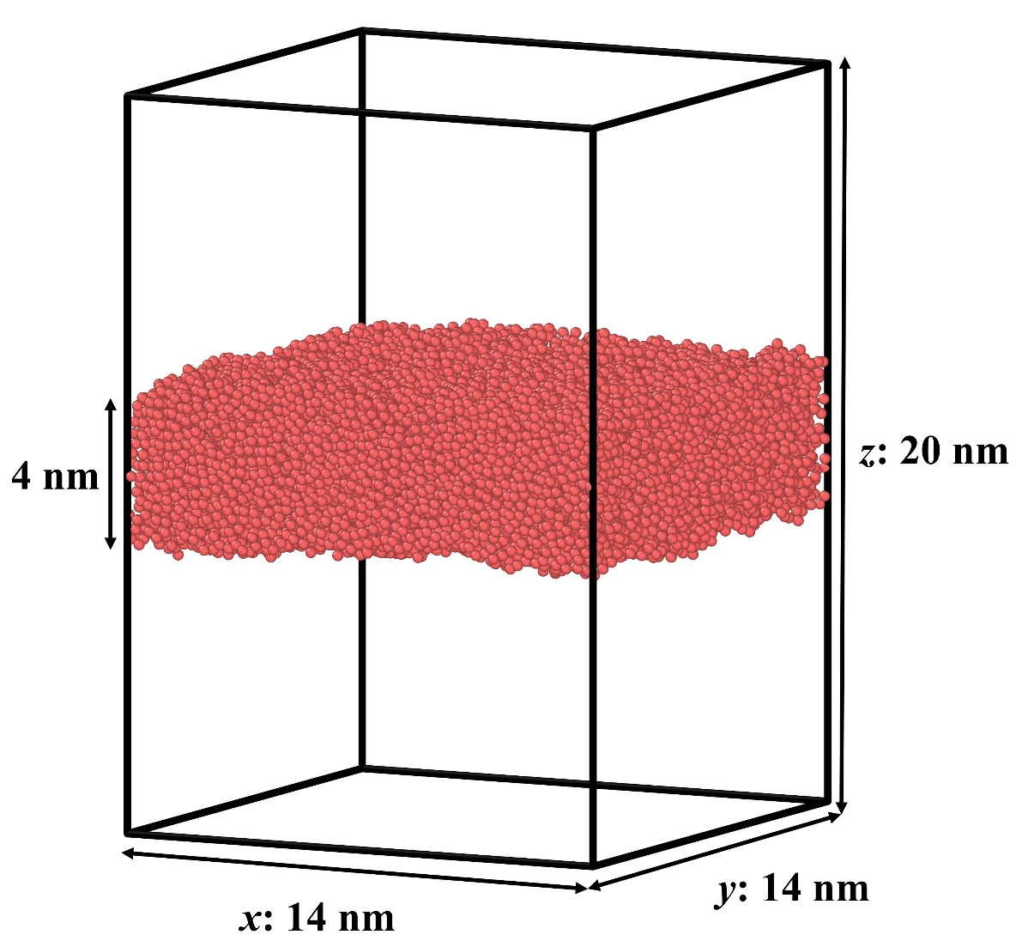
Figure S2. The system for calculating the surface tension of mW water. The calculation is based on the Kirkwood-Buff theory (Kirkwood & Buff 1949), expressed as 1/2L_{N}[<p_{N}>-<p_{T}>]. The eventual result in this work is γ=0.0659 mN m⁻¹ that is the same as the result from Molinero & Moore (2009).

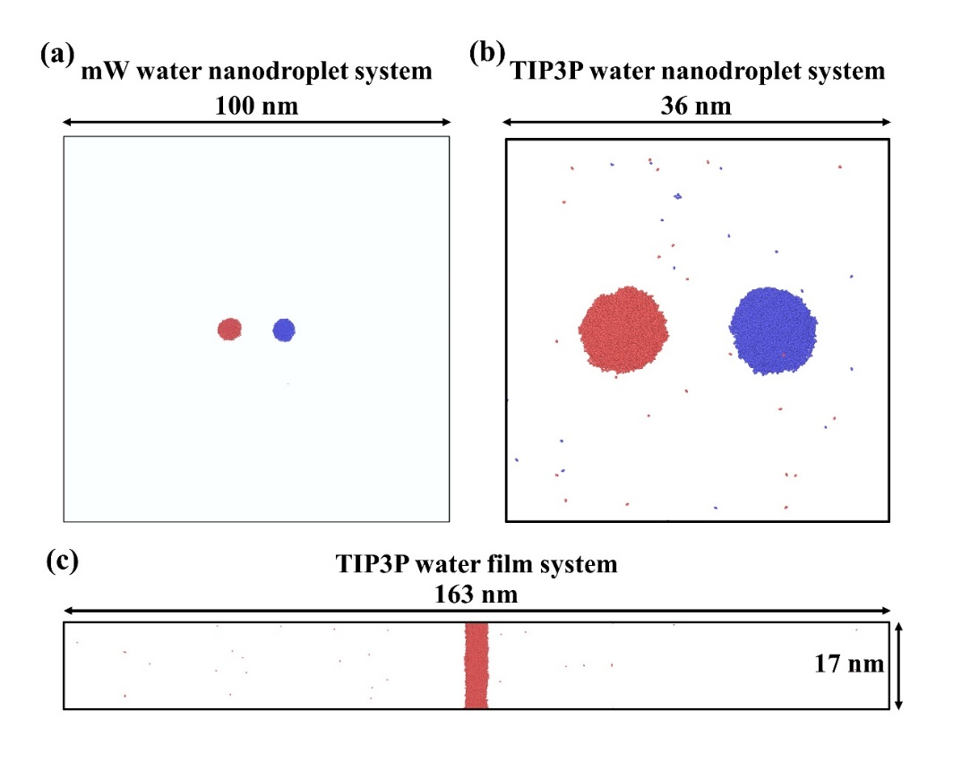
Figure S3. (a-c) Snapshots at the end of the equilibrium process for (a) the mW water system containing 6-nm nanodroplets in 100×100×100=10⁶ nm³ domain, (b) the TIP3P water system containing 8-nm nanodroplets in 36×36×36≈4.7×10⁴ nm³ domain, and (c) the TIP3P water film system in 163×17×17≈4.7×10⁴ nm³ domain. (d) The comparison of β_{max} between the results of the mW water systems with and without additional gas molecules. Here, the TIP3P water model is a water model that can reasonably reproduce the vapour pressure of real water in experiments compared with other popular water models (such as SPC, SPCE, and TIP5P) (Vega & Abascal 2011). The number of vapour molecules ranges from 2 to 3 in system (a), from 45 to 48 in system (b), and from 38 to 40 in system (c), where the reason for the larger number in system (b) compared with the one in system (c) is the Kelvin effect. It is found that, although the volume of the vapour space in system (a) is larger than the ones in systems (b-c), and the liquid-gas interface has a larger curvature (that can result in a stronger Kelvin effect) in system (a) compared with the ones in systems (b-c), the vapour molecules in system (a) are still significantly lower than the ones in systems (b-c). Therefore, the saturated vapour pressure is significantly underestimated by the mW water model, and the gas space can be treated as a vacuum. However, the underestimation of saturated vapour pressure by the mW water model does not affect the investigation of the collision dynamics, because even if the gas pressure is increased to the saturated vapour pressure of water in experiments, the effect of low gas pressures is weak and negligible for the collision dynamics of nanodroplets. To prove this, another mW water system filled with gas molecules (argon) that create a gas pressure of 3.5 kPa (the value of saturated vapour pressure for water at 300 K) is considered. The comparison of β_{max} between the results of the mW water systems with and without additional gas molecules is shown in Fig. S3(d). Good agreement between them is found with a maximum relative derivation of 2.7%, and therefore, the underestimation of saturated vapour pressure by the mW water model does not affect the investigation of collision dynamics.

Figure S4. The number ratio of evaporated molecules during collisions to the initial molecules of droplets before collisions. Here, the ratios are extracted from the same cases exhibited in Fig. S1(a) at We=25.

Figure S5. The values of 12-6 Lennard-Jones potential with respect to r. When the distance between atoms is long enough, the corresponding potential value is close to zero, which does not affect the results of MD simulations. To save computational costs from negligible interactions, the cut-off distance is used. Here, the values of 12-6 Lennard-Jones potential for both water-Ar and Ar-Ar interactions have attained zero when r=1 nm. As a result, the used cut-off distance of 1 nm is long enough.

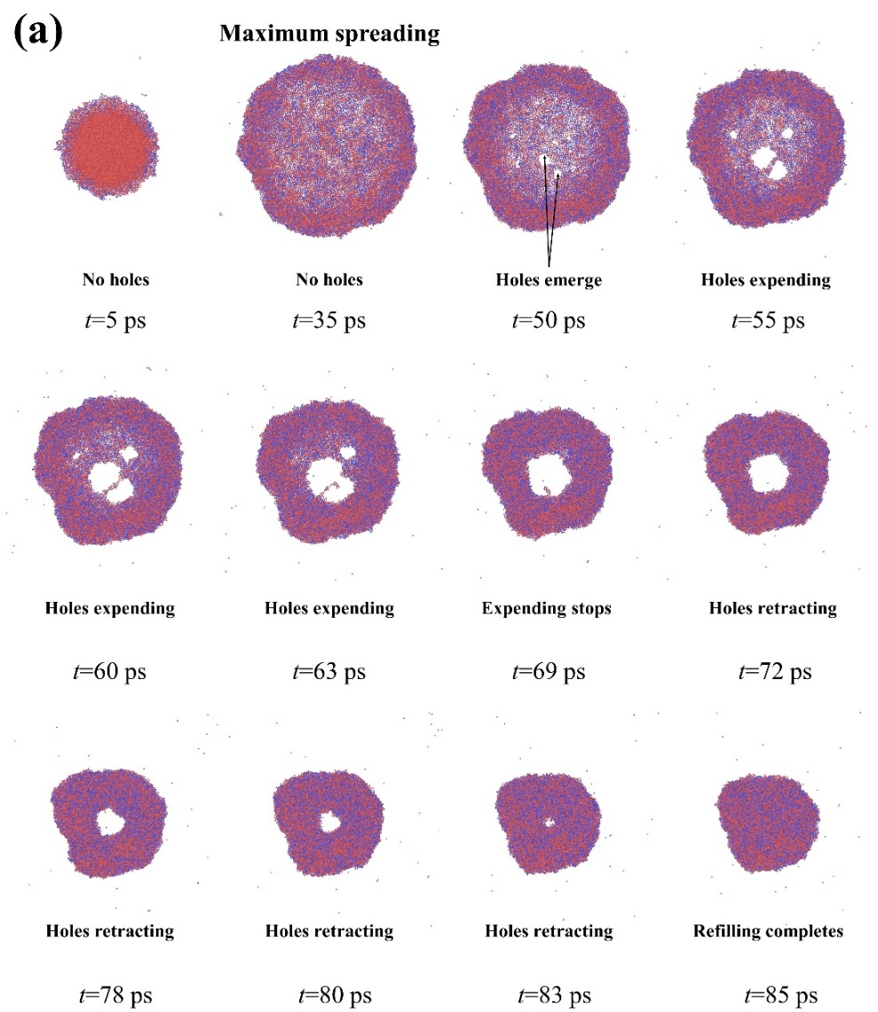
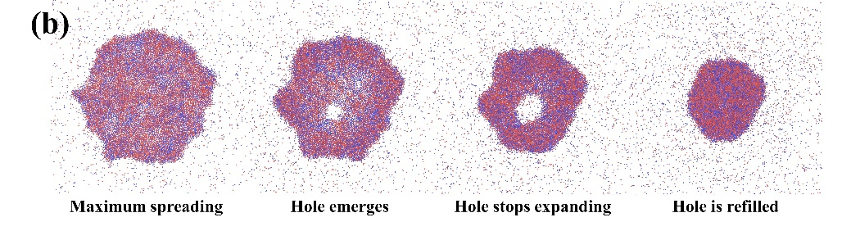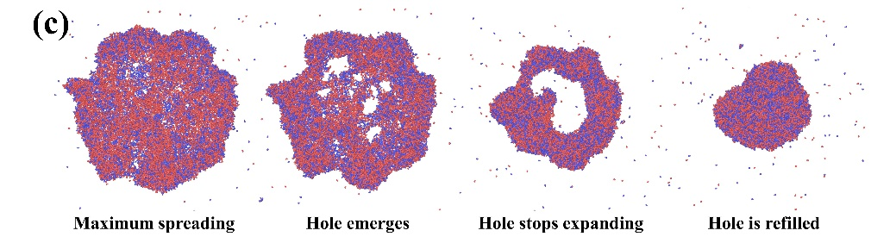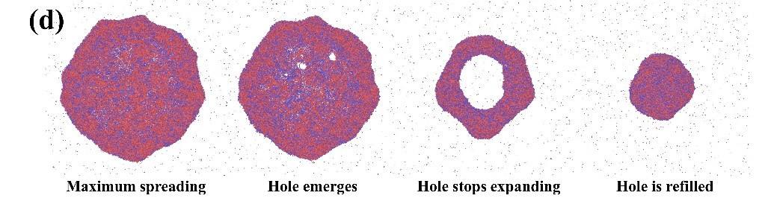
Figure S6. (a) Side-view snapshots of head-on collisions of mW nanodroplets in the collision direction at We=64. (b-d) Hole-refilling during head-on collisions of (b) argon nanodroplets at Oh=0.49 and We=81, (c) TIP3P nanodroplets at Oh=0.49 and We=119, and (d) SPCE nanodroplets at Oh=0.69 and We=167. (e-f) Sliced snapshots near the beginning of forming holes at We=(e) 74 and (f) 109, which are supplementary snapshots for Fig. 4(c-d). Because when the thickness of the peripheric rim is larger than the one at the centre of liquid films, only the outline of the rim can be seen in the front view, these sliced snapshots are supplemented to show the thickness of both the rim and the centre of liquid films, for discussing the hole-refilling mechanism. As shown in Fig. S6(e), when the holes emerge, the retracting rim has formed and grown up with considerable thickness so that it can stop the expanding of the holes and then trigger the refilling process. However, as shown in Fig. S6(f), almost no significant rim forms as the holes are generated, i.e., the expanding of the holes cannot be stopped, and eventually, the merged nanodroplet shatters (completely breaks up).

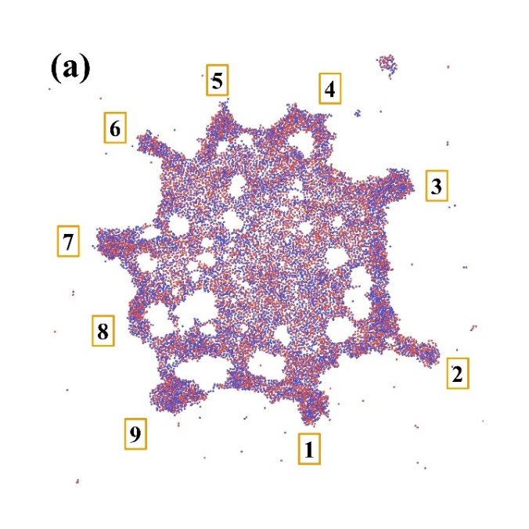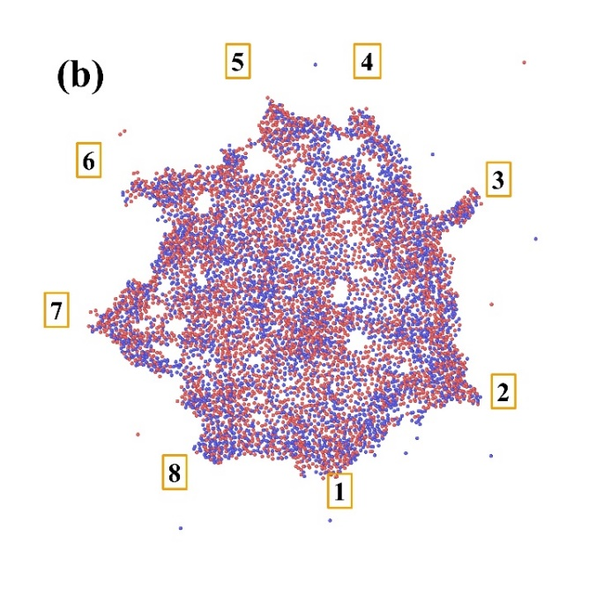
Figure S7. The comparisons between the theoretical numbers of generated fingers (N=[kρ/(12γ)]^{1/2}D₀β_{max}, where k=V₀²/D₀) and the simulation ones. (a) D₀=8 nm, V₀=950 m s⁻¹, and β_{max}≈3, leading to theoretical N=9, and (b) D₀=6 nm, V₀=1000 m s⁻¹, and β_{max}≈2.8, resulting in theoretical N=7.7. Both of the presented results are consistent with the Rayleigh-Taylor theory.

Figure S8. The data of the phase diagram from Yin et al. (2021) for TIP4P water with an Oh range from 0.53 to 0.63, where the physical properties of TIP4P water are from Vega & De Miguel (2007) and Markesteijn et al. (2012). Here, C=9 is the optimal value that can satisfactorily fit the boundary between Regimes CO and SS in a wide range of We from 10 to 120. Therefore, the data point of C=9 at Oh=0.58 is added in Fig. 6(e) for comparison.

References for this supplementary material:
KIRKWOOD, J. G. & BUFF, F. P. 1949 The statistical mechanical theory of surface tension. J. Chem. Phys. 17, 338-343.
MARKESTEIJN, A. P., HARTKAMP, R., LUDING, S. & WESTERWEEL, J. 2012 A comparison of the value of viscosity for several water models using Poiseuille flow in a nano-channel. J. Chem. Phys. 136, 134104.
MOLINERO, V. & MOORE, E.B. 2009 Water modeled as an intermediate element between carbon and silicon. J. Phys. Chem. B 113, 4008-4016.
PASCAL, T.A. & GODDARD, III W.A. 2014 Interfacial thermodynamics of water and six other liquid solvents. J. Phys. Chem. B 118, 5943-5956.
SONG, Y. & DAI, L.L. 2010 The shear viscosities of common water models by non-equilibrium molecular dynamics simulations. Mol. Simulat. 36, 560-567.
VEGA, C. & ABASCAL, J. L. 2011 Simulating water with rigid non-polarizable models: a general perspective. Phys. Chem. Chem. Phys. 13, 19663-19688.
VEGA, C. & DE MIGUEL, E. 2007 Surface tension of the most popular models of water by using the test-area simulation method. J. Chem. Phys. 126, 154707.
WANG, Y.-F., WANG, Y.-B., HE, X., ZHANG, B.-X., YANG, Y.-R., WANG, X.-D. & LEE, D.-J. 2022b Scaling laws of the maximum spreading factor for impact of nanodroplets on solid surfaces. J. Fluid Mech. 937, A12.
YIN, Z., SU, R., ZHANG, W., ZHANG, C., XU, H., HU, H., ZHANG, Z., HUANG, B. & LIU, F. 2021 Binary collisions of equal-sized water nanodroplets: Molecular dynamics simulations. Comp. Mater. Sci. 200, 110774.

