The Extent of the Market for Early American Banknotes
Online appendices (not for publication)

Howard Bodenhorn
Professor, John E. Walker Department of Economics, Wilbur O. and Ann Powers College of Business, Clemson University, 225 Walter T. Cox Blvd, Clemson, SC 29634 and National Bureau of Economic Research, 1050 Massachusetts Ave, Cambridge, MA 02138. E-mail: bodnhrn@clemson.edu.

Appendix 1: Comparisons of reporting and non-reporting banks and selection in reporting 1842 interbank statistics
Table 1A reports the dollar value of several common balance sheet entries from Pennsylvania banks that complied fully with the legislative request for information on interbank balances and notes of other banks held in March 1842. Each item is in current dollars and a two-tailed t-statistic for a test of differences of means follows the columns reporting averages for Philadelphia and country banks. The only significant difference is that between the DUE TO OTHER BANKS value for reporting and non-reporting country banks, although the difference is significant at only the 10 percent level.

Table 1A
Comparison of reporting and nonreporting Pennsylvania banks, 1842
 | Philadelphia banks |  | t statistic | Country banks |  | t-statistic
Measure ($) | Reporting | Nonreporting |  | Reporting | Nonreporting
LIABILITIES
Capital | 1072000 | 667619 | 1.04 | 255584 | 230820 | 0.29
Circulation | 159714 | 207757 | 0.52 | 102183 | 124290 | 0.78
Deposits | 338199 | 416527 | 0.38 | 78791 | 54453 | 0.85
Due to other banks | 114407 | 124569 | 0.13 | 2916 | 6179 | 1.76*
ASSETS
Loans | 758952 | 614849 | 0.54 | 262565 | 256964 | 0.1
Due from other banks | 486091 | 327004 | 0.63 | 25392 | 14653 | 0.99
Notes of other banks | 105685 | 97302 | 0.18 | 10519 | 12475 | 0.27
Total assets | 1899388 | 1591896 | 0.41 | 462917 | 452926 | 0.08
Observations | 5 | 8 |  | 12 | 21
Notes: *p<0.10
Sources: Author's calculations from Weber (2018).

Sample selection is a common problem in economics, one that arises when the econometrician does not observe a random sample of the population of interest (Heckman 1979, Winship and Mare 1992). If observations enter the sample when they are not independent of the outcome variables in a study, statistical analysis may lead to biased inferences.

Table 1B
Selection on observables
 | (1) | (2) | (3)
VARIABLES | Summary | Marginal | Marginal
Bank reported | 0.35
 | (0.48)
Loans / 100000 | 7.51 | 0.004
 | (9.95) | (0.018)
Circulation / 100000 | 2.24 | -0.028
 | (1.71) | (0.039)
Due from / 100000 | 1.05 | 0.004
 | (1.82) | (0.030)
Due to / 100000 | 1.16 | -0.062*
 | (2.46) | (0.037)
Notes of others / 100000 | 0.86 | 0.007
 | (1.58) | (0.043)
Assets / 100000 | 11.18 | 0.007
 | (14.67) | (0.015)
Philadelphia | 0.32 | -0.005 | -0.063
 | (0.47) | (0.179) | (0.167)
Loans / assets | 0.67 |  | 0.591
 | (0.13) |  | (0.453)
Circulation / reserves | 4.78 |  | -0.054***
 | (3.95) |  | (0.015)
Due from / assets | 0.1 |  | 0.385
 | (0.09) |  | (0.565)
Due to / assets | 0.06 |  | -1.130
 | (0.07) |  | (0.696)
Notes of others / assets | 0.06 |  | 0.359
 | (0.06) |  | (0.826)
Wald chi2 |  | 4.95 | 16.88***
Pseudo R-sq |  | 0.02 | 0.08
Observations |  | 455 | 454
Notes: Standard errors clustered on bank. ***p<0.01, **p<0.05.
Sources: Author's calculations from data in Weber (2018).

Appendix Table 1B reports the results of two probit regressions of whether a bank responded to the call for a detailed report (equals 1 if yes, zero otherwise) on a set of observable balance sheet ratios. The sample includes information for the ten years (1832-1841) prior to the report. The longer sample captures long-run bank features rather than potential responses to temporary, idiosyncratic shocks. The estimation period spans the years of crisis and recession between 1837 and 1841 so half of the sample includes data drawn from atypical macroeconomic conditions.
Column 2 of Table 2B reports marginal effects when common measures of bank size enter in real dollar terms. Banks with more notes in CIRCULATION, Philadelphia banks, and banks that held larger interbank accounts were less likely to report the detailed accounts requested by the Auditor General. The remaining coefficients imply that bank with more loan outstanding, banks that hold more in accounts at other banks, hold more notes of other banks, and have more total assets are more likely to enter the sample. The only significant coefficient, however, is on the DUE TO OTHER BANKS variable, but it is marginally significant (p<0.10).
Column 3 reports marginal effects when the same variables are measured as ratios commonly encountered in the literature. Philadelphia banks and more leveraged banks – higher CIRCULATION/RESERVES and DUE TO OTHER BANKS/ASSETS – were less likely to report the detailed accounts requested by the Auditor General. Banks with higher assets / total assets were more likely to report. But only one coefficient is statistically significant. There is, therefore, limited evidence that the sample is selected on observables.

Appendix 2: Distribution of banknotes held by Pennsylvania banks of other banks, 1842 – 1850

Figure 2A provides a histogram of the non-zero values of banknotes of other banks held by the Pennsylvania banks that reported in 1842 and the Columbia Bank & Bridge Company in 1849 and 1850. The histogram excludes the zeros, which account for more than 75 percent of the observations. And the upper bound is limited to $250 in other banknotes. The upper limit in the data is $34,620, which is the balance of one Philadelphia bank against another. The resulting histogram reports values that lay between the 75th and 97th percentiles of the distribution. The value of other notes declines rapidly and nonlinearly and follows a pattern consistent with Brockmann, David and Gallardo’s (2009) power law model of modern banknote dispersal.

Figure 2A
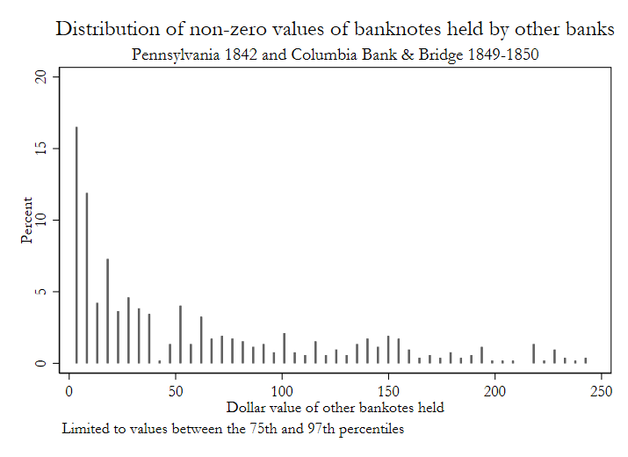

Figure 2B plots a log-log graph of banknotes held versus miles traveled, which is comparable to the plot in Brockmann et al. (2009) that they use to understand patterns of human travel. They plot time versus number of banknotes, but the data here can be interpreted similarly because Gorton (1989) shows that the correlation between travel time and distance is about 0.9 and statistically significant. Using the dispersal of modern banknotes, they find patterns that they interpret as dispersals (circulation) within small clusters or geographic space that are sometimes interrupted by long leaps followed by dispersals within another small clusters, and so on. See Figure 3 in Brockmann et al. (2009, p. 8) for a mapping of the clusters and leaps. Because I observe banknote values only once, I cannot determine whether antebellum banknotes follow the cluster-leap-cluster pattern they identify.

Figure 2B
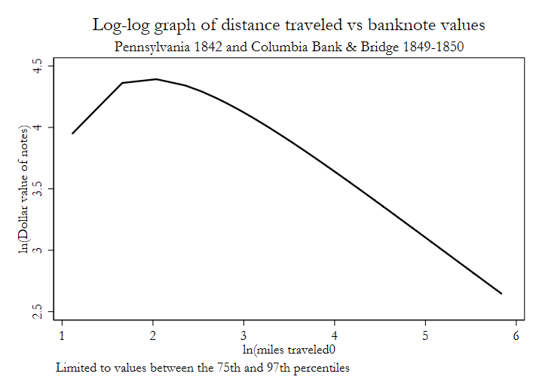

Appendix 3: Robustness analysis

In Table 3A, I report coefficient estimates from four separate zero-inflated negative binomial models designed to test the robustness of the main specifications to alternative definitions of DUE TO BANKS and DUE FROM BANKS reported in Table 2, using the same definitions of the other independent variables as in Table 2. In the sake of space, I do not report the corresponding Logit regressions estimated in the zero-inflated negative binomial models. The dependent variable in each is treated as count data and is the dollar value of notes held by one of the reporting banks. Significant ln(alpha) statistics imply that the zero-inflated negative binomial is preferred to the zero-inflated Poisson. As in Table 2, the models are estimated using a quadratic in miles. Unreported regressions that include a cubic or quartic polynomial in miles do not change the results; the cubic term was significant in some regressions, and the quartic term was not significant in any. The inclusion of the cubic in miles does not alter the predicted values presented in Figure 3A in any meaningful way. There is a 20 percent probability of observing zero notes within five miles and 95 percent probability of holding zero notes at 200 miles.
The remaining columns of Table 3 report coefficient estimates using alternative measures of correspondent relationships between issuing banks and reporting banks. All other independent variables are the same as in Table 2. Column (1) uses a single dummy variable to capture whether there is any correspondent relationship between issuing and reporting banks. A correspondent relationship exists if either the DUE TO or DUE FROM, or both, take on non-zero values. The incidence rate ratio in Column (1) on the DUE TO / FROM (0/1) coefficient implies that a correspondent relationship between two banks increases the dollar value of banknotes held by a factor of 1.10. The estimated effect of the dummy variable in the logit model points to a small and insignificant effect. It is likely that combining the two types of accounts creates a noisy measure of interbank relationships, which would explain why the estimated effect of the measure on the number of banknotes held is approximately one half of the value of the separate dummy variable coefficients reported in Table 2 in the main text.
Column (2) uses the dollar value of interbank balances as measures of the extent of interbank relationships on holding notes of another bank, using the same additional confounders as in Table 2 in the main text. An extra dollar held in a DUE TO account reduced the odds of observing zero dollars and increases the dollar value of banknotes of other banks held by a factor of 1.14. An extra dollar DUE FROM another bank has no meaningful effect on the odds of zero notes, though it points to a reduction in the odds, or the dollar value of notes held.
Columns (3) and (4) report estimated incidence rate ratios using the same DUE TO and DUE FROM dummy-variable models using the same variables as in Table 2 in the main text, except the sample is divided between five banks located inside and thirteen banks located outside Philadelphia’s central financial district. The Bank of Germantown was in Philadelphia County, but outside the then city limits and about six miles from the central financial district. Probably because it was outside center city, it held just $2,800 in aggregate interbank accounts in 1842, compared to an average of $272,800 for the five reporting banks in center city so it is treated as a country bank in the analysis (Weber 2018).
The constant terms in Columns (3) and (4) reveal that the Philadelphia banks held a baseline value of $1,588 in other banks notes compared to just $302 held by the country banks. When a Philadelphia bank owed another bank (DUE TO) a positive value, the value of notes of the issuing bank increased by a factor of 3.42. When a country bank owed another bank a positive value, the reported value of notes increased by a factor of 1.85. Differences in the coefficients on the interbank relationship measures between Philadelphia and country banks point to Philadelphia’s centrality in the regional payments system (Weber 2003). Yet, banks in regional market centers, especially those located on a waterway – Pittsburgh, Columbia and Easton, among others – played important roles in the system, as well. They redeemed and cleared notes moving through their towns.
My analysis of the 1842 Pennsylvania bank data reveal how the clearing of one type of privately issued debt relied on and was facilitated by available transportation and communication systems. Trade between the periphery and the metropolis moved along canals and waterways and debt instruments of various kinds – banknotes, bank drafts, inland bills of exchange, and so on – moved with the traded goods and people who moved them. Banks in the periphery developed correspondent relationships with banks in the center to redeem and return their notes, which gave those notes circulation. As the payments system literature posits, spatial separation is a fundamental factor underlying the structure of the payments system at a point in time, and systems arise to reduce the costs of transferring resources across space. This is one of the first studies to document the extent of the market – the extent of the spatial separation – for a vital early American debt instrument.

Table 3A
Determinants of banknotes held by Pennsylvania banks
Alternative specifications -- robustness analysis
 | (1) | (2) | (3) | (4)
VARIABLES | Due combined | Due values | Philadelphia | Country banks
Miles | 0.968*** | 0.966*** | 0.964*** | 0.977***
 | (0.004) | (0.003) | (0.011) | (0.004)
Miles squared | 1.000*** | 1.000*** | 1.000** | 1.000***
 | (0.000) | (0.000) | (0.000) | (0.000)
Circulation | 1.213*** | 1.216*** | 1.169** | 1.229***
 | (0.049) | (0.050) | (0.088) | (0.044)
Any correspondent | 1.104***
 | (0.030)
Due to bank ($) |  | 1.142***
 |  | (0.030)
Due from bank ($) |  | 0.982
 |  | (0.035)
Due to bank (0/1) |  |  | 3.416*** | 1.876***
 |  |  | (1.353) | (0.367)
Due from bank (0/1) |  |  | 2.288* | 1.889***
 |  |  | (1.071) | (0.359)
Counterfeits | 0.947*** | 0.945*** | 0.912*** | 0.952***
 | (0.015) | (0.015) | (0.027) | (0.012)
Bank age | 1.004 | 1.005 | 1.017 | 1.002
 | (0.009) | (0.009) | (0.023) | (0.007)
Banknote discount | 1.032*** | 1.033*** | 0.990 | 1.033***
 | (0.011) | (0.011) | (0.024) | (0.011)
Constant | 489.128*** | 539.051*** | 1,588.005*** | 291.661***
 | (167.498) | (178.828) | (1,028.992) | (80.475)
ln(alpha) | 2.641*** | 2.409*** | 2.941*** | 1.705***
 | (0.441) | (0.295) | (0.418) | (0.175)
Observations | 4,527 | 4,527 | 1,235 | 3,292
Notes: Zero-inflated negative binomial estimates of incidence rate ratios. *** p<0.01 ** p<0.05 * p<0.10.
Sources: Author's calculations from data reported in Pennsylvania Auditor General (1843, 1850, 1851).

Figure 3A presents the predicted probabilities of one of the 18 reporting banks recording zero notes issued by one of the other banks in the seven-state sample. These predictions are derived using a cubic in miles in the negative binomial and logit regressions. Otherwise, the independent variables included in the regressions are the same as those reported in Column (5) and (6) of Table 2 in the main text. The predictions are comparable to the ones reported in Figure 3 in the text. There is a 20 percent probability of observing zero notes from issuing banks located within five miles of the reporting banks. There is a 95 percent probability of observing zero notes at about 200 miles.

Figure 3A
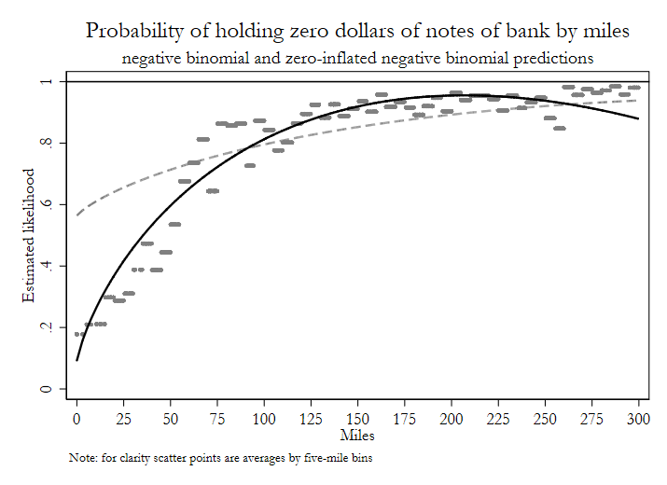
Notes: Estimated probability of observing zero notes of other banks held by the reporting bank by miles separating the issuing and reporting banks.
Sources: Author’s calculations from data reported in Pennsylvania Auditor General (1843, 1850, 1851).

In Figure 3B, I report the probability that a redeeming bank holds $25 worth of banknotes issued by another bank, predicted from the specifications reported in Columns (5) and (6) in Table 2 in the main text. The $25 value represents the 90th percentile of banknotes held. The interpretation of the results using this approach is the same as using $0 as the relevant criterion. The probability of observing $25 is 0.03% or less at 25 miles of less. At 200 miles the probability falls to 0.005%. Thus, we can conclude that the likelihood that a bank 200 miles removed from another randomly selected bank assigns a near-zero probability that they will encounter one of that bank’s notes.
Figure 3B
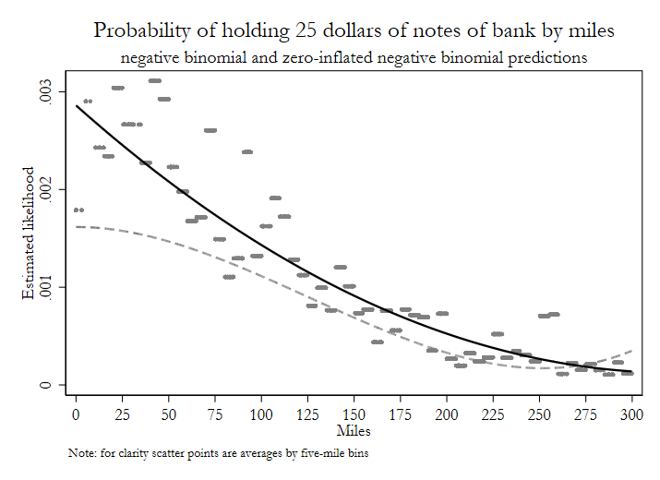
Notes: Estimated probability of observing $25 in value of banknotes of other banks held by the reporting bank by miles separating the issuing and reporting banks.
Sources: Author’s calculations from data reported in Pennsylvania Auditor General (1843, 1850, 1851).

Appendix 4: The market for banknotes in 1840s Philadelphia

Figure 4A

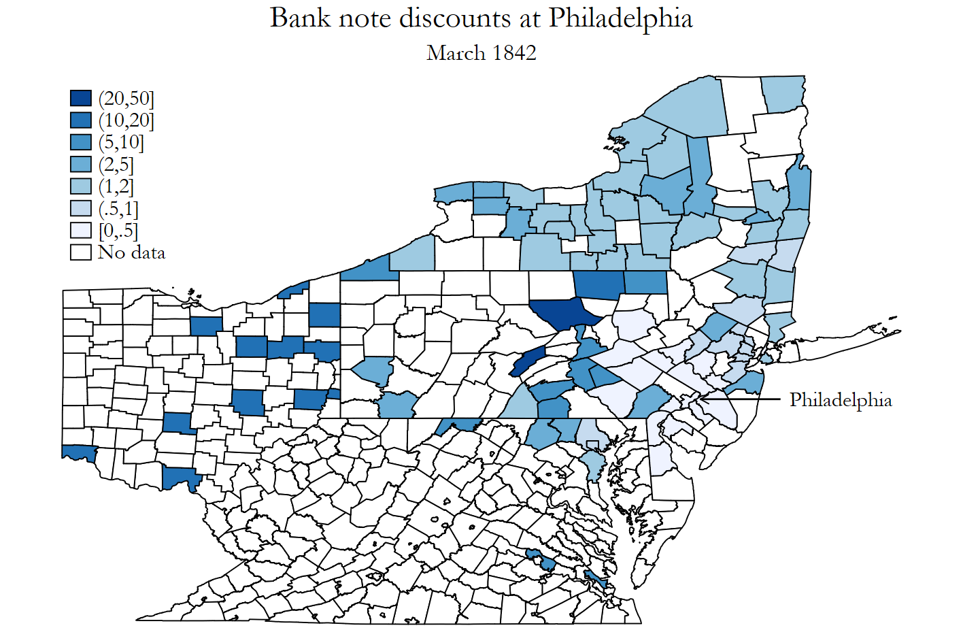

Figure 4A plots market-based discounts from face value of 220 banks in Pennsylvania and six contiguous states reported in Bicknell (March 19, 1842). The darker the shading the greater the discount. The map highlights several important features of mid-nineteenth century banking. First, banks were not widely or evenly distributed across the Mid-Atlantic region. In the early 1840s, every state except New York required prospective bankers to obtain a charter granted by the legislature and many such grants were driven by whether a majority of the legislature was pro- or anti-bank, the state’s current fiscal condition, and the prospective banker’s rent-seeking abilities (Hammond 1957, Sylla, Legler and Wallis 1987, Bodenhorn 2019). Second, discounts increased in distance between bank and broker, though the discounts did not increase monotonically in distance. Quoted discounts for notes issued by banks at Lewistown and Williamsport in central Pennsylvania (50%) exceeded quoted discounts for notes of banks in Rochester, New York (2%) or Cincinnati, Ohio (12.5%). A third feature, which is not evident from the map, is that banknote discounts were not necessarily symmetric. The discount on the notes of a Pittsburgh bank in Philadelphia, for example, differed from the discount of a Philadelphia bank in Pittsburgh (Ales et al 2008). Discounts reflect in part regional trade imbalances, which influences the demand for monies issued in spatially separated markets linked through trade (Knodell 1988).
Several scholars estimate OLS models of note prices on bank leverage ratios, travel costs or travel time (or spatial separation) between issuing banks and a secondary market in which their notes trade, and macroeconomic factors, but this is the first to investigate the extent of that spatial separation. The results are not always consistent with expectations. Discounts increase in distance using some samples, but not others (Jaremski 2011). Haupert (1994), in fact, finds a negative association. And correlations between bank riskiness and discounts are not consistent across studies, but this may be due to authors measuring risk in different ways. One point of concern across all studies is that we have no sense of the quantities involved. If distant notes are rarely or never traded in a local market, it is not clear what prices mean or how price discovery occurs. This is the first study to document distances over which banknotes moved prior to redemption.
Figure 4B provides a histogram of banknote discounts of banks in New York State (excluding New York City) in March 1842 and March 1850. The histogram reveals that there is little variation in banknote discounts despite individual banks being different distances (or travel times) from Philadelphia. Nearly 75 percent of the reported discounts in 1842 are -3.0 percent; nearly 10 percent of discounts are at 0.0 percent. The remainder are banks that failed during the preceding panics of 1837 and 1839. In March 1850, 5 percent of notes are quoted at 0.5 percent discount, about 90 percent are quoted at 0.75 percent discount.
One potential reason for the insignificance of the Discount variable in the zero-inflated negative binomial regressions reported in the paper is that there is very little meaningful variation among New York State bank’s quoted discounts. In March 1850, which is between the reporting dates for the Columbia Bank & Bridge Company, for example, the mean discount is 2.49 and the standard deviation is 8.55. If we drop the three highest discounts among the 110 quotes, the average falls to 1.16 and the standard deviation to 3.08. If the six highest discounts are excluded, the average falls to 0.72 and the standard deviation to 0.12 (two banks are quoted at 0.0 discount and eight at 0.5% discount). Although sample statistics naively calculated using the full sample appears to demonstrate substantial variation around the mean, a deeper dive into the quoted discounts reveal very little variation.
In his bank census data, Weber (2018) reports that the three banks quoted at 50 percent discount failed between March 1841 and February 1844, or between six and nine years prior to the Columbia Bank & Bridge’s 1850 report. By 1850, it seems reasonable to believe that few of these banks’ notes remained in circulation and, prior to the banks’ failures, it seem unlikely that they circulated over a wide enough area that the Columbia Bank would have reported holding any of them.

Figure 4B
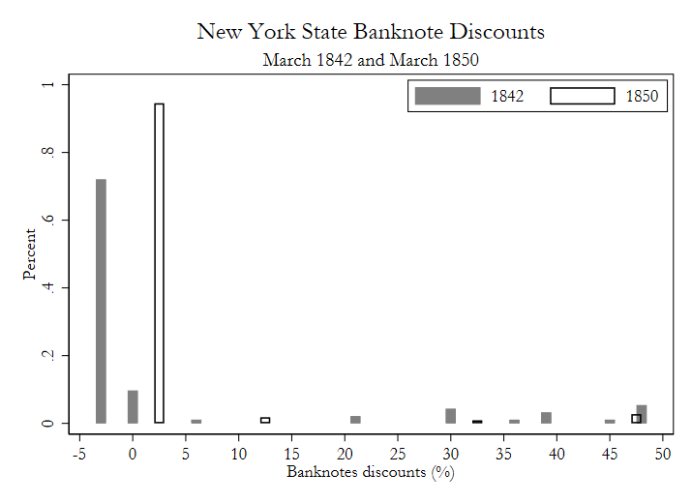
Finally, the distance between Philadelphia and the location of the six banks is uncorrelated with the probability of these banks’ failures and large discounts.

Appendix 5: Analysis of transactions and miles traveled by banknotes presented at Gorham & Garland in Darien, Connecticut.

The histogram on the left of Figure 5A demonstrates that most of the transactions involved $5 or less. The histogram on the right reveals that Gorham & Garland discounted more notes from New York City and its immediate environs and from Connecticut than elsewhere.

Figure 5A
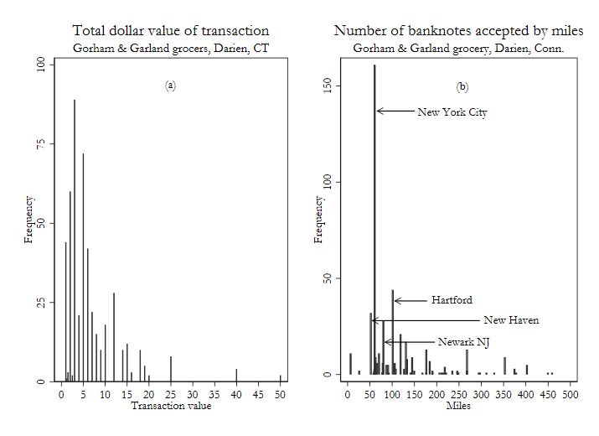
Sources: Author’s calculations from data reported in Gorham Family Records (1824).

References
Ales, Laurence, Francesca Carapella, Pricila Maziero, and Warren E. Weber. “A Model of Banknote Discounts. Journal of Economic Theory 142 (1008), 5-27
Bicknell, Robert. Bicknell’s Counterfeit Detector, Banknote List, and General Prices Current. Philadelphia, March 19, 1842.
Bodenhorn, Howard. “Private Seeking of Private Monopoly in Early American Banking.” In Public Choice Analysis of American Economic History, Vol. 3, edited by Joshua Hall and Marcus Witcher, 167-206. Springer International, 2019.
Brockmann, Dirk, Vincent David, and Alejandro Morales Gallardo. “Human Mobility and Spatial Disease Dynamics.” Reviews of Nonlinear Dynamics and Complexity 2 (2009), 1-24.
Diamond, Douglas W. “Financial Intermediation and Delegated Monitoring.” Review of Economic Studies 51, no. 3 (1984), 393-414.
Diamond, Douglas W. “Reputation Acquisition in Debt Markets.” Journal of Political Economy 97, no. 4 (1989), 828-862.
Gibbons, James S. The Banks of New York: Their Dealers, the Clearing-house and the Panic of 1857. New York: D. Appleton & Company, 1859.
Gorham Family Records. Bank Notes Accepted. (1824) Records of General Stores in Connecticut and Rhode Island, 1809-1852. Baker Library Special Collections, Harvard Business School. Mss: 77 c1824-40 G668 v.1.
Gorton, Gary. “Ante Bellum Transportation Indices.” Working Paper, The Wharton School, University of Pennsylvania, 1989.
Gorton, Gary. “Reputation Formation in Early Bank Note Markets.” Journal of Political Economy 104, no. 2 (1996), 346-397.
Hammond, Bray. Banks and Politics in America from the Revolution to the Civil War. Princeton: Princeton University Press, 1957.
Haupert, Michael. “New York Free Banks and the Role of Reputations.” American Economist 38, no. 2 (1994), 66-77.
Heckman, James J. “Selection Bias as a Specification Error.” Econometrica 47, no. 1 (1979), 153-161.
Jaremski, Matthew. “Bank-Specific Default Risk in the Pricing of Banknote Discounts” Journal of Economic History 74, no. 4 (2011), 950-75.
Knodell, James. “Interregional Financial Integration and the Banknote Market: The Old Northwest, 1815-1845.” Journal of Economic History 48, no. 2 (1988), 287-98.
Pennsylvania. Auditor General. Communication from the Auditor General Transmitting the Quarterly Statements of the Several Banks and Savings Institutions of Pennsylvania. Harrisburg: J. M. G. Lescure, Printer to the State, 1843.
Pennsylvania. Auditor General. Communication from the Auditor General Transmitting the Quarterly Statements of the Several Banks and Savings Institutions of Pennsylvania. Harrisburg: J. M. G. Lescure, Printer to the State, 1850.
Pennsylvania. Auditor General. Communication from the Auditor General Transmitting the Quarterly Statements of the Several Banks and Savings Institutions of Pennsylvania. Harrisburg: J. M. G. Lescure, Printer to the State, 1851.
Quinn, Stephen and William Roberds. “The Evolution of the Check as a Means of Payment: A Historical Survey.” Federal Reserve Bank of Atlanta Economic Review 93, no. 4 (2008), 1-28.
Redlich, Fritz and Webster M. Christman. 1967. Early American checks and an example of their use. Business History Review 41(3), 285-302.
Sylla, Richard, John B. Legler, and John J. Wallis. “Banks and State Public Finance in the New Republic: The United States, 1790-1860. Journal of Economic History 47, no. 2 (1987), 391-403.
Weber, Warren E. Historical Data Archive. Federal Reserve Bank of Minneapolis (2019). Available at: https://researchdatabase.minneapolisfed.org/collections/2j62s4898?locale=en
Winship, Christopher and Robert D. Mare. “Models for Sample Selection Bias.” Annual Reviews in Sociology 18 (1992), 327-50.

I thank David Drukker for our discussions about the econometric issues involved when independent variables exhibit very little variation.
The three banks with 50 percent discount quotes are Bank of Brockport in Brockport, NY, Allegany County Bank in Angelica, NY, and Erie County Bank in Buffalo, NY.

