Online Appendix

Appendix A: Accounting for the spread of phylloxera
This section takes a more in-depth look at the dynamics of the spread of phylloxera. Some feeling for the average dynamics is obtained by running regressions along the lines of Wolfers (2006), which allow the impact of Phylloxera to evolve over time:
(A1) ${Lprodwine}_{it} = α +\sum_{i≥1}{α_{i}}{·Infect}_{i} + δt + α_{i} + v_{i}·t + ϵ_{it}$
where Lprodwine_{it} is the logarithm of wine production in hectoliters in district i during year t. Infect_{i} is defined for every district as a function of the first sighting of phylloxera in the district: The variable Infect₁ is set to one in the first year after the arrival of phylloxera in the district, Infect₂ in the second year and so on. Therefore, i takes a value between 1 and 27 (the maximum value for the districts contaminated in 1863). To control for structural differences between districts and shocks at the national level all regressions include time δ_{t} and district α_{i} fixed effects.

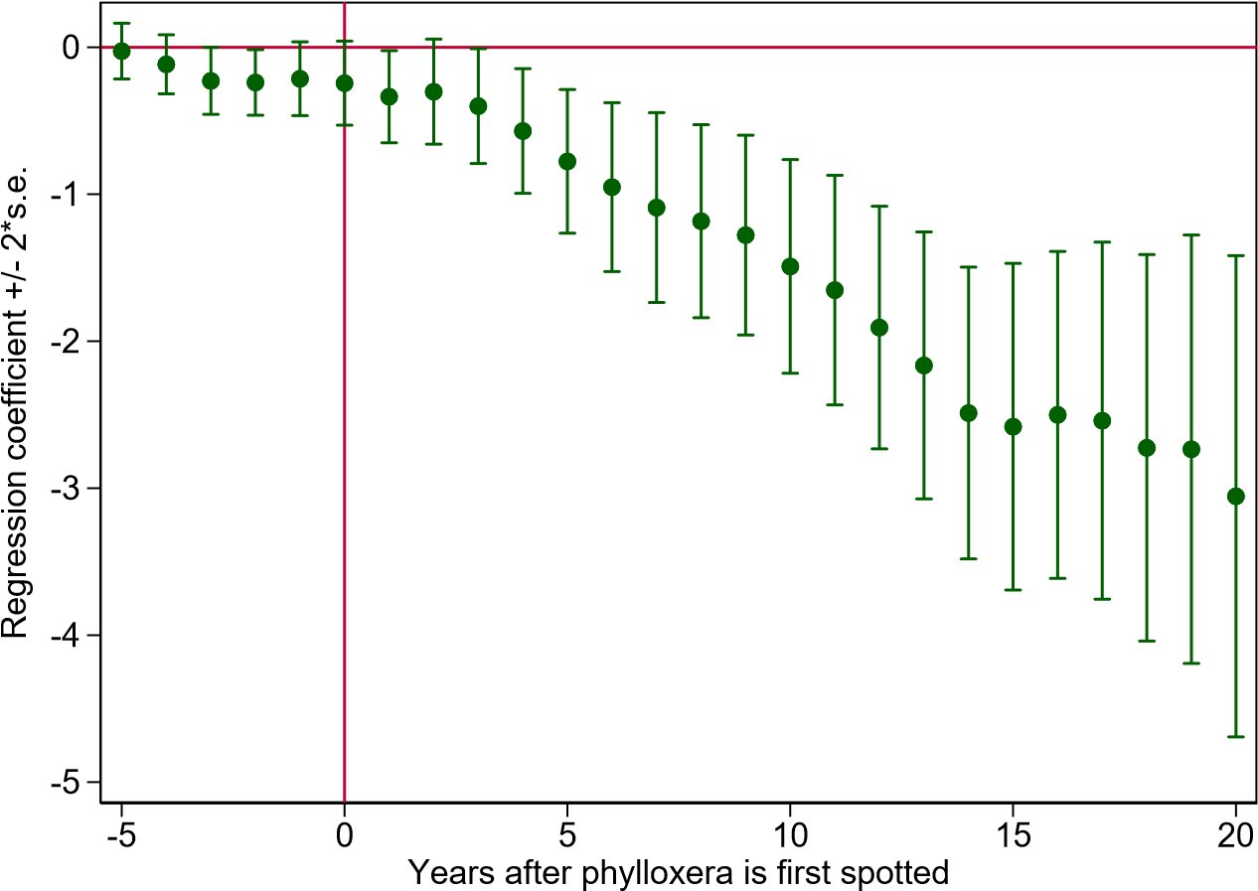
Figure A1: Dynamic effect of the spread of phylloxera on wine production, 1863–1890, with pre-trend.
District specific time trends δ_{t}∗α_{i} capture potential differences in the long-run evolution of wine production across districts. Finally, residuals are clustered at the district level, that is each regression controls for correlation among the observations of a given district. The coefficient and standard errors are plotted on figure 5. Inspection of the level reveals that on average phylloxera started to have a significant negative effect on wine production only four years after the first sighting of the aphid in a district. The coefficients imply that after controlling for time and district fixed effects, wine production declined by about 37 percent after five years and by 66 percent after ten years relative to the last year before phylloxera.

A similar analysis can be undertaken for the relationship between the spread of phylloxera and local economic distress by studying the dynamic impact of the local magnitude of the crisis triggered by phylloxera on the default rate of non-agricultural firms. In this case, the dependent variable is a pure measure of the indirect impact of the shock on the services and industrial sectors.
The following regression equation checks that the negative productivity shock on agriculture triggered an increase in the default rate in banking, services and industry:

(A2) ${DR}_{it} = α +\sum_{i≥1}{α_{i}}{·\left({Infect}_{i}∙{Wine}_{i}^{1862}\right)}_{} + δt + α_{i} + v_{i}·t + ϵ_{it}$
where DR_{it} is the default rate in district i and year t and Wine¹⁸⁶²_{i} is the share of wine in the 1862 district GDP. Other variables are the same as in equation A1. Residuals are clustered at the district level.
Figure A2 plots the evolution of the regression coefficient α_{k} and its confidence interval. It shows that the shock produced by phylloxera significantly increased the default rate of firms in services and industry and that the impact increased over some time before levelling off. The coefficient becomes significantly different from zero five years after the aphid was first spotted in the district. Calculated at the average size of the phylloxera shock, the coefficients imply an increase in the default rate of 2.5 percent five years and 6.8 percent ten years after the first spotting of phylloxera and one respectively six years after the illness had led to a significant decrease in the wine production of the infected district. Note that this magnitude is the average of districts with and without access to the mitigating facilities of the Bank of France.
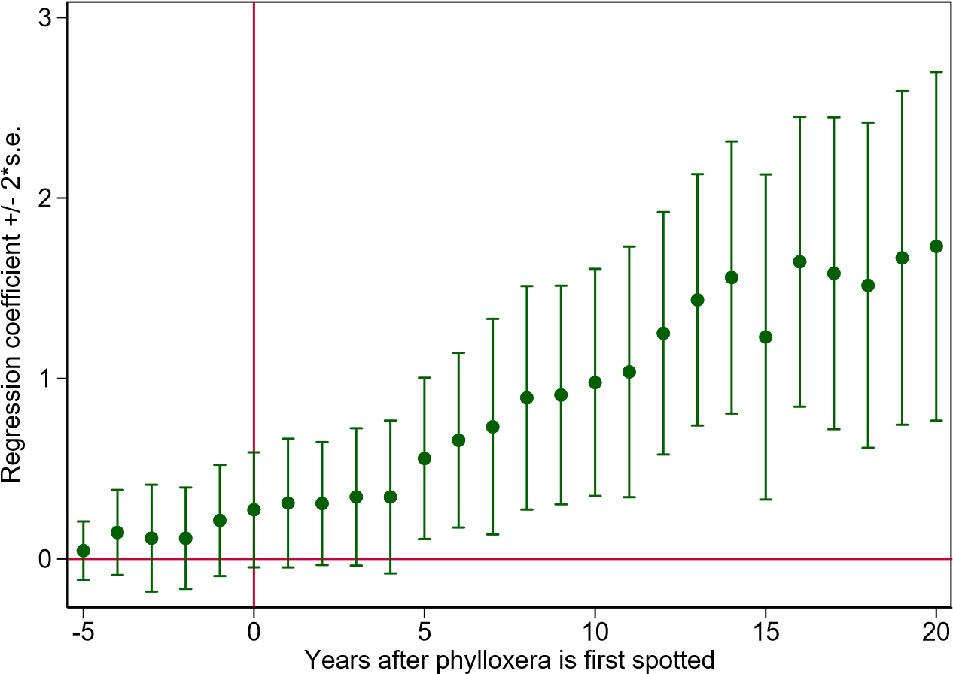
Figure A2: Dynamic effect of the spread of phylloxera on départements default rates of services and industry, 1863–1890 - with pre-trend.

Together, both results show that in the absence of any proper treatment to prevent the vines from dying, Phylloxera led to a sharp decline in wine production, triggering a sufficiently high negative shock to the productive assets of farmers to cause local (macro-)economic crises in the affected districts. The relatively long time it took for Phylloxera to significantly affect local wine production and broader economic conditions as well as the differing size of the impact – as evidenced by the relatively wide confidence intervals around Infect_{i} – help to better assess the relative merits of the different specifications of Shock_{it} presented in the section DATA in the main text As shown in figure A1, it could take several years for the fall of wine production to materialize, making thus the variable Spotted_{it} a more conservative measure of the Phylloxera shock on local economy than impactdummy_{it} or impactvolume_{it}.

Appendix B: Data sources

French districts. In 1826 France was composed of 86 districts with a size equivalent to the average size of a U.S. county. Two main changes in France’s frontiers make the panel slightly unbalanced. First, in 1860 France incorporated three new districts with the annexation from Italy of Savoy and Nice, which brought the total number of districts to 89. The defeat in the Franco-Prussian War in 1871 resulted in the loss of two districts in Alsace and of half of the Meurthe district and half of the Moselle district. Those two remaining parts were merged in a new district to form a new district – Meurthe et Moselle – but we have to drop it from the database for lack of an estimate of the district GDP in 1862. Part of the Alsatian district “Haut-Rhin” remained French in the post 1871 period, but was dropped from our sample. We drop district 7 and 23 as there is no data on phylloxera there. We also drop district 75 and the districts added in 1860 to keep the panel balanced over the years. In the end, 79 districts are included in the database. The low quality of the data during the war years of 1870 and 1871 led us to drop the observations for these years.
Population and urbanization. Data are from Bignon, Caroli, and Galbiati (2017). Urbanization rates are available every five years and starting in 1851. Years in between were linearly interpolated. Observations for 1912 and 1913 were set equal to the value of 1911.
Wine production and phylloxera. Data on wine come from Galet (1957). We use data collected by Banerjee et al. (2010) on the years during which phylloxera was spotted in each district and on the variables of wine cultivation and wine production. The source for the average vineyard size is the Agricultural survey of France in 1862. Galet (1957) does not provide any information on the presence of phylloxera in two districts: Ardèche and Creuse. They were dropped from the regression analysis.
District GDP in 1862. Following most of the empirical literature on nineteenth-century France, we take local GDP in 1862 from Delefortrie and Morice (1959), the year just before Phylloxera arrived in France. Delefortrie and Morice (1959) use extensive sources with more than 150 series to compute the most precise series of district GDP using an income approach, see Diez-Minguela and Sanchis Llopis (2019).
Central bank and banks. Statistics on the activities of the Bank of France were taken from the annual report to the General Assembly of the Shareholders. A typical report indicated where the branches of the Bank were operated during the year and the volume of outright purchases made. The annual reports also reported data on protested bills at the national level. Information on the branch offices operated by the two most important national branch banks, Société Générale and Crédit Lyonnais, comes from Billoret (1969) and the annual reports of Société Générale.
Defaults of firms in the industrial and service sectors. Few corrections had to be made to those data since the definition of the universe of firms that could default under the faillites procedure did not change during the nineteenth century, nor did the definition of what constituted a failure, that is the fact that the manager of a unit defaulted on his payment obligations. Yet some innovations introduced in the course of the century require some assumptions. The most notable change was the 1889 law that introduced a new process through which disputes over the payment of debt could be settled, the liquidation judiciaire. This new procedure was said to have been motivated by the intention to reduce the failed debtor’s shame and social stigma associated with filing for bankruptcy. Therefore, a strict reading of the letter of the law would have led to exclude cases under this procedure from the actual number of bankruptcies. But following the letter of the law would have also created a spurious decrease of the default rate, as a huge substitution occurred between the traditional failure procedures and the new one. Hence following all previous scholars, the failure numbers for the 1889–1913 period include both the number of faillites and the number of liquidations judiciaires.
The stock of operating firms in services and industry. Most previous scholars have used and commented on the absolute number of defaults, without any correction for the changes in the number of firms operated (Jobert and Chevailler 1986). We use a fiscal source (the patente) to document the population of firms in services and industry. The patente was a tax introduced in 1791 that survived the whole of the nineteenth century. The firms liable for the payment of this tax were also those that were eligible for the default procedure that we use to compute the default rate, as noted in the 1880s by the Ministry of Justice in the introduction to the Compte général de la justice civile et commerciale. Loua (1877) and Limousin (1900) also used this tax to measure default rates. Corrections must be implemented to correct for the spurious changes created by a number of tax reforms that altered for all French firms either the tax base or the population liable to pay it. The number of firms in services and industry was retrieved from statistics on the French patentes (business tax). The business tax was paid by every trader, that is any business selling goods or services for profit on the market, which again encompassed all shopkeepers, wholesalers, factories, craftsmen, and banking and insurance firms. As in the statistics on defaults, the agricultural sector was exempted. This business tax was paid at the level of individual establishments. To ensure the comparability of the number of defaults with the stock of firms eligible for the default procedure, we have collected the number of patentes payers, that is the number of firms that paid the tax, and not the cote des patentes which measures the number of branches of business units paying the tax.

Appendix C: Credit markets in 19th century France

In nineteenth-century France, agents could resort to two types of debt instruments when they needed to weather a negative income shock: short- and long-term debt. Long-term debt was not intermediated by banks but by notaries (Hoffman, Postel-Vinay, and Rosenthal 2001). Notaries acted as matchmakers between agents with excess savings and others in need of funds. Each notary operated on a local market (usually a town) and used his private proprietary information on contractual relationships between families to assess the wealth of savers and indebtedness of borrowers. Based on this information notaries were able to match lenders and borrowers depending on the characteristics of the loans such as their duration. Segmentation between notaries was pretty strong. Notaries had no interest in sharing information with colleagues (Postel-Vinay 1998), which prevented the pooling of borrowers and lenders across notaries’ clienteles and limited their capacity to smooth income shocks across regions.
The other main class of debt was the bill of exchange. A bill of exchange was an instrument for short-term credit, typically for a term of a couple of months up to a year (Roulleau 1914). In French law, a bill was an order to pay an amount of money – gold or silver coins and banknotes – to the bearer at some pre-determined future date in some specified location (Dalloz 1830). In French law there were three relevant parties to a bill: The tireur drew a bill on the tiré (debtor) against whom he had a previous claim. To obtain cash before the due date the tireur passed on the bill to an escompteur, typically a bank, who in this case became the creditor. The escompteur could either hold the bill in his portfolio and demand payment from the tiré when the bill fell due or rediscount the bill with another bank or the Bank of France, which now became the new creditor. In order to be eligible for rediscount at the Bank of France the bill had to carry three signatures, typically the signatures of the tireur, the tiré, who by his acceptation (signature) acknowledged the validity of the claim, and the escompteur. In case of non-payment by the tiré, these signatures allowed the Bank of France (or any other creditor holding the bill at maturity) to take recourse against the other two parties.
Bills were negotiable before maturity and could be sold at face value, a deduction being made for the interest rate, the so-called discount. As a result, bills were used as instrument of credit and as instrument of payment. The negotiability of bills was aided by the specific legal provision of joint liability. In the process of negotiating – that is discounting – a bill, the previous owner endorsed the bill, thereby guaranteeing the following purchaser to pay in case of a default of the ultimate debtor. If a bill was discounted several times, each endorser became jointly liable with the other endorsers for the end-payment of the bill (Santarosa 2015).
Hence, everybody who signed a bill had "skin in the game". If the debtor defaulted at maturity, French jurisprudence accorded the creditor (the holder of the bill) the right to immediately activate the guarantees once the creditor had proven the debtor’s inability to pay, using a simple procedure called protêt faute de paiement (protest, see Tate (1868)). With the protest in his hand the creditor was allowed to immediately ask for payment at the home of every endorser as well as the creditor who had initially drawn the bill (Bravard-Veyrières and Demangeat 1862). Strategic default on debt obligations was harshly punished and hence very costly (Dalloz 1830; Percerou 1935). As long as the creditors had not been entirely reimbursed, debtors were not allowed to restart and manage any business. In a failure procedure, if creditors agreed on debt restructuring and allowed the continuation of the debtor’s business (under a concordat), the defaulter did not recover his commercial and civil rights before the full reimbursement of all debts. The cost of default and ability to immediately activate guarantees made bills of exchange a safe and liquid instrument.

Appendix D: Additional tables

Table D1: Pairwise correlations

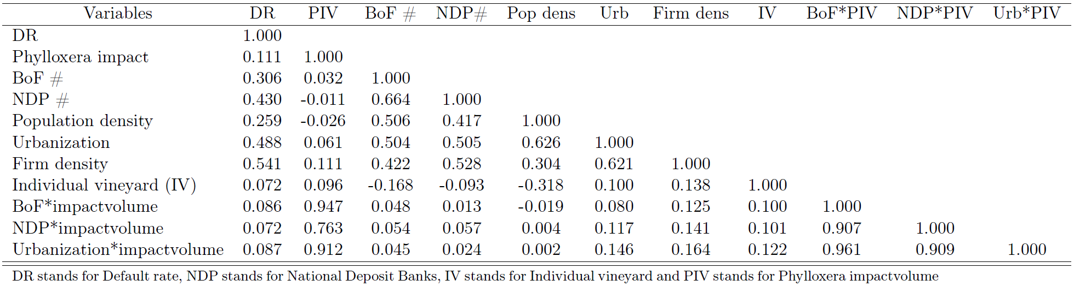

Table D2: Alternative specification for economic shock (phylloxera impactdummy)
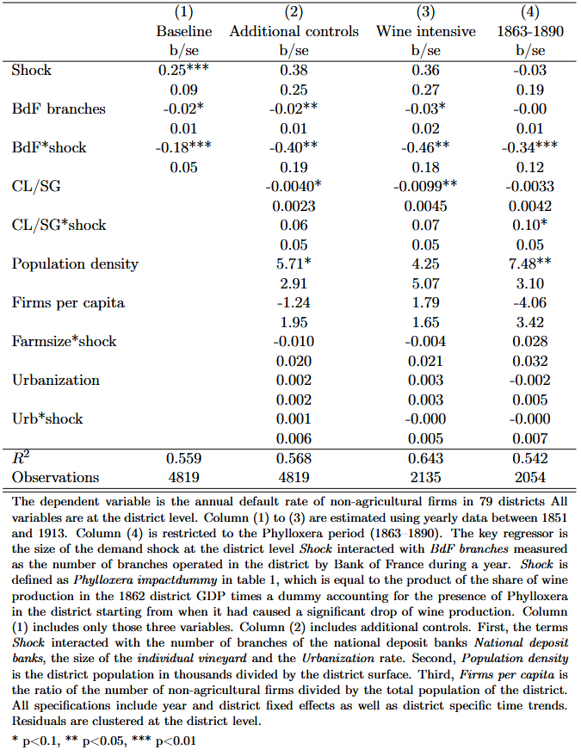

Table D3: Alternative specification for economic shock (phylloxera spotted)
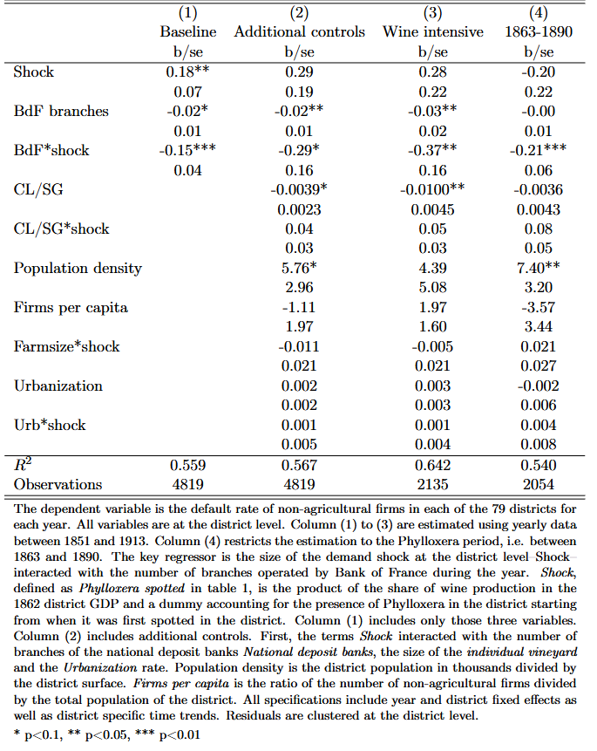
Table D4: Controlling for spatial correlation
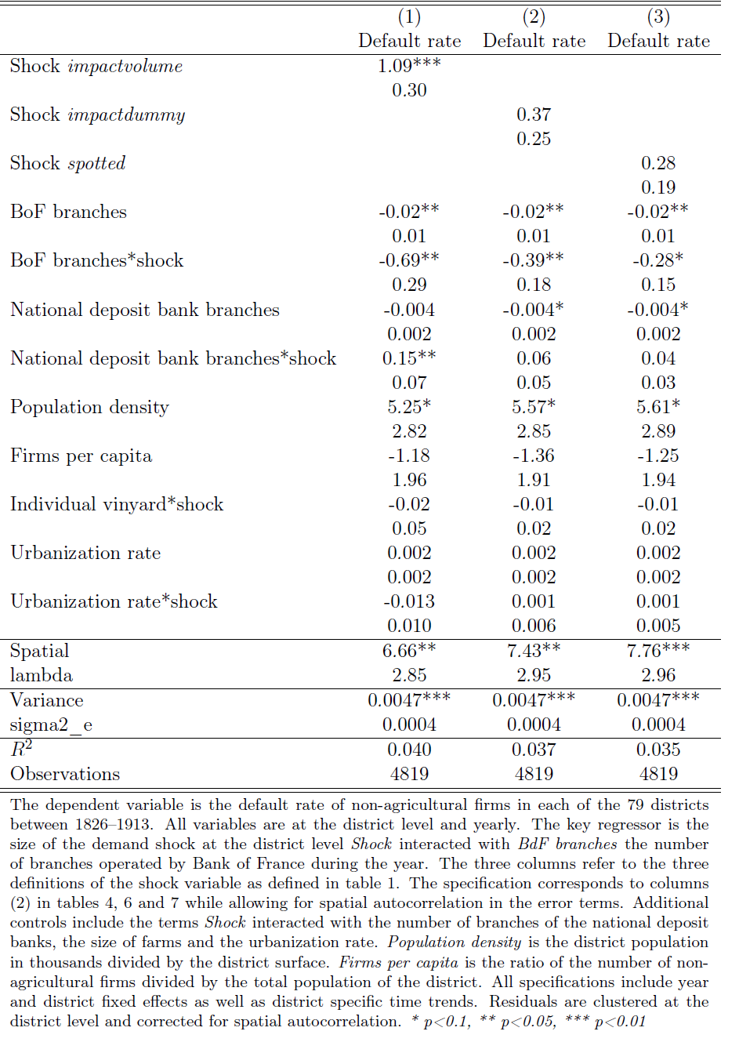

Appendix E: Additional figures

Figure E1: Frequency distribution of the share of the wine production in district GDP 1862

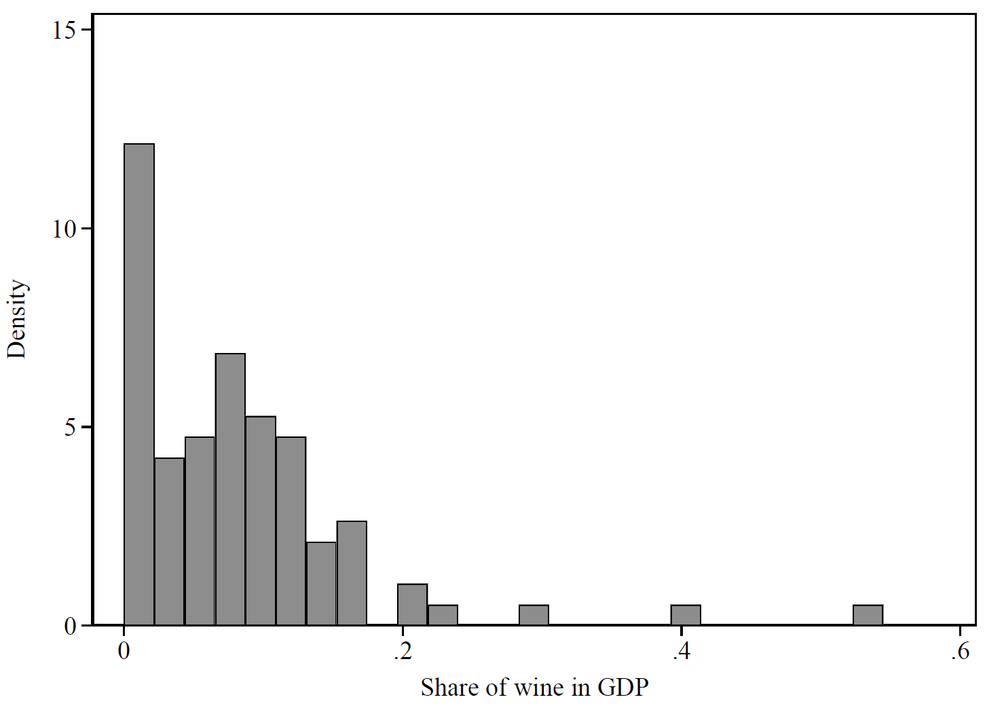
Source: Authors’ computation using Delafortrie and Morice (1959) and Galet (1957).

Additional references cited in the appendices but not in the main text

Delefortrie, Nicole, and Janine Morice. Les revenus départementaux en 1864 et 1954. Paris: Librairie Armand Colin, 1959.
Diez-Minguela, A., and M. Sanchis Llopis. “Regional Income Inequality in France 1860–1954: Methods and Findings.” Historical Methods 52, no. 1 (2019): 1–14.
Jobert, Philippe, and Jean-Claude Chevailler. “La Démographie des Entreprises Françaises en France au 19ème Siècle.” Economie et Société 2 (1986): 233–264.
Limousin, C. M. “Philosophie de la Statistique de Faillite.” Journal de la Société de Statistique de Paris 41 (1900): 52–61.
Loua, Toussaint. “Les Faillites.” Journal de la Société de Statistique de Paris 18 (1877): 281–291.

