Appendix for “State Formation and Bureaucratization: Evidence from Pre-Imperial China”

**Appendix A Additional Tables and Figures**

|  |  |  |  |  |  |  |
| --- | --- | --- | --- | --- | --- | --- |
| Table A1: Summary Statistics for Counties and Fiefs | | | | | | |
| **Variables** | **Mean** | **SD** | **N** | **Mean** | **SD** | **N** |
|  | **Counties** | | | **Fiefs** | | |
| *Panel A: Administrative Districts* | | | | | | |
| Located on State Border | 0.517 | 0.504 | 58 | 0.784 | 0.417 | 37 |
| Has a Strong Neighbor | 0.155 | 0.365 | 58 | 0.541 | 0.505 | 37 |
| Has a Weak Neighbor | 0.414 | 0.497 | 58 | 0.324 | 0.475 | 37 |
| Distance to Capital City (100 Miles) | 1.264 | 0.703 | 58 | 1.021 | 0.676 | 37 |
| Irrigation Potential | 0.258 | 0.344 | 58 | 0.245 | 0.343 | 37 |
| Terrain Roughness | 0.445 | 0.103 | 58 | 0.431 | 0.124 | 37 |
| Millet Suitability Index (Divided by 1000) | 6.135 | 1.197 | 58 | 6.799 | 1.055 | 37 |
| Rice Suitability Index (Divided by 1000) | 2.388 | 2.960 | 58 | 0.749 | 1.423 | 37 |
|  |  |  |  |  |  |  |
| *Panel B: Military Conflicts* | | | | | | |
| Number of Attacks within 50 Miles (Per Decade) | 0.168 | 0.494 | 1,566 | 0.168 | 0.498 | 891 |
| Number of Attacks within 51-150 Miles (Per Decade) | 1.059 | 1.410 | 1,566 | 0.845 | 1.286 | 891 |
| Average Distance to Attacks (Nearest 10 Districts) | 80.707 | 81.323 | 618 | 58.189 | 85.409 | 431 |
| Average Distance to Attacks (Nearest 5 Districts) | 44.863 | 65.801 | 618 | 27.767 | 55.450 | 431 |
| Note: This tables displays the summary statistics of key variables used in the regressions. Columns 2 to 4 present statistics for counties, and columns 5 to 7 present statistics for fiefs. | | | | | | |

|  |  |  |  |  |  |  |
| --- | --- | --- | --- | --- | --- | --- |
| Table A2: Robustness Checks: Distance to Capital, Irrigation Potential and Direction of Threat | | | | | | |
|  | Whether Administrative District is a Fief | | | | | |
| Variables | (1) | (2) | (3) | (4) | (5) | (6) |
| OnBorder | 0.403*** |  | 0.284*** |  |  |  |
|  | (0.119) |  | (0.098) |  |  |  |
| StrongNeighbor |  | 0.437*** |  | 0.370*** |  |  |
|  |  | (0.111) |  | (0.113) |  |  |
| WeakNeighbor |  | 0.066 |  | 0.014 |  |  |
|  |  | (0.134) |  | (0.123) |  |  |
| DistanceToCapital | -0.179** | -0.114 |  |  |  |  |
|  | (0.089) | (0.082) |  |  |  |  |
| IrrigationPotential |  |  | -0.341* | -0.261 |  |  |
|  |  |  | (0.195) | (0.204) |  |  |
| MultiDirect |  |  |  |  | 0.127 | -0.009 |
|  |  |  |  |  | (0.114) | (0.130) |
|  |  |  |  |  |  |  |
| Observations | 95 | 95 | 95 | 95 | 95 | 59 |
| R-squared | 0.221 | 0.249 | 0.214 | 0.250 | 0.127 | 0.244 |
| Controls | Yes | Yes | Yes | Yes | Yes | Yes |
| State FE | Yes | Yes | Yes | Yes | Yes | Yes |
| Period Dummy | Yes | Yes | Yes | Yes | Yes | Yes |
| *Notes:* *** *p* < 0.01, ** *p* < 0.05, * *p* < 0.1. Robust standard errors in parentheses. | | | | | | |

|  |  |  |  |  |  |  |
| --- | --- | --- | --- | --- | --- | --- |
| Table A3: Robustness Checks: Kinship Ties and Young Rulers | | | | | | |
|  | Whether District Administrator Was Ruler’s Kin | | | | Whether Administrative District is a Fief | |
|  | 3 Generations | | 5 Generations | |  | |
| Variables | (1) | (2) | (3) | (4) | (5) | (6) |
| OnBorder | 0.076 |  | 0.088 |  | 0.368*** |  |
|  | (0.080) |  | (0.102) |  | (0.102) |  |
| StrongNeighbor |  | -0.004 |  | -0.103 |  | 0.437*** |
|  |  | (0.080) |  | (0.096) |  | (0.121) |
| WeakNeighbor |  | 0.040 |  | 0.032 |  | 0.056 |
|  |  | (0.108) |  | (0.112) |  | (0.121) |
| YoungRuler |  |  |  |  | 0.403* | 0.322 |
|  |  |  |  |  | (0.215) | (0.200) |
| OnBorder * YoungRuler |  |  |  |  | -0.368 |  |
|  |  |  |  |  | (0.283) |  |
| StrongNeighbor * YoungRuler |  |  |  |  |  | -0.288 |
|  |  |  |  |  |  | (0.320) |
| WeakNeighbor * YoungRuler |  |  |  |  |  | -0.198 |
|  |  |  |  |  |  | (0.318) |
|  |  |  |  |  |  |  |
| Observations | 92 | 92 | 92 | 92 | 95 | 95 |
| R-Squared | 0.294 | 0.289 | 0.263 | 0.265 | 0.224 | 0.261 |
| Controls | Yes | Yes | Yes | Yes | Yes | Yes |
| State FE | Yes | Yes | Yes | Yes | Yes | Yes |
| Period Dummy | Yes | Yes | Yes | Yes | Yes | Yes |
| *Notes:* *** *p* < 0.01, ** *p* < 0.05, * *p* < 0.1. Robust standard errors in parentheses. | | | | | | |

|  |  |  |  |
| --- | --- | --- | --- |
| Table A4: Correlation between Agricultural Suitability and County Status | | | |
|  | Whether Administrative District is a County | | |
| Variables | (1) | (2) | (3) |
|  |  |  |  |
| Millet Suitability | -0.061 | -0.055 | -0.055 |
|  | (0.054) | (0.058) | (0.058) |
| Rice Suitability | 0.043** | 0.041* | 0.041* |
|  | (0.020) | (0.022) | (0.022) |
|  |  |  |  |
| Observations | 95 | 95 | 95 |
| R-squared | 0.110 | 0.111 | 0.112 |
| State FE | No | Yes | Yes |
| Period Dummy | No | No | Yes |
| *Notes:* *** *p* < 0.01, ** *p* < 0.05, * *p* < 0.1. Robust standard errors in parentheses. | | | |

|  |  |  |  |  |  |  |
| --- | --- | --- | --- | --- | --- | --- |
| Table A5: Robustness Check: Number of Attacks Near Border Fiefs and Counties | | | | | | |
|  | 0-50 Miles | | | 51-150 Miles | | |
|  | Number | | Dummy | Number | | Dummy |
| Variables | (1) | (2) | (3) | (4) | (5) | (6) |
|  |  |  |  |  |  |  |
| County | 0.061 | 0.039 | 0.030 | 0.522*** | 0.532*** | 0.194*** |
|  | (0.075) | (0.078) | (0.049) | (0.162) | (0.176) | (0.064) |
|  |  |  |  |  |  |  |
| Observations | 1,485 | 1,485 | 1,485 | 1,485 | 1,485 | 1,485 |
| R-squared | 0.150 | 0.272 | 0.302 | 0.432 | 0.630 | 0.564 |
| Sample | Border | Border | Border | Border | Border | Border |
| Controls * Decade | No | Yes | Yes | No | Yes | Yes |
| State-Decade FE | No | Yes | Yes | No | Yes | Yes |
| *Notes:* *** *p* < 0.01, ** *p* < 0.05, * *p* < 0.1. Robust standard errors in parentheses are clustered at district level. | | | | | | |

|  |  |  |  |  |
| --- | --- | --- | --- | --- |
| Table A6: Average Distance to Attacks for Fiefs and Counties in Jin and Chu, 772-471 B.C. | | | | |
| Panel A: Full Sample | | | | |
|  | Nearest 10 Districts | | Nearest 5 Districts | |
| Variables | (1) | (2) | (3) | (4) |
|  |  |  |  |  |
| County | 19.951*** | 15.874** | 16.710** | 12.088* |
|  | (6.889) | (7.512) | (7.008) | (6.539) |
|  |  |  |  |  |
| Observations | 1,049 | 1,049 | 1,049 | 1,049 |
| R-squared | 0.318 | 0.407 | 0.241 | 0.336 |
| Controls | No | Yes | Yes | Yes |
| State FE | Yes | No | Yes | No |
| Decade FE | Yes | No | Yes | No |
| State-Decade FE | No | Yes | No | Yes |
|  |  |  |  |  |
| Panel B: Border Districts | | | | |
|  | Nearest 10 Districts | | Nearest 5 Districts | |
| Variables | (1) | (2) | (3) | (4) |
|  |  |  |  |  |
| County | 28.848*** | 28.669*** | 24.989*** | 21.181*** |
|  | (7.354) | (8.463) | (8.781) | (7.531) |
|  |  |  |  |  |
| Observations | 758 | 758 | 758 | 758 |
| R-squared | 0.314 | 0.420 | 0.261 | 0.390 |
| Controls | No | Yes | Yes | Yes |
| State FE | Yes | No | Yes | No |
| Decade FE | Yes | No | Yes | No |
| State-Decade FE | No | Yes | No | Yes |
| *Notes:* *** *p* < 0.01, ** *p* < 0.05, * *p* < 0.1. Robust standard errors in parentheses are clustered at district level. | | | | |

|  |  |  |  |  |  |  |
| --- | --- | --- | --- | --- | --- | --- |
| Table A7: Clan Membership of Administrators of Fiefs and Counties in Jin and Chu, 772-471 B.C. | | | | | | |
|  | *Qing* Clan | | Large Clan | | Small/No Clan | |
| Variables | (1) | (2) | (3) | (4) | (5) | (6) |
|  |  |  |  |  |  |  |
| County | -0.150 | -0.143 | -0.156* | -0.130 | 0.306*** | 0.273*** |
|  | (0.099) | (0.119) | (0.082) | (0.105) | (0.085) | (0.099) |
|  |  |  |  |  |  |  |
| Observations | 118 | 92 | 118 | 92 | 118 | 92 |
| R-squared | 0.040 | 0.034 | 0.142 | 0.115 | 0.185 | 0.153 |
| Controls | No | Yes | No | Yes | No | Yes |
| State FE | Yes | Yes | Yes | Yes | Yes | Yes |
| Period FE | Yes | Yes | Yes | Yes | Yes | Yes |
| *Notes:* *** *p* < 0.01, ** *p* < 0.05, * *p* < 0.1. Robust standard errors in parentheses. | | | | | | |

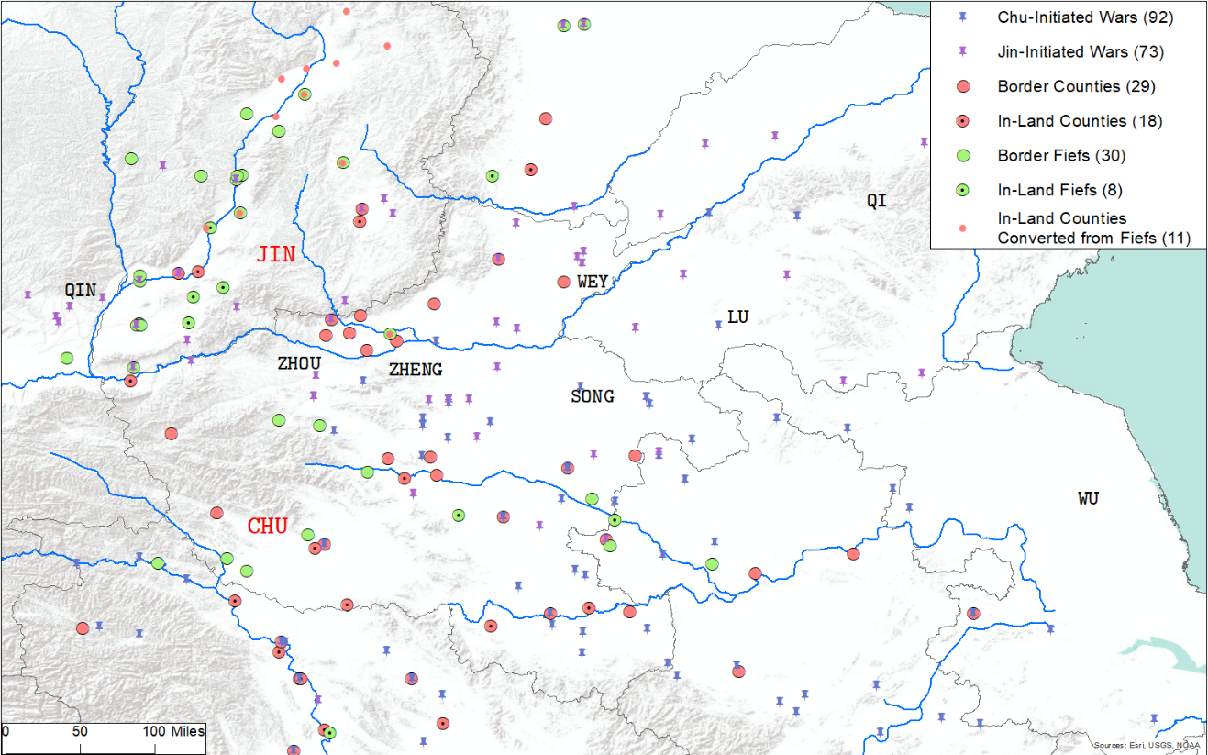

Note: This map presents the locations of fiefs, counties and self-initiated wars for the state of Jin from 772 to 471 BCE Red units are counties, and green units are fiefs. Circles are units located on the state border, and dotted circles are units located in-land. Smaller red dots are counties that were converted from fiefs, and located in-land at the time of conversion. Blue pins are sites of Chu-initiated wars, and purple pins are sites of Jin-initiated wars. Blue lines are rivers, taken from World Rivers dataset. Names of neighboring states are displayed in black text.

Figure A1: Location of Counties, Fiefs and Self-Initiated Wars for the States of Jin and Chu, 772-496 BCE.

**Appendix B Model Solution and Proofs**

**B.1 Equilibrium Contract Payoffs**

**B.1.1 Fief Contract**

I solve (2) and (4) by taking the partial derivative of the objective functions with respect to $m$. Denoting the solution to (2) by $m_{fd}$, we have:

$$m_{fd}=\sqrt{m_{e}t}-m_{e}, where t>m_{e}. (B1)$$

Similarly, denoting the solution to (4) by $m_{fo}$, we have:

$$m_{fo}=\sqrt{m_{e}\left(t+λt_{e}\right)}-m_{e}, where t+λt_{e}>m_{e}. (B2)$$

The equilibrium payoffs of $A$ and $R$ can be found by substituting $m_{fd},m_{fo}$ into their respective objective functions:

$$π_{afd}=P\left(m_{fd},m_{e}\right)t-m_{fd}=t-2\sqrt{m_{e}t}+m_{e},$$

$$π_{afo}=t+λt_{e}-2\sqrt{m_{e}\left(t+λt_{e}\right)}+m_{e}.$$

$$π_{rfd}=P\left(m_{fd},m_{e}\right)α=\left(1-\sqrt{\frac{m_{e}}{t}}\right)α,$$

$$π_{rfo}=α+\left(1-λ\right)\left(1-\sqrt{\frac{m_{e}}{t+λt_{e}}}\right)t_{e}.$$

**B.1.2 County Contract**

I solve (3) and (5) using a similar procedure as above. Letting the solution to (3) be denoted by $m_{cd}$, we have:

$$m_{cd}=\sqrt{λm_{e}t}-m_{e}, where λt>m_{e}. (B3)$$

Denoting the solution to (5) by $m_{co}$, we have:

$$m_{co}=\sqrt{λm_{e}\left(t+t_{e}\right)}-m_{e}, where λ\left(t+t_{e}\right)>m_{e}. (B4)$$

Similarly, I derive the equilibrium payoffs of $A$ and $R$ by plugging $m_{cd},m_{co}$ into their respective objective functions:

$$π_{acd}=λP\left(m_{fd},m_{e}\right)t-m_{cd}=λt-2\sqrt{λm_{e}t}+m_{e},$$

$$π_{aco}=λt+λt_{e}-2\sqrt{λm_{e}\left(t+t_{e}\right)}+m_{e}.$$

$$π_{rcd}=P\left(m_{cd},m_{e}\right)\left[\left(1-λ\right)t+α\right]=\left(1-\sqrt{\frac{m_{e}}{λt}}\right)\left[\left(1-λ\right)t+α\right],$$

$$π_{rco}=\left(1-λ\right)t+α+\left(1-λ\right)\left(1-\sqrt{\frac{m_{e}}{λ\left(t+t_{e}\right)}}\right)t_{e}.$$

**B.2 Proofs of Propositions**

**B.2.1 Proof of Proposition 1**

First, $m_{fd}=\sqrt{m_{e}t}-m_{e}>\sqrt{λm_{e}t}-m_{e}=m_{cd}$

Now consider the function $π\left(m,x\right)=P\left(m,m_{e}\right)x-m$. Let $m^{*}=m^{*}(x)$ be the maximizer of $π$ with respect to $x$. Then by the Envelope Theorem:

$$\frac{∂π\left(m^{*}\left(x\right),x\right)}{∂x}=P\left(m^{*},m_{e}\right)>0.$$

Thus, $π_{afd}=π\left(m,t\right)>π\left(m,λt\right)=π_{acd}$.

**B.2.2 Proof of Proposition 2**

Obvious.

**B.2.3 Proof of Proposition 3**

We know that

$$Δπ≔π_{rfd}-π_{rcd} \\ =\left(\frac{1}{\sqrt{λ}}-1\right)\sqrt{\frac{m_{e}}{t}}α-\left(1-\sqrt{\frac{m_{e}}{λt}}\right)\left(1-λ\right)t.$$

Taking a partial derivative with respect to $m_{e}$ yields:

$$\frac{∂Δπ}{∂m_{e}}=\frac{1}{2\sqrt{m_{e}t}}\left(\frac{1}{\sqrt{λ}}-1\right)α+\frac{1}{2 \sqrt{λm_{e}t}}\left(1-λ\right)t>0.$$

This shows that the difference between $R$’s payoff under the fief contract and under the county contract is monotonically increasing in $m_{e}$. Moreover:

$$Δπ\left(0\right)=-\left(1-λ\right)t<0,$$

$$Δπ\left(λt\right)=\left(\frac{1}{\sqrt{λ}}-1\right)\sqrt{λ}α>0.$$

By the Intermediate Value Theorem, there exists a $m_{e}^{*}∈\left(0,λt\right)$ such that $Δπ\left(m_{e}^{*}\right)=0$. Therefore, the ruler prefers the fief contract when $m_{e}>m_{e}^{*}$.

**B.2.4 Proof of Proposition 4**

First, $m_{fo}=\sqrt{m_{e}\left(t+λt_{e}\right)}-m_{e}>\sqrt{m_{e}\left(λt+λt_{e}\right)}-m_{e}=m_{co}$. Then we know from Proof B.2.1 that $π_{afo}>π_{aco}$.

**B.2.5 Proof of Proposition 5**

The bureaucrat participates in the attack if:

$$π_{aco}=λt+λt_{e}-2\sqrt{λm_{e}\left(t+t_{e}\right)}+m_{e}≥v.$$

This is equivalent to:

$${\left(\sqrt{λ\left(t+t_{e}\right)}-\sqrt{m_{e}}\right)}^{2}≥v \\ ⇒\sqrt{λ\left(t+t_{e}\right)}≥\sqrt{v}+\sqrt{m_{e}} \\ ⇒t_{e}≥\frac{{\left(\sqrt{v}+\sqrt{m_{e}}\right)}^{2}-λt}{λ}=:t_{e}^{c}$$

I eliminate the other root because we must have $m_{e}<λ\left(t+t_{e}\right)$.

Similarly, the vassal participates in the attack if:

$$π_{afo}=t+λt_{e}-2\sqrt{m_{e}\left(t+λt_{e}\right)}+m_{e}≥t.$$

This is true if:

$${\left(\sqrt{t+λt_{e}}-\sqrt{m_{e}}\right)}^{2}≥t \\ ⇒t_{e}≥\frac{m_{e}+2\sqrt{m_{e}t}}{λ}=:t_{e}^{f}.$$

Again, the other root is eliminated because we must have $m_{e}<t$ by Assumption 1.

Then:

$$t_{e}^{f}-t_{e}^{c}=2\frac{\sqrt{m_{e}}}{λ}\left(\sqrt{t}-\sqrt{v}\right)+\frac{λt-v}{λ}.$$

Since $v<λt$ by Assumption 2, we have $t_{e}^{f}>t_{e}^{c}$.

**B.2.6 Proposition 6: Statement and Proof**

In both the defensive and the offensive game, the size of $v$ affects the feasibility of both the fief and county contracts. That is, an administrator with a smaller $v$ will accept a contract over a wider range of payoffs $π$. Recall from Propositions 1 and 4 that a bureaucrat always receives a lower payoff than a vassal. A decrease in $v$ would therefore work to the favor of the bureaucrat. More formally:

**Proposition 6.** *A decrease in the administrator's outside option, $v$, makes the county contract more likely to prevail in equilibrium.*

*Proof:* Propositions 1 and 4 show that a bureaucrat always receives a smaller payoff than a vassal, that is, $π_{afd}>π_{acd}$ and $π_{afo}>π_{aco}$. Assume that $π_{afd}>v$, so that some form of administration happens under defense. Then a decrease in $v$ would increase the chances that $π_{acd}$ also becomes greater than $v$, and therefore the likelihood for the county contract to be feasible for the ruler. Since the value of $v$ does not affect the ruler's payoffs, this translates to a higher likelihood that the county contract will prevail in equilibrium. Applying the same logic to the offensive scenario, a decrease in $v$ benefits the county contract and increases the probability that it will prevail in equilibrium.

**Appendix C Additional Discussion**

**C.1 Cases of SA States**

**Defense.** I demonstrate that Prediction 1 applies to the regional states of Zheng, Song and Wey. First, I argue that those three states were consistently under serious military threat. To get a sense of the external environment faced by these three states, a glance at Figures 1 and 4 suggests that they were situated close to Chu and Jin, which were among the four major powers of the SA period.

In fact, the locations of Zheng and Song were “strategically essential for gaining control over military affairs in southern and northern China” (Wang 1988: 205). Zheng's situation was particularly dire, as it was “squeezed between the archenemies Jin and Chu,” and was often forced to switch allegiance between the two states as the balance of power shifted (von Glahn 2016: 50). Zhao (2015: 120) found that Zheng switched alliances 13 times within the 97 years between 643 and 546 BCE. Year 2 and Year 3 of Duke Xuan from *Zuo’s Commentary* recounts a highly representative example (Durrant et al. 2016: 589, 601, 603):

“In the second year, in spring, Gongzi Guisheng of Zheng received a command from Chu to attack Song... [Next year], the Prince of Jin attacked Zheng, advancing as far as Yan. Zheng and Jin made peace, and Fan Hui entered Zheng to swear a convenant... In summer, a Chu leader invaded Zheng: the latter had gone over to Jin.”

Wey faced severe threat from non-Zhou tribes, in addition to Chu and Jin. In 661 BCE, Wey was vanquished by the Di tribe, but was able to relocate. In just over 30 years, threat from non-Zhou tribes once again forced the duke of Wey to move. Power struggles among the nobility further weakened the state towards the end of the Spring and Autumn Period.

Unsurprisingly, as shown in Section 3.2, Zheng, Song and Wey were slow in their state-building process and created very few counties. Thus, their circumstances are consistent with Prediction 1, in that counties are less likely to be adopted in states that faced serious external threat.

**Offense.** In the state of Chu, county-based armies were known to have played a much more active role in military offenses compared to fief-based armies. In particular, historical records document a number of instances in which armies from the counties of Shen, Xi, Qisi and Fanyang participated in offensive campaigns. In contrast, fief-based armies made almost no appearance in chronicles except for the Ruo'ao soldiers in early Spring and Autumn Period (Tian 2017: 215). Moreover, this result is also consistent with the historical reality that the county-creating states – Jin, Chu, Qin and Qi – were also the major military powers, suggesting that the need for military aggression drove states to centralize.

**C.2 Models of State-Building: Comparing China and Europe**

**Military Feudalism.** The result on the defensive function of fiefs sees immediate parallels in medieval Europe. The first European knights emerged in the Carolingian Age as well-equipped horseback warriors. Maintenance of armor proved costly, and knights remained rare for a period of time. As invasions from Vikings and Magyars became increasingly frequent since the 9th century, the feudal system burgeoned as civilians agreed that “heavy payment for the support for a knight perpetually in residence and on call was better than periodic exposure to devastating raids” (McNeill 1974: 86). As a result, knights quickly grew in number, and formed a defensive barrier against the invaders. In return, they were granted the rights to collect income from villages (North et al. 2009: 79). More generally, the need to combat external invasion led the emperor to “acquiesce in the transformation of counties and other benefices into hereditary property” (Ertman 1997: 48).

Border counties and provinces in England, France and Spain also tended to enjoy greater autonomy for military purposes. Upon conquering England, William I gave “extensive powers to earls of certain frontier counties” (Strayer 1970: 37). Also known as palatinates, these counties enjoyed special autonomy, and their earls possessed the power to collect taxes and raise private armies. Examples of palatinates include County Chester, which bordered Wales, and County Durham, which was a buffer zone between England and Scotland. Similarly, the County of Foix, which was located on the border between France and Spain and swore allegiance to the king of France, maintained a status of semi-independence throughout the Middle Ages.

**Military Technology.** Many works that study state capacity in premodern Europe emphasize the role of the Military Revolution. Inventions such as gunpowder and new methods of fortification that could withstand cannon fire greatly extended the duration of wars, and war-making became much more costly. Gennaioli and Voth (2015) argue that the resulting increase in the impact of money on military success induced states to invest in state capacity.

Compared to technological advancements in the Military Revolution, there were relatively few changes to fortification techniques in pre-imperial China. Rammed earth had become the main construction material for building city walls since Western Zhou, and remained so in the next one-thousand years (Ma 1998). In the WS era, techniques for building large dams were adapted for the purpose of wall construction, allowing states to erect defensive walls made of earth. For example, the states of Zhao, Yan and Qin built walls in the mountainous regions of their northern frontier to defend against nomadic invasion (Yang 1998: 320-25).[1]

Weapons in the Western Zhou and the SA periods were predominantly made of bronze. Since the early WS era, new technologies that enhanced the flexibility and durability of cast iron were developed, and iron now had a substantial edge over bronze in weapon-making (Bai 2005). This technology initiated the substitution of bronze by iron in weapon-making, the process of which only came to a completion in the Western Han (202 BCE-8 CE).

The impact of the adoption of iron on the cost of wars is ambiguous. On the one hand, iron was much cheaper and more plentiful compared to bronze (Keegan 1993: 291), and weapons would become less costly to produce. On the other hand, the abundance of iron meant that rulers of states could arm a greater proportion of their population, thereby increasing the size of armies. However, the rise in army size and scale of warfare in the WS period was most likely a result of population growth and the increased capacity of states to directly conscript a greater number of soldiers under the county system (Yang 1998: 311; Zhao 2004). Some scholars also argue that the adoption of iron may produce a “politically equalizing” effect as ordinary people could more easily acquire weapons to fight the rulers (Keegan 1993; Boix 2015: 19, 134).

In summary, military technology had remained largely unchanged in the SA era, and little evidence suggests that innovations in the WS period transformed the nature of warfare. It is therefore unlikely that changes in military technology produced a significant impact on state-building in pre-imperial China.

**Political Divergence.** A large literature highlights the role of warfare in promoting the emergence of representative assemblies in Europe (e.g., Levi 1989, Dincecco 2011, Becker et al. 2022). While representative assemblies are outside the scope of this paper’s theoretical framework, which centers on political delegation, it is important to discuss this institution as a road-not-taken in the state-building process of SA and WS China. I begin by briefly revisiting the origin and nature of representative assemblies in Europe as a venue of political participation. Then, I postulate that the absence of representative institutions in SA and WS China was due to the precocious development of the central bureaucracy, which provided an alternative and effective mechanism of political participation for powerful elites to express their preferences.

Representative institutions in Europe originated from early traditions and burgeoned under the influence of Roman and Germanic legacies. Carolingian kings of the 9th century held annual assemblies to obtain consensus from notables across the empire; and Anglo-Saxon monarchs had councils that met regularly and comprised of social elites as well as subordinates of the king (Stasavage 2020: 112-116). By the 13th century, assemblies “appeared everywhere” in Western and Central Europe, where rulers sought cooperation from local magnates and the clergy to collect taxes for national defense as royal revenue became inadequate for coping with rising military pressure (Strayer 1970: 65; Ertman 1997: 68).[2] At those meetings, magnates also provided counsel to the king on important matters, and such counsel was “greatly valued and often carefully considered” (Maddicott 2010: 87).

Bureaucratic administrations, at the same time, developed rather slowly. Specialized organs of administration, finance and justice (Chancery, Exchequer, central law courts) appeared in 12th century England; and writing offices, central courts and treasuries emerged in 12th and 13th century Latin Europe (Ertman 1997: 68, 157). During the infancy of these administrative organs, many offices were held by clerics, largely because of their literacy and celibacy (Ertman 1997: 78-79, 172; Lyon 2016: 36). Thus, political participation through office-holding may have been limited for the magnates, due to ecclesiastical appointments as well as the lack of institutionalization of the bureaucratic apparatus.

Stasavage (2020) claims that “the fundamental factor that made for the development of representative government in Europe was the backwardness of its state bureaucracies, [as] this left rulers with no alternative but to govern by negotiating and seeking consent” (p.137). I argue that this statement needs some modification for the context of SA and WS China. Rather than eliminating the ruler’s need to seek consent, precocious development of the bureaucracy provided an alternative and effective mechanism of political participation for powerful elites in pre-imperial China to express their preferences, thereby reducing the need for representative institutions. In other words, bureaucracy was the mechanism through which ruler sought consent from the elites.

The earliest Chinese bureaucracy was formed in Western Zhou, the predecessor dynasty of the Spring and Autumn Period. The Zhou central government, which administered the royal domain, had “organizational features of a bureaucracy,” and appointed officials using a “routine and bureaucratic procedure” (Li 2008: 21). Governments of duke-ruled regional states were less developed, even though they performed similar political and administrative functions as the central government and “replicated its structural features” (Li 2008: 255). Despite considerable bureaucratization at the center, the state-building process over the next few centuries unfolded in the regional states, which became the foci of warfare and political activity following the collapse of the Zhou court in 771 BCE.

Given that powerful land-holding elites had long existed – ministers of the regional states (­*qing-dafu*) held fiefs which were their “independent base of territory, subjects, and resources” (von Glahn 2016: 48) – one may naturally wonder why representative institutions did not arise in the regional states. In other words, if representative institutions were to emerge at all, then those ministers, who were local powerholders and had obligations to provide military assistance to their duke just like their medieval English counterparts, should be in the best position to form and participate in assemblies.

This absence of representative institutions may have been a result of the precocious development of bureaucracy, which have been adopted by dukes of regional states to govern their domains by the early SA period (Li 2008: 256). The existence of a (proto-)bureaucratic administrative apparatus allowed the *qing-dafu* to participate in state politics on a regular and frequent basis,[3] through their service in various official capacities in the state government (Hsu 1965). Their roles included, but were not restricted to, chancellorship, military command and advisory on domestic and diplomatic matters. *Zuo’s Commentary* contains various records of policy discussions between the dukes and their ministers, the nature of which was highly similar to the counsel provided by magnates to their kings. This suggests that ministers’ preferences would have been embedded in the usual policy-making processes of the regional states, and that they may not have needed an alternative mechanism such as representative assemblies to express their voice.

Further development of the bureaucracy over the course of the SA and WS periods is a complex socio-political phenomenon. Here, I propose three additional factors that may be associated with this change. First, the decline of the land-owning nobility in the regional states may have reduced obstacles for further rationalization of the bureaucracy (Kiser and Cai 2003). Using a dataset on political elites in the SA period, Chen (2020) shows that coups and civil conflicts were the main causes of elites’ unnatural deaths, leading to internal political consolidation. Second, the rise of individuals who had low socio-political status and were qualified for office-holding, as discussed in Section 5.4, increased the supply of administrative candidates and reduced the rulers’ reliance on nobles for administration. Third, the literacy skills possessed by those new candidates were deemed important for a career in state service (Lewis 1999: 79) and functionally beneficial for the bureaucracy, as a system of writing would facilitate record keeping and communication across distance and over time (Stasavage 2020: 9).

Now remains the last question: what led to the precocious development of bureaucracy in the Western Zhou royal administration? Existing studies propose three explanatory factors. First, as was discussed in Section 5.3, Wittfogel (1957) argues that the need for irrigation and flood control required centralized bureaucracies and gave rise to despotism. Alternatively, Ahmed and Stasavage (2020) demonstrate that lower variation in agricultural productivity gives rise to centralized states as information problems are less severe. They also show that the presence of writing systems further increases the chance of centralized governance.

**C.3 Fief Granting in Spring and Autumn China**

Recall that the model presented in Section 4 assumes that both fief and county contracts are always in the ruler's feasibility set. This may be an overly strong assumption, as the ruler may be forced to grant fiefs in some circumstances. In this subsection, I provide additional historical evidence to discuss the applicability of this assumption.

The circumstances in which a ruler is forced to grant a fief can be divided into two scenarios: (1) the ruler is forced to grant a fief, but can choose the location of that fief; and (2) the ruler is forced to grant a designated place as fief. Case (1) is not problematic, as the ruler can embed her preferences into her choice of the fief's location. For example, she can choose a place that should optimally be turned into a fief anyway (e.g. one that’s next to tribes), thereby increasing her own payoff. It is reasonable to assume that the ruler has multiple locations to choose from, as fiefs come from either newly conquered land or existing state territory under the ruler's direct control.[4] Case (2), which is a stronger case than (1), is what the model does not currently capture.

To analyze the extent to which each case holds for the context of my analysis, I gather information from Ma (2007), Tian (2017) and *Zuo's Commentary* on the family background of the recipient of each of the 37 fiefs in my dataset (see Table C1 for a summary). I argue that, if powerful nobles received a high percentage of fiefs, then case (1) is likely to be true; and if they, in addition, received better fiefs, then case (2) is likely to be true. I then demonstrate that, while case (1) is likely to be true, case (2) does not find much support.

I begin my discussion by identifying the “powerful nobles” in the recipients. Recall from Section 3.1 that recipients of fiefs were state officials, and that officials of the Spring and Autumn states were collectively named the *qing-dafu*. The *qing*, translated as high-officials, were the top statesmen in each state, and were above the class of *dafu* in terms of political power and status (Zhu 1990: 458). Therefore, if there existed powerful statesmen with the ability to coerce the ruler into granting fiefs, they were most likely the high-officials.

In the second column of Table C1, I indicate whether the fief recipient or his father was a high-official. The idea is that, a high-official could coerce the ruler into granting a fief to himself, or to grant a fief to his adult son. Note also that there are five “special” fiefs that were granted to “important persons”: three to duke's sons, and two to foreign princes who left their home in exile after a failed coup. Among the remaining 32 fiefs, 14 were granted to high-officials or sons of high-officials, and 18 were granted to individuals of lesser background. This shows that, while high-officials constituted a small share of the state officials, they and their sons received almost half of the fiefs on record. This suggests that holders of top offices were very likely to have used their power to force the ruler to grant fiefs. That is, case (1) is likely to be true.

Then, I examine the characteristics of the fiefs that were granted to powerful nobles and individuals of lesser background. I argue that fiefs that do not have strong neighbors are more preferable over ones that do. This is intuitive since no one wants strong enemies at their doorsteps, and the five special fiefs highlighted above provide further support to this argument. It would be natural to expect the duke to give out good fiefs to the “important persons”: his sons, and foreign princes who could make great allies in the future. Unsurprisingly, none of the five fiefs had strong neighbors.

Going back to Table C1, we can see that among the 14 fiefs that were granted to high-officials or sons of high-officials, 4 did not have strong neighbors; and among the 18 that were granted to individuals of lesser background, 6 did not have strong neighbors. The percentages (0.29 and 0.33) are very similar, which suggests that powerful nobles did not get better fiefs compared to the less powerful recipients. In other words, the ruler appears to have a choice in the location of the fief, and that case (2) is unlikely to hold in the context of my analysis.

|  |  |  |
| --- | --- | --- |
| Table C1: Details on Fiefs | | |
| **Fief** | **Background of the Recipient** | **Has Strong Neighbor** |
| Geng |  | Yes |
| Wei |  | No |
| Sui | *Qing:* self | No |
| Zhi | *Qing:* self, father | Yes |
| Guayan |  | Yes |
| Li | *Qing:* self, father | No |
| Xun | *Qing:* self, father | Yes |
| Fei | *Qing:* self, father | Yes |
| Gu | *Qing:* self, father | Yes |
| Luhun | *Qing:* self, father | Yes |
| Zhi | *Qing:* self | Yes |
| Fushi |  | Yes |
| Lou | *Qing:* father | Yes |
| Jiang | *Qing:* self, father | No |
| Hanshi |  | No |
| Han |  | Yes |
| Ji |  | Yes |
| Huo |  | Yes |
| Chu |  | No |
| Lu |  | Yes |
| Linghu |  | Yes |
| Anyi | *Qing:* self | No |
| Qi | *Qing:* self | Yes |
| Tongdi |  | No |
| Yang |  | No |
| Zhou |  | Yes |
| Qu | Duke’s son | No |
| Dou | Duke’s son | No |
| Chengyi | Duke’s son | No |
| Qinqiu | *Qing:* self, father | Yes |
| Jiao |  | No |
| Fan |  | Yes |
| Zhongchou |  | Yes |
| Man | *Qing:* self | Yes |
| Yang | Prince of Wu | No |
| Tangxi | Prince of Wu | No |

**C.4 Estimating State Area**

Throughout the SA and WS Periods, a number of states engaged in aggressive territorial expansion. Thus, normalizing the number of counties by area would provide a better sense of the intensity of state-building. Since state borders for these periods are usually unclear, no data or estimates on state area currently exist. To overcome this problem, I rely on a set of state borders estimated by historians to produce my own estimates of state area for Jin, Qin and Chu. The procedure for estimating the area of Jin, Qin and Chu is as follows.

First, I estimate state borders for the years 674 BCE, 577 BCE, 481 BCE, 395 BCE, 308 B.C and 222 BCE. To do so, I use border estimates produced by historians as base borders. Since these estimates are usually not for those years, I consult data on wars and conquests to determine border changes between my years of interest and the years of the border estimates. Second, I import those border estimates into ArcGIS, and map them to contemporary China. Then, I draw a set of polygons to represent areas enclosed by these borders, and use a function in ArcGIS to compute the areas of those polygons.

Maps are displayed in Figures C3 and C4. Details are outlined as below.

**Jin.** Historical border estimates are obtained from Chapter 6 of Ma (2007), which is a study of the historical geography of Jin.

674 BCE: border estimates during the reign of Duke Xian (p.247) are used. I remove places that were conquered by Duke Xian (e.g. Pu, Qu, Huo and Geng) to obtain border estimates for 674 BCE.

577 BCE: border estimates during the reign of Duke Li and Duke Dao (p.254) are used. I remove a portion of land in the north, which was conquered between 582 BCE and 558 BCE, to obtain estimates for 577 BCE.

481 BCE: border estimates for late Jin are used. Since Jin engaged in minimal territorial expansion between 515 BCE and 403 BCE, these estimates are relatively accurate reflections of border status in 481 BCE.

395 BCE uses the same estimates as for 481 BCE.

**Chu.** I was unable to find historical border estimates for Chu in the Spring and Autumn Period. However, Zuo (2012: 51-69) contains a long, detailed description of the evolution of Chu borders. I produce my own estimates for 674 BCE, 577 BCE and 481 BCE based on this description.

For 395 BCE and 308 B.C, I rely on border estimates by Tan (1996) in the year 350 BCE I then remove areas conquered between 395 BCE and 350 BCE from the map to produce border estimates for 395 BCE, and add areas conquered between 350 BCE and 308 BCE to produce border estimates for 308 BCE.

Between 308 BCE and 222 BCE, Chu lost a sizable amount of territory to and was ultimately conquered by Qin. Thus, I use the 308 BCE estimates for late Warring States to reflect the maximum amount of territory that Chu possessed during this period.

**Qin.** Since Qin only began to create counties in the Warring States Period, only areas in 395 BCE, 308 B.C and 222 BCE need to be estimated.

For 395 BCE and 308 BCE, I rely on border estimates Tan (1996) in the year 350 BCE. I then remove areas conquered between 395 BCE and 350 BCE from the map to produce border estimates for 395 BCE, and add areas conquered between 350 BCE and 308 BCE to produce border estimates for 308 BCE.

|  |  |  |  |  |  |  |
| --- | --- | --- | --- | --- | --- | --- |
| Table C2: Number of New Counties Normalized by State Area, 722-222 BCE | | | | | | |
| **Period** | **Area (1000 Squared Miles)** | | | **Number of Counties/Area** | | |
|  | **Jin** | **Chu** | **Qin** | **Jin** | **Chu** | **Qin** |
| Early SA | 5.39 | 26.5 | - | 0.19 | 0.23 | 0 |
| Mid SA | 49.95 | 72.9 | - | 0.22 | 0.22 | 0 |
| Late SA | 96.45 | 95.11 | - | 0.28 | 0.29 | 0 |
| Early WS | 96.45 | 131.6 | 29.75 | 0.38 | 0.27 | 0.27 |
| Mid WS | - | 165.6 | 139.26 | - | 0.23 | 0.22 |
| Late WS and Unknown | - | 165.6 | 981.75 | - | 0.36 | 0.2 |

For 222 BCE, I rely on border estimates of the Qin dynasty (Tang 1996). Since territory containing the commanderies of Xiang, Guilin, Nanhai and Minzhong were conquered after 221 BCE, I remove these four commanderies from the map to produce the correct estimates.

State area and the number of counties normalized by area are displayed in Table C2. Counties with unknown creation dates are combined with counties in the late Warring States Period. The intensity of state-building in Jin has consistently been rising over time until its dissolution in 403 BCE. For Chu, this trend somewhat oscillates, though the normalized number of counties is certainly higher towards the end than at the beginning. For Qin, this trend slightly decreases over the Warring States Period. However, it should be noted that Qin created many counties upon unification in 221 BCE.[5]

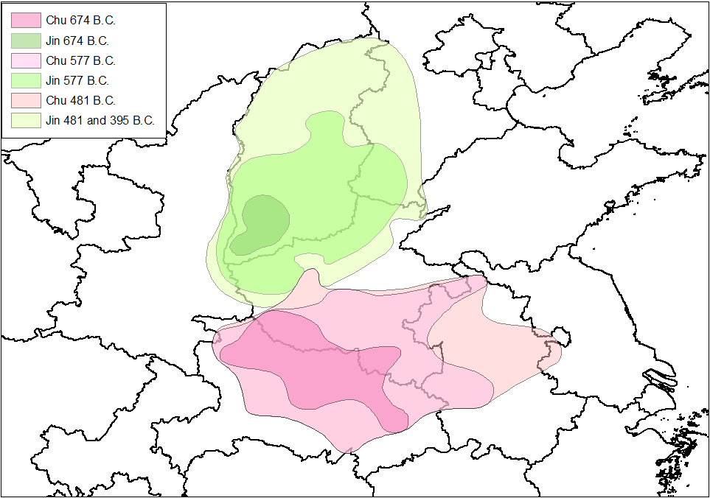

Figure C3: Border Estimates for Chu and Jin, 674-481 BCE.

Note: This map displays estimated state borders for Chu and Jin, for years 674 BCE, 577 BCE and 481 BCE.

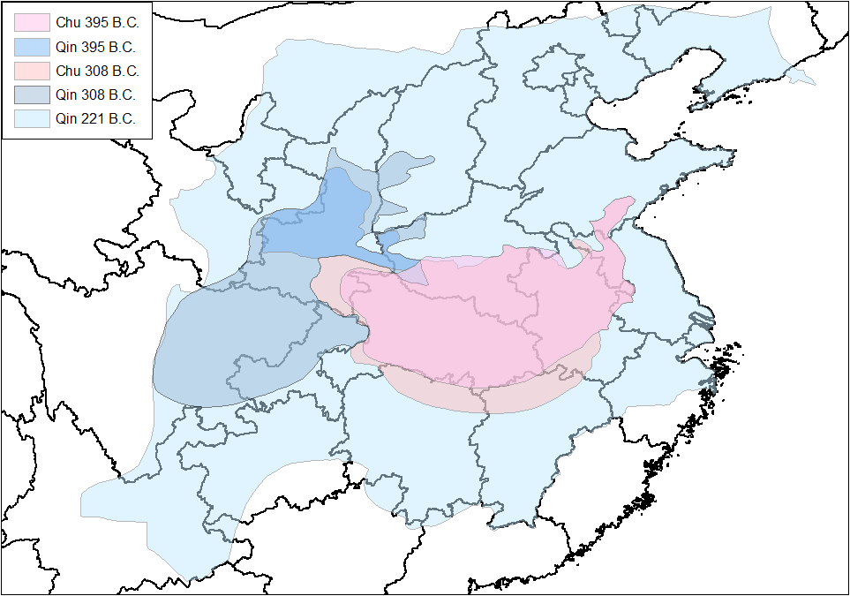

Figure C4: Border Estimates for Chu and Jin, 674-481 BCE.

Note: This map displays estimated state borders for Chu and Qin, for years 395 BCE, 308 BCE and 221 BCE.

**References**

**Ahmed, Ali., and David Stasavage.** 2020. “Origins of Early Democracy.” *American Political Science Review*, 114(2): 502-518.

**Bai, Yunxiang.** 2005. *Xianqin Lianghan Tieqi De Kaoguxue Yanjiu (Archaeological Studies of Ironware in the Pre-Qin Period and the Han Dynasty)*. Kexue Chubanshe.

**Becker, Sascha O., Andreas Ferrara, Eric Melander, and Luigi Pascali.** 2022. “Wars, Taxation and Representation: Evidence from Five Centuries of German History.” *Working Paper*.

**Boix, Carles. 2015.** *Political Order and Inequality: Their Foundations and Their Consequences for Human Welfare.* Cambridge University Press.

**Chen, Joy.** 2024. “Political Elites and Human Capital Formation in Pre-Imperial China.” *SSRN Working Paper*.

**Dincecco, Mark**. 2011. *Political Transformations and Public Finances.* Cambridge University Press.

**Durrant, Stephen, Wai-Yee Li, and David Schaberg.** 2016. *Zuo Tradition/Zuozhuan: Commentary on the “Spring and Autumn Annals”.* University of Washington Press.

**Ertman, Thomas.** 1997. *Birth of the Leviathan: Building States and Regimes in Medieval and Early Modern Europe.* Cambridge University Press.

**Ertman, Thomas.** 2017. “Otto Hintze, Stein Rokkan and Charles Tilly’s Theory of European State-building.” In *Does War Make States? Investigations of Charles Tilly’s Historical Sociology,* ed. Lars Bo Kaspersen and Jeppe Strandsbjerg. Cambridge University Press.

**Gennaioli, Nicola, and Hans-Joachim Voth.** 2015. “State Capacity and Military Conflict.” *Review of Economic Studies,* 82(4): 1409-1448.

**von Glahn, Richard. 2016.** The Economic History of China: From Antiquity to the Nineteenth Century. Cambridge University Press.

**Hintze, Otto.** 1970. “Typologie der ständischen Verfassungen des Abendlandes.” In *Staat und Verfassung – Gesammelte Abhandlungen zur Allgemeinen Verfassungsgeschichte*. Vandenhoeck & Ruprecht.

**Hou, Xiaorong.** 2009. *Qindai Zhengqu Dili (Administrative Geography in Qin D [;/ y0nasty)*. Shehui Kexue Wenxian Chubanshe.

**Hsu, Cho-yun.** 1965. *Ancient China in Transition: An Analysis of Social Mobility, 722-222 BC*. Stanford University Press.

**Keegan, John.** 1993. *A History of Warfare*. Vintage Books.

**Kiser, Edgar, and Yong Cai.** 2003. “War and Bureaucratization in Qin China: Exploring an Anomalous Case.” *American Sociological Review*, 68(4): 511-539.

**Lewis, Mark.** 1999. *Writing and Authority in Early China.* State University of New York Press.

**Levi, Margaret**. 1989. *Of Rule and Revenue.* University of California Press.

**Li, Feng.** 2008. *Bureaucracy and the State in Early China.* Cambridge University Press.

**Lyon, Ann**. 2016. *Constitutional History of the UK.* Routledge.

**Ma, Zhenglin.** 1998. *Zhongguo Chengshi Lishi Dili (Historical Geography of Chinese Cities)*. Jiaoyu Chubanshe.

**Ma, Baochun.** 2007. Jinguo Lishi Dili Yanjiu (Historical Geography of the State of Jin). Wenwu Chubanshe.

**Maddicott, J.R. 2010.** *The Origins of the English Parliament, 924-1327.* Oxford University Press.

**McNeill, William H.** 1974. *The Shape of European History.* Oxford University Press.

**North, Douglass C., John Joseph Wallis, and Barry R. Weingast.** 2009. *Violence and Social Orders: A Conceptual Framework for Interpreting Recorded Human History.* Cambridge University Press.

**Song, Yan.** 1994. “Zhongguo Lishishang Jige Chaodai De Jiangyu Mianji Gusuan (Estimating the Area of A Few Dynasties in Chinse History).” *Shixue Lilun Yanjiu*, 3: 149-150.

**Stasavage, David.** 2020. *The Decline and Rise of Democracy: A Global History from Antiquity to Today*. Princeton University Press.

**Strayer, Joseph R**. 1970. *On the Medieval Origins of the Modern State.* Princeton University Press.

**Tan, Qixiang.** 1996. *The Historical Atlas of China, vol. 1*. China Cartographic Publishing House.

**Tian, Chengfang.** 2017. *Dongzhou Shiqi Chuguo Zongzu Yanjiu (A Study of Chu Lineages in Eastern Zhou)*. Kexue Chubanshe.

**Wang, Yumin.** 1988. *Zhongguo Lishi Dili Gailun (An Introduction to Chinese Historical Geography), Vol.2*. Renmin Jiaoyu Chubanshe.

**Wittfogel, Karl A.** 1957. *Oriental Despotism: A Comparative Study of Total Power*. Yale University Press.

**Yang, Kuan.** 1998. *Zhanguo Shi (Warring States History)*. Shanghai Renmin Chubanshe.

**Zhao, Dingxin.** 2004. “Spurious Causation in a Historical Process: War and Bureaucratization in Early China.” *American Sociological Review*, 69: 603-607.

**Zhao, Dingxin.** 2015. *The Confucian-Legalist Sate: A New Theory of Chinese History.* Oxford University Press.

**Zhou, Zhenhe, and Xiaojie Li.** 2009. *Zhongguo Xingzheng Quhua Tongshi (The History of Chinese Administrative Divisions), Vol 1.* Fudan Daxue Chubanshe.

**Zhu, Fenghan.** 2004. *Shangzhou Jiazu Xingtai Yanjiu (A Study of Family Structures in Shang and Zhou)*. Tianjin Guji Chubanshe.

**Zuo, Peng.** 2012. *Chuguo Lishi Dili Yanjiu (Historical Geography of the State of Chu)*. Hubei Jiaoyu Chubanshe.

1. While the in-land walls were demolished by the First Emperor upon China's unification, the latter were connected together to form the Great Wall of China.
2. The fates of these national assemblies, however, diverged greatly in the next few centuries. By the 18th century, England had become a constitutional state whose Parliament possessed powers over legislation, taxation and foreign policy (Ertman 1997: 93-100; Stasavage 2020: 134, 259). For France and more generally Latin Europe, however, assemblies had been undermined as absolutism prevailed. German princes were also able to eliminate the influence of representative assemblies by the 17th century, and the electorate of Brandenburg ultimately evolved into the centralized bureaucratic state of Prussia (Stasavage 2020: 134-137).
3. Frequent participation in politics is reflected in the fact that ministers and their families resided in the state capital (Zhu 2004: 477).
4. Examples of the first type include Geng, Wei and Huo of Jin. Examples of the second type include Chu, Guayan and Li of Jin (Zhou and Li 2009: 254-287).
5. Hou (2009)’s comprehensive study of Qin's administrative geography suggests that Qin had a total of 732 counties. Song (1994) estimates the area of Qin dynasty to be 3.4 million square kilometers, which is 1312.75 thousand square miles. Thus, for the Qin dynasty, the total number of counties divided by area is 0.56, which is much higher than in the Warring States Period.