Supplementary file 1

Undernutrition among children and its determinants across the parliamentary constituencies of India: A geospatial analysis

Univariate Local Moran’s I Results

Table 1 Univariate LISA Moran's I Statistics showing the spatial dependency (at parliamentary constituency level) of the prevalence of undernutrition and predictor variables, India, 2015-16
Indicators of undernutrition and predictor variables | Univariate Moran’s I
Children underweight (%) | 0.776
Children stunted (%) | 0.758
Children wasted (%) | 0.562
Poverty head count ratio (%) | 0.670
Households using improved sanitation facility (%) | 0.772
Women with ten or more years of schooling (%) | 0.726
Births delivered at health facilities (%) | 0.755
Mothers who had at least four antenatal care visits (%) | 0.821
Women whose body mass index (bmi) was below normal (bmi < 18.5 kg/m2) (%) | 0.719
Women aged 20-24 years married before age 18 years (%) | 0.751
Children aged 6-59 months who were anaemic (%) | 0.645
Children aged 6-23 months who received adequate diet (%) | 0.756
All Moran’s I values significant at 999 permutation (pseudo p<0.001)

Bi-variate Local Moran’s I Results- LISA Maps

Figures 1-6 depict the Bi-variate Local Moran’s I Results:

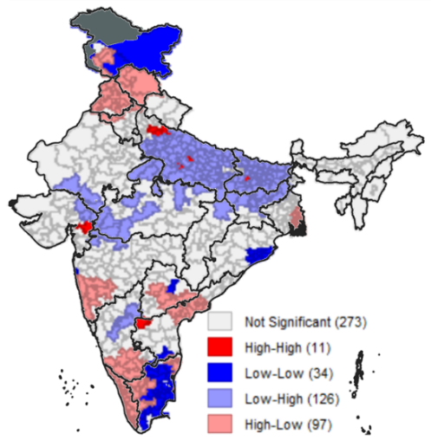(a) | 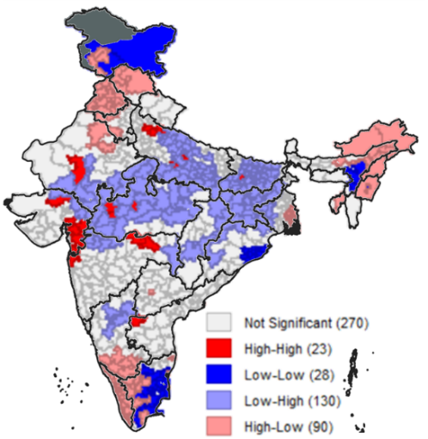(b) | 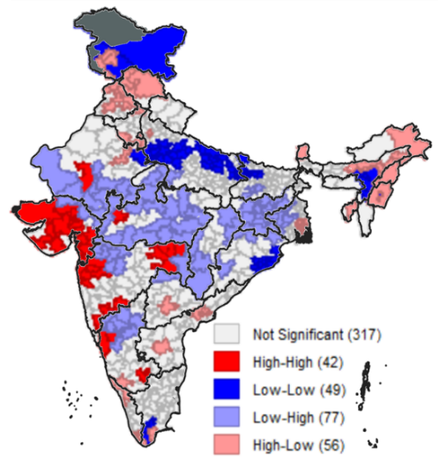 (c)
Fig. 1 Bivariate LISA cluster of improved sanitation vs children (a) stunted, (b) underweight and (c) wasted, across parliamentary constituencies of India
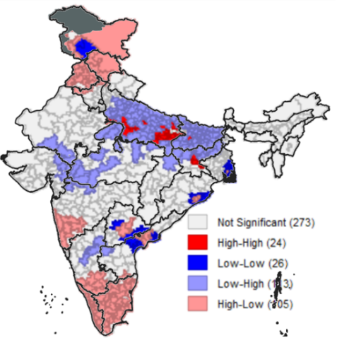(a) | 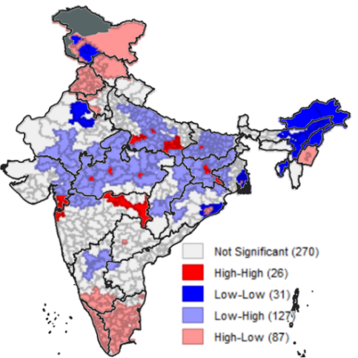(b) | 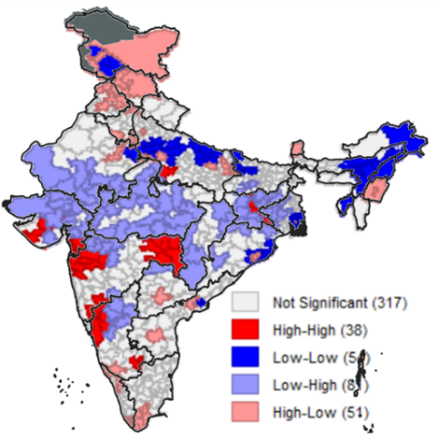 (c)
Fig.2 Bivariate LISA cluster of Women with 10 or more years of schooling vs children (a) stunted, (b) underweight and (c) wasted, across parliamentary constituencies of India
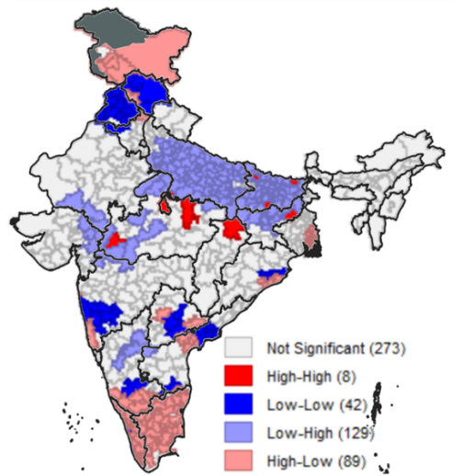(a) | 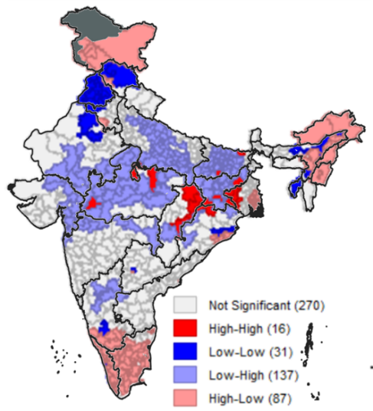(b) | 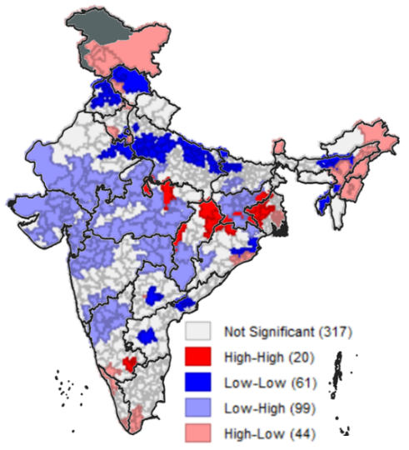(c)
Fig.3 Bivariate LISA cluster of Children age 12-23 months receiving an adequate diet vs children (a) stunted, (b) underweight and (c) wasted, across parliamentary constituencies of India
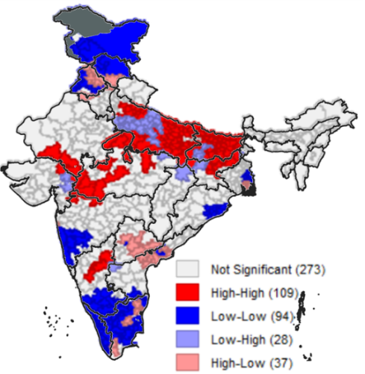(a) | 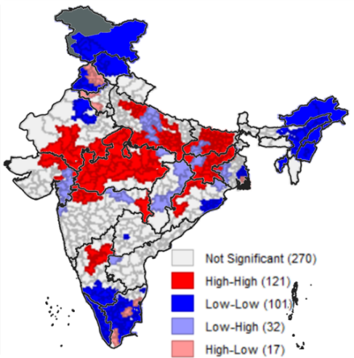(b) | 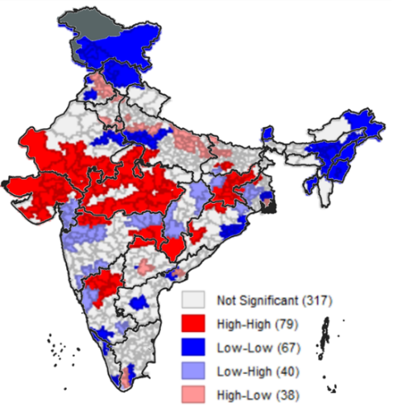(c)
Fig.4 Bivariate LISA cluster of Children age 6-59 months who are anaemic vs children (a) stunted, (b) underweight and (c) wasted, across parliamentary constituencies of India
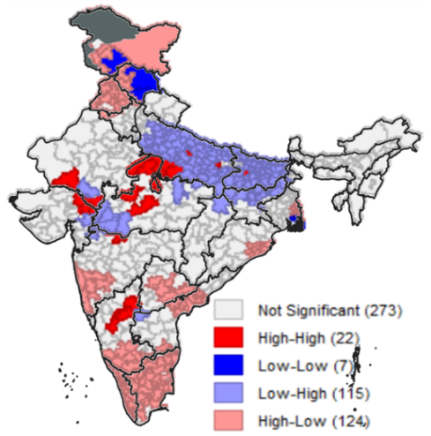(a) | 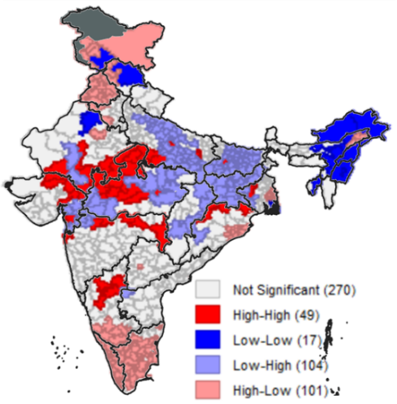(b) | 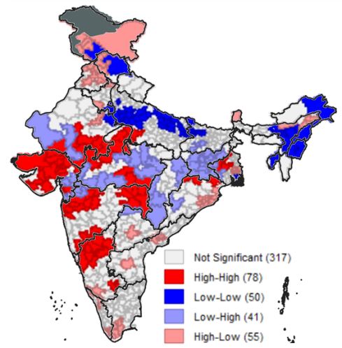(c)
Fig.5 Bivariate LISA cluster of institutional births vs children (a) stunted, (b) underweight and (c) wasted, across parliamentary constituencies of India
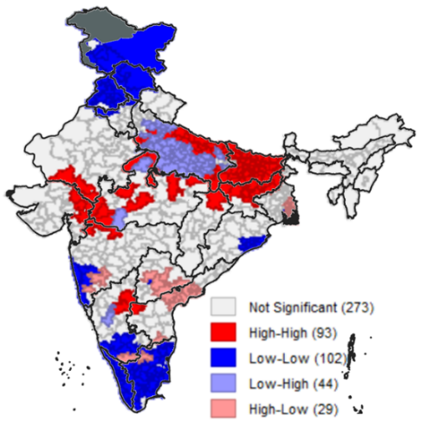(a) | 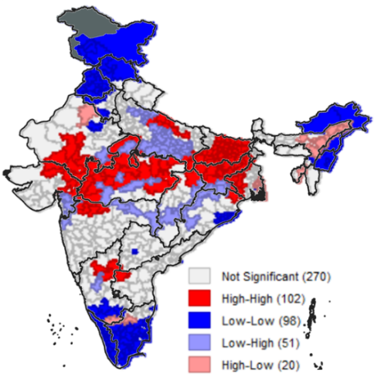(b) | 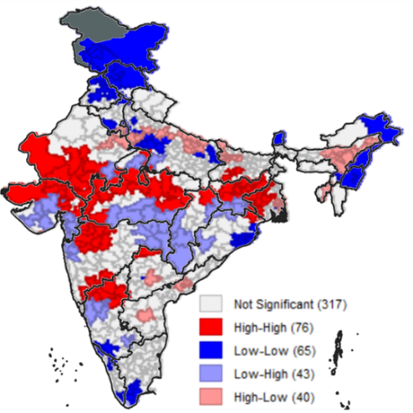(c)
Fig.6 Bivariate LISA cluster of Women age 20-24 years married before age 18 years vs children (a) stunted, (b) underweight and (c) wasted, across parliamentary constituencies of India

