Supplementary file 3

Undernutrition among children and its determinants across the parliamentary constituencies of India: A geospatial analysis

Maharashtra – as a Case Study
The state of Maharashtra, located in the western peninsular region of the country, suffers from high rates undernutrition among children, performing poorly in terms of all three indicators of undernutrition. Considerable intra-state variations are evident through the LISA results from above and also in line with the Harvard study. This emphasises the need for further understanding the local context when developing health interventions, as stated by Swaminathan et al.. Hence, a state-specific spatial analysis was carried to explore the undernutrition variation across constituencies specific to the state of Maharashtra, by applying the Univariate and Bivariate LISA statistics. When analysing one state as against the nation, the parameter’s average across the constituencies of one state is considered in the algorithm, which further help highlight more clusters and the intra-state variations. Born of by similar analysis conducted at the state level for intra-state variations, this Maharashtra case study is just to illustrate that even if the average is changed, the broader picture remains the same. And the results of this case study help identify and study the cluster of constituencies underprivileged in terms of child undernutrition which are also disadvantaged in terms of socio-economic characteristics, maternal and child health, specific to one state.
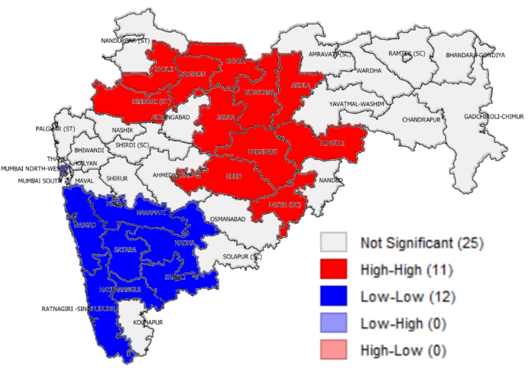 | 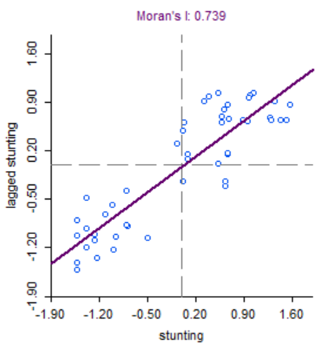
Fig.1 Univariate LISA cluster map for children stunted across Parliamentary constituencies of Maharashtra | Fig.4 Univariate Local Moran’s I for children stunted across Parliamentary constituencies of Maharashtra
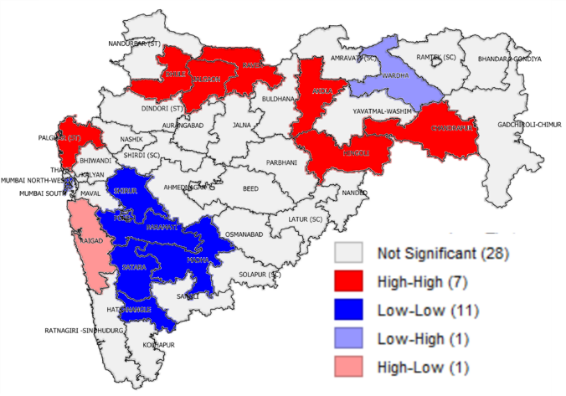 | 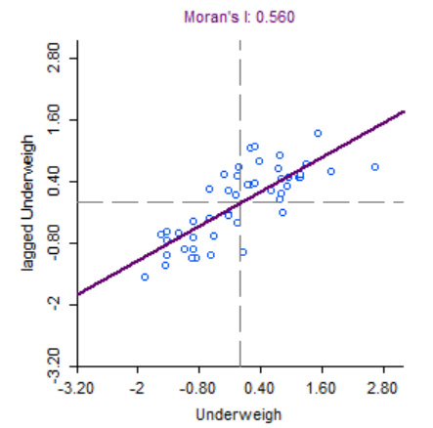
Fig.2 Univariate LISA cluster map for children underweight across Parliamentary constituencies of Maharashtra | Fig.5 Univariate Local Moran’s I for children underweight across Parliamentary constituencies of Maharashtra
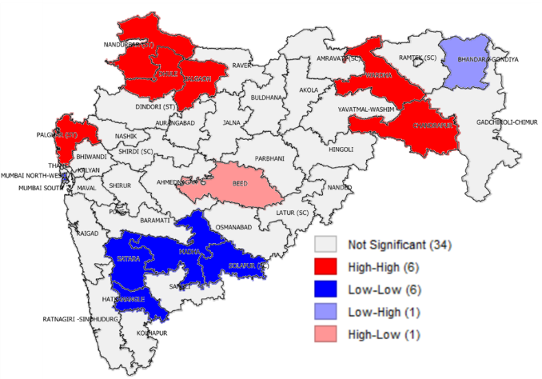 | 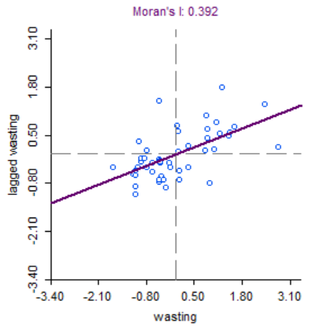
Fig.3 Univariate LISA cluster map for children wasted across Parliamentary constituencies of Maharashtra | Fig.6 Univariate Local Moran’s I for children wasted across Parliamentary constituencies of Maharashtra

The Univariate LISA maps indicate significant and strong clusters within this state (Figures 1-3). Fig 1 showing the cluster map of children stunted, very clearly highlights the eleven constituencies having high prevalence of stunted children surrounded by high prevalence of stunted children, and the twelve constituencies having lower than the average of children stunted. The Moran’s I score is also the highest for children stunted (Moran’s I=0.74) across the constituencies of Maharashtra, followed by children underweight (Moran’s I=0.56). The univariate LISA map of underweight identifies the significant PC- Wardha as a positive deviant PC, having below average prevalence of underweight children but is surrounded by constituencies having high prevalence of underweight children. Similarly, another positive deviant PC- Bhandara-Gondiya has low prevalence of wasted children but has neighbours with high prevalence of wasted children.
The Maharashtra Bivariate LISA maps (Figures 7-11) helped in identifying the constituencies which were underprivileged in terms of child undernutrition and were also disadvantaged in terms of socio-economic characteristics, maternal health. The constituencies which have a higher prevalence of children stunted, underweight and wasted also had high poverty head count ratio (Fig 7), low sanitation facilities (Fig8), low percent of women who have had antenatal care visits (Fig 9), high proportion of women with below normal BMI (Fig 10) and lower per cent children receiving an adequate diet (Fig 11). The Baramati PC is an example of best-case scenarios for the state, as this PC performs well in terms of all parameters with respect to children undernourished as well as the selected independent variables.
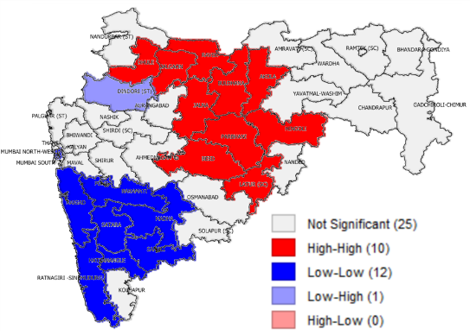(a) | 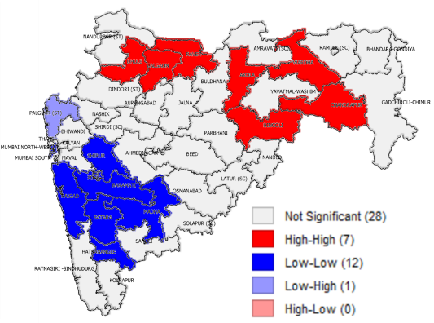(b) | 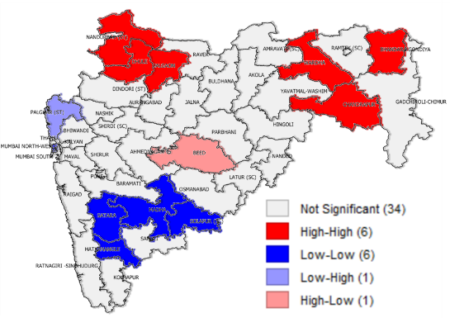(c)
Fig.7 Bivariate LISA cluster of poverty vs children (a) stunted (b) underweight (c) wasted, across parliamentary constituencies of Maharashtra
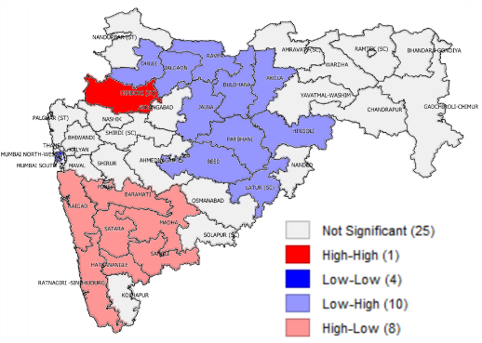(a) | 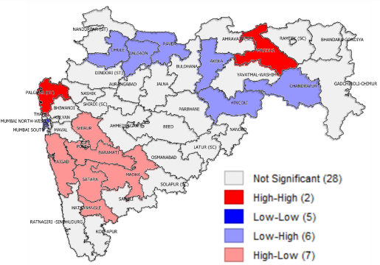(b) | 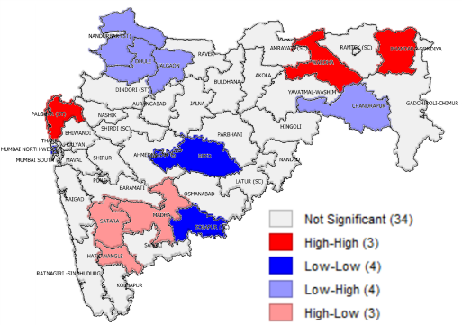(c)
Fig.8 Bivariate LISA cluster of improved sanitation vs children (a) stunted (b) underweight (c) wasted, across parliamentary constituencies of Maharashtra
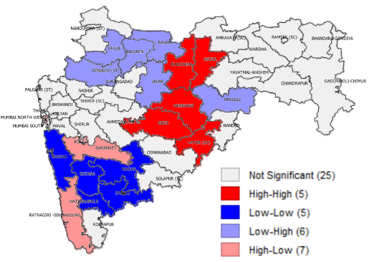(a) | 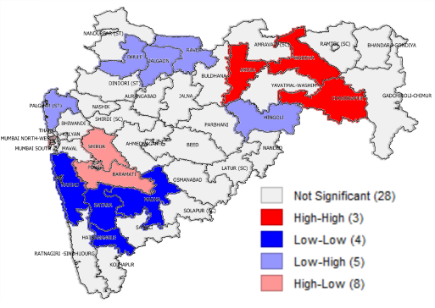(b) | 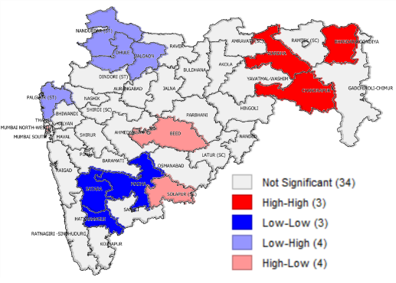(c)
Fig.9 Bivariate LISA cluster of Antenatal care vs children (a) stunted (b) underweight (c) wasted,, across parliamentary constituencies of Maharashtra
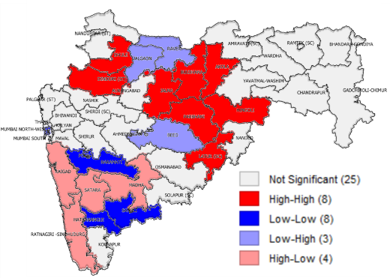(a) | 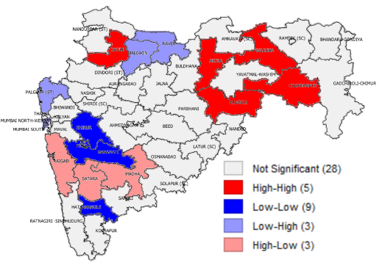(b) | 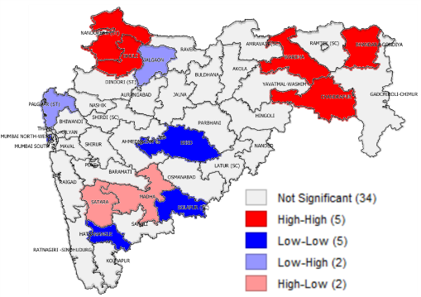(c)
Fig.10 Bivariate LISA cluster of Women whose Body Mass Index (BMI) is below normal (BMI < 18.5 kg/m2) vs children (a) stunted (b) underweight (c) wasted, across parliamentary constituencies of Maharashtra
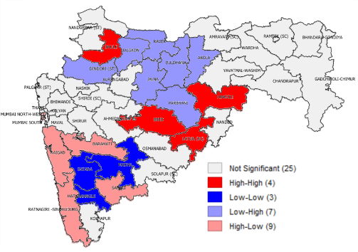(a) | 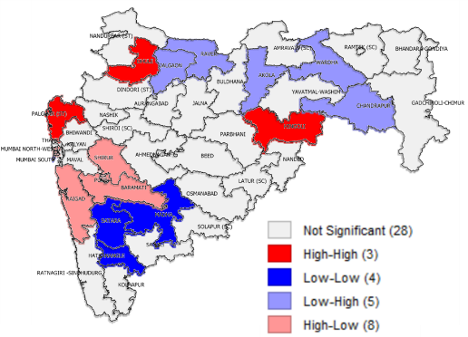(b) | 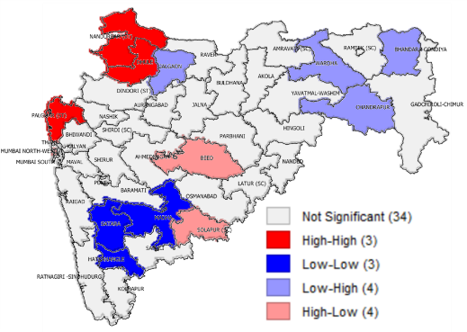(c)
Fig.11 Bivariate LISA cluster of Children age 12-23 months receiving an adequate diet vs children (a) stunted (b) underweight (c) wasted, across parliamentary constituencies of Maharashtra

Swaminathan A, Kim R, Xu Y, Blossom JC, Joe W, Venkatraman R, Kumar A, Subramanian SV. (2019) Burden of child malnutrition in India: a view from parliamentary constituencies. Economic & Political Weekly. 54(2).

