Supporting Information S1: Randomization-based tests

It was mentioned briefly at the end of the sub-section “A brief review of the Mercer & Hall example in Fisher (1925)” that Fisher regarded exact randomization tests merely as a tool for checking the approximate validity of the model-based inference assuming normality. For the example in Table 1, we obtained model-based p-values of 0.461, 0.325 and 0.378 for CRD, RCBD and COV, respectively. By comparison, using the randomization approach described in the section “Empirical comparison,” we found corresponding randomization-based p-values of 0.470, 0.326, and 0.404, suggesting that the model-based p-values provide a good approximation. Three remarks are in order in relation to this check suggested by Fisher. (i) This check is rarely used in practice. Instead, almost invariably researchers inspect residual plots to check the approximate validity of assumptions of normality and homogeneity of variance. (ii) Randomization tests were very cumbersome to perform a century ago, but are easy to implement nowadays (Manly, 2007; Hemerik, 2024). In fact, there are areas of research where such methods of inference feature prominently, e.g. in microbiome research (Kelly et al., 2015) or in community ecology (ter Braak, 1992), where responses are known to be far from normal. (iii) Our randomization-based analyses permute the observed data. This is suitable for the simple designs considered here. For more complex settings, e.g. multiple regression and for analysis of observational data, permutation tests based on residuals are often preferable. Moreover, there are many variants of the general idea, including the use of bootstrapping (ter Braak, 1992) and modifications allowing adjustments for covariates (Tang et al., 2009; Zhao and Ding, 2021).

Kelly BJ, Gross R, Bittinger K, Sherrill-Mix S, Lewis JD, Collman RG, Bushman FD and Li H (2015) Power and sample-size estimation for microbiome studies using pairwise distances and PERMANOVA. Bioinformatics 31, 2461–2468. https://doi.org/10.1093/bioinformatics/btv183
Manly BFJ (2007) Randomization, Bootstrap and Monte Carlo Methods in Biology. Boca Raton: Chapman & Hall/CRC.
Hemerik J (2024) On the term “randomization test”. The American Statistician 78, 327−334. https://doi.org/10.1080/00031305.2024.2319182
Tang L, Duan N, Klap R, Rosenbaum Asarnow J, Belin TR (2009) Applying permutation tests with adjustment for covariates and attrition weights to randomized trials of health-services interventions. Statistics in Medicine 28, 65−74. https://doi.org/10.1002/sim.3453
ter Braak CJF (1992) Permutation versus bootstrap significance tests in multiple regression and ANOVA. pp. 79-86. In: Jöckel KH, Rothe G and Sendler W (eds) Bootstrapping and Related Techniques. Lecture Notes in Economics and Mathematical Systems 376. Berlin: Springer. https://doi.org/10.1007/978-3-642-48850-4_10
Zhao A and Ding P (2021) Covariate-adjusted Fisher randomization tests for the average treatment effect. Journal of Econometrics 225, 278−294. https://doi.org/10.1016/j.jeconom.2021.04.007

Supporting Information S2: Analysis for barley uniformity data in Piepho and Williams (2010)

We repeated the analysis found in the main text using the uniformity trial data described in more detail in Piepho and Wiliams (2010). The trial is for spring barley and was conducted at Ihinger Hof (University of Hohenheim, Germany) in 2007. The trial had 30 rows and 36 columns. Plot width was 1.90 m along rows and 3.73 m along columns. There were missing plots in 2 of the columns, so we dropped these and used only the 34 complete columns. In each column, comprising 30 plots, we moved a window of 20 contiguous plots, allowing for 11 layouts. All other settings were exactly as described for the Mercer and Hall data in the main text.
The results are given in Table S1 and Table S2, as well as in Figure S1 and Figure S2. The general picture emerging from these results is similar to the Mercer and Hall data, with CRD, RCBD and COV providing good empirical estimates of error and Type 1 error rates, whereas SYS and MIT display greater discrepancies between model-based and empirical measures of error. Both SYS and MIT yield model-based estimates of the variance of a difference that is above the empirical variance (Figure S2).

Table S1: Empirical Type 1 error rates, empirical variance of a difference (EMP) and model-based predicted variance of a difference (PRE) using the Piepho and Williams (2010) spring barley uniformity data for different designs and analysis options. The response is yield.
Design³ /  analysis options | No. of analyses¹ | Empirical Type 1 error rate (α=5%) |  | Empirical variance of a difference (EMP) |  |  |  | Model-based predicted variance of a difference (PRE)
 |  | F-test | t-test | Avg. | Min. | Max. |  | Avg. | Min. | Max.
CRD | 11×34×1000 | 0.0463 | 0.0491 | 9.6642 | 0.0045 | 133.971 |  | 9.6432 | 0.5324 | 52.1034
RCBD | 11×34×1000 | 0.0457 | 0.0482 | 7.1321 | 0.0079 | 65.3624 |  | 7.1189 | 0.3319 | 26.6913
COV | 11×34×993 | 0.0484 | 0.0501 | 7.3439 | 0.0055 | 59.1394 |  | 7.2394 | 0.2865 | 28.8783
SYS | 11×34
Block effect |  | 0.0454 | 0.0521 | 7.5111 | 0.1129 | 47.0020 |  | 6.9925 | 1.2984 | 24.0010
+Position covariate |  | 0.0454 | 0.0540 | 7.5111 | 0.1129 | 47.0020 |  | 6.7279 | 1.3937 | 19.0199
SYS + Permutation | 11×34×120
Block effect |  | 0.0454 | 0.0521 | 7.5111 | 0.1129 | 47.0020 |  | 6.9925 | 1.2984 | 24.0010
+Position covariate |  | 0.0454 | 0.0540 | 7.5111 | 0.1129 | 47.0020 |  | 6.7279 | 1.3937 | 19.0199
MIT | 11×34
Block effect |  | 0.0357 | 0.0422 | 7.5630 | 0.0649 | 38.6933 |  | 6.9752 | 1.4291 | 25.4135
Linear variance² |  | 0.0534 | 0.0505 | 7.2522 | 0.1125 | 34.5553 |  | 5.8422 | 0.3010 | 18.6656
MIT + Permutation | 11×34×120
Block effect |  | 0.0357 | 0.0422 | 7.5630 | 0.0649 | 38.6933 |  | 6.9752 | 1.4291 | 25.4135
Linear variance² |  | 0.0599 | 0.0540 | 7.2477 | 0.1125 | 34.5554 |  | 5.8077 | 0.1633 | 18.6655
¹ Eleven sliding windows of 20 plots in each of 34 rows and 1000 randomizations (or all 933 or 120 permutations of treatment labels)
² Model in eq. (1)
³ CRD = completely randomized design; RCBD = randomized complete block design; COV = covariate-adjusted block design (see subsection “Some design considerations”); SYS = systematic arrangement (see Figure 1); MIT = Mitscherlich’s systematic design (MIT)

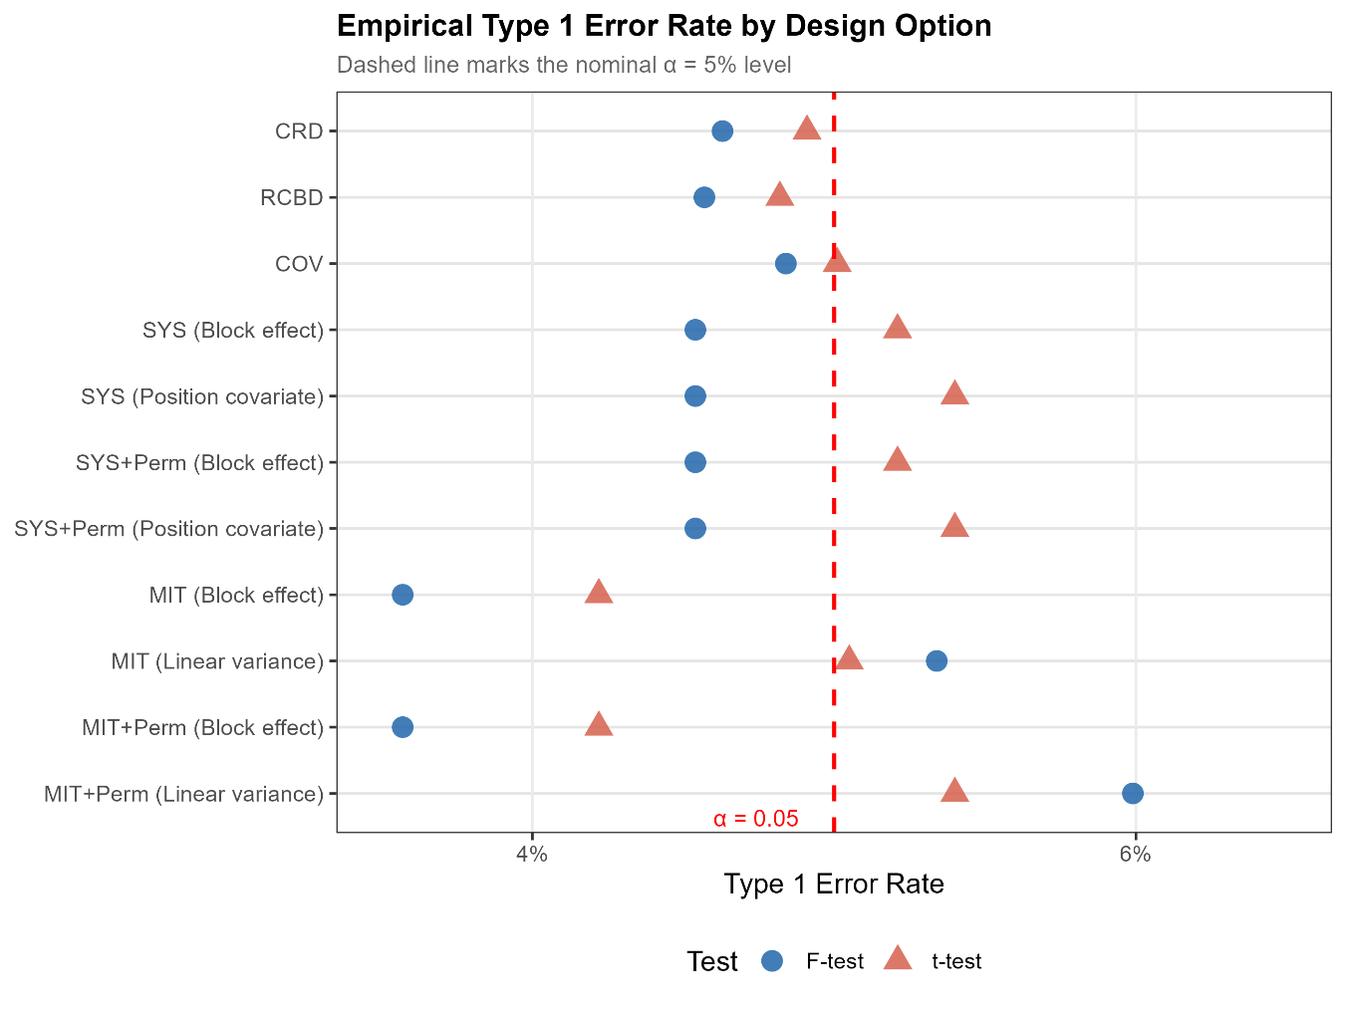
Figure S1: Empirical Type 1 error rates using the Piepho and Williams (2010) spring barley uniformity data for different design and analysis options. The response is grain yield. Linear variance: model in eq. (1).
CRD = completely randomized design; RCBD = randomized complete block design; COV = covariate-adjusted block design (see subsection “Some design considerations”); SYS = systematic arrangement (see Figure 1); MIT = Mitscherlich’s systematic design (MIT); Perm = Permutation of treatment labels on each newly generated design.

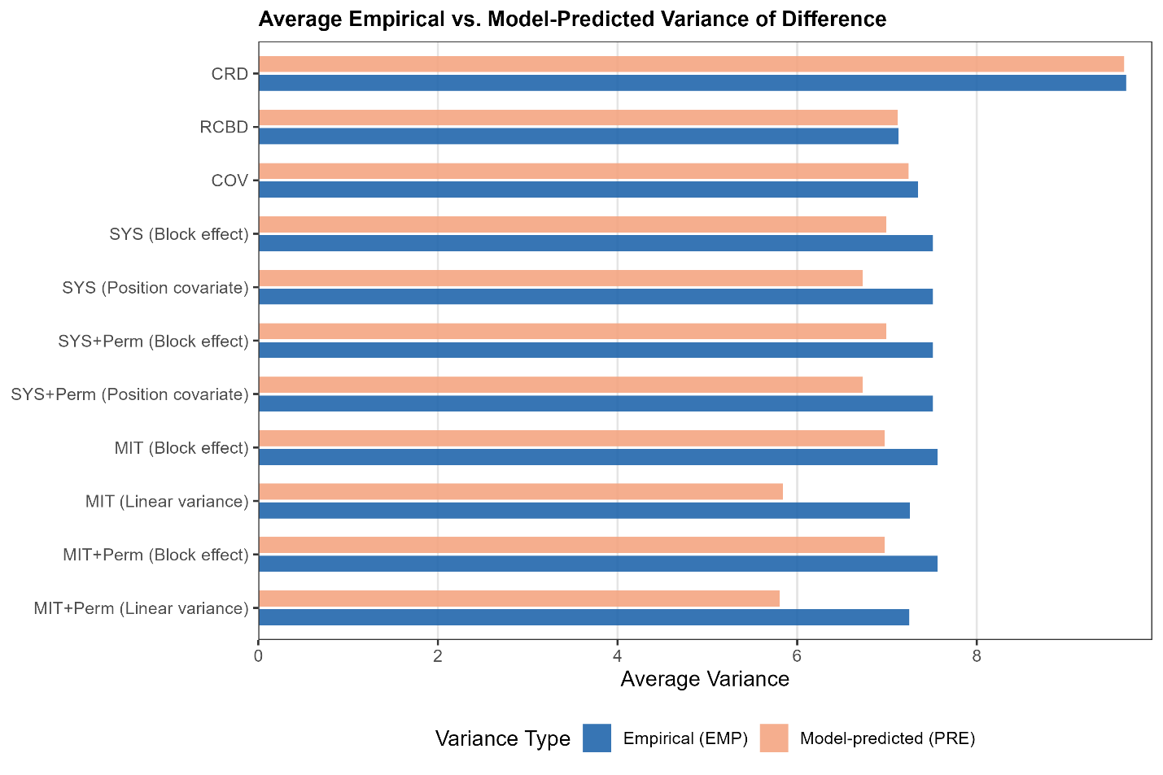
Figure S2: Empirical variance of a difference (EMP) and model-based predicted variance of a difference (PRE) using the Piepho and Williams (2010) spring barley uniformity data for different design and analysis options. The response is grain yield. Linear variance: model in eq. (1).
CRD = completely randomized design; RCBD = randomized complete block design; COV = covariate-adjusted block design (see subsection “Some design considerations”); SYS = systematic arrangement (see Figure 1); MIT = Mitscherlich’s systematic design (MIT); Perm = Permutation of treatment labels on each newly generated design.

Table S2: Pairwise Empirical variance of a difference (EMP) and model-based predicted variance of a difference (PRE) for SYS and MIT designs with different analysis options using the Piepho and Williams (2010) spring barley uniformity data. Upper figures represent EMP, middle figures in brackets represent PRE, and lower figures in square brackets represent the empirical Type 1 error rate at α=5%. The response is grain yield. Details of the randomizations are given in Table S1 (second column).
Design² /  analysis options | A – B | A – C | A – D | A – E | B – C | B – D | B – E | C – D | C – E | D – E
SYS
Block effect | 6.2728  (6.9926)  [0.0374] | 7.6654  (6.9926)  [0.0561] | 8.2989  (6.9926)  [0.0588] | 9.3372  (6.9926)  [0.0775] | 6.5128  (6.9926)  [0.0348] | 6.9733  (6.9926)  [0.0481] | 8.7945  (6.9926)  [0.0642] | 6.6536  (6.9926)  [0.0428] | 8.0727  (6.9926)  [0.0588] | 6.5299  (6.9926)  [0.0428]
+ Position covariate | 6.2728  (6.7279)  [0.0374] | 7.6654  (6.7279)  [0.0454] | 8.2989  (6.7279)  [0.0642] | 9.3372  (6.7279)  [0.0829] | 6.5128  (6.7279)  [0.0454] | 6.9733  (6.7279)  [0.0481] | 8.7945  (6.7279)  [0.0695] | 6.6536  (6.7279)  [0.0401] | 8.0727  (6.7279)  [0.0508] | 6.5299  (6.7279)  [0.0561]
SYS + Permutation
Block effect | 7.5111  (6.9926)  [0.0521] | 7.5111  (6.9926)  [0.0521] | 7.5111  (6.9926)  [0.0521] | 7.5111  (6.9926)  [0.0521] | 7.5111  (6.9926)  [0.0521] | 7.5111  (6.9926)  [0.0521] | 7.5111  (6.9926)  [0.0521] | 7.5111  (6.9926)  [0.0521] | 7.5111  (6.9926)  [0.0521] | 7.5111  (6.9926)  [0.0521]
+ Position covariate | 7.5111  (6.7279)  [0.0540] | 7.5111  (6.7279)  [0.0540] | 7.5111  (6.7279)  [0.0540] | 7.5111  (6.7279)  [0.0540] | 7.5111  (6.7279)  [0.0540] | 7.5111  (6.7279)  [0.0540] | 7.5111  (6.7279)  [0.0540] | 7.5111  (6.7279)  [0.0540] | 7.5111  (6.7279)  [0.0540] | 7.5111  (6.7279)  [0.0540]
MIT
Block effect | 6.3931  (6.9753)  [0.0241] | 7.5787  (6.9753)  [0.0374] | 8.2758  (6.9753)  [0.0535] | 8.7459  (6.9753)  [0.0401] | 6.6247  (6.9753)  [0.0374] | 7.7719  (6.9753)  [0.0508] | 8.4668  (6.9753)  [0.0481] | 6.9411  (6.9753)  [0.0401] | 7.8637  (6.9753)  [0.0481] | 6.9677  (6.9753)  [0.0428]
Linear variance¹ | 6.4111  (5.6646)  [0.0449] | 7.3741  (5.8541)  [0.0505] | 7.6797  (6.0187)  [0.0589] | 7.7328  (6.1784)  [0.0477] | 6.5315  (5.6611)  [0.0393] | 7.4549  (5.8472)  [0.0449] | 7.7914  (6.0187)  [0.0617] | 6.9009  (5.661)  [0.0505] | 7.5671  (5.8541)  [0.0505] | 7.0780  (5.6646)  [0.0562]
MIT + Permutation
Block effect | 7.5629  (6.9752)  [0.0422] | 7.5629  (6.9752)  [0.0422] | 7.5629  (6.9752)  [0.0422] | 7.5629  (6.9752)  [0.0422] | 7.5629  (6.9752)  [0.0422] | 7.5629  (6.9752)  [0.0422] | 7.5629  (6.9752)  [0.0422] | 7.5629  (6.9752)  [0.0422] | 7.5629  (6.9752)  [0.0422] | 7.5629  (6.9752)  [0.0422]
Linear variance¹ | 7.2497  (5.8077)  [0.0541] | 7.2485  (5.8078)  [0.0539] | 7.2478  (5.8076)  [0.0540] | 7.2493  (5.8076)  [0.0541] | 7.2473  (5.8077)  [0.0541] | 7.2464  (5.8077)  [0.0538] | 7.2457  (5.8077)  [0.0539] | 7.2459  (5.8078)  [0.0539] | 7.2496  (5.8078)  [0.0545] | 7.2466  (5.8077)  [0.0539]
¹ Model in eq. (1)² SYS = systematic arrangement (see Figure 1); MIT = Mitscherlich’s systematic design (MIT)

Supporting Information S3: Analysis for wheat uniformity data in Iyer (1942)

We repeated the analysis found in the main text using the uniformity trial data described in more detail in Iyer (1942). The trial is for wheat and was conducted at the Agricultural Sub-station in Karnal, India, in 1938. A net area of 400 ft × 125 ft (122 m × 38 m) was harvested by dividing it into 80 × 25 plots of 5 ft × 5 ft (1.52 m × 1.52 m). The trial had 25 rows and 80 columns. In each row, comprising 80 plots, we moved a window of 20 contiguous plots, allowing for 61 layouts. All other settings were exactly as described for the Mercer and Hall data in the main text.
The results are given in Table S3 and Table S4, as well as in Figure S3 and Figure S4. The general picture emerging from these results is similar to the Mercer and Hall data, with CRD, RCBD and COV providing good empirical estimates of error and Type 1 error rates, whereas SYS and MIT display greater discrepancies between model-based and empirical measures of error. Both SYS and MIT yield model-based estimates of the variance of a difference that is above the empirical variance (Figure S3).

Table S3: Empirical Type 1 error rates, empirical variance of a difference (EMP) and model-based predicted variance of a difference (PRE) using the Iyer (1942) wheat uniformity data for different designs and analysis options. The response is yield in ounce per plot.
Design³ /  analysis options | No. of analyses¹ | Empirical Type 1 error rate (α=5%) |  | Empirical variance of a difference (EMP) |  |  |  | Model-based predicted variance of a difference (PRE)
 |  | F-test | t-test | Avg. | Min. | Max. |  | Avg. | Min. | Max.
CRD | 61×25×1000 | 0.0499 | 0.0498 | 3.4078 | 0 | 40.2500 |  | 3.4071 | 0.1979 | 14.9937
RCBD | 61×25×1000 | 0.0491 | 0.0496 | 2.6023 | 0 | 28.6031 |  | 2.6029 | 0.1114 | 11.7000
COV | 61×25×993 | 0.0513 | 0.0508 | 2.7166 | 0.0019 | 37.9259 |  | 2.6898 | 0.0932 | 12.9527
SYS | 61×25
Block effect |  | 0.0688 | 0.0626 | 2.9095 | 0.0156 | 17.7719 |  | 2.5005 | 0.3010 | 9.5594
+Position covariate |  | 0.0734 | 0.0639 | 2.9095 | 0.0156 | 17.7719 |  | 2.4527 | 0.2147 | 9.1909
SYS + Permutation | 61×25×120
Block effect |  | 0.0688 | 0.0626 | 2.9095 | 0.0156 | 17.7719 |  | 2.5005 | 0.3010 | 9.5594
+Position covariate |  | 0.0734 | 0.0639 | 2.9095 | 0.0156 | 17.7719 |  | 2.4527 | 0.2147 | 9.1909
MIT | 61×25
Block effect |  | 0.0295 | 0.0432 | 2.4835 | 0.0562 | 11.2437 |  | 2.6425 | 0.5083 | 10.8875
Linear variance² |  | 0.0349 | 0.0508 | 2.4995 | 0.0440 | 10.9127 |  | 1.9764 | 0.1078 | 9.0776
MIT + Permutation | 61×25×120
Block effect |  | 0.0295 | 0.0432 | 2.4835 | 0.0562 | 11.2437 |  | 2.6425 | 0.5083 | 10.8875
Linear variance² |  | 0.0370 | 0.0516 | 2.4985 | 0.0440 | 10.9127 |  | 1.7253 | 0.1078 | 9.0776
¹ 61 sliding windows of 20 plots in each of 25 rows and 1000 randomizations (or all 933 or 120 permutations of treatment labels)
² Model in eq. (1)
³ CRD = completely randomized design; RCBD = randomized complete block design; COV = covariate-adjusted block design (see subsection “Some design considerations”); SYS = systematic arrangement (see Figure 1); MIT = Mitscherlich’s systematic design (MIT)

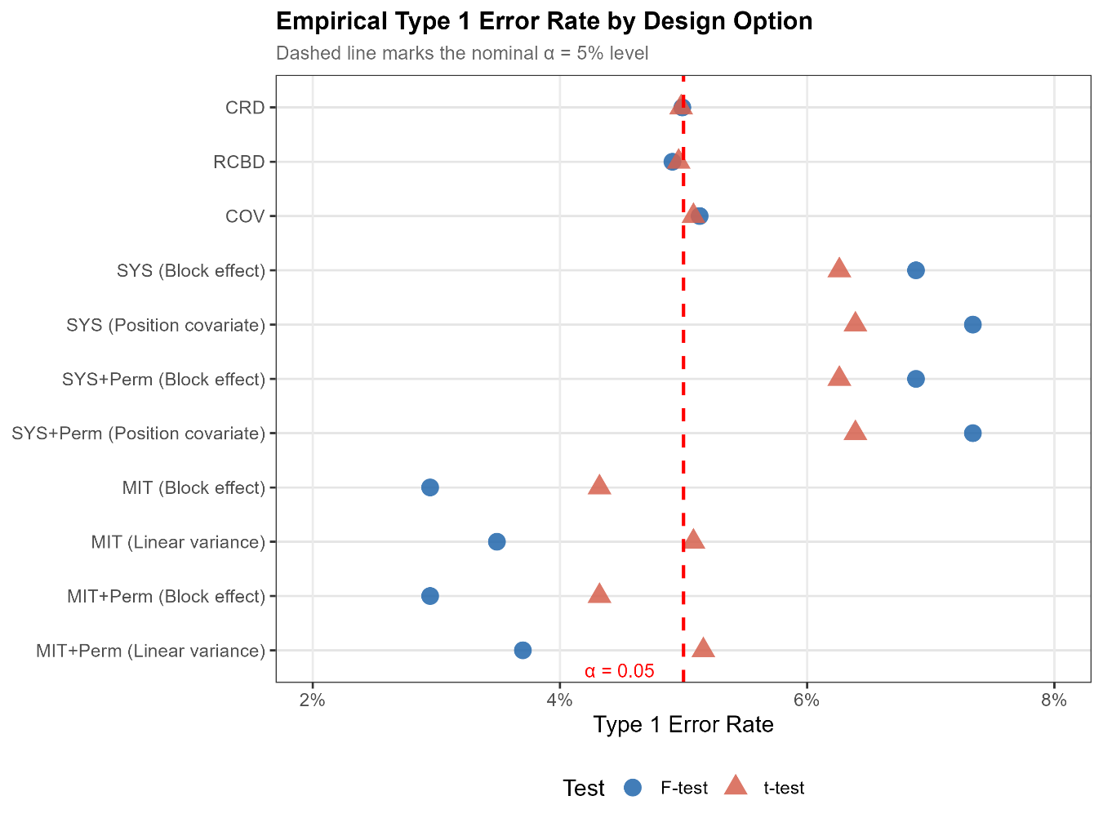
Figure S3: Empirical Type 1 error rates using the Iyer (1942) wheat uniformity data for different design and analysis options. The response is grain yield in ounce per plot. Linear variance: model in eq. (1).
CRD = completely randomized design; RCBD = randomized complete block design; COV = covariate-adjusted block design (see subsection “Some design considerations”); SYS = systematic arrangement (see Figure 1); MIT = Mitscherlich’s systematic design (MIT); Perm = Permutation of treatment labels on each newly generated design.

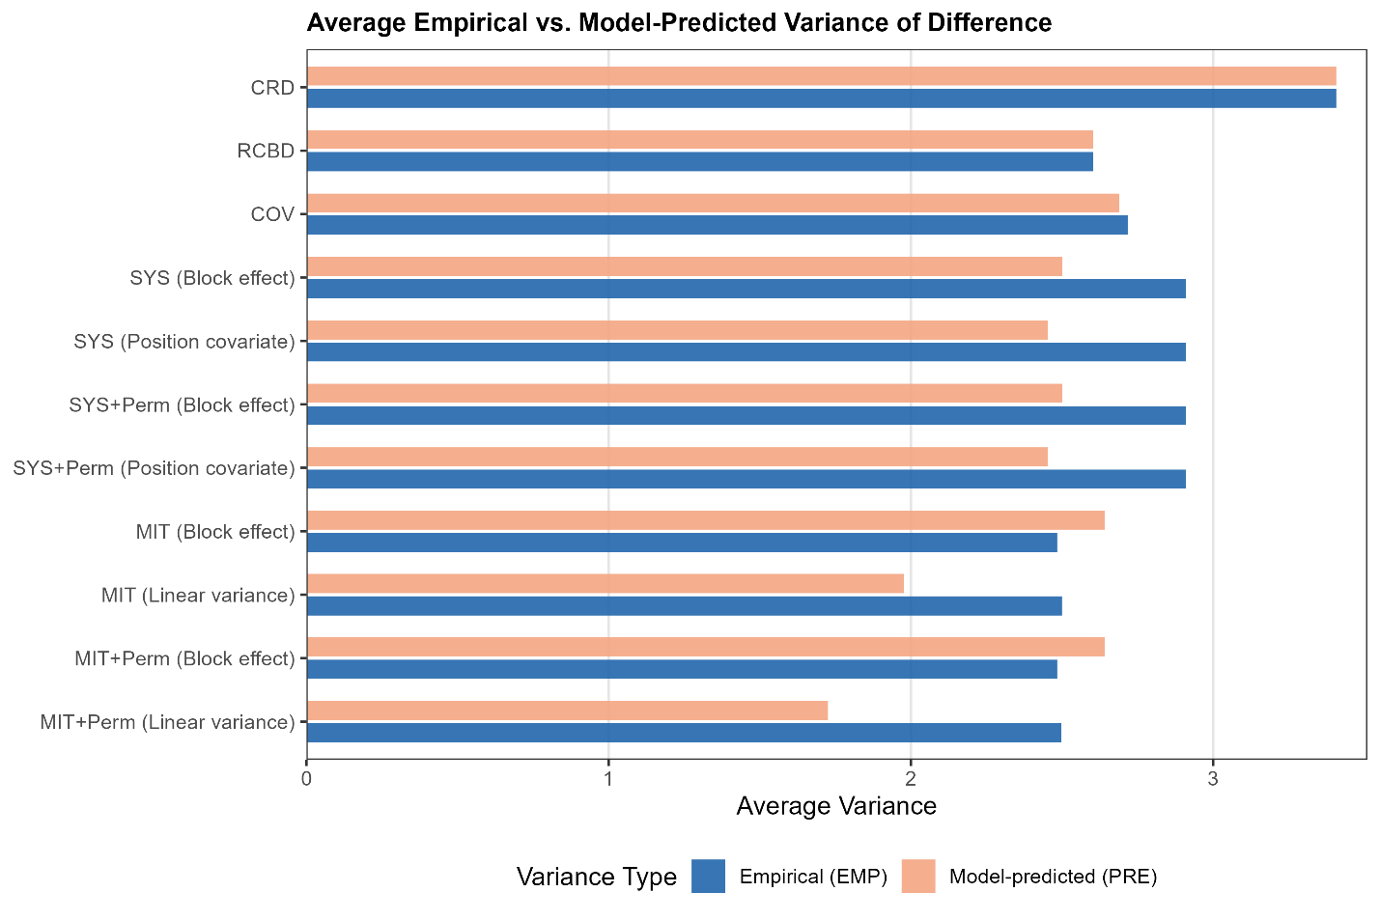
Figure S4: Empirical variance of a difference (EMP) and model-based predicted variance of a difference (PRE) using the Iyer (1942) wheat uniformity data for different design and analysis options. The response is grain yield in ounce per plot. Linear variance: model in eq. (1).
CRD = completely randomized design; RCBD = randomized complete block design; COV = covariate-adjusted block design (see subsection “Some design considerations”); SYS = systematic arrangement (see Figure 1); MIT = Mitscherlich’s systematic design (MIT); Perm = Permutation of treatment labels on each newly generated design.

Table S4: Pairwise Empirical variance of a difference (EMP) and model-based predicted variance of a difference (PRE) for SYS and MIT designs with different analysis options using the Iyer (1942) wheat uniformity data. Upper figures represent EMP, middle figures in brackets represent PRE, and lower figures in square brackets represent the empirical Type 1 error rate at α=5%. The response is grain yield in ounce per plot. Details of the randomizations are given in Table S3 (second column).
Design² /  analysis options | A – B | A – C | A – D | A – E | B – C | B – D | B – E | C – D | C – E | D – E
SYS
Block effect | 2.2813  (2.5005)  [0.0419] | 2.9936  (2.5005)  [0.0662] | 3.4154  (2.5005)  [0.0833] | 4.0937  (2.5005)  [0.1082] | 2.2287  (2.5005)  [0.0498] | 2.8537  (2.5005)  [0.0492] | 3.5915  (2.5005)  [0.0734] | 2.2956  (2.5005)  [0.0426] | 3.0280  (2.5005)  [0.0702] | 2.3136  (2.5005)  [0.0407]
+ Position covariate | 2.2813  (2.4527)  [0.0446] | 2.9936  (2.4527)  [0.0708] | 3.4154  (2.4527)  [0.0859] | 4.0937  (2.4527)  [0.1089] | 2.2287  (2.4527)  [0.0492] | 2.8537  (2.4527)  [0.0525] | 3.5915  (2.4527)  [0.0774] | 2.2956  (2.4527)  [0.0439] | 3.0280  (2.4527)  [0.0695] | 2.3136  (2.4527)  [0.0367]
SYS + Permutation
Block effect | 2.9095  (2.5005)  [0.0625] | 2.9095  (2.5005)  [0.0625] | 2.9095  (2.5005)  [0.0625] | 2.9095  (2.5005)  [0.0625] | 2.9095  (2.5005)  [0.0625] | 2.9095  (2.5005)  [0.0625] | 2.9095  (2.5005)  [0.0625] | 2.9095  (2.5005)  [0.0625] | 2.9095  (2.5005)  [0.0625] | 2.9095  (2.5005)  [0.0625]
+ Position covariate | 2.9095  (2.4527)  [0.0639] | 2.9095  (2.4527)  [0.0639] | 2.9095  (2.4527)  [0.0639] | 2.9095  (2.4527)  [0.0639] | 2.9095  (2.4527)  [0.0639] | 2.9095  (2.4527)  [0.0639] | 2.9095  (2.4527)  [0.0639] | 2.9095  (2.4527)  [0.0639] | 2.9095  (2.4527)  [0.0639] | 2.9095  (2.4527)  [0.0639]
MIT
Block effect | 2.1975  (2.6425)  [0.0334] | 2.6352  (2.6425)  [0.0472] | 2.7393  (2.6425)  [0.0525] | 2.6070  (2.6425)  [0.0433] | 2.2059  (2.6425)  [0.0354] | 2.6365  (2.6425)  [0.0505] | 2.7274  (2.6425)  [0.0505] | 2.2098  (2.6425)  [0.0354] | 2.6430  (2.6425)  [0.0472] | 2.2338  (2.6425)  [0.0367]
Linear variance¹ | 2.2441  (1.9055)  [0.0426] | 2.6728  (1.9819)  [0.0552] | 2.7403  (2.0483)  [0.0601] | 2.5331  (2.1151)  [0.0454] | 2.2581  (1.9044)  [0.0447] | 2.6722  (1.9784)  [0.0629] | 2.7221  (2.0449)  [0.0559] | 2.2367  (1.9038)  [0.0447] | 2.6503  (1.9794)  [0.0566] | 2.2649  (1.9024)  [0.0398]
MIT + Permutation
Block effect | 2.4835  (2.6425)  [0.0432] | 2.4835  (2.6425)  [0.0432] | 2.4835  (2.6425)  [0.0432] | 2.4835  (2.6425)  [0.0432] | 2.4835  (2.6425)  [0.0432] | 2.4835  (2.6425)  [0.0432] | 2.4835  (2.6425)  [0.0432] | 2.4835  (2.6425)  [0.0432] | 2.4835  (2.6425)  [0.0432] | 2.4835  (2.6425)  [0.0432]
Linear variance¹ | 2.4975  (1.9724)  [0.0514] | 2.4981  (1.9724) [0.0514] | 2.4991  (1.9724) [0.0516] | 2.4984  (1.9724) [0.0517] | 2.4995  (1.9724) [0.0517] | 2.4982  (1.9724) [0.0514] | 2.4975  (1.9724) [0.0516] | 2.4995  (1.9724) [0.0516] | 2.4983  (1.9724) [0.0517] | 2.4986  (1.9724) [0.0516]
¹ Model in eq. (1)
² SYS = systematic arrangement (see Figure 1); MIT = Mitscherlich’s systematic design (MIT)

Supporting Information S4: Analysis for rice uniformity data in Khin (1950)

We repeated the analysis found in the main text using the uniformity trial data described in more detail in Khin (1950). The trial is for rice and was conducted at the Mudon Agricultural Station Burma, in 1947-48. A net area of 90 ft × 108 ft (27.4 m × 32.9 m) was harvested by dividing it into 36 × 30 plots of 3 ft × 3 ft (0.91 m × 0.91 m). The trial had 36 rows and 30 columns. In each row, comprising 30 plots, we moved a window of 20 contiguous plots, allowing for 11 layouts. All other settings were exactly as described for the Mercer and Hall data in the main text.
The results are given in Table S5 and Table S6, as well as in Figure S5 and Figure S6. The general picture emerging from these results is similar to the Mercer and Hall data, with CRD, RCBD and COV providing good empirical estimates of error and Type 1 error rates, whereas SYS and MIT display greater discrepancies between model-based and empirical measures of error. Both SYS and MIT yield model-based estimates of the variance of a difference that is above the empirical variance (Figure S5).

Table S5: Empirical Type 1 error rates, empirical variance of a difference (EMP) and model-based predicted variance of a difference (PRE) using the Khin (1950) rice uniformity data for different designs and analysis options. The response is yield in ounce per plot.
Design³ /  analysis options | No. of analyses¹ | Empirical Type 1 error rate (α=5%) |  | Empirical variance of a difference (EMP) |  |  |  | Model-based predicted variance of a difference (PRE)
 |  | F-test | t-test | Avg. | Min. | Max. |  | Avg. | Min. | Max.
CRD | 11×36×1000 | 0.0510 | 0.0502 | 0.6015 | 0.0015 | 3.7328 |  | 0.6021 | 0.0489 | 1.2947
RCBD | 11×36×1000 | 0.0501 | 0.0498 | 0.4856 | 0 | 3.1992 |  | 0.4866 | 0.0159 | 1.3479
COV | 11×36×993 | 0.0477 | 0.0485 | 0.4955 | 0 | 3.5904 |  | 0.4999 | 0.0169 | 1.6035
SYS | 11×36
Block effect |  | 0.0454 | 0.0515 | 0.5035 | 0.0296 | 1.7172 |  | 0.4805 | 0.0901 | 1.2008
+Position covariate |  | 0.0479 | 0.0523 | 0.5036 | 0.0296 | 1.7172 |  | 0.4661 | 0.0881 | 1.1724
SYS + Permutation | 11×36×120
Block effect |  | 0.0454 | 0.0515 | 0.5035 | 0.0296 | 1.7172 |  | 0.4805 | 0.0901 | 1.2008
+Position covariate |  | 0.0479 | 0.0523 | 0.5035 | 0.0296 | 1.7172 |  | 0.4661 | 0.0881 | 1.1724
MIT | 11×36
Block effect |  | 0.0782 | 0.0684 | 0.5656 | 0.0391 | 1.5406 |  | 0.4599 | 0.0731 | 1.0523
Linear variance² |  | 0.0628 | 0.0683 | 0.5621 | 0.0352 | 1.5489 |  | 0.3944 | 0.0246 | 0.9564
MIT + Permutation | 11×36×120
Block effect |  | 0.0782 | 0.0684 | 0.5656 | 0.0391 | 1.5406 |  | 0.4599 | 0.0731 | 1.0523
Linear variance² |  | 0.0644 | 0.0692 | 0.5624 | 0.0352 | 1.5489 |  | 0.3942 | 0.0228 | 0.9564
¹ Eleven sliding windows of 20 plots in each of 36 rows and 1000 randomizations (or all 933 or 120 permutations of treatment labels)
² Model in eq. (1)
³ CRD = completely randomized design; RCBD = randomized complete block design; COV = covariate-adjusted block design (see subsection “Some design considerations”); SYS = systematic arrangement (see Figure 1); MIT = Mitscherlich’s systematic design (MIT)

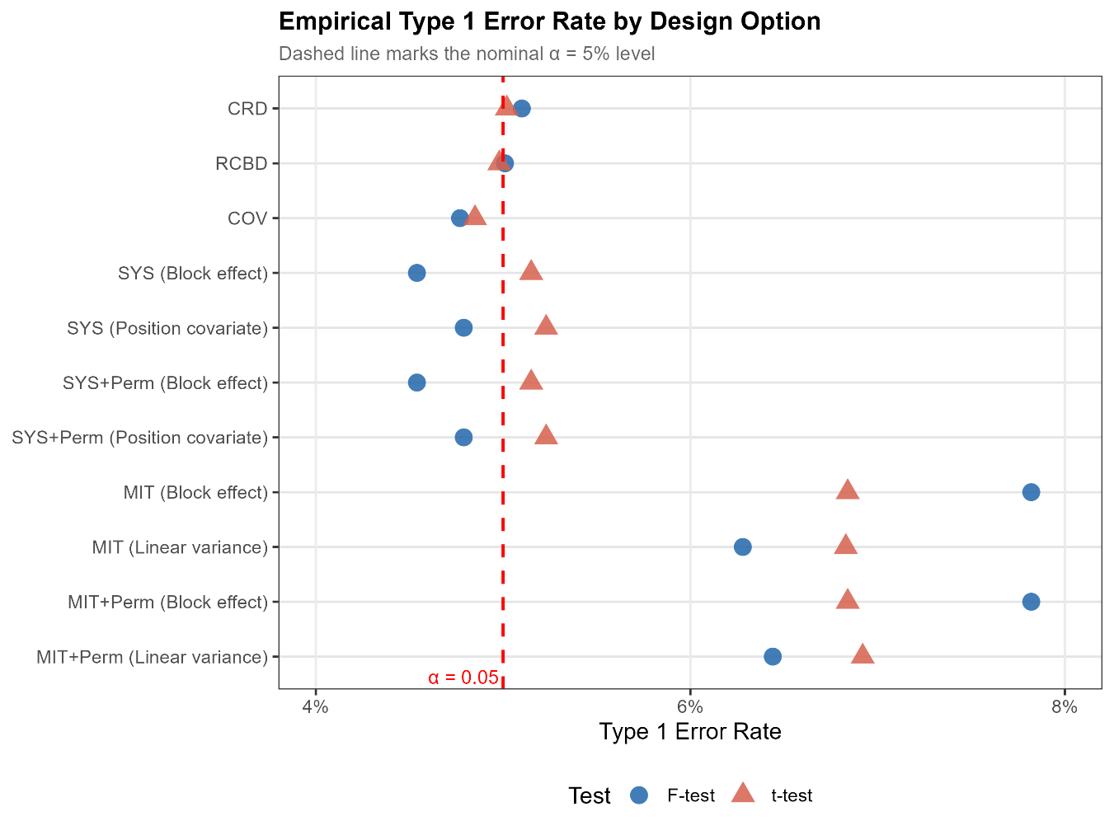
Figure S5: Empirical Type 1 error rates using the Khin (1950) rice uniformity data for different design and analysis options. The response is grain yield in ounce per plot. Linear variance: model in eq. (1).
CRD = completely randomized design; RCBD = randomized complete block design; COV = covariate-adjusted block design (see subsection “Some design considerations”); SYS = systematic arrangement (see Figure 1); MIT = Mitscherlich’s systematic design (MIT); Perm = Permutation of treatment labels on each newly generated design.

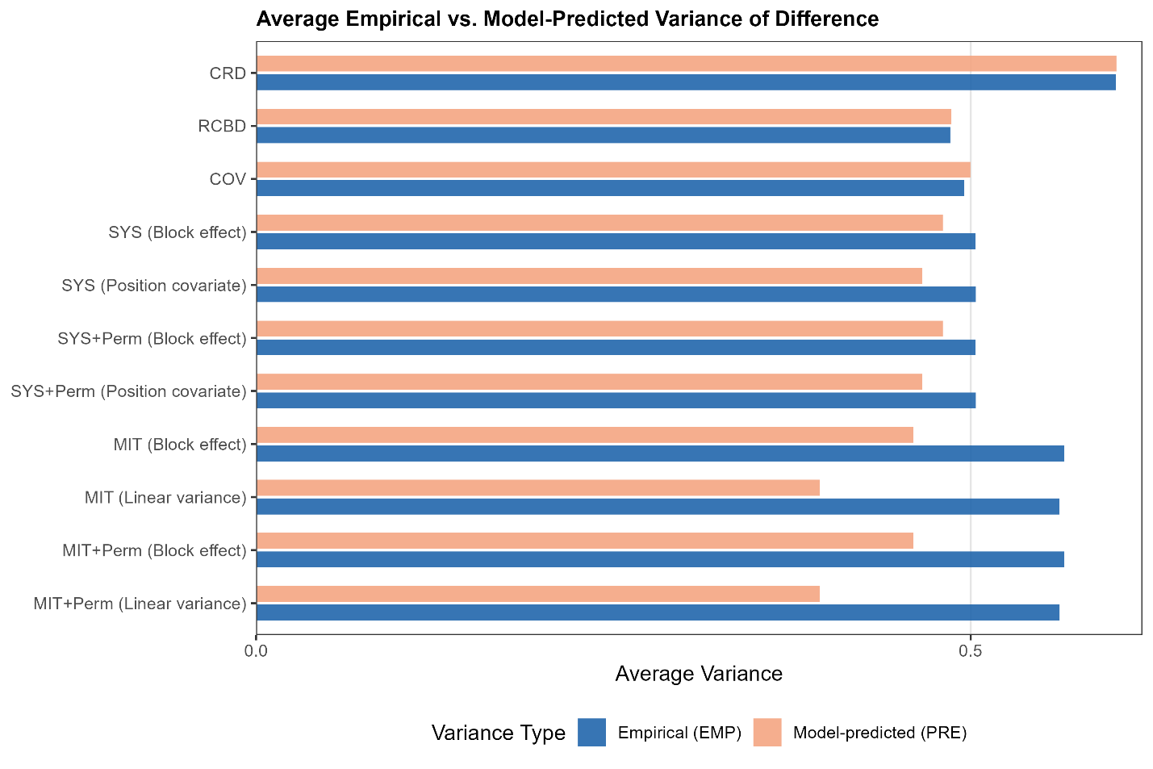
Figure S6: Empirical variance of a difference (EMP) and model-based predicted variance of a difference (PRE) using the Khin (1950) rice uniformity data uniformity data for different design and analysis options. The response is grain yield in ounce per plot. Linear variance: model in eq. (1).
CRD = completely randomized design; RCBD = randomized complete block design; COV = covariate-adjusted block design (see subsection “Some design considerations”); SYS = systematic arrangement (see Figure 1); MIT = Mitscherlich’s systematic design (MIT); Perm = Permutation of treatment labels on each newly generated design.

Table S6: Pairwise Empirical variance of a difference (EMP) and model-based predicted variance of a difference (PRE) for SYS and MIT designs with different analysis options using the Khin (1950) rice uniformity data. Upper figures represent EMP, middle figures in brackets represent PRE, and lower figures in square brackets represent the empirical Type 1 error rate at α=5%. The response is grain yield in ounce per plot. Details of the randomizations are given in Table S5 (second column).
Design² /  analysis options | A – B | A – C | A – D | A – E | B – C | B – D | B – E | C – D | C – E | D – E
SYS
Block effect | 0.4696  (0.4805)  [0.0404] | 0.5716  (0.4805)  [0.0732] | 0.4696  (0.4805)  [0.0328] | 0.4672  (0.4805)  [0.0379] | 0.4437  (0.4805)  [0.0479] | 0.4746  (0.4805)  [0.0353] | 0.5258  (0.4805)  [0.0555] | 0.5275  (0.4805)  [0.0505] | 0.5632  (0.4805)  [0.0859] | 0.5228  (0.4805)  [0.0555]
+ Position covariate | 0.4696  (0.4661)  [0.0429] | 0.5716  (0.4661)  [0.0707] | 0.4696  (0.4661)  [0.0404] | 0.4672  (0.4661) [0.0379] | 0.4437  (0.4661)  [0.0429] | 0.4746  (0.4661)  [0.0404] | 0.5258  (0.4661)  [0.0555] | 0.5275  (0.4661)  [0.0530] | 0.5632  (0.4661)  [0.0808] | 0.5228  (0.4661)  [0.0581]
SYS + Permutation
Block effect | 0.5036  (0.4805)  [0.0515] | 0.5036  (0.4805)  [0.0515] | 0.5036  (0.4805)  [0.0515] | 0.5036  (0.4805)  [0.0515] | 0.5036  (0.4805)  [0.0515] | 0.5036  (0.4805)  [0.0515] | 0.5036  (0.4805)  [0.0515] | 0.5036  (0.4805)  [0.0515] | 0.5036  (0.4805)  [0.0515] | 0.5036  (0.4805)  [0.0515]
+ Position covariate | 0.5036  (0.4661)  [0.0523] | 0.5036  (0.4661)  [0.0523] | 0.5036  (0.4661)  [0.0523] | 0.5036  (0.4661)  [0.0523] | 0.5036  (0.4661)  [0.0523] | 0.5036  (0.4661)  [0.0523] | 0.5036  (0.4661)  [0.0523] | 0.5036  (0.4661)  [0.0523] | 0.5036  (0.4661)  [0.0523] | 0.5036  (0.4661)  [0.0523]
MIT
Block effect | 0.5389  (0.4599)  [0.0631] | 0.6073  (0.4599)  [0.0732] | 0.5907  (0.4599)  [0.0859] | 0.5997  (0.4599)  [0.0782] | 0.5214  (0.4599)  [0.0530] | 0.5903  (0.4599)  [0.0732] | 0.5791  (0.4599)  [0.0783] | 0.5076  (0.4599)  [0.0556] | 0.5938  (0.4599)  [0.0707] | 0.5274  (0.4599)  [0.0530]
Linear variance¹ | 0.5425  (0.3846)  [0.0654] | 0.6133  (0.3948)  [0.0864] | 0.5843  (0.4042)  [0.0707] | 0.5753  (0.4137)  [0.0602] | 0.5247  (0.3845)  [0.0549] | 0.5917  (0.3945)  [0.0811] | 0.5726  (0.4042)  [0.0759] | 0.5049  (0.3845)  [0.0549] | 0.5863  (0.3947)  [0.0811] | 0.5253  (0.3846)  [0.0523]
MIT + Permutation
Block effect | 0.5656  (0.4598)  [0.0684] | 0.5656  (0.4598)  [0.0684] | 0.5656  (0.4598)  [0.0684] | 0.5656  (0.4598)  [0.0684] | 0.5656  (0.4598)  [0.0684] | 0.5656  (0.4598)  [0.0684] | 0.5656  (0.4598)  [0.0684] | 0.5656  (0.4598)  [0.0684] | 0.5656  (0.4598)  [0.0684] | 0.5656  (0.4598)  [0.0684]
Linear variance¹ | 0.5623  (0.3942)  [0.0691] | 0.5625  (0.3942)  [0.0693] | 0.5623  (0.3942)  [0.0692] | 0.5623  (0.3942)  [0.0691] | 0.5624  (0.3942)  [0.0691] | 0.5623  (0.3942)  [0.0692] | 0.5624  (0.3942)  [0.0692] | 0.5624  (0.3942)  [0.0691] | 0.5625  (0.3942)  [0.0692] | 0.5624  (0.3942)  [0.0692]
¹ Model in eq. (1)
² SYS = systematic arrangement (see Figure 1); MIT = Mitscherlich’s systematic design (MIT)

Supporting Information S5: SAS code used for analyses presented in main text

/*Fisher 1925 SMRW p. 264*/

data a;
input yield trt_CR $ block trt_RCBD $ trt_sys $ trt_Mit $ pos plot;
datalines;
3504 b 1 a a a 1 1
3430 c 1 e b b 2 2
3376 a 1 c c c 3 3
3334 c 1 d d d 4 4
3253 e 1 b e e 5 5
3314 e 2 c e a 1 6
3287 e 2 b d b 2 7
3361 a 2 e c c 3 8
3404 d 2 d b d 4 9
3366 a 2 a a e 5 10
3416 b 3 a a a 1 11
3291 c 3 d b b 2 12
3244 b 3 e c c 3 13
3210 d 3 b d d 4 14
3168 d 3 c e e 5 15
3195 b 4 c e a 1 16
3330 a 4 e d b 2 17
3118 d 4 b c c 3 18
3029 c 4 a b d 4 19
3085 e 4 d a e 5 20
;

/*CRD*/
proc glm data=a;
class trt_CR;
model yield=trt_CR;
run;

proc glimmix data=a;
class trt_CR;
model yield=trt_CR;
lsmeans trt_CR/pdiff;
run;

/*RCBD*/
proc glm data=a;
class trt_RCBD block;
model yield=block trt_RCBD;
run;

proc glimmix data=a;
class trt_RCBD block;
model yield=block trt_RCBD;
lsmeans trt_RCBD/pdiff;
run;

/*Systematic arrangement*/
proc glm data=a;
class trt_sys block;
model yield=block trt_sys;
run;

proc glimmix data=a;
class trt_sys block;
model yield=block trt_sys;
lsmeans trt_sys/pdiff;
run;

/*Mischerlich arrangement*/
proc glm data=a;
class trt_mit block;
model yield=block trt_mit;
run;

proc glimmix data=a;
class trt_mit block;
model yield=block trt_mit;
lsmeans trt_mit/pdiff;
run;

/*position covariate*/

/*CRD with plot number as covariate --- Fisher did not consider this analysis! Yet, it is the most accurate*/
proc glm data=a;
class trt_CR;
model yield=trt_CR plot;
run;

proc glimmix data=a;
ods output diffs=diffs7;
class trt_CR;
model yield=trt_CR plot;
lsmeans trt_CR/pdiff;
run;

proc means data=diffs7 mean max min;
var StdErr;
run;

/*RCBD with position number as covariate -- SED quite heterogeneous*/
proc glm data=a;
class trt_RCBD block;
model yield=block trt_RCBD pos;
run;

proc glimmix data=a;
ods output diffs=diffs2;
class trt_RCBD block;
model yield=block trt_RCBD pos;
lsmeans trt_RCBD/priff;
run;

proc means data=diffs2 mean max min;
var StdErr;
run;

/*Systematic arrangement with position number as covariate --- Constant SED!!!*/
proc glm data=a;
class trt_sys block;
model yield=block trt_sys pos;
run;

proc glimmix data=a;
class trt_sys block;
model yield=block trt_sys pos;
lsmeans trt_sys/pdiff;
run;

/*Mitscherlich arrangement with position number as covariate.
WARNING: Position number confounded with treatment*/
proc glm data=a;
class trt_mit block;
model yield=block trt_mit pos;
run;

proc glimmix data=a;
class trt_mit block;
model yield=block trt_mit pos;
lsmeans trt_mit/pdiff;
run;

/*do the same with plot no as covariate, but drop block -- SED almost constant*/
proc glm data=a;
class trt_mit;
model yield=trt_mit plot;
run;

proc glimmix data=a;
class trt_mit;
model yield=trt_mit plot;
lsmeans trt_mit/pdiff;
run;

/*LV analysis*/

data L;
input parm row col1-col20;
datalines;
1 1 5 4 3 2 1 0 0 0 0 0 0 0 0 0 0 0 0 0 0 0
1 2 4 5 4 3 2 1 0 0 0 0 0 0 0 0 0 0 0 0 0 0
1 3 3 4 5 4 3 2 1 0 0 0 0 0 0 0 0 0 0 0 0 0
1 4 2 3 4 5 4 3 2 1 0 0 0 0 0 0 0 0 0 0 0 0
1 5 1 2 3 4 5 4 3 2 1 0 0 0 0 0 0 0 0 0 0 0
1 6 0 1 2 3 4 5 4 3 2 1 0 0 0 0 0 0 0 0 0 0
1 7 0 0 1 2 3 4 5 4 3 2 1 0 0 0 0 0 0 0 0 0
1 8 0 0 0 1 2 3 4 5 4 3 2 1 0 0 0 0 0 0 0 0
1 9 0 0 0 0 1 2 3 4 5 4 3 2 1 0 0 0 0 0 0 0
1 10 0 0 0 0 0 1 2 3 4 5 4 3 2 1 0 0 0 0 0 0
1 11 0 0 0 0 0 0 1 2 3 4 5 4 3 2 1 0 0 0 0 0
1 12 0 0 0 0 0 0 0 1 2 3 4 5 4 3 2 1 0 0 0 0
1 13 0 0 0 0 0 0 0 0 1 2 3 4 5 4 3 2 1 0 0 0
1 14 0 0 0 0 0 0 0 0 0 1 2 3 4 5 4 3 2 1 0 0
1 15 0 0 0 0 0 0 0 0 0 0 1 2 3 4 5 4 3 2 1 0
1 16 0 0 0 0 0 0 0 0 0 0 0 1 2 3 4 5 4 3 2 1
1 17 0 0 0 0 0 0 0 0 0 0 0 0 1 2 3 4 5 4 3 2
1 18 0 0 0 0 0 0 0 0 0 0 0 0 0 1 2 3 4 5 4 3
1 19 0 0 0 0 0 0 0 0 0 0 0 0 0 0 1 2 3 4 5 4
1 20 0 0 0 0 0 0 0 0 0 0 0 0 0 0 0 1 2 3 4 5
;

data L2; /*for cirular design -- somehow does not work as expected*/
input parm row col1-col20;
datalines;
1 1 5 4 3 2 1 0 0 0 0 0 0 0 0 0 0 0 1 2 3 4
1 2 4 5 4 3 2 1 0 0 0 0 0 0 0 0 0 0 0 1 2 3
1 3 3 4 5 4 3 2 1 0 0 0 0 0 0 0 0 0 0 0 1 2
1 4 2 3 4 5 4 3 2 1 0 0 0 0 0 0 0 0 0 0 0 1
1 5 1 2 3 4 5 4 3 2 1 0 0 0 0 0 0 0 0 0 0 0
1 6 0 1 2 3 4 5 4 3 2 1 0 0 0 0 0 0 0 0 0 0
1 7 0 0 1 2 3 4 5 4 3 2 1 0 0 0 0 0 0 0 0 0
1 8 0 0 0 1 2 3 4 5 4 3 2 1 0 0 0 0 0 0 0 0
1 9 0 0 0 0 1 2 3 4 5 4 3 2 1 0 0 0 0 0 0 0
1 10 0 0 0 0 0 1 2 3 4 5 4 3 2 1 0 0 0 0 0 0
1 11 0 0 0 0 0 0 1 2 3 4 5 4 3 2 1 0 0 0 0 0
1 12 0 0 0 0 0 0 0 1 2 3 4 5 4 3 2 1 0 0 0 0
1 13 0 0 0 0 0 0 0 0 1 2 3 4 5 4 3 2 1 0 0 0
1 14 0 0 0 0 0 0 0 0 0 1 2 3 4 5 4 3 2 1 0 0
1 15 0 0 0 0 0 0 0 0 0 0 1 2 3 4 5 4 3 2 1 0
1 16 0 0 0 0 0 0 0 0 0 0 0 1 2 3 4 5 4 3 2 1
1 17 1 0 0 0 0 0 0 0 0 0 0 0 1 2 3 4 5 4 3 2
1 18 2 1 0 0 0 0 0 0 0 0 0 0 0 1 2 3 4 5 4 3
1 19 3 2 1 0 0 0 0 0 0 0 0 0 0 0 1 2 3 4 5 4
1 20 4 3 2 1 0 0 0 0 0 0 0 0 0 0 0 1 2 3 4 5
2 1 1 1 1 1 1 1 1 1 1 1 1 1 1 1 1 1 1 1 1 1
2 2 1 1 1 1 1 1 1 1 1 1 1 1 1 1 1 1 1 1 1 1
2 3 1 1 1 1 1 1 1 1 1 1 1 1 1 1 1 1 1 1 1 1
2 4 1 1 1 1 1 1 1 1 1 1 1 1 1 1 1 1 1 1 1 1
2 5 1 1 1 1 1 1 1 1 1 1 1 1 1 1 1 1 1 1 1 1
2 6 1 1 1 1 1 1 1 1 1 1 1 1 1 1 1 1 1 1 1 1
2 7 1 1 1 1 1 1 1 1 1 1 1 1 1 1 1 1 1 1 1 1
2 8 1 1 1 1 1 1 1 1 1 1 1 1 1 1 1 1 1 1 1 1
2 9 1 1 1 1 1 1 1 1 1 1 1 1 1 1 1 1 1 1 1 1
2 10 1 1 1 1 1 1 1 1 1 1 1 1 1 1 1 1 1 1 1 1
2 11 1 1 1 1 1 1 1 1 1 1 1 1 1 1 1 1 1 1 1 1
2 12 1 1 1 1 1 1 1 1 1 1 1 1 1 1 1 1 1 1 1 1
2 13 1 1 1 1 1 1 1 1 1 1 1 1 1 1 1 1 1 1 1 1
2 14 1 1 1 1 1 1 1 1 1 1 1 1 1 1 1 1 1 1 1 1
2 15 1 1 1 1 1 1 1 1 1 1 1 1 1 1 1 1 1 1 1 1
2 16 1 1 1 1 1 1 1 1 1 1 1 1 1 1 1 1 1 1 1 1
2 17 1 1 1 1 1 1 1 1 1 1 1 1 1 1 1 1 1 1 1 1
2 18 1 1 1 1 1 1 1 1 1 1 1 1 1 1 1 1 1 1 1 1
2 19 1 1 1 1 1 1 1 1 1 1 1 1 1 1 1 1 1 1 1 1
2 20 1 1 1 1 1 1 1 1 1 1 1 1 1 1 1 1 1 1 1 1
;
data M;
n=20;
array col col1-col20;
parm=1;
do row=1 to 20;
do j=1 to 20;
col[j]=n-1 - abs(row-j);
end;
output;
end;
run;

data M2;
n=20;
array col col1-col20;
parm=1;
do row=1 to 20;
do j=1 to 20;
col[j]=n-1 - abs(row-j); if row=j then col[j]=col[j]+1;
end;
output;
end;
run;

/*CR*/
proc mixed data=a;
class trt_CR plot;
model yield=trt_CR/ddfm=KR;
random plot/sub=int type=LIN(1) ldata=L2;
lsmeans trt_CR/pdiff;
parms (1)(1);
run;

/*RCBD*/
proc mixed data=a;
class trt_RCBD plot;
model yield=trt_RCBD/ddfm=KR;
random plot/sub=int type=LIN(1) ldata=L;
lsmeans trt_RCBD/pdiff;
parms (1)(1);
run;

/*Systematic arrangement*/
proc mixed data=a;
class trt_sys plot;
model yield=trt_sys/ddfm=KR;
random plot/sub=int type=LIN(1) ldata=L;
lsmeans trt_sys/pdiff;
parms (1)(1);
run;

/*Mischerlich arrangement - by far the smallest SED!*/
proc mixed data=a;
ods output diffs=diffs3;
class trt_mit plot;
model yield=trt_mit/ddfm=KR;
random plot/sub=int type=LIN(1) ldata=L;
lsmeans trt_mit/pdiff;
parms (1)(1);
run;

proc means data=diffs3 mean min max;
var StdErr;
run;

/*just checking if circular structure yields constant SED - yes, it does!
BUT: V is not p.d.*/
proc mixed data=a;
class trt_mit plot;
model yield=trt_mit/ddfm=KR;
random plot/sub=int type=LIN(2) ldata=L2;
lsmeans trt_mit/pdiff;
parms (1)(1)(1e3)/hold=2;
run;

/*also try M for LV*/
proc mixed data=a;
class trt_mit plot;
model yield=trt_mit/ddfm=KR;
random plot/sub=int type=LIN(1) ldata=M;
lsmeans trt_mit/pdiff;
parms (1)(1);
run;

/*LV with positional covariate - plot no*/

data b;
set a;
plot_num=plot;
run;

/*CR*/
proc mixed data=b;
class trt_CR plot;
model yield=trt_CR plot_num/ddfm=KR;
random plot/sub=int type=LIN(1) ldata=L;
lsmeans trt_CR/pdiff;
parms (1)(1);
run;

/*RCBD*/
proc mixed data=b;
class trt_RCBD plot;
model yield=trt_RCBD plot_num/ddfm=KR;
random plot/sub=int type=LIN(1) ldata=L;
lsmeans trt_RCBD/pdiff;
parms (1)(1);
run;

/*Systematic arrangement*/
proc mixed data=b;
class trt_sys plot;
model yield=trt_sys plot_num/ddfm=KR;
random plot/sub=int type=LIN(1) ldata=L;
lsmeans trt_sys/pdiff;
parms (1)(1);
run;

/*Mischerlich arrangement -- SED not improved*/
proc mixed data=b;
class trt_mit plot;
model yield=trt_mit plot_num/ddfm=KR;
random plot/sub=int type=LIN(1) ldata=L;
lsmeans trt_mit/pdiff;
parms (1)(1);
run;

/*LIN without nugget - AIC slightly better*/

/*CR*/
proc mixed data=a;
class trt_CR plot;
model yield=trt_CR/ddfm=KR;
repeated plot/sub=int type=sp(lin) (plot);
parms (.1)(1e3);
lsmeans trt_CR/pdiff;
run;

/*RCBD*/
proc mixed data=a;
class trt_RCBD plot;
model yield=trt_RCBD/ddfm=KR;
repeated plot/sub=int type=sp(lin) (plot);
parms (.1)(1e3);
lsmeans trt_rcbd/pdiff;
run;

/*Systematic arrangement*/
proc mixed data=a;
class trt_sys plot;
model yield=trt_sys/ddfm=KR;
repeated plot/sub=int type=sp(lin) (plot);
parms (.1)(1e3);
lsmeans trt_sys/pdiff;
run;

/*Mischerlich arrangement*/
proc mixed data=a maxfunc=10000;
class trt_mit plot;
model yield=trt_mit/ddfm=KR;
repeated plot/sub=int type=sp(lin) (plot);
parms (.1)(1e3);
lsmeans trt_mit/pdiff;
run;

/*LIN without nugget - AIC slightly better*/

/*CR*/
proc mixed data=a;
class trt_CR plot;
model yield=trt_CR/ddfm=KR;
repeated plot/sub=int type=sp(lin) (plot);
parms (.1)(1e3);
lsmeans trt_CR/pdiff;
run;

/*RCBD*/
proc mixed data=a;
class trt_RCBD plot;
model yield=trt_RCBD/ddfm=KR;
random plot/sub=int type=sp(lin) (plot);
lsmeans trt_RCBD/pdiff;
parms (1e3)(.1)(1e3);
run;

/*Systematic arrangement*/
proc mixed data=a maxiter=10000 convg=1e-6;
class trt_sys plot;
model yield=trt_sys/ddfm=KR;
random plot/sub=int type=sp(lin) (plot);
parms (1e4)(.1)(1e1);
lsmeans trt_sys/pdiff;
run;

/*Mischerlich arrangement*/
proc mixed data=a maxfunc=10000 convg=1e-6;
class trt_mit plot;
model yield=trt_mit/ddfm=KR;
random plot/sub=int type=sp(lin) (plot);
parms (1e4)(.1)(1e1);
lsmeans trt_mit/pdiff;
run;

/*AR(1) with nugget*/

/*CR*/
proc mixed data=a;
class trt_CR plot;
model yield=trt_CR/ddfm=KR;
random plot/sub=int type=AR(1);
parms (.1)(.1)(.1);
lsmeans trt_CR/pdiff;
run;

/*RCBD*/
proc mixed data=a;
class trt_RCBD plot;
model yield=trt_RCBD/ddfm=KR;
random plot/sub=int type=AR(1);
parms (.1)(.1)(.1);
run;

/*Systematic arrangement*/
proc mixed data=a;
class trt_sys plot;
model yield=trt_sys/ddfm=KR;
random plot/sub=int type=AR(1);
parms (.1)(.1)(.1);
run;

/*Mischerlich arrangement*/
proc mixed data=a;
class trt_mit plot;
model yield=trt_mit/ddfm=KR;
random plot/sub=int type=AR(1);
parms (.1)(0 .1)(.1);
lsmeans trt_mit/pdiff;
run;

/*AR(1) without nugget*/

/*CR*/
proc mixed data=a;
class trt_CR plot;
model yield=trt_CR/ddfm=KR;
repeated plot/sub=int type=AR(1);
parms (.1)(1e3);
lsmeans trt_CR/pdiff;
run;

/*RCBD*/
proc mixed data=a;
class trt_RCBD plot;
model yield=trt_RCBD/ddfm=KR;
repeated plot/sub=int type=AR(1);
parms (.1)(1e3);
lsmeans trt_rcbd/pdiff;
run;

/*Systematic arrangement*/
proc mixed data=a;
class trt_sys plot;
model yield=trt_sys/ddfm=KR;
repeated plot/sub=int type=AR(1);
parms (.1)(1e3);
lsmeans trt_sys/pdiff;
run;

/*Mischerlich arrangement*/
proc mixed data=a;
class trt_mit plot;
model yield=trt_mit/ddfm=KR;
repeated plot/sub=int type=AR(1);
parms (.1)(1e3);
lsmeans trt_mit/pdiff;
run;

/*OD*/

data a0;
set a;
keep yield block pos plot;
run;

/*get optimal design with L structure*/
data Treatments;
do trt = 'A','B','C','D','E'; output; end;
run;

proc optex data=Treatments seed=-1 coding=orth;
class trt;
model trt;
blocks covar=L var=(COL1-COL20);
output out=OD;
run;

proc print data=OD;
run;

data c;
merge OD a0;
run;

proc glimmix data=c;
class trt plot;
model yield=trt;
random plot/sub=int type=LIN(1) ldata=L;
lsmeans trt/pdiff;
run;

/*get optimal design with plot as covariate*/

data layout;
plot=0;
do block=1 to 4;
do i=1 to 5;
plot=plot+1;
output;
end;
end;
run;

data Treatments;
do trt = 'A','B','C','D','E'; output; end;
run;

/*with blocks*/
proc optex data=Treatments seed=46732 coding=orth;
class trt;
model trt;
blocks design=layout;
class block;
model block plot;
output out=OD2;
run;

proc print data=OD2;
run;

proc means data=OD2 mean;
var plot;
class trt;
run;

data c2;
merge OD2 a0;
run;

proc glm data=c2;
class trt block;
model yield=block plot trt;
run;

proc glimmix data=c2;
ods output diffs=diffs3;
class trt block;
model yield=block trt plot;
lsmeans trt/pdiff;
run;

proc means data=diffs3 mean min max;
var StdErr;
run;

/*without blocks*/
proc optex data=Treatments seed=-1 coding=orth;
class trt;
model trt;
blocks design=layout;
model plot;
output out=OD3;
run;

proc print data=OD3;
run;

proc means data=OD3 mean;
var plot;
class trt;
run;

data c3;
merge OD3 a0;
run;

proc glm data=c3;
class trt;
model yield=plot trt;
run;

proc glimmix data=c3;
class trt;
model yield=trt plot;
lsmeans trt/pdiff;
run;

/*get optimal design with M2 structure*/
data Treatments;
do trt = 'A','B','C','D','E'; output; end;
run;

proc optex data=Treatments seed=-1 coding=orth;
class trt;
model trt;
blocks covar=M2 var=(COL1-COL20);
output out=OD4;
run;

proc print data=OD4;
run;

data OD4;
set OD4;
plot=_N_;
run;

proc means data=OD4 mean;
var plot;
class trt;
run;

data c4;
merge OD4 a0;
run;

proc glimmix data=c4;
class trt plot;
model yield=trt;
random plot/sub=int type=LIN(1) ldata=M;
lsmeans trt/pdiff;
run;

/*L and plot covariate*/
data Treatments;
do trt = 'A','B','C','D','E'; output; end;
run;

proc iml;
n=20;
plots = int(1:n);
z = j(n,1) || t(plots);
V=j(n,n,0);
do i=1 to n;
do j=1 to n;
v[i,j]=5 - abs(i-j); v[i,j]=max(v[i,j],0); if i=j then v[i,j]=v[i,j]+10;
end;
end; print v;
iv = inv(v);
b = ginv(iv-iv*z*inv(z`*iv*z)*z`*iv);
create BB from b;
append from b;
quit;

proc optex data=Treatments seed=-1 coding=orth;
class trt;
model trt;
blocks covar=BB var=(COL1-COL20);
output out=OD5;
run;

data OD5;
set OD5;
plot=_N_;
run;

proc print data=OD5;
run;

proc means data=OD5 mean;
var plot;
class trt;
run;

data c5;
merge OD5 a0;
plot_num=plot;
run;

proc glimmix data=c5;
class trt plot;
model yield=trt plot_num;
random plot/sub=int type=LIN(1) ldata=L;
lsmeans trt/pdiff;
run;

/*M2 and plot covariate*/
data Treatments;
do trt = 'A','B','C','D','E'; output; end;
run;

proc iml;
n=20;
plots = int(1:n);
z = j(n,1) || t(plots);
V=j(n,n,0);
do i=1 to n;
do j=1 to n;
v[i,j]=(n-1) - abs(i-j); if i=j then v[i,j]=v[i,j]+1;
end;
end;
iv = inv(v);
a = ginv(iv-iv*z*inv(z`*iv*z)*z`*iv);
create AA from a;
append from a;
quit;

proc optex data=Treatments seed=-1 coding=orth;
class trt;
model trt;
blocks covar=AA var=(COL1-COL20);
output out=OD6;
run;

data OD6;
set OD6;
plot=_N_;
run;

proc print data=OD6;
run;

proc means data=OD6 mean;
var plot;
class trt;
run;

data c6;
merge OD6 a0;
plot_num=plot;
run;

proc glimmix data=c6;
class trt plot;
model yield=trt plot_num;
random plot/sub=int type=LIN(1) ldata=M;
lsmeans trt/pdiff;
run;

data Treatments;
do trt = 'A','B','C','D','E'; output; end;
run;

data layout7;
/*need 24 random block effects*/
array blk blk1-blk24;
do plot=1 to 20;
plot2=plot-10.5;
do i=1 to 24;
blk[i]=0;
if abs(i-2-plot)<3 then blk[i]=1;
end;
output;
end;
run;

proc print data=layout7;
run;

proc optex data=Treatments seed=-1 coding=orth;
class trt;
model trt;
blocks design=layout7;
model blk1-blk24, plot/prior=100,0;
output out=OD7;
run;

proc print data=OD7;
var plot trt;
run;

proc means data=OD7 mean;
var plot;
class trt;
run;

data c7;
merge OD7 a0;
plot_num=plot;
run;

proc glimmix data=c7;
class trt plot;
model yield=trt plot_num;
random plot/sub=int type=LIN(1) ldata=L;
lsmeans trt/pdiff;
run;

