# Supplementary

Table S1. The calendar of ELDR in 2022 and 2023

|  |  |  |  |  |  |  |  |
| --- | --- | --- | --- | --- | --- | --- | --- |
| Season | Year | Cultivar | Treatment | Sowing | Transplanting | Heading | Maturity |
| Early season | 2022 | YHSM | RN2 | 2/28 | 3/26 | 6/1 | 7/6 |
|  |  |  | RN1 | 2/28 | 3/26 | 6/1 | 7/6 |
|  |  |  | CN | 2/28 | 3/26 | 6/1 | 7/6 |
|  |  | MXZ | RN2 | 2/28 | 3/26 | 6/4 | 7/8 |
|  |  |  | RN1 | 2/28 | 3/26 | 6/4 | 7/8 |
|  |  |  | CN | 2/28 | 3/26 | 6/4 | 7/8 |
|  | 2023 | YHSM | RN2 | 3/3 | 3/31 | 6/3 | 7/2 |
|  |  |  | RN1 | 3/3 | 3/31 | 6/3 | 7/2 |
|  |  |  | CN | 3/3 | 3/31 | 6/3 | 7/2 |
|  |  | MXZ | RN2 | 3/3 | 3/31 | 6/7 | 7/5 |
|  |  |  | RN1 | 3/3 | 3/31 | 6/7 | 7/5 |
|  |  |  | CN | 3/3 | 3/31 | 6/7 | 7/5 |
| Late season | 2022 | YHSM | RN2 | 7/19 | 8/3 | 9/27 | 11/7 |
|  |  |  | RN1 | 7/19 | 8/3 | 9/27 | 11/7 |
|  |  |  | CN | 7/19 | 8/3 | 9/27 | 11/7 |
|  |  | MXZ | RN2 | 7/19 | 8/3 | 9/27 | 11/9 |
|  |  |  | RN1 | 7/19 | 8/3 | 9/27 | 11/9 |
|  |  |  | CN | 7/19 | 8/3 | 9/27 | 11/9 |
|  | 2023 | YHSM | RN2 | 7/17 | 8/1 | 9/29 | 11/6 |
|  |  |  | RN1 | 7/17 | 8/1 | 9/29 | 11/6 |
|  |  |  | CN | 7/17 | 8/1 | 9/29 | 11/6 |
|  |  | MXZ | RN2 | 7/17 | 8/1 | 9/28 | 11/2 |
|  |  |  | RN1 | 7/17 | 8/1 | 9/28 | 11/2 |
|  |  |  | CN | 7/17 | 8/1 | 9/28 | 11/2 |

YHSM, Yuehesimiao; MXZ, Meixiangzhan 2. RN2, 20% reduction in the N fertilizer application rate treatment; RN1, 10% reduction in the N fertilizer application rate treatment; CN, conventional N fertilizer application rate treatment.

Table S2. Effects of a short-term reduction in N fertilizer application on grain-filling parameters of ELDR in 2023

|  |  |  |  |  |  |  |
| --- | --- | --- | --- | --- | --- | --- |
| Season | Cultivar | Treatment | GRmax  (mg grain-1 d-1) | GRmean  (mg grain-1 d-1) | Tmax (d) | D (d) |
| Early season | YHSM | RN2 | 1.55b | 0.92b | 7.94a | 25.00a |
|  |  | RN1 | 1.72ab | 1.00ab | 7.89a | 24.78a |
|  |  | CN | 1.84a | 1.03a | 7.81a | 22.15a |
|  | MXZ | RN2 | 1.52a | 0.89a | 7.42a | 22.72a |
|  |  | RN1 | 1.51a | 0.88a | 7.51a | 22.77a |
|  |  | CN | 1.42a | 0.84a | 7.65a | 23.79a |
| Late season | YHSM | RN2 | 0.97a | 0.58a | 12.15a | 39.25a |
|  |  | RN1 | 0.98a | 0.60a | 12.10a | 39.01a |
|  |  | CN | 0.98a | 0.60a | 11.59a | 38.43a |
|  | MXZ | RN2 | 0.83a | 0.50a | 12.50a | 41.42a |
|  |  | RN1 | 0.87a | 0.52a | 12.34a | 40.09a |
|  |  | CN | 0.88a | 0.54a | 11.84a | 39.95a |

GRmax, the maximum grain-filling rate; GRmean, the mean grain-filling rate; Tmax, the time to reach a maximum grain-filling rate; D, the active grain-filling period. YHSM, Yuehesimiao; MXZ, Meixiangzhan 2. RN2, 20% reduction in the N fertilizer application rate treatment; RN1, 10% reduction in the N fertilizer application rate treatment; CN, conventional N fertilizer application rate treatment. Different letters indicate significant differences among nitrogen treatments at *P* < 0.05 level using the LSD-test.

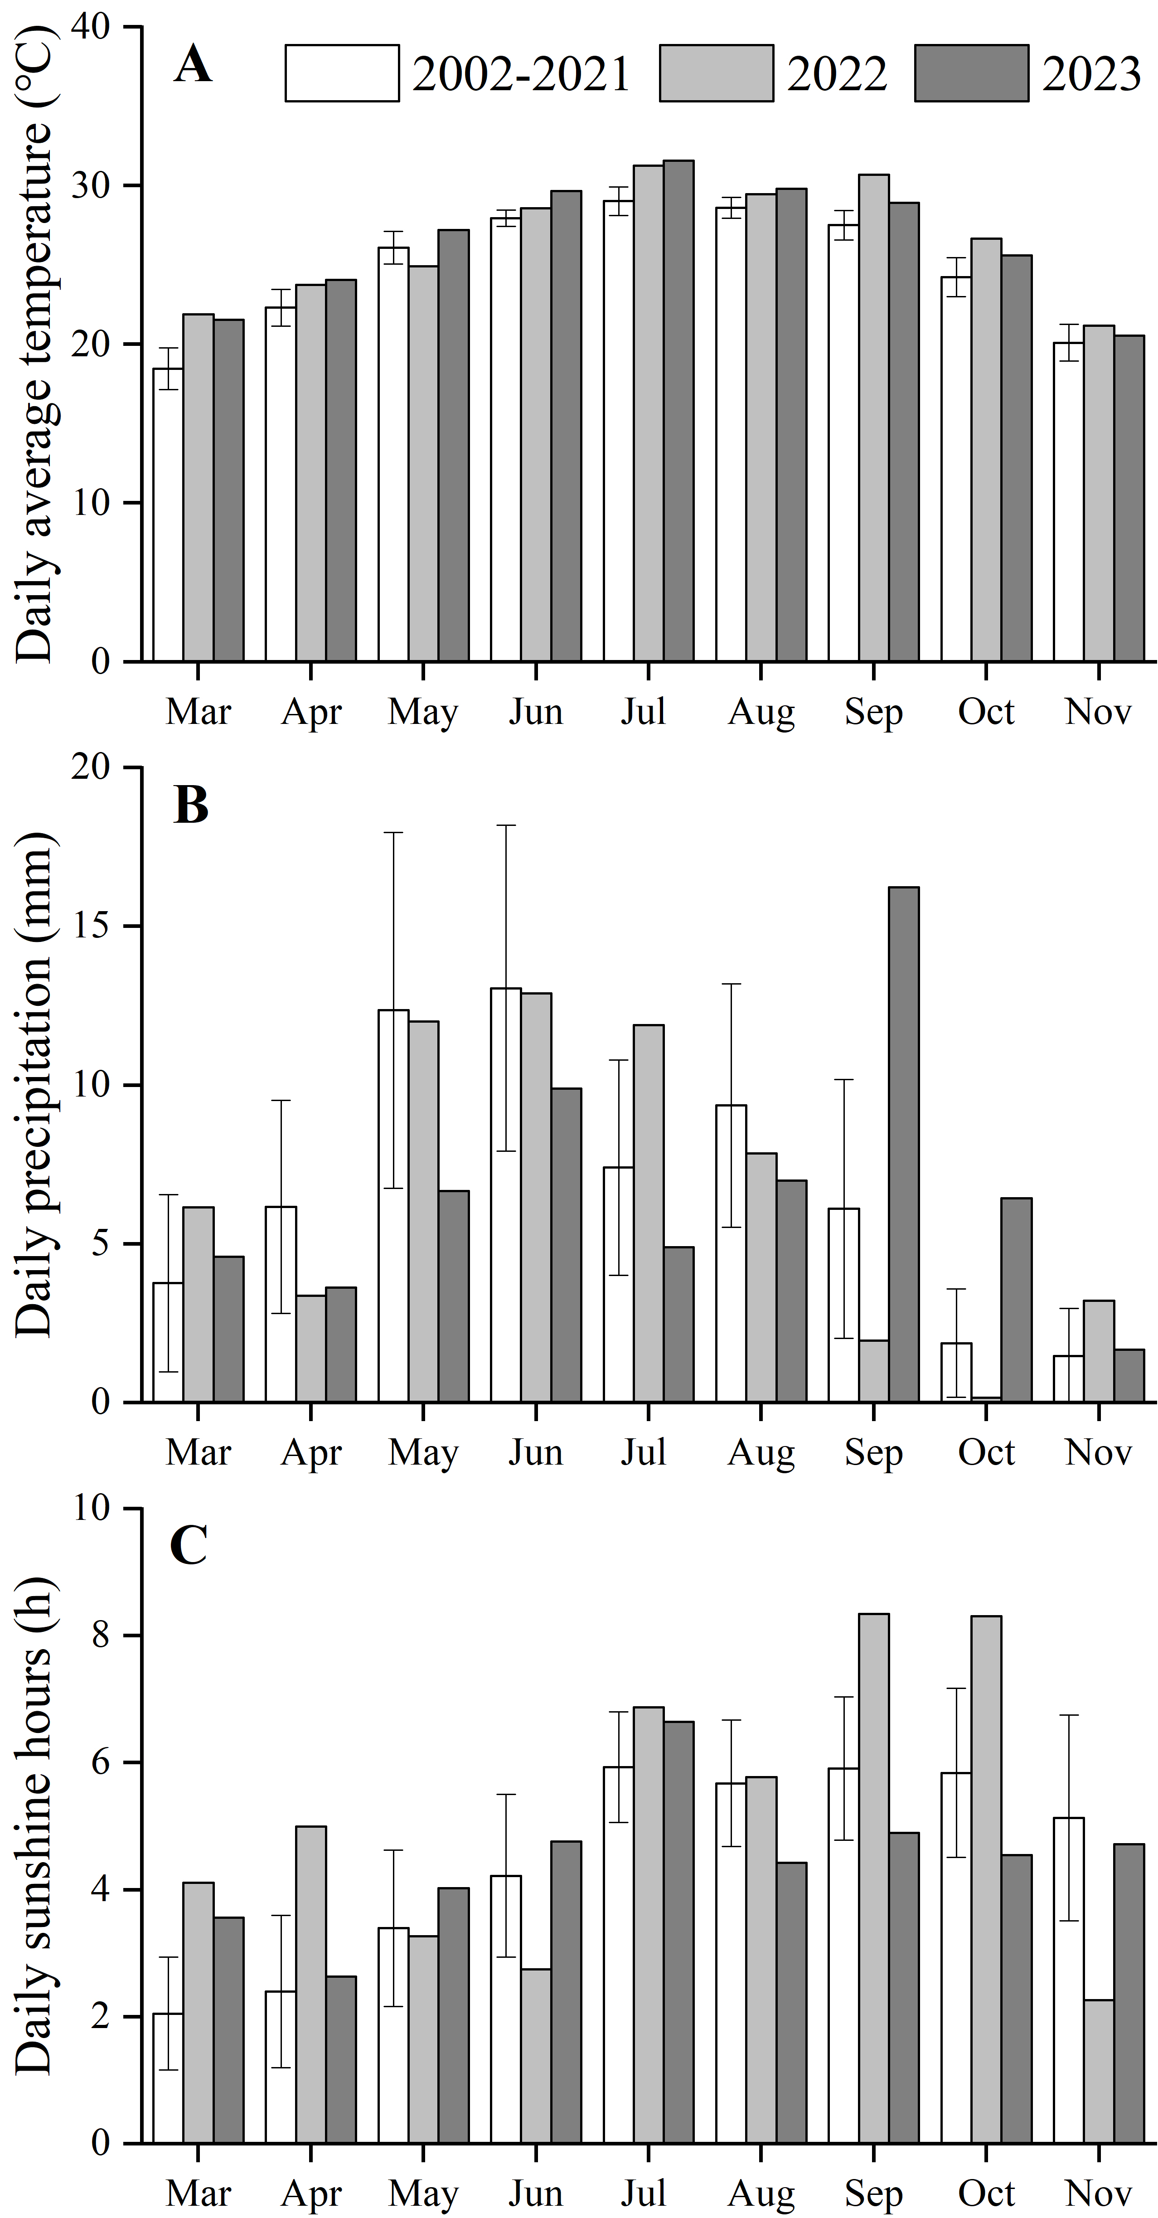

Figure S1. Daily average temperature (A), daily precipitation (B) and daily sunshine hours (C) in each month during the rice growing season.