Table S1. Gene-based/linked markers used for foreground selection for blast resistance and cooking quality for validation in the breeding lines.
Target Traits | Gene | Chr. | Marker name | SNP/Indel | Homozygous target SNP/Indel | LGC code^{/1} | Aliquot ID^{/1}
Amylose content | wx^{b} | 6 | wx_5UTR_G/T | G/T | T:T | 002–0052.1 | 1107690034
Gelatinization temperature | SSIIa^{J} | 6 | ALK_ex8_SNP_A/G | A/G | A:A | 002–0049.1 | 1103441167
Short grain | GS3 | 3 | GS3 | C/A | C:C | 002-0755.1 | 1132528814
Blast resistance | Pi-ta | 11 | TBGI453598 | T/C | T:T | 002–0821.1 | 1140749274
^{1/} LGC group, 2015

Table S2. Thermal cycling conditions for polymerase chain reaction amplification used by HydrocyclerTM
Stage | Temperature | Duration | Number of cycles
1 | 94°C | 15 min | 1
2 | 94°C | 20 s | 10
 | 61°C (decrease of 0.6°C per cycle to achieve a final temperature of 55°C) | 1 min
3 | 94°C | 20 s | 26
 | 55°C | 1 min

Table S3. SNP/Indel marker information on the breeding lines identified in F₃, F₄ and F₅
Lines/  Varieties | GS3 |  |  | wx^{b} |  |  | SSIIa^{J} |  |  | Pi-ta
 | F₃ | F₄ | F₅ | F₃ | F₄ | F₅ | F₃ | F₄ | F₅ | F₃ | F₄ | F₅
62-2-17 | +/- | +/- | n/a | +/+ | +/+ | n/a | +/- | +/- | n/a | +/- | +/+ | n/a
69-1-1 | +/+ | +/+ | +/+ | +/+ | +/+ | +/+ | +/- | +/+ | +/+ | +/- | +/+ | +/+
69-3-4 | +/- | +/+ | n/a | +/+ | +/+ | n/a | +/- | +/- | n/a | +/- | +/- | n/a
72-4-1 | +/- | +/+ | n/a | +/+ | +/+ | n/a | +/- | +/+ | n/a | +/- | +/- | n/a
72-4-2 | +/- | +/- | n/a | +/+ | +/+ | n/a | +/- | +/- | n/a | +/- | +/+ | n/a
72-4-3 | +/- | +/+ | +/+ | +/+ | +/+ | +/+ | +/+ | +/+ | +/+ | +/- | +/- | +/+
72-4-9 | +/- | +/- | +/+ | +/+ | +/+ | +/+ | +/- | +/+ | +/+ | +/- | +/- | +/+
AK | +/+ | +/+ | +/+ | +/+ | +/+ | +/+ | +/+ | +/+ | +/+ | -/- | -/- | -/-
Riceberry | -/- | -/- | -/- | +/+ | +/+ | +/+ | -/- | -/- | -/- | +/+ | +/+ | +/+

Remarks: + =desirable allele, - =undesirable allele, +/+ or -/- = homozygous, +/- = heterozygous, n/a = discarded line
AK = Akitakomachi

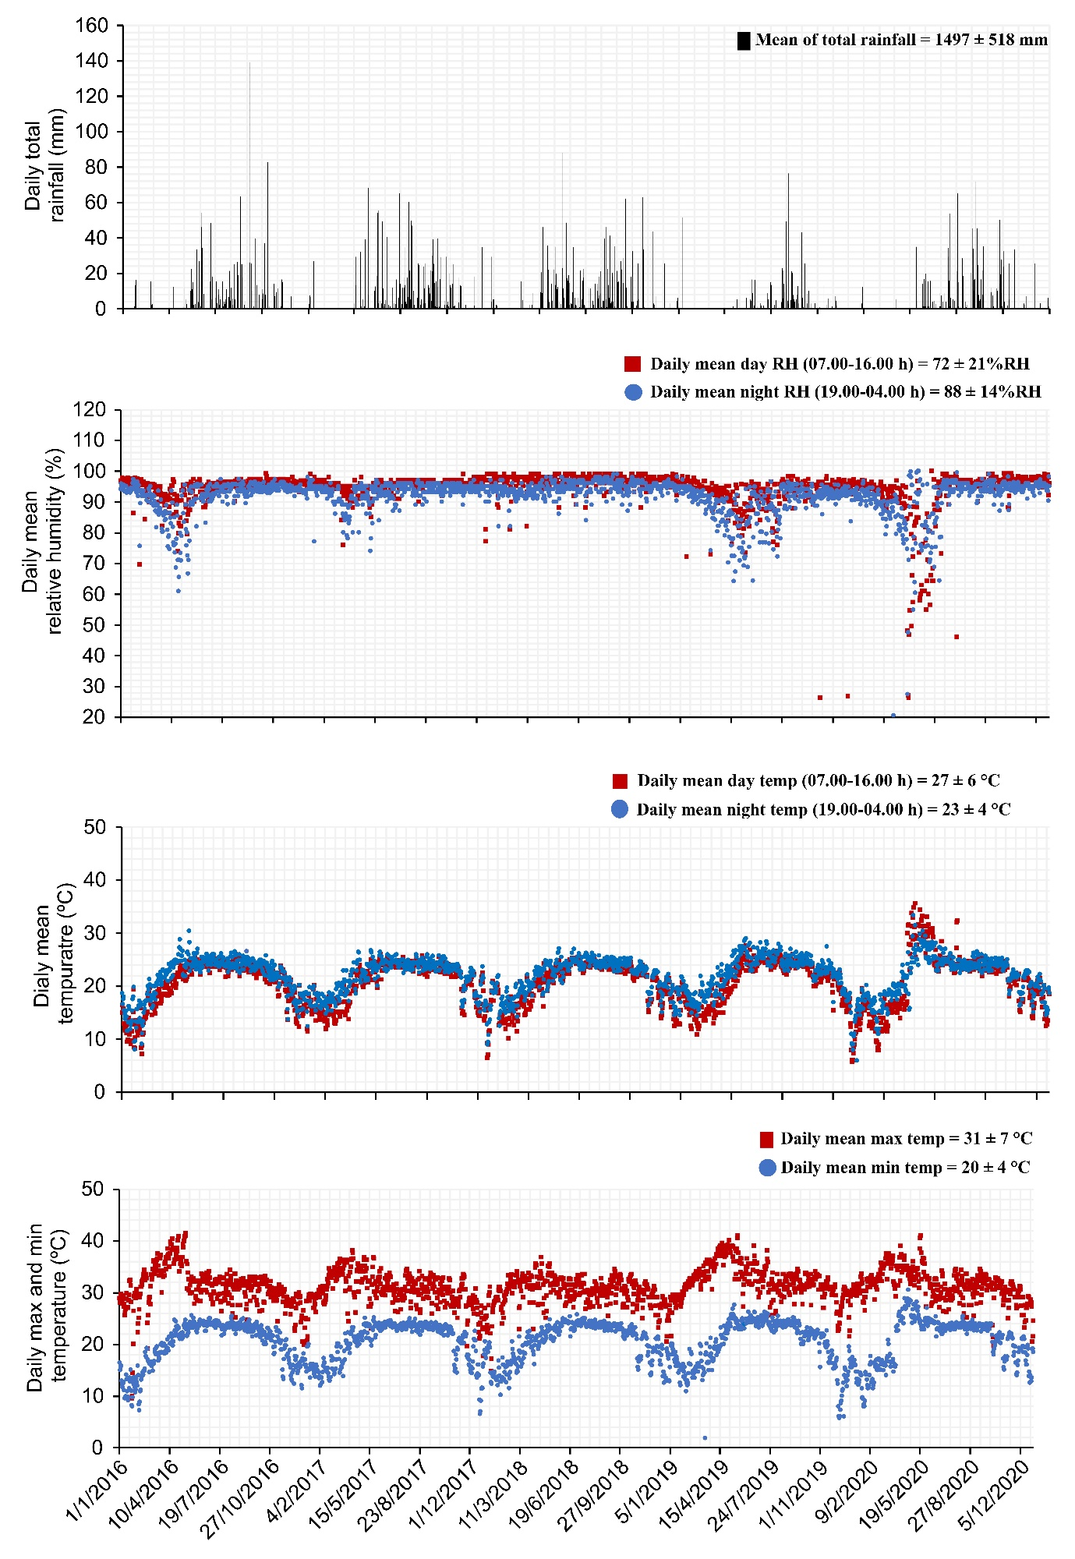
Figure S1. Weather data from WS16-WS20 in the Phan District, Chiang Rai Province.

