Supplemental figures

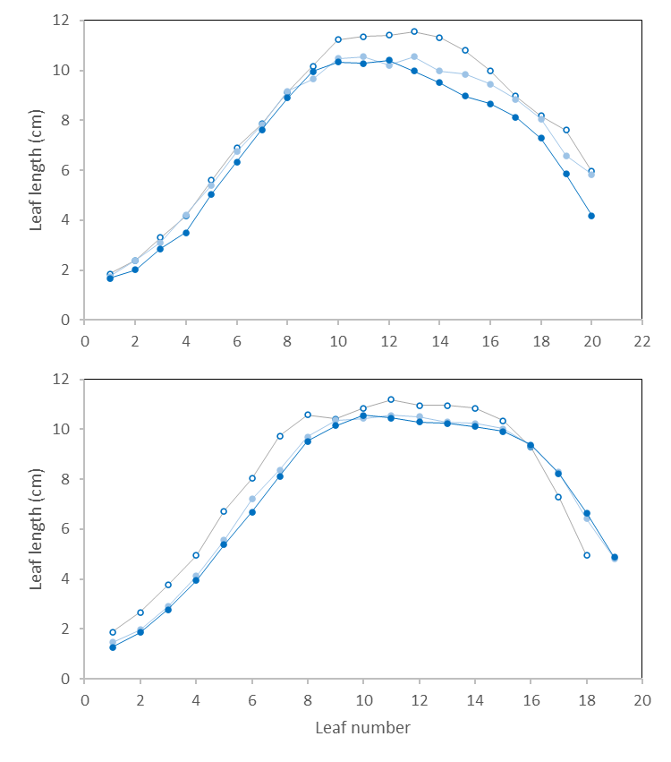
Figure S1. Leaf length for the two years (2021 upper panel, 2022 lower panel) and the three plant populations (empty circles, 6 plants/m²; light blue symbols, 8 plants/m²; dark blue symbols, 10 plants/m²).

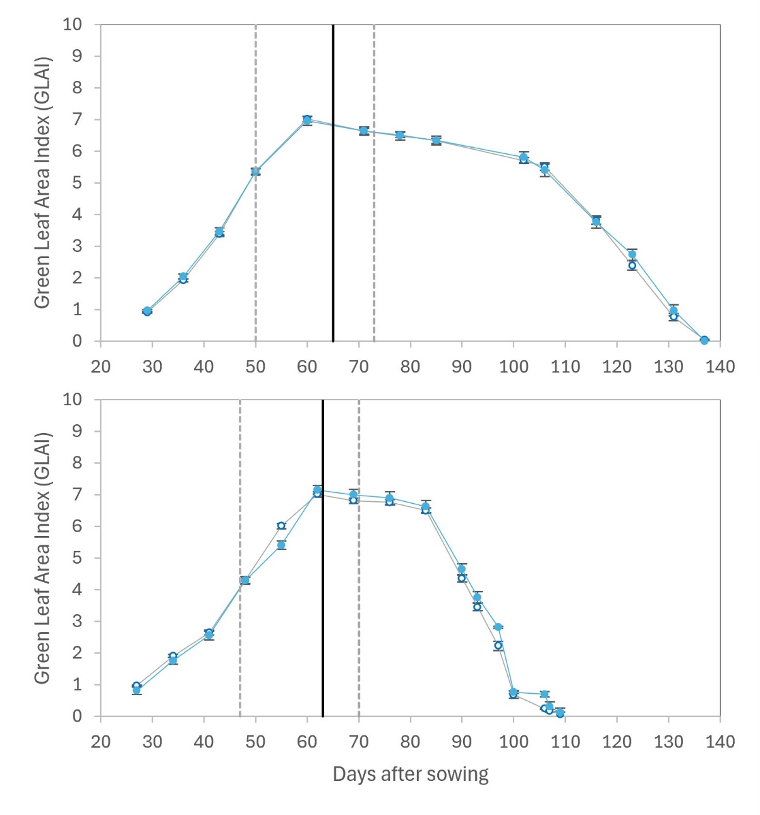
Figure S2. Green leaf area index (GLAI) for the two years (2021 upper panel, 2022 lower panel) and the row distances (empty circles, 35 cm; full symbols, 70 cm). Vertical dashed lines indicate the beginning and end of the critical period for kernel number determination (V12 – 100 °Cd after silking). The central vertical line signals flowering. Bars are standard error of the means at P≤0.05.

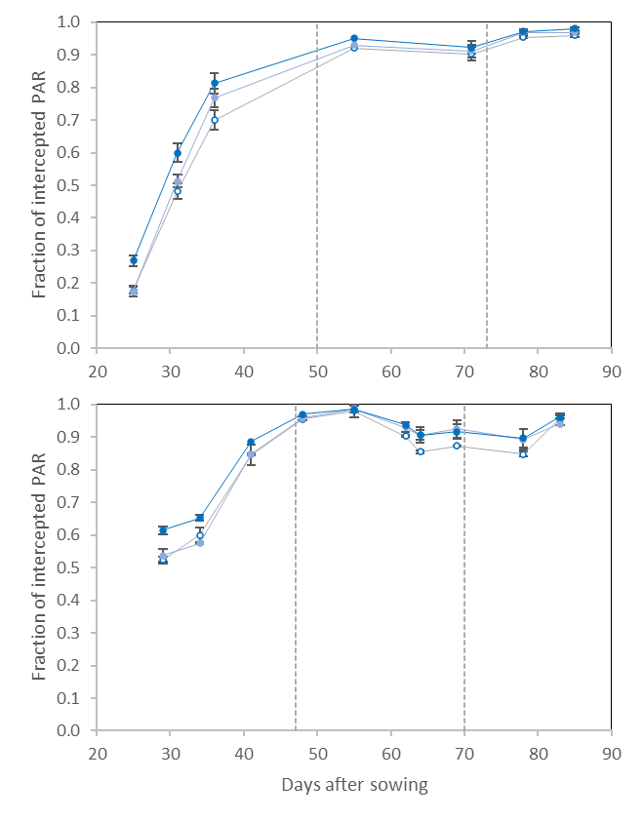
Figure S3. Pattern in the fraction of intercepted PAR for the two years (2021 upper panel, 2022 lower panel) and the three plant densities (empty circles, 6 plants/m²; light blue symbols, 8 plants/m²; dark blue symbols, 10 plants/m²) during the critical period for kernel number determination (indicated by dashed vertical lines).

