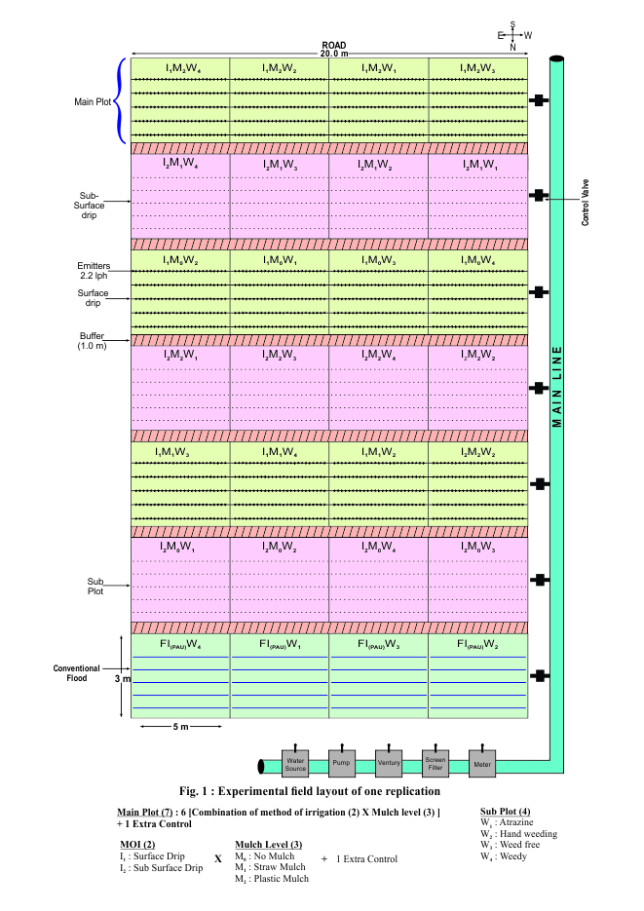

**Supplementary Figure 1. Experimental field layout of one replication**

|  |  |
| --- | --- |
|  |  |
| **Laying and fixation of plastic mulch** | **Laying of Surface drip** |
|  |  |
| **Laying of Sub surface drip** | **Straw mulch** |

**Supplementary Figure 2. Field preparation**

|  |  |  |
| --- | --- | --- |
| **Dibbling** | **Sowing in plastic mulch** | **Furrow irrigation** |
|  |  |  |
| **Emergence** | **Emergence under straw mulch** | **Emergence under plastic mulch** |

**Supplementary Figure 3. Crop emergence under different treatments**