**Supplementary Information**

**Yield improvement with antitranspirant application in droughted wheat associated with both reduced transpiration and reduced abscisic acid**

W. Mphande*1,2, A.D. Farrell3, L.H. Vickers1, I.G. Grove1, and P.S. Kettlewell1

\***Author for correspondence**: W. Mphande primary email address: [wmphande@mu.ac.zm](mailto:wmphande@mu.ac.zm), secondary email address: [wizac2008@gmail.com](mailto:wizac2008@gmail.com),

1*Drought Mitigation Group, Agriculture and Environment Department, Harper Adams University, TF10 8NB, Newport, UK*.

2*Permanent Address: Department of Agricultural Biotechnology and Biosciences, School of Agriculture and Natural Resources, Mulungushi University, P.O. Box 80415, Kabwe, Zambia*

3*Department of Life Sciences, The University of The West Indies, St. Augustine, Trinidad and Tobago.*

1. Meteorological information



Figure SI-1: Mean daily temperature (a) and mean daily relative humidity (b) inside rain shelters across the spring and summer growing seasons. Bold arrows indicate the starting date and ending date (GS87) of the growing season for the spring-sown experiment while the broken ones are for the summer-planted experiment.

1. Vapour pressure deficit

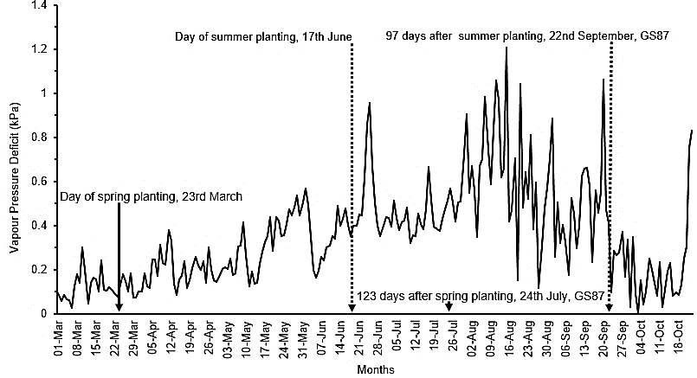

Figure SI-2: Mean daily vapour pressure deficit between 1st March and 23rd October. Bold arrows indicate the starting date and ending date (GS87) of the growing season for the spring-sown experiment while the broken arrows are for the summer-planted experiment. Data were recorded and provided by the meteorological station based at Harper Adams University located within 100 metres of the experimental site

1. Dates for spray application and sampling for spike ABA

Table SI-1: Spray application and endogenous ABA sampling dates

|  |  |  |  |  |  |  |  |
| --- | --- | --- | --- | --- | --- | --- | --- |
| Season |  | Spraying1 | | | Spike sampling | | |
|  | GS | Spray types | DAP | Date | GS | DAP | DAS Date |
| Spring | GS37 | Water, DpM, DpM+ABA, F10, | 57 | 19th May | GS68 | 73 16 4th June | |
| Summer | GS37 | Water, DpM,  F20, F50 | 40 | 27th July | GS68 | 64 | 24 20th Aug |

1DAP - days after planting; DAS – days after spraying; DpM - di-1-*p*-menthene; F - fluridone; DpM+ABA - combination of di-1-*p*-menthene and exogenous ABA. Fluridone concentrations at 10 µM, 20 µM and 50 µM; GS - Growth stage.

1. Spike ABA

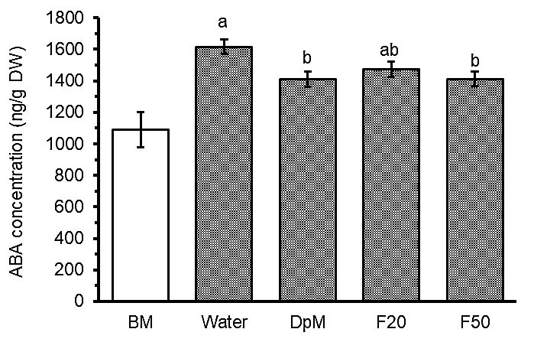

Figure SI-3: Spray type effects on spike ABA concentration in summer (p = 0.019, at 54 days after planting and 14 days after spraying, GS63) under progressive drought except for the benchmark (BM). Error bars are common standard errors of means from the ANOVA table. To facilitate irrigation, the BM plots were not part of randomisation hence data were not included in statistical analysis. DpM, F20 and F50 stand for di-1-*p*-menthene, and fluridone concentrations at 20 µM and 50 µM, respectively.

1. Gas exchange and relative water content

Table SI-2: Gas exchange and relative water content sampling dates

|  |  |  |  |  |  |  |  |  |
| --- | --- | --- | --- | --- | --- | --- | --- | --- |
| Season | Gas exchange | | | | Relative water content | | | |
| 1GS | DAP | DAS | Date | GS | DAP | DAS | Date |
| Spring | GS75 | 81 | 24 | 12th Jun | - | - | - | - |
| Summer | GS54 | 51 | 11 | 7th Aug | GS | DAP | DAS | Date |
| GS73 | 70 | 30 | 26th Aug | GS73 | 69 | 29 | 25th Aug |

1GS - Growth stage; DAP - days after planting; DAS – days after spraying.

1. Transpiration

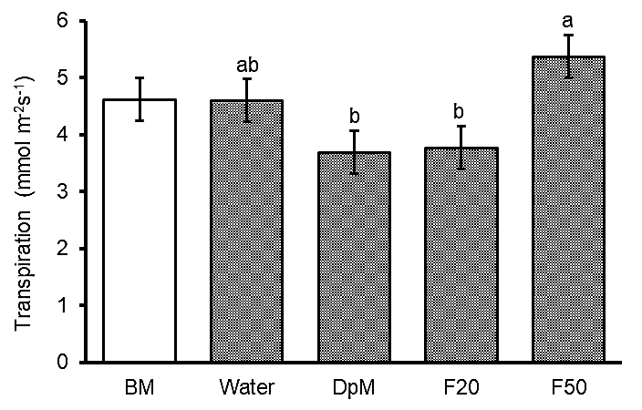

Figure SI-4: Spray type effects on transpiration in summer (b, p = 0.021, at 51 days after planting i.e., 11 days after spraying, GS54) under progressive drought except for the benchmark (BM). Error bars are common standard errors of means from the ANOVA table. To facilitate irrigation, the BM plots were not part of randomisation hence data were not included in statistical analysis. DpM, F20 and F50 stand for di-1-*p*-menthene, and fluridone concentrations at 20 µM and 50 µM, respectively.

1. Photosynthesis

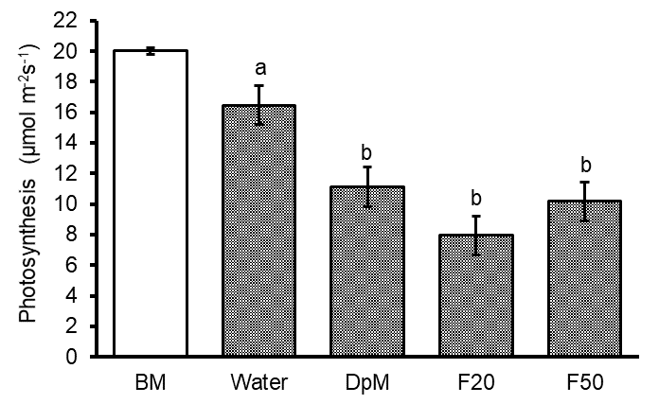

Figure SI-5: Spray type effects on transpiration in summer (p = 0.001, at 51 days after planting and 30 days after spraying, GS54) under progressive drought except for the benchmark (BM). Error bars are common standard errors of means from the ANOVA table. To facilitate irrigation, the BM plots were not part of randomisation hence data were not included in statistical analysis. DpM, F20 and F50 stand for di-1-*p*-menthene, and fluridone concentrations at 20 µM and 50 µM, respectively.

1. Cost benefit analysis of using DpM

For practical guidance, yield response attributed to DpM was greater with sowing in spring than in summer. The benefit of applying DpM onto droughted spring wheat was estimated for each season. The benefit of applying DpM onto droughted spring wheat was estimated for each season. At the January 2022 bread wheat market price in the UK of £282.5/tonne (<https://ahdb.org.uk/cereals-oilseeds/uk-delivered-prices>), the gross income from the 1.94 tonnes/ha yield benefit attributed to DpM in spring was £548.05, compared to 0.83 tonnes/ha and £234.48 in summer. The DpM price per USA gallon (3.79 L ~ $18.44/L = £13.56/L) was $69.9 (SeedRanch, 2022) and the national average pesticide spraying cost for the UK was £12.98/ha (National Association of Agricultural Contractors, NAAC, 2021). This means that the unit cost to spray DpM per hectare was £26.54. To break even or to justify the application of DpM, yield was to increase by not less than (1.94 x 26.54)/548.05 or (0.83 x 26.54)/234.48 = 0.094) = 0.094 tonnes/ha or 94 kg/ha. The net profits in spring and summer were £521.51 and £207.94, respectively. This indicated that spring sowing optimised the benefits of DpM. Thus, DpM could significantly contribute to mitigating the effects of water stress on wheat productivity in the drought-prone areas of the UK, where up to 2 tonnes/ha of losses were on record (Dodd et al., 2011; Foulkes et al., 2007).

References

Dodd IC, Whalley WR, Ober ES and Parry MAJ (2011). Genetic and management approaches to boost UK wheat yields by ameliorating water deficits. *Journal of Experimental Botany*, **62,** 5241–5248.

Foulkes MJ, Sylvester-Bradley R, Weightman R and Snape JW (2007). Identifying physiological traits associated with improved drought resistance in winter wheat. *Field Crops Research,* **103,** 11–24.

NAAC. (2021). Contracting Prices Survey 2021- 2022. Retrieved January 10, 2022, from https://www.naac.co.uk/pricesguide/

SeedRanch, 2022. Millers Vapor Gard Anti-Transpirant Concentrate. Retrieved October 1, 2022, from https://www.seedranch.com/Millers-Vapor-Gard-Concentrate-1-Gallon-p/vapor-gard-gallon.htm.