Supplementary material

2.0 Details about diets used in fattening and growing phases in the confinement and total amount of dry matter (DM) and phosphorus (P) used in the confinement

Table S1. Diets used in fattening and growing confinement in the years 2020 and 2021 at Farm 1 and Farm 2.
 | Farm1 |  |  |  | Farm2
Food | Fattening |  | Growing |  | Fattening |  | Growing
 | 2020 | 2021 | 2020 | 2021 | 2020 | 2021 | 2020 | 2021
 | % Dry mass |  |  |  | % Dry mass
Wheat straw | 10.5 | 6.0 | 12.0 | 12.6 | 8.6 | 6.3 | 10.3 | 15.3
Wheat grain | 0.0 | 0.0 | 0.0 | 0.0 | 0.0 | 0.0 | 0.0 | 25.6
Maize silage | 0.0 | 10.5 | 38.4 | 33.0 | 14.0 | 20.2 | 27.1 | 40.9
Maize snaplage | 20.0 | 24.8 | 0.0 | 7.0 | 0.0 | 0.0 | 0.0 | 0.0
Maize grain (ground) | 6.3 | 17.5 | 20.0 | 4.5 | 25.0 | 19.9 | 7.5 | 1.3
Maize grain (wet ground) | 0.0 | 20.0 | 0.0 | 0.0 | 0.0 | 39.0 | 0.0 | 0.0
Sweet potato | 37.1 | 7.0 | 10.0 | 22.0 | 0.0 | 0.0 | 0.0 | 0.0
Cotton seed | 6.3 | 5.0 | 15.0 | 7.5 | 0.0 | 7.5 | 0.0 | 7.5
Sorghum grain | 0.0 | 0.0 | 0.0 | 0.0 | 33.1 | 0.0 | 15.0 | 0.0
Oat grain | 0.0 | 0.0 | 0.0 | 0.0 | 15.2 | 0.0 | 16.2 | 0.0
Broken wheat | 10.0 | 0.0 | 0.0 | 0.0 | 0.0 | 0.0 | 0.0 | 0.0
Broken grain | 0.0 | 0.0 | 0.0 | 0.0 | 0.0 | 0.0 | 11.5 | 0.0
Soybean meal | 6.0 | 0.0 | 0.0 | 0.0 | 0.0 | 0.0 | 0.0 | 0.0
Soybean grain | 0.0 | 0.0 | 0.0 | 0.0 | 0.0 | 3.5 | 0.0 | 6.0
DDG¹ | 0.0 | 5.0 | 0.0 | 9.0 | 0.0 | 0.0 | 8.0 | 0.0
Ureia | 1.4 | 1.75 | 2.3 | 1.9 | 1.9 | 1.5 | 2.3 | 1.25
Limestone | 0.4 | 0.6 | 0.4 | 0.6 | 0.8 | 0.7 | 0.7 | 0.7
Dhells mineral core | 1.3 | 0.0 | 0.0 | 0.0 | 0.0 | 0.0 | 0.0 | 0.0
Dicalcium phosphate | 0.0 | 0.25 | 0.4 | 0.3 | 0.0 | 0.0 | 0.0 | 0.0
Agroceres mineral core | 0.63 | 1.25 | 1.25 | 1.3 | 1.3 | 1.3 | 1.25 | 1.25
Common salt | 0.2 | 0.3 | 0.3 | 0.3 | 0.2 | 0.2 | 0.2 | 0.2
Total | 100 | 100 | 100 | 100 | 100 | 100 | 100 | 100
¹Dried Distillers Grains.

Table S2. Total amount of dry matter (DM) and phosphorus (P) used in the confinement in 2020 and 2021 from forage and food leftovers produced at farms and purchased by farms in the market.
 | Farm 1 |  |  |  |  | Farm 2
Food | Year 2020 |  | Year 2021 |  |  | Year 2020 |  | Year 2021
 | DM | P | DM | P |  | DM | P | DM | P
 | kg/year |  |  |  | kg/year
 | Forage and food leftovers produced at farms
Wheat straw | 110058 | 220 | 162360 | 325 | 14086 |  | 28 | 550884 | 170
Wheat grain |  |  |  |  |  |  |  | 53913 | 173
Broken wheat | 60820 | 207 | 0 | 0
Maize silage | 147638 | 251 | 368544 | 627 | 29928 |  | 51 | 147231 | 250
Maize grain | 115160 | 484 | 442012 | 1856 | 25857 |  | 109 | 340734 | 1431
Maize snaplage | 121640 | 268 | 323563 | 712
Oat grain |  |  |  |  | 23535 |  | 71
Soybean grain |  |  |  |  | 0 |  |  | 22642 | 111
Broken grains |  |  |  |  | 7758 |  | 41
Sweet potato | 264140 | 528 | 245386 | 491
Total | 819456 | 1958 | 1541865 | 4011 | 101164 |  | 300 | 1115404 | 2135
 | Forage and leftovers food purchased by farms in the market
Sorghum grain |  |  |  |  | 37675 |  | 215
DDG¹ |  |  | 123593 | 1063 | 5397 |  | 2.4
Cotton seed | 96063 | 856 | 112047 | 940 |  |  |  | 78989 | 419
Soybean meal | 36492 | 241
Oat grain |  |  |  |  | 23535 |  | 71
Ureia | 17369 |  | 33636 |  | 3132 |  |  | 10812
Dicalcium phosphate | 1540 | 297 | 5025 | 970
Dhells mineral core | 7603 | 152
Total | 159067 | 1546 | 274301 | 2973 | 69739 |  | 288.4 | 89801 | 419
¹Dried Distillers Grains.
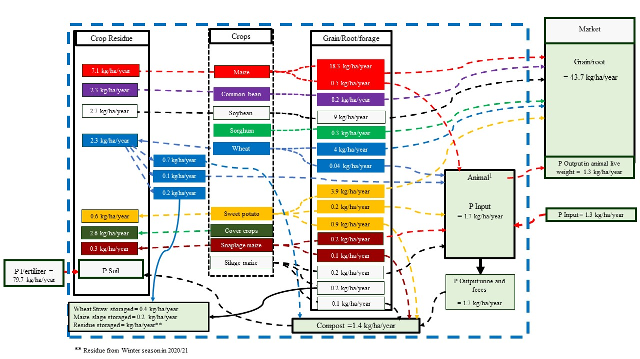
Figure S1. Average inputs and outputs of phosphorus (kg/ha/year) in the production system of 3W Agronegócio Farm (Farm 1) based on the 2018/19, 2019/20 and 2020/21 harvests and beef cattle production from 2020 to 2021.
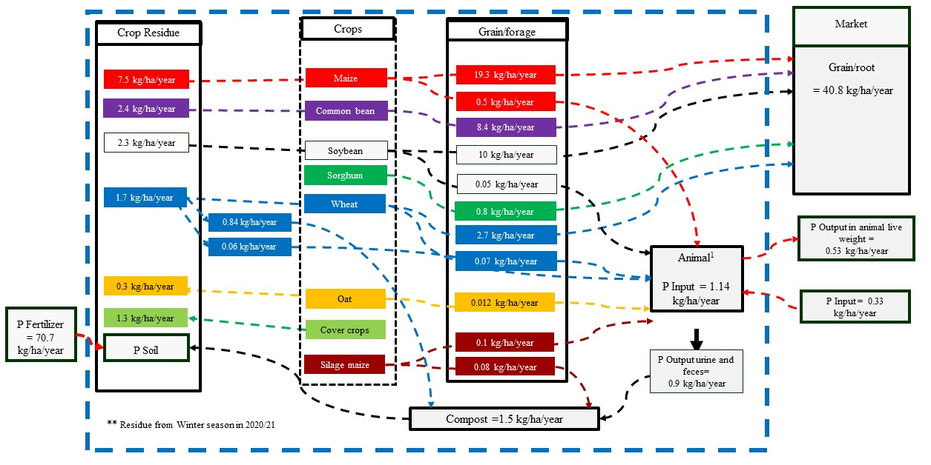
Figure S2. Average inputs and outputs of phosphorus (kg/ha/year) in the production system of Santa Helena Farm (Farm 2), based on the 2018/19, 2019/20 and 2020/21 harvests and beef cattle production from 2020 to 2021.

