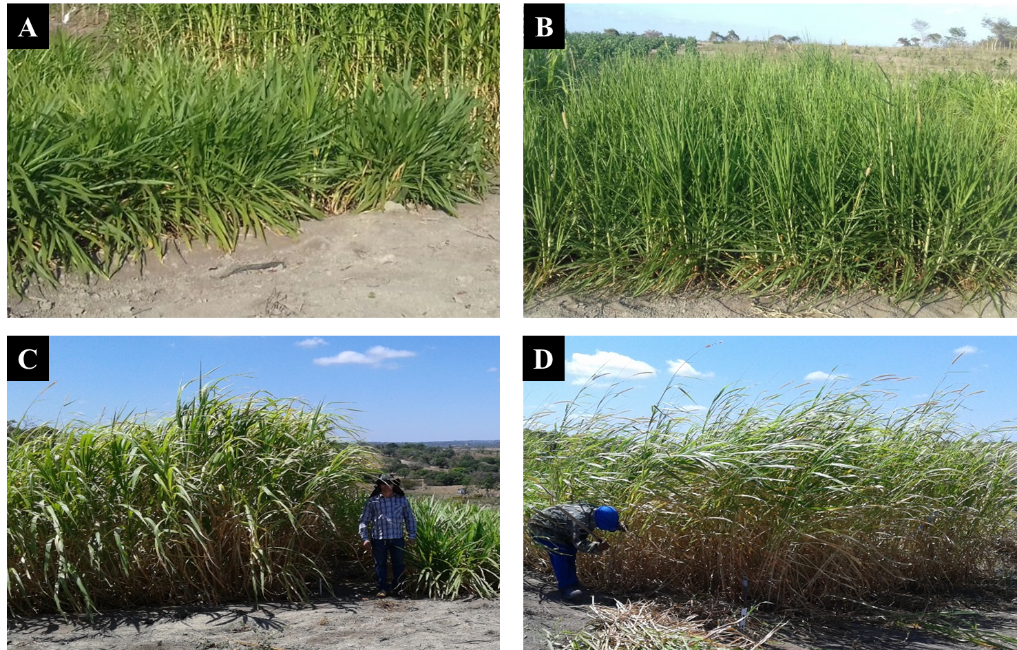
Supplemental Figure 1. Elephant-grass genotypes at 90 days after planting/establishment; Mott (A); Taiwan A-146 2.37 (B); Elephant B (C); IRI 381 (D).

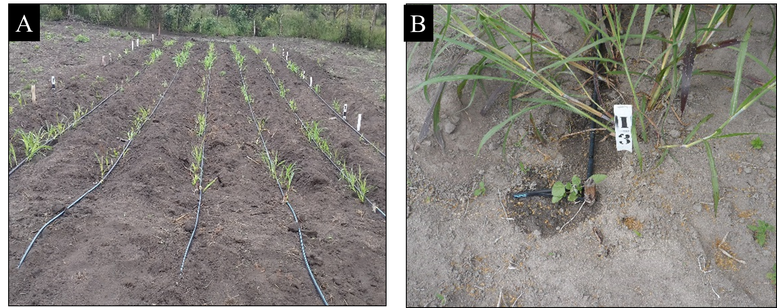

Supplemental Figure 2. Planting spacing (A) and irrigation system (B) of the elephant-grass plantations.

