(a) (b)
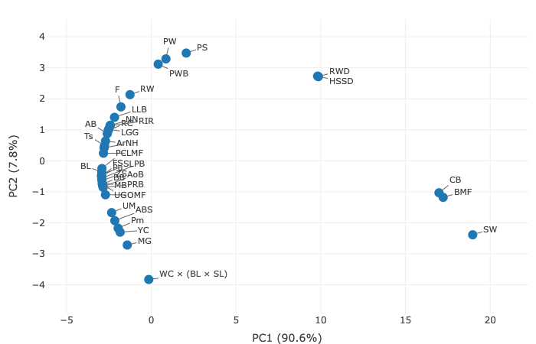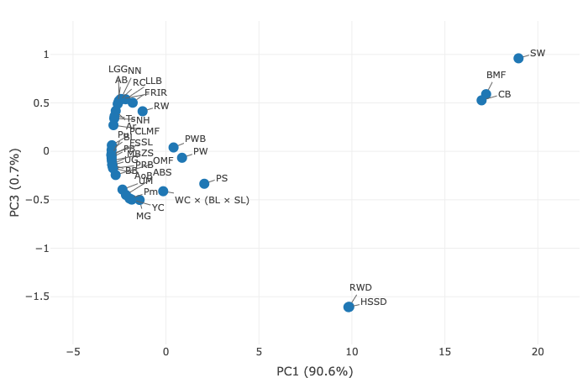

(c) (d)
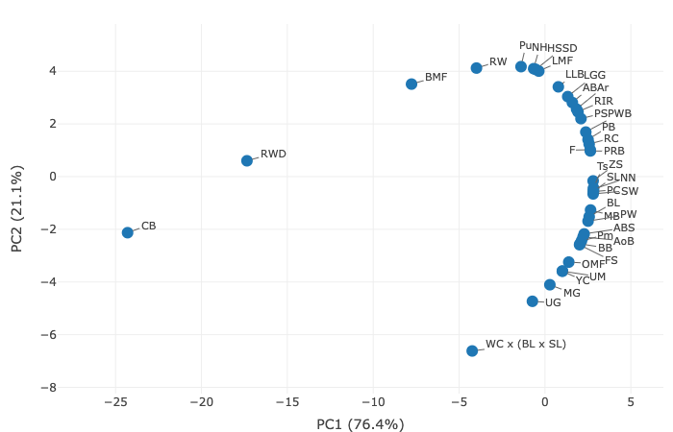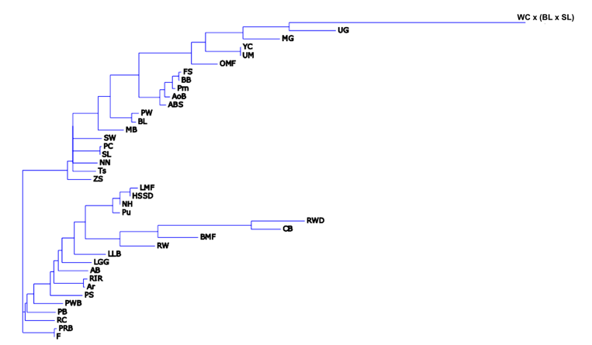

Supplementary Fig. S2. Clustering patterns for 39 chickens breeds. PCA plot composed using the mean PA/BW values in females, in the plane of (a) the first (X-axis, PC1) and second (Y-axis, PC2) components, and (b) the first (X-axis, PC1) and third (Y-axis, PC3) components. IPI values-based PC1–PC2 plot (c) and rootless hierarchical horizontal Neighbor Joining tree (d) using proportional edge length. Chicken breeds: Amrock (Ar), Aurora Blue (AB), Australorp Black (AoB), Australorp Black Speckled (ABS), Bantam Mille Fleur (BMF), Brahma Buff (BB), Brahma Light (BL), Cochin Bantam (CB), Faverolles Salmon (FS), Frizzle (F), Hamburg Silver Spangled Dwarf (HSSD), Leghorn Light Brown (LLB), Leningrad Golden-and-gray (LGG), Leningrad Mille Fleur (LMF), Minorca Black (MB), Moscow Game (MG), Naked Neck (NN), New Hampshire (NH), Orloff Mille Fleur (OMF), Pantsirevka Black (PB), Pavlov Spangled (PS), Pavlov White (PW), Pervomai (Pm), Plymouth Rock Barred (PRB), Poland White-crested Black (PWB), Poltava Clay (PC), Pushkin (Pu), Red White-tailed Dwarf (RWD), Rhode Island Red (RIR), Russian Crested (RC), Russian White (RW), Silkie White (SW), Sussex Light (SL), Tsarskoye Selo (Ts), Ukrainian Muffed (UM), Uzbek Game (UG), White Cornish × (Brahma Light × Sussex Light) (crossbred; WC × (BL × SL)), Yurlov Crower (YC), Zagorsk Salmon (ZS)

