Supplementary Material (Appendix) for the article:

Who Dominates the Coalition? Frame Salience and Public Support for Policy-Democracy Protest Coalitions under Authoritarian Rule

Published in Government and Opposition

Mai Truong
Assistant Professor
Marquette University

Appendix 1: Balance of potential covariates across frame treatments

 | Land and Pro-democracy Protest Frame | Land Protest Frame | Pro-democracy Protest Frame | Test
Gender |  |  |  | ${}^{2}$ = 2.356
- Men | 56.3% | 51% | 54.8%
- Women | 43.7% | 49% | 45.2%
Residence |  |  |  | ${}^{2}$ = 0.381
- Big cities | 59.1% | 59.5% | 61.1%
- Others | 40.9% | 40.5% | 38.9%
Education Level | 3.957 | 3.899 | 3.951 | F=0.188
 | (1.434) | (1.495) | (1.401)
Party membership |  |  |  | ${}^{2}$ = 1.054
- No | 76.9% | 78.9% | 75.9%
- Yes | 23.1% | 21.1% | 24.%
Income Level | 5.368 | 5.436 | 5.365 | F=0.248
 | (1.568) | (1.538) | (1.652)
Agriculture Involvement |  |  |  | ${}^{2}$ = 1.274
- Yes | 67.3% | 68% | 70.7%
- No | 32.7% | 32% | 29.3%
Risk Acceptance | 4.211 | 4.268 | 4.234 | F=0.171
 | (1.372) | (1.383) | (1.378)
Economic Perception | 4.157 | 4.235 | 4.185 | F=0.757
 | (0.918) | (0.839) | (0.904)
Interest in Politics | 1.995 | 1.933 | 1.911 | F=1.125
 | (0.835) | (0.823) | (0.817)
National Pride | 5.44 | 5.421 | 5.28 | F=2.583*
 | (0995) | (1.116) | (1.204)
Government Trust | 4.921 | 4.932 | 4.943 | F = 0.0042
 | (1.128) | (1.063) | (1.063)
Age | 30.224 | 30.911 | 30.059 | F=1.08
 | (9.028) | (8.599) | (8.241)
Observations | 394 | 388 | 427 | 1209
Note: This table shows the means of the different covariates according to whether they receive the land-democracy coalition-based frame, the land protest frame, or the pro-democracy protest frame.

Appendix 2: Distribution of respondents recalling the hypothetical province

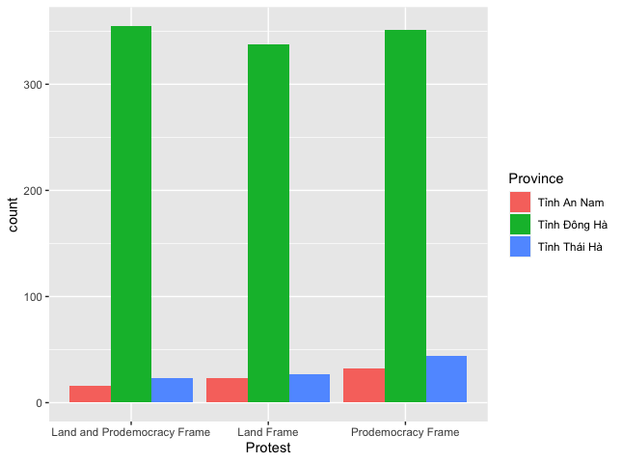

Appendix 3: Effect of protest frames among respondents reading the land frame first in the coalition

VARIABLES | DEPENDENT VARIABLES
 | Protest Support | Protest Justified
Land and pro-democracy frame | 0.121  (0.119) | 0.073  (0.114)
Pro-democracy frame | -0.413*** | -0.509***
 | (0.099) | (0.095)
Constant | 3.747*** | 3.979***
 | (0.071) | (0.068)
Observations | 997 | 997
R -squared | 0.026 | 0.036

Appendix 4: Effect of protest frames among respondents reading the pro-democracy frame first in the coalition

VARIABLES | DEPENDENT VARIABLES
 | Protest Support | Protest Justified
Land and pro-democracy frame | -0.181  (0.127) | -0.188  (0.122)
Pro-democracy frame | -0.413*** | -0.509***
 | (0.099) | (0.095)
Constant | 3.747*** | 3.979***
 | (0.072) | (0.068)
Observations | 997 | 997
R -squared | 0.026 | 0.036

Appendix 5: Effect of protest frames on protest support using an averaged index for support

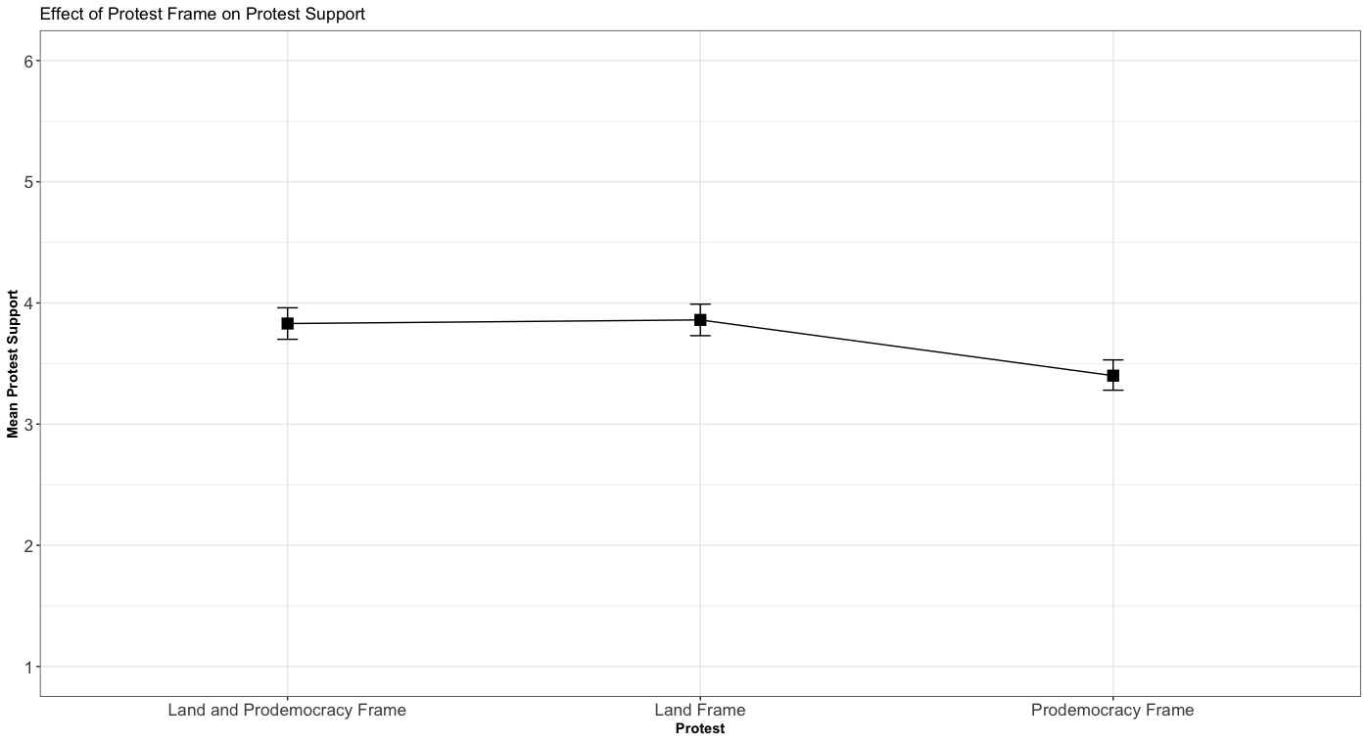

Appendix 6: Results of Protest Frames on Support for Protests; Feeling that Protests are Justified with Covariates
VARIABLES | Protest Support | Protest Justified
Land and Prodemocracy Frame | -0.032 | -0.055
 | (0.101) | (0.097)
Prodemocracy Frame | -0.441*** | -0.528***
 | (0.099) | (0.095)
Women | -0.013 | -0.001
 | (0.082) | (0.079)
Age | -0.002 | -0.004
 | (0.005) | (0.005)
Major cities | 0.145 | 0.108
 | (0.093) | (0.089)
Education Level | -0.001 | 0.007
 | (0.034) | (0.032)
Income Level | -0.045 | -0.001
 | (0.029) | (0.028)
Party Membership | 0.090 | 0.076
 | (0.099) | (0.095)
Agricultural Involvement | -0.023 | 0.053
 | (0.090) | (0.086)
Risk Acceptance | 0.057* | 0.056*
 | (0.032) | (0.030)
Economic Perception | 0.093* | 0.105**
 | (0.050) | (0.048)
National Pride | 0.064 | 0.031
 | (0.041) | (0.040)
Low Government Trust | 0.469*** | 0.501***
 | (0.136) | (0.131)
Constant | 3.144*** | 3.123***
 | (0.410) | (0.395)
Observations | 1,192 | 1,192
R-squared | 0.043 | 0.050
Notes: Model is OLS with robust standard errors in parentheses. Each model includes controls listed in Table 2. Land and prodemocracy frame, and prodemocracy frame are compared to the land protest frame. *** p<0.01, ** p<0.05, * p<0.1. Protest support is a six-point variable ranging from 1 (strongly oppose) to 6 (strongly support). Protest justified is a six-point variable ranging from 1 (strongly unjustified) to 6 (strongly justified).

Appendix 7: Effect of protest frame on protest support, dropping those who failed to pass the manipulation check

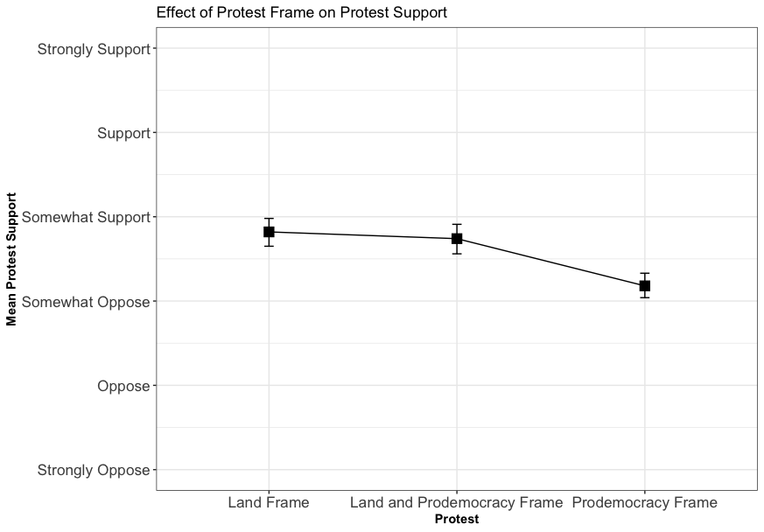
Note: This figure shows the means of support for the hypothetical protests (95% CI)

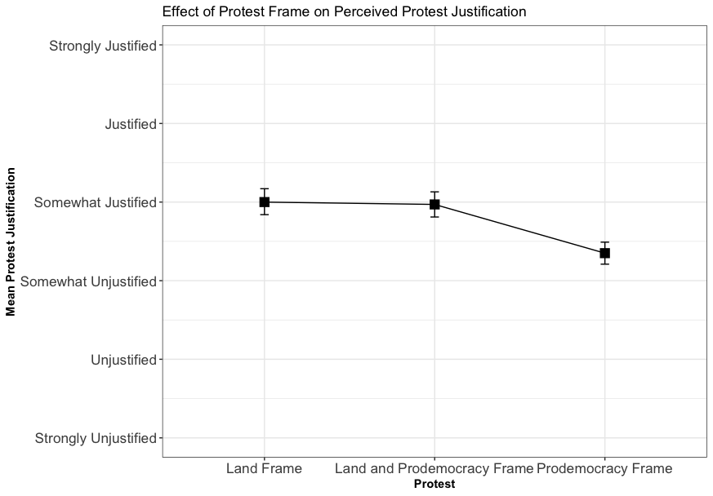
Note: This figure shows the means of the perceived justification of the hypothetical protests (95% CI)

Appendix 8: Results of Potential Heterogeneous Effects
VARIABLES | Protest Support | Protest Justified
Land and Prodemocracy Frame | -0.096 | -0.093
 | (0.234) | (0.225)
Prodemocracy Frame | -0.576** | -0.803***
 | (0.160) | (0.153)
Major city | 0.236 | 0.113
 | (0.165) | (0.158)
College Degree | -0.015 | 0.040
 | (0.170) | (0.163)
High government trust | -0.504** | -0.533**
 | (0.239) | (0.229)
Party member | 0.206 | 0.248
 | (0.176) | (0.169)
Low interest in politics | 0.026 | 0.135
 | (0.174) | (0.167)
Land and Prodemocracy frame * Major city | -0.204 | 0.030
 | (0.230) | (0.220)
Prodemocracy frame * Major city | -0.076 | 0.068
 | (0.228) | (0.219)
Land and Prodemocracy frame * College degree | 0.139 | 0.060
 | (0.231) | (0.222)
Prodemocracy frame * College degree | 0.019 | 0.124
 | (0.227) | (0.218)
Land and Prodemocracy frame * High government trust | 0.165 | 0.274
 | (0.310) | (0.297)
Prodemocracy frame * High government trust | -0.030 | -0.150
 | (0.307) | (0.295)
Land and Prodemocracy frame * Party member | 0.039 | 0.028
 | (0.247) | (0.237)
Prodemocracy frame * Party member | -0.246 | - 0.389
 | (0.238) | (0.228)
Land and Prodemocracy frame *High interest in politics | -0.106 | -0.034
 | (0.240) | (0.230)
Prodemocracy frame * High interest in politics | 0.308 | 0.277
 | (0.241) | (0.231)
OTHER CONTROL VARIABLES | YES | YES
Constant | 3.217*** | 3.257***
 | (0.410) | (0.395)
Observations | 1,192 | 1,192
R-squared | 0.043 | 0.050

Appendix 9: Effect of protest frame, dropping party members

VARIABLES | Protest Support | Protest Justified
Land and Prodemocracy Frame | -0.008 | -0.040
 | (0.112) | (0.107)
Prodemocracy Frame | -0.389*** | -0.442***
 | (0.110) | (0.106)
Women | -0.013 | -0.001
 | (0.082) | (0.079)
Age | 0.003 | 0.0001
 | (0.006) | (0.006)
Major cities | -0.032 | -0.035
 | (0.13) | (0.099)
No college degree | -0.084 | -0.115
 | (0.108) | (0.104)
Income Level | -0.045 | -0.001
 | (0.029) | (0.028)
Agricultural Involvement | -0.023 | 0.053
 | (0.090) | (0.086)
Risk Acceptance | 0.057* | 0.056*
 | (0.032) | (0.030)
Economic Perception | 0.043 | 0.035
 | (0.055) | (0.053)
National Pride | 0.027 | 0.008
 | (0.047) | (0.045)
Low Government Trust | -0.417*** | -0.369***
 | (0.148) | (0.141)
Constant | 3.716*** | 4.095***
 | (0.382) | (0.366)
Observations | 920 | 920
R-squared | 0.029 | 0.033

Appendix 10: Sensitivity analysis of mediated effects of protest frame

Protest Support | Protest Justification
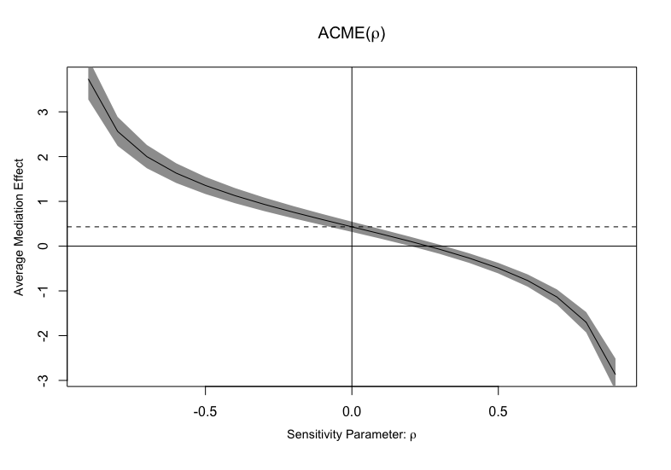 | 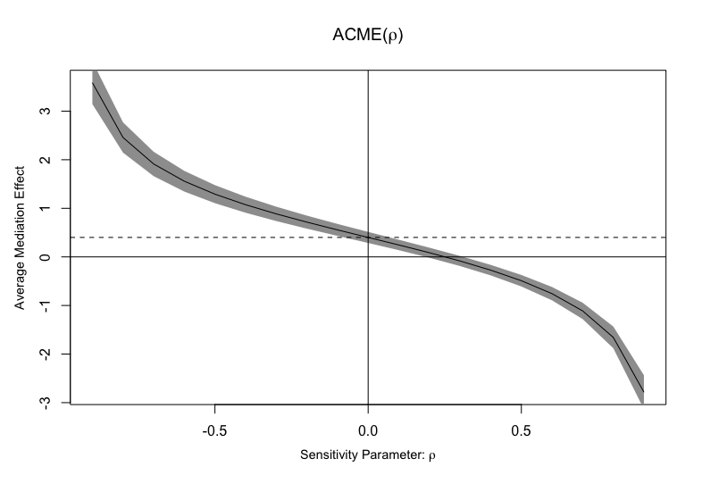
Note: The dashed line represents the estimated average mediation effect for ρ = 0. The gray areas represent the 95% confidence interval for the mediation effects at each value of ρ. The solid line represents the estimated average mediation effect at different values of ρ.

Appendix 11: Is democracy needed in Vietnam?

