Supplementary Information for

“Shocks to the System:
Electoral Manipulation, Protests and the Evolution of Political Trust in Russia”
By Hannah S. Chapman
Published in Government & Opposition

Appendix A: Survey Methodology and Additional Results

A standard multi-stage sampling procedure was used. Primary sampling units (PSUs) were urban settlements (cities and towns) and rural counties, stratified based on the formal legal status of the region, locality size, and ethnic composition. PSUs were selected within strata using probabilities proportionate to size, with Moscow and St. Petersburg self-representing. Extremely remote, sparsely populated counties in the far north and east were excluded, as were those in Chechnya and Ingushetia due to military conditions in those provinces. Secondary sampling units (SSUs) consisted of electoral districts (in urban PSUs) and villages (in rural PSUs). The response rates in all four waves were in the range of 36–38 percent, which is standard for surveys conducted in Russia. Most non-responses resulted from unattainable respondents, not refusals. For quality control, field supervisors verified a random 20 percent of interviews by phone or mail. No violations were revealed. The surveys covered 135 settlements (42 regional centers, 54 towns, and 39 rural regions), belonging to 46 oblasts (provinces) of the Russian Federation.

Figure A1: Response Rate over Time
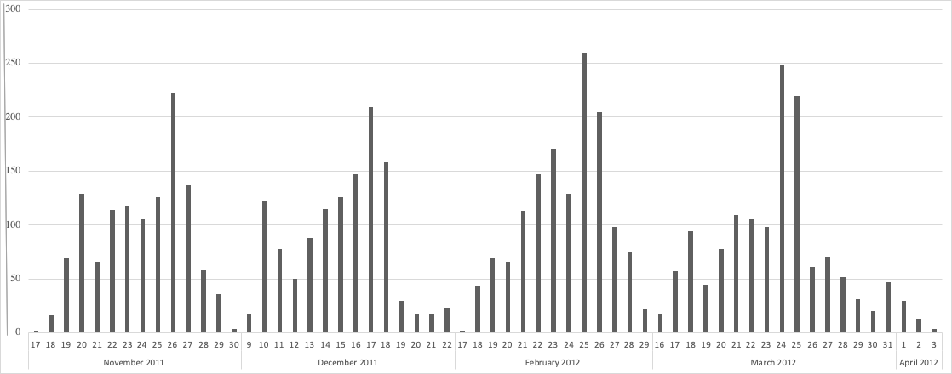
Note: Graph shows only dates during which data were collected.

Table A1: Question Descriptions
Variable | Description
Age | Years of age
Gender | Binary indicator for gender
Education | Three-point scale increasing in the level of education acquired by the respondent.
Income | Five-point scale increasing in the level of the respondent’s income.
Locality | Three-point scale denoting whether the respondent lived in a rural, small urban (<1 million residents), or large urban area.
Trust in… | Five-point scale measuring the extent the respondent trusts a particular political entity.
Interest in politics | Three-point scale measuring the respondent’s professed interest in politics.
Support [party] | Binary indicator measuring whether the respondent states that they support a particular political party more than any other party.
Preferred gov’t | Binary indicator measuring whether the respondent prefers democracy, autocracy, or does not have a preference in government.
Russia’s path | Four-point scale increasing in whether the respondent beliefs Russia is on the right path.
TV viewership | Binary indicator measuring TV viewership.

Table A2: Correlations between Trust in Institutions
Trust in... | Putin | Duma | Army | Courts | Local gov’t | Police
Putin | 1.00
Duma | 0.51 | 1.00
Army | 0.38 | 0.39 | 1.00
Courts | 0.34 | 0.50 | 0.45 | 1.00
Local government | 0.40 | 0.51 | 0.30 | 0.44 | 1.00
Police | 0.33 | 0.46 | 0.40 | 0.51 | 0.51 | 1.00

Table A3: Balance Tests for Covariates
 | Pre- Duma | Post- Duma | Post- Protest | Pre- Pres. | Post- Pres.
Age | 45.159 | 47.078 | 46.036 | 46.192 | 46.686f
 | (0.508) | (1.437) | (0.539) | (0.469) | (0.473)
Male | 0.470 | 0.525 | 0.460 | 0.458 | 0.467
 | (0.014) | (0.042) | (0.015) | (0.013) | (0.013)
Education | 2.111 | 2.156b | 2.033c | 2.072 | 2.104
 | (0.019) | (0.052) | (0.020) | (0.018) | (0.018)
Income | 2.975a | 2.619 | 2.821c | 3.097de | 3.203f
 | (0.043) | (0.106) | (0.044) | (0.039) | (0.040)
Interest in Politics | 0.414 | 0.471 | 0.444 | 0.428 | 0.439
 | (0.014) | (0.042) | (0.015) | (0.013) | (0.013)
Urban | 2.968 | 3.085 | 2.952 | 2.687e | 2.687f
 | (0.024) | (0.077) | (0.026) | (0.028) | (0.028)
Support UR | 2.310a | 2.096b | 2.281 | 2.400e | 2.393f
 | (0.0254) | (0.078) | (0.026) | (0.022) | (0.022)
Note: Table reports means for each period with standard deviations in parentheses. Difference in means only shown for period-dyads with statistically significant differences.
a) Difference in means between Pre-Duma and Post-Duma are statistically significant at p < .05.
b) Difference in means between Post-Duma and Post-Protest are statistically significant at p < .05.
c) Difference in means between Pre-Duma and Post-Protest are statistically significant at p < .05.
d) Difference in means between Pre-Presidential and Post-Presidential are statistically significant at p < .05.
e) Difference in means between Pre-Duma and Pre-Presidential are statistically significant at p < .05.
f) Difference in means between Pre-Duma and Post-Presidential are statistically significant at p < .05.

Table A4: Weighted Trust in…
 | Pre-Duma | Post-Duma | Post-Protest
Putin | 3.423a | 3.000b | 3.300c
 | (0.038) | (0.120) | (0.043)
Duma | 2.521 | 2.607 | 2.640
 | (0.107) | (0.039) | (0.041)
Army | 3.389 | 3.359 | 3.379
 | (0.038) | (0.112) | (0.041)
Courts | 2.758 | 2.791 | 2.725
 | (0.039) | (0.112) | (0.043)
Local Government | 2.612 | 2.579 | 2.650
 | (0.039) | (0.109) | (0.040)
Police | 2.737 | 2.683 | 2.665
 | (0.039) | (0.117) | (0.040)
Note: Table reports weighted means for each period with standard deviations in parentheses. Difference in means only shown for period-dyads with statistically significant differences.
a) Difference in means between Pre-Duma and Post-Duma are statistically significant at p < .05.
b) Difference in means between Post-Duma and Post-Protest are statistically significant at p < .05.
c) Difference in means between Pre-Duma and Post-Protest are statistically significant at p < .05.

Table A5: Trust in Institutions
 | Putin | Duma | Army | Courts | Local Gov’t | Police
Post-Duma | -0.382***  (0.122) | -0.052  (0.112) | -0.020  (0.118) | 0.118  (0.120) | -0.011  (0.116) | -0.038  (0.121)
Post-Protest | -0.109*  (0.058) | 0.010  (0.056) | -0.030  (0.055) | -0.037  (0.058) | 0.056  (0.058) | -0.079  (0.057)
Pre-Presidential | -0.035  (0.052) | 0.056  (0.052) | -0.081  (0.051) | -0.026  (0.054) | 0.113**  (0.053) | -0.069  (0.053)
Post-Presidential | -0.035  (0.053) | 0.101  (0.052) | -0.086*  (0.052) | -0.096  (0.054) | 0.044  (0.054) | -0.359***  (0.054)
Constant | 3.609***  (0.071) | 2.737***  (0.079) | 3.733***  (0.065) | 2.883***  (0.070) | 3.662***  (0.070) | 2.832***  (0.070)
N | 4,231 | 4,280 | 4,285 | 4,266 | 4,265 | 4,274
R² | .021 | .013 | .04 | .014 | .009 | .025
Ordinary least squares regression with robust standard errors. Controls for income and education not shown. Reference period is “pre-Duma.” ***p<.01, **p<.05, *p<.1

Table A6: Trust in Putin by Views of United Russia
Support UR | 0.703***
 | (0.104)
Support Opposition | -0.801***
 | (0.125)
Post-Duma | -0.153
 | (0.251)
Post-Duma*Support UR | -0.136
 | (0.311)
Post-Duma*Support Opposition | -0.082
 | (0.240)
Post-Protest | -0.197
 | (0.132)
Post-Protest*Support UR | 0.135
 | (0.146)
Post-Protest*Support Opposition | -0.099
 | (0.178)
Note: OLS results with robust standard errors, fixed effects for education and income not shown. Reference group are those indifferent to UR. * p<.1, ** p<.05, *** p<.01

Figure A2: Predicted Margins for Trust in Putin by Preferred Government
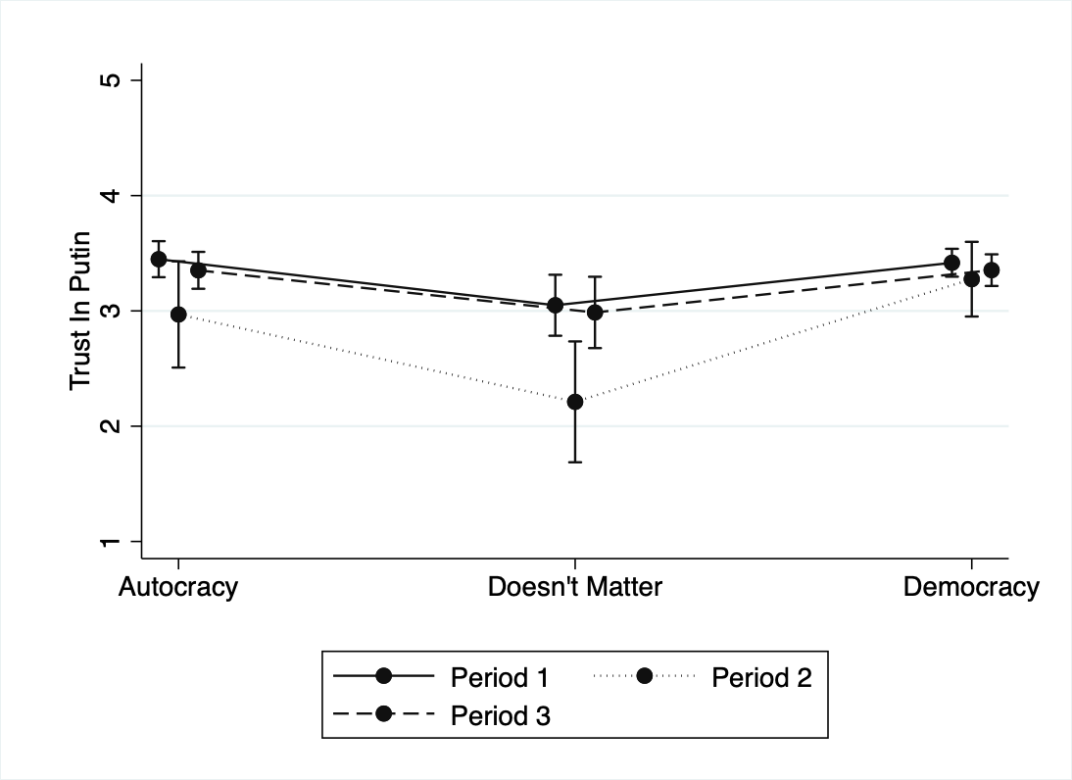
Note: Predicted trust in Vladimir Putin by preferred government with 95% confidence intervals. Ordinary least squares with robust standard errors. Fixed effects for income and education are not shown.

Figure A3: Predicted Margins for Trust in Putin by Attitudes about Russia’s Path
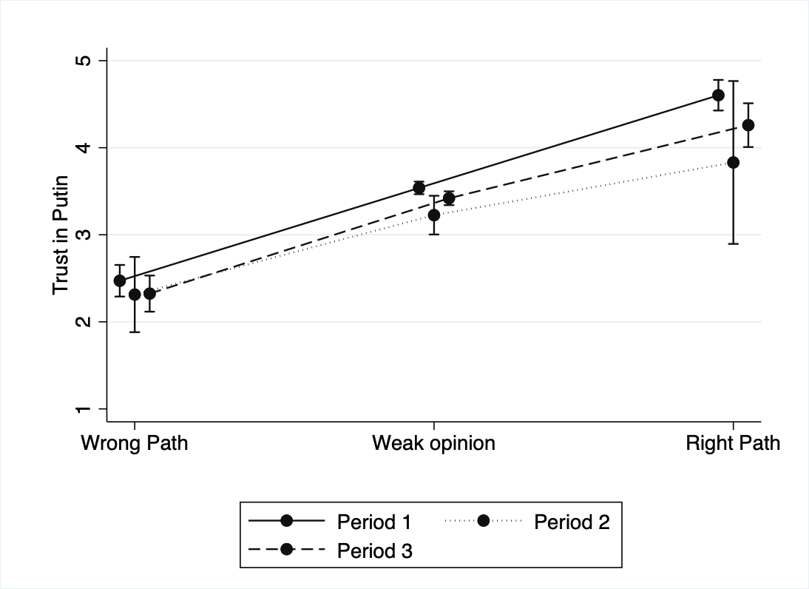
Note: Predicted trust in Vladimir Putin by attitudes of Russia’s path with 95% confidence intervals. Ordinary least squares with robust standard errors. Fixed effects for income and education are not shown.

Appendix B: Political Trust and the 2012 Presidential Elections

This study primarily focuses on political trust before and after an election with particularly blatant, egregious fraud—the 2011 Duma elections. As the case study suggests, the Duma elections were considered to be among the most fraudulent in Russian history and were perceived by the public as being particularly unfair compared to other elections. Indeed, the relatively high levels of perceived manipulation sparked the subsequent anti-fraud protests that swept through the country, marking one of the first main challenges to the Putin regime. However, this raises the question: Do we observe a similar change in political trust after elections with seemingly “average” levels of fraud (that are perceive as being neither more nor less honest than usual)?
To tentatively address this question, I examine trust in political institutions and entities following an election with perceived “average” levels of fraud—2012 presidential election. The presidential elections took place after the height of the protest movement when societal support for the protests had wane (see Appendix E). In response to the allegations of fraud and the resulting protests, the government took several steps to assuage concerns about future falsification, such as installing web cameras in polling stations around the country. Overall, the presidential elections were seen as substantially less fraudulent than the 2011 Duma elections and neither more nor less honest than the previous presidential election in 2008 (Levada Analytical Center 2012). While it is impossible to directly compare the parliamentary and presidential elections elections—people may react to parliamentary and presidential elections in different ways and the elections took place in different political atmospheres—examining trust during the presidential elections can provide some insights into political trust when election manipulation was not viewed as being unusual.
Table A7: Information on Time Periods
Period | Description | Dates | Observations
3 | Post-Protest | December 11-22 | 1,060
4 | Pre-Presidential | February 16-31 | 1,401
5 | Post-Presidential | March 16-April 3 | 1,401

To assess this idea, I examine trust in political entities and institutions before and after the March 3 presidential elections from February 16-31 and from March 16-April 3. I also examine changes during these periods compared to the post-protest period in December. See Table A7 for information on these time periods. Table A8 presents the mean, standard deviation, and t-tests for the post-protest, pre-presidential election, and post-presidential election periods for political trust. There is little evidence to suggest that the presidential election influenced trust in Putin or any other political institution. If anything, there is a slight increase in trust in Putin from the post-protest period during the height of the subsequent protests, to the post-presidential elections period. These findings provide initial evidence to suggest that it is not elections in-and-of themselves, but rather the perceived egregious fraud of the Duma elections that impacted trust in Putin. Future research should further consider the extent to which relative levels of perceived manipulation—that is, when electoral manipulation is viewed as more or less egregious than usual—influence attitudes toward government entities and officials.

Table A8: Trust in…
 | Post-Protest | Pre-Presidential | Post-Presidential
Putin | 3.301 | 3.401 | 3.411c
 | (0.039) | (0.033) | (0.034)
Duma | 2.631 | 2.680 | 2.691
 | (0.037) | (0.032) | (0.0372)
Army | 3.387 | 3.358 | 3.329
 | (0.037) | (0.035) | (0.033)
Courts | 2.755 | 2.741 | 2.682
 | (0.038) | (0.034) | (0.034)
Local Government | 2.669 | 2.738 | 2.657
 | (0.037) | (0.033) | (0.034)
Police | 2.713 | 2.716b | 2.427c
 | (0.037) | (0.033) | (0.033)
Note: Table reports means for each period with standard errors in parentheses.
a) Difference in means between Post-Protest and Pre-Presidential are statistically significant at p < .05.
b) Difference in means between Pre-Presidential and Post-Presidential are statistically significant at p < .05.
c) Difference in means between Post-Protest and Post-Presidential are statistically significant at p < .05.

Appendix C: Appropriate Authority Response or Fear of Disorder?

Results suggest that trust in President Putin rebounded to nearly pre-election levels following the anti-regime protests in December 2011. Why do we see this positive shift in attitudes after the protests, a shift made even more puzzling by the actively anti-regime and anti-Putin messaging of the protests? Protests carry different types of information to observers that may influence their attitudes of the government. While anti-regime protests implicitly carry with them messaging that portrays the regime in a negative light, they may also carry information that can improve attitudes toward authorities. Existing scholarship has identified two key mechanisms by which the occurrence of protests may improve trust in existing government institutions and leaders: appropriate authority response and fear of disorder. While my data do not allow me to directly test these mechanisms, I investigate a series of observable implications indicated by them.
First, Frye and Borisova (2019) argue that when authorities in non-democracies allow protests to occur relatively free of repression, attitudes toward the regime will improve as people adjust their expectations about the freedoms afforded to them—what I call the “authority response” mechanism. According to this theory, it is the authorities’ response to the protests, rather than the protests themselves, that contributes to increased levels of trust. This theory has a couple of observable implications. First, the theory presupposes that changes in trust are predicated on authorities pursuing a mild response to protests that uses repression sparingly, if at all. We should therefore expect people to have positive views of authorities’ response to protests. This does appear to be the case for the 2011-2012 Russian Duma election protests: 55 percent of individuals stated that they believed authorities’ response to the protest was just right while less than 10 percent thought the response was too harsh.
Second, the authority response mechanism implies that trust in Putin should increase primarily among those who are supportive of civil liberties, such as the freedom of expression and assembly. If an individual believes that civil liberties are important for society, they will be more likely to be more trusting of the government when they demonstrate a respect for these rights. To examine whether the influence of protest on trust is contingent upon support for civil liberties, I conduct ordinary least squares regressions with robust standard errors and fixed effects for education and include; I include interaction terms for support of protests in general and, separately, support for freedom of expression. See Figures A4 and A5 for results.
There is no evidence to suggest that attitudes toward protests have a discernable impact on trust across any time period. However, attitudes toward protests in general are also likely to be influenced by political events. Indeed, support for protests changed during the election and protest periods. I therefore examine support for freedom of expression, which remained constant over time. The results here tell a different story: Trust in Putin decreased after the Duma elections primarily for those who believe that the right to self-expression is a top priority, only to rebound during the initial protest period. Conversely, trust in Putin increases after the elections for those who believe freedom of expression is harmful for society and decreases after the protests. These results provide some, albeit mixed support for the proposition that permitting protests to occur unmolested can improve trust in authorities.

Figure A4: Predicted Margins for Trust in Putin by Views of Protests (95% CI)
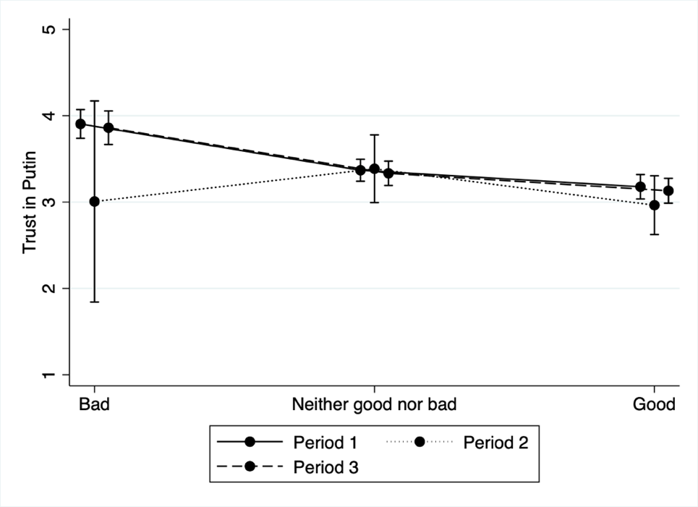
Note: Predicted trust in Vladimir Putin by views of protests with 95% confidence intervals. Ordinary least squares with robust standard errors. Fixed effects for income and education are not shown.

Figure A5: Predicted Margins for Trust in Putin by Freedom of Expression (95% CI)
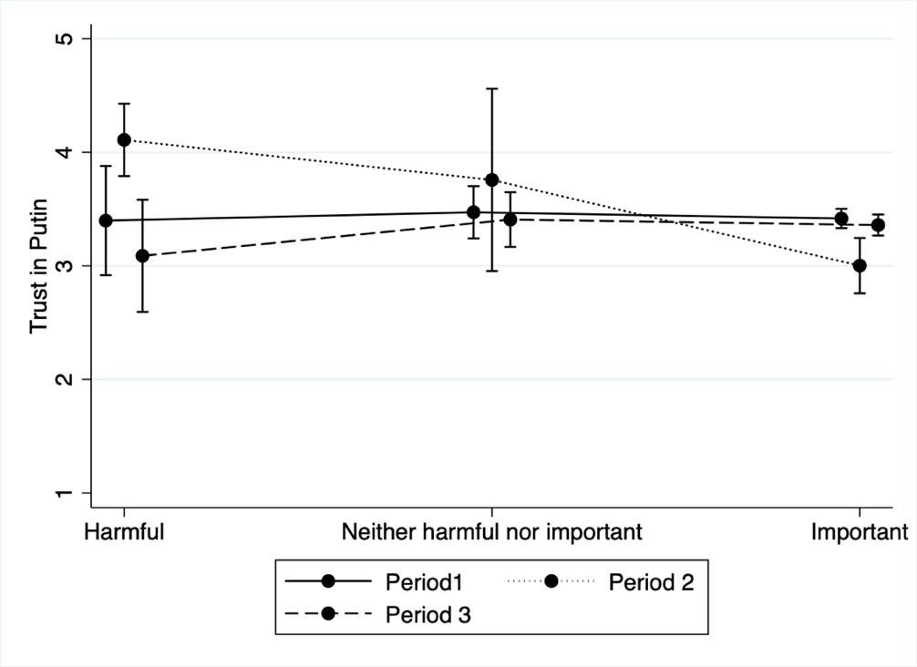
Note: Predicted trust in Vladimir Putin by views of freedom of expression with 95% confidence intervals. Ordinary least squares with robust standard errors. Fixed effects for income and education are not shown.

The second potential mechanism—fear of disorder—suggests that oppositional protests may increase public concerns regarding societal stability, leading to an improvement in attitudes of the existing order (Pepinsky, 2017; El-Mallakh, 2021; Tertychnaya and Lankina, 2020). Some studies have suggested that Russians value social stability and order over democratic ideals (e.g. Carnaghan, 2007), though more recent research has pushed back against this conclusion (Hale, 2011; Gerber and Chapman, 2018). Therefore, it may be the case that protests are viewed as a potential societal destabilizer. Indeed, this narrative was one forwarded by authorities during the period under examination: In his annual call-in broadcast, President Putin explicitly stated that the opposition was using false allegations of fraud to “destabilize” society (Direct Line 2011).
There is, at best, mixed evidence for this idea. Support for the right to protest in general is somewhat robust in Russia: During the period under examination, 38 percent of respondents stated that protests are (definitely or probably) good for Russia compared to 18 percent that said they are (definitely or probably) bad. Even as support for the oppositional protest movement waned in the spring of 2012, there was limited agreement that people should avoid protest in order to preserve order in the event of falsified elections. Finally, despite claims that Russians prefer order over civil liberties, a majority of Russians express preference for public control of authorities over a strong authority. On average, public opinion polls during the period under examination provide limited support that Russians value order at the expense of civil liberties.
However, these figures cannot tell us whether concerns about societal stability increased after the protests and whether these concerns can be linked to increased trust in the existing order. To further examine this mechanism, I look at how fear of a weak government influenced trust in Putin during the December 2011 elections and protest season. The disorder mechanism implies that people who fear instability will be more likely to express increased trust in authorities after protests than those who do not fear instability. While I do not have a direct measure of fear of instability and disorder, concerns about weak government can provide insight into people’s general concerns about stability in the country. There is little evidence to suggest that fear of a weak government increased during the post-protest period: While the percentage of those who stated that they fear a weak government increased from 11 percent during the post-Duma period to 14 percent in the post-protest period, this difference is not statistically significant. Due to the low number of observations in the post-protest period, these results should be viewed as suggestive.
However, this still begs the question: Does fear of a weak government condition the impact of protest on trust in President Putin? While anti-regime protests may increase fears of a weak government, do these concerns in turn influence trust in Putin? To examine this question, I create an interaction term for individuals who state that they fear or do not fear a weak government before and after the elections (pre- and post-Duma periods) and after the protests (post-Protest period). Results do not support the proposition that trust in Putin varies across time periods for those that fear a weak government (Figure A6). Among those that state that they do not fear a weak government, support decreases after the elections and rebounds to roughly pre-election levels after the protest.

Figure A6: Predicted Margins for Trust in Putin by Fear of Weak Government
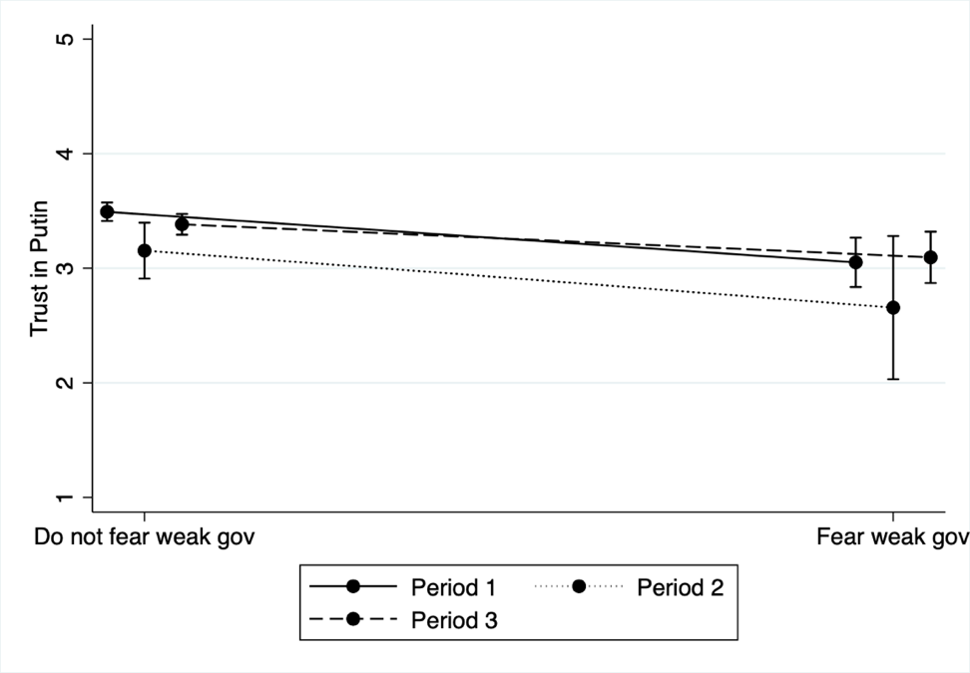
Note: Predicted trust in Vladimir Putin by fear of weak government with 95% confidence intervals. Ordinary least squares with robust standard errors. Fixed effects for income and education are not shown.

In sum, preliminary results provide greater, though still mixed, evidence for the appropriate authority response mechanism than for the fear of disorder mechanism. However, as always, conditional results should be viewed as suggestive. Future research is needed to better illuminate the potential mechanisms that link protest and trust in non-democratic institutions and leaders.

Appendix D: Additional Mechanisms

Urban Residents
Average results indicate that both electoral manipulation and oppositional protests can influence trust in autocrats, although in opposite directions. However, it is unlikely that these events influence all individuals equally. Indeed, Frye and Borisova (2019) analyze these same two events in Moscow alone and find contradictory results: They argue that there was no change in trust in Putin after the election and there was an increase in trust after the protests among Muscovites. This difference in results is not totally surprising: Prior research has shown that residents of “global cities” are exposed to different information than residents of other localities and often hold diverse political attitudes than the rest of the population (cf. Gerber and Chapman 2018). Similarly, as Treisman (2014) argues in his study of approval for Putin in the 2010s, while declining support for the Kremlin in 2011 was broad-based, it was especially significant among the “creative class” of mainly urban dwellers.
To determine whether the influence of protest on trust is conditional on respondents’ residential status, I include an interaction term that captures the impact of living in a rural area, in a small town, or a large city (over 1 million people, including Moscow and St. Petersburg) after the elections (Urban x Post-Duma) and after the protests (Urban x Post-Protest). I use large city residence as the reference category. If extant scholarship is correct and urban dwellers are more likely to perceive the elections as fraudulent, then we would expect the coefficient for Post-Duma to be negative and significant. Indeed, results suggest that the fraudulent elections decreased trust for Putin primarily for urban residents and that trust rebounded after the protests (Post-Protest). Figure A7 shows the predictive margins for rural, small/medium city, and large city residents over time. Electoral fraud does not appear to have reduced trust for Putin for rural residents, who are also generally more likely to trust Putin than urban dwellers.
Figure A7: Predicted Margins for Trust in Putin by Residency
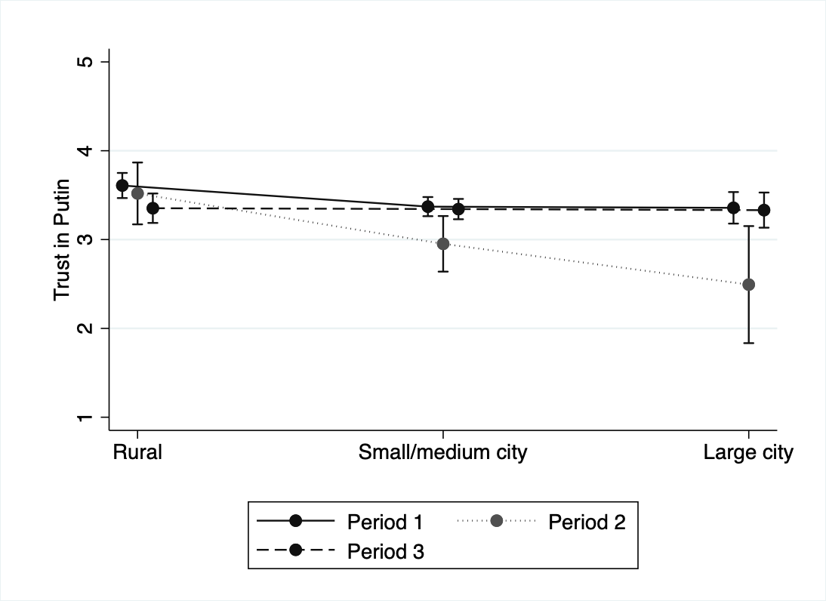
Note: Predicted trust in Vladimir Putin by residency with 95% confidence intervals. Ordinary least squares with robust standard errors. Fixed effects for income and education are not shown.

Interest in Politics

The results on political affiliation suggest that individuals who have already formed strong political opinions are less likely to update their beliefs when presented with new information than individuals with weaker political opinions. We might expect to see similar results based on individuals’ interest in politics: People who are most interested in politics are more likely to have formed strong political beliefs and may therefore be less likely to update their beliefs based on new information. On the other hand, people with no interest in politics may be least likely to be aware of political events and may therefore be also unlikely to update their beliefs. Rather, we might expect those in the middle—those who have some interest in politics—will likely be exposed to and aware of politically-charged events such as fraud and protests, but may not have strongly formed political beliefs, and may therefore be the most likely to update their beliefs based on new information.
To determine whether the influence of electoral manipulation and protest on trust is conditional on respondents’ interest in politics, I include an interaction term that captures the impact of being extremely uninterested in politics, being ambivalent about politics, and being extremely interested in politics after the elections and after the protests. Figure A8 shows the predictive margins for each group over time.
As with political attitudes, the strength of interest in politics conditions the impact of electoral manipulation and oppositional protest on trust in Putin. Individuals on either extreme— those who are extremely uninterested in politics or extremely interested in politics—are not swayed by the new information presented by these events. Individuals who are not at all interested in politics are less likely to be aware or care about political events and update their views of authorities accordingly. On the other extreme, those who are very interested in politics are most likely to have strong pre-existing attitudes and, therefore, are least susceptible to new information (Chapman 2021). Rather, it is those in the middle (those somewhat interested or uninterested in politics) that adjust their views of Putin after politically-charged events. It is precisely these individuals who are simultaneously likely to be aware of political events but have not formed strong political opinions, and therefore are likely to be swayed by new information (Geddes and Zaller, 1989; Zaller, 1992; Chapman, 2021).

Figure A8: Predicted Margins for Trust in Putin by Interest in Politics
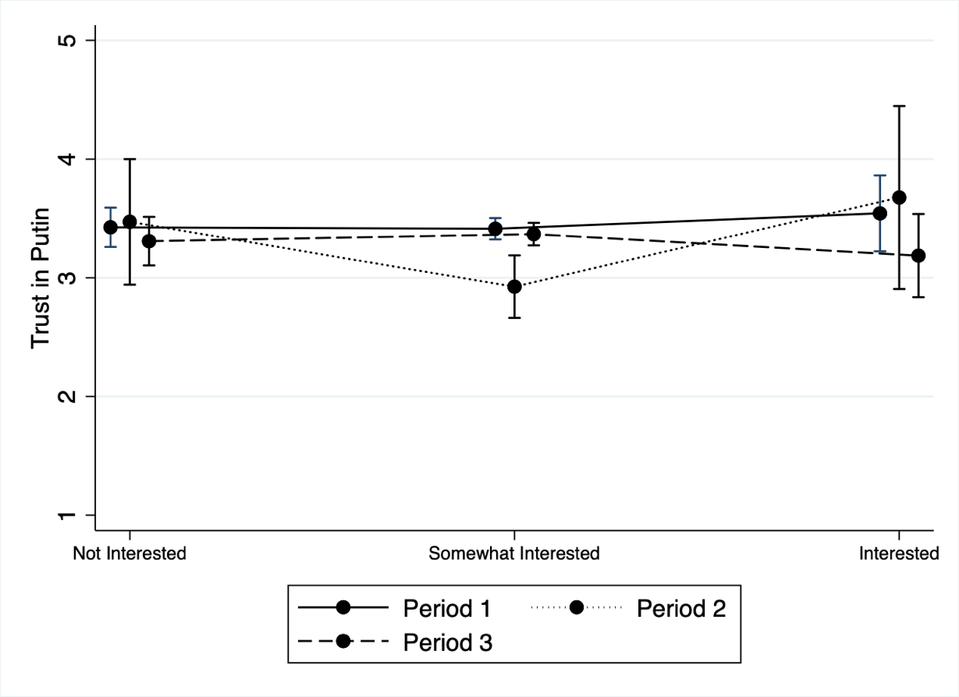
Note: Predicted trust in Vladimir Putin by interest in politics with 95% confidence intervals. Ordinary least squares with robust standard errors. Fixed effects for income and education are not shown.

Exposure to Media

Individuals’ understanding of and attitudes toward political-charged events, such as allegedly fraudulent elections and political protests, may be influenced by how these events are framed in the media. In Russia, the government has extensive control over the media landscape, providing the government with a strong tool for framing these events in a positive light—or cover them at all. To the surprise of many, state media widely covered the protests (Lankina & Watanabe, 2017). At the same time, however, state media downplayed the size of the protests, labeled protesters as foreign agents working for the United States to bring unrest and instability to Russia (Tisdall 2011), and largely ignored protesters demands that Russia’s leaders be held accountable for the electoral manipulation (Koesel & Bunce, 2012; Smyth & Oates, 2015). Therefore, how people interpret these events, and their resulting impact on attitudes toward the government, may be conditioned on individual media usage (Sirotkina & Zavadskaya, 2021).
To determine whether the influence of electoral manipulation and protest on trust is conditional on respondents’ media use, I include an interaction term that captures the impact of watching television for information about politics after the elections and after the protests. Individuals who stated that they watch television every day or several times a week are coded as being High TV users, while those who state that they watch television for information about politics less than once a week are coded as Low TV users. Figure A9 shows the predictive margins for each group over time.

Figure A9: Predicted Margins for Trust in Putin by TV Viewership
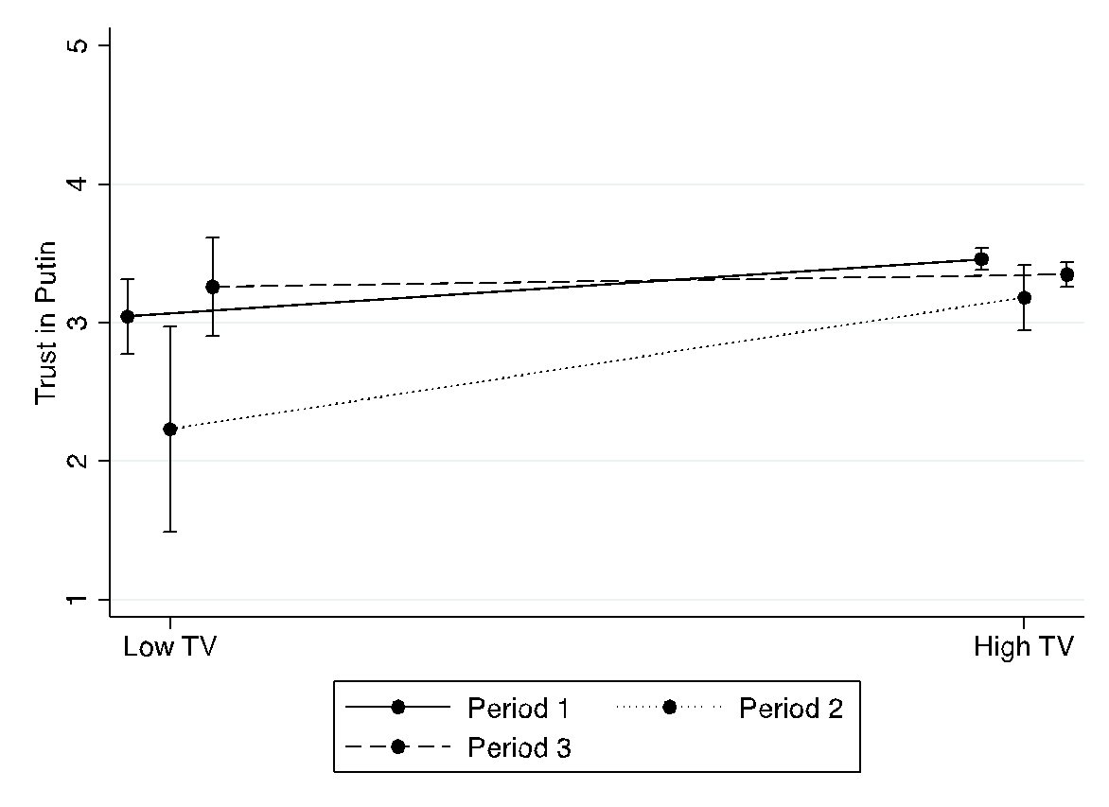
Note: Predicted trust in Vladimir Putin by TV viewership with 95% confidence intervals. Ordinary least squares with robust standard errors. Fixed effects for income and education are not shown.

Interestingly, media use does not appear to have a significant impact on trust in Putin for either low or high television users. While the predicted margins for trust in Putin is negative for the low television users, it falls short of conventional levels of significance. However, null effects of media use should not be viewed as strong evidence that media do not condition the impact of events on trust in institutions due to the relatively small number of observations in the Low TV group. When the survey was fielded, 90 percent of the sample stated that they watched television for political news at least several times per week. Rather, more fine-grained data are needed to make strong conclusions about the impact of media on trust in institutions.

Appendix E: The Rise and Fall of the Protest Movement
The December 10 Bolotnaya protests were only the beginning of the Kremlin’s troubles. The protests continued into 2012 and spread throughout the country. Following the first mass protests on December 10, major rallies occurred in Moscow and Saint Petersburg on December 17-18. The following week, on December 24, protests took place throughout the country, including Saint Petersburg, Nizhny Novgorod, Vladivostok, and Novosibirsk; estimates place between 28,000-120,000 protestors in Moscow alone. Rallies continued into the new year, with major events occurring from February to May.
Even as the protests continued into the new year, support for the movement began to decline as the movement’s leadership faced internal struggles and ineffective issue framing failed to attract sympathizers (Lasnier 2018). During the first weeks of the protest, views toward the movement were mostly split: 44 percent of Russian stated that they definitely or rather supported the protests while 41 percent said they did not (Levada Analytical Center 2013). However, by March the following year, only 32 percent of respondents stated that they supported the protests, while those that did not support the protests increased to 52 percent.
Russians were also skeptical about the effectiveness of the protest and its goals: In November 2012, 58 percent of Russians believed that the protests did nothing to improve the situation in the country (Levada Analytical Center, 2013, p. 113); the percentage of people who viewed the opposition as not having a sound program increased from 49 percent in 2011 to 57 percent in 2012. Indeed, this public souring was not limited to the December 2011 protest movement: Approval of protests in general, which had increased following the Duma elections, faltered as the protests continued into 2012 (Table A9).
Table A9: Views of Protest
 | Pre-Duma | Post-Duma | Post-Protest | Pre-Pres. | Post-Pres.
Protests | 3.243a | 3.610bc | 3.369 | 3.180 | 3.094d
 | (0.030) | (0.078) | (0.030) | (0.027) | (0.027)
Note: Approval of protests measured on a 5-point scale (1 = strongly disapprove, 5 = strongly approve). Difference in means only shown for period-dyads with statistically significant differences.
a) Difference in means between Pre-Duma and Post-Duma are statistically significant at p < .05.
b) Difference in means between Post-Duma and Post-Protest are statistically significant at p < .05.
c) Difference in means between Pre-Duma and Post-Protest are statistically significant at p < .05.
d) Difference in means between Pre-Duma and Post-Presidential are statistically significant at p < .05.

On March 4, Vladimir Putin handedly won the presidential election with 64 percent of the votes. Following the election, trust in Putin reached and surpassed pre-Duma election levels—doubtlessly influenced by his victory in the presidential elections, increasing disillusionment with the opposition movement, state media coverage of the protests, and government handling of the protests.
With his position secured, government response toward the protests changed dramatically. Although many of the earlier rallies took place under heavy police presence and some protesters were detained after unsanctioned meetings, the government used repression sparingly. That is, until May 6, 2012—the day before Putin was inaugurated as President for a third term. May 6 marked the first large-scale protest in nearly a month and attracted approximately 20,000 protesters in Moscow. Unlike previous marches, these protests were marred by significant police violence and intimidation. Approximately 400 protesters were arrested, including leading opposition figures Alexei Navalny, Boris Nemtsov, and Sergei Udaltsov; many opposition members were detained by police before the rallies even began. At least eighty people were injured. According to Lenta.ru, “Moscow had not seen such large-scale street battles for twenty years.”
As support for the protests waned, support for the state’s response strengthened: In October 2012, a plurality (39%) viewed the government’s actions against the protest organizers as an effort to restore law in order, compared to 27 percent that viewed these actions as political repression (Levada, 2013). A majority (56%) did not view the persecution of protestors and opposition leaders and the toughening of protests laws as an onset of political repressions, compared to 27 percent who did. Protest fatigue and disillusionment with the movement opened the door to crackdown on the protesters with little backlash from the general public.
The May 6 protests and the unprecedented police response is widely viewed as a turning point in Putin’s regime (Lankina 2015; Taylor 2013). According to Lankina (2015b), protest activity after mid-2012 has been subject to greater repression. The May protests “provided a convenient basis for a comprehensive crackdown strategy to be put in place” (Hinsey, 2013, p. 132). While future protests were allowed to continue, the Kremlin continued to foster “an atmosphere of intimidation and repression” (ibid)—raiding the homes of opposition leaders, increasing interrogations and arrests against the opposition, passing more stringent protest laws, and further reducing media freedom. If the 2000s were characterized by the cooptation of citizen loyalty and isolation of dissent, Gel’man (2016) argues, upon Putin’s return to power 2012 these methods were “replaced by the politics of fear, which include overt intimidation and public discrediting of the regime’s critics, and selective persecution and open harassment of opposition activists and/or supporters” (p. 28). Following the 2011-2012 protest movement—and partially as a reaction to them—Russia began its definitive move from a backsliding democracy to a hegemonic authoritarian regime.
References
Gel’man, Vladimir. 2016. “The Politics of Fear: How Russia’s Rulers Counter Their Rivals.” Russian Politics 1 (1): 27–45.
Gerber, Theodore P., and Hannah S. Chapman. 2018. “Familiarity Breeds Contempt? Knowledge and Understanding of Democracy, Support for Democratization, and Global City Residence in Russia.” Democratization 25 (3): 481–503.
Hinsey, Ellen. 2013. “Putin Cracks Down: The Russian Presidential Election and Its Aftermath.” New England Review 34 (2): 123–41.
Karrie J. Koesel and Valerie J. Bunce. 2012. “Putin, Popular Protests, and Political Trajectories in Russia: A Comparative Perspective.” Post-Soviet Affairs 28 (4): 403–23.
Lankina, Tomila. 2015. “Daring to Protest: When, Why, and How Russia’s Citizens Engage in Street Protest.” 333. PONARS Eurasia Policy Memo. PONARS Eurasia.
Lasnier, Virginie. 2018. “Russia’s Opposition Movement Five Years After Bolotnaia: The Electoral Trap?” Problems of Post-Communism 65 (5): 359–71.
Levada Analytical Center. 2012a. “Grazhdanye Rossii Ne Zhaluyutsya Na Davleniye Oni Chitayut Vyiboryi Chestnimi, No s Udovols’tviyem Progolosovali Vyi Protiv Vsex.” https://www.levada.ru/2012/03/25/grazhdane-rossii-ne-zhaluyutsya-na-davlenie-oni-schitayut-vybory-chestnymi-no-s-udovolstviem-progolosovali-by-protiv-vseh/.
Levada Analytical Center. 2013. “Russian Public Opinion 2012-2013: From Opinion Toward Understanding.” Levada Analytical Center. http://www.levada.ru/sites/default/files/2012_eng.pdf.
Regina Smyth and Sarah Oates. 2015. “Mind the Gaps: Media Use and Mass Action in Russia.” Europe-Asia Studies 67 (2): 285–305.
Taylor, Brian D. 2013. “Putin’s Crackdown: Sources, Instruments, and Challenges.” 277. PONARS Eurasia Policy Memo. PONARS Eurasia.
Tisdall, Simon. 2011. “Vladimir Putin Accuses Hillary Clinton of Encouraging Russian Protests.” The Guardian, December 8, 2011.
Tomila Lankina and Kohei Watanabe. 2017. “‘Russian Spring’ or ‘Spring Betrayal’? The Media as a Mirror of Putin’s Evolving Strategy in Ukraine.” Europe-Asia Studies 69 (10): 1526–56.
Treisman, Daniel. 2014. “Putin’s Popularity since 2010: Why Did Support for the Kremlin Plunge, Then Stabilize?” Post-Soviet Affairs 30 (5): 370–88.

See Appendix B below for more information on the pre-presidential and post-presidential time periods.
These waves include a Moscow oversample. Results are consistent when using post-stratification weights to adjust the sample to concord with population distributions of locality type, gender, age, and education.
The protest movement continued into and beyond the post-presidential election period, though they lost much of their momentum and broad support for the protests waned.
The variable for support of protests asks, “Are protests good or bad for Russia?”, which is measured on a five-point scale. Due to the low number of observations in Period 2, I collapse the categories to create a three-point scale with 1 being definitely or probably bad, 2 being neither good nor bad, and 3—probably or definitely good. Respondents were also asked to evaluate the importance of freedom of self-expression on a five-point scale with 5 being a “top priority” and 1 being “definitely harmful.” Due to the low number of observations in Period 2, I collapse the five categories into three: definitely and somewhat harmful, neither important nor harmful, and important or a top priority.
During the spring of 2012, 56 percent of respondents (strongly or somewhat) agreed with the statement, “If there is proof that elections are falsified, people have a duty to protest,” compared to 38 percent who (strongly or somewhat) disagreed with this statement.
In December 2011, when asked, “What does Russia need more now: strong authority or the public needs to control the authority?” 31 percent of respondents answered strong authority while 60 percent answered public control of the authority (Levada Analytical Center, 2013).
While it is desirable to further separate St. Petersburg and Moscow from other large cities, the limited number of observations (n=12 in the Post-Duma Period) makes this choice unfeasible.
In 2011-2012, approximately 75% of Russians stated that they used the television for news on a daily basis.
Of course, an individuals’ decision to use media, and which media they choose to use, cannot be easily separated from existing views of authorities. Individuals with pro-regime views are also more likely to select into state-sponsored news sources, while those with anti-regime views may seek out alternative sources.
The exact figures vary widely according to the source: Police estimate that approximately 28,000 individuals attended the protests, while organizers put this number around 120,000.
These arrests resulted in the infamous Bolotnaya Square case in which thirty-seven individuals have been accused of various illegal protest activities.

