Online Appendix for
“The Distinctive Vocabularies of Right-Wing Populists”

Duncan McDonnell (Griffith University, Brisbane) & Stefano Ondelli (University of Trieste)

Published in Government and Opposition

Contents

A | Subcorpora Composition | p. 2
B1 | Analysis excluding stop words | p. 6
B2 | Analysis using chi-square distance | p. 10
C | Sample of concordances analysis | p. 19

Appendix A – Subcorpora Composition

UNITED STATES

Table A.1: Donald Trump speeches

 | Place | Date
1 | Monessen, Pennsylvania | 28.06.2016
2 | New York City, New York | 16.07.2016
3 | Cleveland, Ohio | 21.07.2016
4 | Green Bay, Wisconsin | 05.08.2016
5 | Detroit, Michigan | 08.082016
6 | Fayetteville, North Carolina | 09.08.2016
7 | Youngstown, Ohio | 15.08.2016
8 | Dimondale, Michigan | 19.08.2016
9 | Akron, Ohio | 22.08.2016
10 | Jackson, Mississippi | 24.08.2016
11 | Washington DC | 30.08.2016
12 | Phoenix, Arizona | 31.08.2016
13 | Detroit, Michigan | 03.09.2016
14 | Philadelphia, Pennsylvania | 07.09.2016
15 | Washington DC | 09.09.2016
16 | Miami, Florida | 16.09.2016
17 | West Palm Beach, Florida | 13.10.2016
18 | Gettysburg, Pennsylvania | 22.10.2016
19 | Valley Forge, Pennsylvania | 01.11.2016
20 | Eau Claire, Wisconsin | 01.112016
21 | Pensacola, Florida | 02.11.2016
22 | Raleigh, North Carolina | 07.11.2016

Table A.2: Hillary Clinton speeches

 | Place | Date
1 | New York City, New York | 06.11.2015
2 | Charlotte, North Carolina | 07.05.2016
3 | Hampton, New Hampshire | 09.05.2016
4 | Washington DC | 14.06.2016
5 | Raleigh, North Carolina | 23.06.2016
6 | Atlantic City, New Jersey | 06.07.2016
7 | Philadelphia, Pennsylvania | 11.07.2016
8 | Portsmouth, New Hampshire | 12.07.2016
9 | Springfield, Illinois | 13.07.2016
10 | Cincinnati, Ohio | 18.07.2016
11 | Washington DC | 26.07.2016
12 | Johnstown, Pennsylvania | 30.07.2016
13 | Pittsburgh, Pennsylvania | 30.07.2016
14 | Youngstown, Ohio | 30.07.2016
15 | Columbus, Ohio | 31.07.2016
16 | Tampa, Florida | 22.07.2016
17 | Philadelphia, Pennsylvania | 28.07.2016
18 | Omaha, Nebraska | 01.08.2016
19 | Commerce City, Colorado | 03.08.2016
20 | Warren, Michigan | 11.08.2016
21 | Reno, Nevada | 25.08.2016
22 | Greensboro, North Carolina | 15.09.2016
23 | Washington DC | 16.09.2016
24 | Washington DC | 18.09.2016
25 | Philadelphia, Pennsylvania | 19.09.2016
26 | Orlando, Florida | 21.09.2016
27 | Charlotte, North Carolina | 02.10.2016
28 | Akron, Ohio | 03.10.2016
29 | Columbus, Ohio | 10.10.2016
30 | Miami, Florida | 11.10.2016

FRANCE

Table A.3: Marine Le Pen speeches

 | Place | Date
1 | Fréjus | 18.09.2016
2 | Paris | 09.12.2016
3 | Lyon | 05.02.2017
4 | Pierrelatte | 25.02.2017
5 | Nantes | 26.02.2017
6 | Mont Saint-Michel | 27.02.2017
7 | Mirande | 09.03.2017
8 | Chateauroux | 11.03.2017
9 | Paris | 13.03.2017
10 | Metz | 18.03.2017
11 | Saint Raphael | 21.03.2017
12 | N’Djaména | 23.03.2017
13 | Lille | 27.03.2017
14 | Bordeaux | 02.04.2017
15 | Monswiller | 05.04.2017
16 | Ajaccio | 09.04.2017
17 | Arcis-sur-Aube | 11.04.2017
18 | Pageas | 13.04.2017
19 | Henin-Beaumont | 23.04.2017
20 | Paris | 07.05.2017

Table A.4: Emmanuel Macron speeches

 | Place | Date
1 | Bobigny | 16.11.2016
2 | Angers | 28.02.2017
3 | Caen | 04.03.2017
4 | Talence | 09.03.2017
5 | Reims | 17.03.2017
6 | Dijon | 25.03.2017
7 | Mayotte | 26.03.2017
8 | Marseille | 01.04.2017
9 | Furiani | 07.04.2017
10 | Besançon | 11.04.2017
11 | Pau | 12.04.2017
12 | Chatellerault | 18.04.2017
13 | Nantes | 19.04.2017
14 | Victoire | 23.04.2017
15 | Arras | 26.04.2017
16 | Albi | 04.05.2017

ITALY

Table A.5: Matteo Salvini speeches

 | Place | Date
1 | Milan | 22.02.2014
2 | Pontida | 04.04.2014
3 | Buja | 05.04.2014
4 | Verona | 06.04.2014
5 | Bergamo | 13.04.2014
6 | Treviso | 24.04.2014
7 | Monza | 30.04.2014
8 | Cagliari | 02.05.2014
9 | Genoa | 03.05.2014
10 | Lamezia Terme | 05.05.2014
11 | Rome | 11.05.2014
12 | Padua | 20.07.2014
13 | Milan | 18.10.2014
14 | Rome | 19.12.2014
15 | Bergamo | 28.12.2014
16 | Rome | 28.02.2015
17 | Montesilvano | 21.03.2015
18 | Terni | 14.04.2015
19 | Reggio Emilia | 25.04.2015
20 | Catania | 27.05.2015
21 | Martinengo | 02.06.2015
22 | Pontida | 21.06.2015
23 | Milan | 04.07.2015
24 | Pontida | 18.09.2016
25 | Florence | 12.11.2016

Table A.6: Matteo Renzi speeches

 | Place | Date
1 | Rome | 08.12.2013
2 | Milan | 15.12.2013
3 | Rome | 13.02.2014
4 | Palermo | 14.05.2014
5 | Cesena | 16.05.2014
6 | Bergamo | 20.05.2014
7 | Rome | 22.05.2014
8 | Rome | 14.06.2014
9 | Rome | 08.12.2014
10 | Florence | 13.12.2015
12 | Rome | 14.12.2014
13 | Rome | 07.02.2016
14 | Rome | 13.03.2016
15 | Rome | 04.04.2016
16 | Milan | 31.05.2016
17 | Rome | 04.07.2016
18 | Rome | 23.07.2016
19 | Rome | 29.10.2016
20 | Florence | 06.11.2016

Appendix B1 - Analysis excluding stop words

As explained in the text, we include stop words (i.e. grammar words) in our main analysis since these may contribute to populist style. To ensure that their inclusion does not significantly affect our conclusions regarding the presence of the main pillars of populist ideology, we re-run the analysis excluding stop words. (i.e. words tagged as pronouns, prepositions, determiners, conjunctions, numbers, abbreviations, exclamations by TagAnt: Anthony, L., 2015, TagAnt (1.2.0) [Computer Software]. Tokyo, Japan: Waseda University. Available from https://www.laurenceanthony.net/software ), in addition to all items lemmatized as “unknown”, since their part of speech (POS) classification is likely to be incorrect. In other words, we only leave nouns, proper names, foreign words, adjectives, adverbs, and verbs in our corpus. We then extract the keywords for all leaders again, using the same settings as described in the main text.

The results are reported for each pair of leaders in the figures below. These are consistent with our findings in the paper regarding the distinctive presence of words indicating ‘people’, ‘elite’, and ‘others’ in the speeches of right-wing populists. For example, in Trump’s new list of keywords, only “are” and “is” are not included in our previous keyword list. However, they are not significant in terms of semantic fields. Similarly, while among Clinton’s new keywords, we find “campaign”, “election”, “everything”, “ideas”, and “progress”, this does not change our substantive conclusion that her speeches stressed social inclusion. As regards the French and Italian subcorpora, again we can see no significant changes compared to the analysis reported in the paper that would call into question the conclusions we drew there.

Figure B1.1: Trump and Clinton Keywords (excluding stop words)

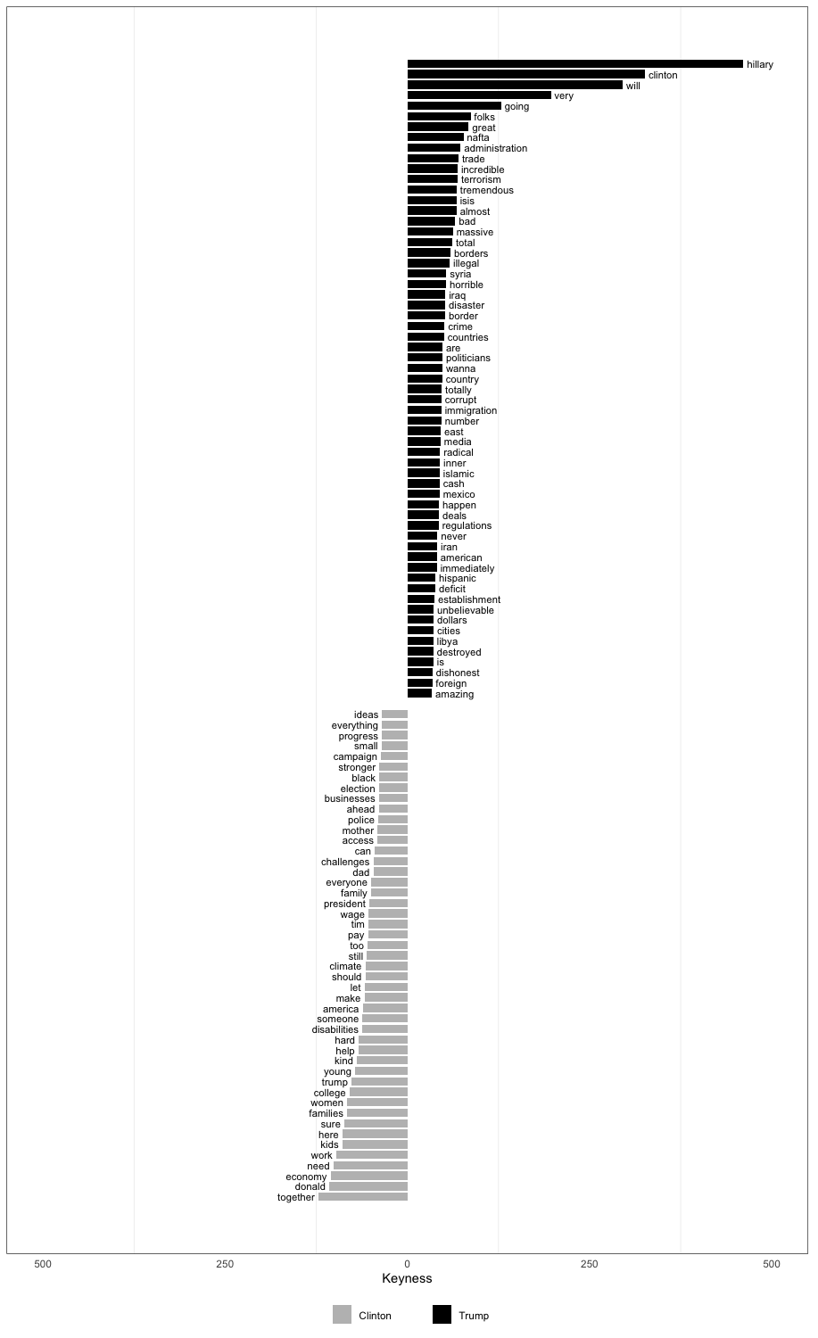
Figure B1.2: Le Pen and Macron Keywords (excluding stop words)

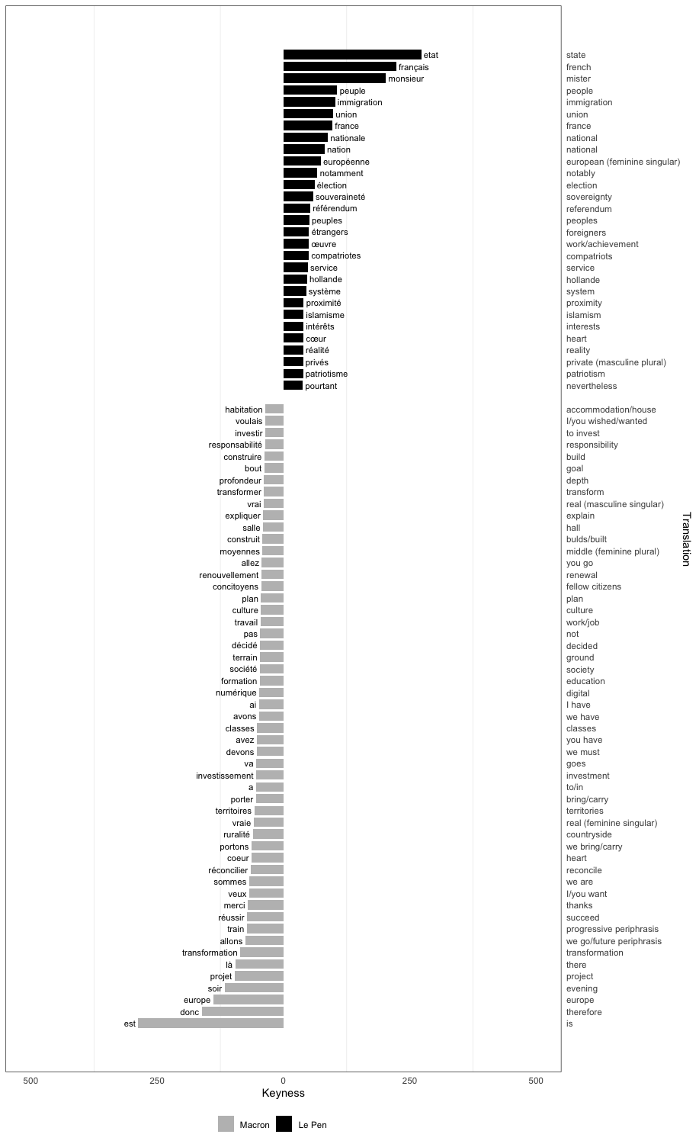

Figure B1.3: Salvini and Renzi Keywords (excluding stop words)

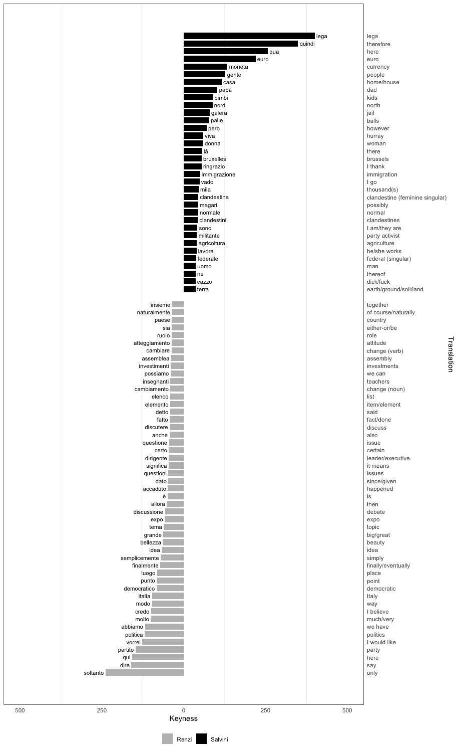

Appendix B2 – Analysis using chi-square distance

The chi-square distance was used to check the results obtained with AntConc.

In descending order of chi-square contribution, the top results were selected in order to match the number of keywords produced by AntConc per each leader, and the resulting tables were compared to extract the types which are not included in both lists referring to the same leader.

Differences in rank order were not taken into account, since the corpus analysis conducted in this research considers all the keywords produced by AntConc in their contexts.

The tables below provide all data obtained through the chi-square distance, along with the differences in the types extracted with both methods. These differences are limited in number and do not identify alternative topics or stylistic traits different to those we discuss in the paper.

Donald Trump

Four types included in the chi-square list but not in the keyness list: by, percent, the, trillion;
Six types included in the keyness list but not in the chi-square list: american, deficit, destroyed, dishonest, establishment, Libya.

Rank | Type | Trump Occurrences | Clinton Occurrences | Chi-Square
1 | hillary | 351 | 2 | 0.00357
2 | clinton | 321 | 9 | 0.00305
3 | will | 1074 | 427 | 0.00285
4 | they | 1169 | 493 | 0.00281
5 | she | 553 | 151 | 0.00236
6 | very | 361 | 76 | 0.00191
7 | gonna | 147 | 0 | 0.00152
8 | it | 1698 | 1181 | 0.00092
9 | great | 347 | 141 | 0.00089
10 | isis | 102 | 8 | 0.00083
11 | folks | 102 | 10 | 0.00078
12 | going | 781 | 484 | 0.00070
13 | trade | 152 | 39 | 0.00069
14 | re | 779 | 487 | 0.00068
15 | administration | 76 | 4 | 0.00067
16 | bad | 99 | 16 | 0.00062
17 | ok | 65 | 2 | 0..00061
18 | incredible | 66 | 3 | 0..00059
19 | terrorism | 62 | 2 | 0..00058
20 | nafta | 56 | 0 | 0..00058
21 | tremendous | 60 | 2 | 0..00056
22 | have | 1091 | 771 | 0.00055
23 | country | 488 | 287 | 0.00053
24 | massive | 56 | 2 | 0.00052
25 | illegal | 61 | 4 | 0.00052
26 | almost | 49 | 0 | 0.00051
27 | disaster | 72 | 9 | 0.00051
28 | immigration | 91 | 18 | 0.00050
29 | total | 51 | 1 | 0.00050
30 | obamacare | 47 | 0 | 0.00049
31 | countries | 93 | 20 | 0.00049
32 | never | 186 | 78 | 0.00045
33 | border | 49 | 2 | 0.00045
34 | horrible | 49 | 2 | 0.00045
35 | borders | 43 | 0 | 0.00045
36 | happen | 107 | 30 | 0.00044
37 | crime | 51 | 3 | 0.00044
38 | number | 74 | 13 | 0.00044
39 | politicians | 55 | 5 | 0.00043
40 | totally | 57 | 6 | 0.00043
41 | iraq | 44 | 1 | 0.00043
42 | mexico | 74 | 14 | 0.00042
43 | radical | 49 | 3 | 0.00042
44 | which | 161 | 65 | 0.00042
45 | deals | 64 | 10 | 0.00041
46 | syria | 39 | 0 | 0.00040
47 | inner | 52 | 5 | 0.00040
48 | media | 44 | 2 | 0.00040
49 | east | 41 | 1 | 0.00039
50 | dollars | 80 | 20 | 0.00037
51 | foreign | 64 | 12 | 0.00037
52 | cash | 41 | 2 | 0.00037
53 | regulations | 41 | 2 | 0.00037
54 | islamic | 38 | 1 | 0.00036
55 | wanna | 35 | 0 | 0.00036
56 | amazing | 55 | 8 | 0.00036
57 | been | 288 | 162 | 0.00036
58 | corrupt | 34 | 0 | 0.00035
59 | cities | 70 | 16 | 0.00035
60 | look | 176 | 82 | 0.00035
61 | its | 79 | 21 | 0.00035
62 | obama | 132 | 53 | 0.00034
63 | these | 230 | 121 | 0.00034
64 | immediately | 36 | 1 | 0.00034
65 | by | 382 | 240 | 0.00033
66 | emails | 31 | 0 | 0.00032
67 | iran | 44 | 5 | 0.00032
68 | unbelievable | 39 | 3 | 0.00032
69 | government | 90 | 30 | 0.00031
70 | ever | 131 | 56 | 0.00031
71 | percent | 123 | 51 | 0.00030
72 | hispanic | 29 | 0 | 0.00030
73 | the | 4034 | 3538 | 0.00030
74 | trillion | 41 | 5 | 0.00029

Hillary Clinton

Three types included in the chi-square list but not in the keyness one: about, access, ahead;
Four types included in the keyness list but not in the chi-square one: America, com, I, need.

Rank | Type | Clinton Occurrences | Trump Occurrences | Chi-Square
1 | he | 929 | 324 | 0.00308
2 | his | 289 | 49 | 0.00179
3 | to | 3889 | 3005 | 0.00125
4 | together | 228 | 55 | 0.00111
5 | donald | 200 | 48 | 0.00098
6 | need | 263 | 84 | 0.00097
7 | economy | 158 | 28 | 0.00095
8 | women | 153 | 26 | 0.00095
9 | work | 309 | 116 | 0.00093
10 | trump | 311 | 119 | 0.00091
11 | here | 336 | 140 | 0.00085
12 | kids | 102 | 10 | 0.00079
13 | sure | 117 | 17 | 0.00078
14 | families | 154 | 36 | 0.00077
15 | college | 80 | 6 | 0.00067
16 | young | 105 | 18 | 0.00065
17 | help | 130 | 32 | 0.00062
18 | kind | 76 | 7 | 0.00060
19 | let | 252 | 110 | 0.00059
20 | us | 311 | 151 | 0.00059
21 | who | 558 | 338 | 0.00058
22 | hard | 137 | 39 | 0.00057
23 | make | 368 | 195 | 0.00057
24 | should | 190 | 75 | 0.00053
25 | when | 340 | 180 | 0.00053
26 | everyone | 128 | 39 | 0.00050
27 | too | 138 | 45 | 0.00050
28 | family | 122 | 36 | 0.00049
29 | still | 80 | 14 | 0.00049
30 | someone | 48 | 1 | 0.00047
31 | can | 523 | 330 | 0.00047
32 | disabilities | 44 | 0 | 0.00046
33 | climate | 46 | 1 | 0.00045
34 | for | 1157 | 870 | 0.00045
35 | well | 184 | 79 | 0.00044
36 | how | 235 | 115 | 0.00044
37 | pay | 154 | 60 | 0.00044
38 | tim | 55 | 5 | 0.00044
39 | wage | 44 | 2 | 0.00040
40 | police | 107 | 34 | 0.00040
41 | about | 433 | 272 | 0.00040
42 | dad | 40 | 1 | 0.00039
43 | businesses | 110 | 37 | 0.00038
44 | president | 254 | 136 | 0.00038
45 | challenges | 42 | 2 | 0.00038
46 | stronger | 60 | 10 | 0.00037
47 | mother | 43 | 3 | 0.00036
48 | access | 42 | 3 | 0.00035
49 | small | 112 | 41 | 0.00035
50 | ahead | 57 | 10 | 0.00035
51 | black | 46 | 5 | 0.00035
52 | every | 271 | 154 | 0.00034
53 | campaign | 127 | 51 | 0.00034
54 | election | 99 | 34 | 0.00034

Marine Le pen

Three types included in the chi-square list but not in the keyness one: comme, mon, ses;
Four types included in the keyness list but not in the chi-square one: à, l, m, s.

Rank | Type | Le Pen Occurrences | Macron Occurrences | Chi-Square
1 | français | 575 | 162 | 0.00236
2 | de | 5190 | 3995 | 0.00145
3 | fillon | 142 | 6 | 0.00129
4 | macron | 152 | 11 | 0.00126
5 | france | 667 | 330 | 0.00114
6 | etat | 277 | 79 | 0.00112
7 | peuple | 241 | 60 | 0.00111
8 | car | 121 | 9 | 0.00099
9 | immigration | 123 | 11 | 0.00096
10 | union | 100 | 5 | 0.00089
11 | son | 267 | 93 | 0.00085
12 | nationale | 98 | 7 | 0.00081
13 | leur | 417 | 200 | 0.00077
14 | nation | 110 | 14 | 0.00076
15 | européenne | 119 | 19 | 0.00074
16 | sans | 221 | 79 | 0.00068
17 | élection | 101 | 17 | 0.00061
18 | du | 789 | 513 | 0.00057
19 | leurs | 158 | 50 | 0.00057
20 | souveraineté | 68 | 5 | 0.00056
21 | notamment | 57 | 1 | 0.00056
22 | système | 147 | 48 | 0.00051
23 | étrangers | 59 | 5 | 0.00047
24 | compatriotes | 53 | 3 | 0.00046
25 | peuples | 53 | 3 | 0.00046
26 | service | 58 | 5 | 0.00046
27 | les | 2378 | 1914 | 0.00046
28 | la | 3222 | 2680 | 0.00044
29 | référendum | 40 | 0 | 0.00041
30 | intérêts | 89 | 22 | 0.00041
31 | hollande | 38 | 0 | 0.00039
32 | réalité | 67 | 12 | 0.00039
33 | oeuvre | 44 | 3 | 0.00037
34 | argent | 62 | 11 | 0.00037
35 | proximité | 40 | 2 | 0.00035
36 | pourtant | 42 | 3 | 0.00035
37 | patriotisme | 35 | 1 | 0.00033
38 | privés | 35 | 1 | 0.00033
39 | nations | 31 | 0 | 0.00032
40 | mon | 96 | 33 | 0.00031
41 | islamisme | 30 | 0 | 0.00031
42 | ses | 182 | 91 | 0.00030
43 | comme | 289 | 171 | 0.00030
44 | des | 1637 | 1329 | 0.00029

Emmanuel Macron

Five types included in the chi-square list but not in the keyness one: faire, pas, qui, responsabilité, temps;
Four types included in the keyness list but not in the chi-square one: c, profondeur, uns, y.

Rank | Type | Macron Occurrences | Le Pen Occurrences | Chi-Square
1 | parce | 748 | 177 | 0.00374
2 | est | 2564 | 1617 | 0.00237
3 | ça | 305 | 41 | 0.00212
4 | que | 2113 | 1345 | 0.00188
5 | ce | 1274 | 692 | 0.00187
6 | nous | 1743 | 1087 | 0.00168
7 | donc | 332 | 90 | 0.00147
8 | cela | 388 | 134 | 0.00132
9 | europe | 208 | 38 | 0.00124
10 | soir | 115 | 8 | 0.00098
11 | on | 714 | 399 | 0.00097
12 | projet | 318 | 127 | 0.00088
13 | oui | 229 | 72 | 0.00087
14 | là | 252 | 87 | 0.00086
15 | allons | 123 | 25 | 0.00069
16 | transformation | 70 | 2 | 0.00067
17 | alors | 235 | 92 | 0.00067
18 | vous | 819 | 535 | 0.00066
19 | celles | 103 | 17 | 0.00065
20 | merci | 105 | 18 | 0.00065
21 | nôtre | 78 | 7 | 0.00062
22 | sommes | 208 | 79 | 0.00062
23 | train | 77 | 7 | 0.00061
24 | veux | 302 | 143 | 0.00061
25 | réussir | 71 | 5 | 0.00060
26 | elle | 391 | 212 | 0.00058
27 | hui | 283 | 138 | 0.00054
28 | mais | 552 | 344 | 0.00053
29 | portons | 64 | 5 | 0.00053
30 | territoires | 91 | 18 | 0.00052
31 | ruralité | 62 | 5 | 0.00051
32 | vraie | 69 | 8 | 0.00051
33 | va | 130 | 41 | 0.00049
34 | porter | 92 | 20 | 0.00049
35 | devons | 145 | 51 | 0.00048
36 | avez | 118 | 35 | 0.00048
37 | quelques | 118 | 35 | 0.00048
38 | investissement | 70 | 10 | 0.00047
39 | classes | 92 | 21 | 0.00047
40 | réconcilier | 45 | 0 | 0.00047
41 | aujourd | 267 | 138 | 0.00045
42 | avons | 191 | 85 | 0.00044
43 | ai | 240 | 121 | 0.00042
44 | société | 108 | 33 | 0.00042
45 | plan | 68 | 12 | 0.00041
46 | culture | 115 | 38 | 0.00041
47 | terrain | 61 | 9 | 0.00041
48 | travail | 155 | 64 | 0.00041
49 | celui | 165 | 71 | 0.00040
50 | numérique | 49 | 4 | 0.00040
51 | décidé | 56 | 7 | 0.00040
52 | formation | 51 | 5 | 0.00040
53 | concitoyens | 59 | 9 | 0.00039
54 | et | 2906 | 2500 | 0.00038
55 | moyennes | 83 | 22 | 0.00038
56 | allez | 48 | 5 | 0.00037
57 | renouvellement | 43 | 3 | 0.00037
58 | front | 47 | 5 | 0.00036
59 | expliquer | 51 | 7 | 0.00035
60 | vrai | 61 | 12 | 0.00035
61 | construit | 41 | 3 | 0.00035
62 | pas | 1046 | 811 | 0.00034
63 | faire | 355 | 221 | 0.00034
64 | construire | 68 | 16 | 0.00034
65 | transformer | 52 | 8 | 0.00034
66 | chacune | 47 | 6 | 0.00033
67 | bout | 49 | 7 | 0.00033
68 | responsabilité | 59 | 12 | 0.00033
69 | temps | 160 | 76 | 0.00032
70 | qui | 1919 | 1615 | 0.00032

Matteo Salvini

Eight types included in the chi-square list but not in the keyness one: battaglia, idee, migliaia, non, poi, sud, veneto, lavorare;
Eight types included in the keyness list but not in the chi-square one: agricoltura, cazzo, e, federale, i, militante, salvini, lavora.

Rank | Type | Salvini Occurrences | Renzi Occurrences | Chi-Square
1 | lega | 334 | 7 | 0.00349
2 | quindi | 494 | 76 | 0.00346
3 | qua | 273 | 21 | 0.00242
4 | euro | 407 | 91 | 0.00228
5 | renzi | 196 | 11 | 0.00185
6 | gente | 245 | 57 | 0.00133
7 | casa | 269 | 76 | 0.00124
8 | moneta | 96 | 0 | 0.00107
9 | papà | 94 | 4 | 0.00092
10 | fra | 99 | 10 | 0.00082
11 | perché | 1061 | 725 | 0.00081
12 | nord | 86 | 5 | 0.00081
13 | però | 435 | 225 | 0.00080
14 | mi | 459 | 244 | 0.00079
15 | bimbi | 64 | 0 | 0.00071
16 | pontida | 64 | 0 | 0.00071
17 | galera | 68 | 2 | 0.00069
18 | se | 855 | 583 | 0.00066
19 | fornero | 62 | 1 | 0.00066
20 | palle | 56 | 0 | 0.00062
21 | coi | 65 | 4 | 0.00060
22 | tanto | 97 | 19 | 0.00059
23 | viva | 75 | 9 | 0.00058
24 | io | 733 | 499 | 0.00057
25 | là | 72 | 9 | 0.00055
26 | bruxelles | 71 | 9 | 0.00054
27 | donna | 54 | 2 | 0.00054
28 | ringrazio | 68 | 8 | 0.00053
29 | sono | 819 | 583 | 0.00052
30 | gli | 432 | 265 | 0.00050
31 | immigrazione | 69 | 10 | 0.00050
32 | vado | 65 | 9 | 0.00048
33 | magari | 124 | 42 | 0.00047
34 | normale | 77 | 16 | 0.00045
35 | ti | 167 | 75 | 0.00041
36 | ne | 174 | 80 | 0.00041
37 | uomo | 70 | 16 | 0.00039
38 | non | 2247 | 1932 | 0.00038
39 | poi | 285 | 167 | 0.00038
40 | idee | 80 | 22 | 0.00038
41 | alfano | 34 | 0 | 0.00038
42 | terra | 65 | 14 | 0.00037
43 | lavorare | 84 | 25 | 0.00037
44 | battaglia | 102 | 36 | 0.00037
45 | clandestina | 32 | 0 | 0.00036
46 | clandestini | 31 | 0 | 0.00034
47 | veneto | 41 | 4 | 0.00034
48 | li | 126 | 54 | 0.00034
49 | migliaia | 45 | 6 | 0.00034
50 | ognuno | 35 | 2 | 0.00033
51 | sud | 60 | 14 | 0.00033

Matteo Renzi

Seven types included in the chi-square list but not in the keyness one: cose, cui, diciamo, insieme, prossimi, semplicemente, sia;
Seven types included in the keyness list but not in the chi-square one: assemblea, atteggiamento, è, investimenti, molta, ruolo, significa.

Rank | Type | Renzi Occurrences | Salvini Occurrences | Chi-Square
1 | soltanto | 183 | 1 | 0.00193
2 | dire | 414 | 126 | 0.00159
3 | noi | 984 | 503 | 0.00154
4 | qui | 174 | 14 | 0.00145
5 | partito | 246 | 47 | 0.00142
6 | politica | 243 | 59 | 0.00117
7 | abbiamo | 564 | 256 | 0.00116
8 | vorrei | 134 | 10 | 0.00114
9 | del | 818 | 439 | 0.00112
10 | che | 3902 | 2993 | 0.00101
11 | molto | 154 | 26 | 0.00096
12 | italia | 474 | 219 | 0.00094
13 | tra | 130 | 17 | 0.00092
14 | credo | 118 | 12 | 0.00092
15 | modo | 124 | 15 | 0.00091
16 | pd | 172 | 38 | 0.00090
17 | quale | 97 | 7 | 0.00083
18 | punto | 178 | 46 | 0.00081
19 | democratico | 83 | 5 | 0.00074
20 | ciò | 73 | 2 | 0.00072
21 | questo | 626 | 357 | 0.00071
22 | semplicemente | 82 | 8 | 0.00065
23 | idea | 95 | 14 | 0.00064
24 | luogo | 59 | 0 | 0.00063
25 | finalmente | 67 | 3 | 0.00063
26 | nostro | 174 | 56 | 0.00063
27 | leopolda | 58 | 0 | 0.00062
28 | grande | 195 | 69 | 0.00062
29 | nel | 364 | 186 | 0.00057
30 | tema | 74 | 8 | 0.00056
31 | di | 3661 | 2970 | 0.00056
32 | discussione | 72 | 8 | 0.00054
33 | allora | 144 | 46 | 0.00052
34 | bellezza | 46 | 0 | 0.00049
35 | expo | 48 | 1 | 0.00048
36 | dato | 85 | 18 | 0.00046
37 | significa | 80 | 16 | 0.00045
38 | ma | 763 | 517 | 0.00043
39 | anche | 501 | 312 | 0.00042
40 | delle | 343 | 192 | 0.00042
41 | fatto | 343 | 192 | 0.00042
42 | detto | 208 | 96 | 0.00041
43 | certo | 63 | 10 | 0.00041
44 | questione | 46 | 3 | 0.00040
45 | discutere | 53 | 6 | 0.00040
46 | possiamo | 84 | 21 | 0.00039
47 | dell | 293 | 159 | 0.00039
48 | accaduto | 35 | 0 | 0.00038
49 | cambiare | 103 | 33 | 0.00037
50 | questioni | 34 | 0 | 0.00037
51 | sia | 211 | 104 | 0.00036
52 | paese | 213 | 106 | 0.00036
53 | insieme | 121 | 45 | 0.00036
54 | cui | 227 | 116 | 0.00036
55 | dirigente | 33 | 0 | 0.00035
56 | cambiamento | 35 | 1 | 0.00034
57 | insegnanti | 35 | 1 | 0.00034
58 | cose | 133 | 55 | 0.00033
59 | diciamo | 67 | 16 | 0.00033
60 | scuola | 104 | 37 | 0.00033
61 | prossimi | 48 | 7 | 0.00032

Appendix C – Sample of concordances analysis

Although we checked all concordances including keywords, we utilized another tool provided by AntConc to extract clusters (i.e. recurrent word strings), thus helping to automatically define the contexts in which a word occurs. In our research, this tool was used to complement and guide human reading, but its contribution is limited and mostly restricted to content words.

For example, Trump’s first keyword according to rank is “Hillary”, which is preceded 17 times (out of 354) by “crooked”, 9 by “Obama and” and 8 by “Bill and”; whereas it is followed 243 times by “Clinton” (unsurprisingly). Albeit helpful (Hillary Clinton is obviously associated with other “enemies of the people” and, as such, is the object of Trump’s aggressive criticism), this analytical tool is less revealing when used with grammar words such as modal verbs. For example, Trump’s second keyword is “will” (1074 occurrences): apart from the string “make America great again” (12 times), it is followed by verbs which may be significant but need further investigation of their contexts, such as “build”, “end”, “fight”, “fix”, “rebuild”, “stop”, etc.

Trump corpus
Clusters pivoting on “Hillary”
Left-oriented
Top results min. 3 occurrences
Rank Freq. Range
1 243 1 hillary clinton
2 25 1 hillary clinton’s
3 21 1 hillary wants
4 20 1 hillary clinton is
5 19 1 hillary clinton has
6 19 1 hillary clinton's
7 19 1 hillary is
8 17 1 hillary clinton wants
9 16 1 hillary wants to
10 14 1 hillary clinton wants to
11 9 1 hillary is the
12 9 1 hillary is the one
13 9 1 hillary is the one who
14 8 1 hillary clinton and
15 6 1 hillary clinton is the
16 5 1 hillary clinton will
17 5 1 hillary clinton's policies
18 5 1 hillary's
19 4 1 hillary clinton said
20 4 1 hillary clinton, who
21 4 1 hillary’s
22 3 1 hillary and
23 3 1 hillary clinton has been
24 3 1 hillary clinton have
25 3 1 hillary clinton is a
26 3 1 hillary clinton wants to double
27 3 1 hillary clinton was
28 3 1 hillary clinton who
29 3 1 hillary clinton's policies than
30 3 1 hillary clinton: death
31 3 1 hillary clinton: death, destruction
32 3 1 hillary clinton’s plan
33 3 1 hillary wants to invade
34 3 1 hillary wants to invade foreign
35 3 1 hillary wants to invade foreign countries
36 3 1 hillary-backed

N-grams pivoting on “Hillary”
Right-oriented
Top results min. 3 occurrences
Rank Freq. Range
1 33 1 and hillary
2 17 1 crooked hillary
3 14 1 by hillary
4 14 1 that hillary
5 12 1 of hillary
6 11 1 for hillary
7 9 1 obama and hillary
8 8 1 bill and hillary
9 6 1 like hillary
10 6 1 under hillary
11 6 1 while hillary
12 5 1 but hillary
13 5 1 president obama and hillary
14 5 1 supported by hillary
15 5 1 yet hillary
16 4 1 about hillary
17 4 1 another bill and hillary
18 4 1 as secretary of state, hillary
19 4 1 if hillary
20 4 1 into hillary
21 4 1 it. hillary
22 4 1 of state, hillary
23 4 1 secretary of state, hillary
24 4 1 state, hillary
25 4 1 the hillary
26 4 1 with hillary
27 3 1 america first. hillary
28 3 1 and by the way, hillary
29 3 1 because hillary
30 3 1 by the way, hillary
31 3 1 first. hillary
32 3 1 from hillary
33 3 1 on hillary
34 3 1 pre-hillary
35 3 1 right? hillary
36 3 1 that. hillary
37 3 1 the way, hillary
38 3 1 think hillary
39 3 1 way, hillary
40 3 1 when hillary
41 3 1 with crooked Hillary

The full corpus is available in Harvard Dataverse at: https://doi.org/10.7910/DVN/N5PYXZ.

