Appendix of the paper:

‘Party-based Sovereignism in the EU countries: Main patterns and their Justification’
Published in Government and Opposition

Authors: Davide Angelucci, Luca Carrieri, Nicolò Conti
Department of Law and Economics, Università degli Studi di Roma Unitelma Sapienza, Rome

Appendix A

Table A1 - Detailed description of the items used to construct the dependent variable of the study
Constructed dependent variable | Indicators/Wording | Source | Availability | Original measurement
Index of sovereignism | EU_POSITION = overall orientation of the party leadership towards European integration in YEAR. | CHES | CHES 2014; CHES 2019 | 1 = Strongly opposed  2 = Opposed  3 = Somewhat opposed  4 = Neutral  5 = Somewhat in favor  6 = In favor  7 = Strongly in favor
 | MULTICULTURALISM = position on integration of immigrants and asylum seekers (multiculturalism vs. assimilation). | CHES | CHES 2014; CHES 2019 | 0 = Strongly favors multiculturalism  :  10 = Strongly favors assimilation
 | NATIONALISM = position towards cosmopolitanism vs. nationalism | CHES | CHES 2014; CHES 2019 | 0 = Strongly promotes cosmopolitan conceptions of society  :  10 = Strongly promotes nationalist conceptions of society
 | PROTECTIONISM = position towards trade liberalization/protectionism. | CHES | CHES 2019 | 0 = Strongly favors trade liberalization  :  10 = Strongly favors protection of domestic producers

Table A2 – Detailed description of the independent variables of the study
Independent variables | Indicators/Wording | Source | Availability | Original measurement
Left-Right general position | LRGEN = position of the party in YEAR in terms of its overall ideological stance | CHES | CHES 2014; CHES 2019 | 0 = Extreme left  :  5 = Center  :  10 = Extreme right
Gal-Tan position | GALTAN = position of the party in 2019 in terms of their views on social and cultural values | CHES | CHES 2014; CHES 2019 | 0 = Libertarian/Postmaterialist  :  5 = Center  :  10 = Traditional/Authoritarian
Electoral size | VOTE = vote percentage received by the party in the national election most prior to YEAR | CHES | CHES 2014; CHES 2019 | Percentage
Immigration rate | Proportion of immigrants over total population | EUROSTAT | EUROSTAT 2014; EUROSTAT 2019 | Total number of long-term immigrants arriving into the reporting country during the reference year
GDP per capita | GDP per capita in PPP | EUROSTAT | EUROSTAT 2014; EUROSTAT 2019 | Gross domestic product at market prices (per head basis)
Public opinion index of sovereignism | “In general, does the EU conjure up for you a very positive, fairly positive, neutral, fairly negative or very negative image?” | Eurobarometer | Eurobarometer 82.3 (November 2014); Eurobarometer 91.5 (June-July 2019) | 1=Very positive; 2= Fairly positive; 3=Neutral: 4=Fairly negative; 5=Very negative
 | “Could you please tell me for each of the following, whether the term brings to mind something very positive, fairly positive, fairly negative or very negative?” (Globalization; Free trade; Protectionism) | Eurobarometer | Eurobarometer 82.3 (November 2014); Eurobarometer 91.5 (June-July 2019) | 1=Very positive; 2= Fairly positive; 3=Fairly negative; 4=Very negative
 | “Please tell me whether each of the following statements evokes a positive or negative feeling for you...Immigration of people  from outside the EU” | Eurobarometer | Eurobarometer 82.3 (November 2014); Eurobarometer 91.5 (June-July 2019) | 1=Very positive; 2= Fairly positive; 3=Fairly negative; 4=Very negative

Table A3 – Results of the factor analysis run on the restricted sample of extreme sovereignist parties (i.e., parties falling within the top and bottom deciles of the distribution of the sovereignist index). Note: For each item, cell entries report the factor loadings on the latent dimension of sovereignism in each CHES wave. The last row reports the eigenvalue for the corresponding latent dimension.
 | Sovereignism 2014 | Sovereignism 2019 (Symmetric) | Sovereignism 2019 (Asymmetric)
Multiculturalism | 0.99 | 0.81 | 0.89
Nationalism | 0.99 | 0.78 | 0.87
EU | 0.93 | 0.67 | 0.69
Economic protectionism |  |  | 0.83
Eigenvalue | 2.8 | 2.9 | 3.5

Table A4 – Results of the factor analysis on the restricted sample of parties falling within the top and bottom decile of the distribution of the sovereignist index. Note: For each item, cell entries report the factor loadings on the latent dimension of sovereignism in each CHES wave. The last row reports the eigenvalue for the corresponding latent dimension.
 | Sovereignism 2014 | Sovereignism 2019 (Symmetric) | Sovereignism 2019 (Asymmetric)
Multiculturalism | 0.90 | 0.94 | 0.94
Nationalism | 0.91 | 0.94 | 0.92
EU | 0.10 | 0.25 | 0.20
Economic protectionism |  |  | 0.31
Eigenvalue | 1.6 | 1.8 | 2.1

Appendix B

Table B1 – Replication of Models 5b and 5c of Table 1, with the addition of party system salience
 | Model 5b + Salience immigration | Model 5c + Salience immigration
Party level
Region
Continental | Baseline | Baseline
Southern | 0.0112 | 0.00811
 | (0.0373) | (0.0393)
Eastern | 0.0393 | 0.0383
 | (0.0356) | (0.0421)
El. Performance | 0.000169 | 0.00103
 | (0.000924) | (0.000918)
Left-Right | -0.104*** | -0.0450*
 | (0.0173) | (0.0181)
Left-Right sq. | 0.00875*** | 0.00516*
 | (0.00182) | (0.00186)
GAL-TAN | 0.0731*** | 0.0689***
 | (0.00595) | (0.00591)
Country level
Public sovereignism | 0.0226 | -0.124
 | (0.244) | (0.296)
GDP per capita | 0.000000747 | 0.00000107
 | (0.000000810) | (0.00000105)
Immigration rate | 0.00229 | 0.00621
 | (0.0122) | (0.0179)
Avg. Salience of immigration | -0.00517 | 0.00335
 | (0.0104) | (0.0120)
Intercept | 0.310* | 0.146
 | (0.127) | (0.135)
N | 230 | 230
R² | 0.723 | 0.728
Standard errors in parentheses * p < 0.05, ** p < 0.01, *** p < 0.001

Table B2 – Replication of Models 5a, 5b, and 5c of Table 1, with the addition of the Gini Index
 | Model 5a + Gini | Model 5b + Gini | Model 5c + Gini
Party level
Region
Continental | Baseline | Baseline | Baseline
Southern | 0.0578 | 0.0208 | 0.0177
 | (0.0367) | (0.0423) | (0.0449)
Eastern | 0.0347 | 0.0452 | 0.0353
 | (0.0344) | (0.0351) | (0.0415)
El. Performance | -0.00160 | 0.000170 | 0.00111
 | (0.0011) | (0.000914) | (0.000908)
Left-Right | 0.00435 | -0.103*** | -0.0434*
 | (0.00887) | (0.0178) | (0.0183)
Left-Right sq. |  | 0.00858*** | 0.00498*
 |  | (0.00189) | (0.00191)
GAL-TAN | 0.0676*** | 0.0735*** | 0.0693***
 | (0.00865) | (0.00611) | (0.00602)
Country level
Public sovereignism | 0.0978 | -0.0699 | -0.222
 | (0.468) | (0.289) | (0.319)
GDP per capita | -0.000000291 | 0.000000621 | 0.000000716
 | (0.00000239) | (0.000000740) | (0.000000951)
Immigration rate | 0.0491 | 0.00644 | 0.0122
 | (0.0428) | (0.0103) | (0.0154)
GINI Index | 0.00277 | -0.00191 | -0.00342
 | (0.00409) | (0.00212) | (0.00227)
Intercept | -0.0567 | 0.368* | 0.307
 | (0.330) | (0.163) | (0.179)
N | 230 | 230 | 230
R² | 0.604 | 0.723 | 0.730
Standard errors in parentheses * p < 0.05, ** p < 0.01, *** p < 0.001

Table B3 – Replication of Model 5a of Table 1, with the addition of the single items of the index of public opinion sovereignism
 | Model 5a + Globalisation | Model 5a + EU | Model 5a + Protectionism | Model 5a + Free trade | Model 5a + Immigration
Party level
Region
Continental | Baseline | Baseline | Baseline | Baseline | Baseline
Southern | 0.0325 | 0.0343 | 0.0323 | 0.0345 | 0.0382
 | (0.0568) | (0.0391) | (0.0390) | (0.0506) | (0.0401)
Eastern | -0.0145 | -0.00934 | -0.000704 | -0.0142 | -0.0118
 | (0.0393) | (0.0529) | (0.0472) | (0.0398) | (0.0368)
El. Performance | -0.00192 | -0.00194 | -0.00197 | -0.00192 | -0.00192
 | (0.00125) | (0.00121) | (0.00124) | (0.00124) | (0.00123)
Left-Right | 0.00429 | 0.00423 | 0.00463 | 0.00430 | 0.00426
 | (0.00892) | (0.00894) | (0.00877) | (0.00891) | (0.00887)
GAL-TAN | 0.0677*** | 0.0678*** | 0.0677*** | 0.0677*** | 0.0679***
 | (0.00873) | (0.00878) | (0.00868) | (0.00876) | (0.00858)
Country level
GDP per capita | -0.000000458 | -0.000000452 | -0.000000112 | -0.000000538 | -0.000000549
 | (0.00000229) | (0.00000208) | (0.00000185) | (0.00000208) | (0.00000181)
Immigration rate | 0.0517 | 0.0534 | 0.0453 | 0.0533 | 0.0534
 | (0.0442) | (0.0338) | (0.0318) | (0.0392) | (0.0317)
GINI Index | 0.00257 | 0.00258 | 0.00156 | 0.00245 | 0.00231
 | (0.00446) | (0.00361) | (0.00440) | (0.00565) | (0.00370)
Globalisation | 0.0234
 | (0.251)
Eu |  | 0.0537
 |  | (0.237)
Protectionism |  |  | 0.113
 |  |  | (0.180)
Free trade |  |  |  | 0.0150
 |  |  |  | (0.357)
Immigration |  |  |  |  | -0.0356
 |  |  |  |  | (0.195)
Intercept | -0.0149 | -0.0317 | -0.0342 | -0.00465 | 0.0239
 | (0.254) | (0.221) | (0.155) | (0.292) | (0.178)
N | 230 | 230 | 230 | 230 | 230
R² | 0.604 | 0.604 | 0.605 | 0.604 | 0.604
Standard errors in parentheses * p < 0.05, ** p < 0.01, *** p < 0.001

Table B4 – Replication of Model 5b and 5c of Table 1, with the addition of the single items of the index of public opinion sovereignism
 | Model 5b + Globalisation | Model 5b + EU | Model 5b + Protectionism | Model 5b + Free trade | Model 5b + Immigration | Model 5c + Globalisation | Model 5c + EU | Model 5c + Protectionism | Model 5c + Free trade | Model 5c + Immigration
Party level
Region
Continental | Baseline | Baseline | Baseline | Baseline | Baseline | Baseline | Baseline | Baseline | Baseline | Baseline
Southern | 0.0173 | 0.0145 | 0.0230 | 0.0131 | 0.0183 | 0.0158 | 0.00498 | 0.0173 | 0.0185 | 0.00635
 | (0.0413) | (0.0328) | (0.0328) | (0.0429) | (0.0328) | (0.0457) | (0.0374) | (0.0364) | (0.0466) | (0.0361)
Eastern | 0.0442 | 0.0500 | 0.0417 | 0.0429 | 0.0513 | 0.0376 | 0.0339 | 0.0270 | 0.0354 | 0.0341
 | (0.0364) | (0.0324) | (0.0360) | (0.0349) | (0.0335) | (0.0433) | (0.0388) | (0.0416) | (0.0403) | (0.0426)
El. Performance | 0.000158 | 0.000172 | 0.000195 | 0.000158 | 0.000204 | 0.00108 | 0.00108 | 0.00114 | 0.00107 | 0.00109
 | (0.000921) | (0.000928) | (0.000928) | (0.000923) | (0.000901) | (0.000912) | (0.000922) | (0.000926) | (0.000917) | (0.000914)
Left-Right | -0.102*** | -0.102*** | -0.103*** | -0.102*** | -0.103*** | -0.0430* | -0.0422* | -0.0442* | -0.0426* | -0.0425*
 | (0.0179) | (0.0181) | (0.0184) | (0.0182) | (0.0181) | (0.0183) | (0.0187) | (0.0192) | (0.0188) | (0.0190)
Left-Right sq. | 0.00856*** | 0.00848*** | 0.00862*** | 0.00855*** | 0.00859*** | 0.00494* | 0.00486* | 0.00502* | 0.00490* | 0.00490*
 | (0.00189) | (0.00189) | (0.00193) | (0.00191) | (0.00191) | (0.00190) | (0.00190) | (0.00195) | (0.00194) | (0.00195)
GAL-TAN | 0.0735*** | 0.0736*** | 0.0734*** | 0.0735*** | 0.0736*** | 0.0694*** | 0.0692*** | 0.0691*** | 0.0693*** | 0.0693***
 | (0.00610) | (0.00611) | (0.00611) | (0.00609) | (0.00608) | (0.00601) | (0.00608) | (0.00607) | (0.00604) | (0.00602)
Country level
GDP per capita | 0.0000007 | 0.0000009 | 0.0000006 | 0.0000007 | 0.0000006 | 0.0000008 | 0.000001 | 0.0000008 | 0.0000009 | 0.000000881
 | (0.0000007) | (0.0000008) | (0.0000008) | (0.0000008) | (0.0000008) | (0.000001) | (0.000001) | (0.000001) | (0.000001) | (0.00000104)
Immigration rate | 0.00536 | 0.00507 | 0.00825 | 0.00502 | 0.00533 | 0.0132 | 0.00843 | 0.0143 | 0.00927 | 0.00853
 | (0.0103) | (0.0116) | (0.0122) | (0.0107) | (0.0119) | (0.0152) | (0.0168) | (0.0171) | (0.0155) | (0.0169)
GINI Index | -0.00166 | -0.000748 | -0.00105 | -0.00143 | -0.00230 | -0.00337 | -0.00225 | -0.00143 | -0.00326 | -0.00280
 | (0.00210) | (0.00221) | (0.00180) | (0.00202) | (0.00163) | (0.00241) | (0.00254) | (0.00199) | (0.00218) | (0.00192)
Globalisation | -0.00261 |  |  |  |  | -0.131
 | (0.160) |  |  |  |  | (0.186)
Eu |  | 0.170 |  |  |  |  | 0.0638
 |  | (0.245) |  |  |  |  | (0.249)
Protectionism |  |  | -0.0823 |  |  |  |  | -0.160
 |  |  | (0.130) |  |  |  |  | (0.140)
Free trade |  |  |  | 0.0484 |  |  |  |  | -0.149
 |  |  |  | (0.207) |  |  |  |  | (0.272)
Immigration |  |  |  |  | -0.0918 |  |  |  |  | -0.0308
 |  |  |  |  | (0.108) |  |  |  |  | (0.136)
Intercept | 0.331** | 0.224 | 0.351*** | 0.309** | 0.400*** | 0.264* | 0.146 | 0.228* | 0.248* | 0.209
 | (0.101) | (0.151) | (0.0845) | (0.0977) | (0.102) | (0.121) | (0.162) | (0.0998) | (0.118) | (0.127)
N | 230 | 230 | 230 | 230 | 230 | 230 | 230 | 230 | 230 | 230
R² | 0.723 | 0.724 | 0.724 | 0.723 | 0.724 | 0.730 | 0.729 | 0.731 | 0.730 | 0.729
Standard errors in parentheses * p < 0.05, ** p < 0.01, *** p < 0.001

Table B5 – Replication of Models 3 and 7 of Table 2, with the addition of the Gini Index
 | Model 3 + Gini | Model 6 + Gini
Party level
Region
Continental | Baseline | Baseline
Southern | -0.0501 | -0.193**
 | (0.0729) | (0.0670)
Eastern | 0.0802 | 0.0685
 | (0.0830) | (0.0739)
Δ El. Performance | 0.00359 | -0.000852
 | (0.00811) | (0.00803)
Δ Left-Right | 0.00947 | 0.0347
 | (0.0943) | (0.111)
Δ Gal-Tan | 0.0958 | 0.120
 | (0.0506) | (0.0607)
Country level
Δ Public sovereignism | 3.366** | 2.817**
 | (1.105) | (0.990)
Δ GDP per capita | -0.0000144*** | -0.0000178***
 | (0.00000292) | (0.00000282)
Δ Immigration rate | -0.0723 | -0.0697
 | (0.0835) | (0.0889)
Δ GINI Index | -0.0154 | -0.0213
 | (0.0180) | (0.0144)
Intercept | 0.203*** | 0.250***
 | (0.0461) | (0.0517)
N | 173 | 173
R² | 0.117 | 0.153
Standard errors in parentheses * p < 0.05, ** p < 0.01, *** p < 0.001
Table B6 – Replication of Models 3 and 7 of Table 2, with the addition of the single items of the index of public opinion sovereignism
 | Model 3 + Globalisation | Model 3 + EU | Model 3 + Free trade | Model 3 + Protectionism | Model 3 + Immigration | Model 6 + Globalisation | Model 6 + EU | Model 6 + Free trade | Model 6 + Protectionism | Model 6 + Immigration
Party level
Region
Continental | Baseline | Baseline | Baseline | Baseline | Baseline | Baseline | Baseline | Baseline | Baseline | Baseline
Southern | -0.155 | -0.104 | -0.104 | -0.134 | -0.0371 | -0.304* | -0.243** | -0.239** | -0.243** | -0.141
 | (0.125) | (0.0629) | (0.0668) | (0.0808) | (0.102) | (0.124) | (0.0705) | (0.0670) | (0.0720) | (0.0766)
Eastern | 0.142 | 0.121 | 0.154 | 0.124 | 0.126 | 0.115 | 0.121 | 0.130 | 0.129 | 0.0939
 | (0.0818) | (0.0829) | (0.0802) | (0.102) | (0.0747) | (0.0783) | (0.0722) | (0.0748) | (0.0847) | (0.0634)
Δ El. Performance | 0.00246 | 0.00324 | 0.00295 | 0.00263 | 0.00299 | -0.00196 | -0.00144 | -0.00141 | -0.00152 | -0.00123
 | (0.00796) | (0.00807) | (0.00796) | (0.00782) | (0.00802) | (0.00786) | (0.00792) | (0.00784) | (0.00777) | (0.00798)
Δ Left-Right | -0.00208 | 0.00236 | 0.00347 | -0.000532 | 0.00674 | 0.0238 | 0.0275 | 0.0293 | 0.0272 | 0.0360
 | (0.0912) | (0.0922) | (0.0925) | (0.0913) | (0.0947) | (0.108) | (0.109) | (0.110) | (0.109) | (0.113)
Δ Gal-Tan | 0.104 | 0.101 | 0.105* | 0.104 | 0.0936 | 0.126* | 0.127* | 0.127* | 0.127* | 0.112
 | (0.0508) | (0.0509) | (0.0496) | (0.0509) | (0.0532) | (0.0612) | (0.0611) | (0.0604) | (0.0611) | (0.0634)
Country level
Δ GDP per capita | -0.00002*** | -0.00002*** | -0.00002*** | -0.00002*** | -0.00001* | -0.00002*** | -0.00002*** | -0.00002*** | -0.00002*** | -0.00001***
 | (0.000005) | (0.000003) | (0.000003) | (0.000004) | (0.000005) | (0.000005) | (0.000003) | (0.000003) | (0.000004) | (0.000003)
Δ Immigration rate | -0.0984 | -0.0861 | -0.124 | -0.0888 | -0.0978 | -0.0872 | -0.0940 | -0.111 | -0.0993 | -0.0863
 | (0.0887) | (0.0915) | (0.0915) | (0.0816) | (0.0793) | (0.0831) | (0.0901) | (0.0915) | (0.0865) | (0.0786)
Δ GINI Index | -0.0232 | -0.0224 | -0.0253 | -0.0231 | -0.0133 | -0.0277 | -0.0278 | -0.0293 | -0.0280 | -0.0140
 | (0.0200) | (0.0201) | (0.0207) | (0.0200) | (0.0200) | (0.0161) | (0.0163) | (0.0168) | (0.0161) | (0.0140)
Δ Globalisation | -0.813 |  |  |  |  | -1.130
 | (1.258) |  |  |  |  | (1.224)
Δ EU |  | 0.804 |  |  |  |  | 0.159
 |  | (0.686) |  |  |  |  | (0.616)
Δ Free trade |  |  | 1.057 |  |  |  |  | 0.733
 |  |  | (1.310) |  |  |  |  | (1.276)
Δ Protectionism |  |  |  | 0.421 |  |  |  |  | -0.0327
 |  |  |  | (0.823) |  |  |  |  | (0.810)
Δ Immigration |  |  |  |  | 1.005 |  |  |  |  | 1.396*
 |  |  |  |  | (0.573) |  |  |  |  | (0.546)
Intercept | 0.122* | 0.174** | 0.168* | 0.144* | 0.138* | 0.174** | 0.201*** | 0.216** | 0.193*** | 0.195***
 | (0.0470) | (0.0585) | (0.0630) | (0.0527) | (0.0571) | (0.0524) | (0.0542) | (0.0641) | (0.0521) | (0.0441)
N | 173 | 173 | 173 | 173 | 173 | 173 | 173 | 173 | 173 | 173
R² | 0.107 | 0.108 | 0.107 | 0.106 | 0.115 | 0.148 | 0.144 | 0.145 | 0.144 | 0.163
Standard errors in parentheses * p < 0.05, ** p < 0.01, *** p < 0.001

Appendix C

Figure C1- Index of party-based sovereignism and left-right ideology (CHES, 2019)
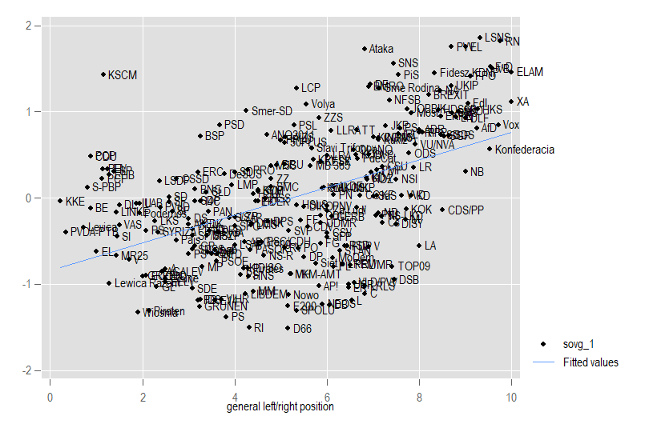
Note: Correlation between left-right position and sovereignism (R=0.49, p<0.001)
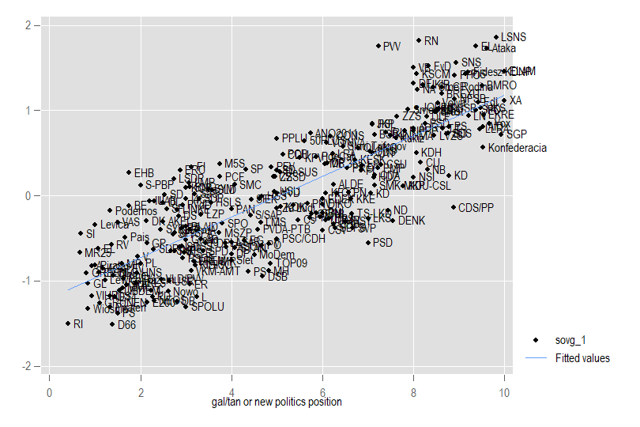
Figure C2 - Index of party-based sovereignism and GAL-TAN (CHES, 2019)

Note: Correlation between GAL-TAN position and sovereignism (R=0.82, p<0.001)

