Religious Institutions’ Stances Towards Autocratization in the Post-Third Wave Period Published in Government and Opposition
By Dina Osama Lotfy
Appendix
Table A1: 52 Cases Witnessed Autocratic Acts Related to Regime Survival
Term limit amendment attempts  (38 cases) | Military takeover attempts  (14 cases)
Latin America  Bolivia 2017, Colombia 2010, Dominican Rep. 2019, Ecuador 2008, Honduras 2009/ 2015, Nicaragua 2011/2016, Paraguay 2017, and Venezuela 2007/2009.  Middle East & Sub-Saharan Africa  Algeria 2019, Benin 2015, Burkina Faso 2014, Burundi 2015/2018, Chad 2018, Comoros 2018, Congo Republic 2015, Democratic Republic of Congo 2016, Egypt 2019, Guinea 2020, Ivory Coast 2020, Malawi 2004, Niger 2009, Nigeria 2006, Rwanda 2015, Senegal 2012, Togo 2019, Uganda 2017, and Zambia 2001.  Post-communist region  Azerbaijan 2016, Belarus 2004/2020, Russia 2020, Tajikistan 2016, Uzbekistan 2007.  Asia  Philippines 1998 | Latin America  Honduras 2009 and Venezuela2002.  Middle East & Sub Saharan Africa  Burkina Faso 2015, Central African Rep 2013, Egypt 2013, Gambia 1994, Guinea 2021, Guinea-Bissau 2003, Mali 2012/2020.  Asia-Pacific Region  Fiji 2000/2006, Philippines 2006, and Thailand 2014

Table A2: Logit Models for Opposing Regime Survival
 | (1) | (2) | (3) | (4) | (5)
% dominant religion | .384 |  | 2.38 | 7.228
 | (1.485) |  | (1.818) | (4.487)
Religious regulation |  | -5.474*** | -6.261*** | 3.278
 |  | (2.03) | (2.156) | (7.755)
Interaction term |  |  |  | -12.747 | -4.336**
 |  |  |  | (10.392) | (1.837)
Historical pro-democratizing role | 2.026*** | 2.287*** | 2.277*** | 2.383*** | 2.253***
 | (.716) | (.847) | (.851) | (.872) | (.807)
Ruler’s religion | -1.793* | -1.271 | -1.643 | -1.719 | -1.161
 | (1.004) | (.991) | (1.06) | (1.085) | (1.006)
GDP per capita | -.086 | -.098 | -.066 | -.051 | -.097
 | (.126) | (.143) | (.152) | (.151) | (.134)
Government favouritism | .5 | .949 | .902 | 1.245 | .849
 | (.625) | (.721) | (.721) | (.84) | (.691)
_cons | -.016 | 1.054 | .11 | -4.045 | .239
 | (1.617) | (1.495) | (1.689) | (3.793) | (1.449)
Observations | 52 | 52 | 52 | 52 | 52
Pseudo R² | .181 | .338 | .365 | .388 | .288
Standard errors are in parentheses
*** p<.01, ** p<.05, * p<.1

Table A3: Linear Probability Models for Opposing Regime Survival
 | (1) | (2) | (3)
Religious monopoly | -.816*** | -.788*** | -.443
 | (.257) | (.274) | (.362)
Historical pro-democratizing role | .348*** | .377*** | .222
 | (.115) | (.117) | (.134)
Ruler’s religion |  | -.174 | -.182
 |  | (.149) | (.144)
GDP per Capita |  | -.016 | -.017
 |  | (.023) | (.024)
Government favouritism |  | .138 | .117
 |  | (.114) | (.115)
Religious families:
Islamic |  |  | -.333*
 |  |  | (.184)
Protestant |  |  | -.395**
 |  |  | (.188)
other |  |  | -.425
 |  |  | (.268)
_cons | .699*** | .552** | .789***
 | (.113) | (.249) | (.269)
Observations | 52 | 52 | 52
R-squared | .29 | .331 | .421
Standard errors are in parentheses
*** p<.01, ** p<.05, * p<.1

Table A4: Logit Models for Opposing Regime Survival
 | (1) | (2) | (3)
Religious monopoly | -5.651** | -5.476** | -3.038
 | (2.258) | (2.675) | (2.91)
Historical pro-democratizing role | 2.09*** | 2.248*** | 1.848*
 | (.759) | (.789) | (.988)
Ruler’s religion |  | -1.069 | -1.833
 |  | (1.006) | (1.262)
GDP per Capita |  | -.06 | -.17
 |  | (.134) | (.172)
Government favouritism |  | .642 | .608
 |  | (.7) | (.727)
Religious families:
Islamic |  |  | -3.059**
 |  |  | (1.374)
Protestant |  |  | -3.211**
 |  |  | (1.459)
Other |  |  | -2.525
 |  |  | (1.774)
_cons | .476 | -.027 | 2.954
 | (.484) | (1.489) | (2.013)
Observations | 52 | 52 | 52
Pseudo R² | .262 | .29 | .424
Standard errors are in parentheses
*** p<.01, ** p<.05, * p<.1

Table A5: Logit Models for Opposing Regime Survival
 | (1) | (2) | (3)
Religious monopoly | -4.893** | -9.239** | -6.752
 | (2.071) | (3.688) | (4.582)
Historical pro-democratizing role | 1.818*** | 2.408*** | 2.149**
 | (.706) | (.882) | (1.075)
Government favouritism |  | 2.134** | 1.804
 |  | (.969) | (1.185)
Ruler’s Religion |  | -1.457 | -2.19*
 |  | (1.027) | (1.25)
GDP per Capita |  | -.058 | -.174
 |  | (.142) | (.176)
Religious families:
Islamic |  |  | -2.85**
 |  |  | (1.409)
Protestant |  |  | -3.429**
 |  |  | (1.548)
Other |  |  | -1.977
 |  |  | (1.926)
_cons | .332 | -2.676 | .8
 | (.467) | (1.884) | (2.707)
Observations | 52 | 52 | 52
Pseudo R² | .211 | .324 | .446
Standard errors are in parentheses
*** p<.01, ** p<.05, * p<.1

Table A6: Factor Change Coefficients for Model 1
logit (N=52): Factor change in odds
Odds of: 1 vs 0
 | b | z | P>z | e^b | e^bStdX | SDofX
Religious monopoly | -4.309 | -2.689 | 0.007 | 0.013 | 0.380 | 0.225
Historical pro-democratizing role | 1.976 | 2.652 | 0.008 | 7.213 | 2.704 | 0.503
constant | 1.020 | 1.712 | 0.087 | . | . | .
b = raw coefficient
z = z-score for test of b=0
P> | z | = | p-value | for | z-test
e^b = exp(b) = factor change in odds for unit increase in X
e^bStdX = exp(b*SD of X) = change in odds for SD increase in X
SDofX = standard deviation of X

Table A7: Factor Change Coefficients for Model 2
logit (N=52): Factor change in odds
Odds of: 1 vs 0
 | b | z | P>z | e^b | e^bStdX | SDofX
Religious monopoly | -4.336 | -2.360 | 0.018 | 0.013 | 0.377 | 0.225
Historical pro-democratizing role | 2.252 | 2.792 | 0.005 | 9.512 | 3.108 | 0.503
Government favouritism | 0.849 | 1.228 | 0.219 | 2.336 | 1.588 | 0.545
Ruler’s Religion | -1.161 | -1.154 | 0.249 | 0.313 | 0.610 | 0.425
GDP per capita | -0.097 | -0.723 | 0.470 | 0.907 | 0.778 | 2.587
constant | 0.239 | 0.165 | 0.869 | . | . | .
b = raw coefficient
z = z-score for test of b=0
P> | z | = | p-value | for | z-test
e^b = exp(b) = factor change in odds for unit increase in X
e^bStdX = exp(b*SD of X) = change in odds for SD increase in X
SDofX = standard deviation of X
Table A8: Discrete Change for the Historical Pro-Democratizing Role at the Lowest and Highest Degrees of Religious Monopoly
Discrete change | lincom | pvalue | 84%Lower limit | 84%Upper limit
DC for the historical pro-democratizing role at the lowest degree of Religious monopoly | 0.292 | 0.016 | 0.122 | 0.462
DC for the historical pro-democratizing role at the highest degree of Religious monopoly | 0.280 | 0.195 | -0.024 | 0.584

Figure A1: The Correlation between Dominant Religion’s Size and Religious regulation
(Covariation= 0.02)

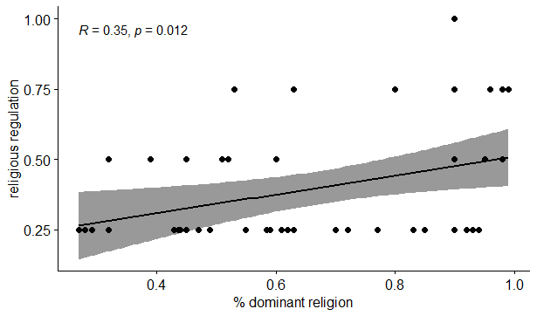

Figure A2: The Correlation between Religious Monopoly and Discrimination Against religious minorities
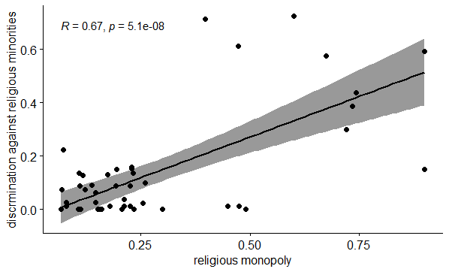

Figure A3: The Correlation between Government Favouritism and Discrimination Against religious minorities
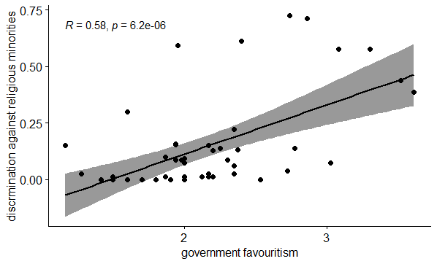

Figure A4: Simple Slope Analysis for the Interaction between Dominant Religions’ Size and Religious Regulation, Using Model 4 in Table A2
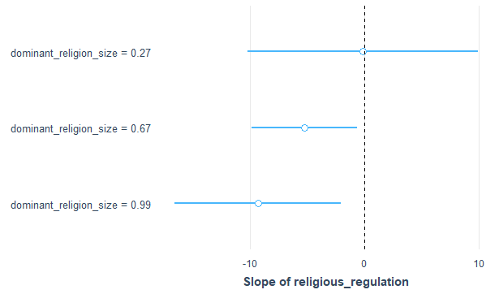

Figure A5: Johnson-Neyman plot for the Interaction between Dominant Religions’ Size and Religious Regulation, Using Model 4 in Table A2

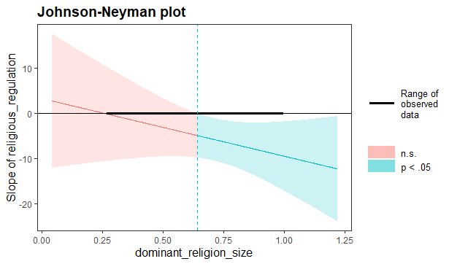

Figure A6: The Density of Protestant Institutions’ Stances by Religious Monopoly Score and Historical Pro-Democratizing Role
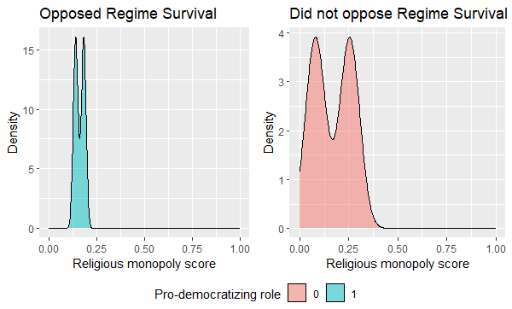

Religious regulation variable, one of the components of religious monopoly, is taken here from Religion and State’s project, Round 3. (Fox, J. (2019, February 10). The Religion and State Project, Main Dataset and Societal Module, Round 3).
I changed the religious regulation variable, one of the components of religious monopoly, with discrimination against minority composite variable that is taken here from Religion and State’s project, Round 3. (Fox, J. (2019, February 10). The Religion and State Project, Main Dataset and Societal Module, Round 3).

