Supplementary Material
Alberto Penadés and Sergio Velasco, ‘The Effect of Referendums on Autocratic Survival: Running Alone and Not Finishing Second’, published in Government and Opposition
Annex
In this annex we will include all the statistical supplementary elements mentioned throughout the main text but not included for reasons of style or simplicity. First, we include the descriptive statistics table for the main variables used throughout this paper.
A1 Descriptive Statistics
 | Mobilization Event | Coup d'etat | Time since last plebiscite | Plebiscite | GDPpc (log10) | GDP Growth
Mean | 0.434 | 0.049 | 6.566 | 0.071 | 8.008 | 0.024
Max | 1 | 2 | 40 | 29.000 | 11.230 | 2.720
Min | 0 | 0 | 0 | 0 | 5.920 | -1
Std. Dv. | 0.496 | 0.232 | 7.433 | 0.555 | 0.924 | 0.088
P25 | 0 | 0 | 1 | 0 | 7.270 | -0.010
P50 | 0 | 0 | 4 | 0 | 7.910 | 0.020
P75 | 1 | 0 | 9 | 0 | 8.640 | 0.050
 | Natural Resources | Regime Type | Election of any kind | Presidential Election | Regime's tenure
Mean | 773.507 | 2.498 | 0.258 | 0.076 | 16.323
Max | 66860.940 | 4 | 3 | 1 | 65
Min | 0 | 1 | 0 | 0 | 1
Std. Dv. | 3714.327 | 1.006 | 0.520 | 0.265 | 13.633
P25 | 0.507 | 2 | 0 | 0 | 5
P50 | 32.651 | 2 | 0 | 0 | 12
P75 | 261.166 | 4 | 0 | 0 | 24

The next figure will show the graph for the Cox’s Proportional Hazards assumption test, in which we expect that data that follow said assumption would follow parallel paths.
A2 Cox’s Proportional Hazards Assumption
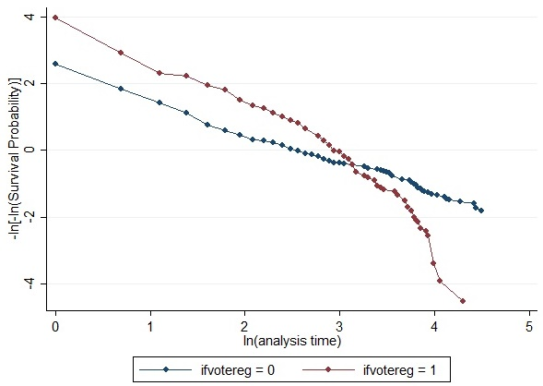
As we can see in Figure A2, instead of a parallel form, we find that both series cross, which means that the hypothesis is violated, leading us to look for alternative forms to the Cox model. Those alternatives are compared in the next figure.
A3 Survival Models
 | Exponential | Gompertz | Log-Logistic | Weibull | Log-Normal | Gen-Gamma
At least held one plebiscite | -.3183** | -.3358** | .3887*** | -.4249*** | .3708*** | .353***
 | (.1484) | (.1502) | (.1088) | (.1508) | (.1098) | (.1097)
Avg. GDP | 0 | 0 | 0 | 0 | 0 | 0
 | (0) | (0) | (0) | (0) | (0) | (0)
Avg. Nat. Res. | 0 | 0 | .0002 | 0 | .0002 | .0001
 | (.0003) | (.0003) | (.0002) | (.0003) | (.0002) | (.0002)
Total Pres. Elect. | .1094 | .1827*** | -.1261*** | .1546** | -.1187** | -.1152**
 | (.0676) | (.0687) | (.0462) | (.0688) | (.0502) | (.0497)
Total Elect. | -.1572*** | -.2165*** | .1835*** | -.2109*** | .1766*** | .1716***
 | (.0281) | (.0296) | (.0201) | (.0293) | (.0207) | (.0212)
Party Reg. | 1.121*** | 2.4167*** | -.845*** | 1.7134*** | -.8812*** | -.974***
 | (.3278) | (.4544) | (.2599) | (.3451) | (.2473) | (.2523)
Military Reg. | 1.6244*** | 3.1718*** | -1.2634*** | 2.4864*** | -1.3905*** | -1.4651***
 | (.3217) | (.4829) | (.2653) | (.3541) | (.2445) | (.248)
Personalist Reg. | 1.4702*** | 2.9163*** | -1.124*** | 2.2297*** | -1.2676*** | -1.3341***
 | (.3235) | (.4702) | (.2637) | (.3505) | (.2446) | (.2465)
Constant | -3.1864*** | -4.8032*** | 2.5537*** | -4.9069*** | 2.6369*** | 2.8291***
 | (.296) | (.4681) | (.2558) | (.4176) | (.2315) | (.2697)
Observations | 214 | 214 | 214 | 214 | 214 | 214
Akaike IC | 559.9 | 525.7 | 510.2 | 519.4 | 506.7 | 506.9
Standard errors are in parentheses. Risk parameters of the model omitted from the table. *** p<.01, ** p<.05, * p<.1 .
A note of interpretation is necessary at this point. Although Log-Logistic, Log-Normal and Gen-Gamma model signs are opposite due to their different estimation form, their interpretation is similar to the rest of the table. From this table we extract that regardless of the model used, the direction of the effects is the robust to the model form. But given the choice between the different possibilities, we use the Log-Normal, as it is the best model if we compare them using the Akaike Information Criterion.
The following figure shows the results for a parallel analysis that of Figure 1 in the main text but with number of plebiscites grouped in clusters. Cluster was made with k-means method, being 4 the number of groups. That allowed us to create two big groups for non-using countries and single-using countries, another for 2-6 plebiscites per regime and finally one for more than seven plebiscites, a rarity in autocratic regime history.
A4 Kaplan-Meier Survival Estimates for clustered regimes
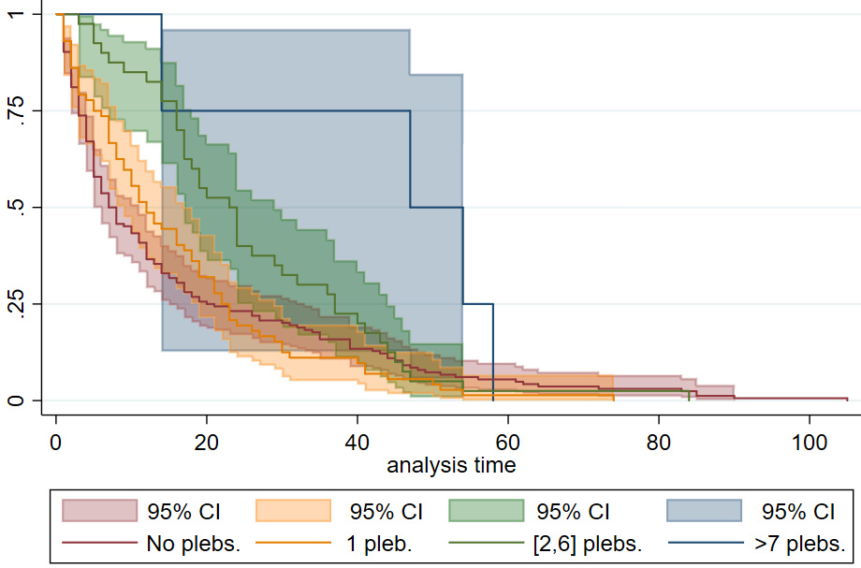
We can clearly observe a tendency towards survival as the number of plebiscites rises. The last cluster had only four observations: Al Assad’s Syria, post-monarchy Egypt, Morocco, and Marcos’ Philippines. The three first regimes were long-lasting, but since the last of them ended in only 14 years, causing the notable disruption in the confidence interval. Besides this, the graph shows the expected pattern.
A5 Timing of plebiscite event.
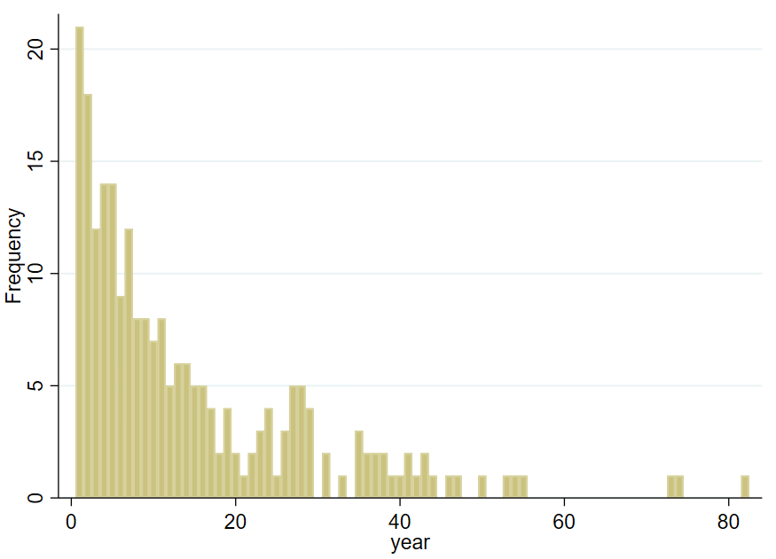

A6 Timing of plebiscite event in percentage
Time interval since the beginning of the regime | 0-5 | 6-10 | 11-20 | +20
Percentage of plebiscites | 34.8% | 19.4% | 20.7% | 25.1%
Cumulative | 34.8% | 54.2% | 74.9% | 100%

