Appendix
Table A1. Summary statistics on parties, elections, and years covered.
Country | Number of parties |  |  | Number of elections |  |  | Years covered
 | MARPOR 1970- | CHES | MARPOR, Matched elections | MARPOR 1970- | CHES | MARPOR, Matched elections | MARPOR 1970- | CHES | MARPOR, Matched elections
Austria | 7 | 6 | 6 | 15 | 6 | 6 | 1970-2017 | 1999- 2017 | 1999-2017
Belgium | 15 | 10 | 12 | 14 | 4 | 4 | 1971-2014 | 1999-2010 | 1999-2010
Bulgaria | 8 | 6 | 6 | 7 | 4 | 4 | 1991-2013 | 2001-2013 | 2001-2013
Croatia | 11 | 7 | 9 | 8 | 3 | 3 | 1992-2016 | 2011-2016 | 2011-2016
The Czech Republic | 7 | 4 | 5 | 5 | 2 | 2 | 1996-2010 | 2002, 2006 | 2002, 2006
Denmark | 14 | 9 | 11 | 17 | 6 | 6 | 1971-2015 | 1998-2015 | 1998-2015
Estonia | 8 | 4 | 5 | 5 | 2 | 2 | 1995-2011 | 2007, 2011 | 2007, 2011
Finland | 9 | 8 | 8 | 13 | 5 | 5 | 1970-2015 | 1999-2015 | 1999-2015
France | 8 | 5 | 6 | 10 | 2 | 2 | 1973-2012 | 2002, 2007 | 2002, 2007
Germany | 5 | 5 | 5 | 13 | 6 | 6 | 1972-2017 | 1998-2017 | 1998-2017
Greece | 10 | 9 | 10 | 12 | 7 | 7 | 1981-2015 | 1996-2015 | 1996-2015
Hungary | 8 | 7 | 7 | 6 | 4 | 4 | 1994-2014 | 2002-2014 | 2002-2014
Iceland | 9 |  |  | 12 |  |  | 1971-2009
Ireland | 8 | 7 | 8 | 12 | 5 | 5 | 1973-2016 | 1997-2016 | 1997-2016
Italy | 23 | 4 | 14 | 13 | 3 | 3 | 1972-2018 | 2001, 2008, 2018 | 2001, 2008, 2018
Latvia | 10 |  |  | 5 |  |  | 1998-2011
Lithuania | 9 |  |  | 4 |  |  | 1996-2008
The Netherlands | 18 | 10 | 12 | 15 | 7 | 7 | 1971-2017 | 1998-2017 | 1998-2017
Norway | 7 |  |  | 11 |  |  | 1973-2017
Poland | 9 | 4 | 7 | 5 | 3 | 3 | 1993-2011 | 2005-2011 | 2005-2011
Portugal | 7 | 4 | 4 | 12 | 5 | 5 | 1979-2011 | 1999-2011 | 1999-2011
Romania | 10 |  |  | 6 |  |  | 1992-2012
Slovakia | 8 | 6 | 8 | 5 | 3 | 3 | 1994-2012 | 2006-2012 | 2006-2012
Slovenia | 9 | 7 | 7 | 6 | 2 | 2 | 1992-2011 | 2000, 2004 | 2000, 2004
Spain | 12 | 10 | 10 | 8 | 6 | 6 | 1982-2016 | 2000-2016 | 2000-2016
Sweden | 8 | 8 | 8 | 15 | 6 | 6 | 1970-2018 | 1998-2018 | 1998-2018
The United Kingdom | 6 | 5 | 5 | 12 | 6 | 6 | 1970-2017 | 1997-2017 | 1997-2017
Total | 263 | 145 | 173 | 266 | 97 | 97

Robustness tests
The first set of robustness tests consists of estimating the model on the three data subsets, but with ten percent of parties removed at random. The estimated coefficients, reported in Tables A2 through A4 below, remain remarkably similar to the estimates from the full data subsets, and all terms retain their significance. What is notable, however, is the volatility of the instrument exogeneity tests, indicating that particular parties or groups of parties may have an influence in this regard.

Table A2. Sensitivity analysis 1
 | MARPOR, 1970- | CHES | MARPOR, Matched elections
 | Salience of secondary dimension
Salience of secondary dimension, lagged | 0.451*** | 0.337** | 0.640***
 | (0.069) | (0.128) | (0.116)
Gross CIP | 0.150*** | 0.109** | 0.088*
 | (0.021) | (0.037) | (0.037)
Gross CIP x Gross CIP | -0.012*** | -0.009** | -0.008*
 | (0.002) | (0.003) | (0.003)
Distance from coalition | 0.149*** | 0.073*** | 0.069
 | (0.022) | (0.017) | (0.037)
Gross CIP x Distance from coalition | -0.065*** | -0.026*** | -0.038*
 | (0.009) | (0.008) | (0.016)
Gross CIP x Gross CIP x Distance from coalition | 0.005*** | 0.002* | 0.003*
 | (0.001) | (0.001) | (0.001)
Niche party status | -0.087** | -0.004 | -0.060
 | (0.030) | (0.036) | (0.040)
Incumbent | -0.011 | 0.015 | 0.000
 | (0.012) | (0.012) | (0.011)
Pre-electoral coalition | 0.007 | -0.004 | -0.024
 | (0.014) | (0.026) | (0.021)
Seat Share | 0.010 | 0.092 | 0.165
 | (0.130) | (0.158) | (0.103)
General left-right position | -0.015 | 0.038** | -0.028**
 | (0.008) | (0.013) | (0.010)
Observations | 1091 | 364 | 360
No. groups | 206 | 126 | 125
No. instruments | 160 | 69 | 66
AR(1) (p-value) | 0.000 | 0.001 | 0.015
AR(2) (p-value) | 0.586 | 0.172 | 0.140
Hansen-J (p-value) | 0.929 | 0.363 | 0.506
Difference-in-Hansen, GMM instruments for levels (p-value) | 0.601 | 0.166 | 0.810
Difference-in-Hansen, IV instruments for levels equation (p-value) | 1 | 0.017 | 0.065

Table A3. Sensitivity analysis 2
 | MARPOR, 1970- | CHES | MARPOR, Matched elections
 | Salience of secondary dimension
Salience of secondary dimension, lagged | 0.452*** | 0.577*** | 0.629***
 | (0.072) | (0.073) | (0.122)
Gross CIP | 0.146*** | 0.067* | 0.085*
 | (0.021) | (0.029) | (0.037)
Gross CIP x Gross CIP | -0.012*** | -0.006* | -0.007*
 | (0.002) | (0.002) | (0.003)
Distance from coalition | 0.146*** | 0.043*** | 0.063*
 | (0.023) | (0.011) | (0.032)
Gross CIP x Distance from coalition | -0.066*** | -0.019** | -0.035*
 | (0.010) | (0.007) | (0.014)
Gross CIP x Gross CIP x Distance from coalition | 0.005*** | 0.002* | 0.003**
 | (0.001) | (0.001) | (0.001)
Niche party status | -0.079* | -0.033 | -0.039
 | (0.032) | (0.045) | (0.039)
Incumbent | -0.002 | 0.011 | 0.013
 | (0.011) | (0.016) | (0.010)
Pre-electoral coalition | 0.007 | 0.012 | -0.025
 | (0.014) | (0.036) | (0.025)
Seat Share | 0.078 | 0.202* | 0.178**
 | (0.132) | (0.099) | (0.066)
General left-right position | -0.019* | 0.028* | -0.031***
 | (0.008) | (0.012) | (0.007)
Observations | 1088 | 357 | 364
No. groups | 207 | 126 | 122
No. instruments | 158 | 67 | 66
AR(1) (p-value) | 0.000 | 0.018 | 0.019
AR(2) (p-value) | 0.670 | 0.230 | 0.148
Hansen-J (p-value) | 0.959 | 0.337 | 0.346
Difference-in-Hansen, GMM instruments for levels (p-value) | 0.689 | 0.564 | 0.628
Difference-in-Hansen, IV instruments for levels equation (p-value) | 0.594 | 0.015 | 0.176

Table A4. Sensitivity analysis 3
 | MARPOR, 1970- | CHES | MARPOR, Matched elections
 | Salience of secondary dimension
Salience of secondary dimension, lagged | 0.447*** | 0.398*** | 0.624***
 | (0.069) | (0.121) | (0.116)
Gross CIP | 0.151*** | 0.109** | 0.081*
 | (0.021) | (0.039) | (0.038)
Gross CIP x Gross CIP | -0.012*** | -0.009** | -0.007*
 | (0.002) | (0.003) | (0.003)
Distance from coalition | 0.153*** | 0.070*** | 0.066*
 | (0.023) | (0.018) | (0.031)
Gross CIP x Distance from coalition | -0.068*** | -0.030** | -0.034*
 | (0.010) | (0.010) | (0.014)
Gross CIP x Gross CIP x Distance from coalition | 0.005*** | 0.002** | 0.003*
 | (0.001) | (0.001) | (0.001)
Niche party status | -0.084** | -0.040 | -0.063
 | (0.030) | (0.038) | (0.038)
Incumbent | -0.005 | 0.011 | 0.010
 | (0.012) | (0.018) | (0.013)
Pre-electoral coalition | 0.011 | 0.004 | -0.006
 | (0.015) | (0.046) | (0.024)
Seat Share | -0.005 | 0.205 | 0.221
 | (0.135) | (0.136) | (0.117)
General left-right position | -0.015 | 0.033** | -0.031**
 | (0.008) | (0.012) | (0.010)
Observations | 1128 | 377 | 362
No. groups | 207 | 126 | 125
No. instruments | 160 | 69 | 66
AR(1) (p-value) | 0.000 | 0.002 | 0.015
AR(2) (p-value) | 0.786 | 0.269 | 0.141
Hansen-J (p-value) | 0.826 | 0.300 | 0.449
Difference-in-Hansen, GMM instruments for levels (p-value) | 0.158 | 0.086 | 0.673
Difference-in-Hansen, IV instruments for levels equation (p-value) | 0.899 | 0.000 | 0.057

The second set of robustness tests involves alternate specifications of the model. The first of these concerns an alternative measure for bargaining strength, the Banzhaf power index. Compared to the more complex coalition inclusion probability index used in the main model, the Banzhaf power index is based on the number of ’swings’ a party has when determining majority situations in parliament, based on two parameters: the number of seats (or seat share) and the decision rule in parliament. The more influence a party has over majority conditions, the greater its Banzhaf index, from 0 to 1. The expectation here is that while the same pattern should be visible as when using gross CIP as the measure of bargaining strength, as the Banzhaf power index is a more straight-forward approach, it may not be as precise, and hence the estimates are expected to be less certain (i.e., the standard errors should be larger). As we can see from Table A5 below, there are some notable differences, albeit the main results remain largely similar (as can be confirmed in the set of figures included at the end of the online appendix). Some notable differences compared to the estimates using gross CIP as the measure of bargaining strength is that there the p-value for the AR(2) test for the MARPOR data subset is noticeably lower than in the main model.

Table A5. Alternate model specification, Banzhaf power index
 | MARPOR, 1970- | CHES | MARPOR, Matched elections
 | Salience of secondary dimension
Salience of secondary dimension, lagged | 0.687*** | 0.488*** | 0.821***
 | (0.044) | (0.122) | (0.041)
Banzhaf index | 0.075*** | 0.077* | 0.021
 | (0.017) | (0.032) | (0.014)
Banzhaf index x Banzhaf index | -0.007*** | -0.007* | -0.003*
 | (0.001) | (0.003) | (0.001)
Distance from coalition | 0.068*** | 0.059*** | 0.020
 | (0.013) | (0.017) | (0.010)
Banzhaf index x Distance from coalition | -0.042*** | -0.027* | -0.018**
 | (0.010) | (0.010) | (0.007)
Banzhaf index x Banzhaf x Distance from coalition | 0.003*** | 0.002* | 0.002**
 | (0.001) | (0.001) | (0.001)
Niche party status | -0.065* | -0.012 | -0.013
 | (0.027) | (0.031) | (0.037)
Incumbent | 0.013 | 0.017 | 0.012
 | (0.009) | (0.012) | (0.012)
Pre-electoral coalition | 0.028* | 0.006 | -0.015
 | (0.013) | (0.031) | (0.019)
Seat Share | 0.028 | 0.207 | 0.200
 | (0.124) | (0.106) | (0.163)
General left-right position | -0.032*** | 0.032** | -0.029*
 | (0.007) | (0.011) | (0.013)
Observations | 1257 | 390 | 385
No. groups | 239 | 137 | 134
No. instruments | 160 | 69 | 67
AR(1) (p-value) | 0.000 | 0.000 | 0.000
AR(2) (p-value) | 0.203 | 0.135 | 0.139
Hansen-J (p-value) | 0.737 | 0.551 | 0.492
Difference-in-Hansen, GMM instruments for levels (p-value) | 0.334 | 0.950 | 0.731
Difference-in-Hansen, IV instruments for levels equation (p-value) | 0.314 | 0.481 | 0.275

In the next two tests, rather than using a two-dimensional measure of distance from the likeliest coalition, I instead use single-dimensional measures, corresponding to the primary and secondary dimension. If either dimension plays little effect in a party’s choice of strategy, it should be reflected in clearly diverging estimates depending on which measure of distance is used, while if the results are similar, it lends credence to the idea that using two-dimensional measures of distance has merit. In Table A6, the estimates using distance on the primary dimension are reported. The 1970- MARPOR data subset and CHES data subset estimates remain similar and significant to their two-dimensional counterpart, the matched MARPOR estimates do not fare so well. Notably, the gross CIP and squared gross CIP terms fail to reach customary levels of significance. Again, it seems that not leveraging the full set of MARPOR data results in a toll paid.

Table A6. Alternate model specification, primary distance from likeliest coalition
 | MARPOR, 1970- | CHES | MARPOR, Matched elections
 | Salience of secondary dimension
Salience of secondary dimension, lagged | 0.547*** | 0.461*** | 0.702***
 | (0.060) | (0.106) | (0.127)
Gross CIP | 0.109*** | 0.078** | 0.056
 | (0.017) | (0.029) | (0.036)
Gross CIP x Gross CIP | -0.009*** | -0.008** | -0.005
 | (0.001) | (0.002) | (0.003)
Distance from coalition on primary dimension | 0.150*** | 0.066*** | 0.083
 | (0.025) | (0.018) | (0.058)
Gross CIP x Distance from coalition on primary dimension | -0.068*** | -0.035** | -0.049
 | (0.012) | (0.011) | (0.031)
Gross CIP x Gross CIP x Distance from coalition on primary dimension | 0.006*** | 0.003** | 0.005
 | (0.001) | (0.001) | (0.003)
Niche party status | -0.084** | -0.040 | -0.073
 | (0.031) | (0.026) | (0.046)
Incumbent | -0.002 | 0.017 | 0.003
 | (0.011) | (0.018) | (0.014)
Pre-electoral coalition | 0.012 | 0.007 | -0.013
 | (0.012) | (0.027) | (0.028)
Seat Share | 0.104 | 0.289* | 0.099
 | (0.127) | (0.128) | (0.191)
General left-right position | -0.023** | 0.041** | -0.037***
 | (0.008) | (0.016) | (0.008)
Observations | 1229 | 406 | 402
No. groups | 232 | 141 | 139
No. instruments | 160 | 69 | 67
AR(1) (p-value) | 0.000 | 0.000 | 0.004
AR(2) (p-value) | 0.823 | 0.213 | 0.213
Hansen-J (p-value) | 0.636 | 0.594 | 0.270
Difference-in-Hansen, GMM instruments for levels (p-value) | 0.056 | 0.686 | 0.567
Difference-in-Hansen, IV instruments for levels equation (p-value) | 0.250 | 0.018 | 0.137

Turning instead to distance on the secondary dimension, with coefficients reported in Table A7. Results are largely similar to the previous model, but with some important caveats. First, instrument exogeneity appears to have stronger support for the 1970- MARPOR data subset than when using primary distance. Second, the estimates for the matched MARPOR data subset again reach significance for all the terms of interest, albeit the instruments cannot be considered exogeneous as a group. To summarize briefly, then, using a two-dimensional measure appears to have merit, given the comparatively more certain estimates in the main model for the matched MARPOR data subset.

Table A7. Alternate model specification, secondary distance from likeliest coalition
 | MARPOR, 1970- | CHES | MARPOR, Matched elections
 | Salience of secondary dimension
Salience of secondary dimension, lagged | 0.541*** | 0.391** | 0.758***
 | (0.059) | (0.127) | (0.070)
Gross CIP | 0.117*** | 0.084* | 0.044*
 | (0.017) | (0.039) | (0.022)
Gross CIP x Gross CIP | -0.010*** | -0.007* | -0.004
 | (0.001) | (0.003) | (0.002)
Distance from coalition on secondary dimension | 0.164*** | 0.091** | 0.053
 | (0.029) | (0.029) | (0.029)
Gross CIP x Distance from coalition on secondary dimension | -0.080*** | -0.033* | -0.029
 | (0.013) | (0.014) | (0.015)
Gross CIP x Gross CIP x Distance from coalition on secondary dimension | 0.007*** | 0.002 | 0.003
 | (0.001) | (0.001) | (0.002)
Niche party status | -0.068** | -0.030 | -0.029
 | (0.026) | (0.028) | (0.042)
Incumbent | 0.003 | 0.006 | 0.008
 | (0.010) | (0.015) | (0.013)
Pre-electoral coalition | 0.000 | -0.005 | -0.022
 | (0.014) | (0.022) | (0.029)
Seat Share | 0.165 | 0.155 | 0.159
 | (0.128) | (0.143) | (0.181)
General left-right position | -0.018** | 0.042** | -0.027**
 | (0.006) | (0.014) | (0.008)
Observations | 1229 | 406 | 402
No. groups | 232 | 141 | 139
No. instruments | 160 | 69 | 67
AR(1) (p-value) | 0.000 | 0.015 | 0.027
AR(2) (p-value) | 0.151 | 0.440 | 0.184
Hansen-J (p-value) | 0.700 | 0.266 | 0.310
Difference-in-Hansen, GMM instruments for levels (p-value) | 0.372 | 0.100 | 0.889
Difference-in-Hansen, IV instruments for levels equation (p-value) | 0.171 | 0.010 | 0.007

In Table A8, an alternate operationalisation of niche party status has been used compared to the main model reported in the paper. Here, niche party status is determined solely based on a party’s party family, where green, regionalist, and far/radical right parties have been classified as niche parties, while all other parties have been classified as not niche. For the MARPOR and CHES data subsets, the results differ little compared to the main model. The alternate operationalisation used for niche party status here is not significant for the MARPOR data subset, and seat share is significant in the CHES data subset when compared to the main model. All terms also have the same sign and roughly similar coefficients, indicating that little substantial effect, which is further confirmed in Figure A7. As has been a partly recurring theme in this appendix, the MARPOR data subset which is matched against the CHES data subset the story is different. The only terms that remain significant with the alternate specification are the lagged dependent variable and general left-right position, while seat share also reaches significance.

Table A8. Alternate model specification, niche party status by party family
 | MARPOR, 1970- | CHES | MARPOR, Matched elections
 | Salience of secondary dimension
Salience of secondary dimension, lagged | 0.542*** | 0.367*** | 0.773***
 | (0.072) | (0.105) | (0.084)
Gross CIP | 0.118*** | 0.079** | 0.042
 | (0.023) | (0.028) | (0.026)
Gross CIP x Gross CIP | -0.010*** | -0.007** | -0.004
 | (0.002) | (0.002) | (0.002)
Distance from coalition | 0.113*** | 0.057*** | 0.021
 | (0.023) | (0.013) | (0.028)
Gross CIP x Distance from coalition | -0.056*** | -0.022*** | -0.016
 | (0.01) | (0.006) | (0.017)
Gross CIP x Gross CIP x Distance from coalition | 0.005*** | 0.002** | 0.001
 | (0.001) | (0.001) | (0.002)
Niche party status | 0.159 | 0.0482 | -0.012
 | (0.108) | (0.093) | (0.083)
Incumbent | 0.0013 | 0.014 | 0.010
 | (0.010) | (0.016) | (0.011)
Pre-electoral coalition | 0.000 | -0.002 | -0.023
 | (0.014) | (0.030) | (0.031)
Seat Share | -0.011 | 0.222* | 0.202*
 | (0.133) | (0.110) | (0.082)
General left-right position | -0.013 | 0.045** | -0.034***
 | (0.008) | (0.014) | (0.009)
Observations | 1248 | 421 | 421
No. groups | 235 | 143 | 143
No. instruments | 160 | 72 | 71
AR(1) (p-value) | 0.000 | 0.046 | 0.024
AR(2) (p-value) | 0.577 | 0.201 | 0.138
Hansen-J (p-value) | 0.881 | 0.642 | 0.329
Difference-in-Hansen, GMM instruments for levels (p-value) | 0.352 | 0.174 | 0.687
Difference-in-Hansen, IV instruments for levels equation (p-value) | 0.251 | 0.007 | 0.020

The final robustness test concerns the inclusion of decade dummies to account for any potential temporal effect. In part, this should be expected, as party system fragmentation and increased dimensionality in the party system have been increasing, especially so in recent decades. The reference category is set to the 1990s, and the estimates are reported in Table A9. As is fairly evident, the 1970- MARPOR data estimates remain virtually intact, while the estimates in the other two data subsets are wiped out entirely by the decade dummies, which are highly significant and with very large estimated coefficients. One culprit, as already mentioned, is that party system fragmentation and increased dimensionality are assumed to increase during the decades covered in these two data subsets. The size of the effect is however considerable. That all the decade dummies remain significant but with much weaker effects in the 1970- MARPOR data may be due to the impact of the relative time series available on a party per party basis. The number of elections covered by the CHES and MARPOR data subsets are limited, as seen in Table A1 above. Moreover, the number of parties covered is also likewise limited. As the sensitivity analyses above showcased, some tests appeared to be sensitive to which parties were included in the data. It may therefore be the case that the same applies with regard to the decade dummies. An additional point of note that is no longer clear evidence that the model estimated on the CHES data subset follows an AR(1) process.

Table A9. Alternate model specification, inclusion of decade dummies
 | MARPOR, 1970- | CHES | MARPOR, Matched elections
 | Salience of secondary dimension
Salience of secondary dimension, lagged | 0.465*** | -0.079 | -0.030
 | (0.068) | (0.120) | (0.114)
Gross CIP | 0.124*** | -0.021 | 0.008
 | (0.017) | (0.025) | (0.021)
Gross CIP x Gross CIP | -0.010*** | 0.002 | -0.001
 | (0.001) | (0.002) | (0.002)
Distance from coalition | 0.113*** | -0.002 | 0.001
 | (0.017) | (0.011) | (0.020)
Gross CIP x Distance from coalition | -0.054*** | 0.003 | -0.006
 | (0.008) | (0.006) | (0.010)
Gross CIP x Gross CIP x Distance from coalition | 0.004*** | -0.000 | 0.001
 | (0.001) | (0.001) | (0.001)
Niche party status | -0.076** | -0.013 | -0.036
 | (0.027) | (0.014) | (0.029)
Incumbent | -0.000 | 0.016 | 0.011
 | (0.011) | (0.009) | (0.008)
Pre-electoral coalition | 0.005 | 0.056 | 0.107
 | (0.012) | (0.083) | (0.083)
Seat Share | 0.206 | -0.006 | -0.019**
 | (0.108) | (0.006) | (0.006)
General left-right position | -0.016* | -0.079 | -0.030
 | (0.007) | (0.120) | (0.114)
1970s | 0.041*
 | (0.019)
1980s | 0.054**
 | (0.018)
2000s | 0.074*** | 0.901*** | 0.742***
 | (0.017) | (0.134) | (0.096)
2010s | 0.074*** | 0.898*** | 0.748***
 | (0.017) | (0.135) | (0.100)
Observations | 1229 | 406 | 402
No. groups | 232 | 141 | 139
No. instruments | 164 | 71 | 69
AR(1) (p-value) | 0.000 | 0.134 | 0.090
AR(2) (p-value) | 0.610 | 0.335 | 0.326
Hansen-J (p-value) | 0.907 | 0.353 | 0.497
Difference-in-Hansen, GMM instruments for levels (p-value) | 0.404 | 0.221 | 0.347
Difference-in-Hansen, IV instruments for levels equation (p-value) | 0.597 | 0.048 | 0.246

Figures
Figure A1. Sensitivity analysis 1
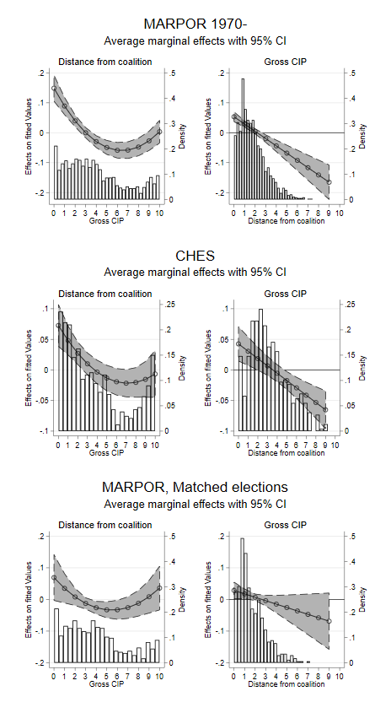
Figure A2. Sensitivity analysis 2
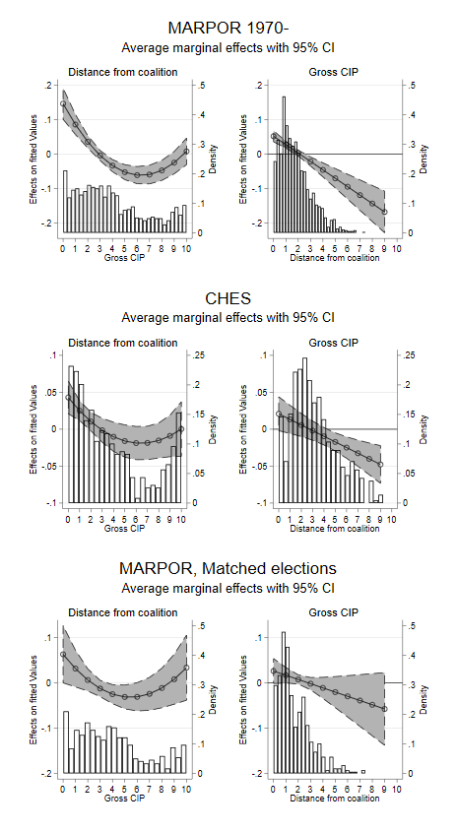

Figure A3. Sensitivity analysis 3
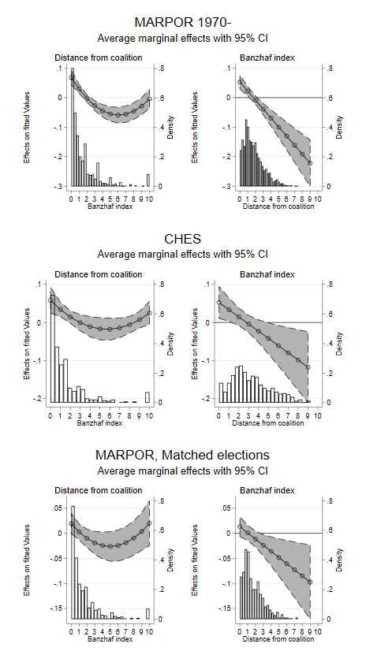

Figure A4. Alternate model specification, Banzhaf power index
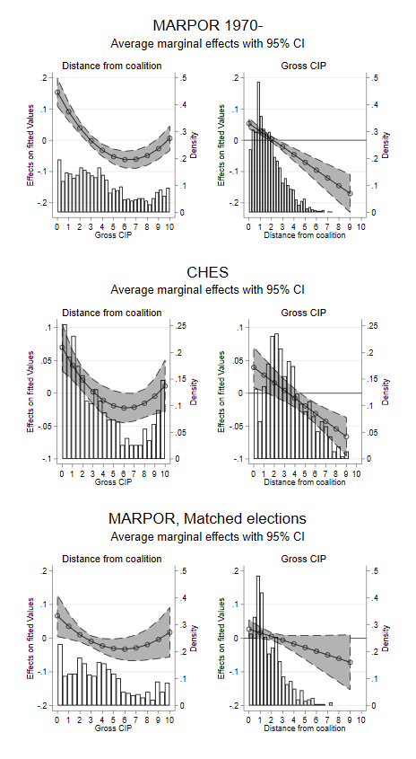

Figure A5. Alternate model specification, primary distance from likeliest coalition
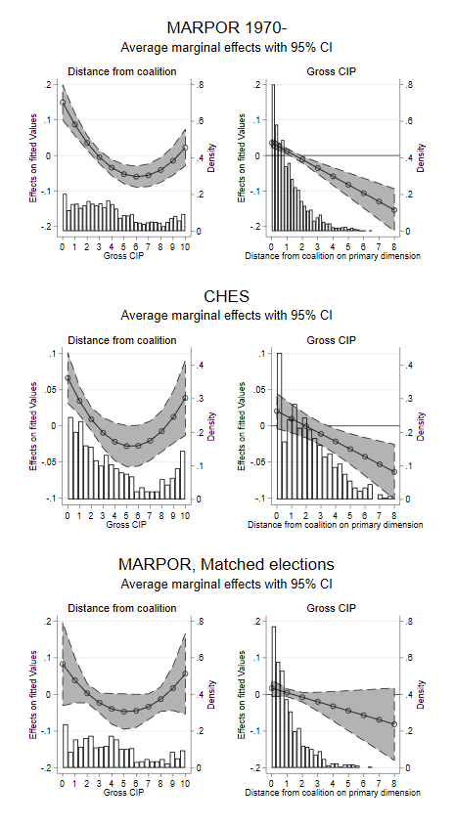

Figure A6. Alternate model specification, secondary distance from likeliest coalition
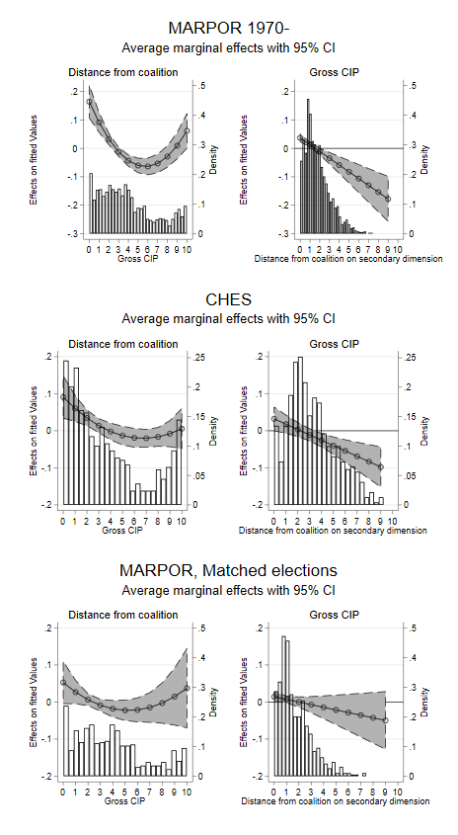

Figure A7. Alternate model specification, niche party status by party family
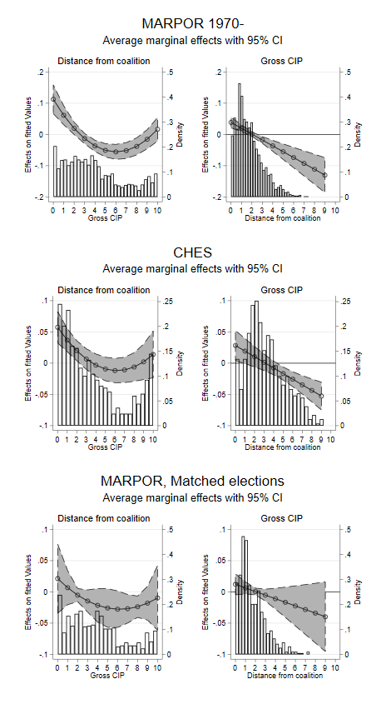

Figure A8. Alternate model specification, inclusion of decade dummies
