Appendix 2: Logged sections of all wells of the Rotliegend Group with sampled intervals. See table 1 for lithofacies codes, and table 2 for facies associations codes.

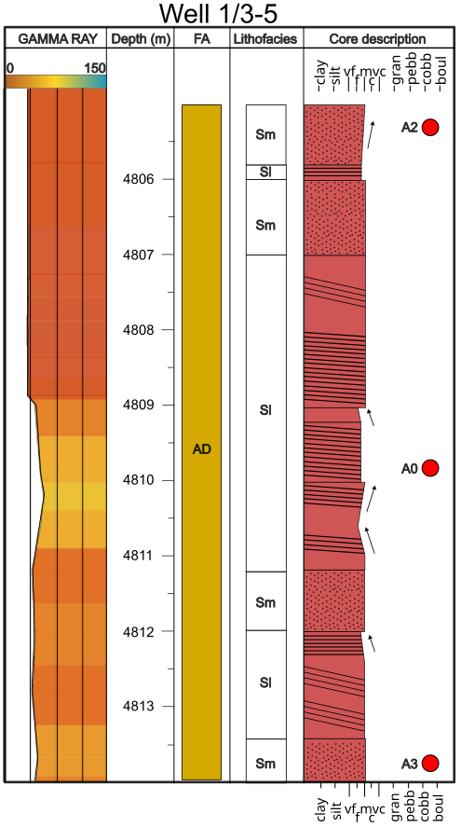
Fig. A1: Core description and provenance sample location of well 1/3-5. Interpreted lithofacies and facies associations (FA). Gamma ray is in API units.

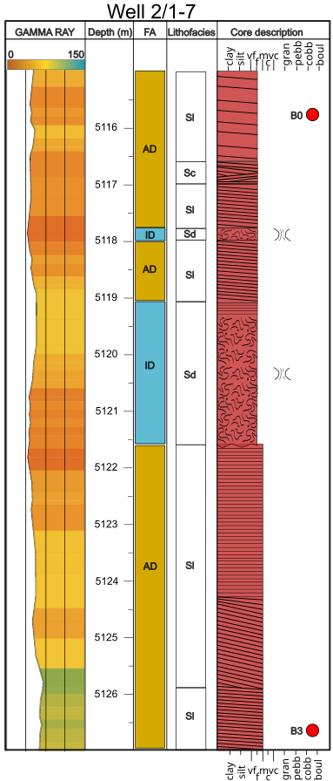
Fig. A2: Upper core description and provenance sample location of well 2/1-7. Interpreted lithofacies and facies associations (FA). Gamma ray is in API units.
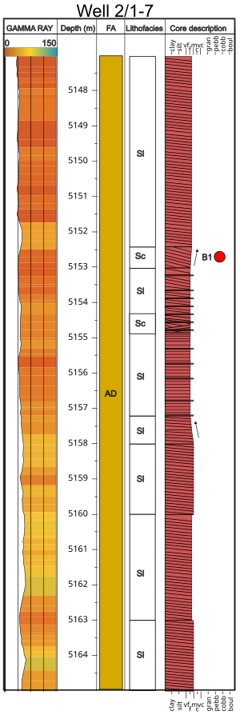
Fig. A3: Lower core description and provenance sample location of well 2/1-7. Interpreted lithofacies and facies associations (FA). Gamma ray is in API units.

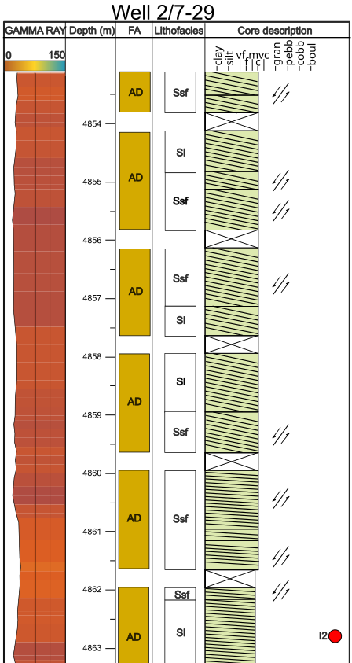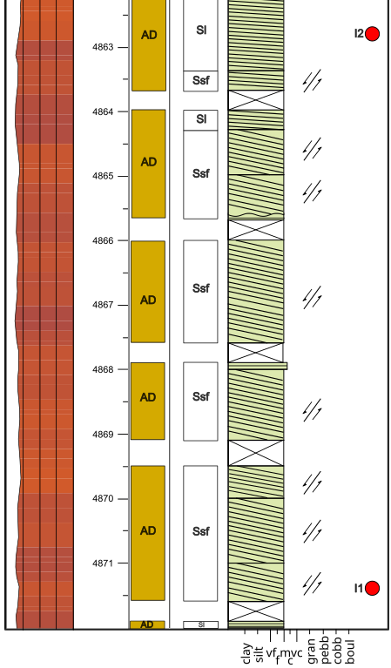

Fig. A4: Core description and provenance sample location of well 2/7-29. Interpreted lithofacies and facies associations (FA). Gamma ray is in API units.

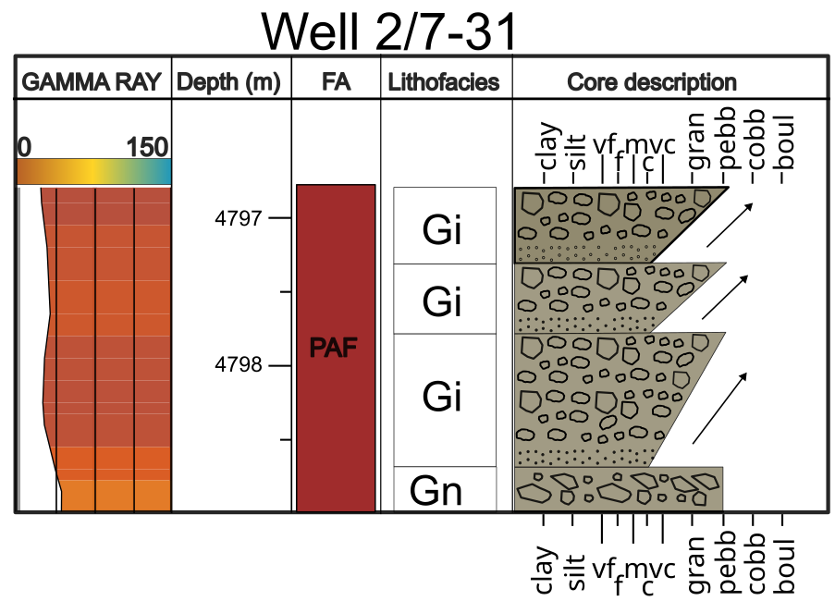
Fig. A5: Upper core description and provenance sample location of well 2/7-31. Interpreted lithofacies and facies associations (FA). Gamma ray is in API units.
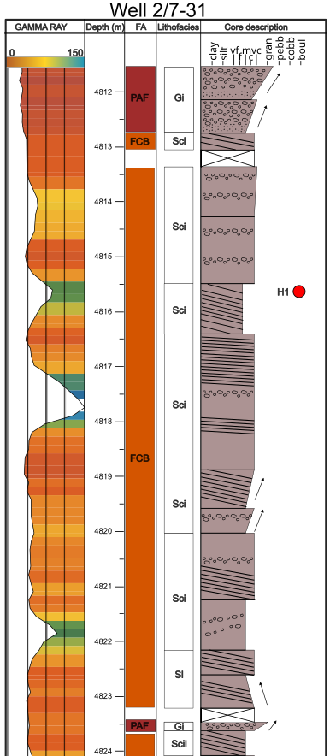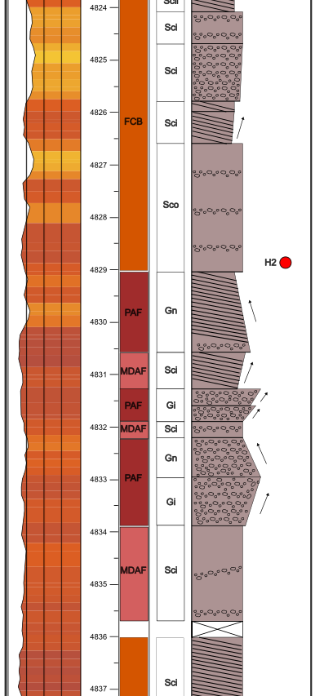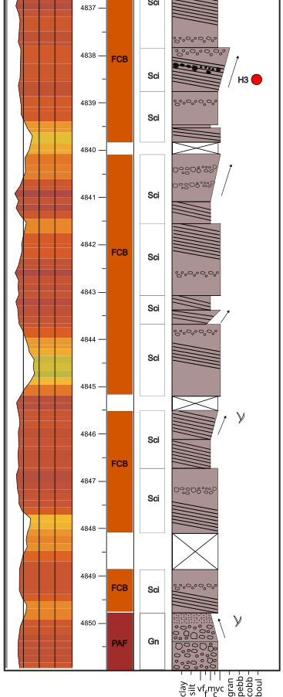
Fig. A6: Lower core description and provenance sample location of well 2/7-31. Interpreted lithofacies and facies associations (FA). Gamma ray is in API units.
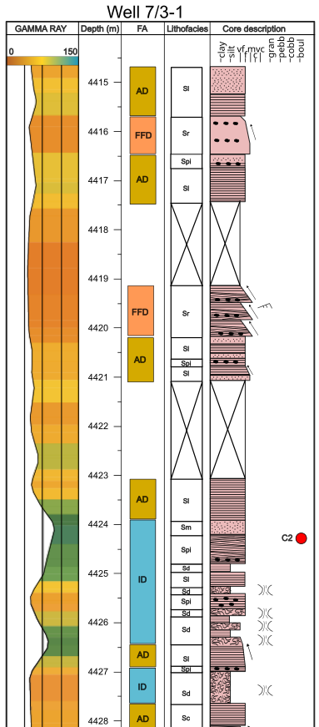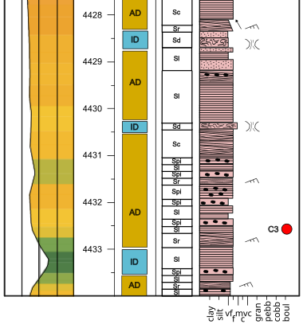
Fig. A7: Upper core description and provenance sample location of well 7/3-1. Interpreted lithofacies and facies associations (FA). Gamma ray is in API units.
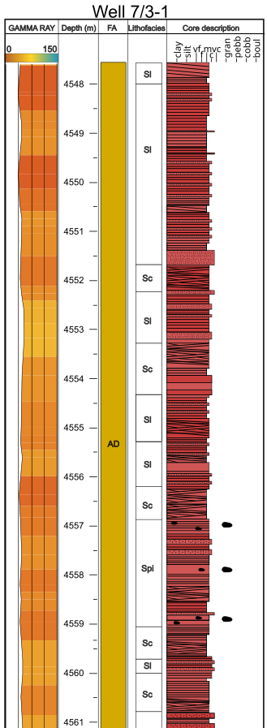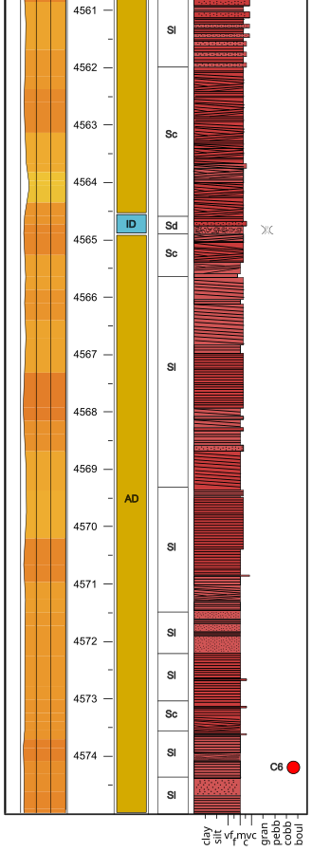
Fig. A8: Lower core description and provenance sample location of well 7/3-1. Interpreted lithofacies and facies associations (FA). Gamma ray is in API units.

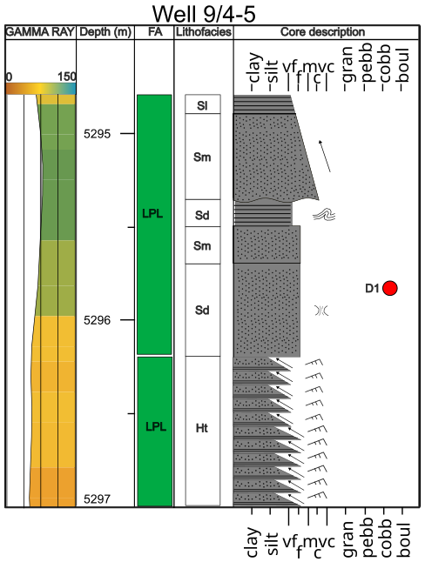
Fig. A9: Upper core description and provenance sample location of well 9/4-5. Interpreted lithofacies and facies associations (FA). Gamma ray is in API units.

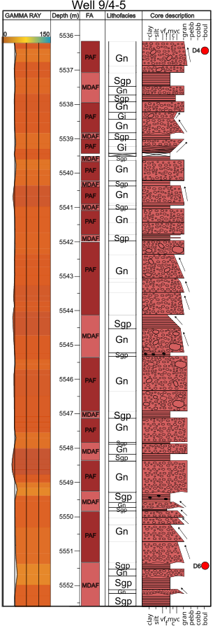
Fig. A10: Lower core description and provenance sample location of well 9/4-5. Interpreted lithofacies and facies associations (FA). Gamma ray is in API units.

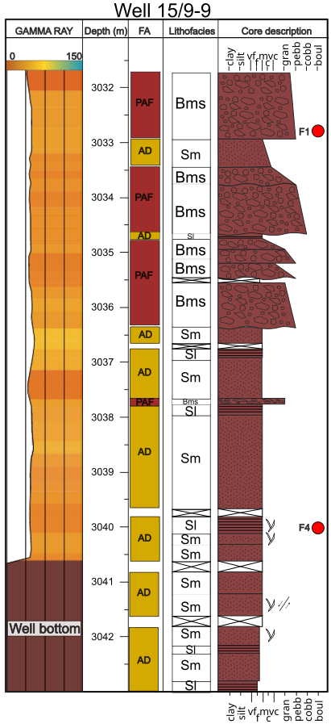
Fig. A11: Core description and provenance sample location of well 15/9-9. Interpreted lithofacies and facies associations (FA). Gamma ray is in API units.
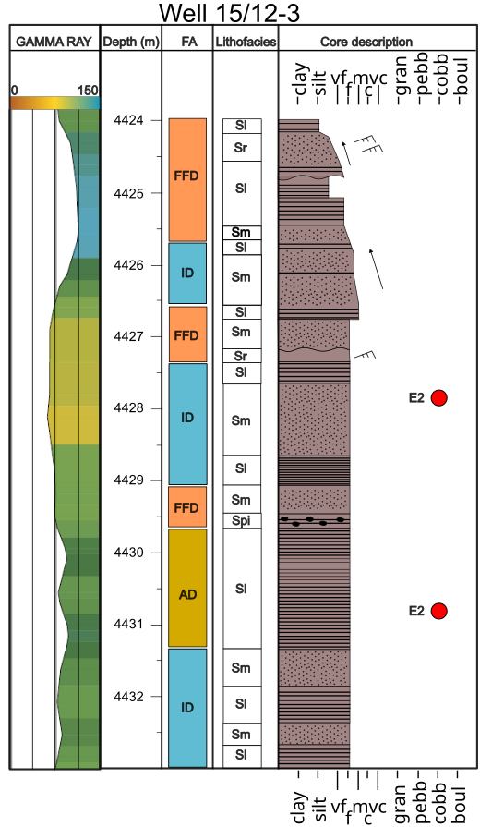
Fig. A12: Core description and provenance sample location of well 15/12-3. Interpreted lithofacies and facies associations (FA). Gamma ray is in API units.

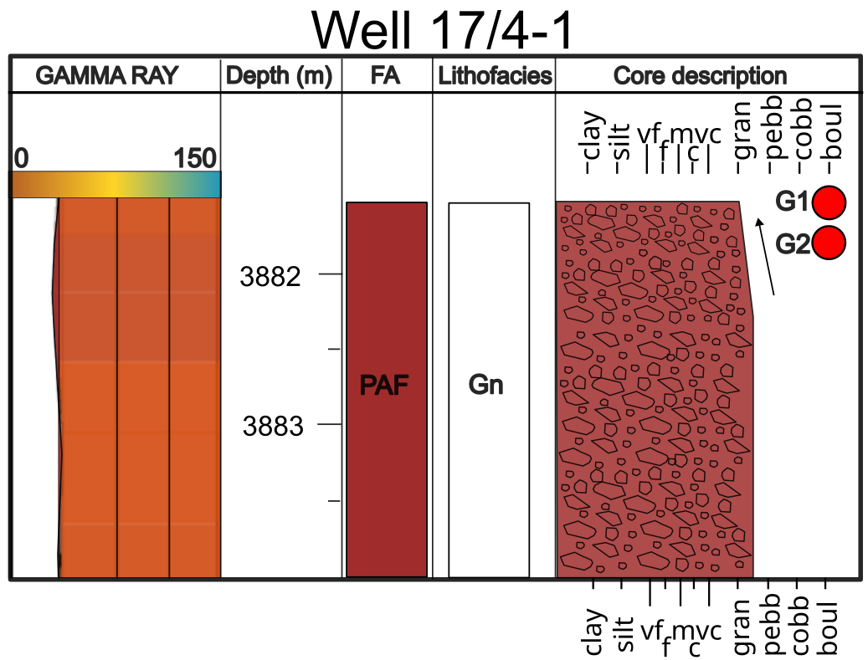
Fig. A13: Core description and provenance sample location of well 17/4-1. Interpreted lithofacies and facies associations (FA). Gamma ray is in API units.

