Electronic supplement document 1

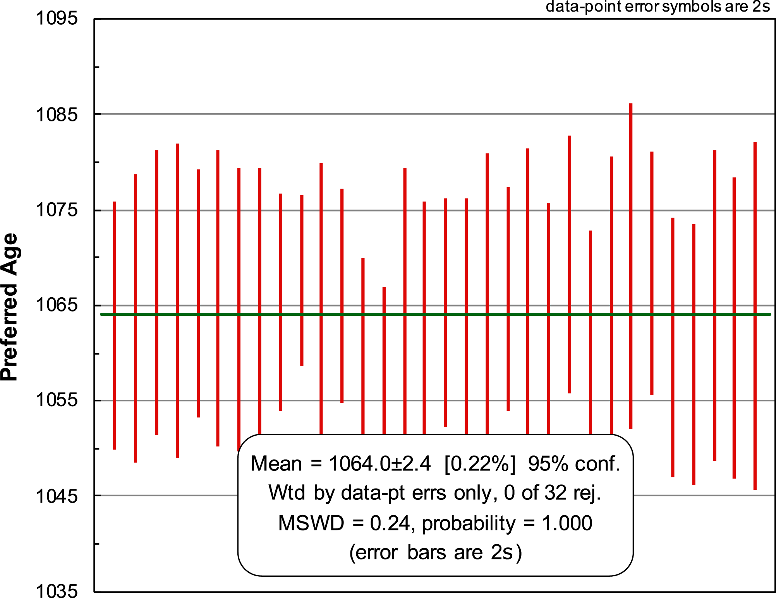

Electronic supplement figure esFig. 1: Weighted average age plot of repeat analyses of the 91500 standard (²⁰⁶Pb/²³⁸Pb age of 1065 Ma, Wiedenbeck et al., 1995) which yielded a weighted average ²⁰⁶Pb/²³⁸Pb age of 1064.0 ± 2.4 (n=32).

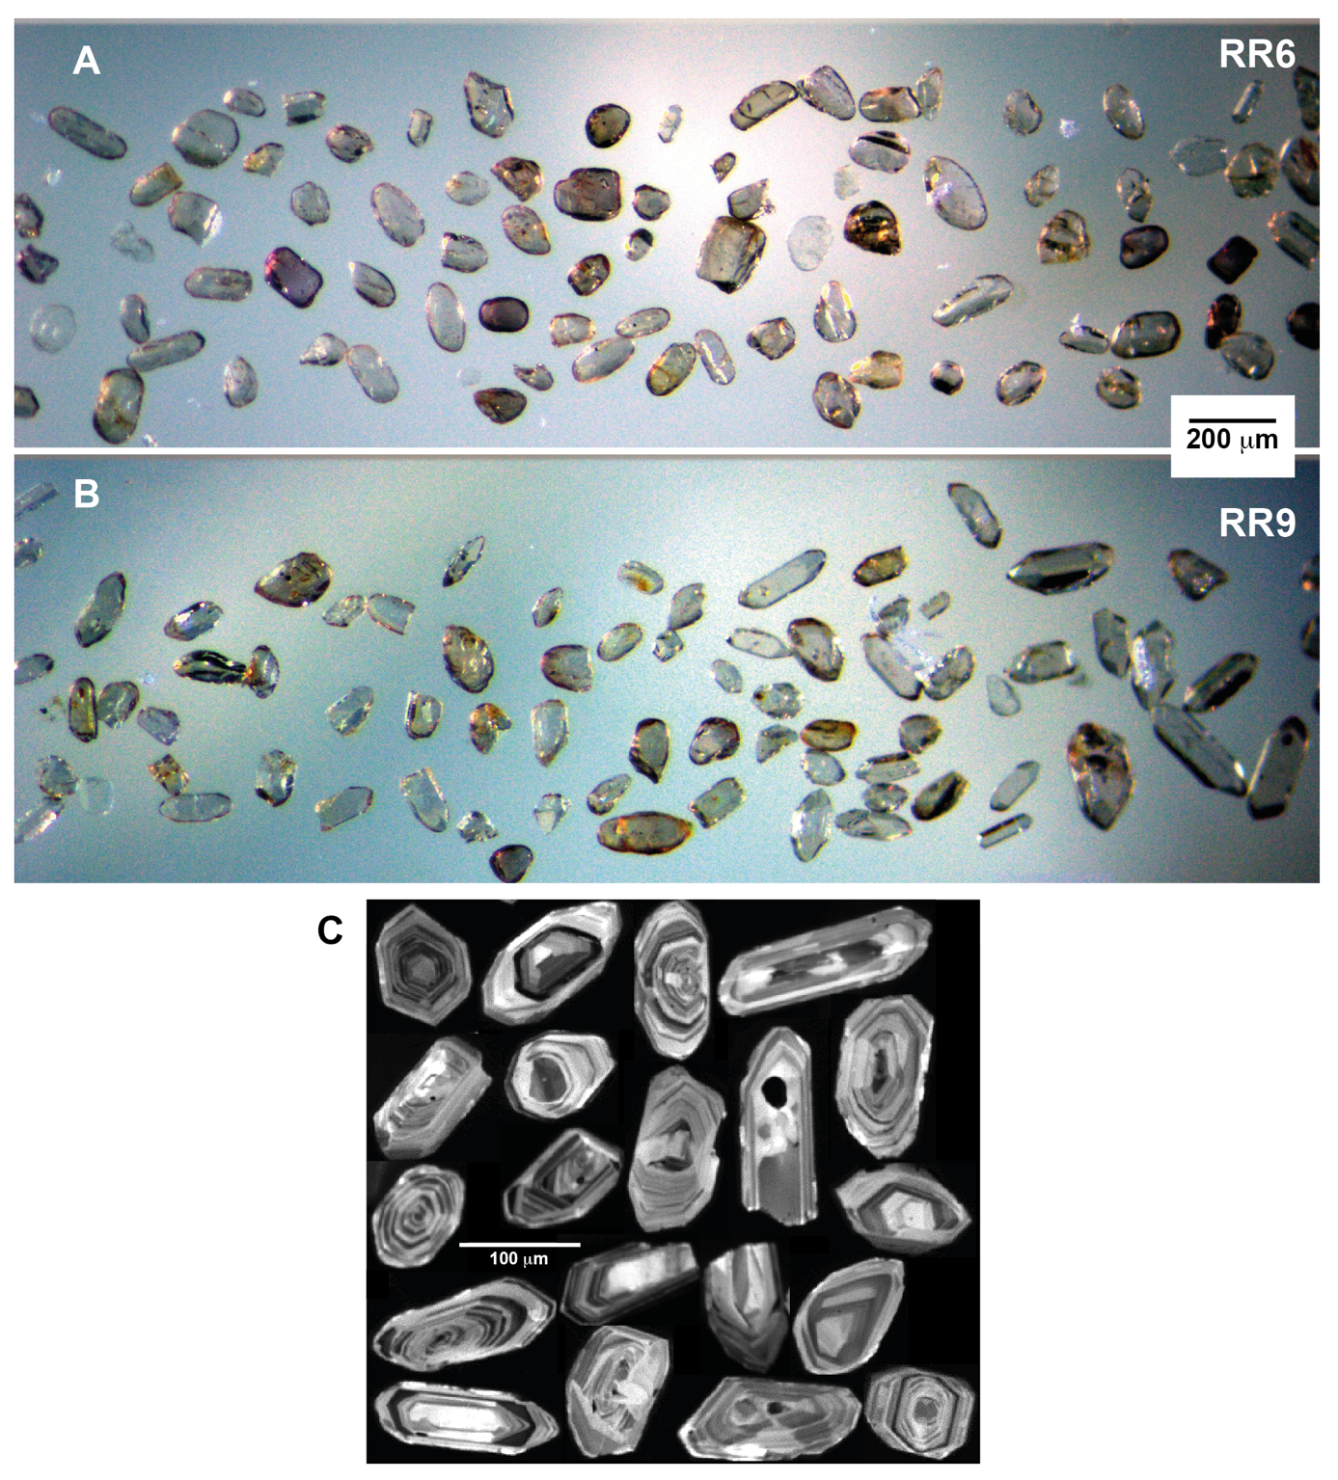Electronic supplement figure esFig. 2: A and B, representative transmitted light images of detrital zircons of medium-sand turbidite RR6 and fine-sand turbidite RR9. Zircon long axis diametres are mostly between 10 and 150 μm. RR9 also has some larger grains long prismatic idiomorphic grains with long axis diametres of >200 μm. C, representative cathodoluminescence (CL) images of zircons from the Puna Turbidite Complex showing oscillatory zoning characteristic of a magmatic origin.

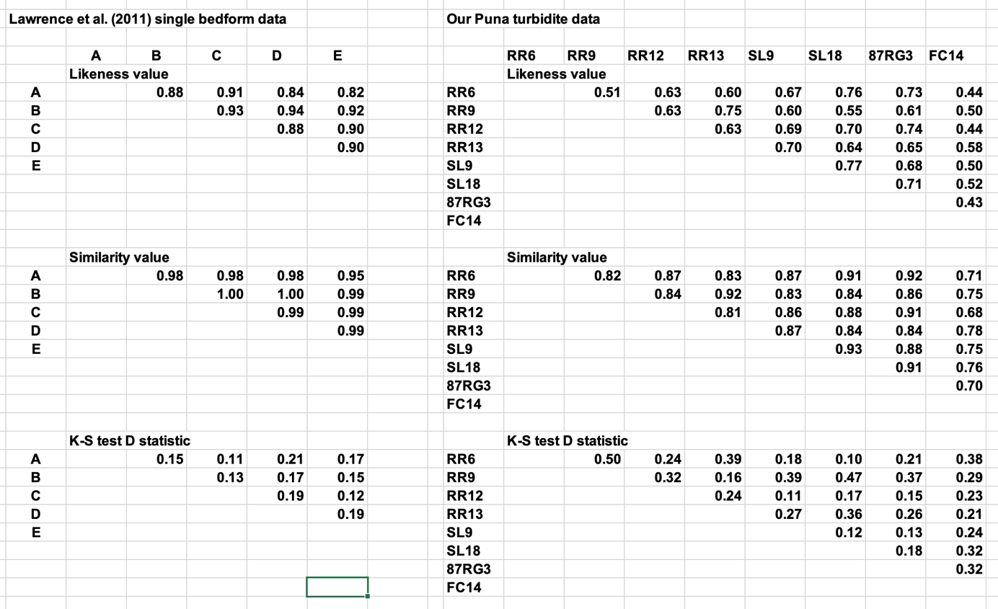
Electronic supplement table esTab. 2: Synopsis of dissimilarity matrices of Likeness (Satkosky et al., 2013), Similarity (Gehrels, 2000) and Kolmogorov-Smirnov D-values of Modern Amazon river bedform laminae (Lawrence et al., 2011) and the studied units. Values calculated with DZstats (Sundell and Saylor, 2017). Samples in a): RR, Río Rosario; SL, Sierra de Lina; RG, Río Grande; FC, Falda Ciénaga (Figs. 2, 7).

