Geological Magazine
Biostratigraphy, mineralogy, and paleoenvironmental analysis of the Miocene Gaj Formation from the Dwarka Basin, western India
Swagata Chaudhuri*^{1,2}, Kanishka Bose³, Koustav Chattopadhyay⁴, Shiladri S. Das², Ajoy K. Bhaumik⁴
¹Archaeology, Environmental changes, and Geo-chemistry (AMGC), Vrije Universiteit Brussel, Pleinlaan 2, Brussels B-1050, Belgium.
² Geological Studies Unit, Indian Statistical Institute, 203, B. T. Road, Kolkata 700108, India.
³Department of Earth Science, Indian Institute of Technology Bombay, Powai, Mumbai 400076, Maharashtra, India.
⁴Department of Applied Geology, Indian Institute of Technology (Indian School of Mines), Dhanbad, Jharkhand-826004, India.
* Corresponding author

Supplementary Material

Table 1: Stratigraphy of the Dwarka Basin (modified after Jain (2014))

Age | Formation | Member | Lithology | Index Fossil
Sub Recent to Recent | Mojap Coral Reef (5-6 m) |  | Soil, alluvium, shore sand, Rann clay and mud. Dead coral reef and consolidated sea shore material
Pleistocene | Miliolite Limestone Formation (2-8 m) |  | Oolitic, pelletoid and shelly Lst.  Pink, hard, compact fine pelletoid Lst.  Calcereous conglomerate, pebbly Lst.
late Miocene to Pliocene | Dwarka Formation | Bhadkeshwar (35 m) | Grey and greyish yellow Lst, generally current bedded | Pecten pascoei Acme zone
late Miocene | Dwarka Formation | Bet Sankhodhar (55 m) | Laminated clay and sand, sandstone and marl | Gryphaeostra brongniarti; Crassostrea gryphoides Acme Zone
middle Miocene | Dwarka Formation | Rangasar (20 m) | Yellow marly Lst, marl and variegated Lst at top | Scaphander javanus, Ostrea vestita, Conus (Leptoconus) protofurvus Zone
middle Miocene | Gaj Formation | Dabla Mandir (8 m) | Yellow red hard, compact fossiliferous limestone
middle Miocene | Gaj Formation | Lowrali (20 m) | Orange and yellow profusely fossiliferous silty marl | Lyria (Indolyria) jugosa Zone
middle Miocene | Gaj Formation | Charkala (8 m) | Hard, compact, massive sandy Lst | Lyria (Indolyria) jugosa Zone
early to middle Miocene | Gaj Formation | Ashapuramata (30 m) | Repetitive sequence of orange-red marly Lst, variegated clay, siltstone and marl. | Ostrea protoimbricata, Diplodonta incerta naricum, Aturia aturi Zone
early Miocene | Gaj Formation | Ranjitpur (15 m) | Mainly pale yellow profusely fossiliferous Lst. Highly fossiliferous yellow and orange Lst, marl and thin bands of clay.
early Miocene | Gaj Formation | Kuranga (15 m) | Orange fossiliferous marl, calcareous clay and ash grey clay
early Miocene | Gaj Formation | Nandana (10 m) | Hard, compact yellow, orange and grey Lst and Reddish Yellow Orange Foraminiferal Lst.
Cret. - Eocene | Laterite and Bauxite
Cretaceous | Deccan Trap

Table 2: Geographic information of different litho-section localities of Gaj Formation, Dwarka Basin.

Litho-section Localities | Latitude and Longitude | Geographic Location information
Locality 1 | 22°14’55.9”N, 69°14’59.1”E | Laterite Quarry 770 m NW of Pindara Village
Locality 2 | 22°11’21.3”N, 69°16’14.1”E | Near Mahadeviya Village
Locality 3 | 22°06’44.9”N, 69°14’29.2”E | 4.32 km NW of Bhatiya
Locality 4 | 22°06’13.0”N, 69°15’11.2”E | 2.4 km NW of Bhatiya Village
Locality 4 | 22°06’19.8”N, 69°15’00.2”E | 2.77 km NW of Bhatiya Village
Locality 5 | 22°04’01.0”N, 69°16’07.9”E | 2.7 km NNE of Gokalpar Village and 2.2 km S of Bhatiya Village
Locality 6 | 22°06’39.0”N, 69°17’42.4”E | 2 km SSE of Nandana Village
Locality 7 | 22°01’25.0”N, 69°18’05.6”E | Near Hadmatiya/Mehul? Village water tank
Locality 8 | 22°01’15.8”N, 69°17’37.0”E | 1.12 km WSW (252 ̊) of Hadmatiya Village
Locality 9 | 22°01’07.6”N, 69°17’15.7”E | 1.81 km WSW (250 ̊) of Hadmatiya Village
Locality 10 | 22°00’54.7”N, 69°16’57.1”E | 2.39 km WSW (247.18 ̊) of Hadmatiya Village
Locality 11 | 22°00’39.0”N, 69°16’57.2”E | 4.6 km ENE (61.56 ̊) of Bhogat Village
Locality 12 | 21°59’59.1”N, 69°15’43.4”E | 2.12 km NNE (64.19 ̊) of Bhogat Village
Locality 13 | 22°00’36.4”N, 69°15’04.9”E | River section 950 m N of Sonal Mandir, Bhogat
Locality 14 (Traverse AB) | A= 22°04’52.2”N, 69°07’25.8”E | 3.2 km SE of Okha Madhi
Locality 14 (Traverse AB) | B= 22°03’17.9”N, 69°09’08.4”E | 2.4 km E of Kuranga Lake
Locality 15 | 22°02’31.5”N, 69°11’58.1”E | 3 km SW of Bhatvadiya Village
Locality 16 | 22°03’18.4”N, 69°10’25.8”E | 700 m S of Kuranga Railway Station
Locality 17 | 22°03’32.24”N, 69°08’17.66”E | In the eastern bank of the Kuranga Lake
Locality 18 | 22°03’35.7”N, 69°11’17”E | 1.3 km E of Kuranga Railway Station
Locality 19 | 22°03’7.6”N, 69°11’30.8”E | 2.04 km SE of Kuranga Railway Station
Locality 20 | 22°10’48.7”N, 69°14’26.8”E | In a pond locality beside NH947 2.6 km E of Ranjitpur Village
Locality 21 | 22°07’21.5”N, 69°11’51.2”E | 2 km S of Gaga Village
Locality 22 | 22°04’41.2”N, 69°10’14.5”E | Beside GJSH29 1.82 km NNW of Kuranga Railway Station and 4 km SW of Bamanasa Village
Locality 23 | 22°06’49.4”N, 69°13’22.2”E | A river section 1 km SW of Battaria Village
Locality 24 | 22°10’43.9”N, 69°12’39.0”E | Near Ranjitpur Village
Locality 25 | 22°17’58.5”N, 69°09’28.0”E | Near Ashapuramata Mandir 2.6 km ENE of Khatumba Village
Locality 26 | 22°15’07.0”N, 69°08’59.0”E | 2.40 km NE of Tupani Village
Locality 27 | 22°20’11.4”N, 69°10’05.5”E | 6.60 km NNE of Khatumba Village
Locality 28 | 22°19’17.3”N, 69°09’19.0”E | 4.39 km NNE of Khatumba Village
Locality 29 | 22°20’20.6”N, 69°09’02.6”E | 6.67 km SSW of Positra Village
Locality 30 | 22°21’56.7”N, 69°07’35.8”E | Near Samlasar Village
Locality 31 | 22°13’56.4”N, 69°07’47.1”E | Near Charan Ganga Mandir 2.25 km ESE of Tupani Village
Locality 32 | 22°12’19.4”N, 69°07’06.3”E | A hillock N of Charakla Village
Locality 33 | 22°13’50.2”N, 69°06’41.1”E | 2.39 km WSW of Tupani Village
Locality 34 | 22°10’42.7”N, 69°05’44.9”E | 800 m E of Lowrali Village
Locality 35 | 22°10’40.4”N, 69°05’18.5”E | Near Gokeshvar Mahadev Temple near Lowrali Village
Locality 36 | 22°09’32.6”N, 69°05’41.6”E | 2.12 km SSE of Lowrali Village
Locality 37 | 22°09’28.2”N, 69°06’09.0”E | 2.63 km SE of Lowrali Village
Locality 38 | 22°07’29.6”N, 69°04’50.5”E | 500 m SW of Bhimpara Village
Locality 39 | 22°06’39.5”N, 69°05’12.8”E | A road section on NH51 near Okha Madhi Beach
Locality 40 | 22°07’29.6”N, 69°04’50.5”E | Around a lake 300 m S of Bhimapara Village

Figure S1.1. Schematic diagram illustrating the detailed lithology of the Gaj Formation, Dwarka Basin. Recovered and analyzed lithologies are displayed alongside isotopic data (δ¹⁸O from Miller et al. 2020; δ¹³C from (Westerhold et al. 2020) and a sea-level curve (Miller et al. 2020). SBZ biozones are differentiated using distinct colour codes. Units, epochs, and member names are assigned based on previous observations and the findings of this research. The MMCO event is further substantiated by microfossil as well as macrofossil data.

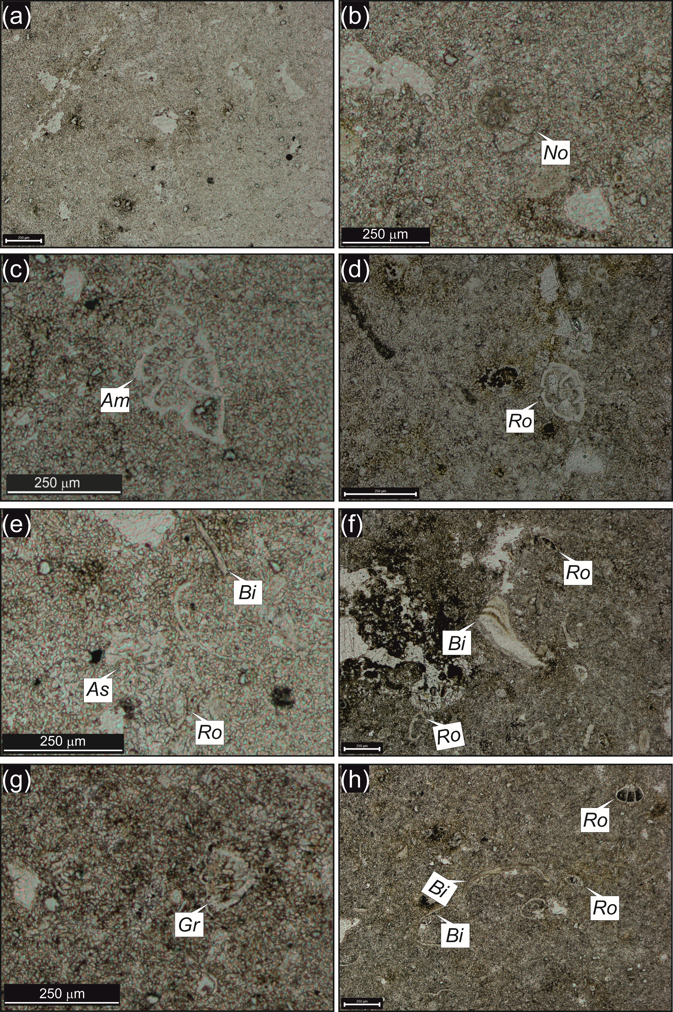

Figure S1.2. Thin-section photomicrographs of the identified fossils from the Nandana Member (Nma) of the Gaj Formation. (a-f) Thin section photomicrograph of biomicrite illustrating the presence of various fossils in it. Abbreviations: Ammonia sp. (Am), Amphistegina sp. (As), Bivalves (Bi), Globorotalia sp. (Gr), Nonion sp. (No), Rotaliida (Ro).
Figure S1.3. Thin-section photomicrographs of the identified Larger Benthic Foraminifera and associated fossils from the Nandana Member (Nmb) of the Gaj Formation. (a-i) Thin section photomicrograph of fossiliferous shale showing some of the fossils present in it. Abbreviations: Ammonia sp. (Am), Bolivina sp. (Bo), Conus sp. (Co), Halimeda sp. (Ha), Miliolida (Mi), Operculina sp. (Op), Quinqueloculina sp. (Qu), Rotaliida (Ro). (j-l) Thin section photomicrographs of a 20 cm thin unit of varying lithologies inside the Nmb Unit. Abbreviations: Ammonia sp. (Am), Barnacles (Bn), Organic matter (Om), Fig. S1.3.b has been taken under crossed nicols.

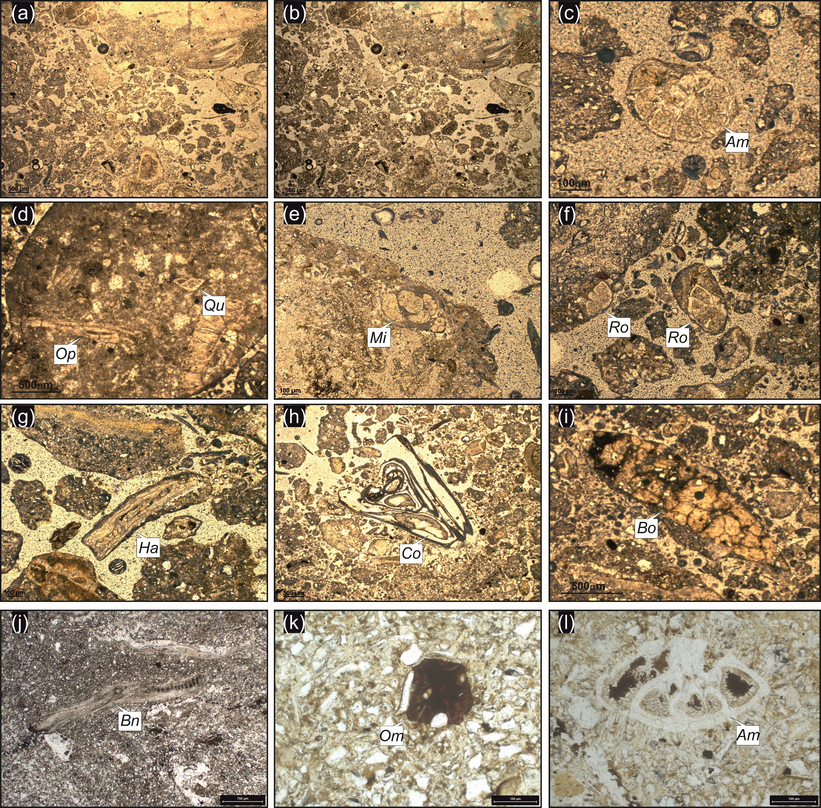
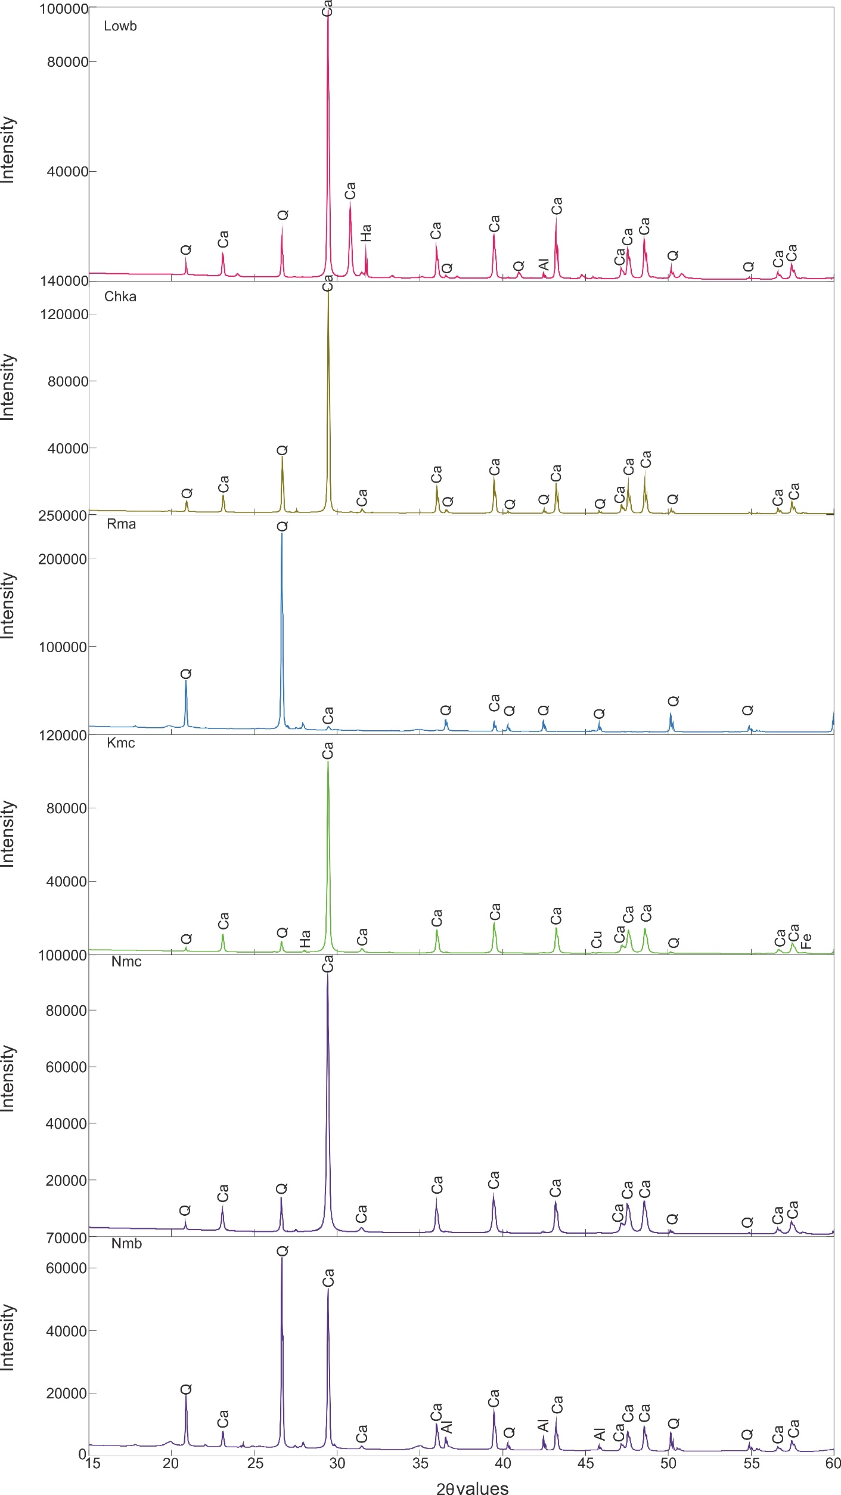

Figure S1.4. X-ray diffraction (XRD) patterns of lithologies from the different members of the Gaj Formation (marked by specific colour code). Nandana (Nmb and Nmc), Kuranga (Kmc) Ranjitpur (Rma), Charkala (Chka), Lowrali (Lowb) Member. Quartz (Q) and Calcite (Ca) are identified as the primary mineral constituents across all analysed members, whereas Halite (Ha), Aluminium oxide (Al), Iron oxide (Fe), and copper Iron sulphide (Cu) are the minor mineral constituents.

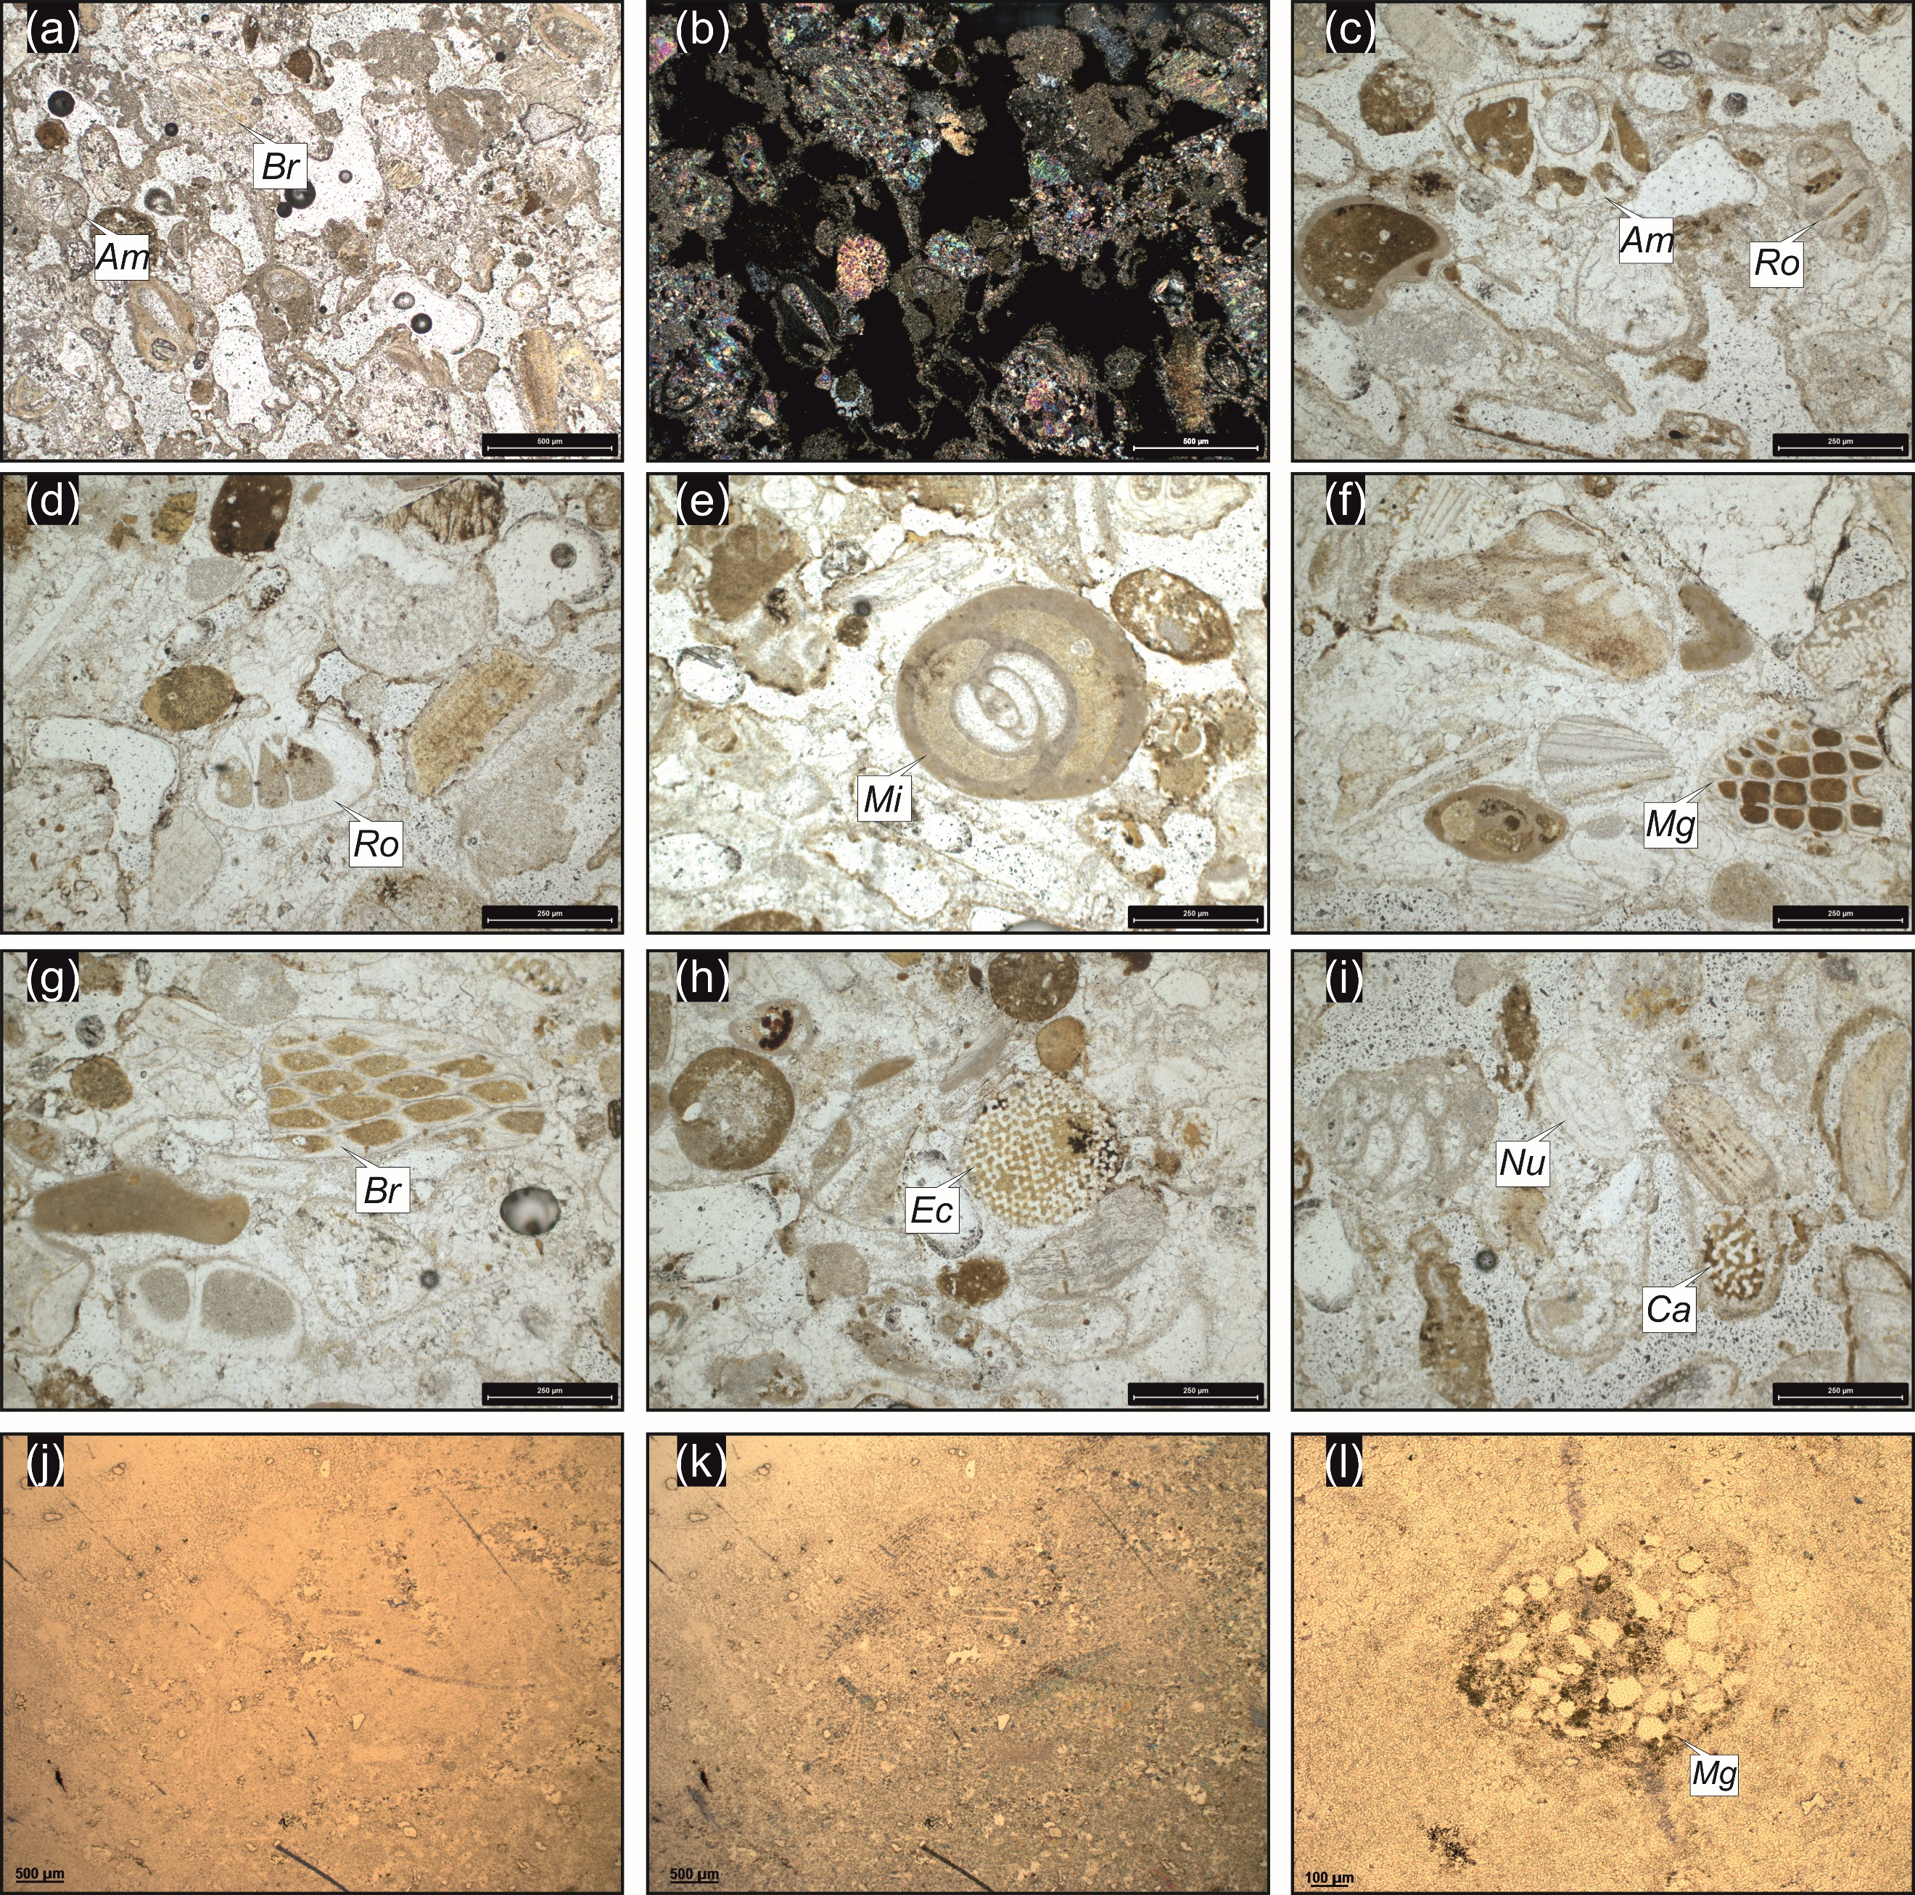
Figure S1.5. Thin-section photomicrographs of the identified Larger Benthic Foraminifera and associated fossils from the Nandana Member (Nmc and Nmd) of the Gaj Formation. (a-i) Thin-section photomicrographs of fine-grained sandstone revealing a diverse fossil assemblage within the Nmc Unit. (j-l) Thin-section photomicrographs of fossiliferous wackestone from the Nmd Unit. Abbreviations: Ammonia sp. (Am), Bivalves (Bi), Bryozoa (Br), Coralline algae (Ca), Echinoids (Ec), Rotaliida (Ro), Miliolida (Mi), Miogypsina sp. (Mg), Nummulites sp. (Nu). Fig. S1.5.b and k have been taken under crossed nicols.

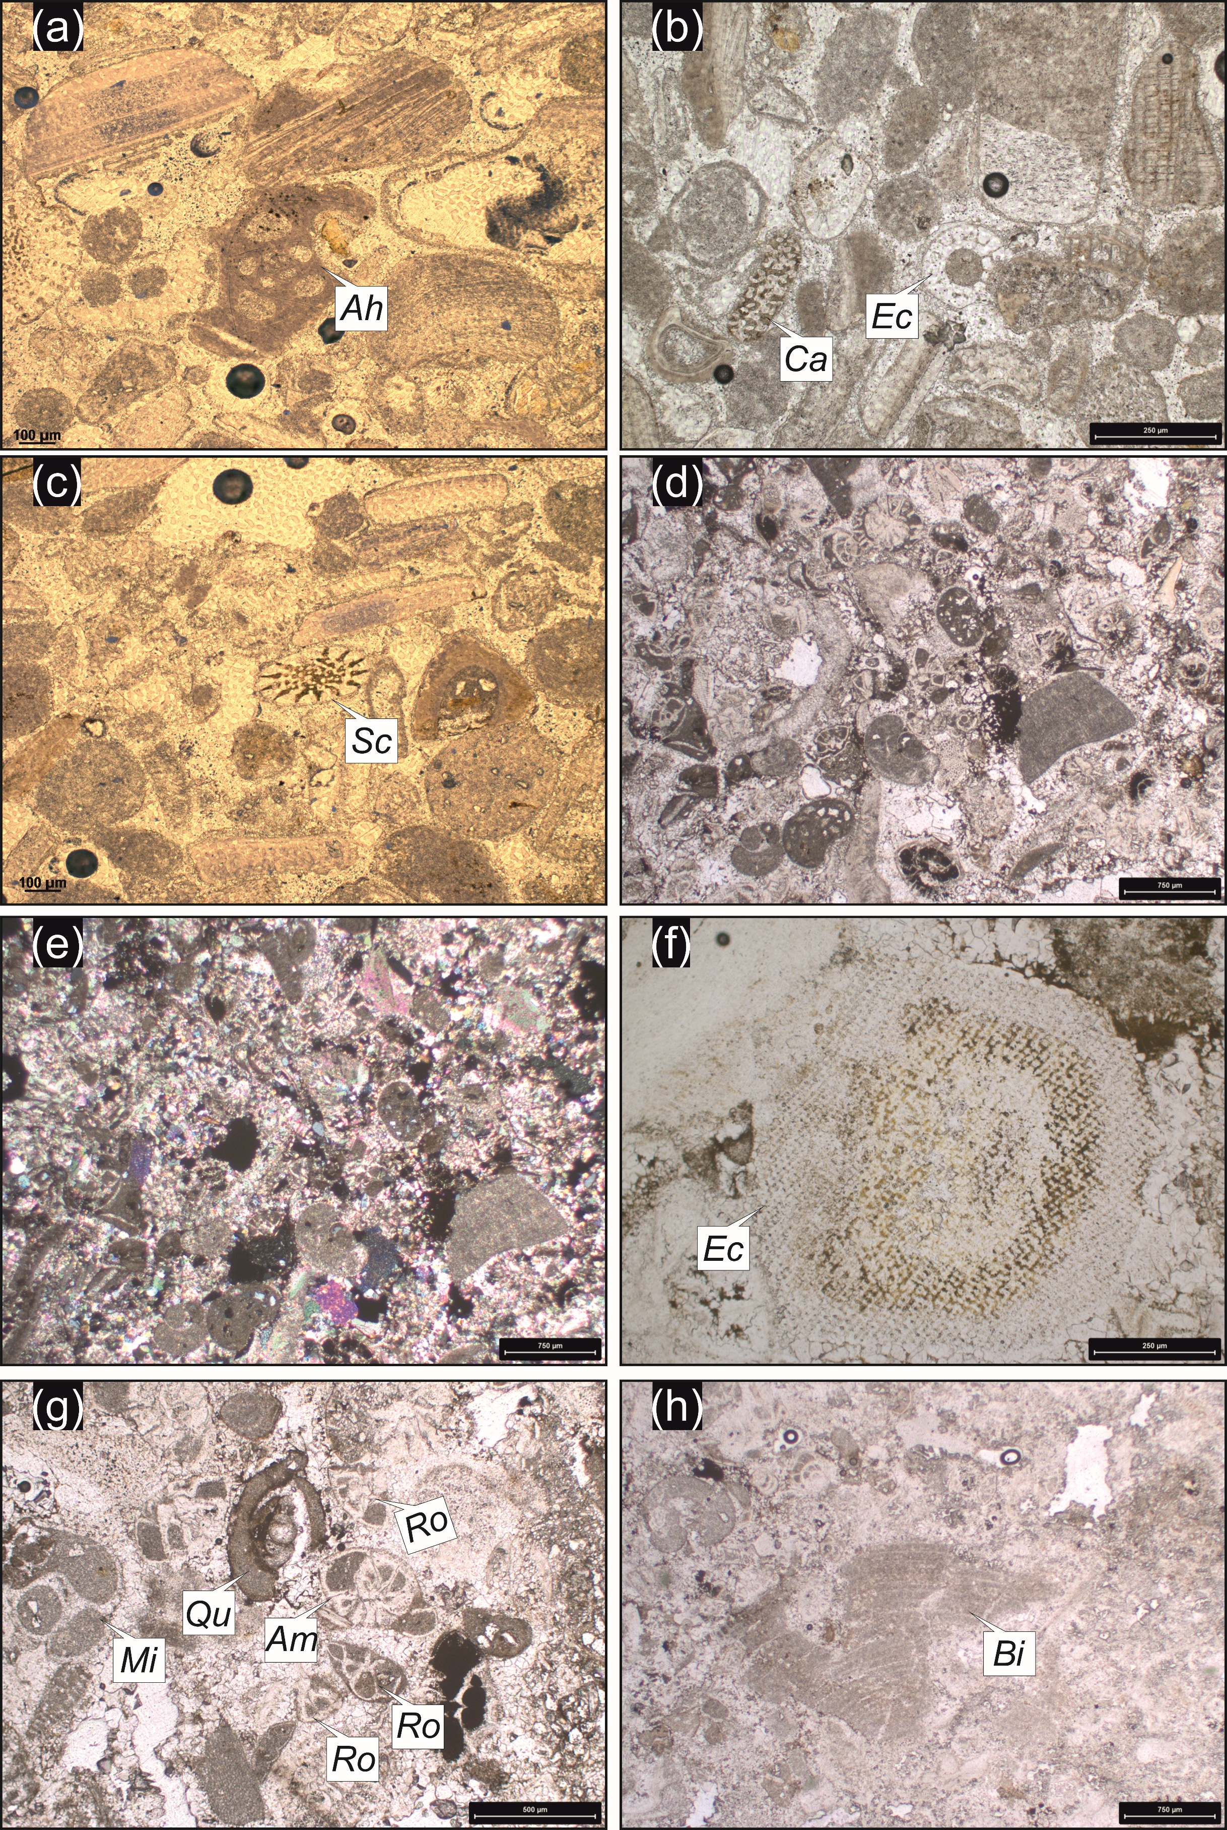
Figure S1.6. Thin-section photomicrographs of Larger Benthic Foraminifera and associated fossils from the Kuranga Member (Kma and Kmb) of the Gaj Formation. (a-c) Thin-section photomicrographs of bioclastic arenite reveal a diverse fossil assemblage within the Kma. (d-h) Thin-section photomicrographs of arenite along with microfossils and associated fossils within Kmb. Abbreviations: Ammonia sp. (Am), Austrotrillina howchini (Ah), Bivalves (Bi), Coralline algae (Ca), Echinoids (Ec), Miliolida (Mi), Nummulites sp. (Nu), Quinqueloculina sp. (Qu), Rotaliida (Ro), Scleractinian corals (Sc). Fig. S1.6.e has been taken under crossed nicols.

Figure S1.7. Thin-section photomicrographs of the identified Larger Benthic Foraminifera and associated fossils from the Kuranga Member (Kmc) of the Gaj Formation. (a-i) Photomicrographs of lithic arenite depicting a huge number of fossils associated with it. Abbreviations: Ammonia sp. (Am), Archaias sp. (Ar), Bryozoans (Br), Echinoids (Ec), Miogypsina sp. (Mg), Nummulites sp. (Nu), Quinqueloculina sp. (Qu), Rotaliida (Ro). Fig. S1.7.b has been taken under crossed nicols.

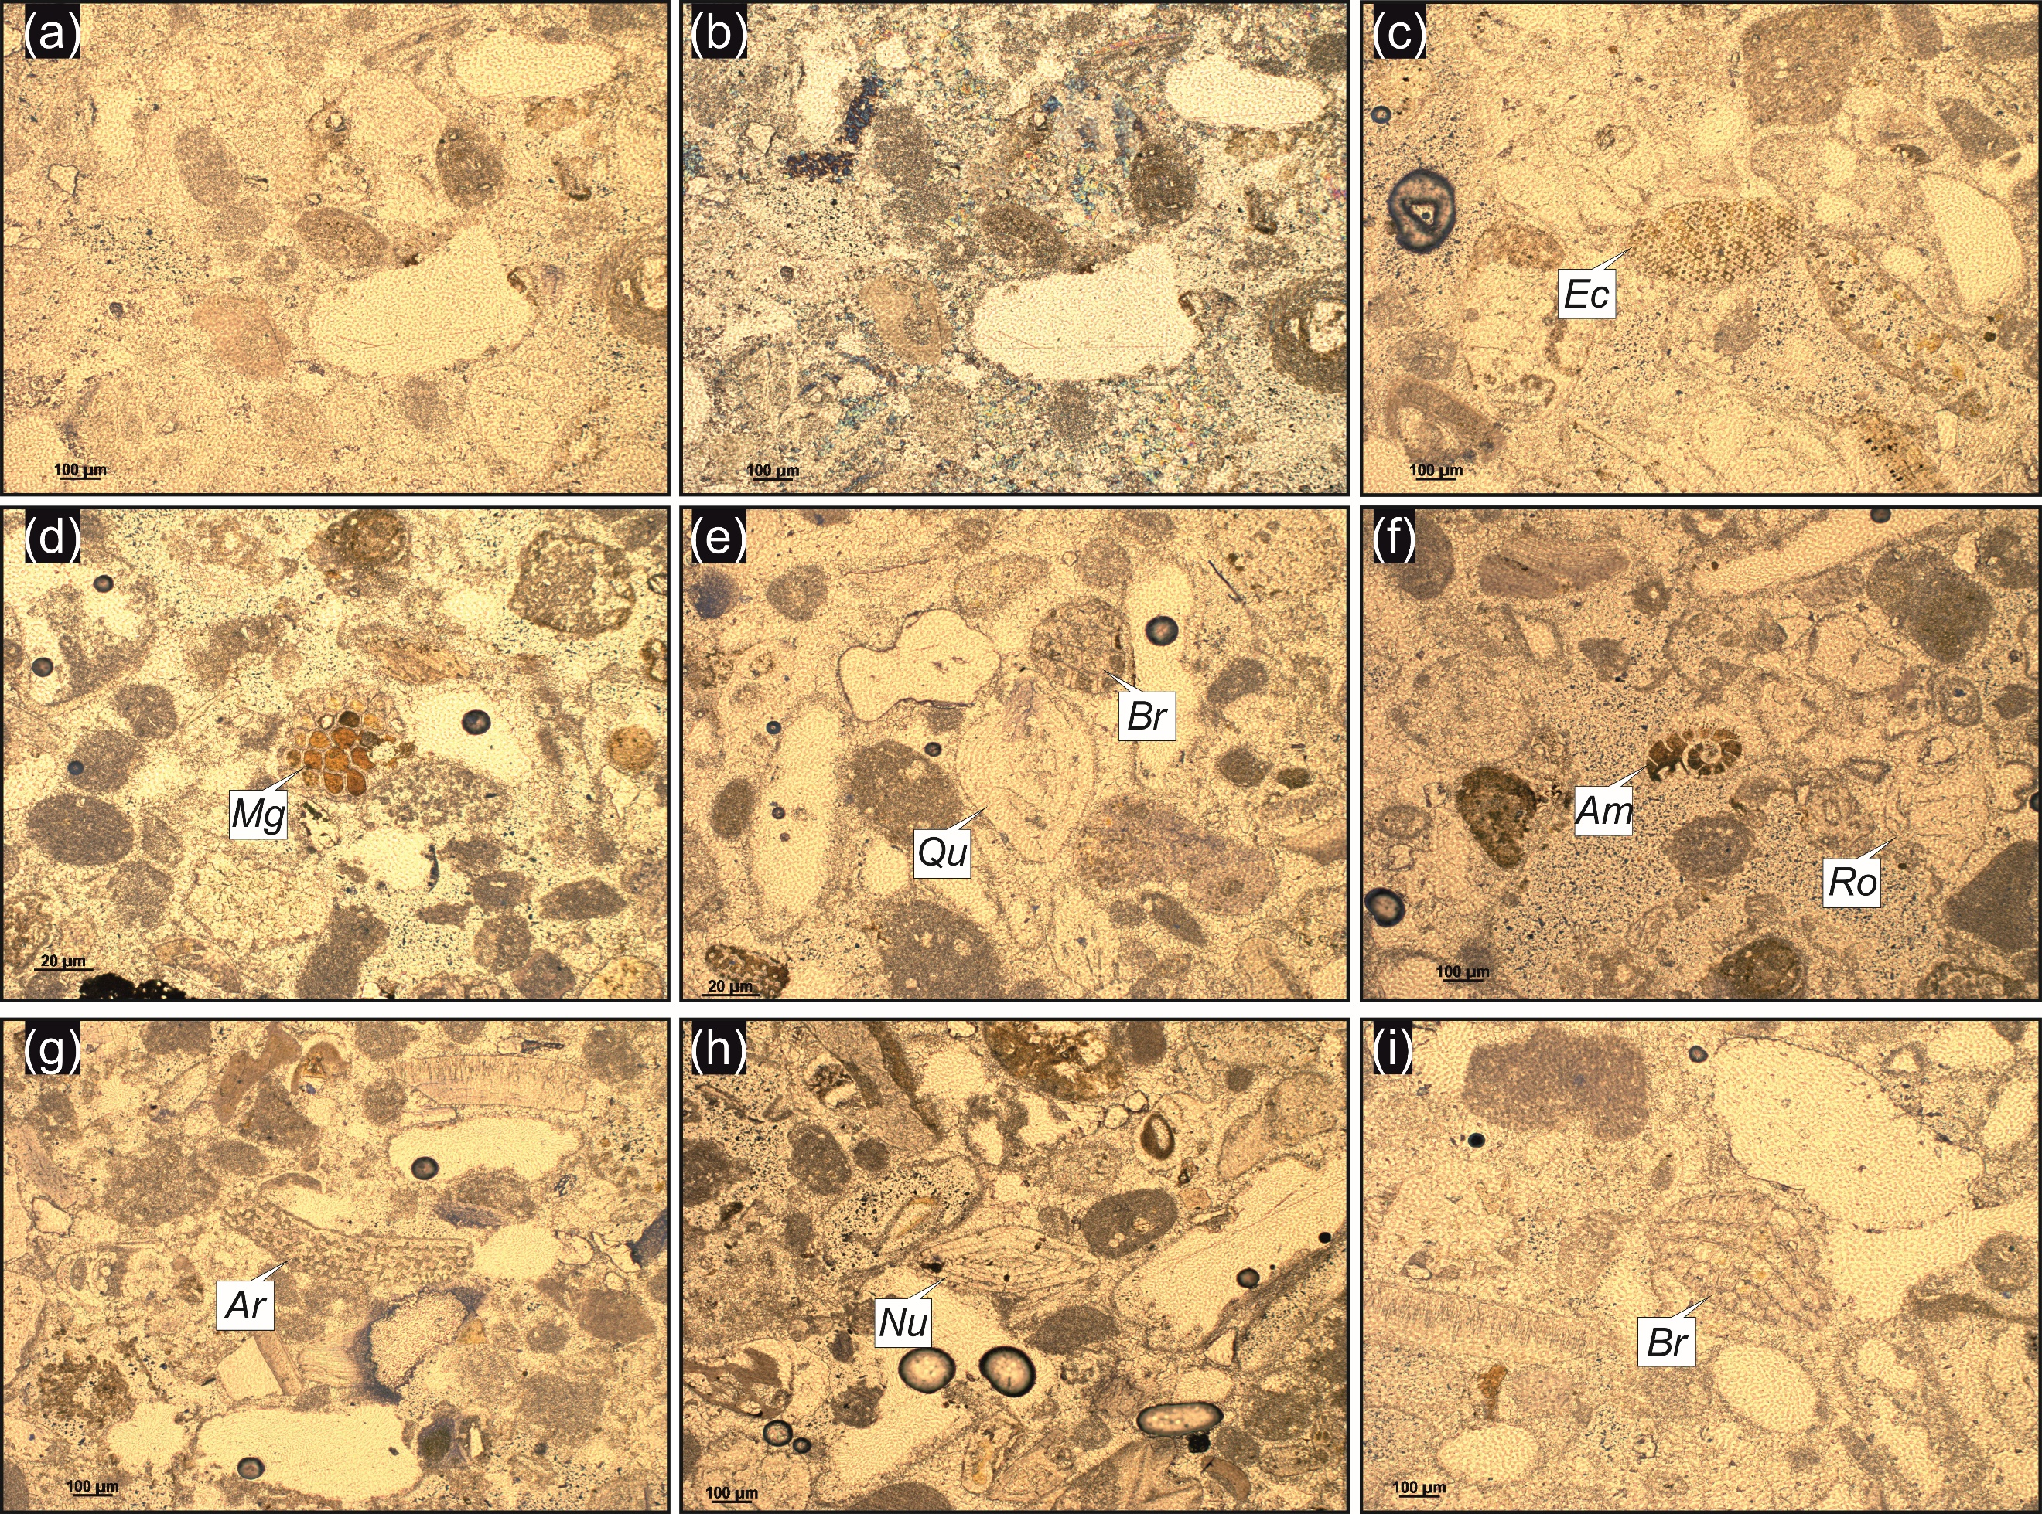
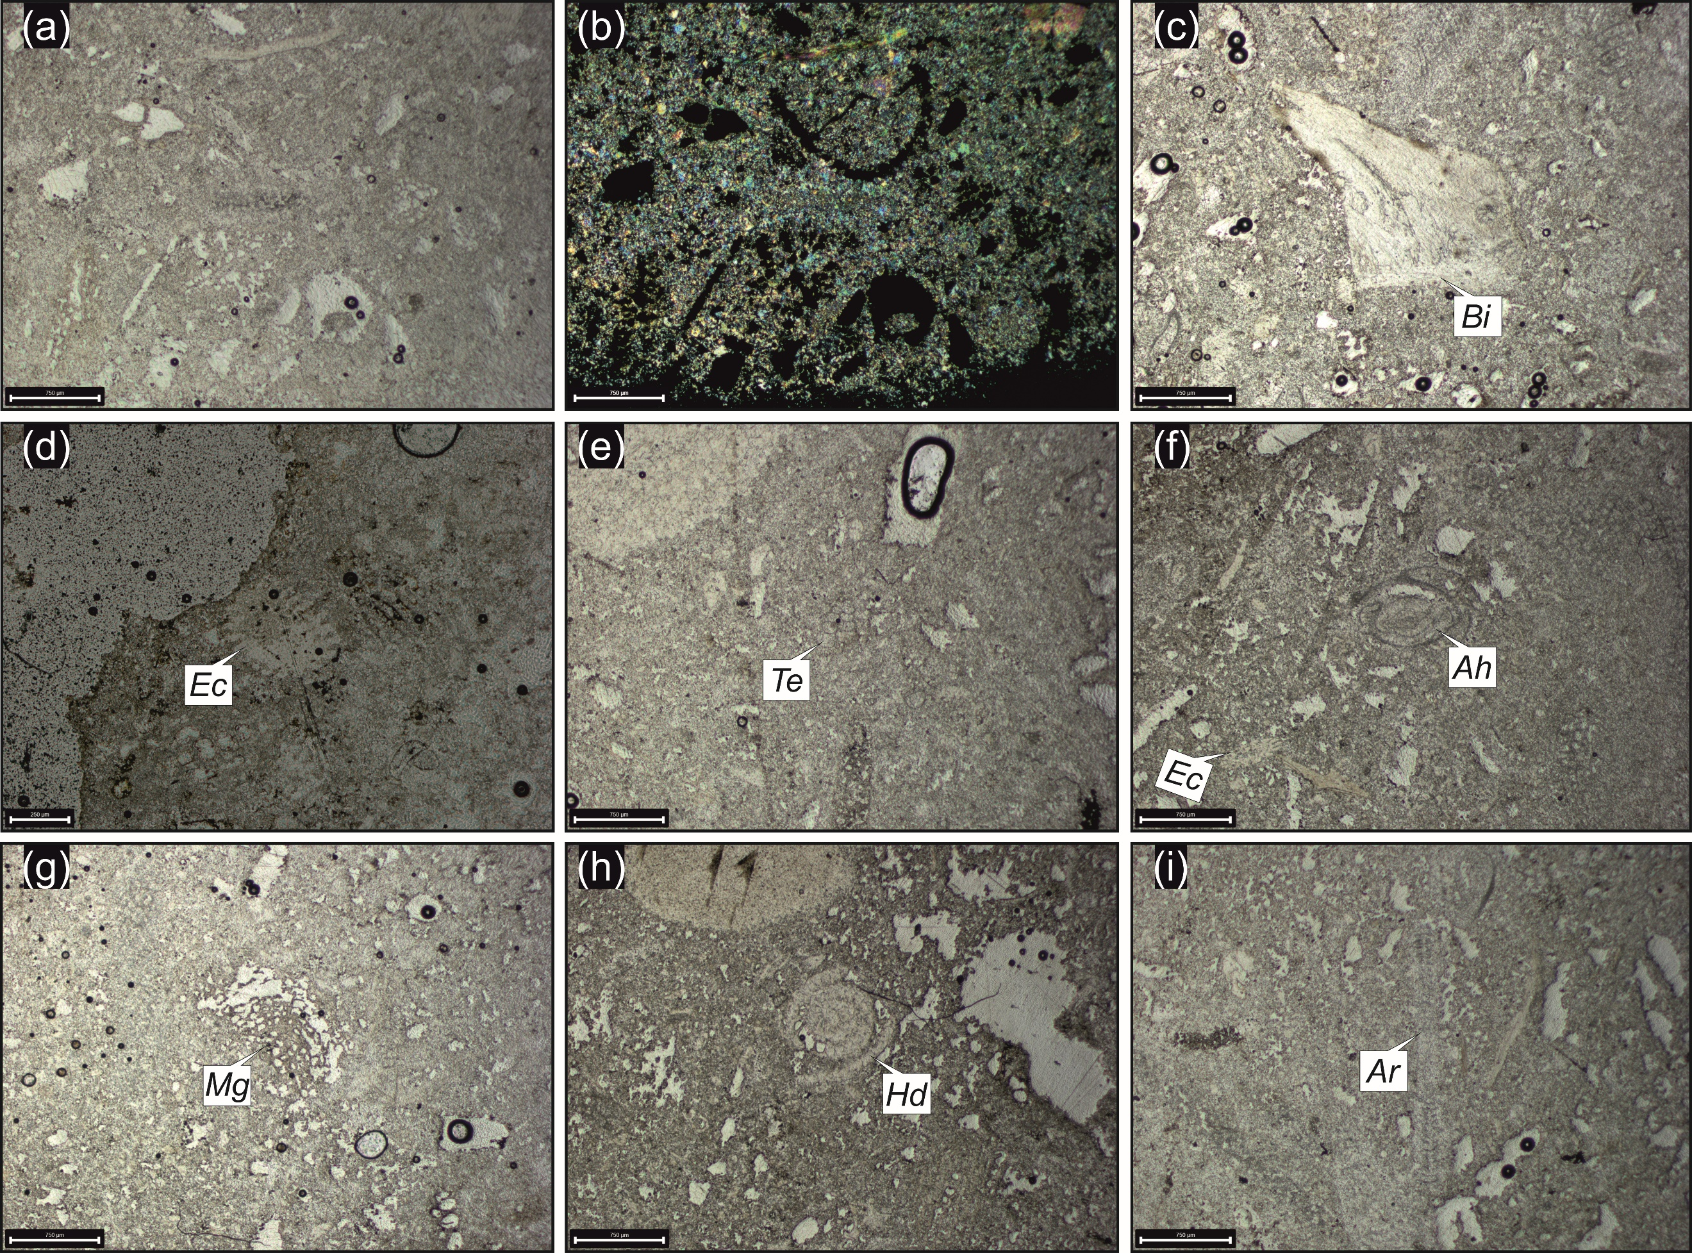
Figure S1.8. Thin-section photomicrographs of the identified Larger Benthic Foraminifera and associated fossils from the Kuranga Member (Kmd) of the Gaj Formation. (a-i) Photomicrographs of biomicrite. Abbreviations: Archaias sp. (Ar), Austrotrillina howchini (Ah), Bivalves (Bi), Echinoids (Ec), Heterolepa dutemplei (Hd), Miogypsina sp. (Mg), Textularia sp. (Te). Fig. S1.8.b has been taken under crossed nicols.

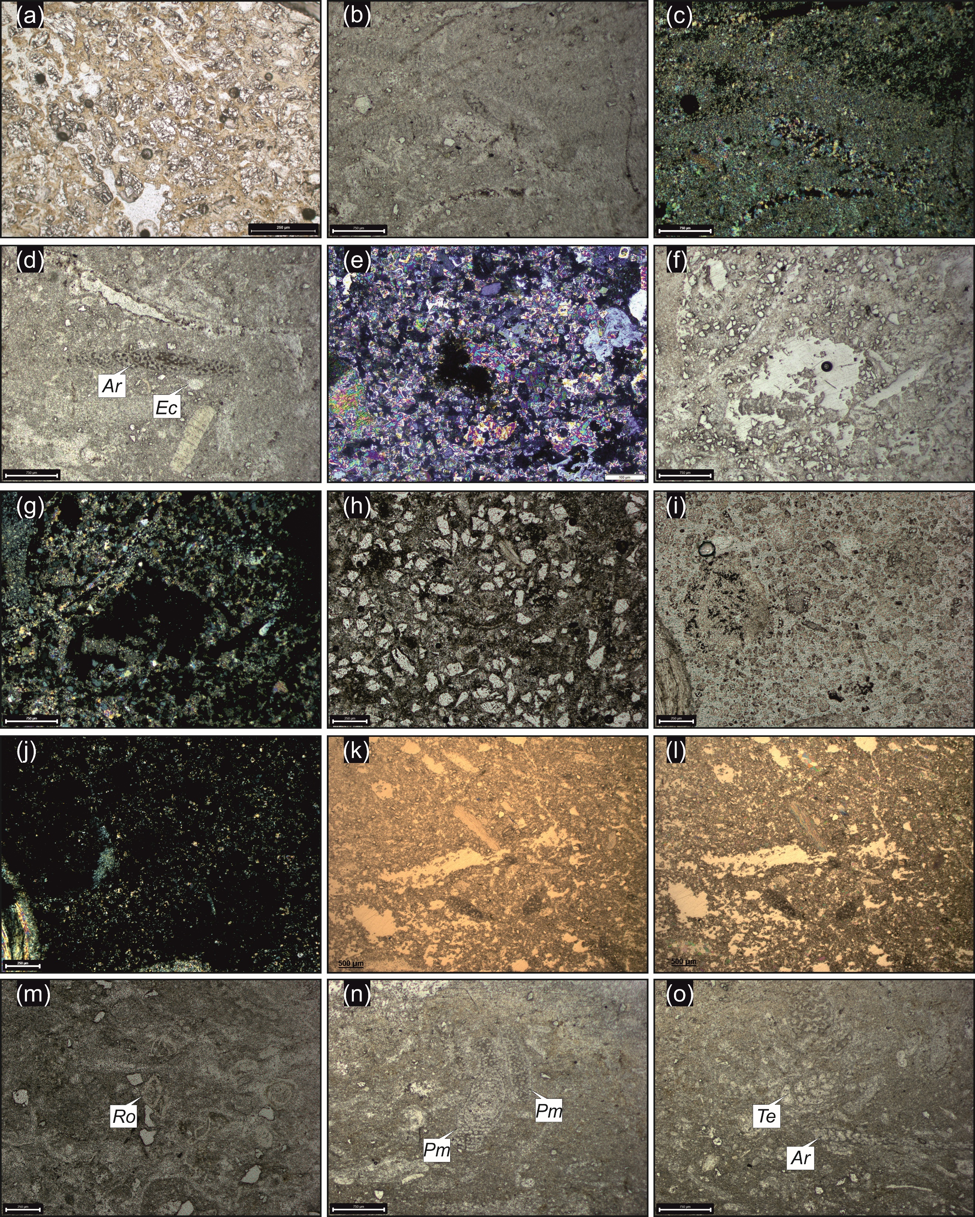
Figure S1.9. (a) Thin-section photomicrographs of siltsone from the Ranjitpur Member Rma Unit, (b-d) Thin-section photomicrographs of Rmb Unit and its associated fossils. (e) Photomicrograph of medium-grained sandstone from the Rmc Unit, (f, g) Thin-section photomicrograph of the calcareous shale from the Charkala Member (Chka), (h) Photomicrograph of coarse-grained sandstone from the Lowrali Member (Lowa), (i, j) Thin-section photomicrograph of fossiliferous calcareous siltstone from the Lowrali Member (Lowb), (k, l) Photomicrograph of biomicrite from Dabla Mandir Member (Dma), (m-o) Thin-section photomicrographs of the identified Larger Benthic Foraminifera and associated fossils from the Dabla Mandir Member (Dmb) of the Gaj Formation. Fig. S1.9.c, e, g, j has been taken under cross nicols. Abbreviations: Archaias sp. (Ar), Echinoids (Ec), Pseudotaberina malabarica (Pm), Rotaliida (Ro), Textularia sp. (Te).
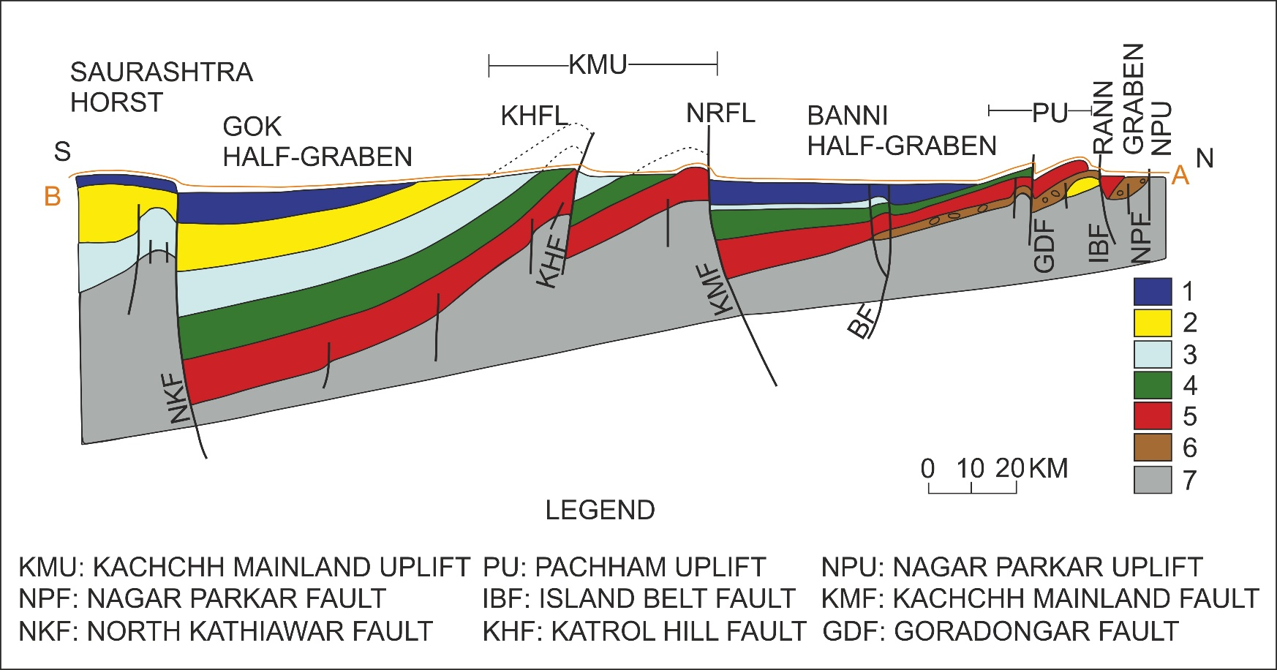

Figure S1.10. Geological cross-section along A-B in N-S direction across the Saurashtra and Kachchh Basin showing different faulting arrangements across the blocks (modified after Biswas (2005)). Box legend: 1. Cenozoic (incorporating Quaternary), 2. Deccan Trap and Intrusives, 3. Lower Cretaceous, 4. Upper Jurassic, 5. Middle Jurassic, 6. Lower Jurassic, 7. Precambrian (vertical scale exaggerated).

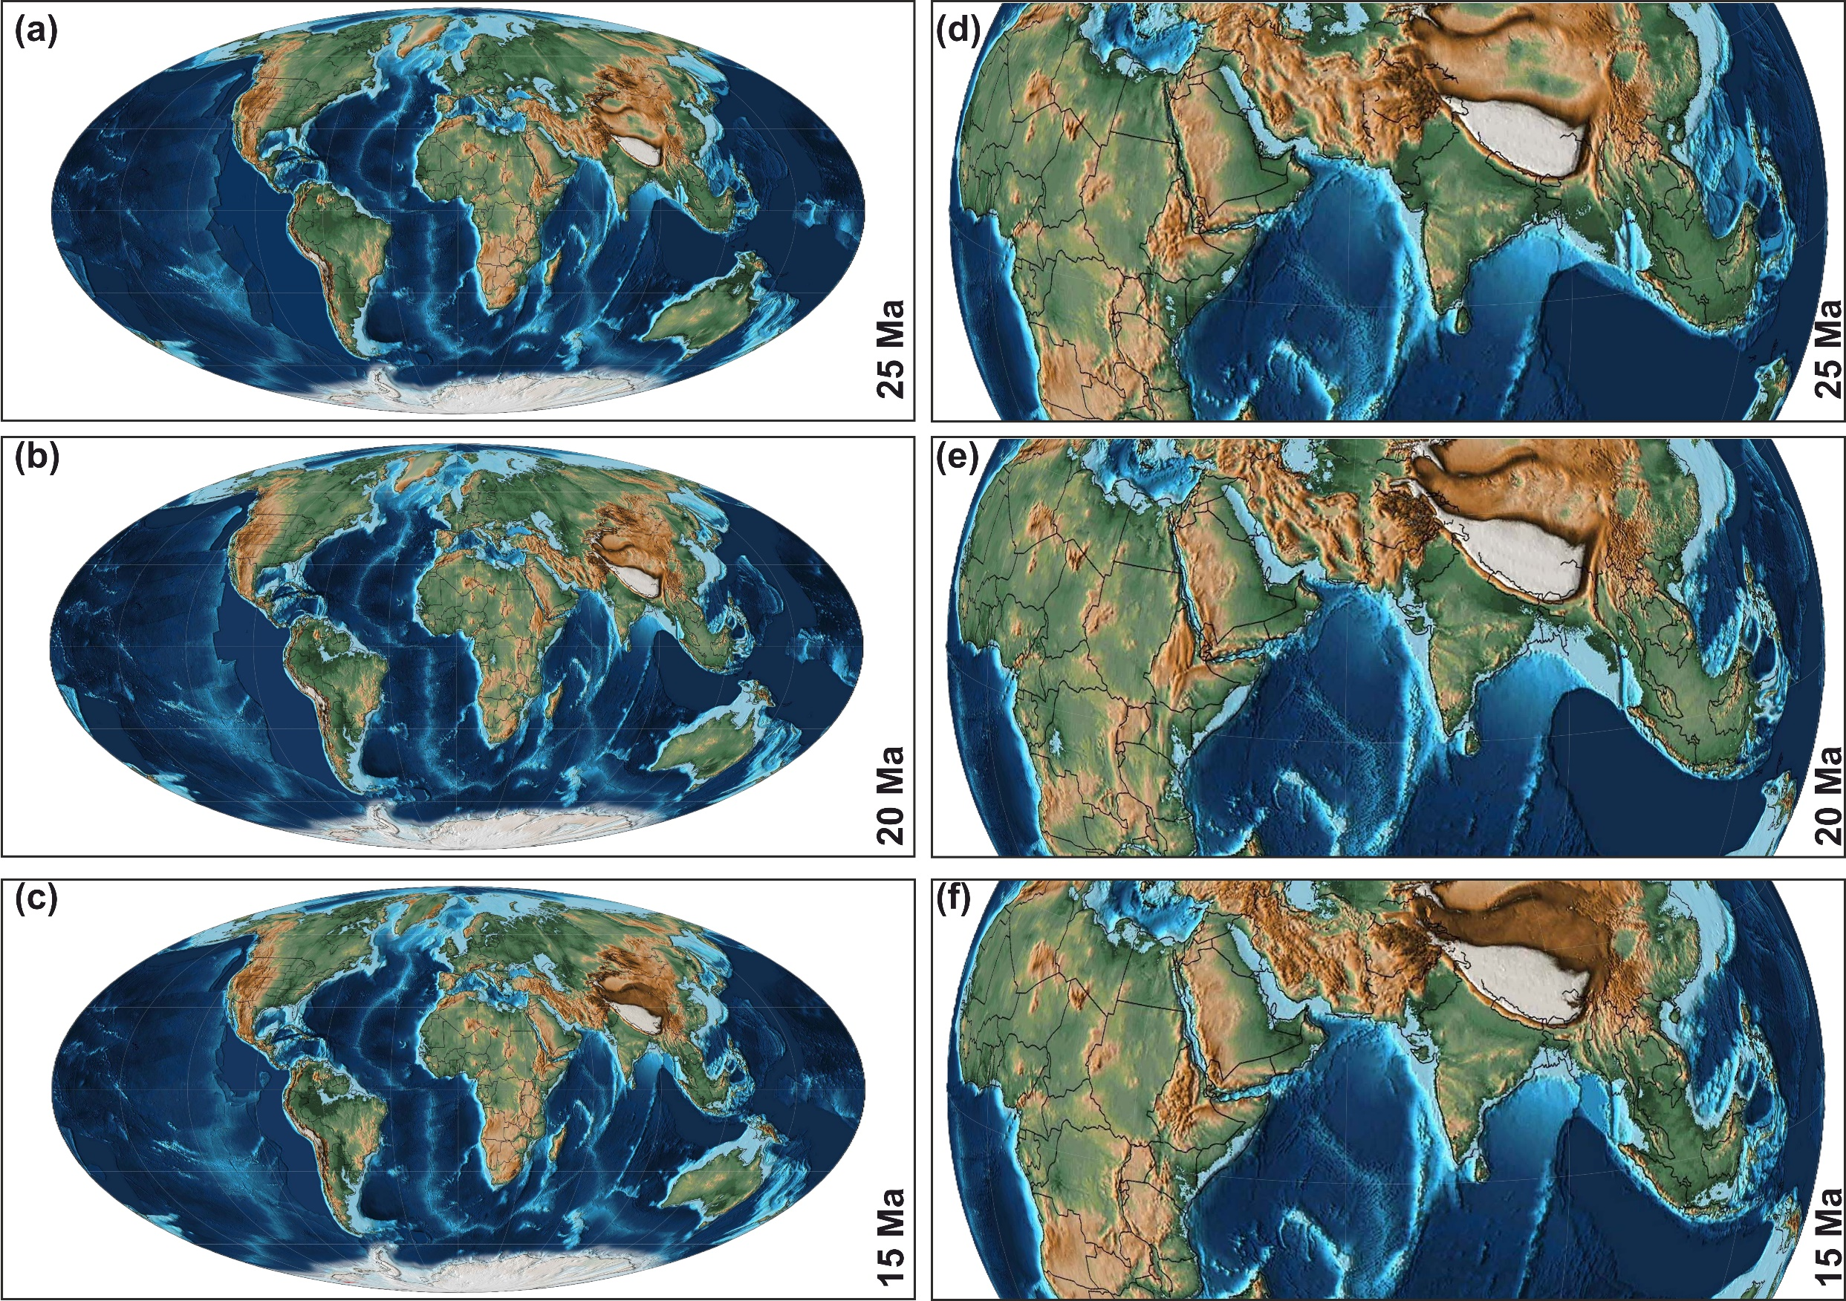

Figure S1.11. Paleogeographic map of Miocene emphasizing the Western margin of India and northward movement of the Indian plate and tectonic evolution of Saurashtra Basin (modified after Scotese (2016), PALEOMAP project).

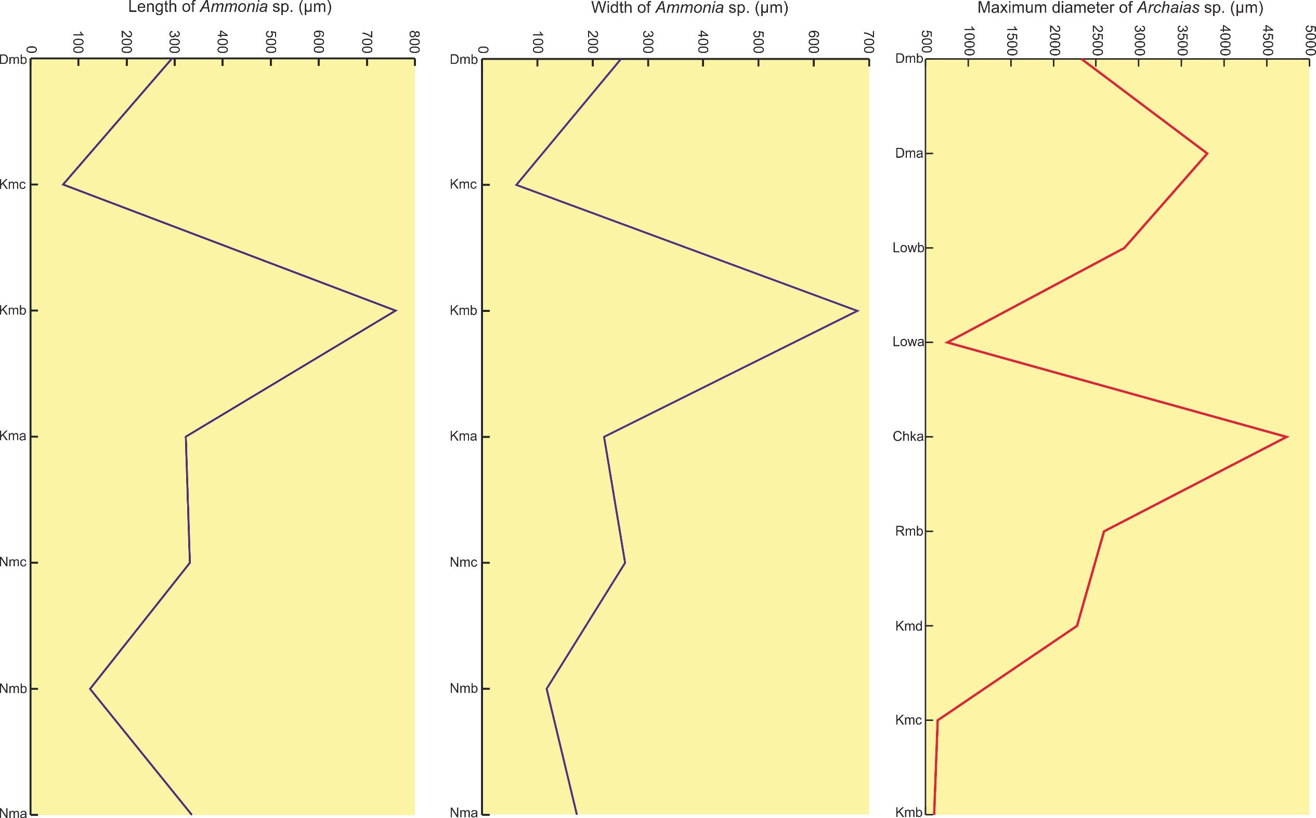

Figure S1.12. Distribution of Ammonia Shells and Archaias sp. in the Gaj Formation showing MMCO impact on foraminifera shells. The length and width of Ammonia shells vary across different members of the Gaj Formation, with lengths ranging from 68 µm to 760 µm and widths from 62 µm to 679 µm. The maximum diameter of Archaias sp. ranges from 604 µm to 4731 µm across different members of the Gaj Formation.

Table 3: List detailing the identified microfossils and macrofossils assemblages recovered from distinct members of the Gaj Formation. The Paleobiology Database (PBDB), and World Register of Marine Species Database (WoRMS) were used to identify some of the foraminiferal taxa.

Member | Sample No. | Fossils identified | Macrofossils
Dabla Mandir Member | Dmb (MD15) | Pseudotaberina malabarica (Eames 1971) | Gastropods: Perisististrombus cf. deperditus, Perisististrombus sp., Phos sp., Natica obscura, Lyncina cf. prunum
Dabla Mandir Member | Dmb (MD15) | Borelis melo (Fichtel & Moll, 1798)
Dabla Mandir Member | Dmb (MD15) | Archaias sp. (Montfort, 1808)
Dabla Mandir Member | Dmb (MD15) | Miliolida (Delage & Hérouard, 1896)
Dabla Mandir Member | Dmb (MD15) | Bivalve shell (Linnaeus, 1758)
Dabla Mandir Member | Dmb (MD15) | Ammonia sp. (Brünnich, 1771)
Dabla Mandir Member | Dmb (MD15) | Ostracod (Latreille, 1802)
Dabla Mandir Member | Dmb (MD15) | Rotaliida (Delage & Hérouard, 1896)
Dabla Mandir Member | Dmb (MD15) | Textularia sp. (Defrance, 1824)
Dabla Mandir Member | Dmb (MD15) | Miosorites sp.(Loeblich & Tappan, 1988)
Dabla Mandir Member | Dma (MD14) | Archaias sp. (Montfort, 1808) | Gastropods: Perisististrombus cf. deperditus, Perisististrombus sp., Phos sp., Natica obscura, Lyncina cf. prunum, Semicassis cf. vredenburgi, Globularia cf. carlei, Conus (Lithoconus) cf. literatus, Tibia cf. indica
Dabla Mandir Member | Dma (MD14) | Archaias angulatus (Fichtel & Moll, 1798)
Dabla Mandir Member | Dma (MD14) | Archaias kirkukensis (Henson, 1950)
Lowrali Member | Lowb (MD13) | Archaias sp. (Montfort, 1808) | Gastropods: Perisististrombus cf. deperditus, Perisististrombus sp., Natica obscura, Pachycrommium cf. harissi, Semicassis cf. vredenburgi, Globularia cf. carlei, Conus (Lithoconus) cf. literatus, Tibia cf. indica
Lowrali Member | Lowb (MD13) | Globigerina sp. (d'Orbigny, 1826)
Lowrali Member | Lowb (MD13) | Bivalve shell (Linnaeus, 1758)
Lowrali Member | Lowa (MD12) | Bivalve shell (Linnaeus, 1758) | Gastropods: Perisististrombus cf. deperditus, Perisististrombus sp., Natica obscura, Pachycrommium cf. harissi, Semicassis cf. vredenburgi, Globularia cf. carlei, Conus (Lithoconus) cf. literatus, Tibia cf. indica
Lowrali Member | Lowa (MD12) | Heterolepa dutemplei (d'Orbigny, 1846)
Lowrali Member | Lowa (MD12) | Echinoids (Leske, 1778)
Lowrali Member | Lowa (MD12) | Globigerinoides sp. (Cushman, 1927)
Lowrali Member | Lowa (MD12) | Archaias sp. (Montfort, 1808)
Charkala Member | Chkb (MD3) | Phylloid algae (Pray & Wray, 1963) | Gastropods: Globularia cf. carlei, Perisististrombus cf. deperditus, Perisististrombus sp., Natica obscura, Pachycrommium cf. harissi, Semicassis cf. vredenburgi
Charkala Member | Chkb (MD3) | Bivalve shell (Linnaeus, 1758)
Charkala Member | Chkb (MD3) | Ostracod shell (Latreille, 1802)
Charkala Member | Chka (MD11) | Pseudotaberina malabarica (Eames, 1971) | None
Charkala Member | Chka (MD11) | Bivalve shell (Linnaeus, 1758) | None
Charkala Member | Chka (MD11) | Bioclasts | None
Charkala Member | Chka (MD11) | Miliolida (Delage & Hérouard, 1896) | None
Charkala Member | Chka (MD11) | Archaias angulatus (Fichtel & Moll, 1798) | None
Charkala Member | Chka (MD11) | Quinqueloculina seminulum (Linnaeus, 1758) | None
Charkala Member | Chka (MD11) | Archaias sp. (Montfort, 1808) | None
Ashapuramata Member | Asm (MD10) | Echinoids (Leske, 1778) | Gastropods: Vicarya verneuili, Perisististrombus cf. deperditus, Perisististrombus sp., Conus (Leptoconus) cf. protofurvus, Conus (Lithoconus) cf. ineditus, Lyncina cf. prunum, Genota sp., Globularia cf. carlei, Natica obscura
Ashapuramata Member | Asm (MD10) | Scaphopod (Dentalium sexangulare) (Linnaeus, 1758)
Ranjitpur Member | Rmc (MD9) | Bryozoa (Ehrenberg (1831) | None
Ranjitpur Member | Rmc (MD9) | Echinoids (Leske, 1778) | None
Ranjitpur Member | Rmc (MD9) | Rotaliida (Delage & Hérouard, 1896) | None
Ranjitpur Member | Rmb (MD8) | Bivalve shell (Linnaeus, 1758) | Gastropods: Gibbula sp., Persististrombus cf. depertitus, Persististrombus sp., Lyncina cf. prunum, Phos sp., Xenophora cf. gajensis, Lyria (Harpeola) cf. jugosa, Natica obscura, Sinum sp., Cantharus erythrostomus
Ranjitpur Member | Rmb (MD8) | Archaias sp. (Montfort, 1808)
Ranjitpur Member | Rmb (MD8) | Elphidium sp. (Montfort, 1808)
Ranjitpur Member | Rmb (MD8) | Bolivina sp. (d'Orbigny, 1839)
Ranjitpur Member | Rmb (MD8) | Miliolida (Delage & Hérouard, 1896)
Ranjitpur Member | Rmb (MD8) | Coralline algae (Silva & Johansen, 1986)
Ranjitpur Member | Rmb (MD8) | Echinoids (Leske, 1778)
Ranjitpur Member | Rmb (MD8) | Rotaliida (Delage & Hérouard, 1896)
Ranjitpur Member | Rma (220201) | Organic matter | None
Kuranga Member | Kmd (MD7) | Heterolepa dutemplei (d'Orbigny, 1846) | Gastropods: Natica obscura, Cantharus erythrostomus, Conus (Lithoconus) cf. literatus, Persististrombus cf. depertitus, Lyncina cf. prunum, Xenophora cf. gajensis, Lyria cf. jugosa, Persististrombus sp., Zaria cf. angulata
Kuranga Member | Kmd (MD7) | Coralline algae (Silva & Johansen, 1986)
Kuranga Member | Kmd (MD7) | Miogypsina sp. (Sacco, 1893)
Kuranga Member | Kmd (MD7) | Ostracod shell (Latreille, 1802)
Kuranga Member | Kmd (MD7) | Bivalve shell (Linnaeus, 1758)
Kuranga Member | Kmd (MD7) | Textularia sp. (Defrance, 1824)
Kuranga Member | Kmd (MD7) | Bryozoa (Ehrenberg, 1831)
Kuranga Member | Kmd (MD7) | Archaias kirkukensis (Henson, 1950)
Kuranga Member | Kmd (MD7) | Archaias sp. (Montfort, 1808)
Kuranga Member | Kmd (MD7) | Rotaliida (Delage & Hérouard, 1896)
Kuranga Member | Kmd (MD7) | Austrotrillina howchini (Schlumberger, 1893)
Kuranga Member | Kmd (MD7) | Echinoids (Leske, 1778)
Kuranga Member | Kmc (MD6) (210101+210102) | Echinoids (Leske, 1778) | None
Kuranga Member | Kmc (MD6) (210101+210102) | Ammonia sp. (Brünnich, 1771) | None
Kuranga Member | Kmc (MD6) (210101+210102) | Miliolida (Delage & Hérouard, 1896) | None
Kuranga Member | Kmc (MD6) (210101+210102) | Miogypsina sp. (Sacco, 1893) | None
Kuranga Member | Kmc (MD6) (210101+210102) | Bryozoa (Ehrenberg, 1831) | None
Kuranga Member | Kmc (MD6) (210101+210102) | Globigerinid sp. (Carpenter et al. 1862) | None
Kuranga Member | Kmc (MD6) (210101+210102) | Nummulites sp. (Lamarck, 1801) | None
Kuranga Member | Kmc (MD6) (210101+210102) | Globigerinella sp. (Cushman, 1927) | None
Kuranga Member | Kmc (MD6) (210101+210102) | Quinqueloculina sp. (d'Orbigny, 1826) | None
Kuranga Member | Kmc (MD6) (210101+210102) | Archaias sp. (Montfort, 1808) | None
Kuranga Member | Kmc (MD6) (210101+210102) | Rotaliida (Delage & Hérouard, 1896) | None
Kuranga Member | Kmc (MD6) (210101+210102) | Scleractinian corals (Bourne, 1900) | None
Kuranga Member | Kmc (MD6) (210101+210102) | Radiolarians (210101) (Müller 1858) | None
Kuranga Member | Kmc (MD6) (210101+210102) | Organic matter (210102) | None
Kuranga Member | Kmb (210201) | Bivalve shell (Linnaeus, 1758) | None
Kuranga Member | Kmb (210201) | Rotaliida (Delage & Hérouard, 1896) | None
Kuranga Member | Kmb (210201) | Ammonia sp. (Brünnich, 1771) | None
Kuranga Member | Kmb (210201) | Miliolida (Delage & Hérouard, 1896) | None
Kuranga Member | Kmb (210201) | Quinqueloculina sp. (d'Orbigny, 1826) | None
Kuranga Member | Kmb (210201) | Archaias kirkukensis (Henson, 1950) | None
Kuranga Member | Kmb (210201) | Heterolepa dutemplei (d'Orbigny, 1846) | None
Kuranga Member | Kmb (210201) | Ammonia beccarii (Linnaeus, 1758) | None
Kuranga Member | Kmb (210201) | Archaias sp. (Montfort, 1808) | None
Kuranga Member | Kmb (210201) | Echinoids (Leske, 1778) | None
Kuranga Member | Kma (MD5) | Nummulites sp. (Lamarck, 1801) | None
Kuranga Member | Kma (MD5) | Ammonia sp. (Brünnich, 1771) | None
Kuranga Member | Kma (MD5) | Austrotrillina howchini (Schlumberger, 1893) | None
Kuranga Member | Kma (MD5) | Echinoids (Leske, 1778) | None
Kuranga Member | Kma (MD5) | Rotaliida (Delage & Hérouard, 1896) | None
Kuranga Member | Kma (MD5) | Gastropod (Cuvier, 1795) | None
Kuranga Member | Kma (MD5) | Coralline algae (Silva & Johansen, 1986) | None
Kuranga Member | Kma (MD5) | Scleractinian corals (Bourne, 1900) | None
Nandana Member | Nmd (MD4) | Lepidocyclina sp. (Gümbel, 1870) | Gastropods: Xenophora gajensis, Persististrombus deperditus, Tibia indica
Nandana Member | Nmd (MD4) | Discocyclina sp. (Gümbel, 1870)
Nandana Member | Nmd (MD4) | Bivalve shell (Linnaeus, 1758)
Nandana Member | Nmd (MD4) | Miogypsina sp. (Sacco, 1893)
Nandana Member | Nmd (MD4) | Bioclasts
Nandana Member | Nmd (MD4) | Rotaliida (Delage & Hérouard, 1896)
Nandana Member | Nmd (MD4) | Nummulites sp. (Lamarck, 1801)
Nandana Member | Nmc (210301) | Bryozoa (Ehrenberg (1831) | None
Nandana Member | Nmc (210301) | Ammonia sp. (Brünnich, 1771) | None
Nandana Member | Nmc (210301) | Cycloclypeus carpenteri (Brady, 1881) | None
Nandana Member | Nmc (210301) | Bivalve shell (Linnaeus, 1758) | None
Nandana Member | Nmc (210301) | Rotaliida (Delage & Hérouard, 1896) | None
Nandana Member | Nmc (210301) | Nummulites sp. (Lamarck, 1801) | None
Nandana Member | Nmc (210301) | Echinoids (Leske, 1778) | None
Nandana Member | Nmc (210301) | Coralline algae (Silva & Johansen, 1986) | None
Nandana Member | Nmc (210301) | Miliolida (Delage & Hérouard, 1896) | None
Nandana Member | Nmc (210301) | Scleractinian corals (Bourne, 1900) | None
Nandana Member | Nmc (210301) | Miogypsina sp. (Sacco, 1893) | None
Nandana Member | Nmc (210301) | Gastropod (Cuvier, 1795) | None
Nandana Member | Nmc (210301) | Bioclasts | None
Nandana Member | Nmc (210301) | Bolivina sp. (d'Orbigny, 1839) | None
Nandana Member | Nmb (MD2) | Halimeda sp. (Lamouroux 1812) | Gastropods: Turritelline gastropods (Zaria angulata, Turritella assimilis, Turritella narica, Haustator tauroperturritus, Turritella pseudotethys, Turritella kacchensis, Turritella bhagotorensis, Protoma deshayesi), Nassarius cf. beui, Rissoina (Rissolina) cf. costulata, Vicarya vernueuili; Bivalves: Corbula trigonalis, Paphia elongata, Corbula cf. acuticosta, Corbula inflata, Saccella virgo, Ostrea kharakheterensis
Nandana Member | Nmb (MD2) | Operculina sp. (d'Orbigny, 1826)
Nandana Member | Nmb (MD2) | Rotaliida (Delage & Hérouard, 1896)
Nandana Member | Nmb (MD2) | Miogypsina sp. (Sacco, 1893)
Nandana Member | Nmb (MD2) | Quinqueloculina sp. (d'Orbigny, 1826)
Nandana Member | Nmb (MD2) | Discocyclina sp. (Gümbel, 1870)
Nandana Member | Nmb (MD2) | Bolivina sp. (d'Orbigny, 1839)
Nandana Member | Nmb (MD2) | Gastropod (Conus sp.) (Linnaeus, 1758)
Nandana Member | Nmb (MD2) | Miliolida (Delage & Hérouard, 1896)
Nandana Member | Nmb (MD2) | Ammonia sp. (Brünnich, 1771)
Nandana Member | Nmb (MD2) | Nodosariid (Calkins, 1933)
Nandana Member | 210303( 20 cm inside Nmb) | Ostracod (Latreille, 1802) | None
Nandana Member | 210303( 20 cm inside Nmb) | Rotaliida (Delage & Hérouard, 1896) | None
Nandana Member | 210303( 20 cm inside Nmb) | Ammonia sp. (Brünnich, 1771) | None
Nandana Member | 210303( 20 cm inside Nmb) | Phylloid algae (Pray & Wray, 1963) | None
Nandana Member | 210303( 20 cm inside Nmb) | Bioclasts | None
Nandana Member | 210303( 20 cm inside Nmb) | Barnacle | None
Nandana Member | 210303( 20 cm inside Nmb) | Organic matter | None
Nandana Member | Nma (MD1) | Rotaliida (Delage & Hérouard, 1896) | Gastropods: Persististrombus cf. depertitus, Persististrombus sp., Tibia cf. indica, Lyncina cf. prunum, Conus (Lithoconus) cf. literatus and Conus (Lithoconus) cf. ineditus; Bivalves: Tellina cf. inflexuosa, Tellina cf. protocandida, Periglypta cf. mekranika, Clementia sp.
Nandana Member | Nma (MD1) | Amphistegina sp. (d'Orbigny, 1826)
Nandana Member | Nma (MD1) | Globorotalia sp. (Cushman, 1927)
Nandana Member | Nma (MD1) | Elphidium sp. (Montfort, 1808)
Nandana Member | Nma (MD1) | Neorotalia viennoti (Greig, 1935)
Nandana Member | Nma (MD1) | Broken shell of Bivalves (Linnaeus, 1758)
Nandana Member | Nma (MD1) | Ammonia sp. (Brünnich, 1771)
Nandana Member | Nma (MD1) | Textularia sp. (Defrance, 1824)
Nandana Member | Nma (MD1) | Bioclasts
Nandana Member | Nma (MD1) | Nonion sp. (Montfort, 1808)
Nandana Member | Nma (MD1) | Ostracod (Latreille, 1802)
Nandana Member | Nma (MD1) | Globigerinid sp. (Carpenter et al. 1862)

