Supplementary Figure

Decoupling between Nd-Hf isotopic evolution of Permian to Triassic granitoids and crustal thickness variation in the westernmost Mongol-Okhotsk Orogen

Jiaqi Ling a, b, Pengfei Li a, b*, Chao Yuan a, b, Tserendash Narantsetseg c

a State Key Laboratory of Deep Earth Processes and Resources, Guangzhou Institute of Geochemistry, Chinese Academy of Sciences, Guangzhou, 510640, China

b University of Chinese Academy of Sciences, Beijing 10049, China

c Institute of Geology, Mongolian Academy of Sciences, Ulaanbaatar 15160, Mongolia

* Corresponding author: Pengfei Li

(E-mail: [pengfeili@gig.ac.cn](mailto:pengfeili@gig.ac.cn); pengfeili2013@gmail.com)

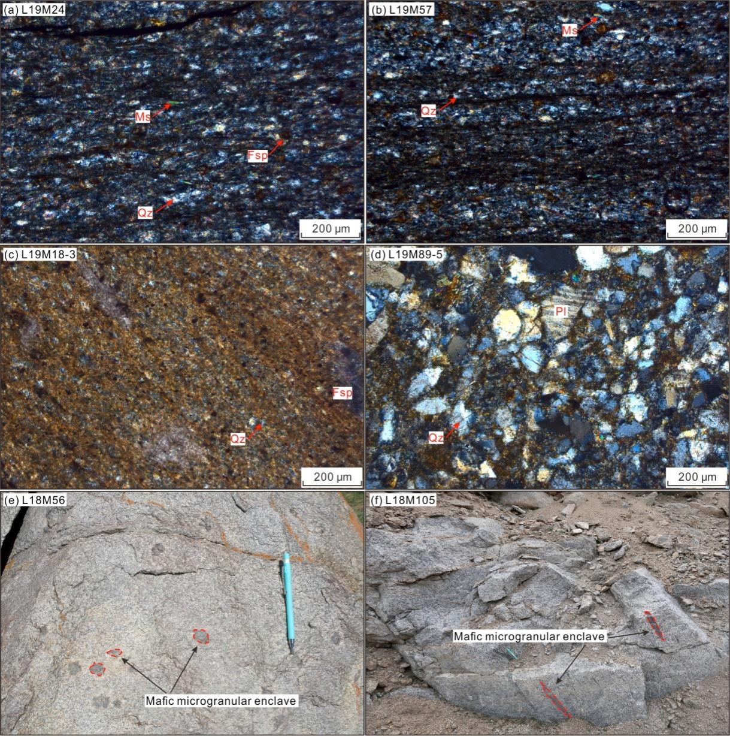

Figure S1. Photographs of sedimentary and igneous rocks. (a-b) Two metasiltstone samples (L19M24 and L19M57) from the Zag zone show a penetrative foliation that is defined by the oriented alignment of quartz, feldspar, and minor muscovite; (c) A siltstone (sample L19M18-3) from the Hangay-Hentey complex with quartz and feldspar clasts in a clay-rich matrix; (d) A fine-grained sandstone (sample L19M89-5) from the Hangay-Hentey complex that is mainly composed of quartz, plagioclase, and opaque minerals; (e-f) Mafic microgranular enclaves within two plutons of samples L18M56 and L18M105 (Group I). Mineral abbreviations: Ms, muscovite; Fsp, feldspar; Pl, plagioclase; Qz, quartz.