Supplementary Information for

U-PB AGES AND HF ISOTOPE DATA FROM DETRITAL ZIRCONS IN THE METASEDIMENTARY ROCKS OF THE MONGOL ALTAI GROUP, MONGOLIAN PART OF THE ALTAI-MONGOLIAN TERRANE: IMPLICATIONS ON THE PROVENANCE AND TECTONIC SETTING

Enkhdalai Batkhuyag^{1,2}, Narantsetseg Tserendash¹, Oyunchimeg Tumen-Ulzii¹, Tong Ying³, Guo Lei³, Udaanjargal Khurelbaatar⁴, Batzorig Garvaa⁴

¹ Institute of Geology, Mongolian Academy of Sciences, Ulaanbaatar 15160, Mongolia
² School of Geology and Mining Engineering, MUST, Ulaanbaatar 14191, Mongolia
³ Institute of Geology, Chinese Academy of Geological Sciences, 100037 Beijing, China
⁴ Ereenchuluu LLC, Ulaanbaatar 14200, Mongolia
E-mail: enkhdalaib@mas.ac.mn

The supplementary information includes:
Figs. S1-S12
Figures
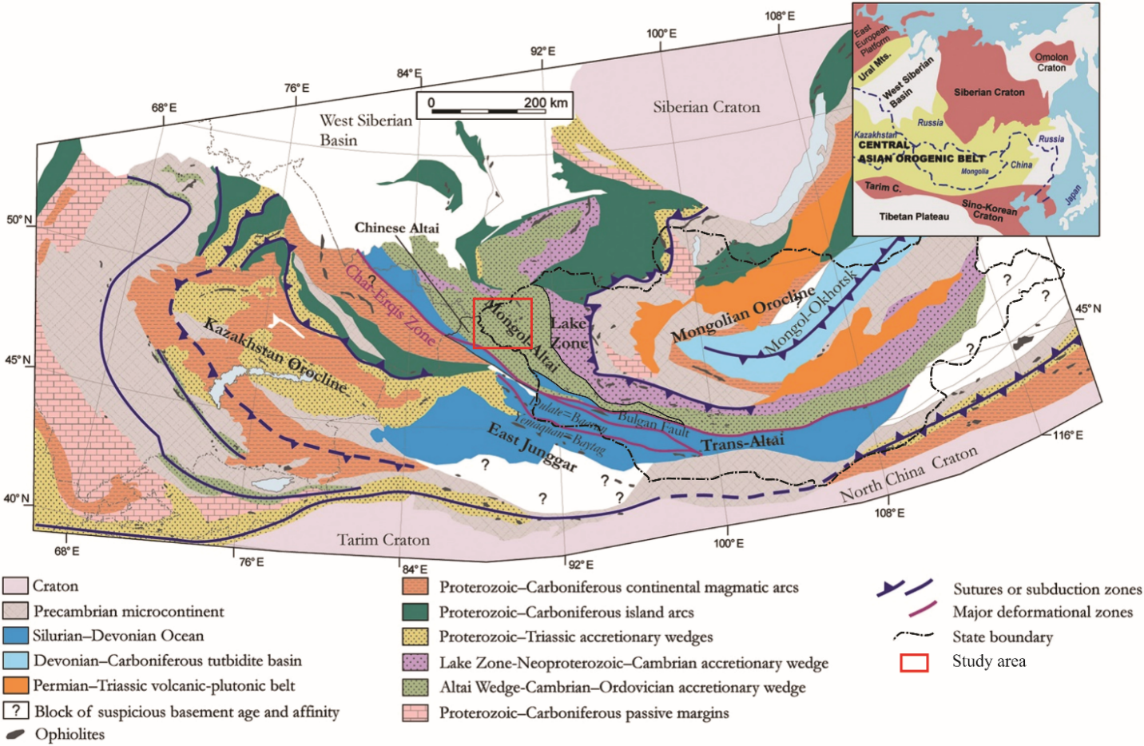
Figure S1. Tectonic map of the Mongolian collage system and the adjacent Kazakhstan collage constituting the central part of the CAOB (modified from Şengör et al. 1993; Parfenov et al. 2003; Kröner et al. 2010; Guy et al. 2020).
Figure S2. (a) The tectonic map of Mongolia (Tomurtogoo et al. 2014), showing the location of the Mongolian Altai Orogenic System. (b) Simplified geological map of the Southern Altai terrane (modified after Tovuudorj et al. 2008)
Figure S3. Field photographs showing constituent metasedimentary rocks from the Mongolian Altai Group, northern part of the Altai terrane, Western Mongolia. (a, b) fine- to medium-grained quartz metasandstone, metasiltstone (Maikhant Formation). (c, d) fine to medium-grained feldspar-quartz sandstone and metasiltstone (Borburgas Formation). (e, f) liliaceous siltstone with interlayers of sandstone (Tsengel Formation). (g, h) medium- to coarse-grained sandstone, and siltstone (Jivert-Uul Formation)
Figure S4. Representative photomicrographs of the samples used for detrital zircon U-Pb geochronology. a) Medium-grained metasandstone sample M21-1079/1; b) Medium-grained metasandstone (sample M21-2062); c) Medium-grained schistose sandstone (sample M21-1061); d) Medium-coarse-grained metasandstone (sample M21-1063/1). Legend: Q-quartz, Pl-plagioclase, Epi-epidote, Tur-tourmaline, Py-pyrite, Bi-biotite, Ser-sericite, rock fragments: Qrtz-quartzite.
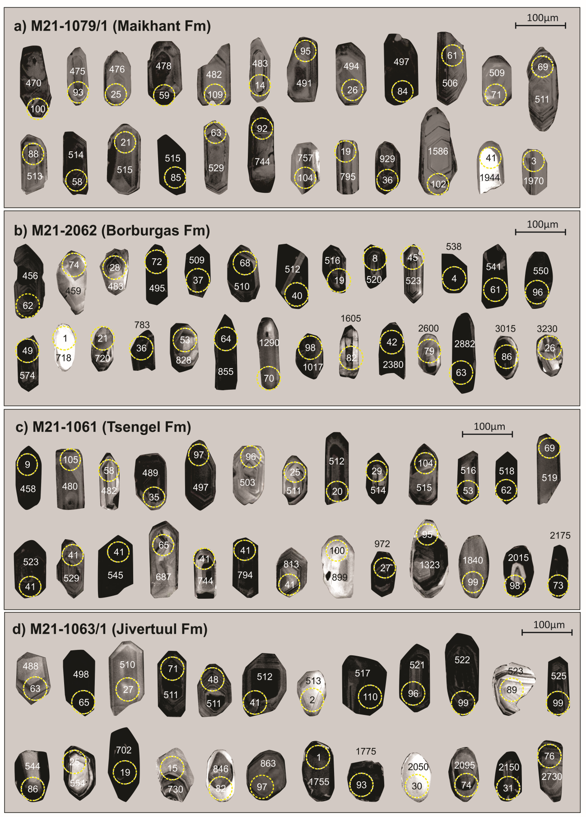
Figure S5. Representative cathodoluminescence (CL) images of zircons from the Mongolian Altai Group. Scale bar=100µm.
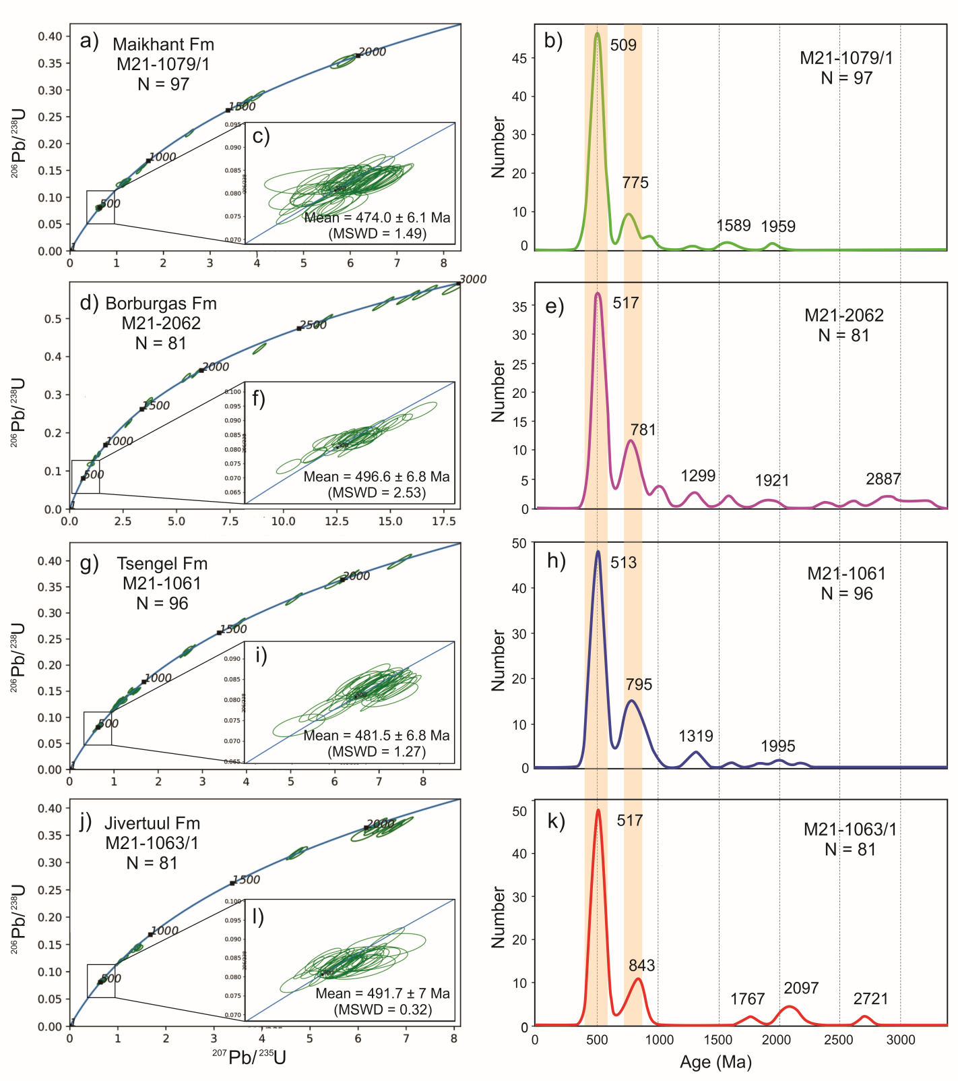
Figure S6. U-Pb concordia and distribution diagrams for detrital zircons of metasandstone from the Mongolian Altai Group. The ²⁰⁶Pb/²³⁸U and ²⁰⁷Pb/²⁰⁶Pb ages are used for zircons younger than 1000 Ma and older than 1000 Ma, respectively. Each sample is shown on a separate diagram. See Table 1 to 4 for a list of zircon ages.
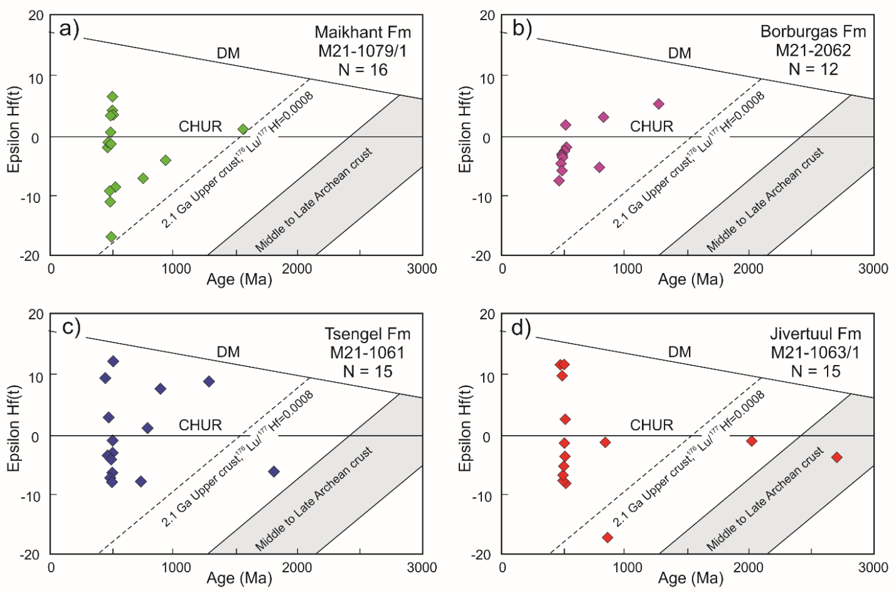
Figure S7. Diagram of _{Ɛ}Hf(t) values versus crystallizing ages for zircons from the Mongolian Altai Group metasandsones. The ²⁰⁶Pb/²³⁸U ages are used for zircons younger than 1000 Ma, and ²⁰⁷Pb/²⁰⁶Pb ages are used for zircons older than 1000 Ma.

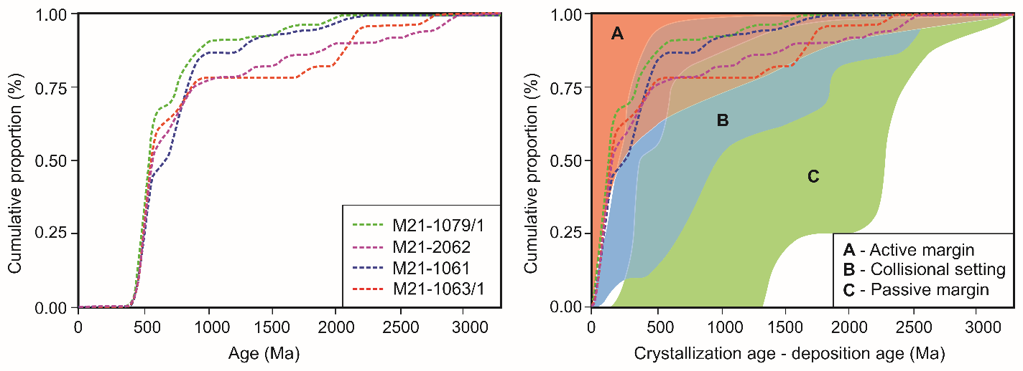
Figure S8. Cumulative distribution curves of detrital zircons from the Early Paleozoic metasedimentary rocks in the Mongolian Altai. The depositional ages of individual units are inferred from the youngest detrital zircon ages. The color fields and reference dashed lines representing different tectonic settings of deposition are after Cawood et al. (2012) and the references therein.
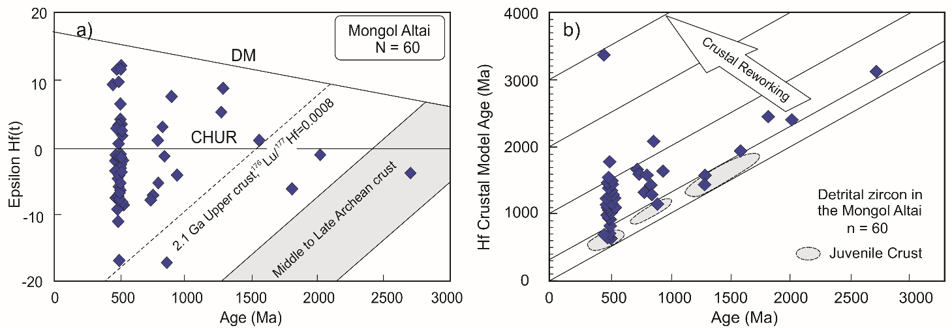
Figure S9. a) Diagram of Ɛ_{Hf}(t) values versus crystallizing ages for zircons from the Mongolian Altai Group metasandsones. b) Crystallization age-Hf crustal model age plot of the detrital zircons from the Mongolian Altai Group metasandsones.
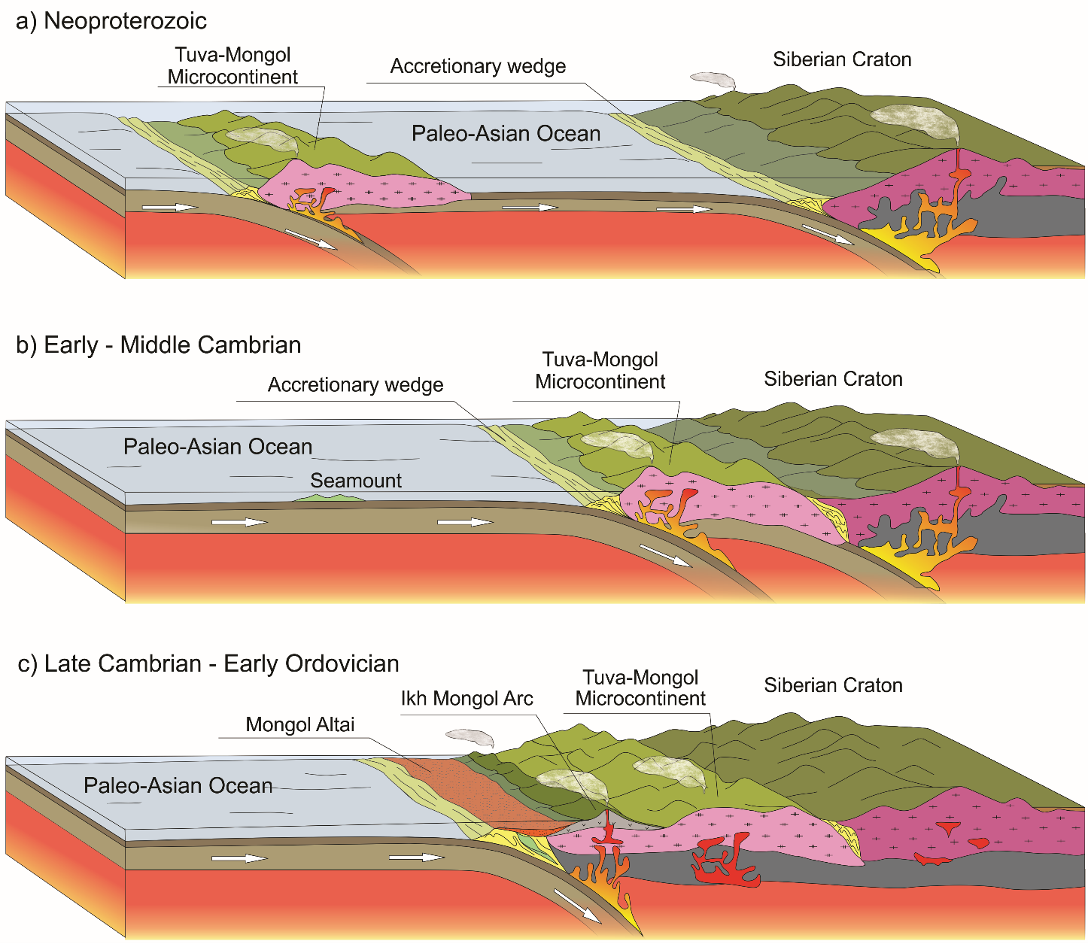
Figure S10. Geodynamic model showing the Neoproterozoic to Ordovician tectonic evolution of the Altai-Mongolian terrane
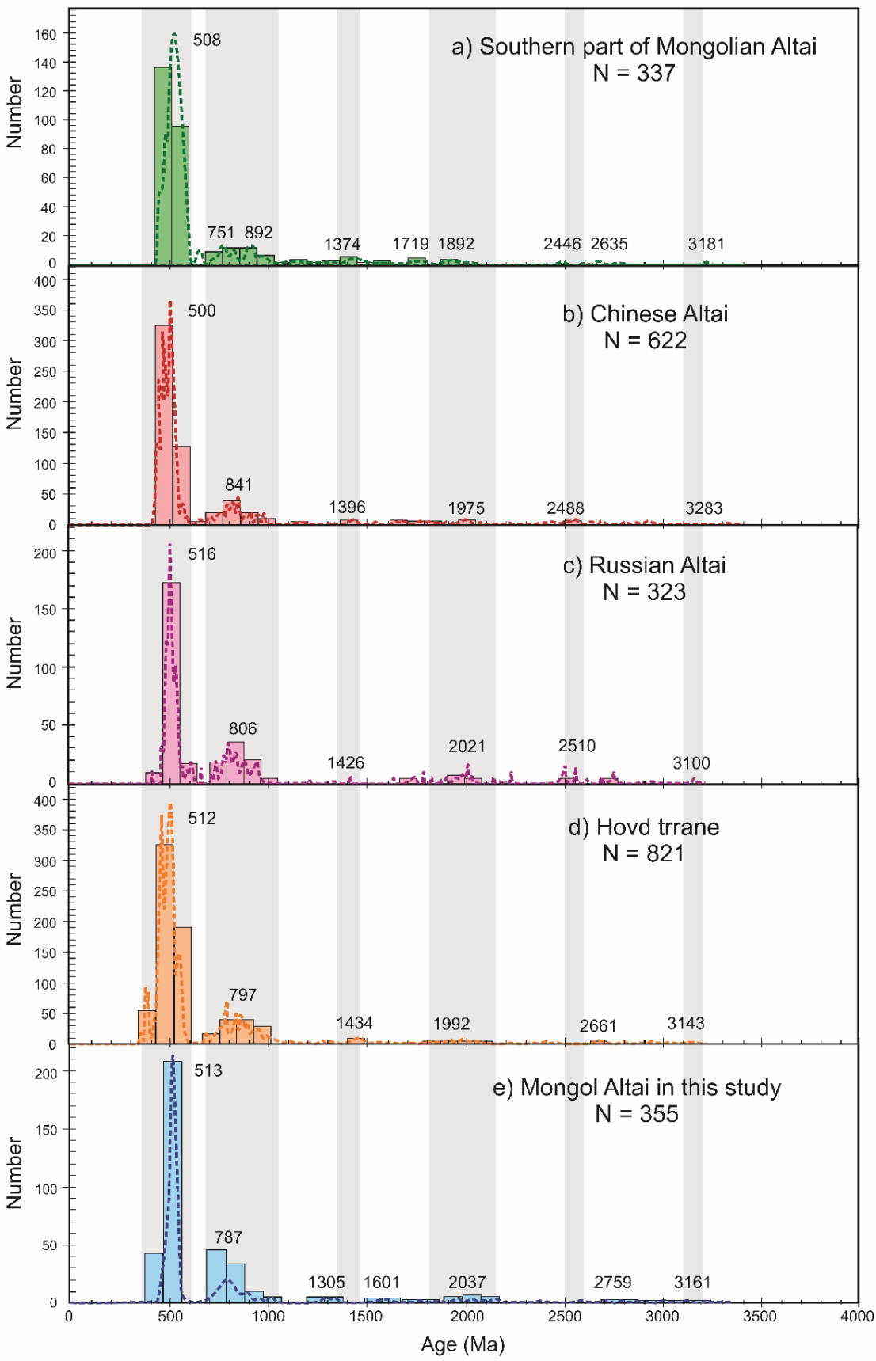
Figure S11. Relative probability plots (concordant data only) for detrital zircons from the (a) southern part of Mongolian Altai (Long et al. 2019), (b) Chinese Altai (Long et al. 2012; Wang et al. 2014; Dong et al. 2018), (c) Russian Altai (Chen et al. 2014, 2016), as well as the adjacent (d) Hovd Zone (Soejono et al. 2018) and (e) Mongolian Altai in this study. (modified from Long et al. 2019).
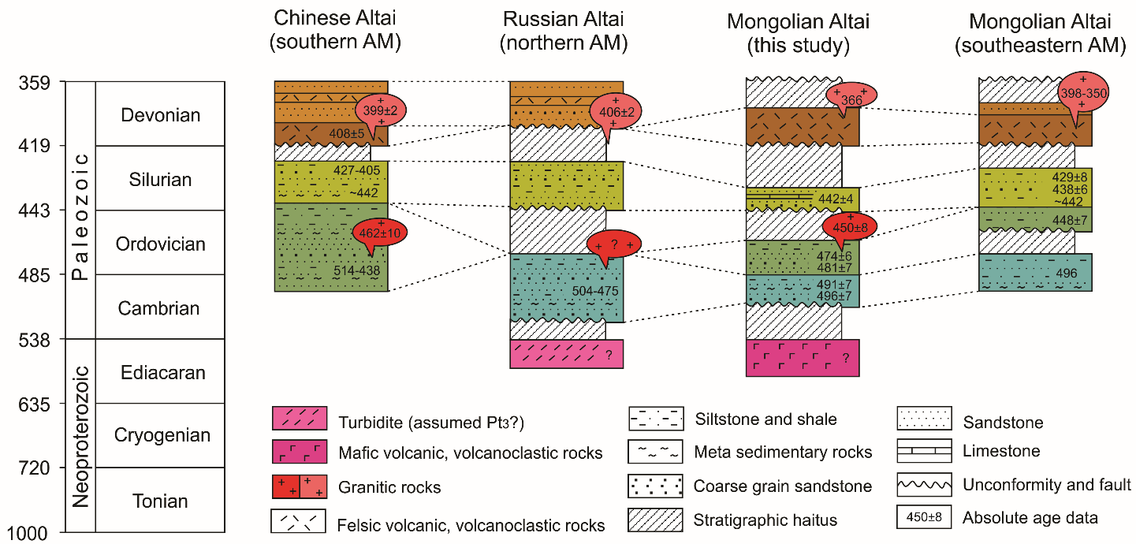
Figure S12. Simplified stratigraphic columns comparing the northern Altai-Mongolian terrane (AM) in the Russian Altai (based on the geological maps of Daukeev et al., 2008; Buslov & Safonova, 2010; Ming Chen et al., 2014, 2016), the Chinese Altai in northwestern China (after Long et al., 2012; Broussolle et al., 2019), the Mongolian Altai in the southeastern part of Mongolia (after Long et al. (2019)), and the Mongolian Altai in western Mongolia (this study).

