**Supplement material**

**Precessional hydroclimatic synchronicity changes in the Indo-Pacific Warm Pool driven by the Intertropical Convergence Zone over the past 450 kyr**

**Fang Qian1, 2, 8,** **Fengming Chang1, 2, 3,** [1]\***, Dirk Nürnberg4, Shuai Zhang5, Yi Wang6, Junru Zhang1, 3, Luyao Tang1, 3, Tiegang Li2, 7,** [2]*

*1 Key Laboratory of Ocean Observation and Forecasting, Key Laboratory of Marine Geology and Environment, Institute of Oceanology, Chinese Academy of Sciences, Qingdao 266071, China*

*2 Laboratory for Marine Geology, Qingdao Marine Science and Technology Center, Qingdao 266237, China*

*3 University of Chinese Academy of Sciences, Beijing 100049, China*

*4 GEOMAR Helmholtz Center for Ocean Research Kiel, Wischhofstrasse 1–3, Kiel 24148, Germany*

*5 College of Oceanography, Hohai University, Nanjing 210098, China*

*6 Department of Earth and Environmental Sciences, Tulane University, New Orleans, LA 70118, USA*

*7 Key Laboratory of Marine Geology and Metallogeny, First Institute of Oceanography, MNR, Qingdao 266061, China*

*8 Present address: Department of Earth and Environmental Sciences, Tulane University, New Orleans, LA 70118, USA; Department of Geology and Geophysics, Woods Hole Oceanographic Institution, Woods Hole, MA 02543, USA*

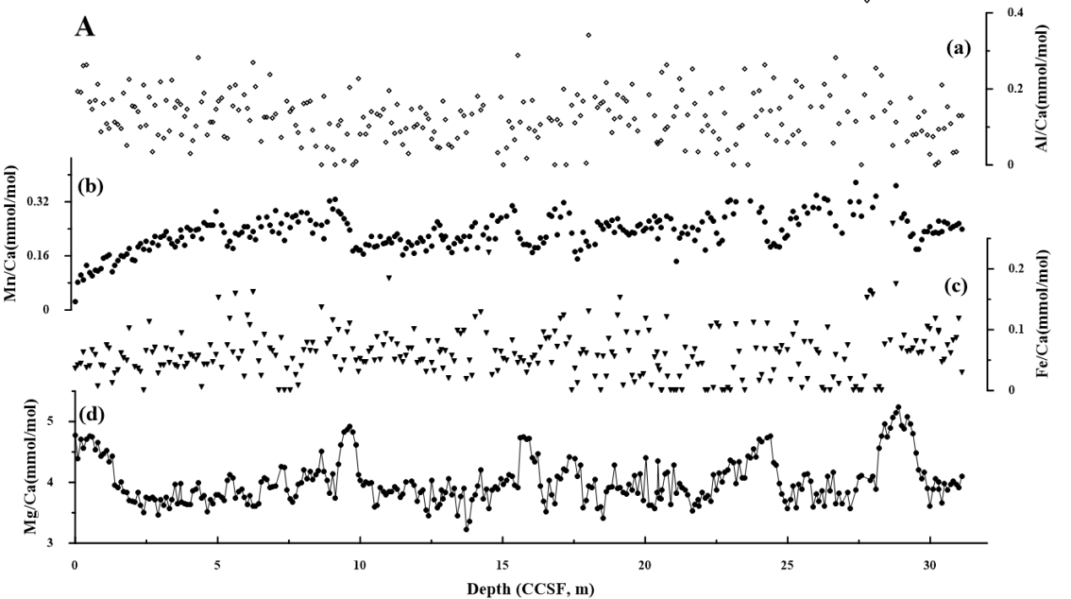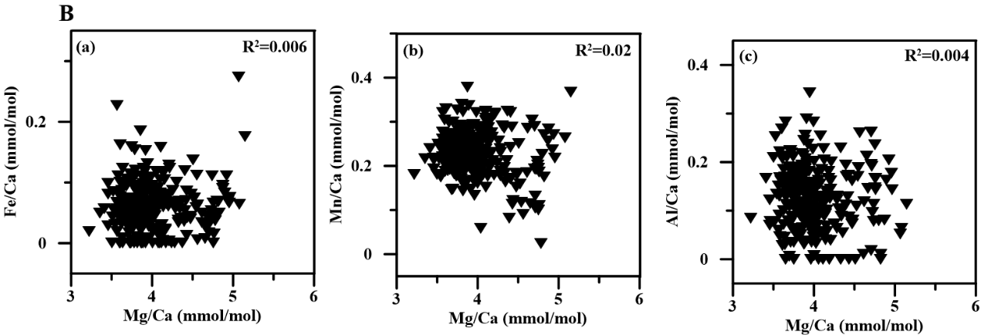

**Fig. S1.** A. Trace element variations in the tests of *G. ruber* in core U1486 with core depth. (a) Al/Ca, (b) Mn/Ca, (c) Fe/Ca, and (d) Mg/Ca. B. Geochemical ratio plots of U1486 *G. ruber*. (a) Fe/Ca vs. Mg/Ca, (b) Mn/Ca vs. Mg/Ca and (c) Al/Ca vs. Mg/Ca.

Table S1. Compilation of Mg/Ca-temperature equations for *G. ruber* and the corresponding results of core-top temperature and seawater δ18O of site U1486

|  |  |  |  |
| --- | --- | --- | --- |
| **Mg/Ca-Temperature function, Mg/Ca=** | **Core-top temperature (℃)** | **Core-top seawater δ18O (‰, SMOW)** | **Reference** |
| 0.30*exp (0.089*T) | 30.7 | 0.53 | Lea et al. (2000) |
| 0.38*exp (0.09*T) | 28.1 | -0.04 | Anand et al. (2003) |
| 0.26*exp (0.097*T) | 29.7 | 0.32 | Hollstein et al. (2017) |
| 0.38*exp [0.09*T-0.38*(core depth km)-1.6 ℃] | 29.3 | 0.25 | Dekens et al. (2002) |
| 0.455*exp (0.077*T) | 31.1 | 0.41 | Sagawa et al. (2012) |



**Fig. S2.** The comparison of reconstructed SST, seawater δ18O (δ18Osw), and the ice volume corrected-seawater δ18O (δ18Osw-iv) by different calibration equations. (a, b) SST and δ18Osw results with different calibration equations are indicated by the following color-coded solid lines: red (Dekens et al., 2002), green (Anand et al., 2003), purple (Hollstein et al., 2017), blue (Lea et al., 2000), and pink (Sagawa et al., 2012). (c) δ18Osw-iv results with different global ice volume δ18Osw are represented by the following colors: black (Bintanja et al., 2005) and gold (Spratt and Lisiecki, 2016).

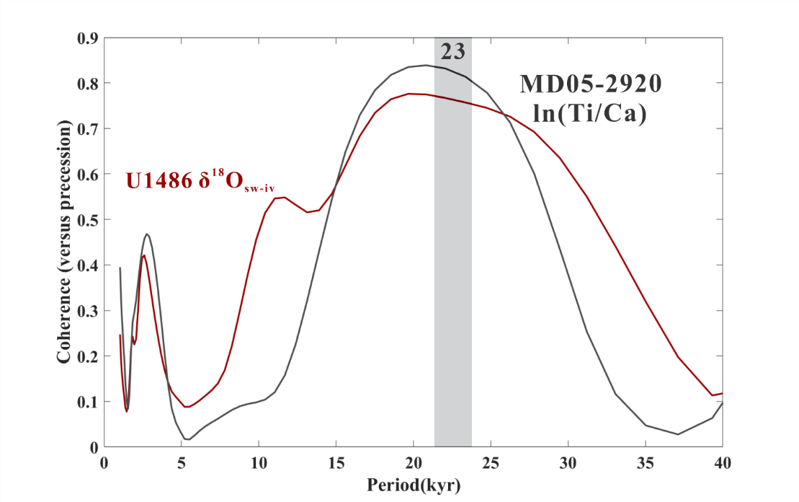

**Fig. S3.** Coherence between Site U1486 δ18Osw-iv and ln(Ti/Ca) from core MD05-2920

**Table S2.** The information of the discussed cores

|  |  |  |  |  |  |
| --- | --- | --- | --- | --- | --- |
| **Region** | **Site** | **Latitude** | **Longitude** | **Depth (m)** | **Reference** |
| Northern sector of the western equatorial Pacific | MD06-3047B | 17°44′N | 124°48′ E | 2510 | Jia et al., 2018 |
| MD06-3067 | 6°31′ N | 126°3′ E | 1575 | Bolliet et al., 2011 |
| Southern sector of the western equatorial Pacific | MD05-2920  MD05-2925 | 2°51′ S  9°18′ S | 144°32′ E  151°30′ E | 1843  1661 | Tachikawa et al., 2011  Lo et al., 2017 |
| Eastern tropical Indian Ocean | MD98-2162 | 4°41′ S | 117°54′ E | 1855 | Jian et al., 2022 |
| SO18480-3 | 12°34′ S | 121°39′ E | 2299 | Jian et al., 2022 |
| U1483 | 13°5′ S | 121°48′ E | 1733 | Zhang et al., 2022 |

**References**

Anand, P., Elderfield, H., & Conte, M. H. (2003). Calibration of Mg/Ca thermometry in planktonic foraminifera from a sediment trap time series. Paleoceanography, 18(2). https://doi.org/10.1029/2002pa000846

Bintanja, R., van de Wal, R. S., & Oerlemans, J. (2005). Modelled atmospheric temperatures and global sea levels over the past million years. Nature, 437(7055), 125-128. https://doi.org/10.1038/nature03975

Dekens, P. S., Lea, D. W., Pak, D. K., & Spero, H. J. (2002). core top calibration of Mg/Ca in tropical foraminifera: Refining paleotemperature estimation. Geochemistry, Geophysics, Geosystems, 3(4), 1–29. https://doi.org/doi:10.1029/2001gc000200

Hollstein, M., Mohtadi, M., Rosenthal, Y., Moffa Sanchez, P., Oppo, D., Martínez Méndez, G., Steinke, S., & Hebbeln, D. (2017). Stable Oxygen Isotopes and Mg/Ca in Planktic Foraminifera From Modern Surface Sediments of the Western Pacific Warm Pool: Implications for Thermocline Reconstructions. Paleoceanography, 32(11), 1174–1194. https://doi.org/10.1002/2017pa003122

Lea, D. W., Pak, D. K., & Spero, H. J. (2000). Climate impact of late quaternary equatorial pacific sea surface temperature variations. Science, 289(5485), 1719–1724. https://doi.org/10.1126/science.289.5485.1719

Spratt, R. M., & Lisiecki, L. E. (2016). A Late Pleistocene sea level stack. Climate of the Past, 12(4), 1079–1092. https://doi.org/10.5194/cp-12-1079-2016

Sagawa, T., Yokoyama, Y., Ikehara, M., & Kuwae, M. (2012). Shoaling of the western equatorial Pacific thermocline during the last glacial maximum inferred from multispecies temperature reconstruction of planktonic foraminifera. Palaeogeography, Palaeoclimatology, Palaeoecology, 346–347, 120–129. https://doi.org/10.1016/j.palaeo.2012.06.002

1. * Corresponding authors.

   *E-mail addresses*: chfm@qdio.ac.cn (F. Chang); tgli@fio.org.cn (T. Li).
2.