Supplementary materials:
1. Fig. S1 Pearson correlation coefficient between stalagmite δ¹⁸O records of SZ-1 and SZ-3 during about 33-25 ka.
2. Fig. S2 XRD analyses results for samples at different sections along stalagmites SZ-1 and SZ-3.
3. Fig. S3 Collected stalagmite δ¹⁸O records in the Asian region for amplitudes comparison.
4. Fig. S4 Simplified graphical sketch explaining the absolute amplitude during the Heinrich stadials.
5. Tab. S1 Amplitudes of δ¹⁸O for collected stalagmite records during the HS 1 to HS 4.
6. References
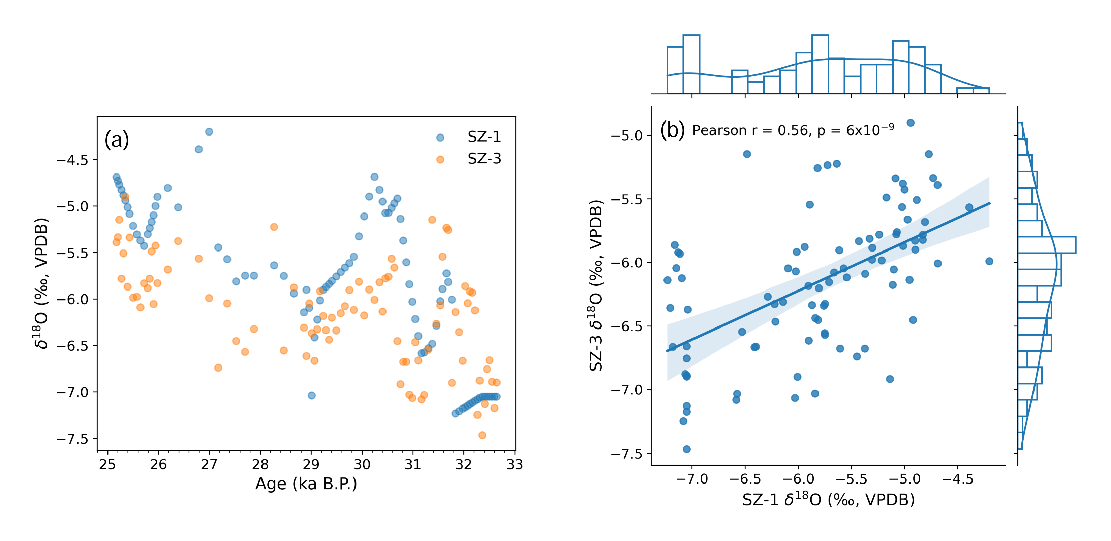
Figure S1. Pearson correlation coefficient between stalagmite δ¹⁸O records of SZ-1 and SZ-3 during their about 33-25 ka. The SZ-1 record is recalculated based on liner interpolation to compare with SZ-3 on a common timescale.

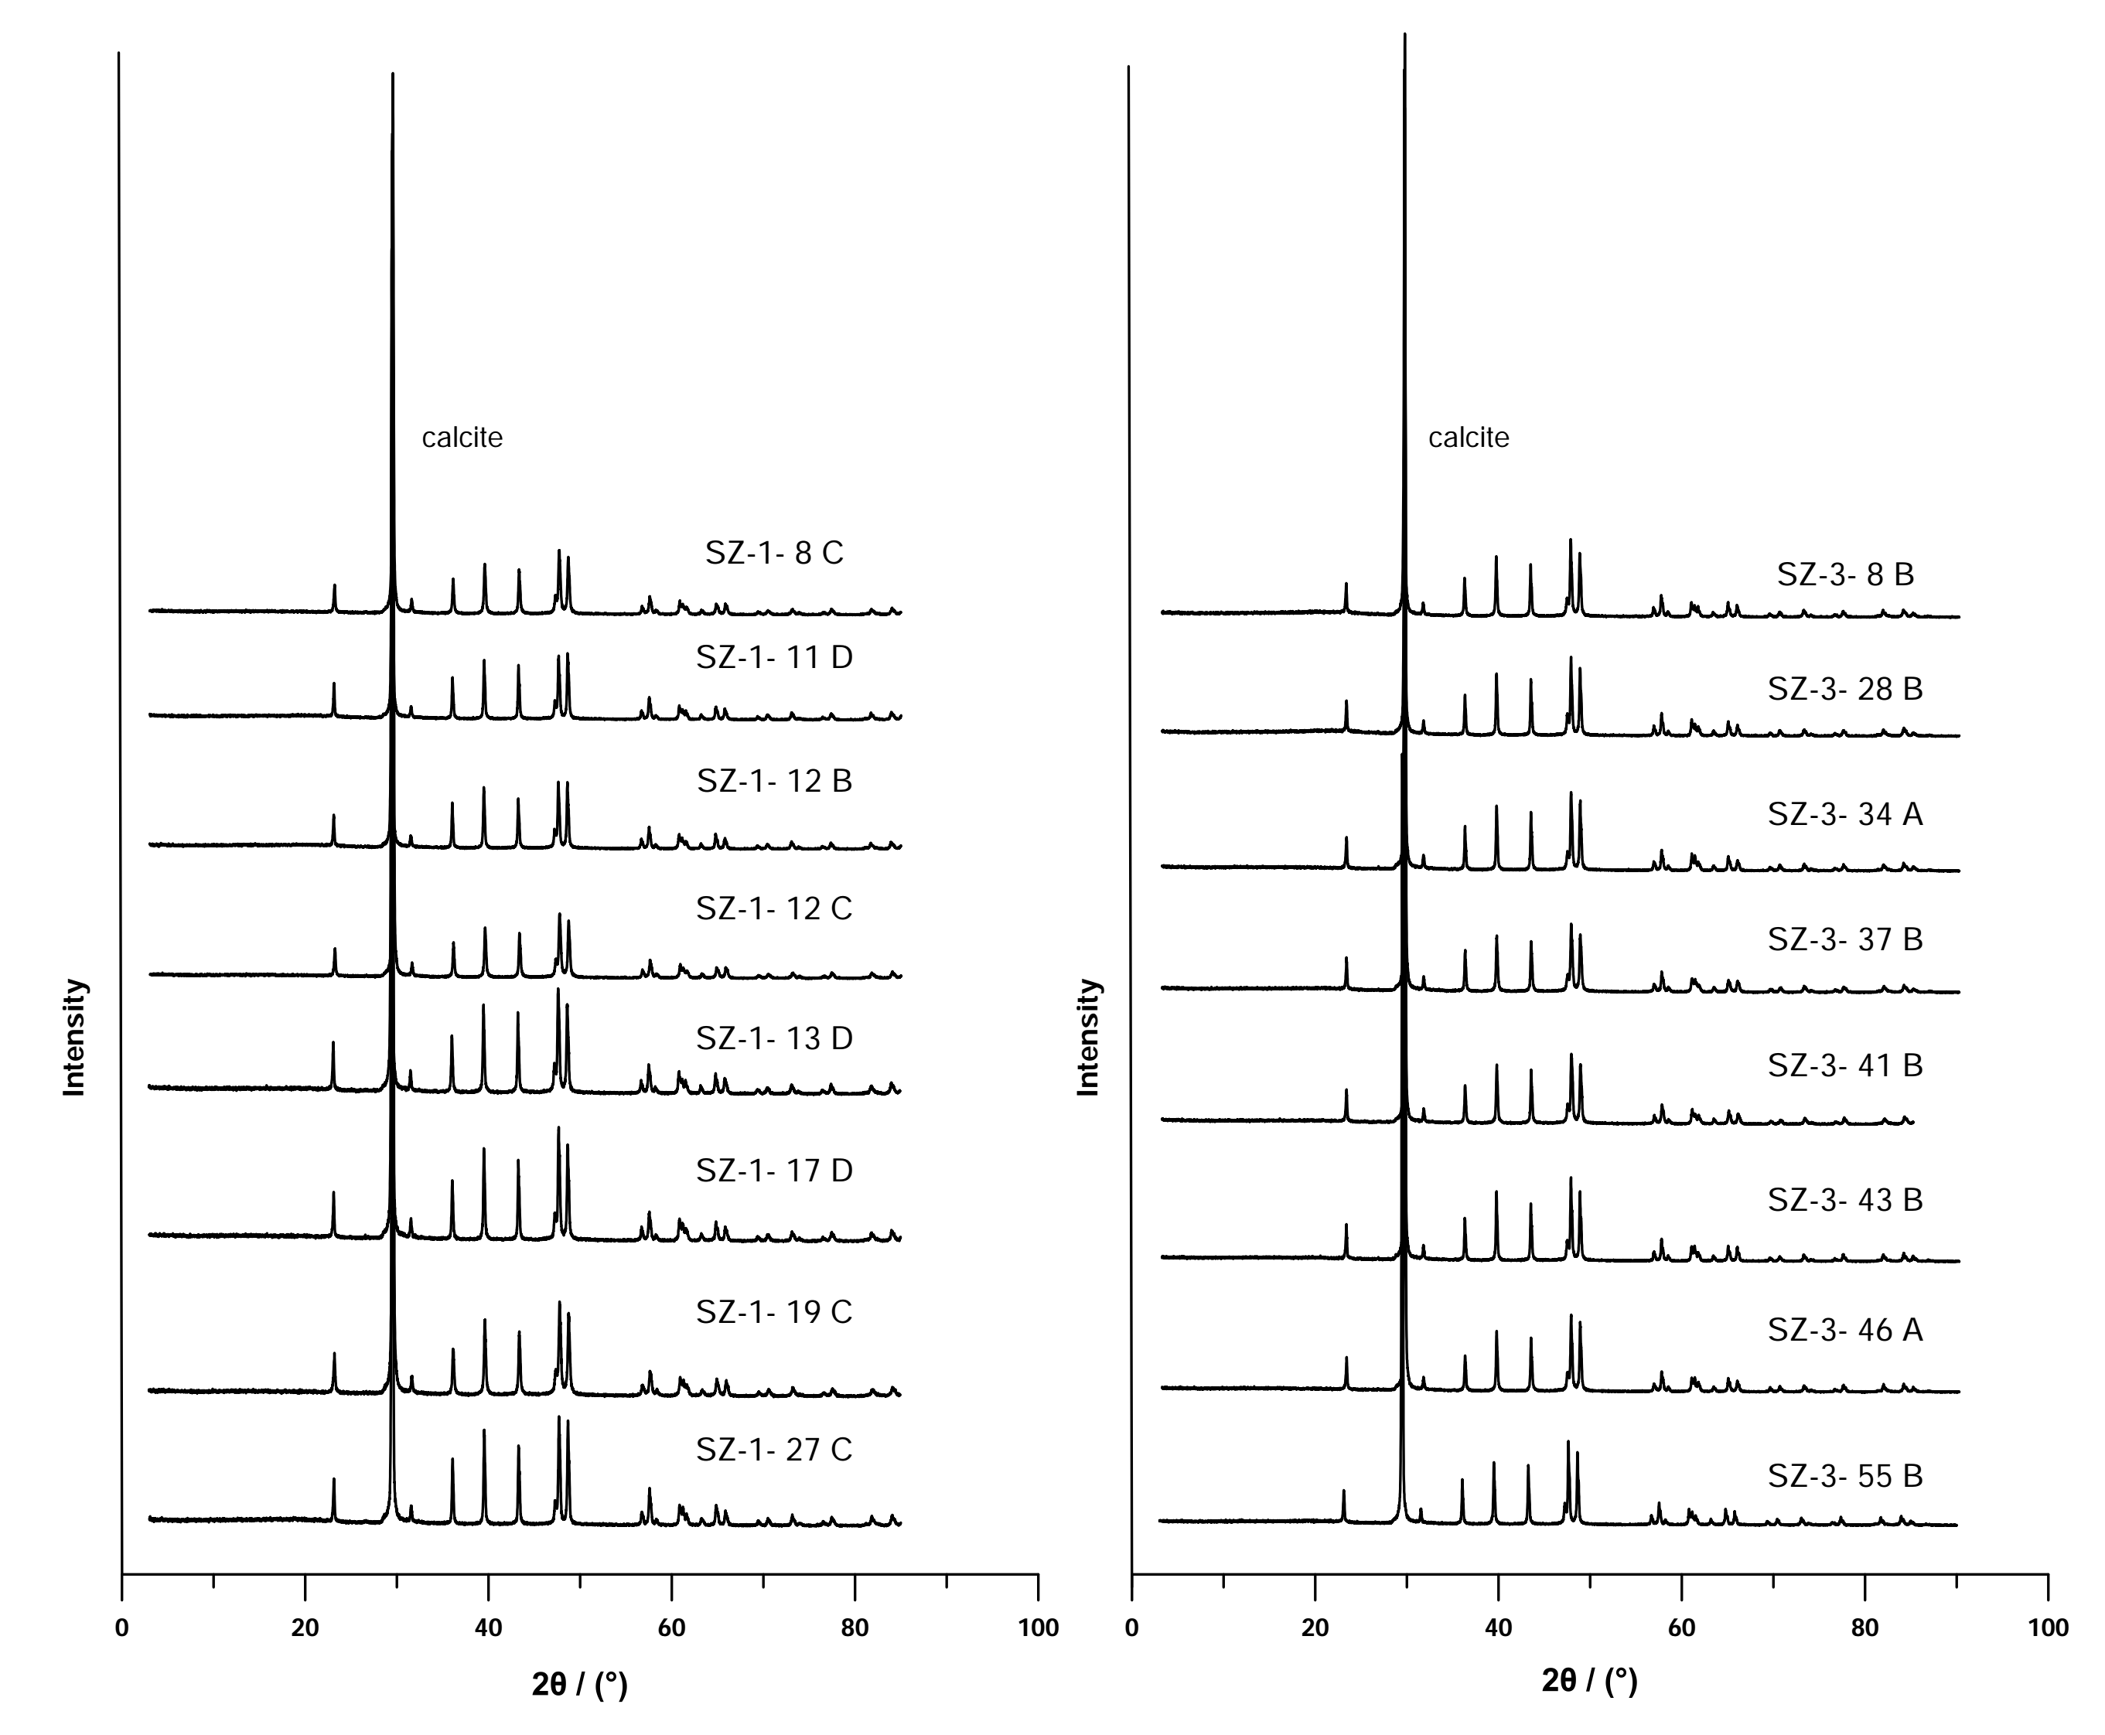
Figure S2. XRD analyses results for samples at different sections along stalagmites SZ-1 and SZ-3. All samples are dominantly composed of calcite.

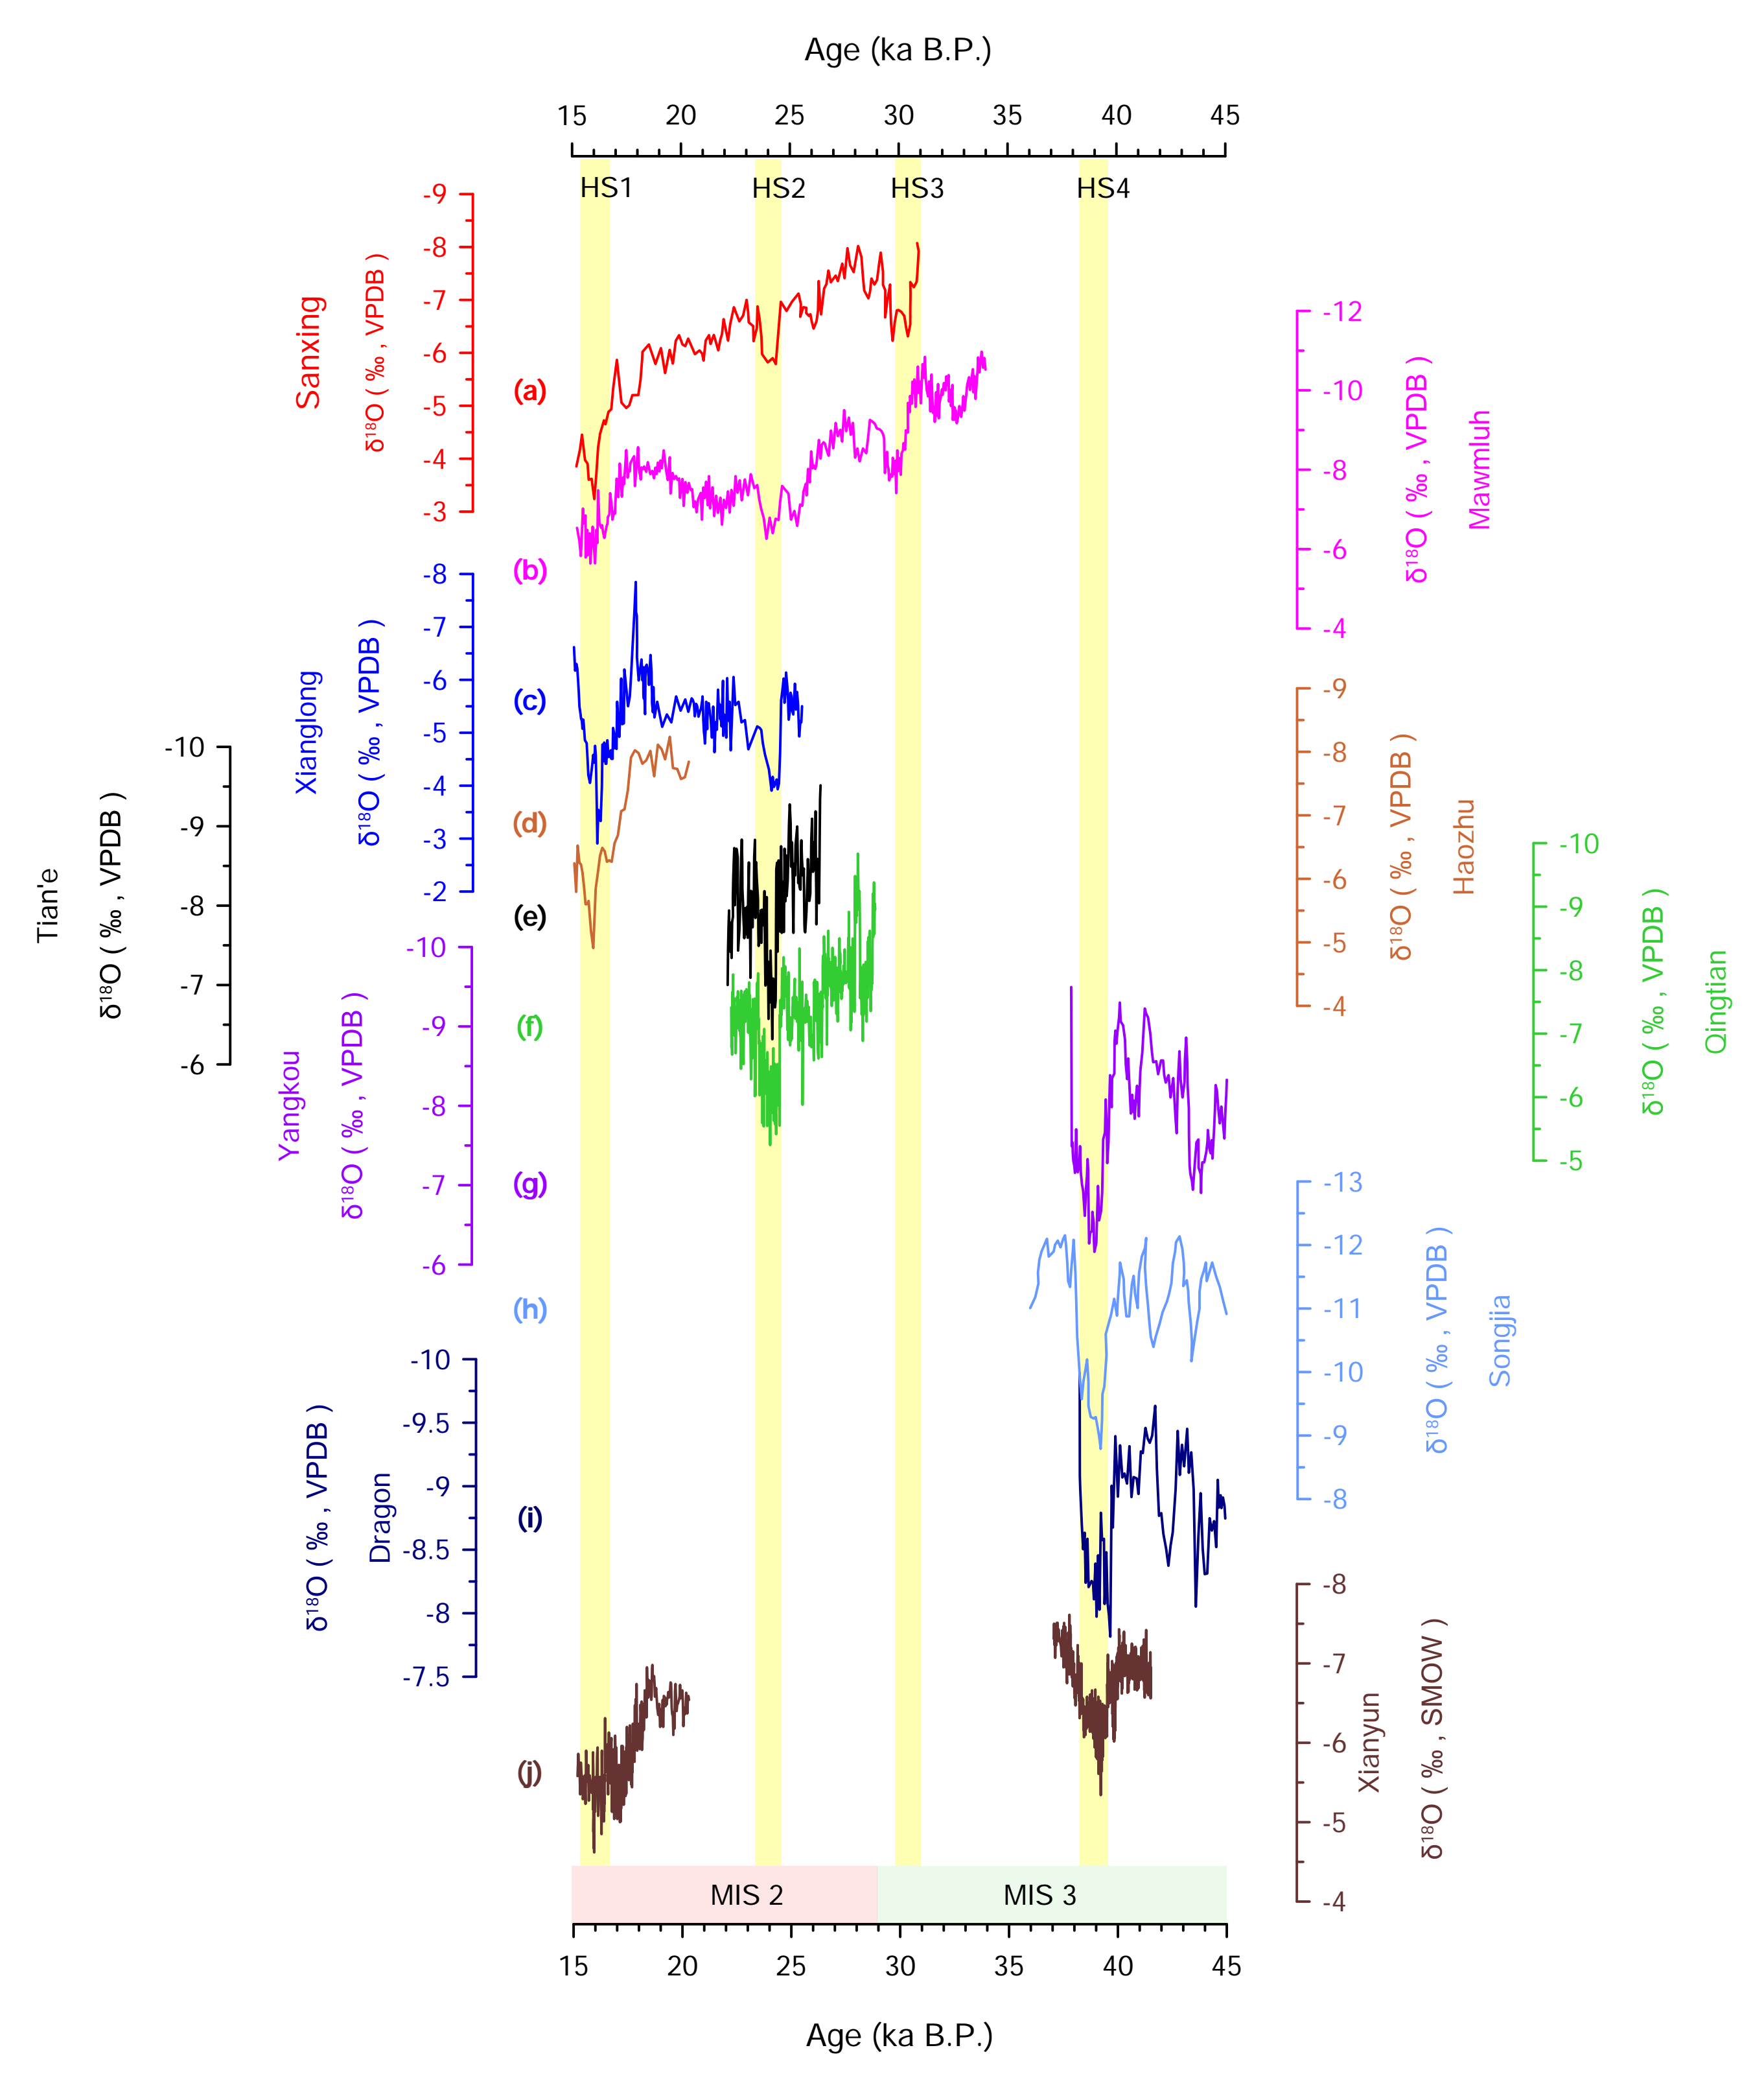
Figure S3. Collected stalagmite δ¹⁸O records in the Asian region for amplitude comparison. (a) Sanxing Cave (Jiang et al., 2014); (b) Didonghe Cave (Chen et al., 2022); (c) Xianglong Cave (Li et al., 2019); (d) Haozhu Cave (Zhang et al., 2016); (e) Tian’e Cave (Chen et al., 2006); (f) Qingtian Cave (Liu et al., 2018); (g) Yangkou Cave (Han et al., 2016; Li et al., 2017); (h) Xiaobailong (Cai et al., 2006); (i) Dragon Cave (Dong et al., 2018); (j) Xianyun Cave (Zhang et al., 2021; Qiu et al., 2022).
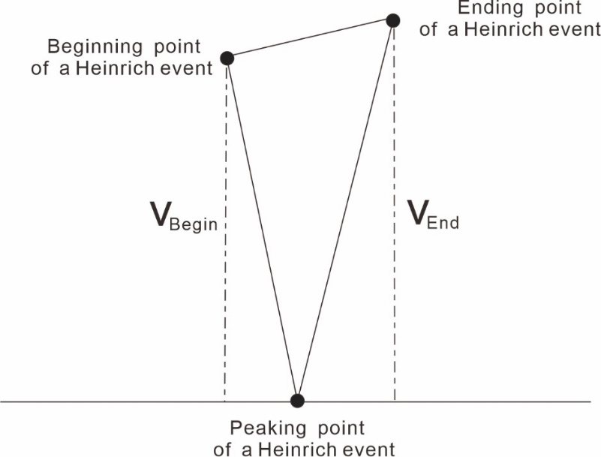

Figure S4. Simplified graphical sketch explaining the absolute amplitude during the Heinrich stadials. The related calculation formula is V _{absolute} = (V _{begin} + V _{end}) / 2; with V _{absolute}, the absolute amplitude of those stadials; V _{begin}, the absolute values between beginning points and peaking points of those stadials; V_{end}, the absolute values between ending points and peaking points of those stadials.

Table S1. Amplitudes of δ¹⁸O for the collected stalagmite records during the HS 1 to HS 4. Dot lines were used to mark the lack of data.
Number | Cave | HS 1 (‰) | HS 2 (‰) | HS 3 (‰) | HS 4 (‰) | Reference
1 | Shizhu | 2.53 | 1.05 | 0.96 | 2.86 | This study
2 | Hulu | 1.21 | 1.50 | 1.76 | 1.47 | Cheng et al., 2016
3 | Xianyun | 1.3 | -- | -- | 1.08 | Zhang et al., 2021;  Qiu et al., 2022
4 | Yongxing | -- | 1.92 | 1.17 | 2.65 | Chen et al., 2016
5 | Songjia | 2.66 | 1.47 | -- | 3.49 | Zhou et al., 2008
6 | Dragon | -- | -- | -- | 1.67 | Dong et al., 2018
7 | Sanxing | 2.19 | 1.27 | 1.13 | -- | Jiang et al., 2014
8 | Didonghe | 1.55 | 1.48 | 2.21 | -- | Chen et al., 2022
9 | Haozhu | 1.29 | -- | -- | -- | Zhang et al., 2016
10 | Xianglong | 3.04 | 1.70 | -- | -- | Li et al., 2019
11 | Tian’e | -- | 1.55 | -- | -- | Chen et al., 2006
12 | Qingtian | -- | 1.97 | -- | -- | Liu et al., 2018
13 | Yangkou | -- | -- | -- | 3.06 | Han et al., 2016;  Li et al., 2017
14 | Xiaobailong | -- | -- | -- | 2.35 | Cai et al., 2006

Reference:
Cai YJ, An ZS, Cheng H, Edwards RL, Kelly MJ, Liu WG, Wang XF and Shen C-C (2006). High-resolution absolute-dated Indian Monsoon record between 53 and 36 ka from Xiaobailong Cave, southwestern China. Geology 34, 8: 621-624.
Chen ST, Wang YJ, Cheng H, Edwards RL, Wang XF, Kong XG and Liu DB (2016) Strong coupling of Asian Monsoon and Antarctic climates on suborbital timescales. Scientific Report 8(6), 32995.
Chen ST, Wang YJ, Wu JY and Liu DB (2006) An event of the East Asian monsoon responding to Heinrich Event 2: Evidence from high-resolution stalagmite record. Geochimica 35, 586-592 (in Chinese with English abstract).
Chen QM, Cheng X, Cai YJ, Luo QZ, Zhang JL, Tang YH, Ren JG, Wang P, Wang Y, Zhang Y, Xue G, Zhou J, Cheng H, Edwards RL and Hong ZL (2022) Asian Summer Monsoon Changes Inferred From a Stalagmite δ¹⁸O Record in Central China During the Last Glacial Period. Frontiers in Earth Science 10, 863829.
Cheng H, Edwards RL, Sinha A, Spotl C, Yi L, Chen ST, Kelly M, Kathayat G, Wang XF, Li XL, Kong XG, Wang YJ, Ning YF and Zhang HW (2016) The Asian monsoon over the past 640,000 years and ice age Terminations. Nature 534(7609), 640-646.
Dong JG, Shen C-C, Kong XG, Wang YJ and Duan FC (2018). Asian monsoon dynamics at Dansgaard/Oeschger events 14-8 and Heinrich events 5-4 in northern China. Quaternary Geochronology 47, 72-80.
Han L-Y, Li T-Y, Cheng H, Edwards RL, Shen C-C, Li H-C, Huang C-X, Li J-Y, Yuan N, Wang H-B, Zhang TT and Zhao X (2016) Potential influence of temperature changes in the Southern Hemisphere on the evolution of the Asian summer monsoon during the last glacial period. Quaternary International 392, 239-250.
Jiang XY, He YQ, Shen C-C, Li S-Y, Yang B, Lin K and Li ZZ (2014) Decoupling of the East Asian summer monsoon and Indian summer monsoon between 20 and 17 ka. Quaternary Research 82, 1: 146-153.
Li D, Tan LC, Cai YJ, Jiang XY, Ma L Cheng H, Edwards RL, Zhang HW, Gao YL and An ZS (2019) Is Chinese stalagmite δ¹⁸O solely controlled by the Indian summer monsoon? Climate Dynamics 53, 2969-2983.
Li T-Y, Han L-Y, Cheng H, Edwards RL, Shen C-C, Li H-C, Li J-Y, Huang C-X, Zhang TT and Zhao X (2017) Evolution of the Asian summer monsoon during Dansgaard/ Oeschger events 13–17 recorded in a stalagmite constrained by high-precision chronology from southwest China. Quaternary Research 88, 121-128.
Liu DB, Wang YJ, Cheng H, Edwards RL, Kong XG, Chen ST and Liu SS (2018) Contrasting Patterns in Abrupt Asian Summer Monsoon Changes in the Last Glacial Period and the Holocene. Paleoceanography and Paleoclimatology 33.
Qiu WY, Zhang X, Jiang XY, Hu HM, Ma L, Xiao HY, Cai BG and Shen C-C (2022). Double-plunge structure of the East Asian summer monsoon during Heinrich Stadial 1 recorded in Xianyun Cave, southeastern China. Quaternary Science Reviews 282, 107442.
Zhang HB, Griffiths ML, Huang JH, Cai YJ, Wang CF, Zhang F, Cheng H, Ning YF, Hu CY and Xie SC (2016) Antarctic link with East Asian summer monsoon variability during the Heinrich Stadial–Bølling interstadial transition. Earth and Planetary Science Letters 453, 243-251.
Zhang X, Qiu WY, Jiang XY, Hu HM, Xiao HY, Cai BG and Shen C-C (2021) Three-phase structure of the East Asia summer monsoon during Heinrich Stadial 4 recorded in Xianyun Cave, southeastern China. Quaternary Science Reviews 274, 107267.
Zhou HY, Zhao JX, Feng YX, Gagan MK, Zhou GQ and Yan J (2008). Distinct climate change synchronous with Heinrich event one, recorded by stable oxygen and carbon isotopic compositions in stalagmites from China. Quaternary Research 69, 306-315.

