**Supplemental material**

**Integrating environmental, socio-economic, and biological data in farmer-led potato trial for enhanced varietal assessment in Rwanda**

Supplemental Tables and Figures

**Table S1**.Tricot questionnaires table by stages

|  |  |  |  |
| --- | --- | --- | --- |
| Evaluation stage | Trait | Tricot questions | |
| Vegetative 1 (VG1) (45 days after planting) | Plant vigor (PV) | Which is the best growing variety? | Which is the worst growing variety? |
| Bacterial wilt (BW) | Which variety shows the least damage from bacterial wilt? | Which variety shows the most damage from bacterial wilt? |
| Disease and insect resistance (DI) | Which variety shows the least damage from other diseases or pests? | Which variety shows the most damage from other diseases or pests? |
| Vegetative 2 (VG2) (75 days after planting) | Bacterial wilt (BW) | Which variety shows the least damage from bacterial wilt? | Which variety shows the most damage from bacterial wilt? |
| Disease and insect resistance (DI) | Which variety shows the least damage from other diseases or pests? | Which variety shows the most damage from other diseases or pests? |
| Post-harvest 1 (PH1) (5 days after harvest) | Maturity | Which variety is ready for harvesting the quickest? | Which variety is ready for harvesting the lowest? |
| Yield | Which variety gives the best yield? | Which variety gives the worst yield? |
| Tuber size | Which variety produces the largest tubers? | Which variety produces the smallest tubers? |
| Tuber appearance (TA) | Which variety has the best appearing tubers? | Which variety has the worst appearing tubers? |
| Marketable after harvest (MAH) | Which variety is the easiest to sell at harvest? | Which variety is the most difficult to sell at harvest? |
| Taste | Which variety tastes best after cooking? | Which variety tastes worst after cooking? |
| Marketable after store (MAS) | Which variety is the easiest to sell after storage? | Which variety is the most difficult to sell after storage? |
| Post-harvest 2 (PH2) (45 days after harvest) | Marketable after store (MAS) | Which variety is the easiest to sell after storage? | Which variety is the most difficult to sell after storage? |
| Dormancy | Which variety has the shortest dormancy? | Which variety has the longest dormancy? |
| Taste | Which variety tastes best after cooking? | Which variety tastes worst after cooking? |
| Post-harvest 3 (PH3) (60 days after harvest) | Dormancy | Which variety has the shortest dormancy? | Which variety has the longest dormancy? |
| Tuber quality | Which variety produces the best tubers? | Which variety produces the worst tubers? |
| Overall performance | Overall, which option was the best? | Overall, which option was the worst? |
| Willing to plants in the future (WPF) | Which variety would you be most likely to plant next season, if you had seed? | Which variety would you be least likely to plant next season, if you had seed? |
| Overall preference | Which variety did you like best overall? | Which variety did you like least overall? |

**Table S2*.*** On-station data genotypic values and way to measure

|  |  |  |  |
| --- | --- | --- | --- |
| Trait category | Trait name | Way to measure | Trait id |
| *Morphological* | Flowering degree | The flowering degree was taken 60 days after planting (DAP) on ordinal scale from 0 to 7 (de Haan et al., 2014). | CO_330:0000003 |
| Plant vigor | Plant vigor was taken 45 days after planting (DAP) on ordinal scale from 1 to 9 (de Haan et al., 2014). | CO_330:0000000 |
| *Agronomic* | Tuber number per plant | Compute the total number of tubers per plant using the formula (Total Number of Tubers/Plot(TNTP) / Number of plants harvested) (de Haan et al., 2014). | CO_330:0000108 |
| Tuber weight | The total weight of tubers (tons/ha) (de Haan et al., 2014). | CO_330:0000315 |
| *Biotic stress* | Late Blight severity | Disease traits were assessed at 30, 60, and 90 days after planting. Severity of diseases (potato viruses, BW, and late blight) were examined as percentage of plant infection 60 days after planting (de Haan et al., 2014). A high value means highly susceptible. | CO_330:0000357 |
| Potato virus severity | Not defined |
| Bacterial wilt resistance | CO_330:0000135 |

*Note:* Source: (https://cropontology.org/)

**Table S3.** Kendall rank correlation between rankings provided for overall preference, overall performance, and willingness to plant in the future (WPF). Assessment data had been collected in 2020 and 2021 in Rwanda. Correlation between assessment provisions is demonstrated as the Kendall rank correlation coefficient (τ).

|  |  |  |  |  |
| --- | --- | --- | --- | --- |
| Trait | Kendall’s tau | N effective | P value |  |
|  | Willingness to plant in the future (WPF) | | | |
| Overall performance | 0.683 | 46.328 | 0.000 | *** |
| Overall preference | 0.649 | 42.646 | 0.000 | *** |
|  | Overall performance | | | |
| Overall preference | 0.599 | 42.646 | 0.000 | *** |

*Note:* Significance levels difference from worth = 0, or Kirundo. 0 ‘***’ 0.001 ‘**’ 0.01 ‘*’ 0.05 ‘.’ 0.1 ‘ ’1. N effective means the equivalent number is needed if all items were compared to all items.

**Table S4.** Log-worth estimates of the overall preference of tested potato varieties and farmer-grown varieties. Varieties are sorted from higher estimate value (on the top) to low value (at the bottom). Significance values are relative to the test that log-worth = 0, the reference being the farmer-grown varieties, that had their log-worth value set to 0. Both positive and negative log-worth values can be significantly different from the reference.

|  |  |  |  |  |  |
| --- | --- | --- | --- | --- | --- |
| Varieties | Log-worth | Standard error | z value | Pr(>|z|) |  |
| *Kirundo* | 0.431 | 0.228 | 1.895 | 0.058 | . |
| *Cruza* | 0.416 | 0.226 | 1.840 | 0.066 | . |
| *Gisubizo* | 0.249 | 0.229 | 1.089 | 0.276 |  |
| *Kazeneza* | 0.044 | 0.224 | 0.195 | 0.845 |  |
| *Izihirwe* | 0.032 | 0.222 | 0.143 | 0.886 |  |
| *Farmer-grown varieties* | 0.000 | - | - | - |  |
| *Seka* | -0.055 | 0.228 | -0.240 | 0.810 |  |
| *Twihaze* | -0.089 | 0.228 | -0.391 | 0.696 |  |
| *Jyambere* | -0.119 | 0.231 | -0.516 | 0.606 |  |
| *Ndamira* | -0.451 | 0.219 | -2.065 | 0.039 | * |
| *Nkunganire* | -0.549 | 0.230 | -2.389 | 0.017 | * |
| *Ndeze* | -0.662 | 0.242 | -2.736 | 0.006 | ** |

*Note:* Significance values: *** <0.001; ** <0.01; * <0.05; . <0.1.

**Figure S1.** The heatmap presents Kendall rank correlations between all traits (blue = positive correlation, red = negative correlation). The dendrogram that attached the side heatmap shows similarity between traits. The complete linkage method was used to calculate dendrogram distance. A first cluster consists of the traits: overall preference, overall performance, and willingness to plant in the future, as well as MAS (PH2), taste (PH2), taste (PH1), and MAS (PH1). A second cluster consists of yield (PH1), tuber size (PH1), tuber appearance (PH1), MAH (PH1), plant vigor (PH1), maturity (PH1), and tuber quality (PH1). A third cluster only consisted of BW resistance (VG2), and disease and insect resistance (VG2). The fourth cluster was composed: disease and insect resistance (VG1), BW resistance (VG1), dormancy (PH2), and dormancy (PH3).

**Figure S2**. A) PLT about BW resistance at VG2 (Day 75 after planting) with environmental covariates: temperature, soil, precipitation, and phenology data. The x-axis of each panel shows the probability of winning of varieties. Dots and bar present winning estimate and quasi-standard error. Vertical lines in each panel indicate the average value of winning probability (1/number of genotypes). In this case, the model selects covariate factors; GDD, Growing degree-days (the number of days required an accumulated temperature of 1007.35°C) and T10p, the 10th percentile of night temperatures (degree Celsius). B) Rwanda season maps display how nodes are different on seasons (season A: from Sep 2020 to Feb 2021, and season B: Mar 2021 to July 2021). Different letters indicate significant differences between the performance of varieties. Letters were allocated based on potato varieties' p-value matrix distance under the 0.05 threshold.

**Table S5**. The influence of genotypic values of potato traits collected from on-station trials on BW resistance performance assessed by farmers divided by environmental conditions (see Figure S2 A). Within each node, variables have been selected using a forward variable selection procedure.

|  |  |  |  |  |  |
| --- | --- | --- | --- | --- | --- |
| Node 2. Warmer conditions: growing degree-days ≦ 101days (n =47) | | | | | |
| Traits of on station trials | Estimate | Std. Error | z value | Pr(>|z|) |  |
| (Intercept) | -2.430 | - | - | - |  |
| Tuber number per plant | -0.277 | 0.144 | -1.924 | 0.054 |  |
| Node 5. Cooler conditions: 10th percentile of day temperature ≦ 12.67 °C (n =110) | | | | | |
| Traits of on station trials | Estimate | Std. Error | z value | Pr(>|z|) |  |
| (Intercept) | -2.451 | - | - | - |  |
| Late blight severity | -0.299 | 0.094 | -3.180 | 0.001 | ** |
| Plant vigor | 0.209 | 0.096 | 2.172 | 0.030 | * |
| Node 6. Conditions: 12.67°C < 10th percentile of day temperature ≦ 13.73 °C (n =48) | | | | | |
| Traits of on station trials | Estimate | Std. Error | z value | Pr(>|z|) |  |
| (Intercept) | -2.479 | - | - | - |  |
| Tuber number per plant | -0.367 | 0.147 | -2.506 | 0.012 | * |
| Potato virus severity | -0.254 | 0.135 | -1.890 | 0.059 | . |
| Node 7. Conditions: 10th percentile of day temperature > 13.73 °C (n =144) | | | | | |
| Traits of on station trials | Estimate | Std. Error | z value | Pr(>|z|) |  |
| (Intercept) | -2.412 | - | - | - |  |
| Late blight severity | 0.167 | 0.074 | 2.242 | 0.025 | * |

*Note:* Significance levels difference 0 ‘***’ 0.001 ‘**’ 0.01 ‘*’ 0.05 ‘.’ 0.1 ‘ ’ 1

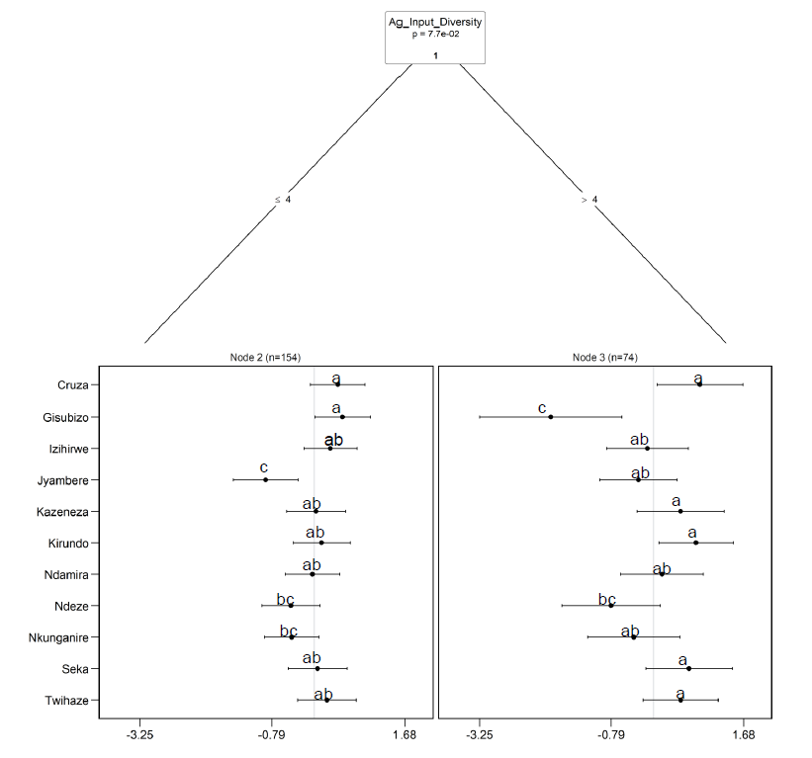

**Figure S3**. Plackett-Luce tree showing yield log-worth values with socio-economic household covariates. The x-axis of each panel shows the probability of winning varieties. Dots and bar present winning estimate and quasi-standard error. Vertical lines in each panel indicate the average value of winning probability (1/number of genotypes). In this case, the model selects covariate factor; Ag_input_Diversity: number of agricultural inputs to be put into the farm (e.g. fertilizer, pesticide.). Different letters indicate significant differences between the performance of varieties. Letters were allocated based on potato varieties' p-value matrix distance under the 0.05 threshold.

**Figure S4**. Plackett-Luce tree showing tuber appearance log-worth values with socio-economic household covariates. The x-axis of each panel shows the probability of winning varieties. Dots and bar present winning estimate and quasi-standard error. Vertical lines in each panel indicate the average value of winning probability (1/number of genotypes). In this case, the model selects covariate factors; Ag_input_Diversity: number of agricultural inputs to be put into the farm (e.g. fertilizer, pesticide.), and Respondentsex: participant farmers’ gender; F: Female and M:Male. Different letters indicate significant differences between the performance of varieties. Letters were allocated based on potato varieties' p-value matrix distance under the 0.05 threshold.