**Supplementary material**

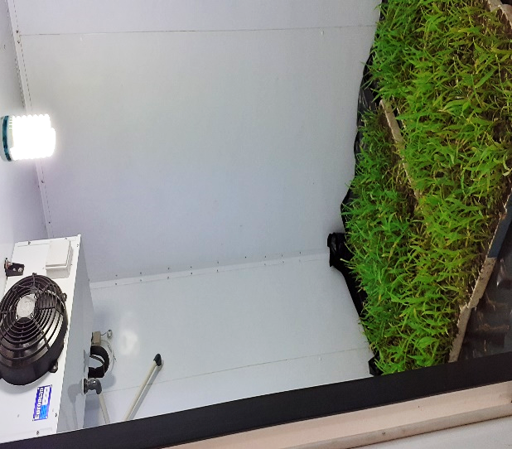

Figure S1. Induction of heat stress at 40 ºC to 21-day-old seedlings (late seedling stage) in a temperature-controlled growth chamber.

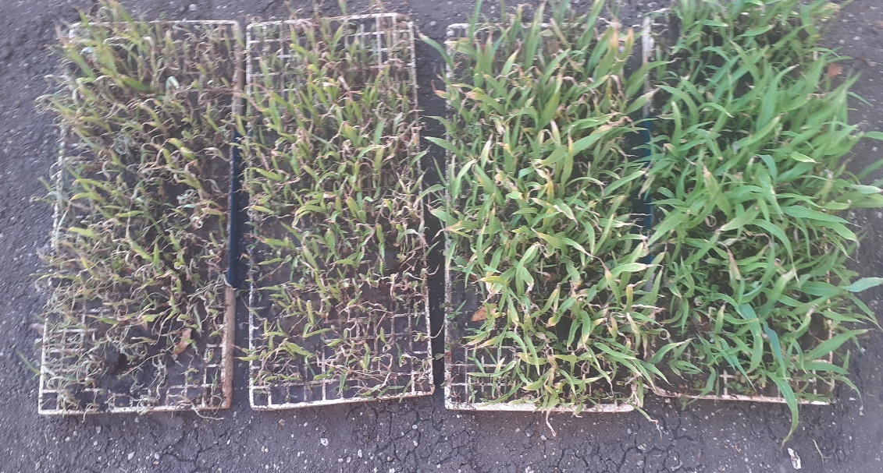

**d**

**c**

**b**

**a here**

Figure S2. Comparison of sorghum seedlings exposed to the four environments (a) combined stress, (b) drought stress, (c) heat stress and (d) no stress induced at 21 days after emergence.