Supplementary Materiel (FOR review)

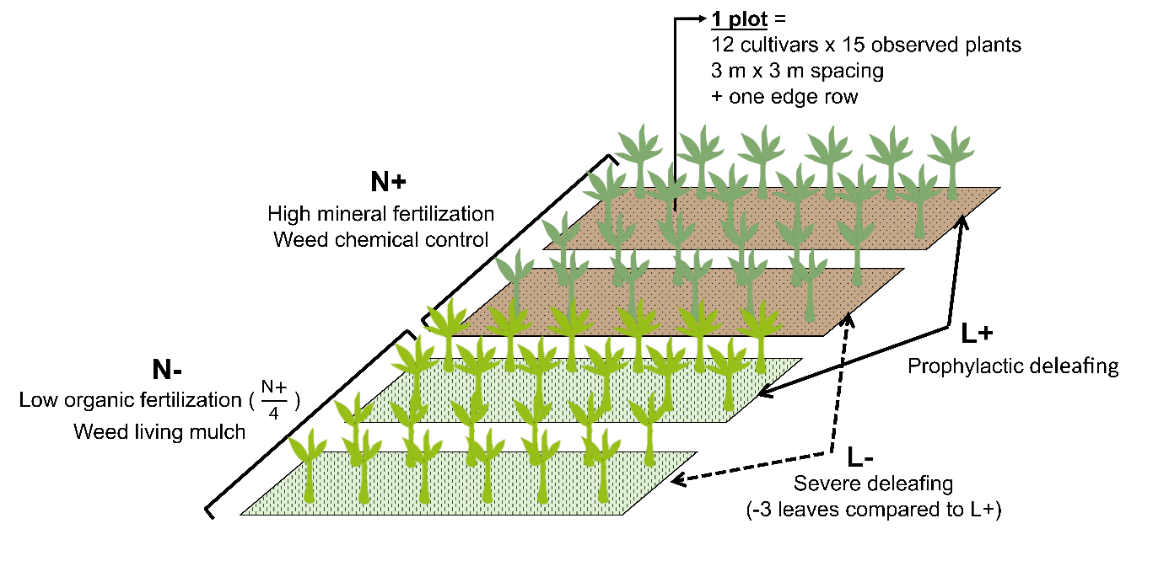
Figure S1: Description of the different crop management modalities (L+, L-, N+, N-) of the four elementary plots. We considered N+L+ plot as the agricultural potential. we considered the three other plots as being sub-optimal, with differences in terms of yield-limiting practices: N+L-: severe deleafing; N-L+: low nutrient conditions; N-L-: severe deleafing with low nutrient conditions.

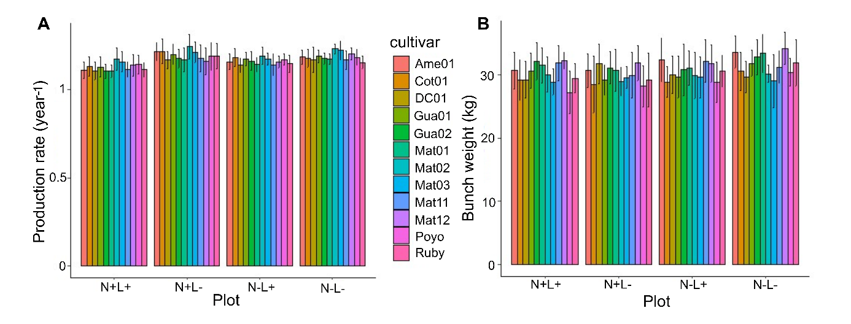
Figure S2: Mean production rate and mean bunch weight measured in the first crop cycle, in the four plots and for all cultivars.

Table S1: Average height and robustness of cultivars in the four elementary plots. The robustenss was calculated as the pseudostem girth 1m above the soil (cm) divised by the pseudostem height (cm). The ANOVA findings were highly significant for all plots (p<0.001). different letters indicate that the average values were significantly different (Tukey test, α = 0.05). We can see that the Tukey groups correspond to the three cavendish types: Dwarf, Giant and Robusta.
