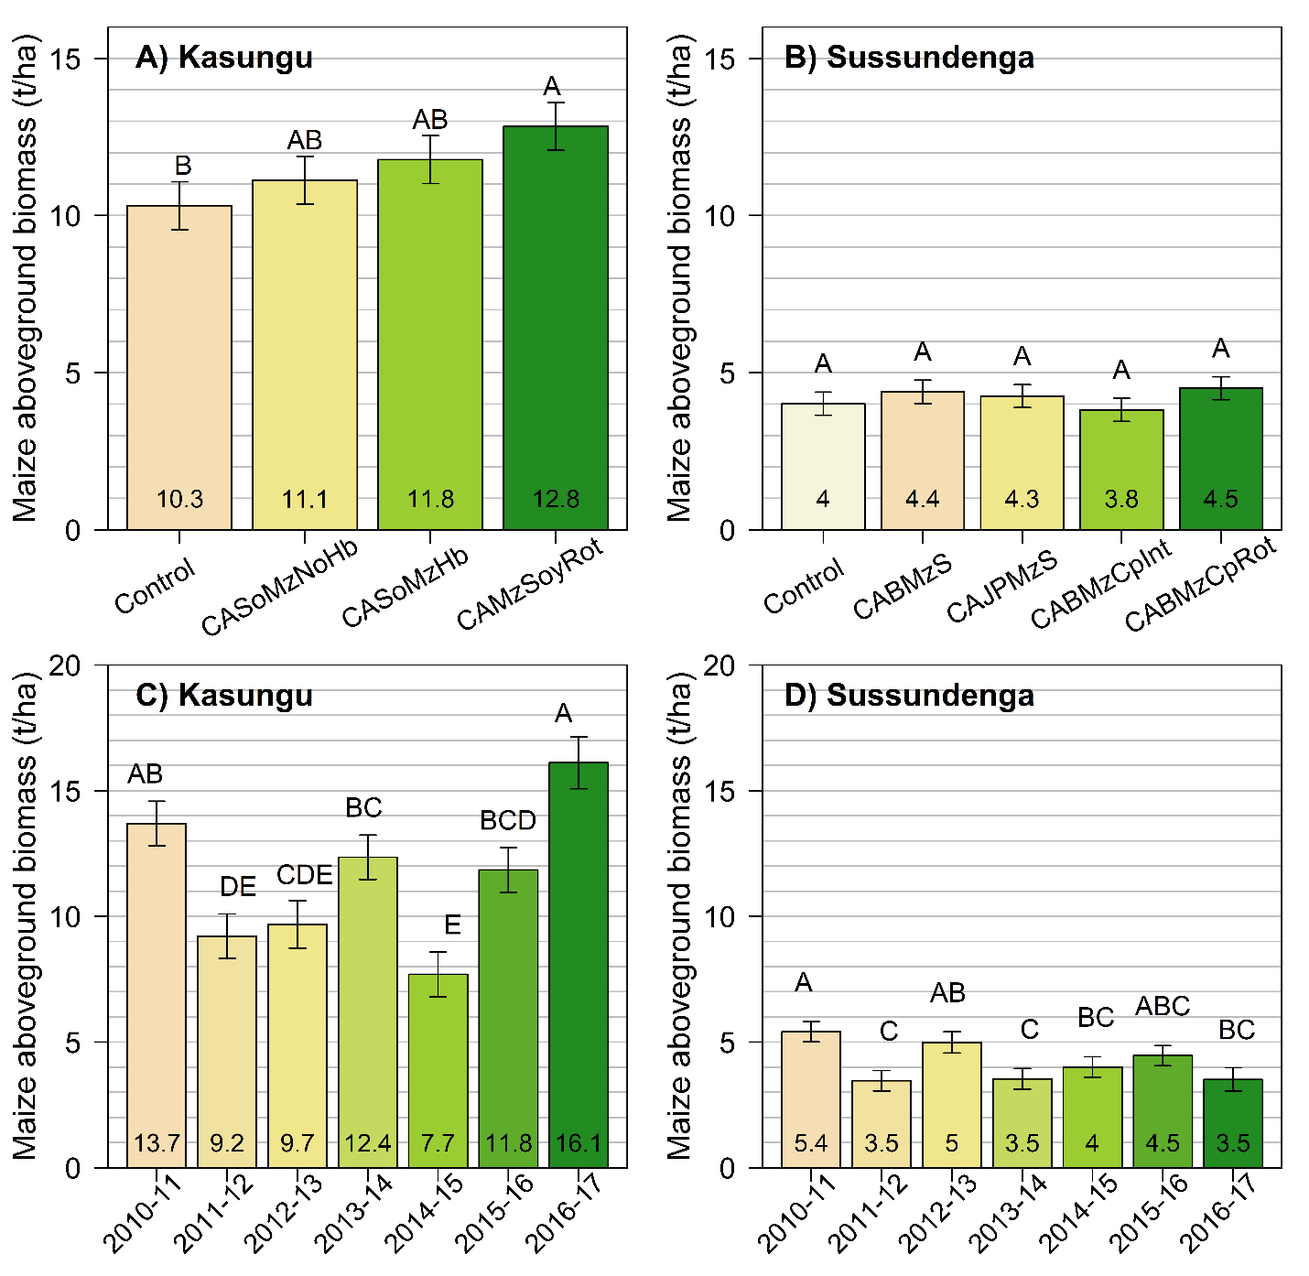

**Figure S1** Aboveground biomassacross the tested cropping systems (A-B) and the growing seasons in which the on-farm trials were conducted (C-D) at Kasungu, Malawi, and Sussundenga, Mozambique.Different letters above each bar denote significant differences in maize yield across cropping systems and growing seasons for each site considering a significance level of 5% (p<0.05). Please refer to Table 1 for the definition of the codes used for the different cropping systems.

**Table S1. Two-way and one-way ANOVA results for the effects of cropping systems and growing seasons on maize yield, aboveground biomass, and plant population at harvest at Kasungu, Malawi, and Sussundenga, Mozambique.**



**Table S2. Absolute and relative yield increases due to improved agronomy and CA averaged over seven consecutive growing seasons at Kasungu, Malawi, and Sussundenga, Mozambique. Please refer to Table 1 for a complete description of the cropping systems tested.**

