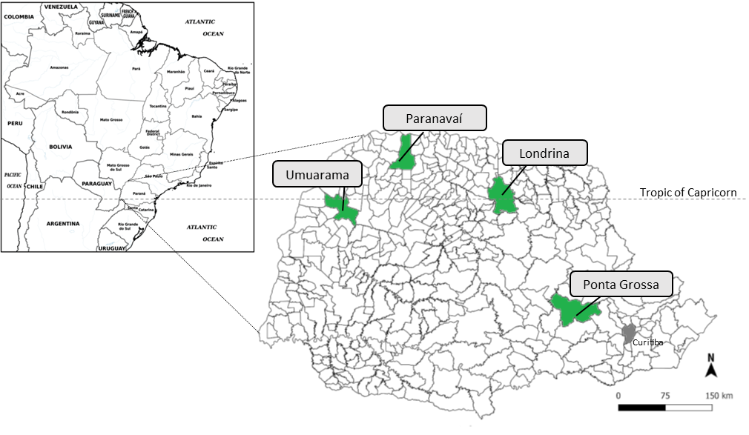

**Fig. S1.** Experimental field locations.

|  |  |
| --- | --- |
|  |  |
|  |  |

**Fig. S2.** Daily maximum and minimum temperature and rainfall during groundnut cropping. (a) Paranavaí, (b) Umuarama, (c) Ponta Grossa, (d) Londrina.

**Legend:** Sowing = and harvest =