Supplementary Materials

Exp. No. | Temperature (X1) |  | Na/Al (X2) |  | Response variable:
 | Coded | Real | Coded | Real | Compressive strength (MPa) (Y)
1 | 0.866 | 450 | 0.5 | 0.8 | 19.51
2 | 0.866 | 450 | -0.5 | 0.6 | 36.09
3 | 0 | 275 | -1 | 0.5 | 40.56
4 | -0.866 | 100 | -0.5 | 0.6 | 41.89
5 | -0.866 | 100 | 0.5 | 0.8 | 23.08
6 | 0 | 275 | 1 | 0.9 | 8.99
7 | 0 | 275 | 0 | 0.7 | 34.86
8 | 0 | 275 | 0 | 0.7 | 33.88
9 | 0 | 275 | 0 | 0.7 | 34.61
Table I- Conditions of geopolymer synthesis according to the Doehlert statistical design.

Table II- Analysis of variance (ANOVA) results for the full model.
Source | SS | Degrees of freedom | MS | Model F | Tabulated F | R² | Adjusted R ²
Model | 944.95 | 5 | 188.99 | 192.15 | 9.03 | 0,99 | 0,99
Error | 2.95 | 3 | 0.98
Total | 947.91 | 8 | 118.49
Pure error | 0.52 | 2 | 0.26 | 9.34 | 18.48
Lack of fit | 2.43 | 1 | 2.43

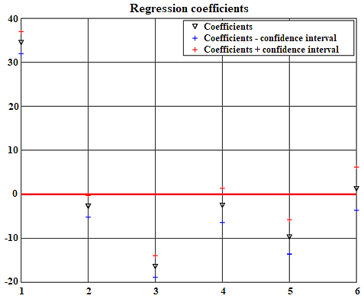

Figure I- Regression coefficients.
Table III- Analysis of variance (ANOVA) results for the recalculated model.
Source | SS | Degrees of freedom | MS | Model F | Tabulated F | R² | Adjusted R²
Model | 936.10 | 3 | 312.03 | 132.17 | 5.41 | 0,98 | 0,99
Error | 11.80 | 5 | 2.36
Total | 947.91 | 8 | 118.49
Pure error | 0.52 | 2 | 0.26 | 14.46 | 19.19
Lack of fit | 11.28 | 3 | 3.76

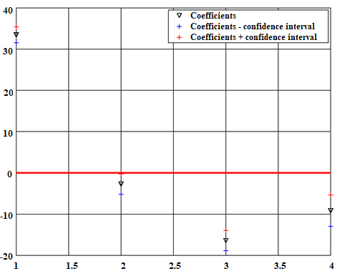

Figure II- Recalculated regression coefficients.

