**Coordination of aluminum in saponite-like clay material as a function of synthesis pH**

Liva Dzene1, Patrick Dutournié1, Séverinne Rigolet1, Loïc Vidal1, Benedikt Lassalle-Kaiser2, Delphine Vantelon2 and Erwan Paineau3

1Institut de Science des Matériaux de Mulhouse CNRS UMR 7361, Université de Haute-Alsace, Université de Strasbourg, 3b rue Alfred Werner, 68093 Mulhouse CEDEX, France

2Synchrotron SOLEIL, l’Orme des Merisiers, Départementale 128, 91190 Saint Aubin, France

3 Université Paris-Saclay, CNRS, Laboratoire de Physique des Solides, Orsay 91405, France

**SUPPORTING INFORMATION**



**Figure S1**. TEM image of synthetic saponite-like material with pHf = 9.7.

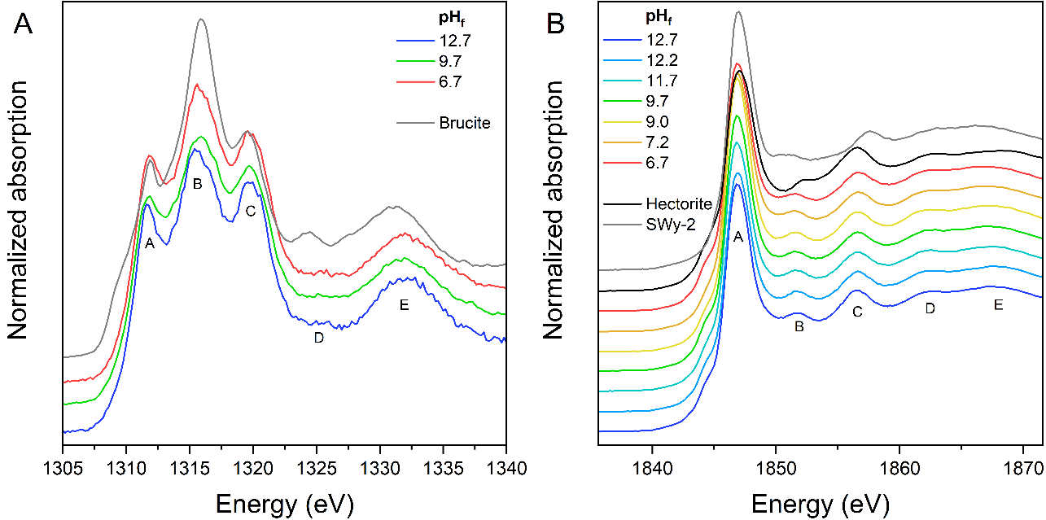

**Figure S2**. XANES spectra of synthetic saponite-like materials, along with mineral references, recorded at the Mg K-edge (A) and Si K-edge (B). The curves have been translated along the y-axis for clarity.

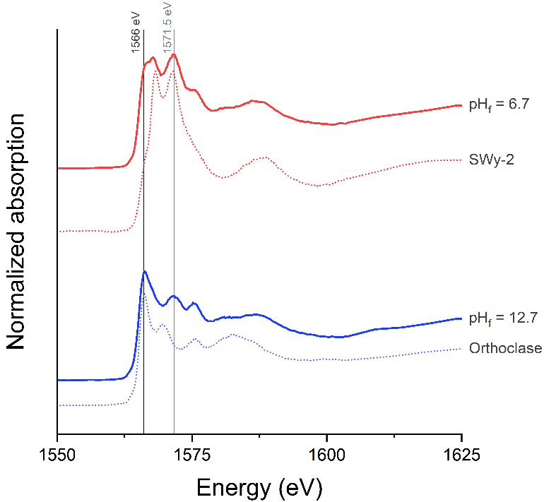

**Figure S3.** XANES spectra at the Al K-edge of the two outermost samples (pHf = 6.7 and 12.7), along with mineral references of IVAl (orthoclase) and mixed IVAl and VIAl (smectite SWy-2). 

**Figure S4.** Results of fitting the intermediate samples by linear combination using the spectral signatures of the two outermost samples (pHf = 6.7 and 12.7).