*Supplementary Information for*

**A molecular dynamics simulation study of paraquat intercalated** **montmorillonite**

Haotian Su1, Yingchun Zhang1, Xiandong Liu1*, Qingfeng Hou2 and Xiancai Lu1

1. State Key Laboratory for Mineral Deposits Research, School of Earth Sciences and Engineering, Nanjing University, Nanjing, Jiangsu 210023, P. R. China

2. State Key Laboratory of Enhanced Oil Recovery, Research Institute of Petroleum Exploration and Development, China National Petroleum Corporation (CNPC), Beijing 100083, P. R. China.

*Corresponding author. Fax: +86 25 83686016.

E-mail address: xiandongliu@nju.edu.cn (X. Liu).

This file includes interlayer structure in PQ-46 and PQ-93 system, Tables S1 to S2 and Fig. S1 to Fig. S6.

**Table S1.** Compositions of the simulated systems.

|  |  |  |  |  |
| --- | --- | --- | --- | --- |
|  | Chemical formula | No. of PQ | No. of Na+ | No. of water |
| paraquat-0.84-Mnt | Na0.17PQ0.33[Si7.75Al0.25]  [Al2.88Fe3+0.54Mg0.58]O20(OH)4 | 8 | 4 | 0 |
| paraquat-1.0-Mnt | PQ0.5[Si8][Al3.0Mg1.0]O20(OH)4 | 12 | 0 | 0, 25, ...375, 400, 450, 500, 550, 600 |

**Table S2.** Partial charges and nonbond force field parameters for PQ cation.

|  |  |  |  |
| --- | --- | --- | --- |
| Atom | charges/*e* | *ϵ* (kcal/mol) | *σ* (Å) |
| N | -0.3682 | 0.1669 | 3.5012 |
| C1 | -0.1333 | 0.0389 | 3.8754 |
| C2 | 0.1369 | 0.1479 | 3.6170 |
| C3 | -0.0279 | 0.1479 | 3.6170 |
| C4 | 0.0362 | 0.1479 | 3.6170 |
| H1 | 0.2053 | 0.0380 | 2.4499 |
| H2 | 0.1778 | 0.0380 | 2.4499 |
| H3 | 0.1379 | 0.0380 | 2.4499 |

*ϵ* and *σ* are the parameters from the standard 12/6 Lennard-Jones potential.

The partial charges of PQ were obtained using the Charge Equilibration method (QEq) (Rappe & Goddard, 1991).

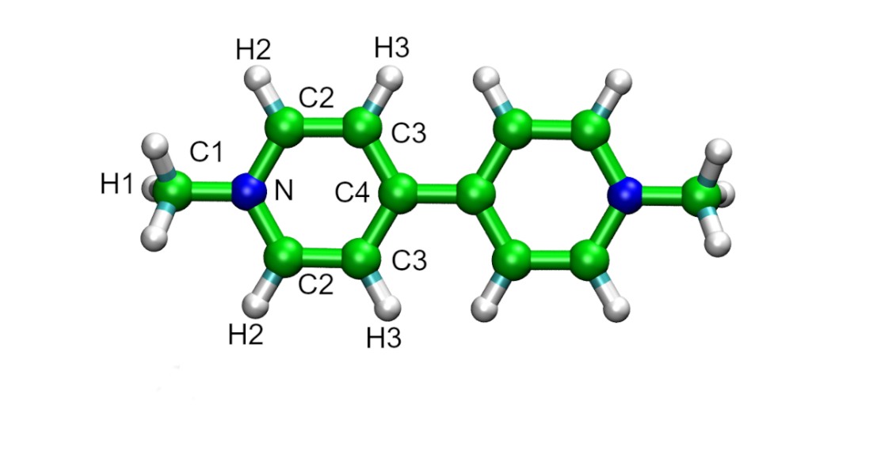

**Fig. S1.** Paraquat cation atom labels.

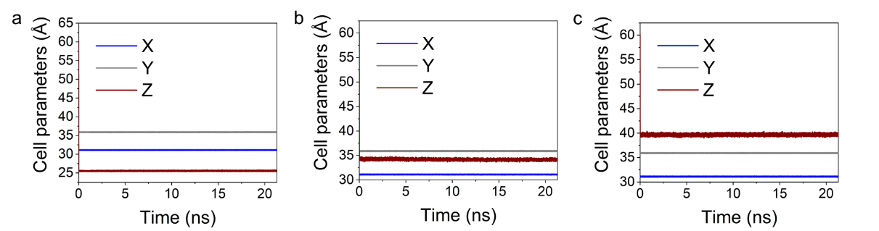

**Fig. S2.** Temporal evolution of cell parameters during NPT simulations (21.3 ns in total) for a: PQ-0, b: PQ-185, and c: PQ-278.

**Interlayer structure in PQ-46 and PQ-93 system.**

In PQ-46 and PQ-93 systems (i.e. water contents below 100 mgwater/gclay), PQ molecules formed a monolayer configuration where PQ molecules adopted a titled orientation (Fig. S3) and the tilt angle increased with interlayer water content. Water molecules in both systems also showed layering configuration. However, the number of water molecules is not enough to form a complete hydration layer (Fig. S3), resulting a very high immersion energy shown in Fig. 3.

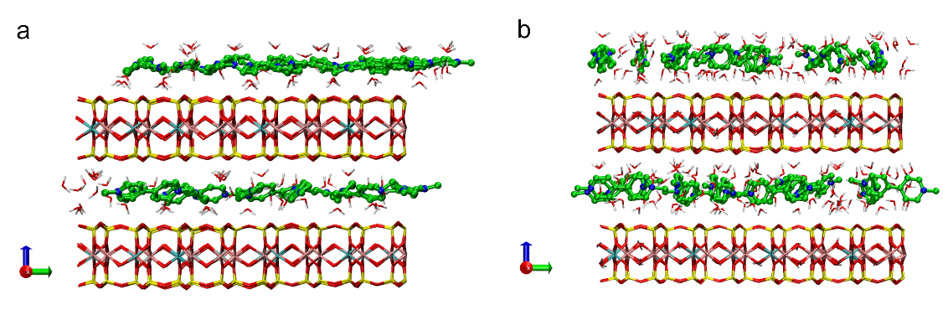

**Fig. S3.** Snapshots of the PQ-1.0-Mnt systems at less than 100 mgwater/gclay. a: PQ-46 system; and b: PQ-93 system; C=green, N=blue, H=white, O=red, Si=yellow, Mg=cyan, and Al=pink. Hydrogen atoms of paraquat molecules were not shown for clarity.

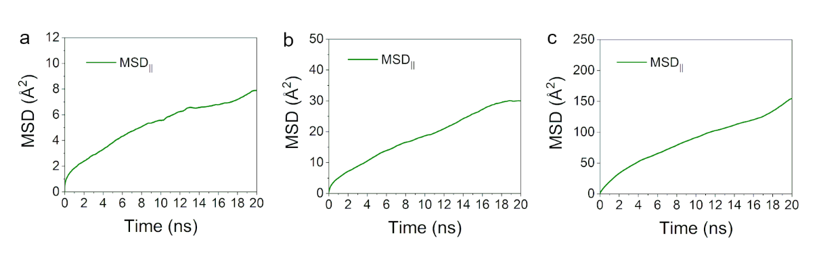

**Fig. S4.** The mean squared displacement (MSD) curve with a total duration of 20ns, a: PQ-0, b: PQ-185, and c: PQ-278.

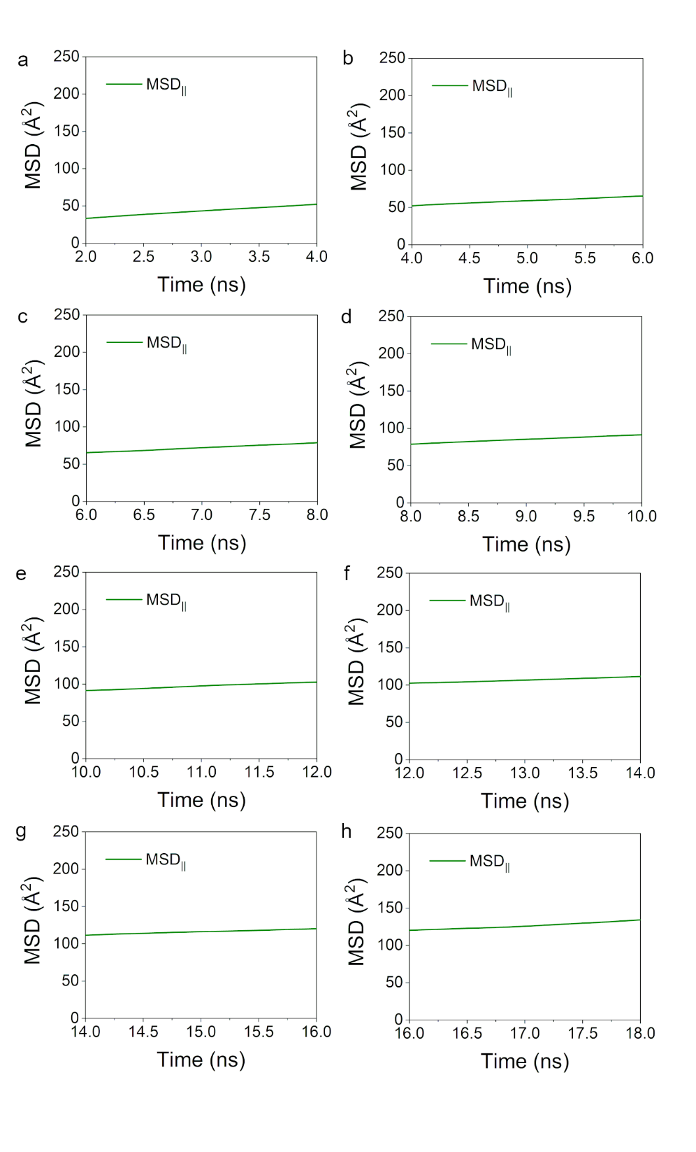

**Fig. S5** The mean squared displacement (MSD) curve of 2 ns with a segmented calculation of the self-diffusion coefficient (taking PQ-278 as an example, others are similar) a: 2~4 ns, b: 4~6 ns, c: 6~8 ns, d: 8~10 ns, e: 10~12 ns, f: 12~14 ns, g: 14~16 ns, and h: 16~18 ns.

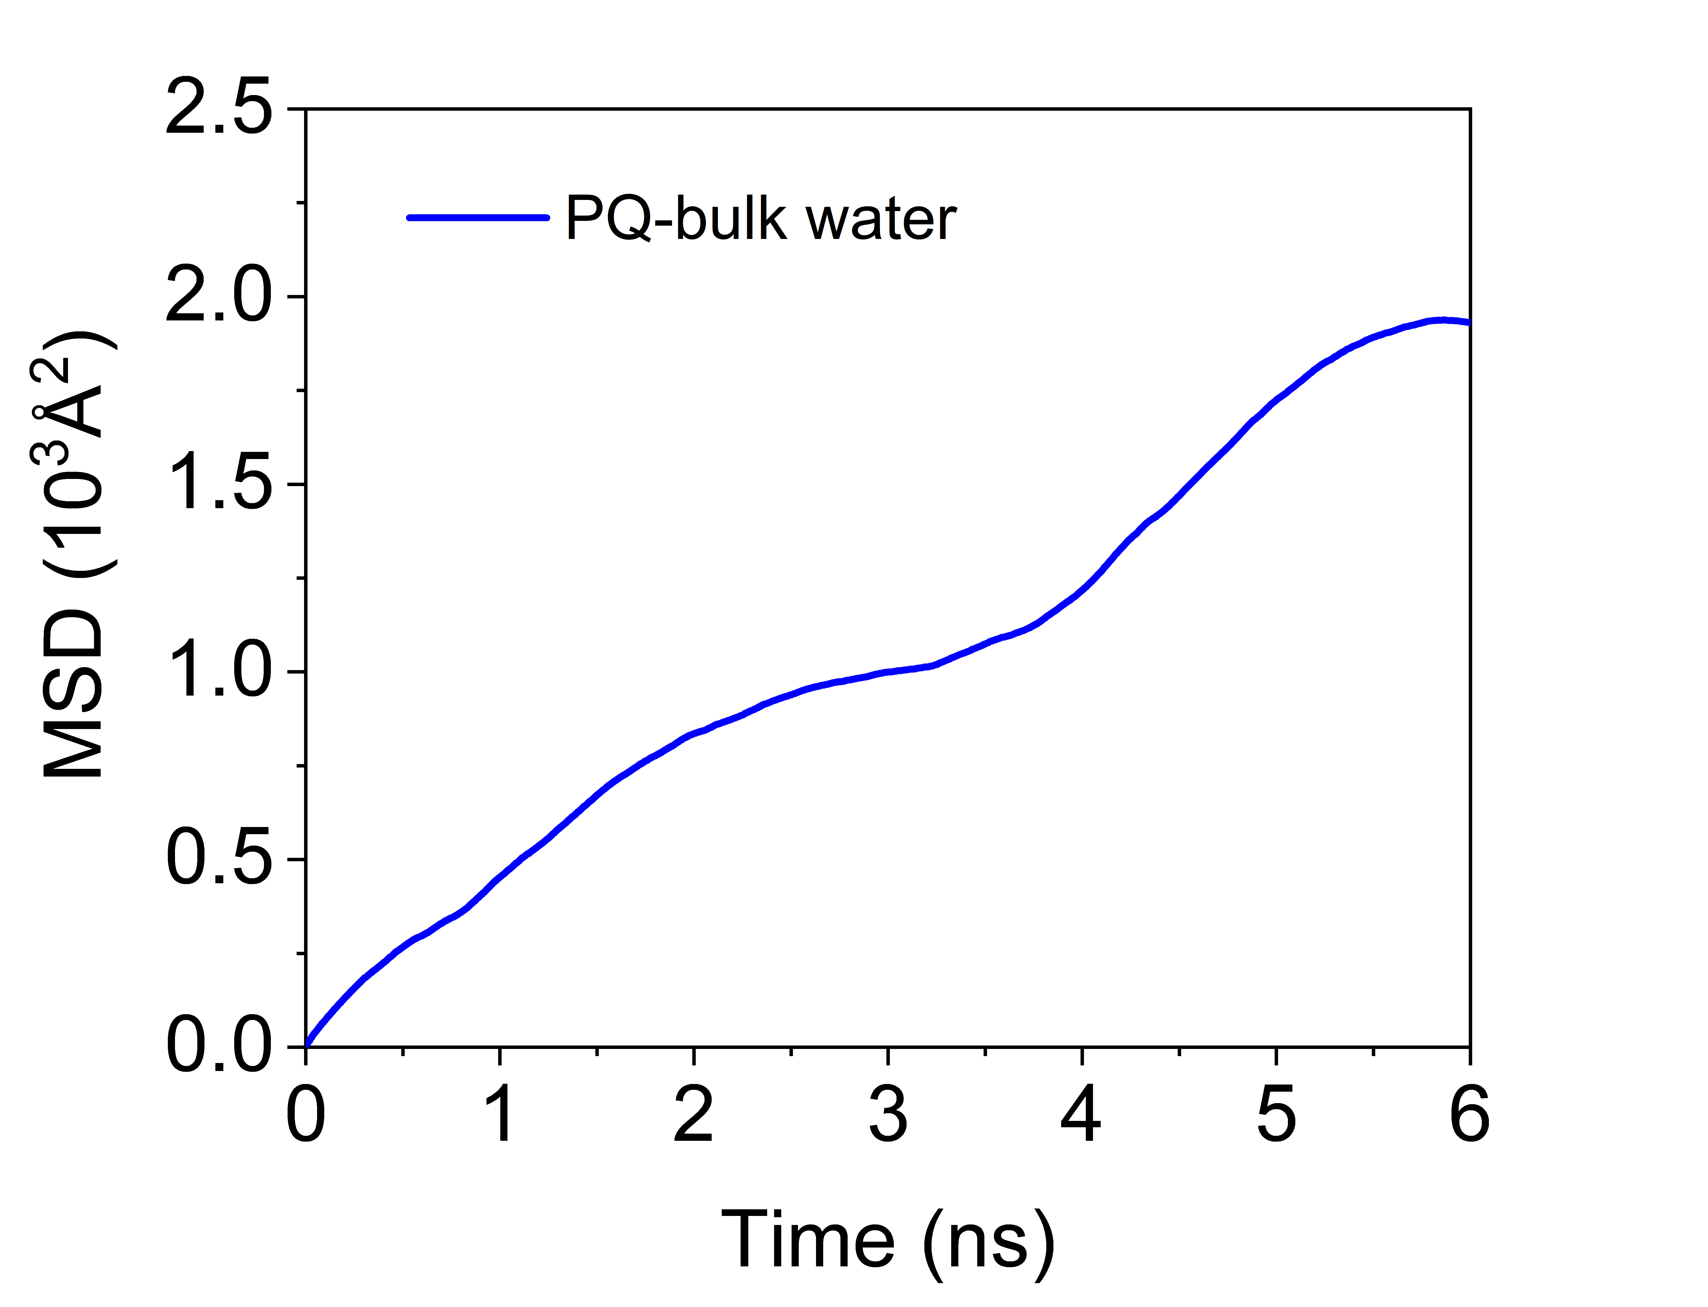

**Fig. S6.** The mean squared displacement (MSD) of paraquat (PQ) in bulk water system.

We randomly placed 882 water molecules, one PQ cation, and two Cl- in a $30×30×30Å$ cube box. We performed 10 ns NPT (298K, 1atm) simulation, followed by 6 ns NVT (298K) simulation. The MSD and self-diffusion coefficient of PQ were calculated using the NVT trajectory.



**Fig. S7.** The mean squared displacement (MSD) of water in PQ-185 and PQ-278 systems.

**References**

Dauber-Osguthor P., Roberts, A.V., Osguthorpe, J.D., Wolff, J., Genest, M. & Hagler, T.A. (1988) Structure and energetics of ligand binding to proteins: E. coli dihydrofolate reductase-trimethoprim, a drug-receptor system. *Proteins: Structure, Function and Genetics,**4,* 31-47.

Rappe, K.A., & Goddard III, W.A. (1991). Charge equilibration for molecular dynamics simulations. *The Journal of Physical Chemistry*, *95*, 3358-3363.