SUPPLEMENTARY MATERIALS
Highly Efficient of TiO₂ Pillared Smectite Clay with Ni and Co Doping for Rhodamine B Removal: Kinetics of Adsorption and Photodegradation

Adi Darmawan ^{1,*}, Setyo Sulaksono ¹, Muhamad Samsul Arifin ¹, Hasan Muhtar ¹, Sriyanti ¹
¹ Department of Chemistry, Diponegoro University, Tembalang, Semarang 50275, Indonesia
* Corresponding author: Tel: +62-822-2121-9817, email: adidarmawan@live.undip.ac.id

a | 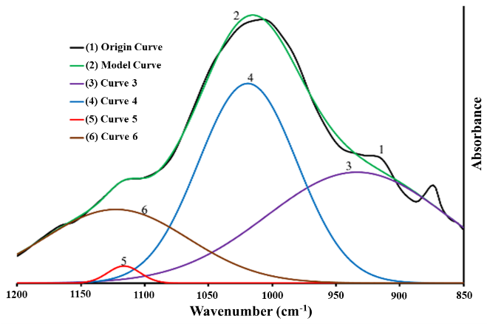 | b | 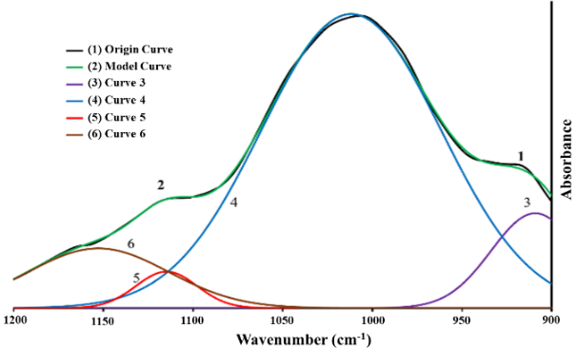
c | 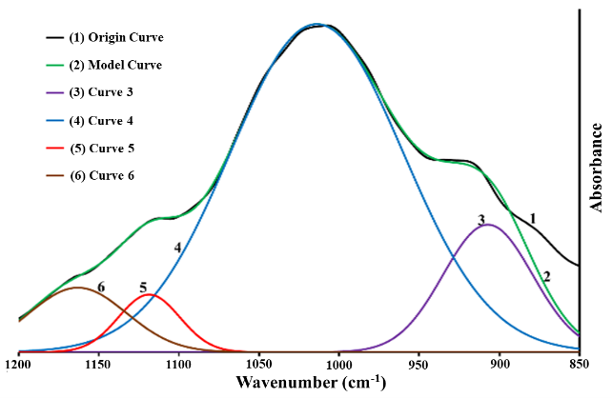 | d | 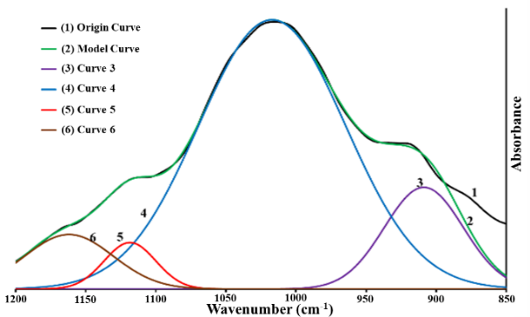
e | 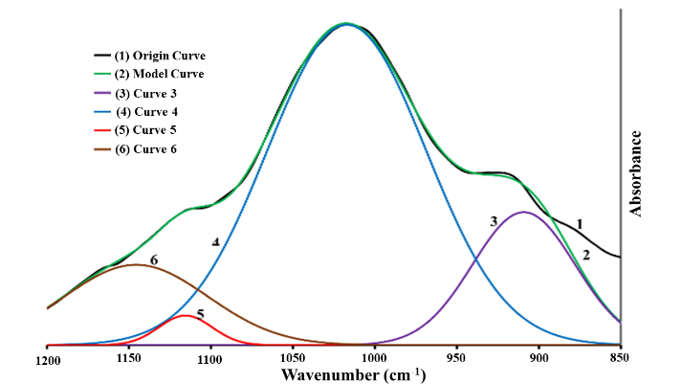
Figure S1. Deconvulation of the FTIR spectra of (a) Clay (b) Clay + EtOH (c) Ti/Clay (d) Ni-Ti/Clay and (e) Co-Ti/Clay
a | 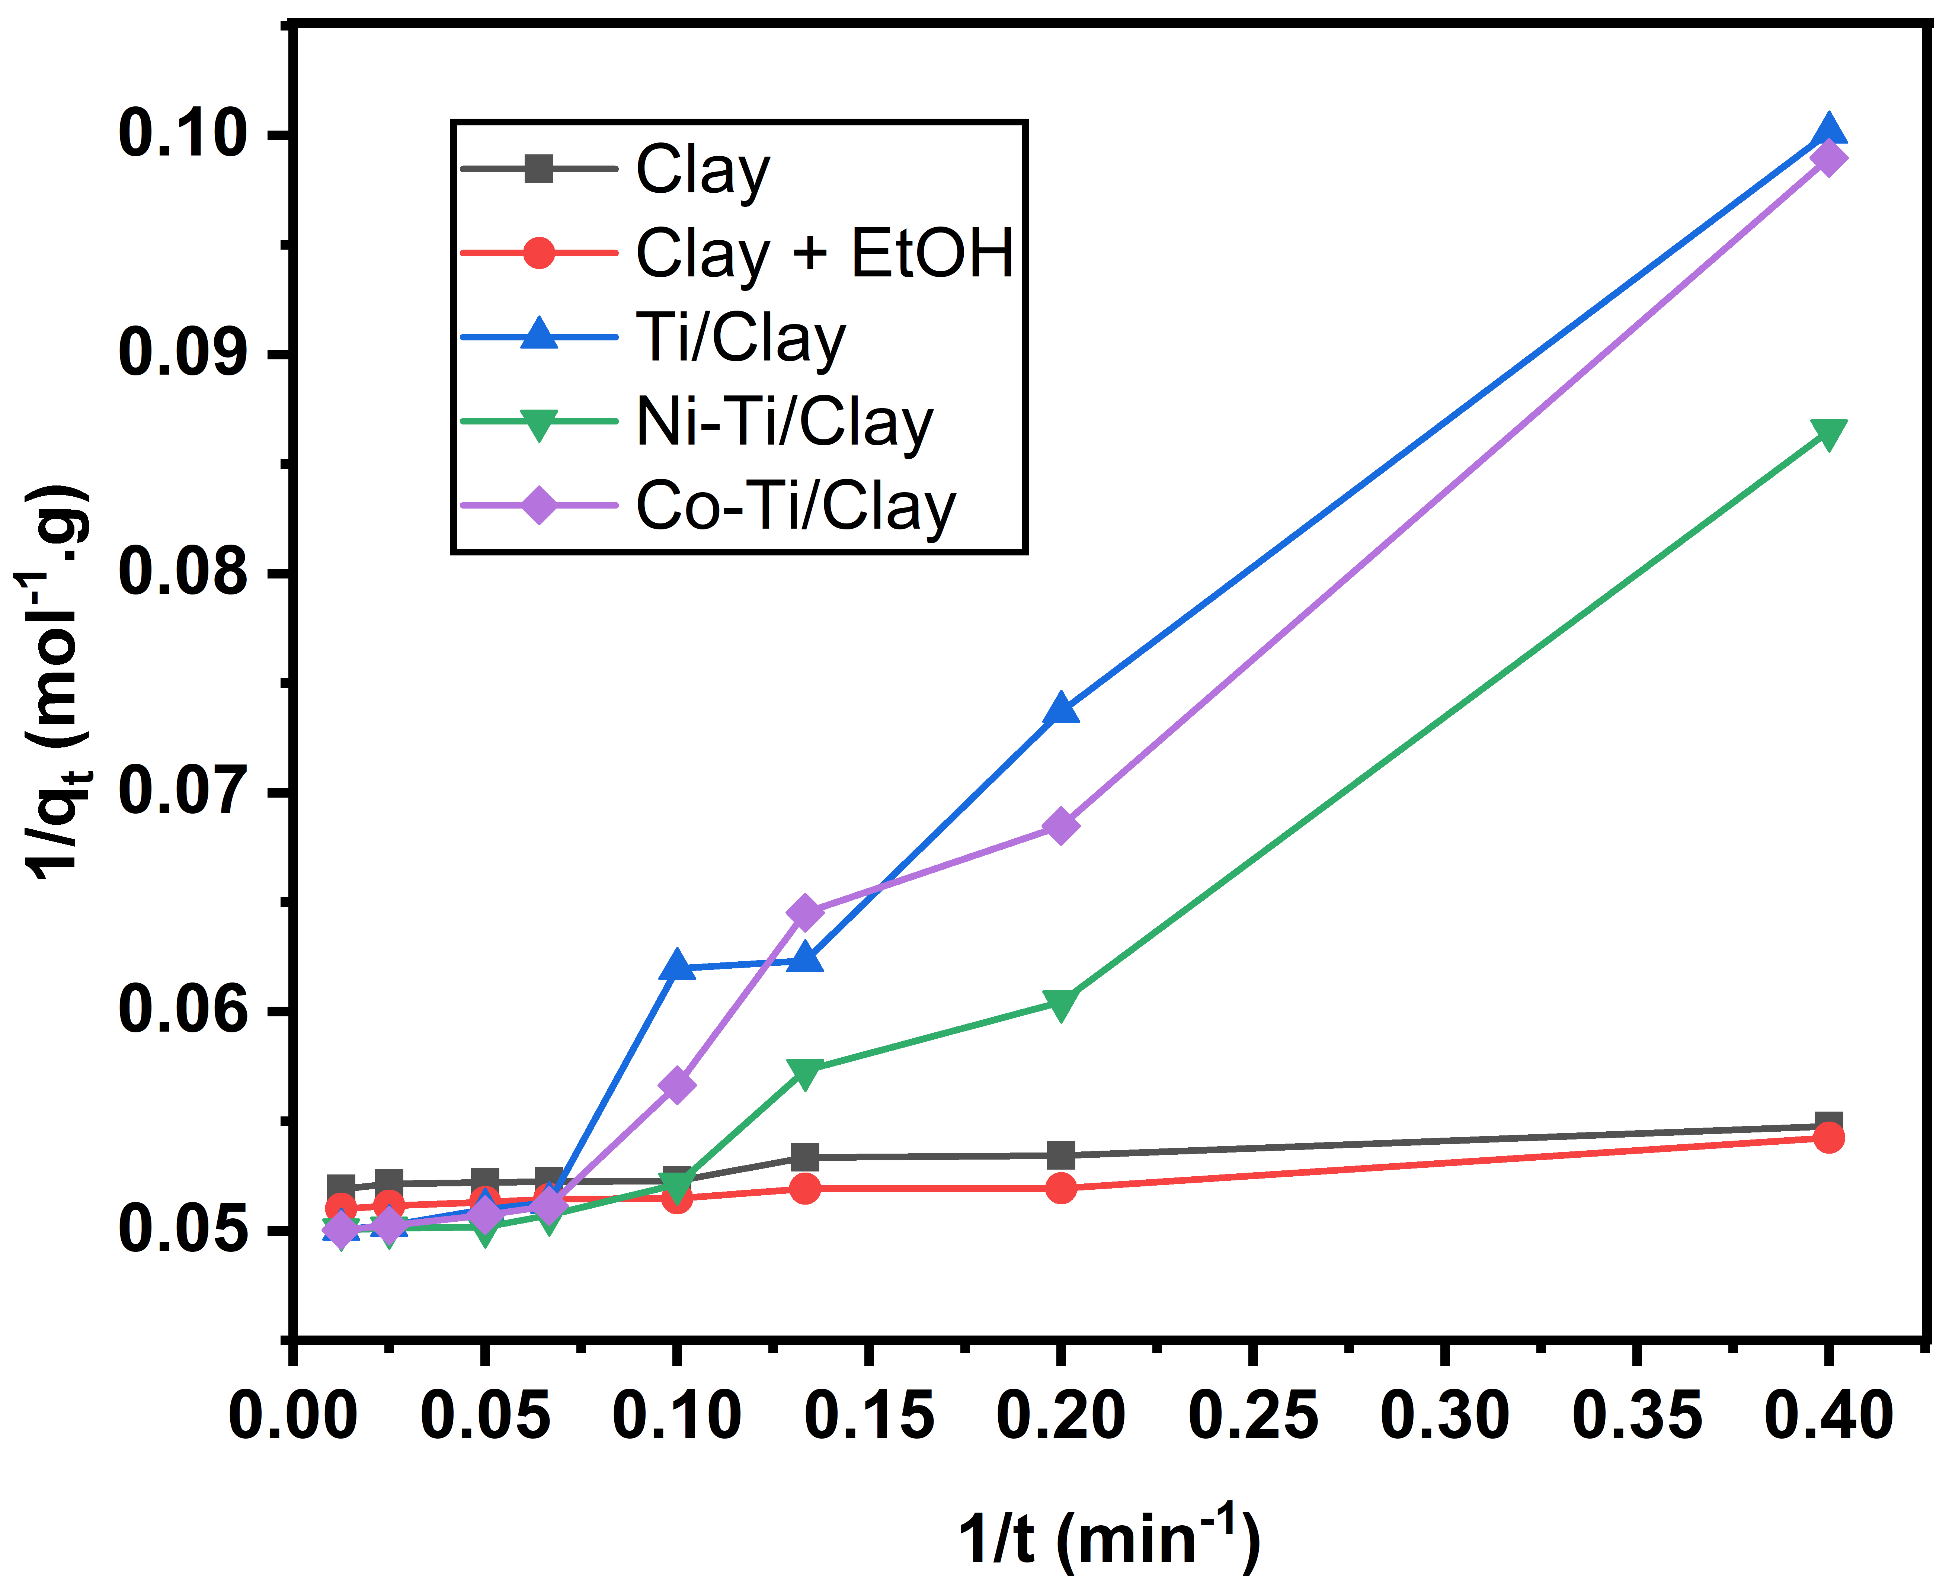 | b | 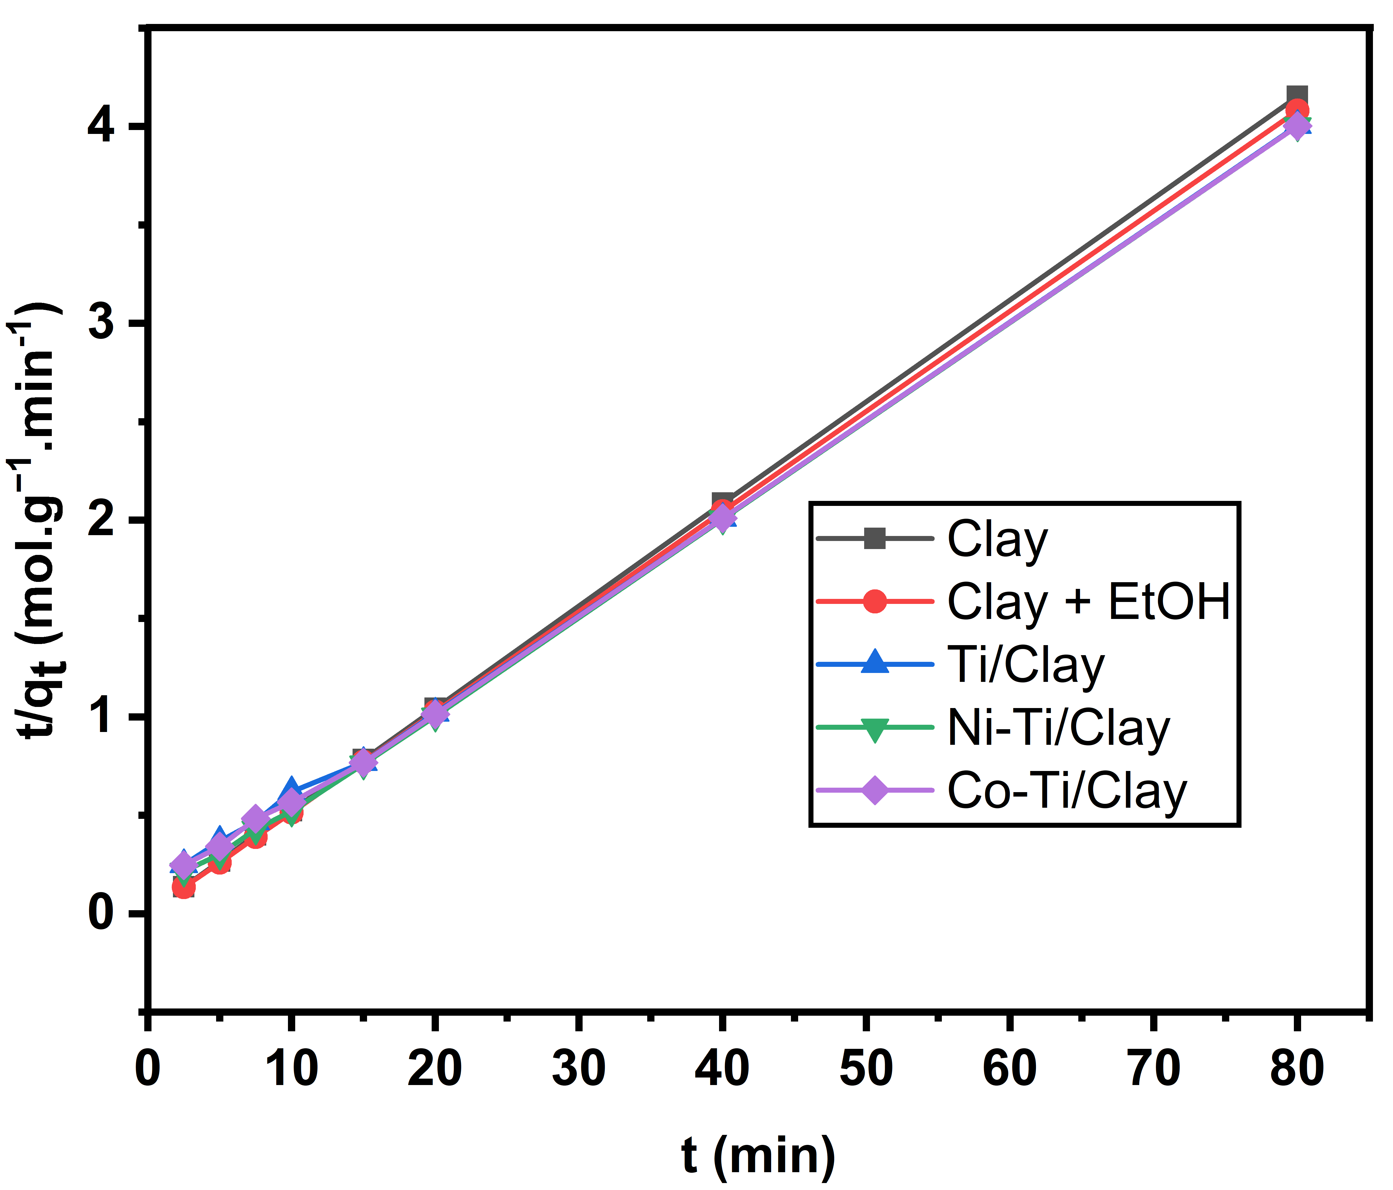
Figure S2. RhB adsorption kinetics curves on Clay, Clay + EtOH, Ti/Clay, Ni-Ti/Clay, and Co-Ti/Clay (a) pseudo-first order and (b) pseudo-second order
Table S1. Adsorption isotherm model and correlation coefficient (R) for RhB in Clay, Clay + EtOH, Ti/Clay, Ni-Ti/Clay, and Co-Ti/Clay at 298 K
Isotherm Model | Linear form equation | Figure axis | Correlation coefficient (r)
 |  |  | Clay | Clay + EtOH | Ti/Clay | Ni-Ti/Clay |  | Co-Ti/Clay
Langmuir | $$\frac{C_{e}}{Q_{e}}=\frac{1}{b Q_{max}}+ \frac{C_{e}}{Q_{max}}$$ | $\frac{C_{e}}{Qe}$ vs C_{e} | 0.998 | 0.999 | 0.998 | 0.997 |  | 0.999
Freundlich | log Q_{e} = n log C_{e} + log Q_{max} | log Q_{e} vs log C_{e} | 0.98 | 0.985 | 0.997 | 0.997 |  | 0.996
Temkin | Q_{e} = $(\frac{2.303}{a})($log Q_{max)} + log C_{e} | Q_{e} vs log C_{e} | 0.955 | 0.946 | 0.905 | 0.904 |  | 0.908

Table S2. Kinetic order model and correlation coefficient (r) for RhB in Clay, Clay + EtOH, Ti/Clay, Ni-Ti/Clay, and Co-Ti/Clay at 298 K
Sampel | Linear form equation | Figure axis | Correlation coefficient (r)
 |  |  | Clay | Clay + EtOH | Ti/Clay | Ni-Ti/Clay | Co-Ti/Clay
Pseudo-first-order | $$\frac{1}{q_{t}}=\left(\frac{k_{1}}{q_{1}}\right)\left(\frac{1}{t}\right)+ \frac{1}{q_{1}}$$ | $\frac{1}{qt}$ vs $\frac{1}{t}$ | 0.999 | 0.999 | 0.999 | 0.999 | 0.999
Pseudo-second-order | $$\frac{t}{q_{t}}=(\frac{1}{q_{2}})t+\frac{1}{k_{2}.q_{2}^{2}}$$ | $\frac{t}{q_{t}}$ vs t | 0.944 | 0.954 | 0.985 | 0.952 | 0.98

