Supporting Information
CLAY MINERALOGY OF SURFACE SEDIMENT IN THE THREE GORGES RESERVOIR: IMPLICATIONS FOR SEDIMENT PROVENANCE AND WEATHERING REGIME
SHUAI WANG¹, WENBO RAO^{1*}, JIN QIAN^{2*}, MENGYING HE³, CHANGPING MAO¹, KUN LI², YUEXING FENG⁴, JIANXIN ZHAO⁴
¹College of Earth Sciences and Engineering, Jiangning Campus of Hohai University, Nanjing 211100, China
²College of Environment, Gulou Campus of Hohai University, Nanjing 210098, China
³School of Geography Science, Nanjing Normal University, Nanjing 210046, China
⁴Radiogenic Isotope Facility, The University of Queensland, Brisbane QLD 4072, Australia
*Corresponding author
E-mail: raowenbo@163.com, hhuqj@hhu.edu.cn.
The supplementary materials include 3 figures and 3 tables.

Fig. S1 Ternary diagram showing textures of mainstream, tributary sediments and hillslope soils in the TGR Basin
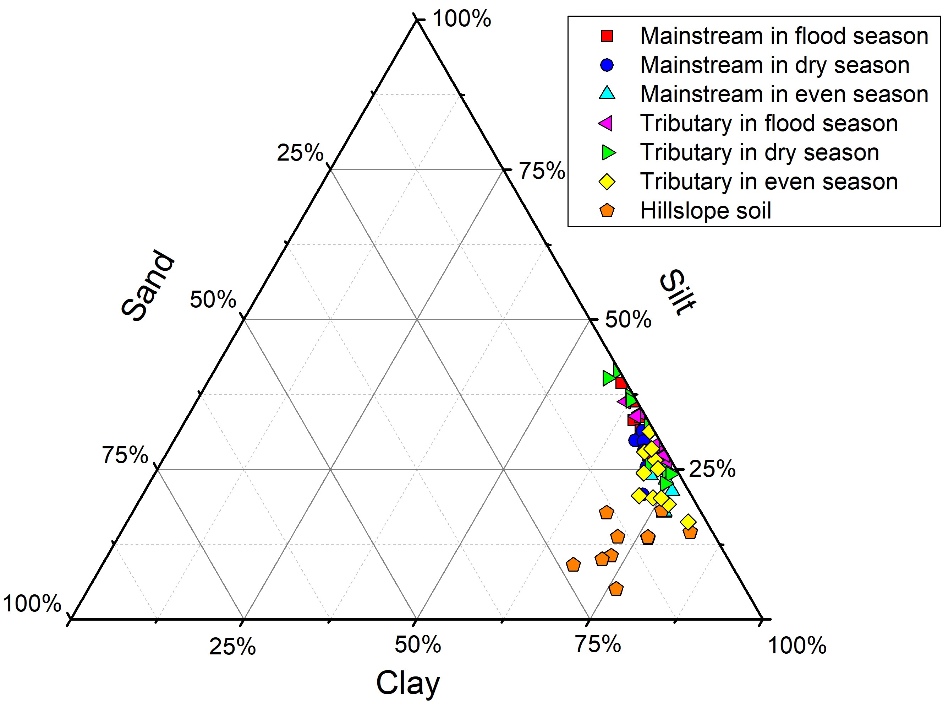

Fig. S2 XRD patterns of the bulk samples in the TGR. Abbreviations: I = illite, K/C = kaolinite/chlorite, Q = quartz, K-f = K-feldspar, P = plagioclase

Fig. S3 Triangle diagrams of major and trace elements in sediments for TGR and potential sources. The data of distal source were from He et al. (2015)
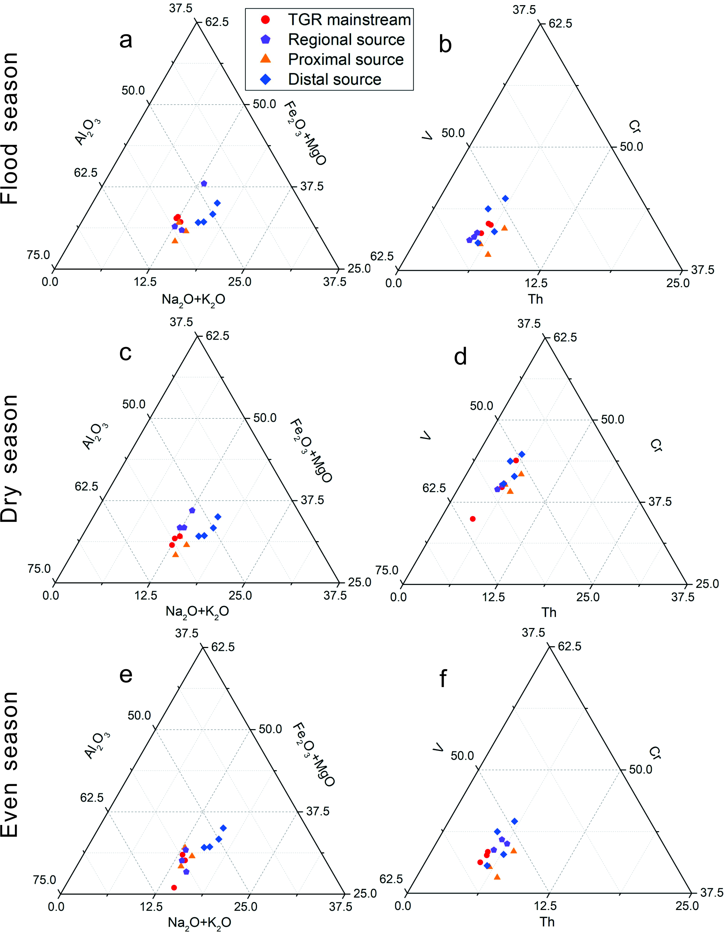

Table S1 Mineral composition of sediments and hillslope soil in the TGR
No. | Site | Season | Quartz (%) | Plagioclase (%) | K-feldspar (%) | Clay mineral (%)
1 | M1 | Flood season | 55.03 | 10.65 | 6.24 | 28.08
2 | M2 | Flood season | 49.09 | 20.97 | 10.20 | 19.73
3 | M3 | Flood season | 46.78 | 15.63 | 10.59 | 27.00
4 | M4 | Flood season | 58.20 | 12.12 | 6.36 | 23.32
5 | M5 | Flood season | 55.06 | 11.85 | 5.87 | 27.21
6 | M6 | Flood season | 44.31 | 33.59 | 5.63 | 16.48
7 | M7 | Flood season | 54.26 | 12.53 | 14.17 | 19.03
8 | M8 | Flood season | 54.62 | 13.26 | 9.28 | 22.84
9 | M1 | Dry season | 50.99 | 12.84 | 9.69 | 26.49
10 | M2 | Dry season | 50.40 | 12.69 | 19.49 | 17.42
11 | M3 | Dry season | 54.70 | 19.92 | 6.67 | 18.71
12 | M4 | Dry season | 51.54 | 12.09 | 9.12 | 27.25
13 | M5 | Dry season | 47.20 | 13.47 | 7.95 | 31.38
14 | M6 | Dry season | 57.44 | 14.35 | 8.88 | 19.32
15 | M7 | Dry season | 56.06 | 13.80 | 8.19 | 21.96
16 | M8 | Dry season | 53.23 | 14.13 | 8.85 | 23.79
17 | M1 | Even season | 51.66 | 15.11 | 7.55 | 25.68
18 | M2 | Even season | 49.79 | 15.26 | 9.44 | 25.52
19 | M3 | Even season | 54.52 | 12.34 | 7.54 | 25.60
20 | M4 | Even season | 55.40 | 13.03 | 14.18 | 17.39
21 | M5 | Even season | 48.88 | 12.42 | 8.64 | 30.06
22 | M6 | Even season | 49.41 | 14.79 | 6.42 | 29.37
23 | M7 | Even season | 49.99 | 17.81 | 8.28 | 23.92
24 | M8 | Even season | 52.33 | 14.67 | 5.00 | 28.00
25 | Jiuwanxi | Flood season | 56.93 | 11.07 | 17.86 | 14.14
26 | Xiangxihe | Flood season | 60.64 | 14.54 | 10.53 | 14.29
27 | Shennongxi | Flood season | 65.76 | 7.83 | 5.95 | 20.46
28 | Daninghe | Flood season | 59.41 | 8.44 | 6.91 | 25.25
29 | Meixihe | Flood season | 56.67 | 10.42 | 9.77 | 23.14
30 | Changtanhe | Flood season | 57.07 | 7.95 | 6.84 | 28.14
31 | Modaoxi | Flood season | 52.13 | 11.36 | 8.95 | 27.56
32 | Tangxihe | Flood season | 57.54 | 17.17 | 6.76 | 18.52
33 | Pengxihe | Flood season | 63.70 | 13.33 | 7.82 | 15.15
34 | Jiuwanxi | Dry season | 68.28 | 9.91 | 7.17 | 14.64
35 | Xiangxihe | Dry season | 60.15 | 8.84 | 6.55 | 24.47
36 | Shennongxi | Dry season | 62.62 | 7.81 | 7.65 | 21.93
37 | Daninghe | Dry season | 63.42 | 8.14 | 7.17 | 21.27
38 | Meixihe | Dry season | 62.32 | 13.06 | 6.04 | 18.58
39 | Changtanhe | Dry season | 51.45 | 13.05 | 9.06 | 26.45
40 | Modaoxi | Dry season | 60.14 | 14.18 | 5.09 | 20.59
41 | Tangxihe | Dry season | 61.06 | 14.62 | 5.54 | 18.78
42 | Pengxihe | Dry season | 68.28 | 9.91 | 7.17 | 14.64
43 | Jiuwanxi | Even season | 70.20 | 10.04 | 9.36 | 10.40
44 | Xiangxihe | Even season | 64.56 | 13.00 | 6.04 | 16.40
45 | Shennongxi | Even season | 51.56 | 10.34 | 5.17 | 32.93
46 | Daninghe | Even season | 71.21 | 6.19 | 6.90 | 15.70
47 | Meixihe | Even season | 49.79 | 10.50 | 5.84 | 33.87
48 | Changtanhe | Even season | 64.66 | 10.02 | 7.74 | 17.57
49 | Modaoxi | Even season | 48.09 | 16.37 | 16.79 | 18.74
50 | Tangxihe | Even season | 61.41 | 13.80 | 8.93 | 15.86
51 | Pengxihe | Even season | 58.20 | 13.62 | 10.08 | 18.10
52 | Longhe | Even season | 59.18 | 12.36 | 13.87 | 14.59
53 | Wujiang | Even season | 63.58 | 17.37 | 6.63 | 12.42
54 | S1 | \ | 77.34 | 8.06 | 5.71 | 8.89
55 | S2 | \ | 80.72 | 8.53 | 5.12 | 5.63
56 | S3 | \ | 64.16 | 15.72 | 6.97 | 13.15
57 | S4 | \ | 56.12 | 22.71 | 10.10 | 11.07
58 | S5 | \ | 50.10 | 18.35 | 11.40 | 20.14
59 | S6 | \ | 64.03 | 16.95 | 5.22 | 13.79
60 | S7 | \ | 62.40 | 11.39 | 5.81 | 20.40
61 | S8 | \ | 74.00 | 8.38 | 8.32 | 9.30
62 | S9 | \ | 54.56 | 20.14 | 8.92 | 16.39
63 | S10 | \ | 63.65 | 14.24 | 4.48 | 17.63

Table S2 Annual sediment discharge of each source to the TGR
Sources | River | Sediment discharge (Mt/a) | References
Distal | Jinshajiang | 139 | Yang et al. (2014)
Distal | Minjiang | 29 | Yang et al. (2014)
Distal | Jialingjiang | 29 | Yang et al. (2014)
Distal | Yalongjiang | 12 | CWRC, 2003-2017
Distal | Daduhe | N/A
Regional | Regional tributaries | 37 | Yang et al. (2014)
Proximal |  | 40 | Liu et al. (2016a)

Table S3 Average clay mineral assemblages of TGR and various rivers in the world
Locations | Smectite (%) | Illite  (%) | Kaolinite (%) | Chlorite (%) | References
TGR (n=24) | 3.37 | 74.68 | 12.50 | 9.48 | this study
Yangtze River (n=32) | 2.26 | 72.76 | 10.82 | 14.16 | He et al. (2013)
Yellow River (n=18) | 20.89 | 52.99 | 6.47 | 19.63 | Pang et al. (2018)
Zhejiang and Fujian rivers (n=28) | 15.36 | 34.43 | 32.43 | 17.64 | Xu a et al. (2009)  Xu et al. (2013b)  Liu et al. (2016)
Taiwanese rivers (n=19) | 0 | 72.25 | 1.50 | 26.25 | Xu a et al. (2009)  Li et al. (2012)  Xu et al. (2013b)
Luzon rivers (n=35) | 85.74 | 0.91 | 8.80 | 4.63 | Liu et al. (2009)
Pearl River (n=37) | 2.65 | 26.08 | 45.95 | 25.38 | Liu et al. (2007)
Red River (n=42) | 6.62 | 43.59 | 26.15 | 23.69 | Liu et al. (2007)
Mekong River (n=17) | 10.76 | 34.53 | 28.29 | 26.18 | Liu et al. (2007)
Ganges River (n=30) | 19.67 | 63.33 | 7.67 | 9.67 | Khan et al. (2019)
Brahmaputra River (n=33) | 1.67 | 77.33 | 10.00 | 11.33 | Khan et al. (2019)
Southern African rivers (n=42) | 53.96 | 24.00 | 16.83 | 5.21 | Garzanti et al. (2014)

References

Liu, Z., Zhao, Y., Colin, C., Siringan, F. P., & Wu, Q. (2009). Chemical weathering in Luzon, Philippines from clay mineralogy and major-element geochemistry of river sediments. Applied Geochemistry, 24, 2195–2205. https://doi.org/10.1016/j.apgeochem.2009.09.025.
Xu, K., Milliman, J. D., Li, A., Paul Liu, J., Kao, S. J., & Wan, S. (2009). Yangtze- and Taiwan-derived sediments on the inner shelf of East China Sea. Continental Shelf Research, 29, 2240–2256. https://doi.org/10.1016/j.csr.2009.08.017.
Xu, Y. H., Chen, J., Wang, A. J., Li, Y. H., Wang, W. G., Zhang, X. F., & Lai, Z. K. (2013b). Clay mineral in surface sediments of the Taiwan Strait and their provenance. Acta Sedimentologica Sinica, 1, 120–129 ( in Chinese).

