SUPPLEMENTARY INFORMATION
EFFECT OF HYDRATION ON POLYTYPISM AND DISORDER IN THE SULPHATE-INTERCALATED LAYERED DOUBLE HYDROXIDES OF Li AND Al

LATHA PACHAYAPPAN AND P. VISHNU KAMATH*

Department of Chemistry, Central College, Bangalore University, Bangalore 560 001, India.
E-mail: vishnukamath8@hotmail.com

This file includes:
- Fig. S1. X-ray powder diffraction pattern of (a) bayerite and (b) gibbsite.
- Fig. S2. X-ray powder diffraction pattern of the as-prepared g-[Li-Al-SO₄]. In the inset, the first basal reflection is expanded to highlight the shoulder.
- Fig. S3. (a) In-situ X-ray powder diffraction pattern of g-[Li-Al-SO₄] LDH at 100°C compared with (b) that simulated for ······ stacking using (0, 0, 1) stacking vector. The reflection marked by the asterisk is due to the 002 plane of the unreacted gibbsite.
- Fig. S4. X-ray powder diffraction pattern of the (a) as-prepared b-[Li-Al-SO₄] LDH, (b) b-[Li-Al-SO₄] obtained in-situ at 120°C, and (c) b-[Li-Al-SO₄] obtained in-situ at RH = 70%.
- Fig. S5. (a) In-situ X-ray powder diffraction pattern of b-[Li-Al-SO₄] (T = 120°C) compared with (b) that simulated for ···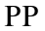··· stacking using (2/3, 0, 1) stacking vector. The reflections marked by asterisks contribute to the hump observed in (a).
- Table S1. Observed 2θ [°] values and the corresponding indices of [Li-Al-SO₄] LDHs.
- Table S2. Refined atomic position coordinates of [Li-Al-SO₄] LDHs.
- Table S3. Bond lengths (Å) and bond angles [°] of [Li-Al-SO₄] LDHs obtained from Rietveld refinement.

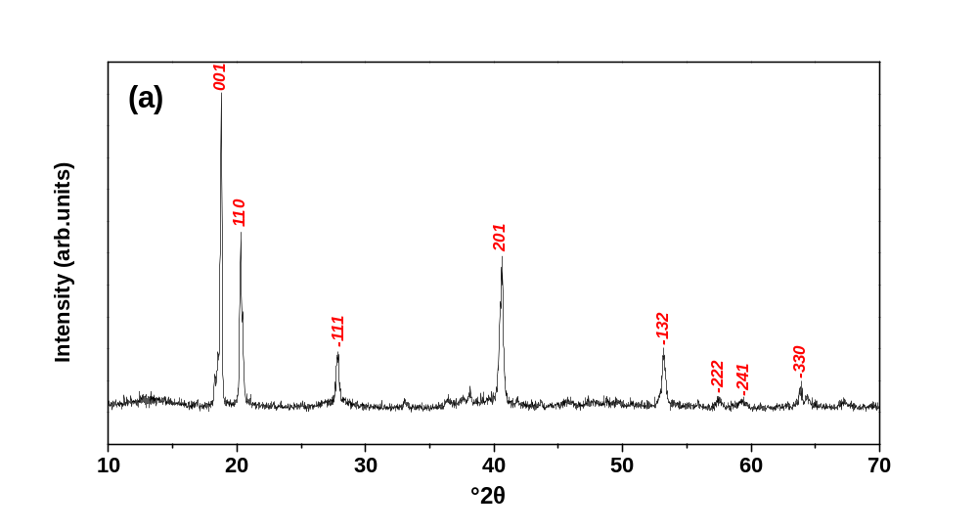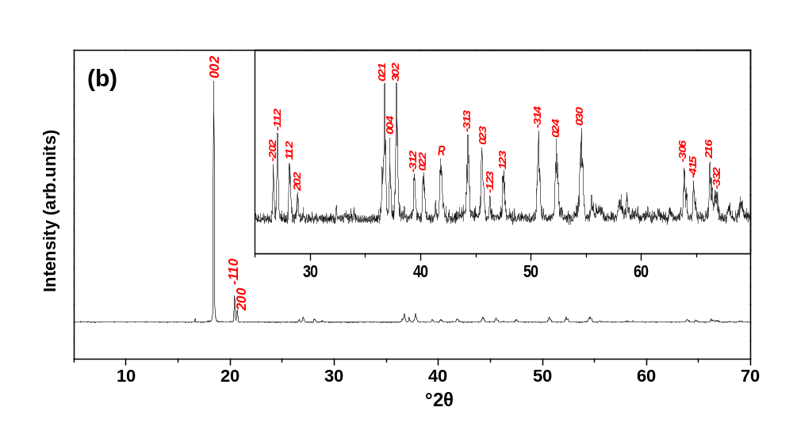

Fig. S1. X-ray powder diffraction patterns of (a) bayerite, and (b) gibbsite.

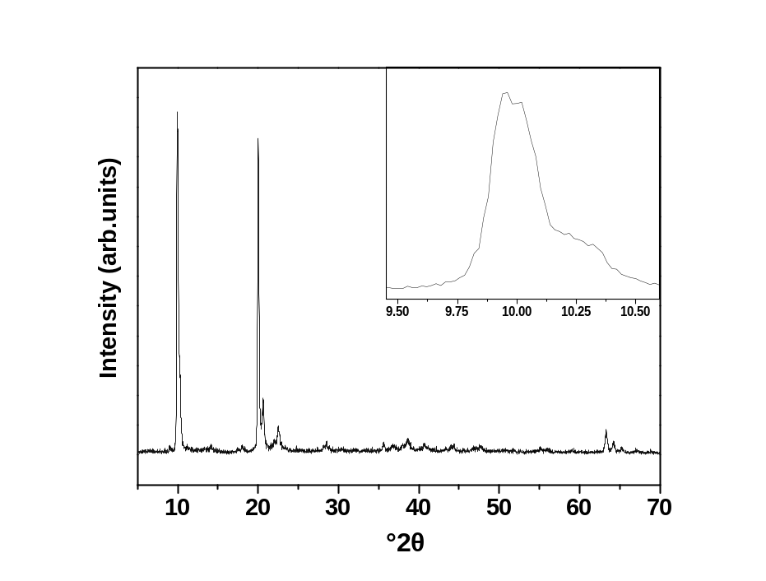
Fig. S2. X-ray powder diffraction pattern of the as-prepared phase g-[Li-Al-SO₄]. In the inset, the first basal reflection is expanded to highlight the shoulder.
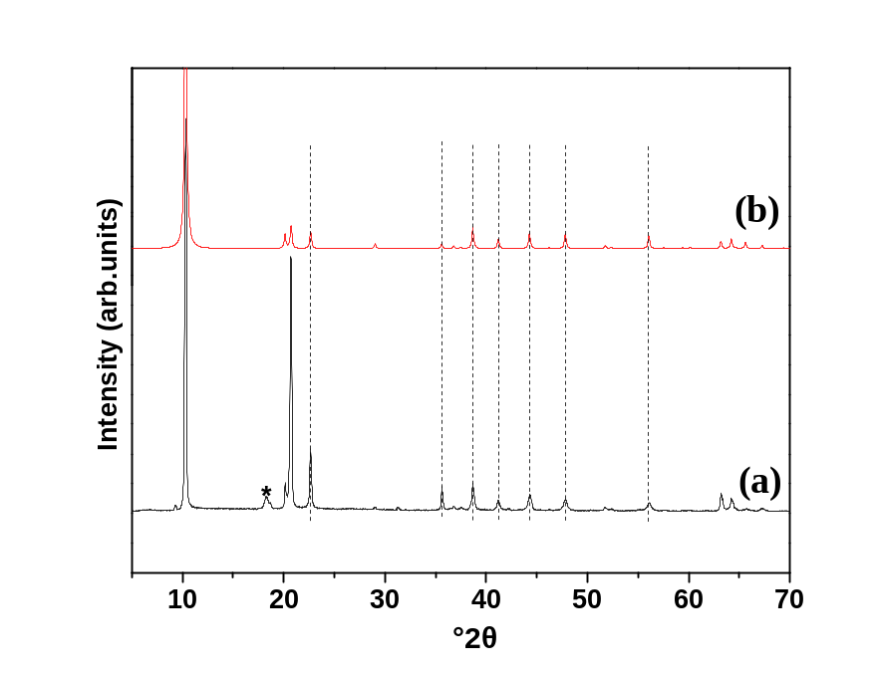
Fig. S3. (a) In-situ X-ray powder diffraction pattern of g-[Li-Al-SO₄] LDH at 100°C compared with (b) that simulated for ······ stacking using (0, 0, 1) stacking vector. The reflection marked by the asterisk is due to the 002 plane of the unreacted gibbsite.

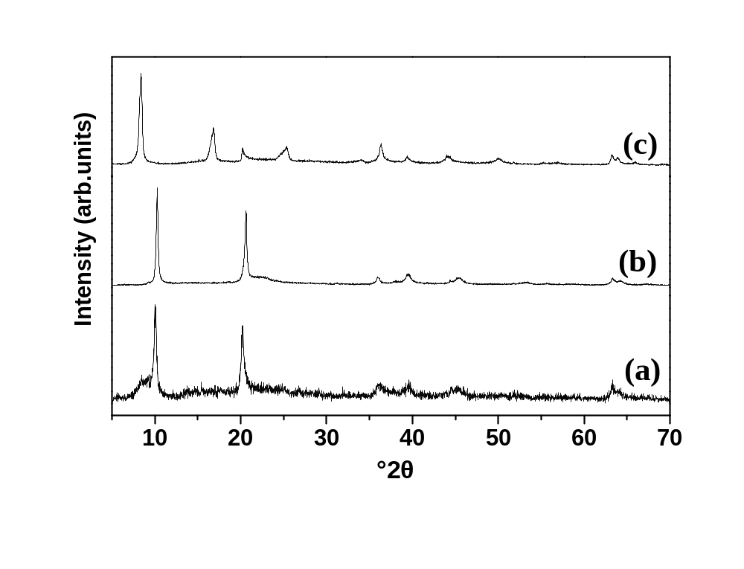
Fig. S4. X-ray powder diffraction pattern of the (a) as-prepared b-[Li-Al-SO₄] LDH, (b) b-[Li-Al-SO₄] obtained in-situ at 120°C, and (c) b-[Li-Al-SO₄] obtained in-situ at RH = 70%.
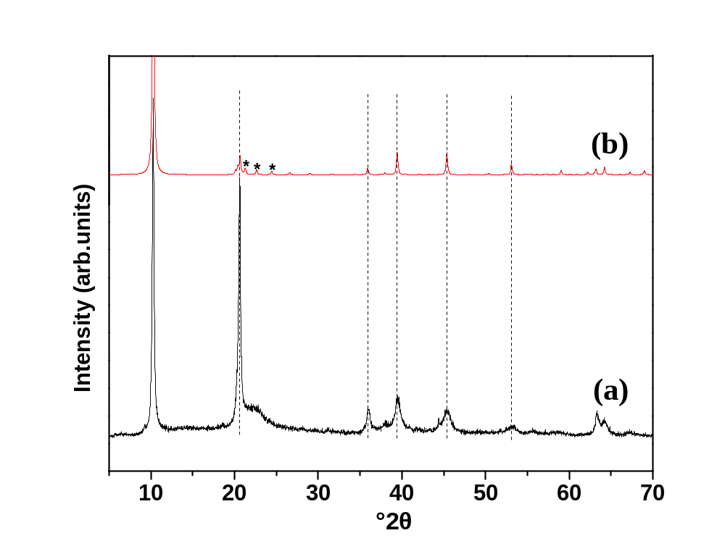
Fig. S5. (a) In-situ X-ray powder diffraction pattern of b-[Li-Al-SO₄] (T = 120°C) compared with (b) that simulated for ······ stacking using (2/3, 0, 1) stacking vector. The reflections marked by asterisks contribute to the hump observed in (a).

Table S1. Observed 2θ [°] values and the corresponding indices of [Li-Al-SO₄] LDHs.
g-[Li-Al-SO₄] (100°C) |  | b-[Li-Al-SO₄] (120°C)
a = b= 5.0944 Å, c = 17.1592 Å, β = 90°, FM value = 24.4 |  | a = 5.0925 Å , b = 8.8211 Å, c = 8.7612 Å, β = 101.2467°, FM value = 2.8
2θ [°] | hkl | 2θ [°] | hkl
10.3 | 002 | 10.3 | 001
20.1 | 100 | 20.6 | 002
20.7 | 004 | 36.0 | 200
22.6 | 102 | 39.5 | 201
29.0 | 104 | 45.4 | -133
31.3 | 006 | 53.3 | 005
35.6 | 2-11 | 63.3 | -331
36.8 | 2-12 | 64.2 | -332
37.5 | 106
38.7 | 2-13
41.2 | 2-14
42.2 | 107
44.3 | 2-15
47.8 | 2-16
51.8 | 2-17
52.4 | 206
56.1 | 3-12
63.2 | 300
64.3 | 302
67.3 | 304

Table S2. Refined atomic position coordinates of [Li-Al-SO₄] LDHs.
 |  | g-[Li-Al-SO₄] | (T = 100°C)
Atom | Wyckoff position | x | y | z | occupancy
O1 | 12i | 0.63539 | 0.652 | 0.05065 | 1
Al | 4f | 0.3333 | 0.6667 | 0 | 1
Li | 2b | 0 | 0 | 0 | 1
S | 6h | 0.38089 | 0.54062 | 0.25 | 0.1667
O2 | 12i | 0.51766 | 0.75374 | 0.31201 | 0.0833
O3 | 12i | 0.61372 | 0.61481 | 0.18985 | 0.0833
O4 | 12i | 0.27171 | 0.23146 | 0.27904 | 0.0833
O5 | 12i | 0.13388 | 0.57473 | 0.22019 | 0.0833
Ow1 | 12i | 0.19294 | 0.95561 | 0.27917 | 0.1110
Ow2 | 4a | 0 | 0 | 0.1767 | 0.2
Ow3 | 2e | 0 | 0 | 0.25 | 0.4257
 |  | b-[Li-Al-SO₄] | (T = 120°C)
O1 | 8j | 0.86213 | 0.17283 | 0.1137 | 1
O2 | 4i | 0.40364 | 0 | 0.1137 | 1
Al | 4g | 0 | 0.3313 | 0 | 1
Li | 2a | 0 | 0 | 0 | 1
S | 8j | 0.64274 | 0.42737 | 0.49874 | 0.125
O3 | 8j | 0.40462 | 0.31815 | 0.47257 | 0.125
O4 | 8j | 0.56293 | 0.58121 | 0.45948 | 0.125
O5 | 8j | 0.76832 | 0.43102 | 0.6547 | 0.125
O6 | 8j | 0.84867 | 0.3707 | 0.41451 | 0.125
Ow1 | 8j | 0.45064 | 0.11056 | 0.48369 | 0.28728
Ow2 | 4i | 0.1567 | 0 | 0.4678 | 0.10552
Ow3 | 4h | 0 | 0.231 | 0.5 | 0.10234

Table S3. Bond lengths (Å) and bond angles [°] of [Li-Al-SO₄] LDHs obtained from Rietveld refinement.
 | Distance (Å) |  | Angle [°]
g-[Li-Al-SO₄] | Li-O1 | 2.0121 | O1-Li-O1 | 77.259, 102.741
(T = 100°C) | Al-O1 | 1.8, 1.9153 | O1-Al-O1 | 101.046, 98.663, 85.044, 75.474
 | S-O2 | 1.4271 | O2-S-O3 | 107.644
 | S-O3 | 1.4708 | O2-S-O4 | 109.945
 | S-O4 | 1.4691 | O2-S-O5 | 107.164
 | S-O5 | 1.4458 | O3-S-O4 | 109.717
 | O2-O1 | 2.9439, 2.5462 | O3-S-O5 | 111.018
 | O3-O1 | 2.3925 | O4-S-O5 | 111.254
 | O4-O1 | 3.2807, 3.3989, 3.5459
 | O5-O1 | 3.0516, 3.4202, 3.7573
 | Ow1-O1 | 3.0076
 | Ow2-O1 | 3.8701
 | Ow3-O1 | 2.8223
 | Ow1-O2 | 2.4088
 | Ow2-O5 | 2.6999
 | Ow3-O5 | 2.7539
 | In-plane O1-O1 | 2.7298, 2.9568, 3.1437
b-[Li-Al-SO₄] | Li-O1 | 2.0150 | O1-Li-O1 | 81.20, 98.80
(T = 120°C) | Li-O2 | 2.1217 | O1-Li-O2 | 81.051, 98.949
 | Al-O1 | 1.9203, 1.9379 | O1-Al-O1 | 81.757, 86.138, 96.651
 | Al-O2 | 1.9049 | O1-Al-O2 | 88.821, 92.875, 98.777
 | S-O3 | 1.5343 | O2-Al-O2 | 76.747
 | S-O4 | 1.4458 | O3-S-O4 | 112.086
 | S-O5 | 1.4089 | O3-S-O5 | 112.064
 | S-O6 | 1.4663 | O3-S-O6 | 108.616
 | O3-O1 | 3.6237, 3.1200 | O4-S-O5 | 105.808
 | O3-O2 | 4.0333, 4.2234 | O4-S-O6 | 113.395
 | O4-O1 | 3.7870, 3.1393, 3.7755 | O5-S-O6 | 104.658
 | O4-O2 | 3.8046
 | O5-O1 | 2.4217, 3.0986, 3.4035
 | O5-O2 | 2.4762
 | O6-O1 | 3.3183, 3.1776
 | O6-O2 | 2.9325
 | Ow1-O5 | 3.4759
 | Ow1-O6 | 3.1882
 | Ow2-O3 | 3.0820
 | Ow3-O3 | 2.2441
 | In-plane O1-O1 | 2.8818, 3.0599
 | In-plane O1-O2 | 2.7847, 2.903, 3.1452

