Supplementary Information for
Molecular dynamics simulation of dodecyl dimethyl benzyl ammonium (DDBA) intercalated-montmorillonite
Haotian Su¹, Yingchun Zhang¹, Jinhong Zhou^{1,} * and Qingfeng Hou²
1.State Key Laboratory for Mineral Deposits Research, School of Earth Sciences and Engineering, Nanjing University, Nanjing, Jiangsu 210023, P. R. China
2.State Key Laboratory of Enhanced Oil Recovery, Research Institute of Petroleum Exploration and Development, China National Petroleum Corporation (CNPC), Beijing 100083, P. R. China.

*Corresponding author: jinhongzhou@nju.edu.cn. Tel: +86 25 83594664,
Fax: +86 25 83686016.

This file includes Tables S1 and calculation details of the density of the organic phase formed by the lauryl chains

1. MSDs of interlayer dodecyl dimethyl benzyl ammonium (DDBA) in DDBA-Mnt systems
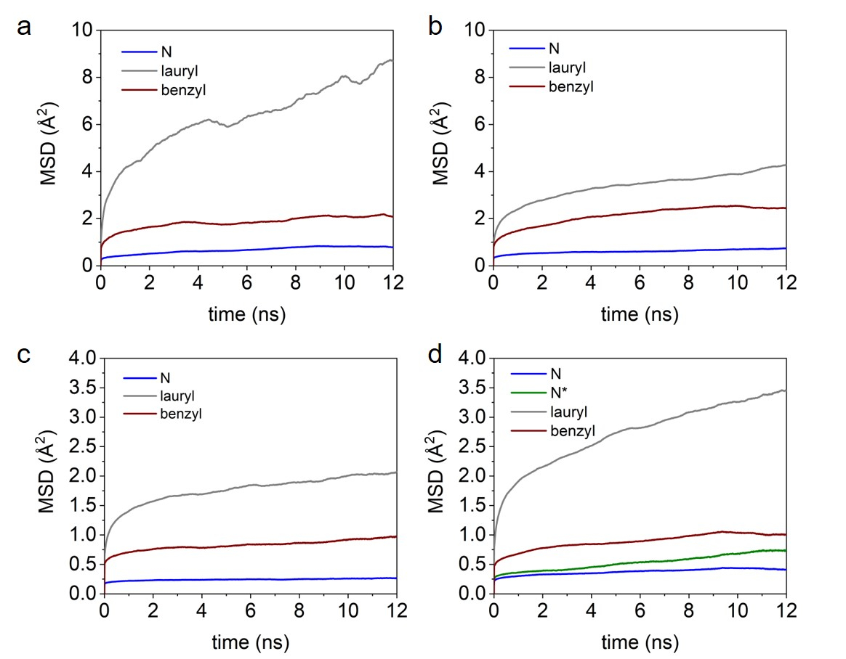
Fig. S1. The mean squared displacement (MSD) of interlayer dodecyl dimethyl benzyl ammonium (DDBA) in DDBA-Mnt systems (N*: N atoms of DDBA that were not attached to the clay mineral surface). a: DA-6 system; b: DA-13 system; c: DA-24 system; d: DA-34 system.

2. Calculation details of the density of the organic phase formed by the lauryl chains
The density of the organic phase formed by the lauryl chains is calculated as follows (Liu et al., 2007):
$$D=M/(S×\left(b-h×2\right))$$
where M denotes the mass of the lauryl chains, S is the area of the basal surface, b is the basal spacing and h is the average distance of the organic phase from the clay surface. h is taken as 3.5 Å, 2.4 Å, 2.5 Å and 2.6 Å in DA-6, DA-13, DA-24 and DA-34, respectively, based on the density profiles (Fig. 2) where it can be observed that the lauryl chains in all systems are limited in the spaces ~ h+6.64 Å (clay sheet is 6.64 Å thick) from the (z = 0) plane.

References
Liu, X.D., Lu, X.C., Wang, R.C., Zhou, H.Q. & Xu, S.J. (2007) Interlayer Structure and Dynamics of Alkylammonium-intercalated Smectites with and without Water: A Molecular Dynamics Study. Clays and Clay Minerals, 55, 554-564.

