Appendix

Table 1.1. Environmental Preoccupation and Tolerance for Political Actions—Nonviolent, Nondisruptive Category

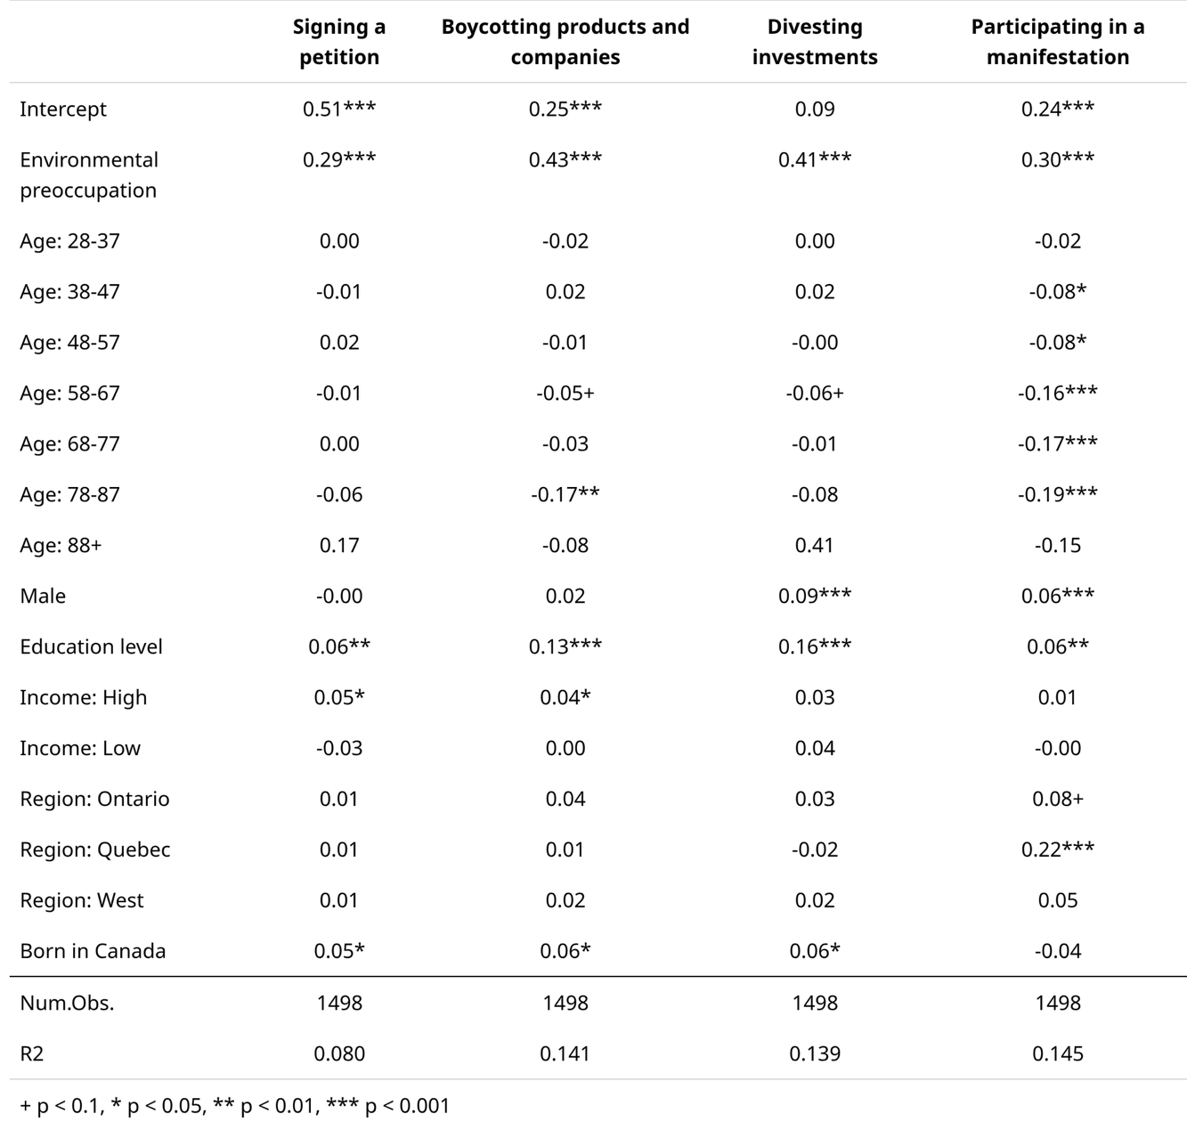

Data: Synopsis, 2022

Table 1.2. Environmental Preoccupation and Tolerance for Political Actions—Nonviolent, Disruptive Category

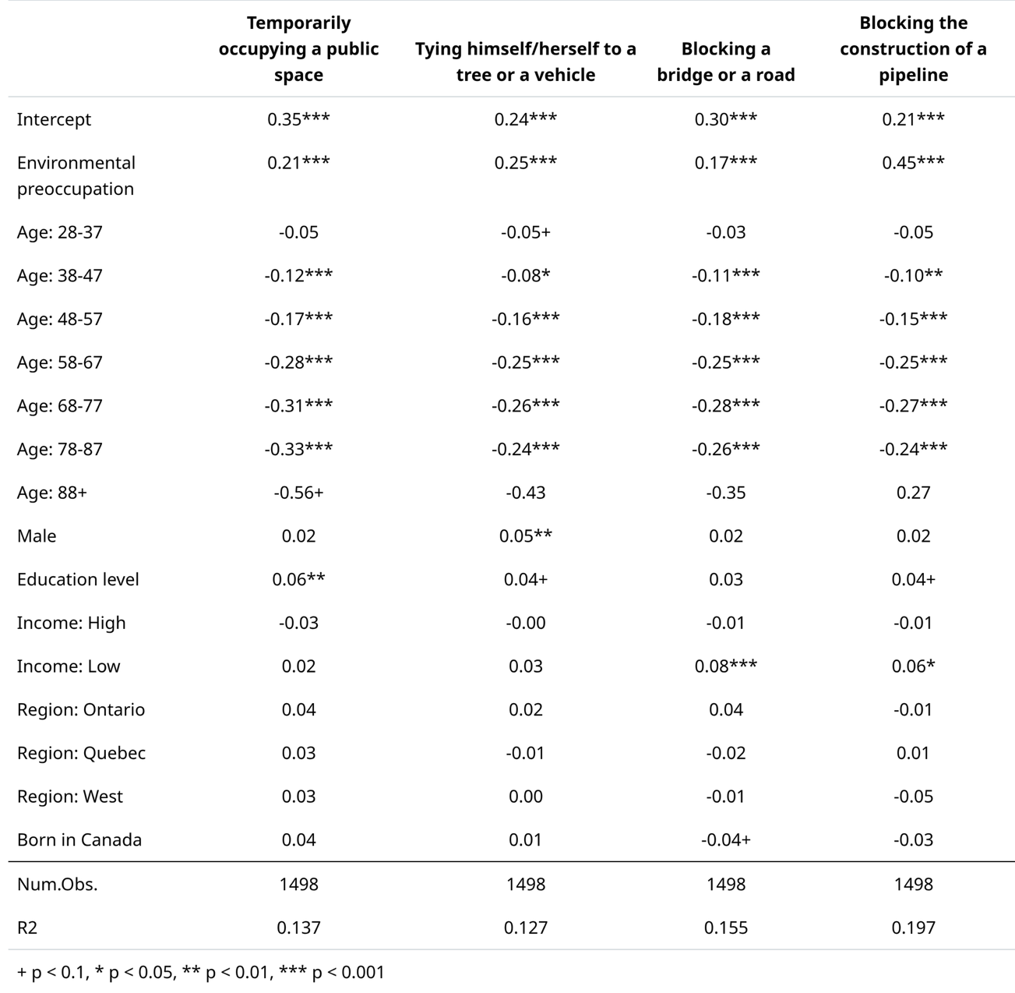

Data: Synopsis, 2022

Table 1.3. Environmental Preoccupation and Tolerance for Political Actions—Violent, Disruptive Category

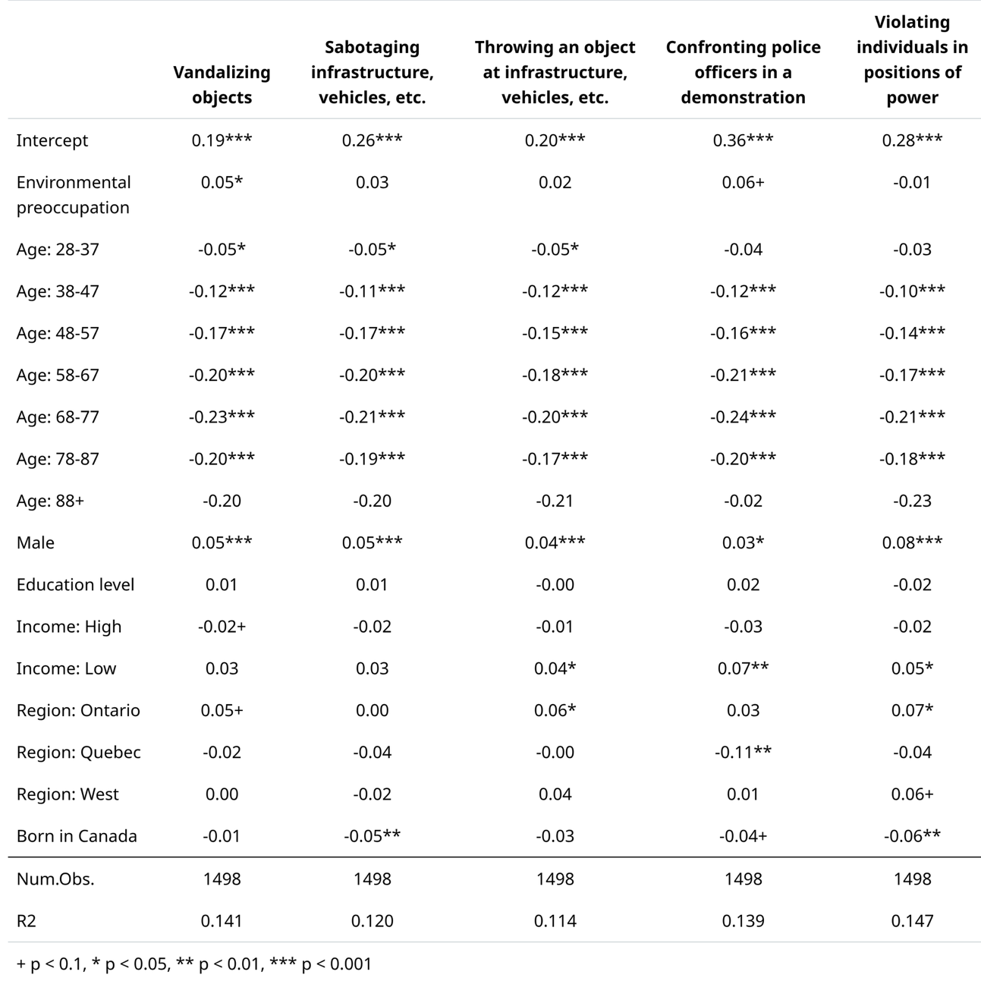

Data: Synopsis, 2022

Table 2.1. Attribution of Responsibility for Climate Change and Tolerance for Political Actions—Nonviolent, Nondisruptive Category

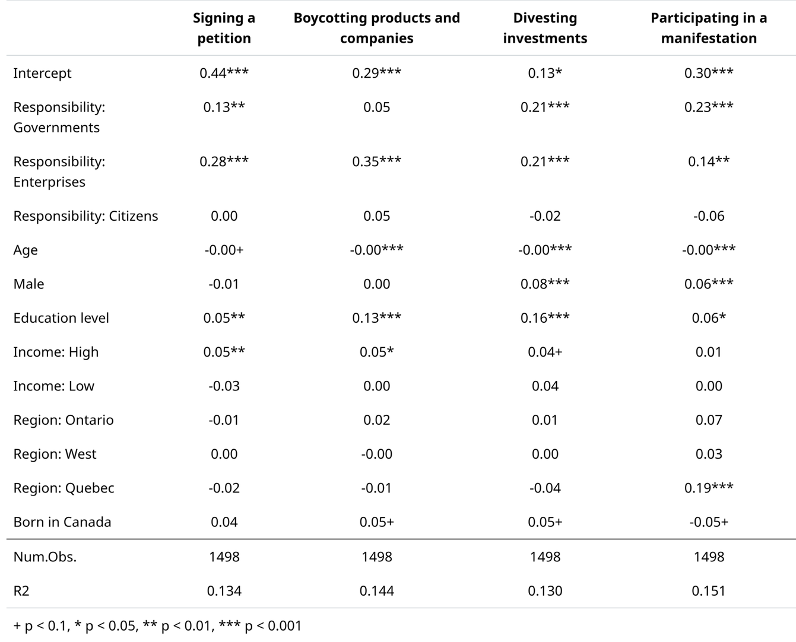

Data: Synopsis, 2022

Table 2.2. Attribution of Responsibility for Climate Change and Tolerance for Political Actions—Nonviolent, Disruptive Category

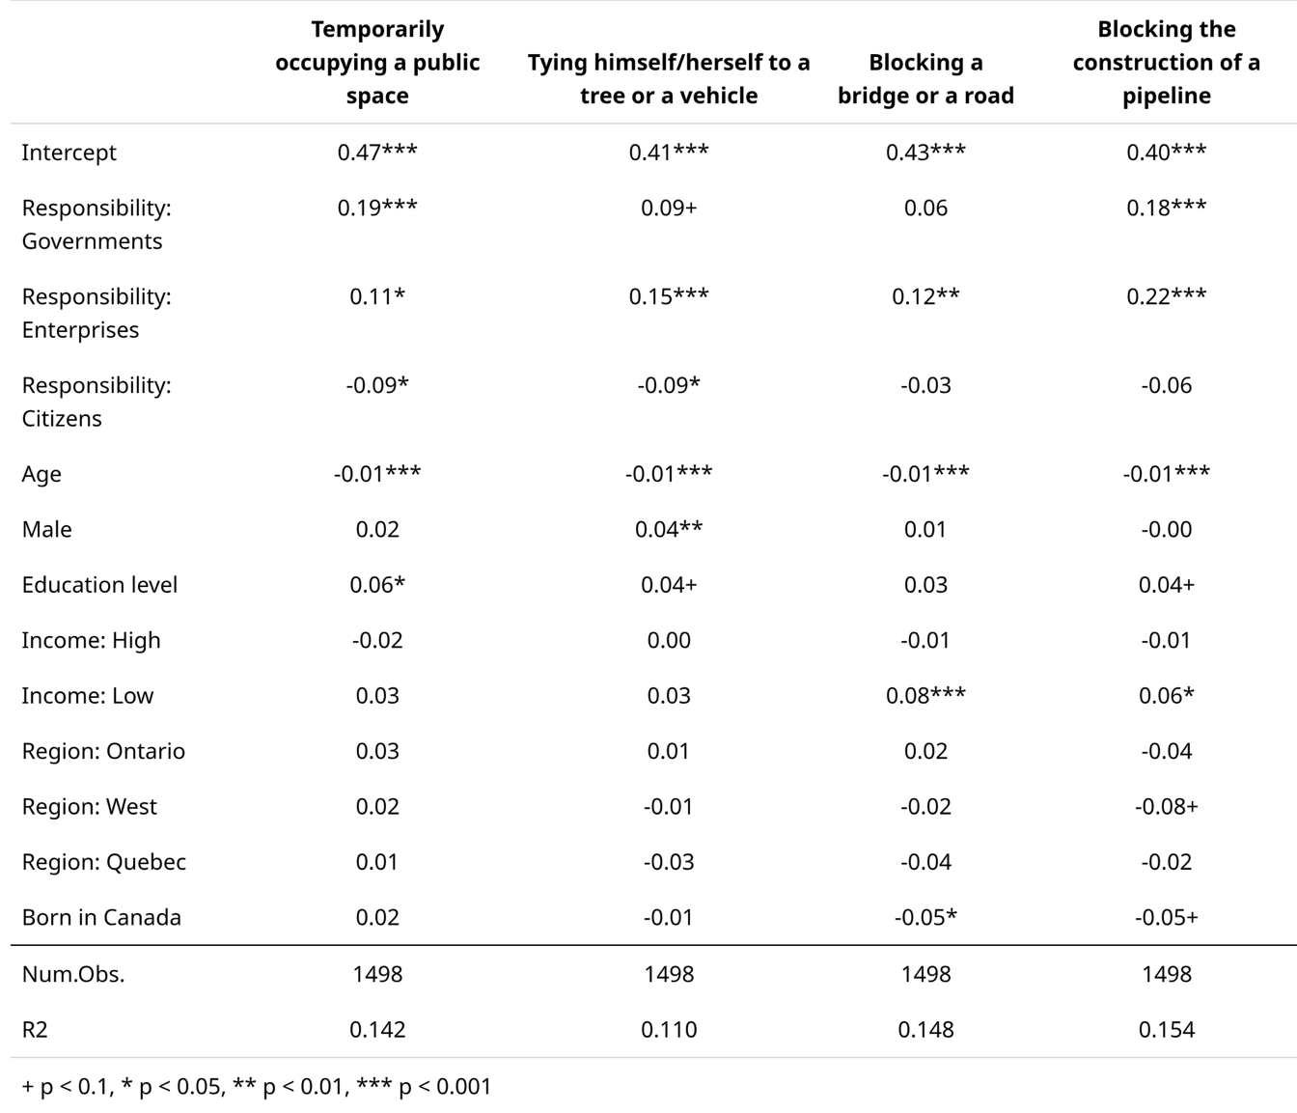

Data: Synopsis, 2022

Table 2.3. Attribution of Responsibility for Climate Change and Tolerance for Political Actions—Violent, Disruptive Category

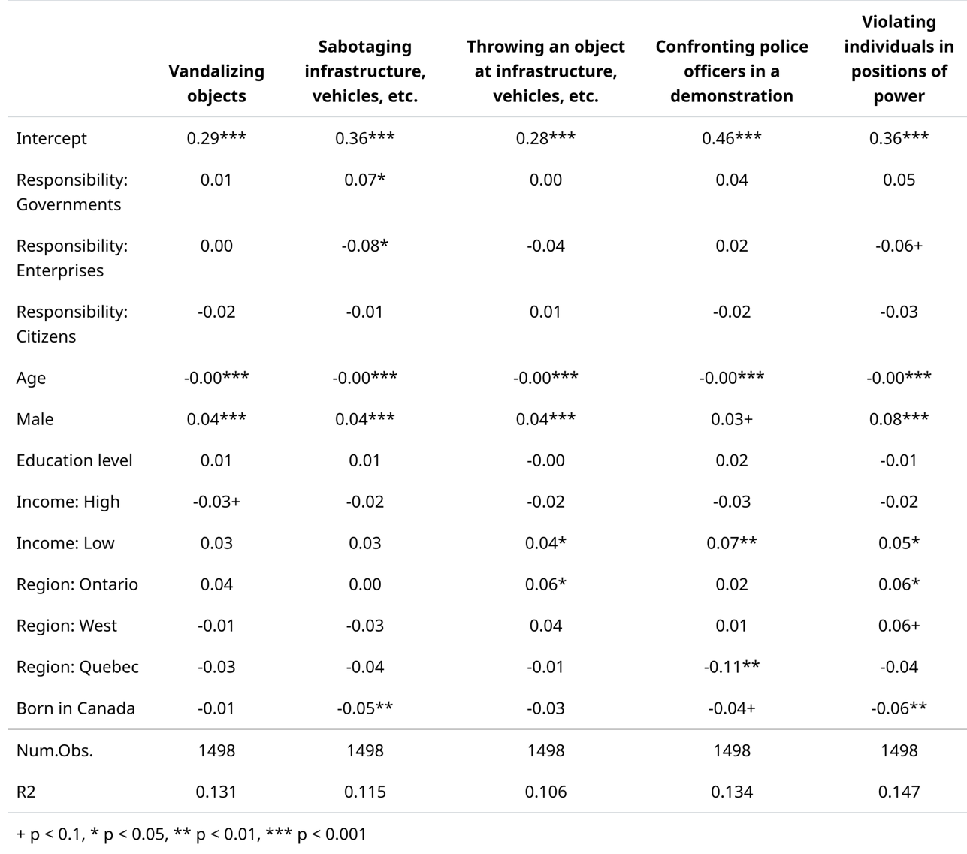

Data: Synopsis, 2022

