The 51st State?
Exploring Canadian Attitudes Towards US Annexation and Their Determinants

Online appendix

Appendix A. Question Wording, Answer Choices, Coding and Data

Age
How old are you?

Coding: Categorical variable where 1 = 18-34 years old; 2 = 35-54; 3 = 55 years old dans more

Gender identity
What is your gender?
-Female
-Male
-Other

Coding: Dichotomous variable where 0 = Man and 1 = Woman

Education
What is the highest level of education that you have completed?

Coding: Dichotomous variable where 0 = No schooling, primary, high school or some post-secondary education and 1 = CEGEP diploma or higher

Language
Which language(s) did you learn as a child and still understand today? (Select all that apply)

Coding: Categorical variable where 1 = French (unilingual); 2 = English (unilingual); 3 = Other

Material well-being
Income
What was your total household income, before taxes, for the year 2024? Be sure to include income from all sources.
Coding: Ordinal variable where 1 = <30,001$; 2 = $30,001 to $60,000; 3 = $60,001 to $90,000; 4 = $90,001 to $110,000; 5 = $110,001 to $150,000; 6 = $150,001 to $200,000; 7 = More than $200,000. The variable is then rescaled on a 0 to 1 scale.
“Don’t know” and refusals are excluded.
Asset
Do you or a member of your household own a business (for example, a piece of property, a farm, or livestock), have stocks or bonds, or have savings? Please check all that apply.
-Own a business, a piece of property, a farm or livestock
-Own stocks or bonds
-Have any savings
-None of these
Coding: Each selected category is coded 1 and summed up to create an index. This index is then rescaled from 0 to 1.
“Don’t know” and refusals are excluded.

Generating the index of material well-being: The income and asset variables are averaged to measure material well-being, as suggested by Nadeau et al. (2019).

Region
Which province or territory are you currently living in?

Coding: Categorical variable where 1 = Ontario; 2 = Quebec; 3 = British Columbia; 4 = Prairies; 5 = Atlantic provinces

Annexation
Would you be in favour of Canada becoming the 51st state of the United States?
- Very opposed
- Somewhat opposed
- Somewhat favourable
- Very favourable
- Don’t know/prefer not to answer

Coding: Used as a categorical variable. “Don’t know” and refusals are excluded.

Party identification
In FEDERAL politics, do you usually think of yourself as a:

Coding: Categorical variable where 1 = Liberal; 2 = Conservative; 3 = New Democrat; 4 = Bloquiste; 5 = Green; 6 = People’s Party; 7 = No partisan identification

Feelings towards Donald Trump
Where 0 means you really dislike the group and 100 means you really like the group, we would like to know your opinion of the following: Donald Trump

Coding: Categorical variable where 0 = 0; 1 = 1-19; 2 = 20-39; 3 = 40-59; 4 = 60-79; 5 = 80-100

Feelings towards the United States
Where 0 means you really dislike the group and 100 means you really like the group, we would like to know your opinion of the following: The United States

Coding: Categorical variable where 0 = 0; 1 = 1-19; 2 = 20-39; 3 = 40-59; 4 = 60-79; 5 = 80-100

Most important issue
What is the most important issue to you personally right now?
- The economy
- Health care
- Education
- The environment
- Poverty
- Immigration
- Quebec independence
- Canadian sovereignty vis-à-vis the United States
- Another issue
Coding: Dichotomous variable, where 1 = Canadian sovereignty vis-à-vis the United States and 0 = Every other issue
Figure A1. Number of Respondents Per Day
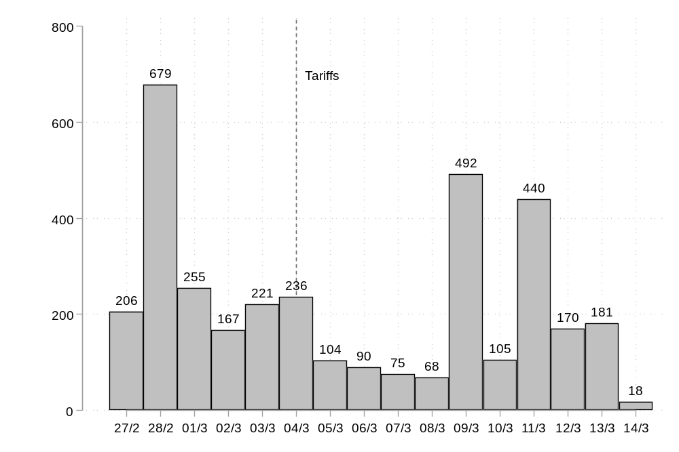
Note. N = 3,507.

Appendix B. Summary Statistics

Table B1. Distributions of Feelings Towards Donald Trump and the United States
 | Trump | United States
0 | 2,031 (59%) | 327 (10%)
1-19 | 611 (18%) | 452 (13%)
20-39 | 214 (6%) | 588 (17%)
40-59 | 247 (7%) | 845 (25%)
60-79 | 155 (4%) | 699 (20%)
80-100 | 192 (6%) | 518 (15%)
Note. Number of observations are displayed with percentages in parentheses.

Table B2. Descriptive statistics
 | Mean | Standard deviation | Minimum | Maximum
18-34 years old | 0.256 | 0.437 | 0 | 1
35-54 years old | 0.309 | 0.462 | 0 | 1
55+ years old | 0.434 | 0.496 | 0 | 1
Female | 0.518 | 0.500 | 0 | 1
Post-secondary diploma | 0.730 | 0.444 | 0 | 1
Material well-being | 0.370 | 0.239 | 0 | 1
French | 0.379 | 0.485 | 0 | 1
English | 0.434 | 0.496 | 0 | 1
Other | 0.187 | 0.390 | 0 | 1
Ontario | 0.223 | 0.416 | 0 | 1
Quebec | 0.535 | 0.499 | 0 | 1
British Columbia | 0.089 | 0.285 | 0 | 1
Prairies | 0.111 | 0.314 | 0 | 1
Atlantic provinces | 0.043 | 0.202 | 0 | 1
Annexation: Very opposed | 0.866 | 0.341 | 0 | 1
Annexation: Somewhat opposed | 0.056 | 0.230 | 0 | 1
Annexation: Somewhat favourable | 0.038 | 0.190 | 0 | 1
Annexation: Very favourable | 0.041 | 0.198 | 0 | 1
Party identification: LPC | 0.313 | 0.464 | 0 | 1
Party identification: CPC | 0.220 | 0.414 | 0 | 1
Party identification: Bloc | 0.144 | 0.351 | 0 | 1
Party identification: NDP | 0.119 | 0.324 | 0 | 1
Party identification: Green | 0.028 | 0.164 | 0 | 1
Party identification: PPC | 0.013 | 0.112 | 0 | 1
Party identification: None | 0.164 | 0.370 | 0 | 1
Feelings towards Trump | 0.974 | 1.494 | 0 | 5
Feelings towards the US | 2.785 | 1.523 | 0 | 5
Most important issue: Canada’s sovereignty vis-à-vis the US | 0.190 | 0.392 | 0 | 1

Appendix C. Robustness Checks

Figure C1. Replication of Figure 1, Separating Quebec and the Rest of Canada
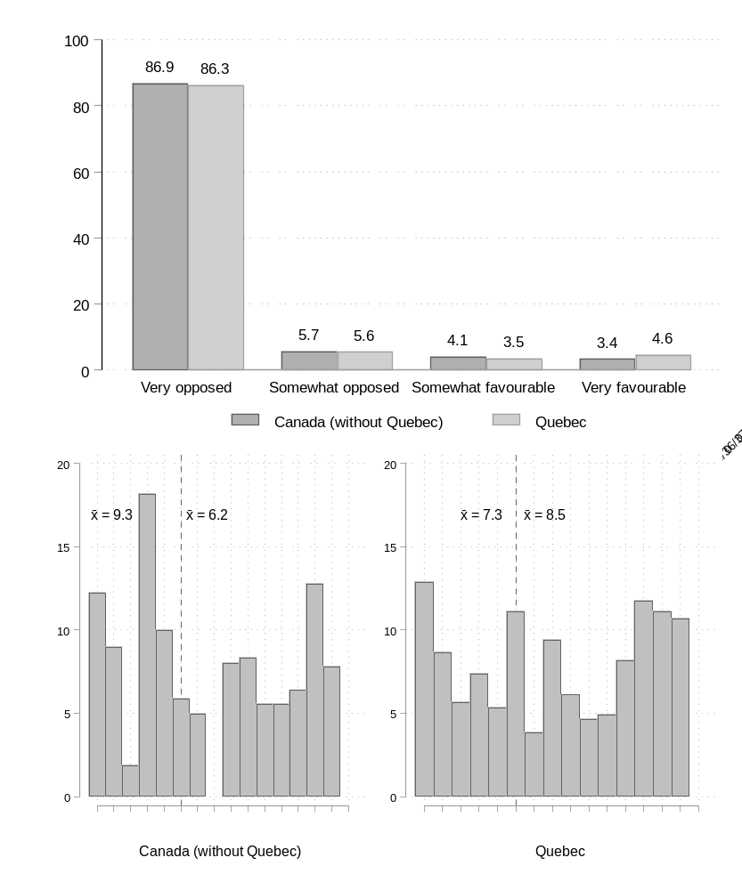
Note. In the upper panel, in Canada (without Quebec), N = 1,575 and in Quebec, N = 1,794. In the lower panel, in Canada (without Quebec), N = 668 pre-March 4th and N = 805 post-March 4th. In Quebec, N = 805 pre-March 4th and N = 863 post-March 4th.

Table C1. Replication of Table 2, Canada (without Quebec)
 | Model 1 |  | Model 2 |  | Model 3
 | b | (SE) | b | (SE) | b | (SE)
35-54 years old [ref = 18-34] | 0.03 | (0.20) | -0.05 | (0.21) | 0.04 | (0.24)
55+ years old [ref = 18-34] | -0.94 | (0.21) | -1.11 | (0.23) | -0.85 | (0.26)
Women [ref = Men] | -0.64 | (0.17) | -0.53 | (0.18) | -0.33 | (0.20)
Post-secondary diploma | 0.10 | (0.21) | 0.27 | (0.22) | 0.45 | (0.25)
Material well-being | 0.31 | (0.36) | -0.01 | (0.38) | 0.19 | (0.42)
English [ref = French] | 0.33 | (0.76) | 0.21 | (0.81) | 0.39 | (0.88)
Other [ref = French] | 0.60 | (0.77) | 0.35 | (0.82) | 0.51 | (0.89)
Region or province: ref=Ontario
British Columbia | 0.14 | (0.22) | 0.20 | (0.23) | -0.02 | (0.26)
Prairies | 0.45 | (0.19) | 0.18 | (0.21) | 0.26 | (0.23)
Atlantic | -1.00 | (0.48) | -0.91 | (0.52) | -0.74 | (0.57)
Party identification: ref = None
LPC |  |  | -0.66 | (0.35) | -0.42 | (0.38)
CPC |  |  | 1.32 | (0.27) | 0.41 | (0.30)
NDP |  |  | -0.52 | (0.39) | -0.21 | (0.44)
Green |  |  | 0.98 | (0.53) | 0.82 | (0.67)
PPC |  |  | 2.90 | (0.50) | 1.33 | (0.53)
Feelings towards Trump: ref = 0
Feelings towards Trump: 1-19 |  |  |  |  | 1.13 | (0.36)
Feelings towards Trump: 20-39 |  |  |  |  | 1.57 | (0.44)
Feelings towards Trump: 40-59 |  |  |  |  | 2.21 | (0.38)
Feelings towards Trump: 60-79 |  |  |  |  | 3.21 | (0.39)
Feelings towards Trump: 80-100 |  |  |  |  | 3.56 | (0.41)
Feelings towards USA: ref = 0
Feelings towards USA: 1-19 |  |  |  |  | 0.36 | (0.84)
Feelings towards USA: 20-39 |  |  |  |  | 0.40 | (0.80)
Feelings towards USA: 40-59 |  |  |  |  | 0.87 | (0.78)
Feelings towards USA: 60-79 |  |  |  |  | 0.53 | (0.79)
Feelings towards USA: 80-100 |  |  |  |  | 1.13 | (0.79)
Most important issue
Canada’s sovereignty |  |  |  |  | -0.79 | (0.42)
Cut 1 | 1.91 | (0.79) | 2.19 | (0.87) | 4.49 | (1.21)
Cut 2 | 2.54 | (0.80) | 2.89 | (0.88) | 5.39 | (1.21)
Cut 3 | 3.40 | (0.80) | 3.84 | (0.89) | 6.56 | (1.22)
Observations | 1316 |  | 1297 |  | 1288
Note. Ordered logistic regressions’ coefficients are displayed. Standard errors in parentheses in the second column of each model are shown. Reference categories are: 18-34 years old for age, men for gender identity, none or some post-secondary education for education, French-speaking for language, Ontario for province or region, none for party identification, 0 for feelings towards Trump and 0 for feelings towards the United States.

Table C2. Replication of Table 2, Quebec Only
 | Model 1 |  | Model 2 |  | Model 3
 | b | (SE) | b | (SE) | b | (SE)
35-54 years old [ref = 18-34] | -0.09 | (0.18) | -0.17 | (0.19) | -0.22 | -0.22
55+ years old [ref = 18-34] | -0.88 | (0.19) | -0.84 | (0.20) | -0.49 | -0.49
Women [ref = Men] | -0.61 | (0.16) | -0.47 | (0.16) | -0.20 | -0.20
Post-secondary diploma | -0.17 | (0.18) | -0.04 | (0.19) | 0.10 | 0.10
Material well-being | -0.18 | (0.35) | -0.15 | (0.36) | -0.09 | -0.09
English [ref = French] | -0.30 | (0.27) | -0.46 | (0.28) | -0.67 | -0.67
Other [ref = French] | -0.27 | (0.21) | -0.40 | (0.22) | -0.88 | -0.88
Party identification: ref = None
LPC |  |  | -0.46 | (0.26) | -0.24 | (0.29)
CPC |  |  | 0.96 | (0.25) | 0.21 | (0.29)
Bloc Québécois |  |  | -0.48 | (0.26) | -0.35 | (0.29)
NDP |  |  | -1.28 | (0.44) | -0.68 | (0.47)
Green |  |  | -0.14 | (0.49) | -0.15 | (0.56)
PPC |  |  | 2.02 | (0.52) | 0.70 | (0.57)
Feelings towards Trump: ref = 0
Feelings towards Trump: 1-19 |  |  |  |  | 0.81 | (0.26)
Feelings towards Trump: 20-39 |  |  |  |  | 1.36 | (0.30)
Feelings towards Trump: 40-59 |  |  |  |  | 2.00 | (0.32)
Feelings towards Trump: 60-79 |  |  |  |  | 2.33 | (0.34)
Feelings towards Trump: 80-100 |  |  |  |  | 2.78 | (0.34)
Feelings towards USA: ref = 0
Feelings towards USA: 1-19 |  |  |  |  | -0.87 | (0.48)
Feelings towards USA: 20-39 |  |  |  |  | -0.73 | (0.43)
Feelings towards USA: 40-59 |  |  |  |  | -0.70 | (0.41)
Feelings towards USA: 60-79 |  |  |  |  | -0.42 | (0.40)
Feelings towards USA: 80-100 |  |  |  |  | 0.31 | (0.40)
Most important issue
Canada’s sovereignty |  |  |  |  | -1.05 | (0.35)
Cut 1 | 0.88 | (0.22) | 0.90 | (0.29) | 1.48 | (0.46)
Cut 2 | 1.44 | (0.22) | 1.50 | (0.29) | 2.22 | (0.46)
Cut 3 | 2.00 | (0.24) | 2.10 | (0.30) | 2.91 | (0.47)
Observations | 1429 |  | 1422 |  | 1399
Note. Ordered logistic regressions’ coefficients are displayed. Standard errors in parentheses in the second column of each model are shown. Reference categories are: 18-34 years old for age, men for gender identity, none or some post-secondary education for education, French-speaking for language, none for party identification, 0 for feelings towards Trump and 0 for feelings towards the United States.

Appendix D. Additional tests

Table D1. Ordered logistic regressions predicting support for annexation, interaction between age and gender
 | b | (SE)
35-54 years old | 0.06 | (0.18)
55+ years old | -0.73 | (0.18)
Women | -0.42 | (0.20)
35-54 years old # Women | -0.20 | (0.27)
55+ years old # Women | -0.42 | (0.29)
Post-secondary diploma | -0.08 | (0.14)
Material well-being | 0.08 | (0.25)
English | -0.37 | (0.20)
Other | -0.18 | (0.18)
Quebec | -0.08 | (0.20)
British Columbia | 0.14 | (0.22)
Prairies | 0.43 | (0.19)
Atlantic provinces | -1.10 | (0.48)
Cut 1 | 1.05 | (0.27)
Cut 2 | 1.64 | (0.28)
Cut 3 | 2.33 | (0.28)
Observations | 2745

Table D2. Ordered logistic regressions predicting support for annexation
 | Model 1 | Model 2 | Model 3 | Model 4 | Model 5 | Model 6
35-54 years old [ref = 18-34] | -0.07 | -0.24 | -0.06 | -0.13 | -0.04 | -0.20
 | (0.16) | (0.15) | (0.14) | (0.16) | (0.16) | (0.15)
55+ years old [ref = 18-34] | -0.60 | -1.10 | -0.83 | -0.71 | -0.52 | -1.00
 | (0.16) | (0.16) | (0.15) | (0.17) | (0.16) | (0.16)
Women [ref = Men] | -0.28 | -0.35 | -0.50 | -0.25 | -0.28 | -0.36
 | (0.13) | (0.12) | (0.12) | (0.13) | (0.13) | (0.12)
Post-secondary diploma | 0.22 | 0.11 | 0.09 | 0.21 | 0.22 | 0.10
 | (0.15) | (0.15) | (0.14) | (0.15) | (0.15) | (0.15)
Material well-being | 0.13 | -0.19 | 0.02 | 0.07 | 0.16 | -0.13
 | (0.28) | (0.27) | (0.26) | (0.28) | (0.28) | (0.27)
English [ref = French] | -0.88 | -0.50 | -0.45 | -0.84 | -0.86 | -0.48
 | (0.23) | (0.22) | (0.21) | (0.23) | (0.23) | (0.22)
Other [ref = French] | -0.84 | -0.39 | -0.36 | -0.79 | -0.85 | -0.39
 | (0.21) | (0.20) | (0.19) | (0.21) | (0.21) | (0.20)
Region or province: ref = Ontario
Quebec | -0.00 | -0.00 | 0.14 | -0.05 | -0.00 | -0.01
 | (0.23) | (0.21) | (0.21) | (0.23) | (0.23) | (0.21)
British Columbia | 0.03 | 0.11 | 0.19 | -0.02 | 0.02 | 0.09
 | (0.25) | (0.24) | (0.23) | (0.25) | (0.25) | (0.24)
Prairies | 0.26 | 0.19 | 0.15 | 0.24 | 0.24 | 0.15
 | (0.22) | (0.21) | (0.21) | (0.22) | (0.22) | (0.21)
Atlantic provinces | -0.98 | -1.04 | -0.91 | -1.04 | -0.88 | -0.95
 | (0.53) | (0.51) | (0.50) | (0.54) | (0.54) | (0.51)
Party identification: ref = None
LPC | -0.28 | -0.63 | -0.46 | -0.33 | -0.24 | -0.58
 | (0.22) | (0.22) | (0.21) | (0.23) | (0.22) | (0.22)
CPC | 0.37 | 0.85 | 1.09 | 0.32 | 0.37 | 0.81
 | (0.20) | (0.19) | (0.18) | (0.21) | (0.20) | (0.19)
Bloc | -0.27 | -0.36 | -0.30 | -0.27 | -0.25 | -0.31
 | (0.25) | (0.24) | (0.23) | (0.26) | (0.25) | (0.24)
NDP | -0.49 | -0.75 | -0.85 | -0.49 | -0.47 | -0.72
 | (0.31) | (0.29) | (0.29) | (0.31) | (0.31) | (0.29)
Green | 0.34 | 0.09 | 0.36 | 0.25 | 0.34 | 0.12
 | (0.41) | (0.39) | (0.36) | (0.42) | (0.41) | (0.39)
PPC | 1.11 | 1.92 | 2.37 | 0.99 | 1.11 | 1.87
 | (0.37) | (0.36) | (0.36) | (0.38) | (0.38) | (0.37)
Feelings towards Trump: ref = 0
Feelings towards Trump: 1-19 | 0.99 |  |  | 0.98 | 0.91
 | (0.20) |  |  | (0.20) | (0.20)
Feelings towards Trump: 20-39 | 1.56 |  |  | 1.47 | 1.45
 | (0.23) |  |  | (0.25) | (0.23)
Feelings towards Trump: 40-59 | 2.20 |  |  | 2.09 | 2.12
 | (0.22) |  |  | (0.23) | (0.22)
Feelings towards Trump: 60-79 | 2.94 |  |  | 2.79 | 2.82
 | (0.23) |  |  | (0.24) | (0.23)
Feelings towards Trump: 80-100 | 3.62 |  |  | 3.15 | 3.52
 | (0.22) |  |  | (0.25) | (0.23)
Feelings towards USA: ref = 0
Feelings towards USA: 1-19 |  | -0.15 |  | -0.49 |  | -0.23
 |  | (0.39) |  | (0.40) |  | (0.40)
Feelings towards USA: 20-39 |  | 0.24 |  | -0.42 |  | 0.15
 |  | (0.36) |  | (0.37) |  | (0.36)
Feelings towards USA: 40-59 |  | 0.82 |  | -0.15 |  | 0.72
 |  | (0.33) |  | (0.35) |  | (0.33)
Feelings towards USA: 60-79 |  | 1.12 |  | -0.13 |  | 0.97
 |  | (0.33) |  | (0.35) |  | (0.33)
Feelings towards USA: 80-100 |  | 2.08 |  | 0.52 |  | 1.96
 |  | (0.32) |  | (0.35) |  | (0.33)
Most important issue
Canada’s sovereignty |  |  | -1.39 |  | -0.97 | -1.26
 |  |  | (0.25) |  | (0.27) | (0.26)
Cut 1 | 2.38 | 1.90 | 1.20 | 2.10 | 2.27 | 1.73
 | (0.36) | (0.43) | (0.31) | (0.45) | (0.36) | (0.43)
Cut 2 | 3.17 | 2.59 | 1.85 | 2.90 | 3.07 | 2.42
 | (0.36) | (0.43) | (0.31) | (0.45) | (0.37) | (0.43)
Cut 3 | 4.02 | 3.37 | 2.59 | 3.77 | 3.93 | 3.22
 | (0.37) | (0.44) | (0.32) | (0.46) | (0.37) | (0.44)
Observations | 2705 | 2688 | 2719 | 2687 | 2705 | 2688
Note. Ordered logistic regressions’ coefficients are displayed. Standard errors in parentheses in the second column of each model are shown. Reference categories are: 18-34 years old for age, men for gender identity, none or some post-secondary education for education, French-speaking for language, none for party identification, 0 for feelings towards Trump and 0 for feelings towards the United States.

Table D3. Average Marginal Effects of Sociodemographic Variables
 | CPC partisan |  | Other partisanship
 | b | (SE) | b | (SE)
35-54 years old [ref = 18-34]
Very opposed | 0.05 | (0.05) | -0.00 | (0.02)
Somewhat opposed | -0.01 | (0.01) | 0.00 | (0.01)
Somewhat favourable | -0.02 | (0.02) | 0.00 | (0.01)
Very favourable | -0.02 | (0.02) | 0.00 | (0.01)
55+ years old [ref = 18-34]
Very opposed | 0.18*** | (0.05) | 0.08*** | (0.02)
Somewhat opposed | -0.05*** | (0.01) | -0.03*** | (0.01)
Somewhat favourable | -0.06*** | (0.02) | -0.02*** | (0.00)
Very favourable | -0.07*** | (0.02) | -0.03*** | (0.01)
Women [ref = Men]
Very opposed | 0.09** | (0.04) | 0.05*** | (0.01)
Somewhat opposed | -0.03* | (0.01) | -0.02*** | (0.01)
Somewhat favourable | -0.03* | (0.01) | -0.01*** | (0.00)
Very favourable | -0.04* | (0.01) | -0.02*** | (0.01)
Post-secondary diploma
Very opposed | 0.01 | (0.04) | -0.01 | (0.02)
Somewhat opposed | -0.00 | (0.01) | 0.00 | (0.01)
Somewhat favourable | -0.00 | (0.01) | 0.00 | (0.00)
Very favourable | -0.00 | (0.02) | 0.00 | (0.01)
Material well-being
Very opposed | 0.02 | (0.08) | 0.01 | (0.03)
Somewhat opposed | -0.01 | (0.02) | -0.00 | (0.01)
Somewhat favourable | -0.01 | (0.02) | -0.00 | (0.01)
Very favourable | -0.01 | (0.03) | -0.00 | (0.01)
English [ref = French]
Very opposed | 0.11 | (0.07) | 0.04 | (0.02)
Somewhat opposed | -0.03 | (0.02) | -0.02 | (0.01)
Somewhat favourable | -0.04 | (0.02) | -0.01 | (0.01)
Very favourable | -0.05 | (0.03) | -0.02 | (0.01)
Other [ref = French]
Very opposed | 0.09 | (0.07) | 0.03 | (0.02)
Somewhat opposed | -0.02 | (0.02) | -0.01 | (0.01)
Somewhat favourable | -0.03 | (0.02) | -0.01 | (0.01)
Very favourable | -0.04 | (0.03) | -0.01 | (0.01)
Quebec [ref = Quebec]
Very opposed | -0.02 | (0.06) | 0.00 | (0.02)
Somewhat opposed | 0.01 | (0.02) | -0.00 | (0.01)
Somewhat favourable | 0.01 | (0.02) | -0.00 | (0.01)
Very favourable | 0.01 | (0.02) | -0.00 | (0.01)
British Columbia [ref = Quebec]
Very opposed | -0.08 | (0.06) | 0.02 | (0.03)
Somewhat opposed | 0.02 | (0.02) | -0.01 | (0.01)
Somewhat favourable | 0.03 | (0.02) | -0.00 | (0.01)
Very favourable | 0.03 | (0.03) | -0.01 | (0.01)
Prairies [ref = Quebec]
Very opposed | -0.05 | (0.05) | -0.03 | (0.03)
Somewhat opposed | 0.01 | (0.01) | 0.01 | (0.01)
Somewhat favourable | 0.02 | (0.02) | 0.01 | (0.01)
Very favourable | 0.02 | (0.02) | 0.01 | (0.01)
Atlantic [ref = Quebec]
Very opposed | 0.03 | (0.11) | 0.08** | (0.02)
Somewhat opposed | -0.01 | (0.04) | -0.03** | (0.01)
Somewhat favourable | -0.01 | (0.04) | -0.02** | (0.01)
Very favourable | -0.01 | (0.04) | -0.03** | (0.01)
Observations | 612 |  | 2133
Note. Ordered logistic regressions’ coefficients are displayed. Standard errors in parentheses in the second column of each model are shown.

Figure D1. Average Marginal Effects of Sociodemographic Variables
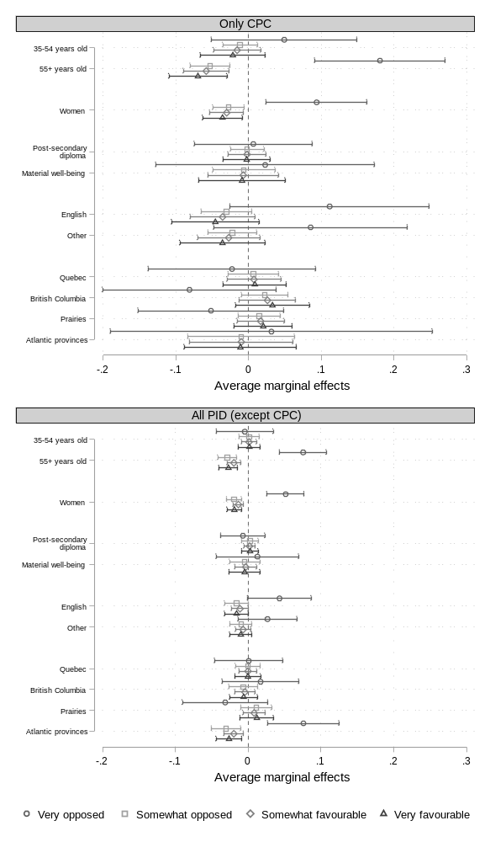
Note. 95% confidence intervals are included.

Table D4. Predicted probability of respondents’ opinion based on their age and whether they feel close to the Conservative party of Canada or not

Predicted opinion | Very opposed | Somewhat opposed | Somewhat favourable | Very favourable | Total
CPC, 18-34 | 62 | 14 | 12 | 12 | 100
Non-CPC, 18-34 | 87 | 5 | 3 | 5 | 100
CPC, 35-54 | 67 | 13 | 10 | 10 | 100
Non-CPC, 35-54 | 86 | 5 | 4 | 5 | 100
CPC, 55+ | 80 | 9 | 6 | 5 | 100
Non-CPC, 55+ | 94 | 2 | 1 | 2 | 100

