**Does administrative burden influence support for a low-income childcare supplement? Evidence from a survey experiment**

**Supplementary Online Appendices**

**Supplementary Materials for *Does administrative burden influence support for a low-income childcare supplement? Evidence from a survey experiment***

Appendix 1. Summary Statistics

We recruited 821 participants through the 2022 Democracy Checkup survey. Tables A1 and A2 show summary statistics for the variables mentioned in our paper, broken out by treatment group.

|  | **Control,**  **N = 276***1* | **High-Burden,**  **N = 268***1* | **Low-Burden,**  **N = 277***1* |
| --- | --- | --- | --- |
| Estimated application time (hours) | 6.55 (5.66) | 8.52 (5.84) | 6.30 (5.39) |
| DV#1: Support for hypothetical childcare program |  |  |  |
| Strongly oppose | 24 / 276 (8.7%) | 21 / 268 (7.8%) | 33 / 277 (12%) |
| Somewhat oppose | 30 / 276 (11%) | 43 / 268 (16%) | 31 / 277 (11%) |
| Neither support nor oppose | 64 / 276 (23%) | 80 / 268 (30%) | 77 / 277 (28%) |
| Somewhat support | 92 / 276 (33%) | 78 / 268 (29%) | 93 / 277 (34%) |
| Strongly support | 66 / 276 (24%) | 46 / 268 (17%) | 43 / 277 (16%) |
| DV #2: Willingness-to-Pay | 23.94 (43.64) | 22.96 (47.63) | 23.51 (45.73) |
| Vote choice in 2021 federal election |  |  |  |
| Bloc | 12 / 276 (4.3%) | 17 / 268 (6.3%) | 26 / 277 (9.4%) |
| Conservative | 59 / 276 (21%) | 55 / 268 (21%) | 55 / 277 (20%) |
| Did not vote | 43 / 276 (16%) | 49 / 268 (18%) | 37 / 277 (13%) |
| Liberal | 86 / 276 (31%) | 84 / 268 (31%) | 86 / 277 (31%) |
| NDP | 59 / 276 (21%) | 42 / 268 (16%) | 52 / 277 (19%) |
| Other | 17 / 276 (6.2%) | 21 / 268 (7.8%) | 21 / 277 (7.6%) |
| Strength of partisan identity |  |  |  |
| Fairly strong | 134 / 240 (56%) | 134 / 221 (61%) | 130 / 240 (54%) |
| Not very strong | 67 / 240 (28%) | 45 / 221 (20%) | 59 / 240 (25%) |
| Very strong | 39 / 240 (16%) | 42 / 221 (19%) | 51 / 240 (21%) |
| (Missing) | 36 | 47 | 37 |
| Left/Right ideology | 5.02 (2.25) | 4.95 (2.25) | 5.06 (2.22) |
| (Missing) | 4 | 6 | 3 |
| Gender |  |  |  |
| Men | 127 / 276 (46%) | 117 / 268 (44%) | 152 / 277 (55%) |
| Non-binary or another gender | 1 / 276 (0.4%) | 2 / 268 (0.7%) | 0 / 277 (0%) |
| Women | 148 / 276 (54%) | 149 / 268 (56%) | 125 / 277 (45%) |
| *1* Mean (SD); n / N (%) | | | |

**Table A1.** Summary Statistics

|  | **Control,**  **N = 276***1* | **High-Burden,**  **N = 268***1* | **Low-Burden,**  **N = 277***1* |
| --- | --- | --- | --- |
| Household income |  |  |  |
| $1 to $30,000 | 42 / 276 (15%) | 29 / 267 (11%) | 33 / 276 (12%) |
| $110,001 to $150,000 | 39 / 276 (14%) | 44 / 267 (16%) | 30 / 276 (11%) |
| $150,001 to $200,000 | 27 / 276 (9.8%) | 22 / 267 (8.2%) | 23 / 276 (8.3%) |
| $30,001 to $60,000 | 71 / 276 (26%) | 62 / 267 (23%) | 70 / 276 (25%) |
| $60,001 to $90,000 | 51 / 276 (18%) | 59 / 267 (22%) | 60 / 276 (22%) |
| $90,001 to $110,000 | 29 / 276 (11%) | 31 / 267 (12%) | 35 / 276 (13%) |
| More than $200,000 | 15 / 276 (5.4%) | 12 / 267 (4.5%) | 17 / 276 (6.2%) |
| No income | 2 / 276 (0.7%) | 8 / 267 (3.0%) | 8 / 276 (2.9%) |
| (Missing) | 0 | 1 | 1 |
| Employment status |  |  |  |
| Caring for a family | 7 / 276 (2.5%) | 3 / 268 (1.1%) | 6 / 277 (2.2%) |
| Caring for family and working for pay | 1 / 276 (0.4%) | 2 / 268 (0.7%) | 0 / 277 (0%) |
| Disabled | 7 / 276 (2.5%) | 2 / 268 (0.7%) | 4 / 277 (1.4%) |
| Other | 5 / 276 (1.8%) | 4 / 268 (1.5%) | 2 / 277 (0.7%) |
| Retired | 68 / 276 (25%) | 64 / 268 (24%) | 61 / 277 (22%) |
| Retired and working for pay | 3 / 276 (1.1%) | 0 / 268 (0%) | 1 / 277 (0.4%) |
| Self-employed (with or without employees) | 16 / 276 (5.8%) | 10 / 268 (3.7%) | 12 / 277 (4.3%) |
| Student | 13 / 276 (4.7%) | 12 / 268 (4.5%) | 9 / 277 (3.2%) |
| Student and working for pay | 1 / 276 (0.4%) | 4 / 268 (1.5%) | 0 / 277 (0%) |
| Unemployed / looking for work | 13 / 276 (4.7%) | 12 / 268 (4.5%) | 12 / 277 (4.3%) |
| Working for pay full-time | 110 / 276 (40%) | 128 / 268 (48%) | 144 / 277 (52%) |
| Working for pay part-time | 32 / 276 (12%) | 27 / 268 (10%) | 26 / 277 (9.4%) |
| Age | 53.70 (17.29) | 53.69 (18.13) | 51.49 (16.88) |
| Marital status |  |  |  |
| Divorced | 25 / 276 (9.1%) | 17 / 268 (6.3%) | 16 / 277 (5.8%) |
| Living with a partner | 44 / 276 (16%) | 42 / 268 (16%) | 33 / 277 (12%) |
| Married | 113 / 276 (41%) | 127 / 268 (47%) | 129 / 277 (47%) |
| Never married | 75 / 276 (27%) | 62 / 268 (23%) | 81 / 277 (29%) |
| Separated | 9 / 276 (3.3%) | 7 / 268 (2.6%) | 8 / 277 (2.9%) |
| Widowed | 10 / 276 (3.6%) | 13 / 268 (4.9%) | 10 / 277 (3.6%) |
| Region |  |  |  |
| Atlantic | 11 / 276 (4.0%) | 21 / 268 (7.8%) | 19 / 277 (6.9%) |
| Ontario | 110 / 276 (40%) | 99 / 268 (37%) | 111 / 277 (40%) |
| Quebec | 56 / 276 (20%) | 56 / 268 (21%) | 66 / 277 (24%) |
| West | 99 / 276 (36%) | 92 / 268 (34%) | 81 / 277 (29%) |
| Citizenship status |  |  |  |
| Canadian Citizen | 266 / 276 (96%) | 252 / 268 (94%) | 266 / 277 (96%) |
| Permanent Resident | 10 / 276 (3.6%) | 16 / 268 (6.0%) | 11 / 277 (4.0%) |
| *1* n / N (%); Mean (SD) | | | |

**Table A2.** Summary Statistics, cont’d

Appendix 2. Balance Test

Following Mutz et al. (2019), we do not necessarily rely on balance tests for confirmation of successful randomization. Nonetheless, for the benefit of the reader, we present the results of a balance test in Table A3. We present results from a likelihood ratio test. Using a multinomial logistic regression, we fit a “full” model with pre-treatment covariates (i.e., 2021 vote choice, ideology, income, marital status, age, employment, gender, and region) and compared this to a “constrained” model with no predictors. The results show that we are unable to reject the hypothesis that the coefficients in the full model are simultaneously equal to zero ([](https://www.codecogs.com/eqnedit.php?latex=%5Cchi%5E2#0) (70)=83.90, P-value=0.12). This bolsters our confidence that randomization was successful, and that our treatment groups are balanced along these key attributes.

|  |  |  |  |  |
| --- | --- | --- | --- | --- |
| **DF** | **Log Likelihood** | **DF** |  | **P-value** |
| 72 | -844.49 |  |  |  |
| 2 | -886.44 | -70 | 83.90 | 0.12 |

**Table A3.** Joint Orthogonality Balance Test

Appendix 3. Regression Results

In Table A4, we present the regression results used in the main analysis. Column 1 shows the results for support. Column 2 adjusts our estimates using pre-treatment covariates shows the same model with pre-treatment covariates. We use the Lin (2013) estimator, which interacts the treatment variable with each covariate, centred at mean zero. Column 3 shows the results for willingness-to-pay (WTP). Column 4 shows the same model with pre-treatment covariates.

|  | **DV1:**  **Support** | **DV1:**  **Support w/ Covariates** | **DV2:**  **WTP** | **DV2:**  **WTP w/ Covariates** |
| --- | --- | --- | --- | --- |
| (Intercept) | 3.529* | 3.495* | 23.942* | 23.595* |
|  | (0.073) | (0.070) | (2.627) | (2.580) |
| High-burden | -0.212* | -0.201* | -0.983 | -0.271 |
|  | (0.102) | (0.100) | (3.920) | (3.960) |
| Low-burden | -0.233* | -0.157 | -0.437 | 0.670 |
|  | (0.103) | (0.101) | (3.802) | (3.864) |
| Estimator | OLS | Lin | OLS | Lin |
| Covariates | No | Yes | No | Yes |
| R2 | 0.008 | 0.211 | 0.000 | 0.184 |
| Num. obs. | 821 | 807 | 821 | 807 |
| *p < 0.05 | | | | |

**A4.** Full Regression Results

Appendix 4. Robustness Check – Results of Ordered Logit Models

As specified in our pre-registration plan, we next present the results from an ordinal logistic regression model. This is the same empirical model as presented in equation (1) in the main analysis, but rather than use linear regression we use an ordered logit model. In Figure A1, we consider support for the hypothetical childcare supplement across treatment groups. We plot the percentage of respondents in each ordered category, from “Strongly oppose” to “Strongly support”. In the control group, we observe a greater percentage of respondents who indicated “Strongly support” (24%) for the supplement, relative to the high- and low-burden groups (17% and 16%, respectively).

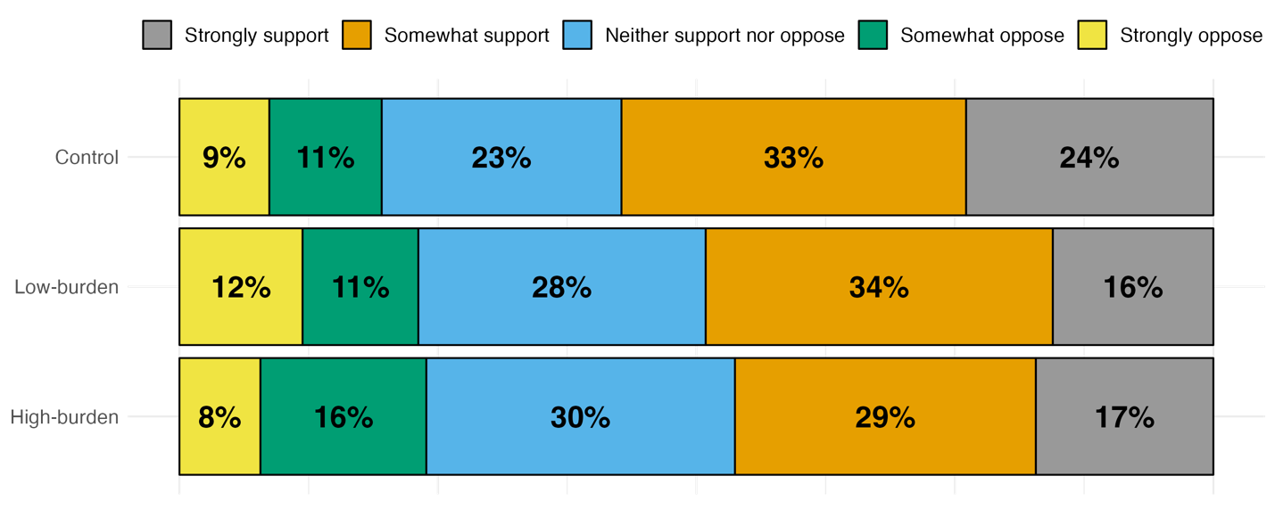

**Figure A1.** Support for Hypothetical Childcare Supplement by Treatment Group

In table A5, we present the ordinal regression results. In the table, we show log-odds with standard errors but for ease of convenience, we convert these results to odds ratios in the text. Consistent with our main analysis, we find the odds of reporting greater support for the childcare supplement are 0.69 times smaller for the high-burden treatment group, relative to control (log-odds = -0.372, SE = 0.154, P-value < 0.05). The odds of reporting greater support for the childcare supplement are approximately the same (odds ratio = 0.69) for the low-burden treatment group, relative to control (log-odds = -0.365, SE = 0.153, P-value < 0.05).

|  | **Log Odds (SE)** |
| --- | --- |
| High-burden | -0.372* |
|  | (0.154) |
| Low-burden | -0.365* |
|  | (0.153) |
| Cut point 1: Strongly oppose - Somewhat oppose | -2.512* |
|  | (0.153) |
| Cut point 2: Somewhat oppose - Neither support nor oppose | -1.512* |
|  | (0.126) |
| Cut point 3: Neither support nor oppose - Somewhat support | -0.285* |
|  | (0.114) |
| Cut point 4: Somewhat support - Strongly support | 1.221* |
|  | (0.123) |
| AIC | 2496.978 |
| BIC | 2525.241 |
| Log Likelihood | -1242.489 |
| Deviance | 2484.978 |
| Num. obs. | 821 |
| *p < 0.05 | |

**Table A5.** Treatment Effects of Administrative Burden on Support for Hypothetical Low-Income Childcare Supplement (ordered logit model)

Appendix 5. Manipulation Check

After seeing each vignette, participants completed a manipulation check: "How many hours do you think it would take a typical low-income family to apply for this program?". Participants indicated their response using a sliding scale, incrementing by 1 unit, where Left = “1 hour or less” and Right = “20 hours or more”.

In Table A6, we present differences in this variable by treatment assignment. People in the control group estimated it would take about 7 hours to apply for the affordable childcare supplement (b = 6.55, SE = 0.34, P-value = <0.05). We find strong evidence that the high-burden vignette shifted peoples’ perceptions of the number of hours it would take people to apply for the hypothetical childcare supplement. The magnitude is approximately 2 hours (b = 1.98, SE = 0.49, P-value = <0.05). People who saw the low-burden vignette estimated it would take less time, about 15 minutes (b = -0.25, SE = 0.47), relative to people in control. However, this difference is not statistically significant (P-value = 0.59). In short, we conclude that our high-burden treatment effectively shifted people’s perceptions of hours needed to apply for this childcare supplement, and hence is an effective manipulation in the experimental design.

|  |  |
| --- | --- |
| (Intercept) | 6.547 (0.341)* |
| High-burden | 1.975 (0.493)* |
| Low-burden | -0.247 (0.470) |
| R2 | 0.030 |
| Num. obs. | 821 |
| *p < 0.05 | |

**Table A6.** Manipulation Check

Appendix 6. Treatment Effect Heterogeneity

Next, we explore the heterogeneity of treatment effect across two variables that prior theory suggests may shape attitudes toward administrative burden in childcare: vote choice and gender.

*Heterogeneity by Vote Choice*

First, we consider the potential for heterogenous treatment effects across partisan affiliation, as measured by prior voting behaviour. As stated in our pre-registration plan, we focus on the difference between voters who identify as Liberals or Conservatives, though we consider differences across other parties too (e.g., the NDP, Bloc). Table A7 presents regression results for our main empirical model with interaction terms for treatment ´ vote choice in the 2021 federal election. Column 1 shows the results for support. Column 2 shows the results for willingness-to-pay (WTP). The results show no evidence of treatment effect heterogeneity – that is, we find no evidence that people’s responsiveness to treatment condition (high vs. low burden vs. control) varies across partisanship. We also find that our treatment effects are no longer statistically significant when we include these interaction terms.

|  | **DV1: Support** | **DV2: WTP** |
| --- | --- | --- |
| (Intercept) | 3.333 (0.300)* | 19.583 (8.394)* |
| High-burden | -0.216 (0.391) | 9.123 (13.647) |
| Low-burden | -0.064 (0.358) | -5.353 (10.491) |
| Conservative (relative to Bloc) | -0.316 (0.343) | -6.431 (9.465) |
| Non-voter (relative to Bloc) | 0.341 (0.334) | -3.188 (10.138) |
| Liberal (relative to Bloc) | 0.353 (0.326) | 9.835 (9.962) |
| NDP (relative to Bloc) | 0.379 (0.339) | 11.705 (10.181) |
| Other party (relative to Bloc) | 0.314 (0.450) | 10.770 (16.047) |
| High-burden x Conservative | 0.162 (0.455) | -10.511 (15.097) |
| Low-burden x Conservative | -0.298 (0.428) | 0.018 (11.755) |
| High-burden x non-voter | -0.234 (0.449) | -14.334 (15.223) |
| Low-burden x non-voter | -0.070 (0.428) | -3.718 (12.283) |
| High-burden x Liberal | 0.065 (0.429) | -6.244 (16.012) |
| Low-burden x Liberal | -0.145 (0.400) | 10.690 (13.245) |
| High-burden x NDP | 0.242 (0.451) | -7.196 (17.077) |
| Low-burden x NDP | 0.064 (0.424) | 14.872 (14.324) |
| High-burden x other party | -0.527 (0.586) | -22.237 (21.512) |
| Low-burden x other party | -0.773 (0.555) | -9.334 (19.237) |
| R2 | 0.080 | 0.056 |
| Num. obs. | 821 | 821 |
| *p < 0.05 | | |

***Table A7.*** *Treatment effect heterogeneity by vote choice*

*Heterogeneity by Gender*

Next, we consider the heterogenous treatment effects across gender identity. Gender is important as childcare programs are designed to help new parents, especially women, find work. Table A8 presents regression results for our main empirical model with interaction terms for treatment ´ gender. Our survey asks respondents to indicate their gender identity, either as “a man”, “a woman”, “non-binary”, or “another gender” with an optional text box. Out of 821 respondents, 51% identified as women (N=422), 48% identified as men (N=396), and 0.4% identified as non-binary (N=3). Unfortunately, this small sample means we cannot estimate treatment effects specifically among non-binary respondents. As such, we screen them out of our analysis. We recognize, however, that gender identity is an important component of socioeconomic outcomes (Government of Canada, 2018), and, in recognition of this fact, some provinces have started to reduce gender-based barriers to childcare (Government of British Columbia, 2023). Columns 1 and 2 show, respectively, support for the hypothetical childcare supplement and WTP for it. Again, the results show no evidence of treatment effect heterogeneity – that is, we find no evidence that people’s responsiveness to treatment condition (high vs. low burden vs. control) varies across gender identity.

|  | **DV1: Support** | **DV2: WTP** |
| --- | --- | --- |
| (Intercept) | 3.433 (0.113)* | 27.063 (4.148)* |
| High-burden | -0.288 (0.151) | 1.561 (6.779) |
| Low-burden | -0.216 (0.149) | -1.175 (5.623) |
| Female (relative to male) | 0.168 (0.148) | -6.651 (5.268) |
| High-burden x Female | 0.123 (0.204) | -3.544 (8.116) |
| Low-burden x Female | 0.007 (0.208) | 1.371 (7.612) |
| R2 | 0.016 | 0.007 |
| Num. obs. | 818 | 818 |
| *p < 0.05 | | |

***Table A8.*** *Treatment effect heterogeneity by gender*

Appendix 7. Administrative Burden and Deservingness Perceptions

Next, we explore whether administrative burdens shift people’s sense of deservingness – i.e., who is worthy of an affordable childcare supplement? Keiser and Miller (2020) argue that burdens are a positive signal of deservingness: People who overcome significant burdens to accessing social spending are seen as *more* deserving than those who more easily access equivalent benefits. In our pre-registration plan, we describe this hypothesis as well as the possibility that burdens may serve as a negative signal of deservingness. Specifically, we explore whether people in the high burden condition may perceive beneficiaries as *less* deserving, relative to people in the control and low-burden conditions, because they may expect that government would only impose burdens on those who are undeserving.

To test these hypotheses, we included five questions adapted from the well-known CARIN framework (Van Oorschot, 2000, 2006). The acronym stands for Control, Attitude, Reciprocity, Identity, and Need, with each item corresponding to a theoretical driver of deservingness. For example, Harell et al. (2022: 988) use the framework to argue that identity, attitude, and reciprocity are central to citizen support for redistribution to migrants, as these items promote a sense of “shared membership” in the community. Our survey question was phrased as follows: "Please indicate whether you agree or disagree with the following statements: 'The proposed supplementary childcare benefit would help people who [are responsible for raising their child/children] / [demand too much support from the government] / [work hard to make a living for the family] / [are an important part of our community] / [are in a bad financial situation]". Permitted responses were: "Strongly disagree / Somewhat disagree / Neither agree nor disagree / Somewhat agree / Strongly agree".

We combine our five CARIN questions into a scale using principal components analysis (PCA).[1] In Figure A2, we plot the PCA results. We find that one component explains approximately 50% of variance in data. In Figure 3, we present boxplots of this single component across levels of support for the hypothetical childcare supplement, separated by treatment group. We observe a positive correlation: Higher levels of the “deservingness” component correlate with greater support for the supplement (Pearson’s correlation = 0.55, t = 19.03, df = 819, p-value < 0.001). However, we do not observe a difference in “deservingness” across our treatment groups.

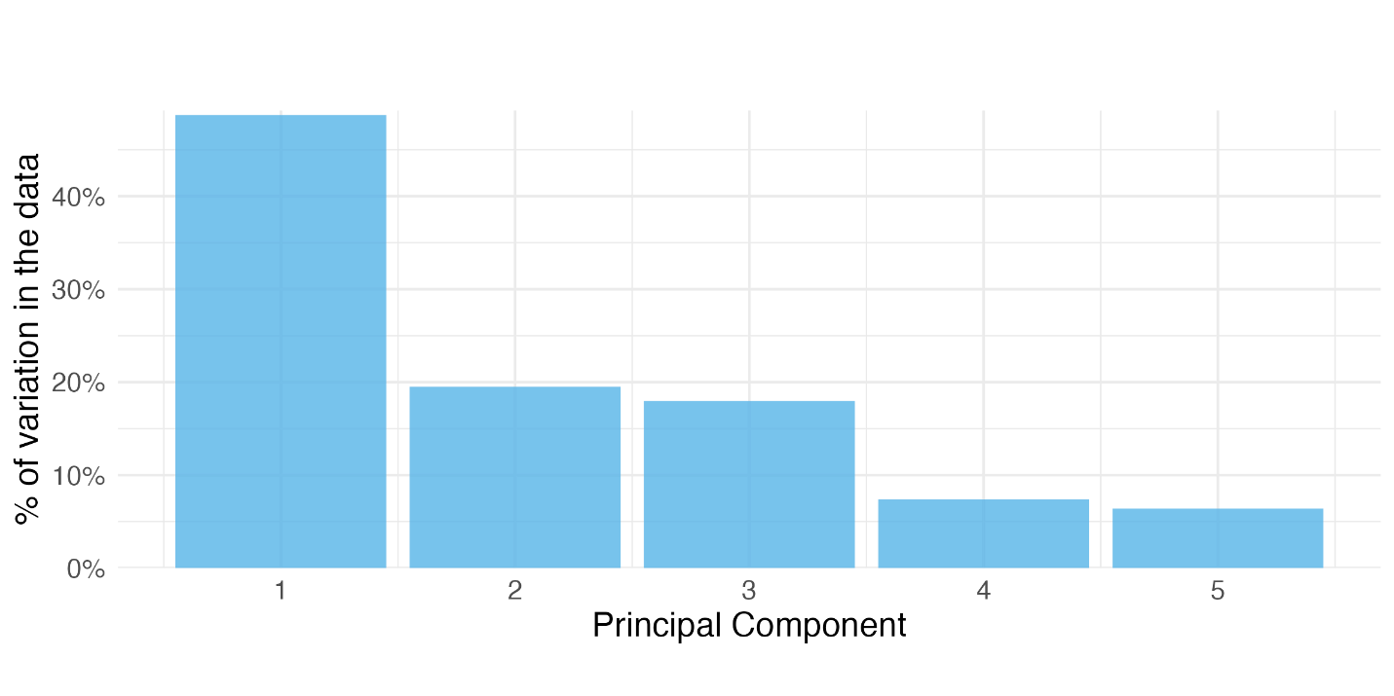

***Figure A2.*** *Principal Components Analysis (PCA) of the CARIN Deservingness Scale*

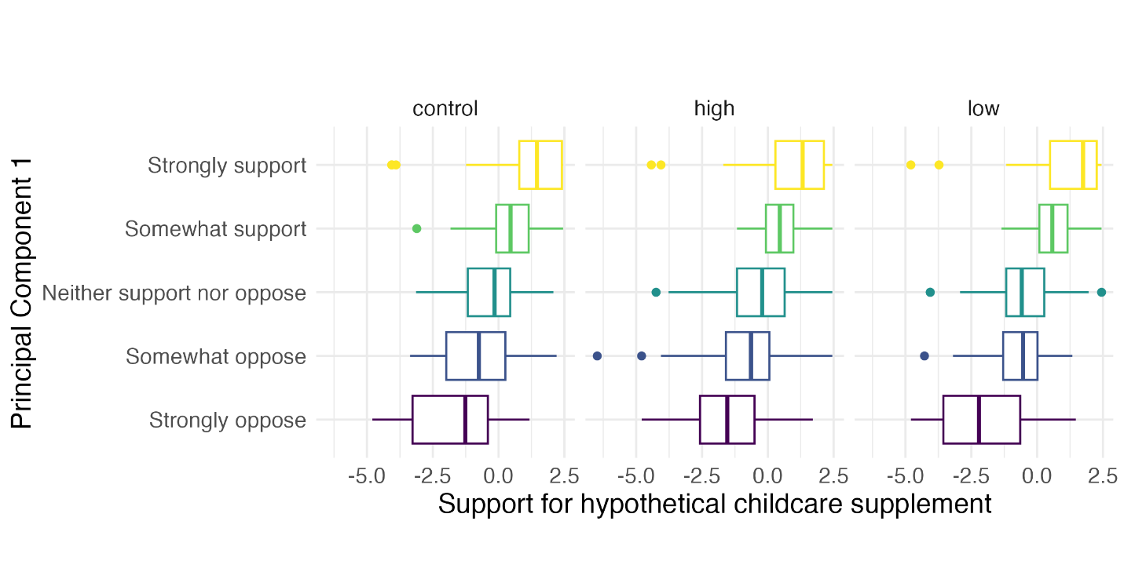

***Figure A3.*** *PCA by Support for Hypothetical Childcare Supplement*

In Table A9, we formally test for differences in deservingness by treatment group. In column 1, we show levels of our PCA-deservingness indicator by treatment group. The results show exposure to information on administrative burdens reduces perceptions of deservingness although the differences are not statistically significant for either the high-burden (b = -0.17, SE = 0.13, P-value = 0.19) or low-burden (b = -0.22, SE = 0.13, P-value = 0.09) groups, relative to control.

|  | **PCA-Deservingness** |
| --- | --- |
| (Intercept) | 0.131 (0.092) |
| High-burden | -0.174 (0.133) |
| Low-burden | -0.221 (0.132) |
| R2 | 0.004 |
| Num. obs. | 821 |
| *p < 0.05 | |

***Table A9.*** *The Effect of Administrative Burden on Deservingness (Principal Components Analysis)*

Taking these results together, we find a strong correlation between deservingness and support – people who support the hypothetical childcare supplement tend to share beliefs about the likely beneficiaries. These beliefs map onto the well-known CARIN framework (e.g., people with caregiving duties, etc.). However, we find no evidence that administrative burden has any effect on perceptions of deservingness. One plausible explanation for this null effect is that the positive signal of burdens on deservingness (i.e., burden as a cue for deserving attributes like effort and need) is canceled out by its negative signal (i.e., burden as a cue for undeserving attributes like race).

Finally, we disaggregate the five variables included in our PCA analysis. These variables correspond to the CARIN framework: control; attitude; reciprocity; identity; and, need. In Table A10, we estimate five linear regressions, comparing the mean of each variable (on a 1-5 scale) across experimental conditions. We find initial evidence of treatment effects in two cases. People in the high-burden group were more likely to think the proposed supplementary childcare benefit would help people who demand too much support from the government (b = 0.25, se = 0.10, P-value = 0.01), relative to people in the control group. People in the low-burden condition were less likely to think it would help people who are an important part of their community (b = -0.22, se = 0.09, P-value = 0.02). However, these effects go away when we use the Holm (1979) adjustment for multiple comparisons. On this basis, we conclude there is little to no evidence that our administrative burden treatments influenced perceptions of deservingness. This analysis was not preregistered.

|  | **CARIN 1 (control)** | **CARIN 2 (attitude)** | **CARIN 3 (reciprocity)** | **CARIN 4 (identity)** | **CARIN 5 (need)** |
| --- | --- | --- | --- | --- | --- |
| (Intercept) | 3.779 (0.065)* | 2.783 (0.073)* | 3.761  (0.061)* | 3.692 (0.062)* | 3.804 (0.061)* |
| High-burden  (relative to control) | -0.029 (0.092) | 0.251 (0.102)* | -0.063  (0.088) | -0.524 (0.393) | -0.092 (0.090) |
| Low-burden  (relative to control) | -0.104 (0.092) | 0.192  (0.099) | -0.162  (0.090) | -0.215 (0.089)* | -0.064 (0.086) |
| R2 | 0.002 | 0.008 | 0.004 | 0.003 | 0.001 |
| Num. obs. | 821 | 821 | 821 | 821 | 821 |
| *p < 0.05 | | | | | |

***Table A10.*** *The Effect of Administrative Burden on Deservingness*

**Works Cited**

Government of British Columbia. “Data improvements for gender, sex make services more inclusive [News Release].” <https://news.gov.bc.ca/28755> (May 11, 2023).

Government of Canada. 2018. “Opportunity for All – Canada’s First Poverty Reduction Strategy.” <https://www.canada.ca/content/dam/canada/employment-social-development/programs/poverty-reduction/reports/poverty-reduction-strategy-report-EN.pdf>

[Harell, Allison, Keith Banting, Will Kymlicka, and Rebecca Wallace. 2022. “Shared Membership Beyond National Identity: Deservingness and Solidarity in Diverse Societies.” *Political Studies* **70** (4): 983-1005.](https://www.zotero.org/google-docs/?Qf2dqA)

Holm, S. 1979. “A simple sequentially rejective multiple test procedure.” *Scandinavian Journal of Statistics* **6** (2): 65-70.

[Keiser, Lael R. and Susan M. Miller. 2020. “Does Administrative Burden Influence Public Support for Government Programs? Evidence from a Survey Experiment.” *Public Administration Review* **80** (1): 137–50.](https://www.zotero.org/google-docs/?Qf2dqA)

Lin, Winston. 2013. “Agnostic Notes on Regression Adjustments to Experimental Data: Reexamining Freedman’s Critique.” *The Annals of Applied Statistics* **7** (1): 295–318.

Mutz, D.C., R. Pemantle, and P. Pham. 2019. “The Perils of Balance Testing in Experimental Design: Messy Analyses of Clean Data.” *The American Statistician* **73** (1): 32–42.

Van [Oorschot, Wim. 2000. “Who Should Get What, and Why? On Deservingness Criteria and the Conditionality of Solidarity among the Public.” *Policy & Politics* **28** (1): 33–48.](https://www.zotero.org/google-docs/?Qf2dqA)

[Van Oorschot, Wim. 2006. “Making the Difference in Social Europe: Deservingness Perceptions among Citizens of European Welfare States.” *Journal of European Social Policy* **16** (1): 23–42.](https://www.zotero.org/google-docs/?Qf2dqA)

1. We rescored each input variable so that positive values indicate greater deservingness.