Online Appendix
Models Using Other Dependent Variables
The total number of cabinet positions includes unoccupied posts and multiple positions held by the same individual. In Table A1, we also test the number of core members in cabinet posts and the number of individual cabinet ministers, considering multiple positions held by the same person. As presented in Models 1 and 2 of Table A1, our theoretical argument is supported, even after using different measures for the number of cabinet members.

Table Al: Alternative Measures of the Proportion of Female Cabinet Members

 | (1)  Ministers  only | (2)  Core members  only
Economic hardship | 1.224*** | 1.196***
 | (0.330) | (0.361)
GDPpc (log) | -0.106 | 0.007
 | (0.210) | (0.236)
GDP growth | 0.017 | 0.011
 | (0.012) | (0.013)
Resource dependence | 0.004 | -0.003
 | (0.029) | (0.031)
Democracy | 0.262 | 0.428
 | (0.383) | (0.415)
Age | -0.104*** | -0.108***
 | (0.011) | (0.012)
Female | 4.838*** | 2.726***
 | (0.599) | (0.647)
College | -1.133*** | -1.202***
 | (0.319) | (0.353)
Constant | 7.442 | 6.878
 | (4.748) | (5.497)
Country-fixed | Yes | Yes
Year-fixed | Yes | Yes
Countries | 146 | 146
N | 4593 | 4588
R-sq | 0.676 | 0.652

Note: OLS regression models predict the proportion of female ministers (%, Model 1) and core female cabinet members (%, Model 2); panel-corrected standard errors are presented in parentheses. Country and year-fixed effects are included. * p<0.01, ** p<0.05, *** p<0.01

Table A2: Models Considering Time Trends

 | (1) | (2) | (3) | (4)
Economic hardship | 0.644*** | 0.788*** | 0.754*** | 0.815***
 | (0.235) | (0.273) | (0.234) | (0.271)
GDPpc (log) |  | 0.380** |  | 0.222
 |  | (0.177) |  | (0.177)
GDP growth |  | 0.016 |  | 0.015
 |  | (0.011) |  | (0.010)
Resource dependence |  | 0.044* |  | 0.055**
 |  | (0.025) |  | (0.025)
Democracy |  | 0.721** |  | 0.316
 |  | (0.334) |  | (0.338)
Age |  |  | -0.075*** | -0.089***
 |  |  | (0.008) | (0.009)
Female |  |  | 4.222*** | 3.356***
 |  |  | (0.453) | (0.483)
College |  |  | -1.156*** | -1.194***
 |  |  | (0.250) | (0.276)
Constant | -368.881*** | -319.692*** | -403.981*** | -382.881***
 | (45.809) | (63.328) | (45.486) | (62.714)
Country-fixed | Yes | Yes | Yes | Yes
Year-fixed | Yes | Yes | Yes | Yes
Countries | 146 | 146 | 146 | 146
N | 5377 | 4594 | 5375 | 4593
R-sq | 0.667 | 0.683 | 0.679 | 0.695

Note: OLS regression models predict the proportion of female ministers (%); panel-corrected standard errors are presented in parentheses. Cubic splines and country- and year-fixed effects are included. * p<0.01, ** p<0.05, *** p<0.01

Economic Hardship and Women’s Rights
We theoretically assumed that experiencing economic hardship nurtures egalitarianism in both men and women. If this logic is correct, leaders from economically-disadvantaged families may improve women’s political representation and enhance their political rights. To test this argument, we estimated three additional models by replacing the dependent variable with various measures of women’s political rights obtained from the V-Dem data. Our findings indicated that leaders’ personal experiences of economic hardship significantly increased women’s civil liberties, civil society participation, and political participation by 0.015, 0.013, and 0.011, respectively. These results suggest that leaders from impoverished backgrounds improve women’s rights overall, driven by the egalitarian values developed during their youth.

Table A3: Effect of Economic Hardship on Women’s Rights

 | (1)  Civil liberties | (2)  Civil society  participation | (3)  Political  participation
Economic hardship | 0.016*** | 0.011** | 0.011**
 | (0.004) | (0.004) | (0.005)
GDPpc (log) | -0.015*** | -0.029*** | -0.025***
 | (0.003) | (0.003) | (0.004)
GDP growth | 0.000 | -0.000* | -0.000
 | (0.000) | (0.000) | (0.000)
Resource dependence | 0.002*** | 0.000 | 0.001**
 | (0.000) | (0.000) | (0.000)
Democracy | 0.172*** | 0.164*** | 0.122***
 | (0.006) | (0.006) | (0.006)
Age | -0.000 | -0.000*** | -0.001***
 | (0.000) | (0.000) | (0.000)
Female | -0.015** | -0.046*** | 0.004
 | (0.007) | (0.007) | (0.009)
College | 0.010** | 0.011** | -0.008
 | (0.004) | (0.004) | (0.005)
Constant | 0.657*** | 0.555*** | 0.702***
 | (0.043) | (0.066) | (0.058)
Country-fixed | Yes | Yes | Yes
Year-fixed | Yes | Yes | Yes
Countries | 145 | 145 | 145
N | 4564 | 4564 | 4511
R-sq | 0.911 | 0.889 | 0.863

Note: OLS regression models predict the levels of women’s economic (Model 1), political (Model 2), and social rights (Model 3); panel-corrected standard errors are presented in parentheses. Country- and year-fixed effects are included. * p<0.01, ** p<0.05, *** p<0.01

Table A4: Models Addressing Potential Confounders

 | (1) | (2) | (3) | (4)
Economic hardship | 0.763*** | 0.853*** | 0.668** | 0.931*
 | (0.273) | (0.276) | (0.271) | (0.497)
Rich background | -0.580
 | (0.364)
GDPpc (log) | 0.038 | 0.009 | -0.108 | -0.047
 | (0.182) | (0.182) | (0.180) | (0.392)
GDP growth | 0.015 | 0.013 | 0.018* | 0.027*
 | (0.010) | (0.011) | (0.010) | (0.015)
Resource dependence | 0.053** | 0.054** | 0.037 | -0.006
 | (0.025) | (0.025) | (0.025) | (0.050)
Democracy | 0.395 | 0.705** | 0.268 | 0.248
 | (0.339) | (0.360) | (0.329) | (0.601)
Age | -0.090*** | -0.093*** | -0.084*** | -0.039**
 | (0.009) | (0.009) | (0.009) | (0.017)
Female | 3.431*** | 3.328*** | 3.254*** | 3.942***
 | (0.480) | (0.491) | (0.477) | (0.667)
College | -1.212*** | -1.194*** | -1.041*** | -1.077**
 | (0.275) | (0.277) | (0.271) | (0.519)
Lawyer |  | -0.639**
 |  | (0.318)
Military |  | 0.473
 |  | (0.334)
Businessperson |  | -1.106**
 |  | (0.459)
Blue-collar |  | -0.077
 |  | (0.545)
Left |  |  | 4.131***
 |  |  | (0.578)
Mean district magnitude (log) |  |  |  | -0.004
 |  |  |  | (0.003)
Female labour participation |  |  |  | 0.372***
 |  |  |  | (0.090)
Constant | 4.765 | 4.270 | 4.891 | 1.836
 | (4.395) | (4.518) | (4.360) | (6.324)
Country-fixed | Yes | Yes | Yes | Yes
Year-fixed | Yes | Yes | Yes | Yes
Countries | 146 | 146 | 145 | 132
N | 4593 | 4540 | 4564 | 2218
R-sq | 0.697 | 0.698 | 0.701 | 0.744

Note: The OLS regression models predict the proportion of female cabinet members (%); panel-corrected standard errors are presented in parentheses. Country- and year-fixed effects are included. * p<0.01, ** p<0.05, *** p<0.01

Table A5: Moderators: Political Factors

 | (1) | (2) | (3) | (4)
Economic hardship | 0.864** | 0.743** | 1.210*** | 3.463***
 | (0.367) | (0.342) | (0.361) | (0.938)
Democracy | 0.362 | 0.338 | 0.237 | -0.270
 | (0.351) | (0.337) | (0.329) | (0.429)
Economic hardship × democracy | -0.066
 | (0.541)
Presidentialism |  | -0.246
 |  | (0.345)
Economic hardship × presidentialism |  | 0.159
 |  | (0.467)
Left |  |  | 4.541***
 |  |  | (0.623)
Economic hardship × left |  |  | -1.685*
 |  |  | (0.861)
Gov’t seat share |  |  |  | 0.017**
 |  |  |  | (0.007)
Economic hardship × Gov’t seat share |  |  |  | -0.046***
 |  |  |  | (0.013)
GDPpc (log) | 0.063 | 0.044 | -0.089 | -0.305
 | (0.180) | (0.183) | (0.180) | (0.241)
GDP growth | 0.014 | 0.016 | 0.019* | 0.020
 | (0.010) | (0.010) | (0.010) | (0.013)
Resource dependence | 0.053** | 0.067*** | 0.035 | 0.053
 | (0.025) | (0.025) | (0.025) | (0.038)
Age | -0.090*** | -0.092*** | -0.084*** | -0.056***
 | (0.009) | (0.009) | (0.009) | (0.012)
Female | 3.417*** | 3.414*** | 3.243*** | 3.778***
 | (0.483) | (0.482) | (0.476) | (0.546)
College | -1.211*** | -1.223*** | -1.013*** | -0.811**
 | (0.284) | (0.275) | (0.272) | (0.359)
Constant | 4.024 | 3.969 | 4.726 | 13.817***
 | (4.403) | (4.425) | (4.354) | (2.485)
Country-fixed | Yes | Yes | Yes | Yes
Year-fixed | Yes | Yes | Yes | Yes
Countries | 146 | 145 | 145 | 144
N | 4593 | 4584 | 4564 | 3484
R-sq | 0.697 | 0.699 | 0.701 | 0.709

Note: The OLS regression models predict the proportion of female cabinet members (%); panel-corrected standard errors are presented in parentheses. Country- and year-fixed effects are included. * p<0.01, ** p<0.05, *** p<0.01
Table A6: Moderators: Upward Mobility

 | (1) | (2) | (3)
Economic hardship | 0.955*** | 0.655** | 0.620*
 | (0.276) | (0.282) | (0.318)
Businessperson | -0.734
 | (0.498)
Economic hardship × businessperson | -2.316**
 | (1.120)
Lawyer |  | -0.328
 |  | (0.316)
Economic hardship × lawyer |  | 2.182**
 |  | (0.915)
Military |  |  | 0.571
 |  |  | (0.349)
Economic hardship × military |  |  | 0.681
 |  |  | (0.616)
GDPpc (log) | 0.054 | 0.035 | 0.088
 | (0.180) | (0.182) | (0.181)
GDP growth | 0.014 | 0.015 | 0.013
 | (0.010) | (0.010) | (0.011)
Resource dependence | 0.054** | 0.049** | 0.051**
 | (0.025) | (0.025) | (0.025)
Democracy | 0.466 | 0.369 | 0.626*
 | (0.339) | (0.339) | (0.356)
Age | -0.090*** | -0.089*** | -0.090***
 | (0.009) | (0.009) | (0.009)
Female | 3.427*** | 3.342*** | 3.425***
 | (0.482) | (0.487) | (0.482)
College | -1.328*** | -1.150*** | -1.227***
 | (0.279) | (0.275) | (0.276)
Constant | 4.098 | 4.237 | 3.643
 | (4.451) | (4.442) | (4.396)
Country-fixed | Yes | Yes | Yes
Year-fixed | Yes | Yes | Yes
Countries | 146 | 146 | 146
N | 4593 | 4593 | 4593
R-sq | 0.698 | 0.697 | 0.697

Note: The OLS regression models predict the proportion of female cabinet members (%); panel-corrected standard errors are presented in parentheses. Country- and year-fixed effects are included. * p<0.1, ** p<0.05, *** p<0.01

Table A7: Matching Estimation

 | (1)
Economic hardship | 0.730*
 | (0.396)
GDPpc (log) | 0.724***
 | (0.265)
GDP growth | 0.003
 | (0.024)
Resource dependence | 0.034
 | (0.029)
Democracy | -1.584**
 | (0.704)
Age | -0.060***
 | (0.018)
Female | Omitted
 | Omitted
College | -1.700***
 | (0.529)
Constant | 1.839
 | (2.837)
Country-fixed | Yes
Year-fixed | Yes
Countries | 129
N | 1416
R-sq | 0.802

Note: OLS regression model predicts the proportion of female cabinet members (%); panel-corrected standard errors are presented in parentheses. Country- and year-fixed effects are included. * p<0.01, ** p<0.05, *** p<0.01
Table A8: Models including Lagged Dependent Variables

 | (1)  T-1 | (2)  T-2 | (3)  T-3
LDV | 0.918*** | 0.860*** | 0.826***
 | (0.008) | (0.010) | (0.012)
Economic hardship | 0.154 | 0.322* | 0.510***
 | (0.130) | (0.170) | (0.193)
GDPpc (log) | 0.187*** | 0.309*** | 0.379***
 | (0.036) | (0.047) | (0.054)
GDP growth | 0.002 | 0.008 | 0.010
 | (0.007) | (0.009) | (0.011)
Resource dependence | -0.014*** | -0.023*** | -0.027***
 | (0.005) | (0.007) | (0.008)
Democracy | 0.427*** | 0.815*** | 1.106***
 | (0.123) | (0.160) | (0.181)
Age | -0.000 | -0.004 | -0.005
 | (0.005) | (0.006) | (0.007)
Female | -0.239 | 0.558 | 1.249***
 | (0.281) | (0.367) | (0.415)
College | 0.083 | 0.189 | 0.200
 | (0.121) | (0.157) | (0.179)
Constant | -0.523 | -0.680 | -0.744
 | (0.359) | (0.469) | (0.539)
Country-fixed | No | No | No
Year-fixed | No | No | No
Countries | 146 | 146 | 146
N | 4593 | 4502 | 4411
R-sq | 0.849 | 0.753 | 0.692

Note: The OLS regression models predict the proportion of female cabinet members (%); panel-corrected standard errors are presented in parentheses.* p<0.01, ** p<0.05, *** p<0.01

Table A7: Leader Level Analysis

 | (1) | (2)
Economic hardship | 1.492*** | 1.373*
 | (0.520) | (0.555)
GDPpc (log) |  | 1.877***
 |  | (0.406)
GDP growth |  | 0.031
 |  | (0.046)
Resource dependence |  | 0.054
 |  | (0.072)
Democracy |  | -0.871
 |  | (0.724)
Age |  | -0.059*
 |  | (0.023)
Female |  | 5.464***
 |  | (0.877)
College |  | -0.890
 |  | (0.553)
Constant | 6.739*** | -5.977
 | (1.401) | (4.217)
Country-fixed | Yes | Yes
Year-fixed | Yes | Yes
Countries | 156 | 147
N | 855 | 758
R-sq | 0.744 | 0.774

Note: The OLS regression models predict the proportion of female cabinet members (%); panel-corrected standard errors are presented in parentheses. Country- and year-fixed effects are included. * p<0.01, ** p<0.05, *** p<0.01

Figure A1. Effect of Economic Hardship on the Proportion of Female Cabinet Members by Businessperson
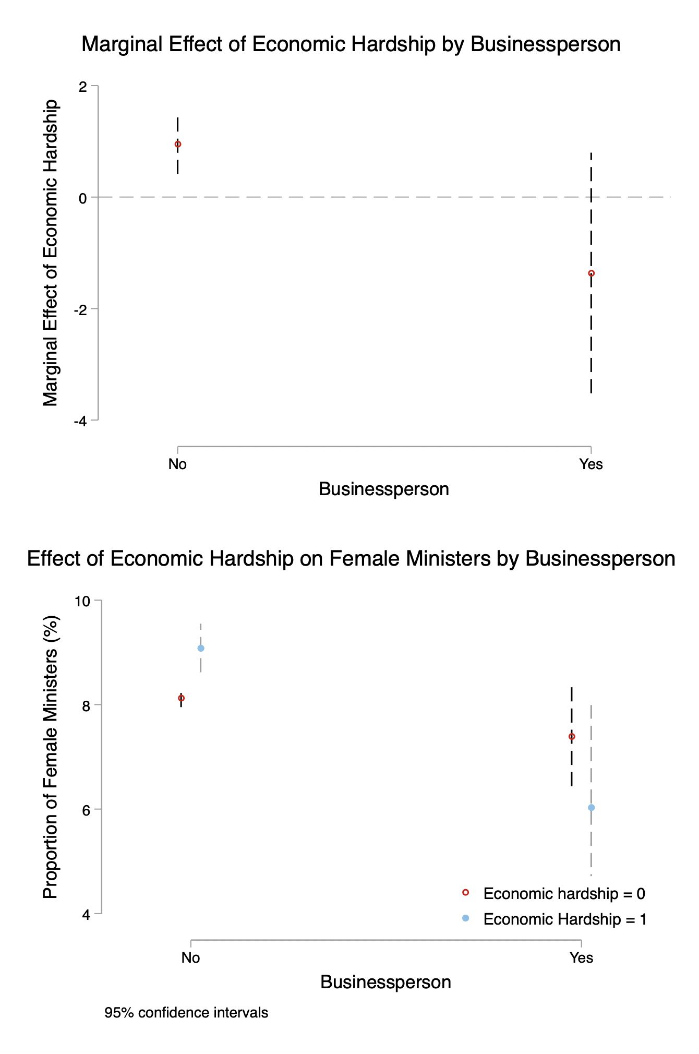
Note: These plots were generated using the coefficient estimates from Model 1 in Table A6. The top figure shows the marginal effects of economic hardship on the percentage of female cabinet members (%). The bottom figure shows the proportion of female cabinet members predicted by leaders’ legal occupational backgrounds. Dashed lines indicate 95 per cent confidence intervals.
Figure A2. Effect of Economic Hardship on the Proportion of Female Cabinet Members by Lawyer

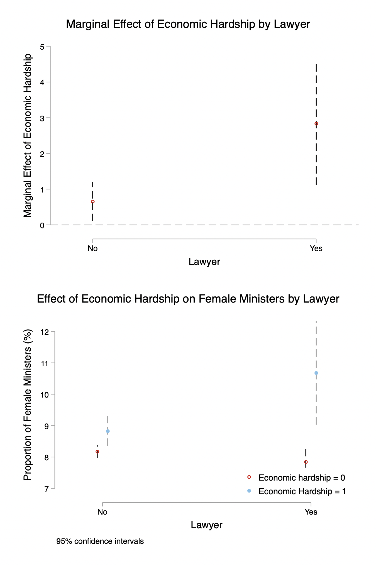

Note: These plots are generated using coefficient estimates from Model 2 in Table A6. The top figure shows the marginal effects of economic hardship on the proportion of female cabinet members (%). The bottom figure shows the predicted proportion of female cabinet member by leaders’ legal occupational backgrounds. Dashed lines indicate 95% confidence intervals.

